Performance of monofilament test:
1.1 Assessment of diabetic neuropathy based on 10gm monofilament test (as per the manufacturer of monofilament 10g Kodys guidelines)
Patients were instructed to close the eye during the assessment for legs. Before this, they were sensitized to understand the touch sensation of 10gm mono filament by placing it over their hands. Once it was ensured they know how to respond when they feel the touch sensation over various sites in legs, the actual assessment was done at six places over plantar aspects of legs namely ball of the great toes, meta tarsal head of first, third and fifth toe, middle of the medial border of foot and heal.

Steps in assessment of neuropathy using monofilament:
- Ask the patient to lie in supine position with barefoot
- Hold the monofilament with thumb and index finger as shown by the manufacturer on the probe
- Place the 10gm Semmelweis 10gm monofilament (Kodys) perpendicularly over dorsum of the hand, middle of the medial border of foot and heal
- Ask the patient whether they are able to feel and instruct them to tell yes when they feel similar kind of sensation over leg
- Ask the patient to close their eyes
- Place the monofilament over plantar aspect of ball of the great toe.
- Keep the contact period for atleast 2 secs till it buckles upto 1cm
- It the patient said yes mark in the foot diagram as present (P) over great toe otherwise mark it as absent (A)
- If for any reason the great toe was not tested mark it as not sure or not recorded (NR)
- Similarly place the monofilament over the other five areas in the plantar aspect of the foot: metatarsal heads of 1st, 3rd and 5th toes, middle of the medial border of foot and heal.
- Mark these areas according to instructions mentioned for the great toe.

Classifying the state of at-risk foot for diabetic peripheral neuropathy using monofilament test:

- Assign score of 1 for each area if the patient is able to feel the sensation of monofilament
- Derive the cumulative score for each leg separately
- If the total score is less than or equal to 4 in a foot it is defined as DPN present hence the foot is considered as ‘at risk’.
In other words, if the patient is not able to feel the sensation in two or more points in one leg it was classified as DPN present.
- Considering the nature of symmetric poly neuropathy in patients with diabetes, if there are signs of DPN in one leg it was considered as overall DPN present (based on monofilament)
- If more than one site is not recognized by the patient, it should be marked as positive to be conservative irrespective of the number of sites tested.
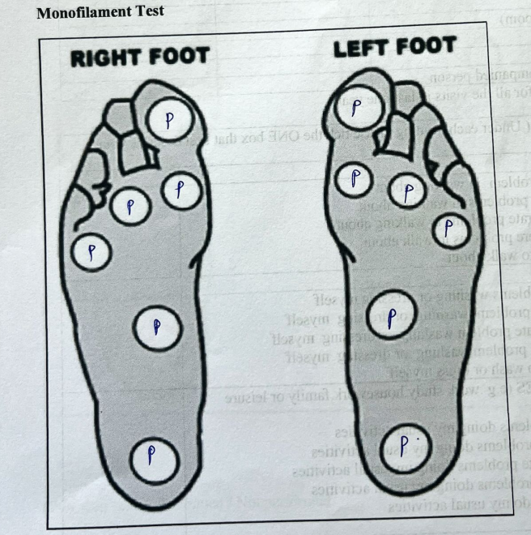

Performance of Biothesiometry test:
1.2 Assessment of diabetic neuropathy based on biothesiometry:
Patients were instructed to close the eye during the assessment for legs. Before this they were sensitized to understand the vibratory sensation by placing the probe over the bony prominence in hands. Once it was ensured that they know how to respond when they feel the vibratory sensation over various sites in legs the actual assessment was done. It was ensured whether the patient was able to differentiate the vibratory from pressure sensation. The assessment was done at six places over plantar aspects of legs namely ball of the great toes, meta tarsal head of first, third, fifth toe, middle of the medial border of foot and heal.
In the leg the starting vibratory threshold was set with the vibratory sensation threshold perceived over the hands. From there it was gradually increased till the patient expressed they could feel the vibratory sensation. To confirm the threshold level, again the vibration levels were reduced to see whether patient is able to feel the vibratory sensation even at the lower threshold level. In each area the vibratory threshold shown in the screen of biothesiometry was noted.
Average score of vibratory threshold was calculated for each leg (cumulative score/6 or number of sites tested). In case any of the site was not assessed for biothesiometry average score was estimated based on number of sites tested. Signs of neuropathy was classified based on the following categories as specified by the manufacturers.
Less than 15- Normal
15-18-Mild
18-25-Moderate
>25-severe

For the study purpose of estimating diagnostic accuracy, mild, moderate and severe categories are considered as abnormal.

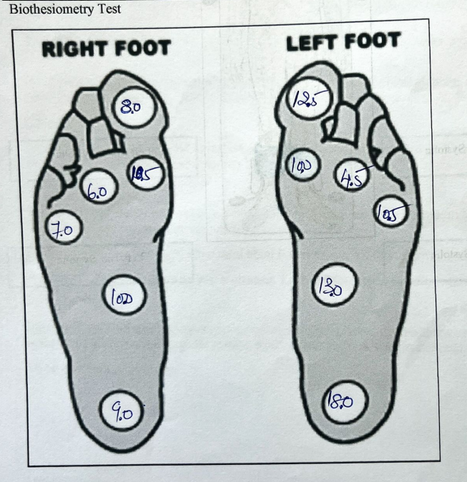

Patient level Preparatory Steps for NCS
Patients scheduled for the NCS were provided with prior appointments and given specific instructions to ensure accurate test results. They were advised to wear loose-fitting clothing for comfort and ease of access to the nerve & muscle sites. Patients were also instructed to refrain from applying oil or lotion on their skin on the test day to avoid interference with electrode placement and signal acquisition. The studies were conducted in a dedicated electrodiagnostic room, where the ambient temperature was carefully maintained between 24–28°C, with a humidity level of 40–50%. Before initiating the procedure, patients were asked if they felt cold, or if their extremities appeared cold to the touch. In such cases, the room temperature was adjusted to ensure that the extremities’ surface temperature exceeded 32°C, facilitating the recording of accurate conduction velocity and amplitudes.

Sensitivity and specificity of biothesiometer at different voltage cut off level compared to nerve conduction study standards among patients with type II diabetes on diabetic peripheral neuropathy screening (N=78)

Cut off level | Sensitivity | Specificity | Accuracy
5mV | 93.55 | 25 | 79.49
10mV | 70.97 | 68.75 | 70.5
15mV | 50 | 81.25 | 56.4
20mV | 37.1 | 87.5 | 47.4
25mV | 12.9 | 87.5 | 28.2

