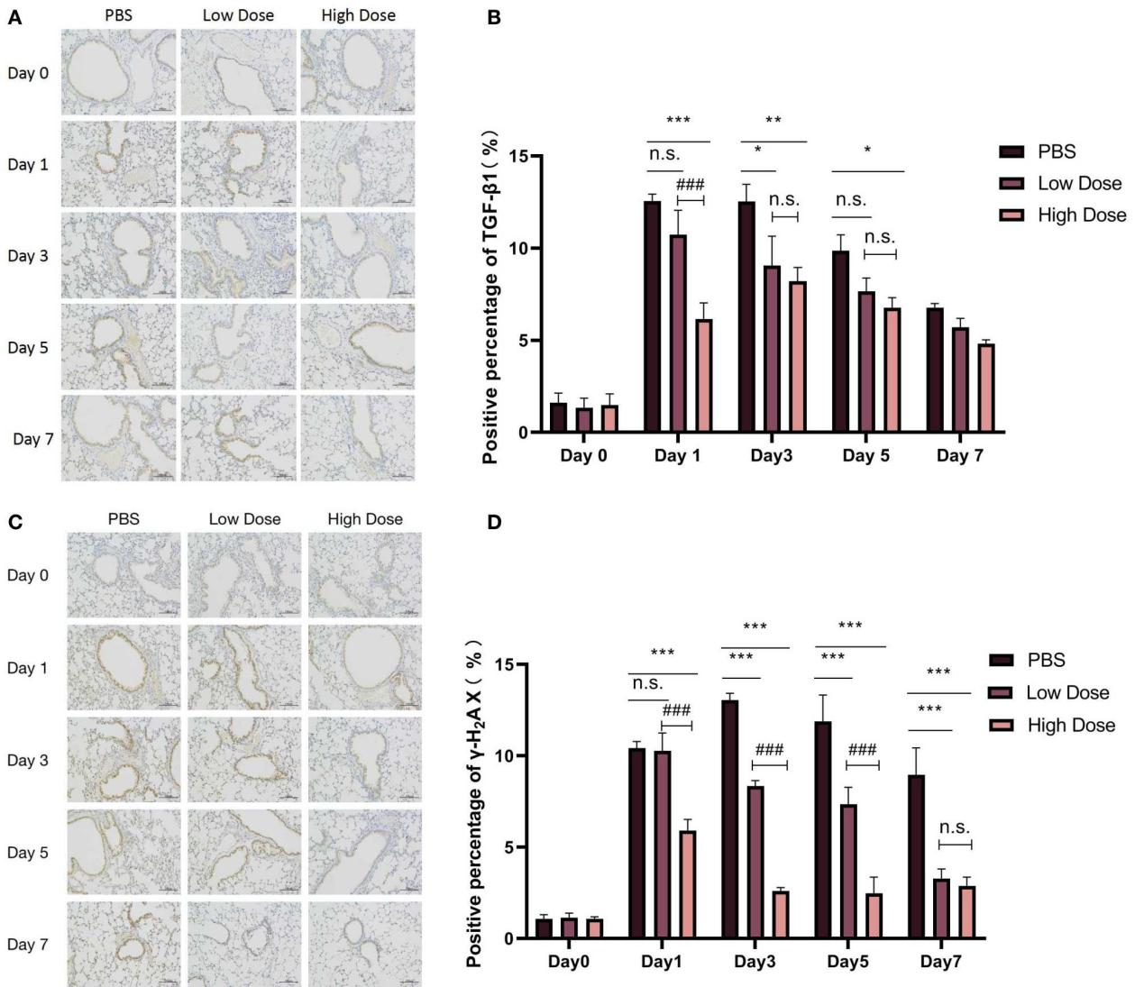
S1. Radiation-induced upregulation of TGF-β1 and γ-H₂AX was reduced by Rac1 inhibition.
C57BL/6 mice were randomly divided into three groups, namely the PBS group (IR+PBS), the Low Dose group (IR+4mg/kg NSC23766) and the High Dose group (IR+8mg/kg NSC23766) (N=15). After three days of injection, all groups were treated with 25Gy local lung radiation. Before radiation treatment (Day 0) and on the 1st, 3rd, 5th and 7th days after local lung radiation, three mice from each group were sacrificed by cervical dislocation and lungs were collected for immunohistochemistry analysis of TGF-β1 (A) and γ-H2AX (C). (B, D) Statistical analysis of the expression level of TGF-β1 and γ-H2AX. Image analysis was conducted using Image J software. ns represented that there was no statistically significant difference between the two groups. *, ** and *** represented P <0.05, 0.01 and 0.001 between the corresponding groups, respectively.

S2. Radiation-induced apoptosis of MLE-12 were reduced by inhibition of Rac1. (A) CCK8 drug toxicity test of NSC23766 for MLE-12. Cells were treated with PBS or different doses of NSC23766 (1μM, 10μM, 100μM and 500μM) for 24hs and then tested with CCK8. (B, C) MLE-12 cells were pretreated with PBS or different doses of NSC23766 (10μM, 50μM and 100μM) for 2hs before 0Gy (no radiation) or 10Gy of radiation. The apoptosis ratio was detected by Annexin V/PI method with a flow cytometry 24hs after radiation. (D, E) Cells were pretreated with PBS or 100μM NSC23766 for 2hs, and collected at designed time points after 10Gy of radiation for WB detection of the expression of Caspase3 and Bax. *** represented P< 0.001 between the two groups. The error value was expressed as mean±SEM. Experiment was repeated for three times.
S3. Construction and efficiency validation of Rac1-knockdown MLE-12 cell lines. A total of 3 targeting-sequences were designed for RAC1 gene (Gene ID: 19353). (A) WB analysis of the expression level of Rac1. Compared with the control group (NC), all three shRNA lentiviruses could down-regulated the expression of Rac1, of which sh1 possessed the best efficiency. (B) qPCR analysis of the relative expression level of Rac1. (C) Virus infection efficiency detected by a fluorescence microscope. Blank groups were not infected with virus. The infection efficiency of Rac1-shNC (control) and Rac1-sh1 were 93.49% and 84.76%, respectively.

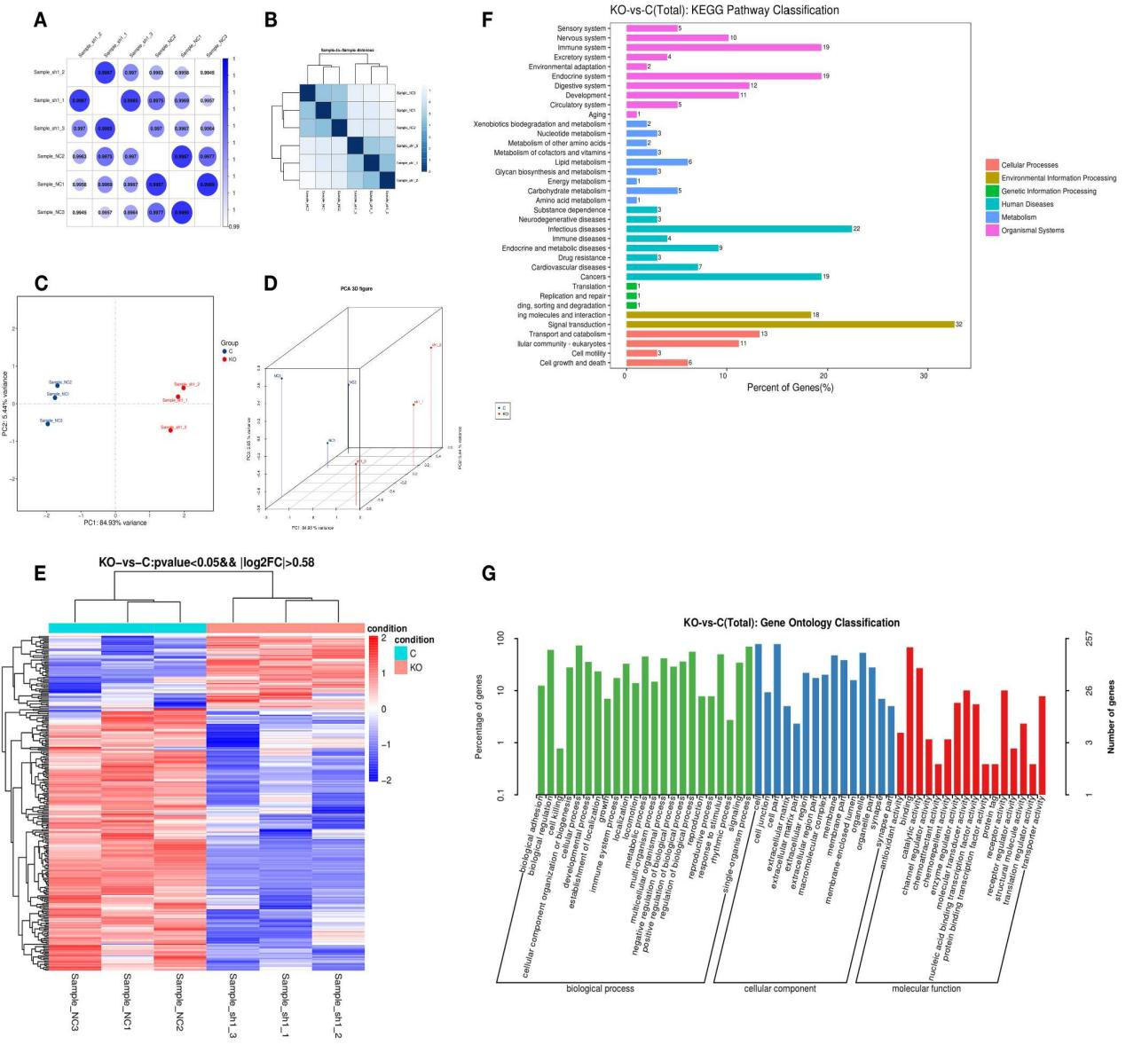
S4. Quality control of RNA-seq samples, Gene ontology and KEGG pathway analysis of differential expression genes caused by Rac1 knockdown. (A) Heat map of correlation coefficient between samples. (B) Sample-to-Sample cluster analysis results. (C) Principal component analysis (PCA analysis) of gene expression. (D) PCA analysis 3D graph. (E) Cluster analysis results of all differential expression genes. (F) Gene ontology (GO) analysis of differential expression genes caused by Rac1 knockdown. (G) KEGG pathway analysis of differential expression genes caused by Rac1 knockdown.

S5. qPCR analysis of another 13 differential expression genes caused by Rac1 knockdown.
A total of 14 differential expression genes (TRP53INP1 was shown in Figure 3F)were tested by qPCR. β-actin was used as the loading control. n.s. represented that there was no statistically significant difference between the two groups. *, ** and *** represented P <0.05, 0.01 and 0.001 between the two groups, respectively. The error value was expressed as mean±SEM, N=3.

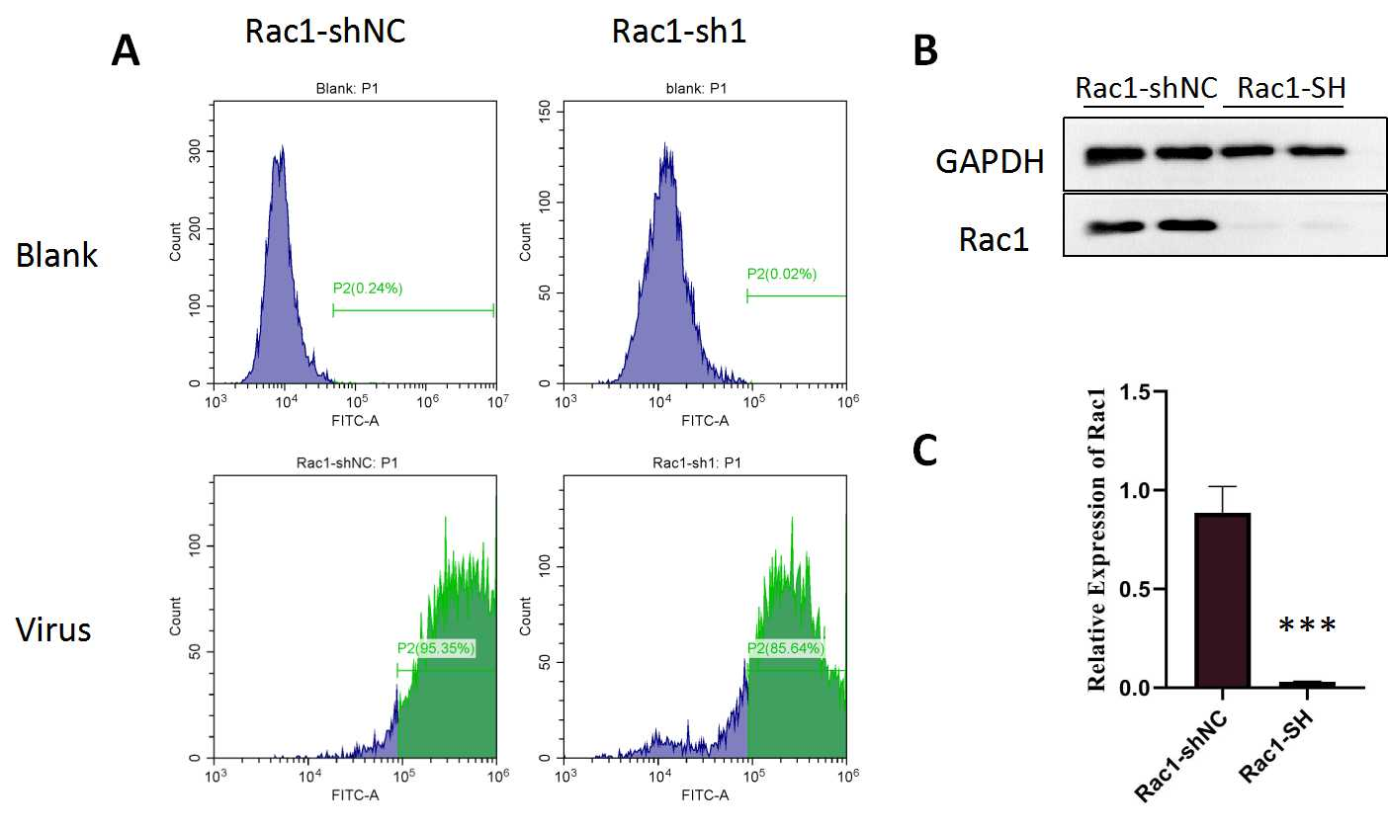
S6. Construction and efficiency validation of Rac1-knockdown LLC cell lines. (A) Virus infection efficiency detected by a fluorescence microscope. Blank groups were not infected with virus. The infection efficiency of Rac1-shNC (control) and Rac1-sh1 were 95.35% and 85.64%, respectively. (B) WB analysis of the expression level of Rac1 in Rac1-shNC (control) and Rac1-SH (Rac1 knockdown) LLC. (C) was the statistical analysis of the relative gray values of (B). *** represented P＜0.001 between the two groups. Experiment was repeated for three times.

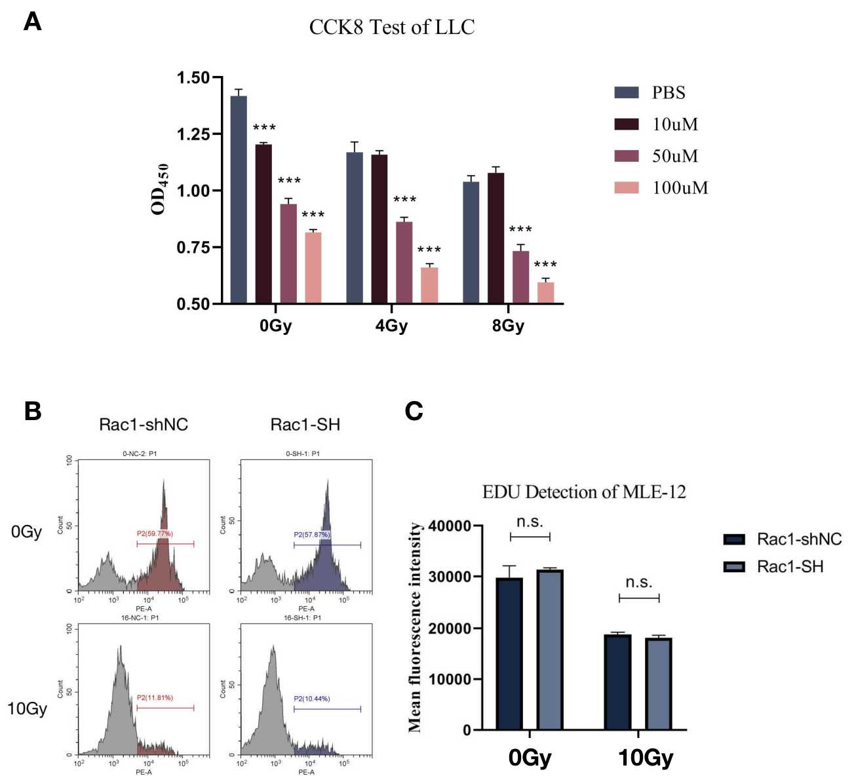
S7. CCK8 test of LLC and EdU detection of MLE-12. (A) CCK8 cell proliferation ability test of LLC. LLC cells were pretreated with PBS or different doses of NSC23766 (10μM, 50μM or 100μM) for 2hs before 0Gy (no radiation) or after different doses of radiation (4Gy or 8Gy). *** represented P＜0.001 between the corresponding group and the PBS group under the same dose of radiation. The error value was expressed as mean±SEM, N=6. (B-C) EdU cell proliferation detection of Rac1-shNC and Rac1-SH MLE-12 cells. 24hs after 10Gy of radiation (0Gy for no radiation), Rac1-shNC and Rac1-SH MLE-12 cells were collected for EdU proliferation detection. n.s. represented that there was no statistically significant difference between the two groups. The error value was expressed as mean±SEM, N=3.

