Table S1.
Imaging parameters of prostatic Mp-MRI scan
Sequence | T2 TSE sagittal | T2 TSE coronal | T2 TSE axial | DWI axial | DCE axial
TR (ms) | 3900 | 3500 | 6980 | 5000 | 4.20
TE (ms) | 105 | 105 | 105 | 72 | 1.34
Flip Angle (deg) | 160 | 160 | 160 | - | 14
FOV (cm) | 25 | 25 | 20 | 20 | 24
Matrix size | 384 | 384 | 384 | 128 | 224
Thickness (mm) | 3 mm | 3 mm | 3 mm | 5 mm | 3 mm
Voxel size (mm) | 0.6×0.6×3 | 0.6×0.6×3 | 0.5×0.5×3 | 1.5×1.5×3 | 1.1×1.1×3
b-value (sec/mm²) | - | - | - | 50, 700, 1500, 2000 | -
Time (min: sec) | 3:28 | 3:23 | 3:32 | 5:05 | 3:44
TR = repetition time; TE = echo time; FOV = field of view; TSE = turbo spin echo; DWI = diffusion-weighted imaging; DCE = dynamic contrast enhanced

Table S2
Hyper-parameter space search configuration of 11 base learners.
Learner | Hyper-parameter set configuration
SVM | RBF kernel; Cost (0.1 to 1, step 0.1);  Loss epsilon (0.1 to 1, step 0.1)
AdaBoost | Estimator (50-400, step 50);  Learning rate (0.1-1, step 0.1)
k-NNs | Neighbors (5, 10);  Metric (Euclidean)
NNs | Hidden layers (100, 100); Activation (ReLu);  Solver (Adam); Regularization (0.01 to 1, step 0.01)
XGB | Tree (10 to 400); Learning rate (0.1 to 1, step 0.1);  Regularization (0.01 to 1, step 0.01); Depth (3-15, step 1)
CatBoost | Tree (10 to 400); Learning rate (0.1 to 1, step 0.1);  Depth (3-15, step 1)
GBM | Tree (10 to 400); Learning rate (0.1 to 1, step 0.1);  Depth (3-15, step 1)
Naïve Bayes | -
XGB-RF | Tree (10 to 400); Learning rate (0.1 to 1, step 0.1);  Regularization (0.01 to 1, step 0.01); Depth (3-15, step 1)
LR | Lasso regression;  Cost (0.1 to 1, step 0.1)
RFs | Tree (10 to 400); Learning rate (0.1 to 1, step 0.1);  Regularization (0.01 to 1, step 0.01); Depth (3-15, step 1)
SVM = Support Vector Machine; k-NN = k-Nearest Neighbors; Naïve Bayes (NB); XGB = Extreme Gradient Boosting; NNs = Neural Networks; LR = Logistic Regression; Gradient Boosting Machine (GBM); RFs = Random Forests.

Table S3.
Results of features selection on mpMRI using six imaging embedders.
Embedder | Vectors | MDGI feature selection
Embedder | Vectors | Top 0.1% | T2WI | DWI | ADC | Top 3 features
Radiomics | intensity, shape, texture, wavelets | 2553 25 | 0 | 25 | 0 | dwi_wavelet.HHH_glcm_Contrast  dwi_wavelet.HHH_glcm_ClusterTendency  dwi_wavelet.LHH_glcm_JointEnergy
DeepLoc | penultimate layer | 1553 16 | 1 | 10 | 5 | dwi_x192  dwi_x411  adc_x75
Inception v3 | flatten10 layer | 6144 61 | 2 | 43 | 6 | dwi_x910  dwi_x1995  dwi_x95
SqueeezeNet | penultimate layer fc-7 | 3000 30 | 1 | 28 | 1 | dwi_x506  dwi_x488  dwi_x740
VGG16 | penultimate layer fc-7 | 12288 112 | 10 | 77 | 25 | dwi_x328  dwi_x3160  dwi_x360
VGG19 | penultimate layer fc-2 | 12288 122 | 18 | 94 | 10 | dwi_x3811  dwi_x3538  dwi_x1840
∑ | - | 37809  376 | 32 | 277 | 47 | -
Note. Feature selection is based on a mean decrease Gini index (MDGI) with a Random Forests (RFs) analysis. T2WI = T2 weighted imaging; DWI = diffusion weighted imaging at b 1500 sec/mm²; ADC = apparent diffusion coefficient.

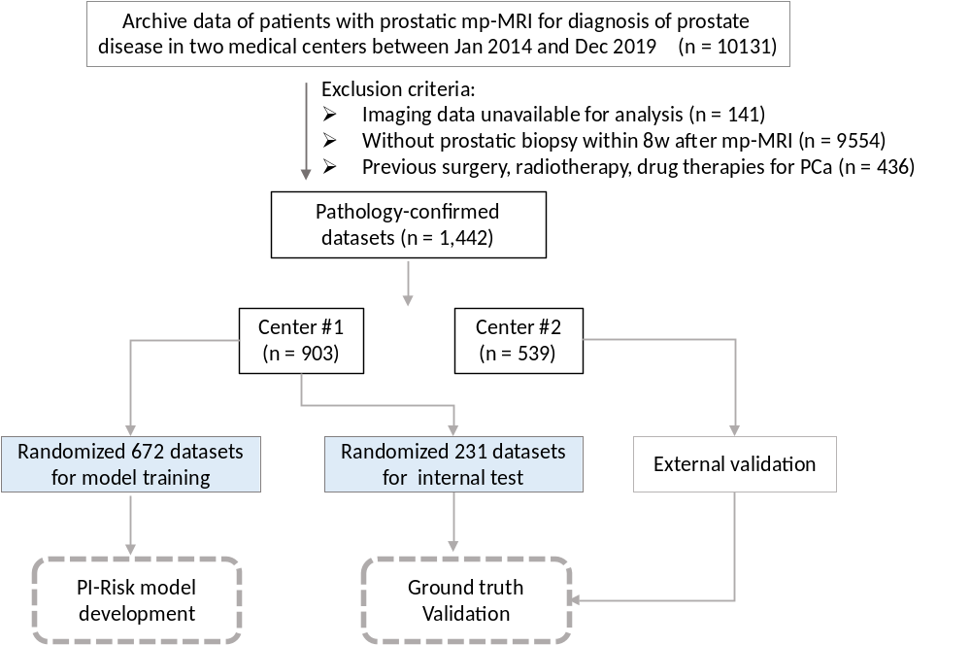
Fig. S1 | The patient enrollment procedures and flowcharts for data analysis.
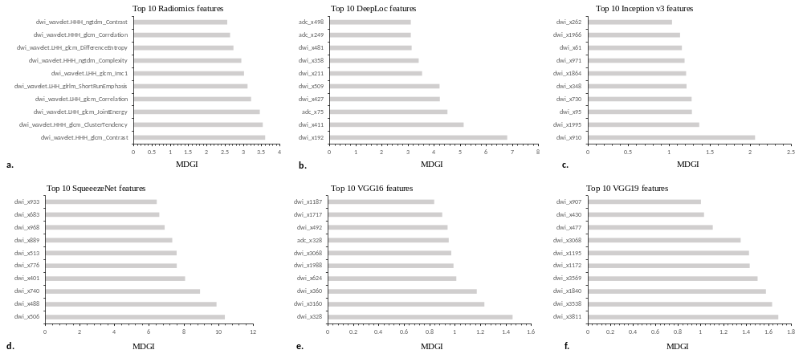
Fig. S2 | Results of feature selection in primary training data sets with 5-fold cross-validation. A random forest classifier, combining the concepts of feature selection and step model training was used to select the relevant features of PCa Gleason grade. Cross-validation was applied on the training cohort to optimize the hyper-parameter of each methods and one-standard error was used to determine the number of the features. A mean decrease Gini index (MDGI) was used for feature selection, in which top 0.1% ranked features were selected as feature candidates. Plots are the top ranked features from radiomics (a), DeepLoc (b), Inception v3 (c), SqueezeNet (d), VGG16 (e) and VGG19 features (f), respectively.

Fig. S3 | The t-distributed stochastic neighbor embedding (t-SNE) plot of MDGI-derived radiomics (a), DeepLoc (b), Inception v3 (c), SqueezeNet (d), VGG16 (e) and VGG19 features (f), respectively, for the multi-class classification of pG0, pG1, pG2, pG3 and pG4 diseases.

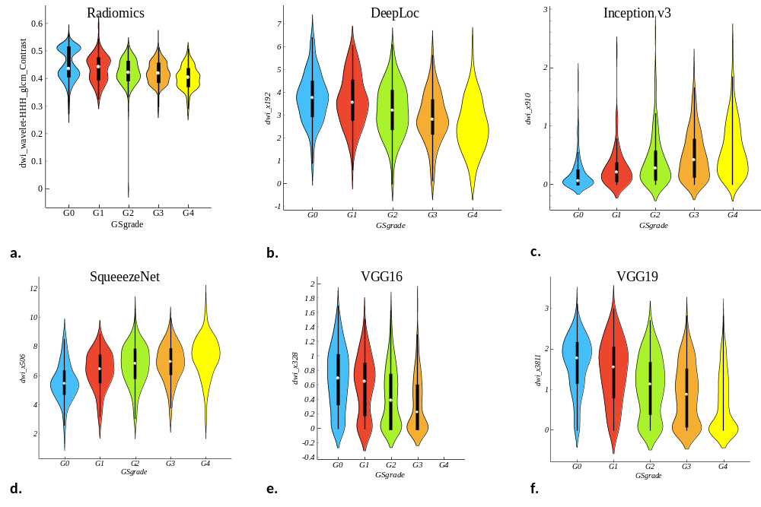
Fig. S4 | Violin plots to visualize the distribution of the leading feature values in radiomics (a), DeepLoc (b), Inception v3 (c), SqueezeNet (d), VGG16 (e) and VGG19 features (f) between pG0, pG1, pG2, pG3 and pG4 group, respectively.

