Supplementary materials
Part 1: Experimental design
In the present study, all mice were randomly assigned to the following experiments.
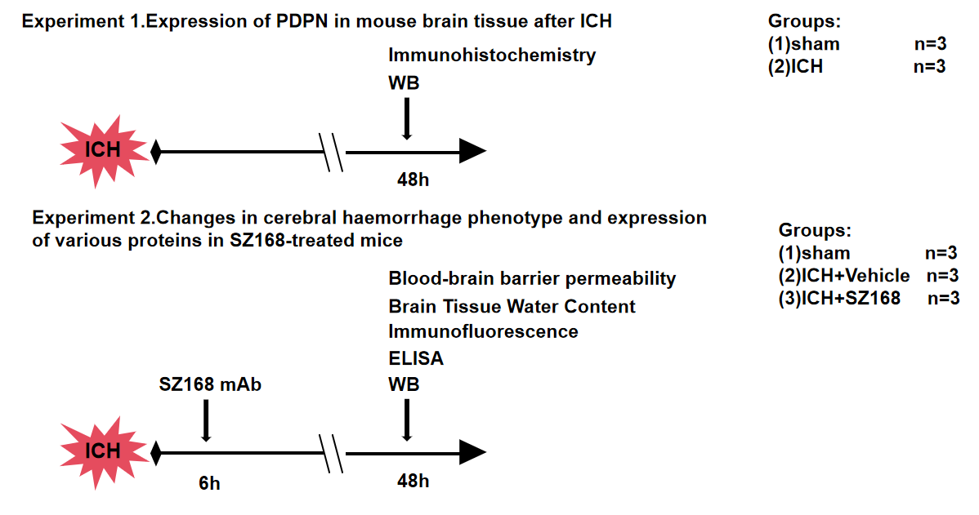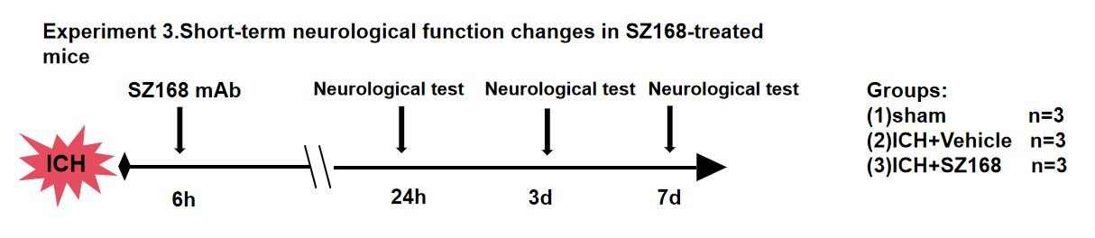
Experiment 1
To observe the expression of PDPN, tissues were harvested from the brain haematoma site after establishing the ICH model in mice and subjected to Western blot analysis, immunohistochemistry and immunofluorescence staining.

Experiment 2
The ICH model was established using C57BL/6 mice and SZ168 was injected intraperitoneally after 2 hours. Three days later, the brains of the mice were removed to observe the cerebral haemorrhage, which showed that the cerebral haematoma area of the mice in the control group was significantly enlarged compared with that of the SZ168 group, and it was speculated that the treatment with SZ168 was able to reduce the size of the cerebral haematoma of the mice after ICH. And also observed the expression of PDPN and related inflammatory factors in ICH after SZ168 treatment.
Experiment 3
In the short-term neurological function observation, by observing the neurological function of mice at 1, 3 and 7 days after modelling, the results showed that the neurological deficits in the ICH+mIgG group were higher than those in the SZ168 treatment group at 1, 3 and 7 days after ICH and that the treatment with SZ168 was able to effectively reduce the degree of neurological impairment.

Part 2
Table S1. Summary of experimental groups and mortality rate in the study.
Experimental Groups | WB | IHC | Neurological test | Exclusion | Mortality (%) | Subtotal
Experimental Groups | ELISA
Experimental Groups | Immunofluorescence
Experimental Groups | BBB
Experimental Groups | BWC
Experimental 1
Sham | 6 | 6 |  | 0 | 0 | 12
ICH | 5 | 6 |  | 0 | 1(8.33%) | 12
Experimental 2
Sham | 23 |  |  | 0 | 0 | 23
ICH+Vehicle | 17 |  |  | 1 | 5(21.74%) | 23
ICH+SZ168 | 19 |  |  | 0 | 4(17.29%) | 23
Experimental 3
Sham |  |  | 5 | 0 | 0 | 5
ICH+Vehicle |  |  | 4 | 1 | 0 | 5
ICH+SZ168 |  |  | 5 | 0 | 0 | 5
Total | 71 | 12 | 15 | 2 | 10 | 108

ICH, intracerebral hemorrhage; WB, western blot, ELISA, enzyme-linked immunosorbent assay, BBB: Blood-brain barrier, BWC: Brain water content;

