Supplementary information: Large scale burning of the upstream catchment results in greater and longer lasting effects on stream macroinvertebrate communities than local site scale burning. Mark D Shenton, Ross M Thompson and Ben J Kefford.

Table S1. Expectations of fire effects on stream macroinvertebrates and macroinvertebrate communities based on results of Shenton et al. (2024 [submitted]) and the published literature (see References column). The expected duration of effects specified in hypothesis column are based on Shenton et al. 2024 (2024 [submitted]). Expected responses are based on the published literature (references column).
Prediction | Expected duration based on Shenton et al. (2024) in prep. | Expected macroinvertebrate response | References
Prediction 1: Macroinvertebrate total abundances and taxa richness will increase because:  - Increased TN will lead to greater macroinvertebrate abundance because of increased availability and quality of food resources, at burnt sites only up to 18 months.  - Increased solar radiation from decreased streamside vegetation (in addition to increased TN) will increase primary production, also contributing to greater food availability and quality at burnt sites only up to 96 months.  - Increased detritus (CPOM, sticks, leaves) provide food and habitat for some macroinvertebrates at site burnt AND catchment burnt sites up to 6 months. | Site burnt: 6m to 96m.  Catchment burnt: Up to 6m. | ↑ total abundance  ↑ taxa richness | Abundances: Martens et al. 2019; Mellon et al. 2008; Leonard et al. 2017; Oliver 2012; Silins et al. 2014; Verkaik et al 2014; Verkaik et al 2015, Robson et al. 2018.  Richness: Leonard et al. 2017, Robson et al. 2018.
Prediction 2: Macroinvertebrate total abundances and taxa richness will decrease because:  - Reduced riparian shrub and grass cover will lead to decreased rainfall interception and increased overland flow (and therefore ash/sediment movement & flashy hydrographs), resulting in taxa declines at burnt sites up to 12 months. Downstream effects at catchment burnt sites expected on a similar timeframe (up to 12 months) because of downstream transport from burnt sites.  - Increased mud/muck leads to smothering of habitat, animals and food resources, and thus results in reduced taxa at burnt sites AND catchment burnt sites up to 48 months.  - Increased detritus (CPOM, sticks, leaves) will reduce habitat, and quantity/quality of food by smothering algae and biofilms, for some macroinvertebrates at site burnt AND catchment burnt sites up to 6 months. | Site burnt: 6m to 48m.  Catchment burnt: 6m to 48m. | ↓ total abundance  ↓ taxa richness | Abundances: Vieira et al. 2004.  Richness: Vieira et al 2004; Verkaik et al. 2014, Minshall 2003, Paul 2022, Martens et al 2019; Oliver et al 2012, Roby & Azuma 1995.
Prediction 3: Taxa diversity will increase because of:  - Increased food resources (quality and quantity) associated with increased TN and solar radiation at burnt sites only up to 96 months.  - Increased food/habitat associated with increased detritus (CPOM, sticks, leaves) will advantage some taxa at burnt sites AND catchment burnt sites up to 48 months. | Site burnt: 6m to 96m.  Catchment burnt: 6m to 48m. | ↑ taxa diversity | Silins et al 2014, Leonard et al 2017.
Prediction 4: Taxa diversity will decrease because:  - Reduced riparian shrub and grass cover will lead to decreased rainfall interception and increased overland flow (and therefore ash/sediment movement, flashy hydrographs), resulting in taxa declines at burnt sites for up to 96 months. Downstream effects are expected at catchment burnt sites on a similar timeframe (up to 96 months).  - Increased mud/muck leads to smothering of habitat, macroinvertebrates and food sources, thus resulting in reduced taxa abundances at burnt sites and catchment burnt sites up to 48 months.  - Increased detritus (CPOM, sticks, leaves) will disadvantage some taxa at burnt sites AND catchment burnt sites up to 48 months. | Site burnt: Up to 96m.  Catchment burnt: Up to 96m. | ↓ taxa diversity | Mellon et al 2008, Roby & Azuma 1995.
Prediction 5: Chironomidae taxa richness and abundances will increase post-fire because:  - Increased TN and solar radiation from removal of riparian vegetation will lead to increased filamentous algae providing habitat favourable to many chironomid species at burnt sites only for up to 96 months.  - Chironomidae taxa are known early colonisers following disturbance. | Site burnt: Up to 96m. | ↑ chironomidae | Martens et al 2019; Mellon et al 2008; Leonard et al 2017; Oliver 2012; Sillins et al 2014; Verkaik 2014 & 2015, Robson et al 2018
Prediction 6: Community composition will change post-fire because:  - Sensitive taxa will reduce in number and richness in response to changes in WQ variables at burnt sites up to 30 months and catchment burnt sites up to 12 months.  - Changes to riparian habitat will advantage some taxa, but disadvantage others, changing taxonomic composition at burnt sites for up to 96 months.  - Changes to substrate composition (including mud/muck and detritus) will advantage some taxa, but disadvantage others, changing taxonomic composition at burnt sites for up to 48 months, and catchment burnt sites up to 60 months.  - Less sensitive, resistant and/or resilient taxa will increase in number and richness. | Site burnt: Up to 96m.  Catchment burnt: Up to 60m. | Changed community composition. ↓E, P, T & EPT as counts, taxa richness and relative abundance. Changed Bray-Curtis dissimilarity index. | Arkle et al 2010; Oliver et al 2012; Minshall et al 2001, Robson et al 2018, Sillins et al 2014, Verkaik 2014

Table S2. Site information for sampling sites located in Kosciuszko National Park. d/s= downstream, STP = sewage treatment plant.
Site number | Longitude | Latitude | Elevation (m ASL) | Site/Upstream Catchment Use | Waterway Name | Classification
011 | 148°17’37”E | 36°30’48”S | 1380 | Golf course, subalpine woodland | Thredbo River | Site Burnt
012 | 148°18’52”E | 36°29’56”S | 1360 | Ski resorts and township | Thredbo River | Catchment Burnt
013 | 148°19’13”E | 36°29’49”S | 1350 | 100 m d/s of STP, subalpine woodland | Thredbo River | Catchment Burnt
014 | 148°19’21”E | 36°29’48”S | 1340 | 500 m d/s of STP, subalpine woodland | Thredbo River | Catchment Burnt
105 | 148°19’5”E | 36°26’14”S | 1780 | Ski resort | Spencers Creek | Unburnt
106 | 148°20’01”E | 36°26’06”S | 1760 | Ski resort activities | Spencers Creek | Unburnt
107 | 148°20’12”E | 36°26’06”S | 1750 | STP | Spencers Creek | Unburnt
121 | 148°24’33”E | 36°24’45”S | 1735 | subalpine woodland | Rock Creek | Unburnt
122 | 148°24’38”E | 36°24’14”S | 1720 | Ski resorts and activities | Perisher Creek | Unburnt
123 | 148°24’32”E | 36°23’18”S | 1700 | STP | Perisher Creek | Unburnt
124 | 148°24’30”E | 36°22’48”S | 1600 | 700 m d/s STP | Perisher Creek | Site Burnt
128 | 148°25’39”E | 36°23’58”S | 1680 | subalpine woodland | Pipers Creek | Site Burnt
129 | 148°26’11”E | 36°23’40”S | 1640 | Ski resort activities | Pipers Creek | Site Burnt
160 | 148°31’22”E | 36°20’55”S | 1450 | Resort | Sawpit Creek | Catchment Burnt
161 | 148°33’45”E | 36°21’08”S | 1200 | d/s resort, subalpine woodland | Sawpit Creek | Site Burnt
162 | 148°34’08”E | 36°21’23”S | 1180 | Campground and subalpine woodland | Sawpit Creek | Site Burnt

Table S3. Results of statistical testing of the interaction between site type and time since fire for macroinvertebrate total abundances (log10 transformed counts).
Time since fire | Burn category | Value | Std.Error | DF | t-value | p-value
25-36 months | Cat burnt | 0.255901 | 0.150602 | 427 | 1.69919 | 0.0900
 | Site burnt | -0.05712 | 0.149706 | 427 | -0.38152 | 0.7030
19-30 months | Cat burnt | 0.219056 | 0.145243 | 429 | 1.50821 | 0.1322
 | Site burnt | -0.1185 | 0.143355 | 429 | -0.8266 | 0.4089
13-24 months | Cat burnt | 0.391548 | 0.151427 | 429 | 2.58573 | 0.0100
 | Site burnt | 0.101497 | 0.149459 | 429 | 0.67909 | 0.4974
12 months | Cat burnt | 0.358245 | 0.152383 | 444 | 2.35095 | 0.0192
 | Site burnt | 0.012006 | 0.155509 | 444 | 0.0772 | 0.9385
9 months | Cat burnt | 0.185798 | 0.172409 | 420 | 1.07766 | 0.2818
 | Site burnt | -0.06419 | 0.176531 | 420 | -0.36364 | 0.7163
6 months | Cat burnt | 0.432718 | 0.183663 | 400 | 2.35604 | 0.0190
 | Site burnt | 0.180703 | 0.189722 | 400 | 0.95246 | 0.3414
4 months | Cat burnt | 0.542593 | 0.196699 | 392 | 2.75849 | 0.0061
 | Site burnt | 0.243354 | 0.195208 | 392 | 1.24664 | 0.2133
1 month | Cat burnt | 0.653383 | 0.320068 | 368 | 2.04139 | 0.0419
 | Site burnt | 0.288895 | 0.286646 | 368 | 1.00784 | 0.3142

Table S4. Results of statistical testing of the interaction between site type and time since fire for macroinvertebrate taxa richness (data not transformed).
Time since fire | Burn category | Value | Std.Error | DF | t-value | p-value
49-60 months | Cat burnt | -3.35033 | 1.886211 | 423 | -1.77622 | 0.0764
 | Site burnt | -1.04103 | 1.850118 | 423 | -0.56268 | 0.5739
37-48 months | Cat burnt | -7.29449 | 1.844644 | 428 | -3.95442 | 0.0001
 | Site burnt | -2.27163 | 1.821159 | 428 | -1.24735 | 0.2130
25-36 months | Cat burnt | -4.35604 | 1.865651 | 427 | -2.33486 | 0.0200
 | Site burnt | -1.59483 | 1.854972 | 427 | -0.85976 | 0.3904
13-24 months | Cat burnt | -5.54165 | 1.879835 | 429 | -2.94795 | 0.0034
 | Site burnt | -2.11671 | 1.855298 | 429 | -1.1409 | 0.2545
12 months | Cat burnt | -5.81162 | 1.861796 | 444 | -3.12152 | 0.0019
 | Site burnt | -2.42521 | 1.901274 | 444 | -1.27557 | 0.2028
9 months | Cat burnt | -7.80286 | 2.148648 | 420 | -3.63152 | 0.0003
 | Site burnt | -3.94878 | 2.201374 | 420 | -1.79378 | 0.0736
6 months | Cat burnt | -8.33807 | 2.368586 | 400 | -3.52027 | 0.0005
 | Site burnt | -4.16183 | 2.447936 | 400 | -1.70014 | 0.0899
4 months | Cat burnt | -4.73659 | 2.472325 | 392 | -1.91585 | 0.0561
 | Site burnt | -2.71659 | 2.453502 | 392 | -1.10723 | 0.2689
1 month | Cat burnt | 5.785502 | 3.775366 | 368 | 1.532435 | 0.1263
 | Site burnt | -2.56963 | 3.381173 | 368 | -0.75998 | 0.4478
Table S5. Results of statistical testing of the interaction between site type and time since fire for Simpson’s diversity index (data not transformed).
Time since fire | Burn category | Value | Std.Error | DF | t-value | p-value
12 months | Cat burn | -0.00381 | 0.022701 | 444 | -0.16775 | 0.8669
 | Site | -0.00841 | 0.023183 | 444 | -0.36255 | 0.7171
9 months | Cat burn | -0.02795 | 0.026057 | 420 | -1.07283 | 0.284
 | Site | -0.02196 | 0.026697 | 420 | -0.82251 | 0.4113
6 months | Cat burn | -0.05579 | 0.02865 | 400 | -1.94723 | 0.0522
 | Site | -0.03587 | 0.029611 | 400 | -1.2114 | 0.2265
4 months | Cat burn | -0.07001 | 0.030743 | 392 | -2.27727 | 0.0233
 | Site | -0.04145 | 0.030508 | 392 | -1.35863 | 0.175
1 month | Cat burn | -0.10847 | 0.049017 | 368 | -2.21287 | 0.0275
 | Site | -0.02058 | 0.043899 | 368 | -0.46889 | 0.6394

Table S6. Results of statistical testing of the interaction between site type and time since fire for the Shannon diversity index (data not transformed).
Time since fire | Burn category | Value | Std.Error | DF | t-value | p-value
25-36 months | Cat burnt | -0.05166 | 0.107263 | 427 | -0.48164 | 0.6303
 | Site burnt | -0.11581 | 0.10665 | 427 | -1.08587 | 0.2782
19-30 months | Cat burnt | -0.06717 | 0.104004 | 429 | -0.6458 | 0.5188
 | Site burnt | -0.00221 | 0.102645 | 429 | -0.0215 | 0.9829
13-24 months | Cat burnt | -0.27699 | 0.107782 | 429 | -2.56991 | 0.0105
 | Site burnt | -0.05074 | 0.106374 | 429 | -0.47697 | 0.6336
12 months | Cat burnt | -0.21177 | 0.102589 | 444 | -2.06424 | 0.0396
 | Site burnt | -0.11959 | 0.104769 | 444 | -1.14148 | 0.2543
9 months | Cat burnt | -0.33853 | 0.11623 | 420 | -2.91257 | 0.0038
 | Site burnt | -0.1846 | 0.119087 | 420 | -1.5501 | 0.1219
6 months | Cat burnt | -0.50325 | 0.12557 | 400 | -4.00776 | 0.0001
 | Site burnt | -0.2819 | 0.129783 | 400 | -2.1721 | 0.0304
4 months | Cat burnt | -0.49376 | 0.135098 | 392 | -3.65482 | 0.0003
 | Site burnt | -0.28032 | 0.134069 | 392 | -2.0909 | 0.0372
1 month | Cat burnt | -0.5262 | 0.214834 | 368 | -2.44932 | 0.0148
 | Site burnt | -0.23561 | 0.192403 | 368 | -1.22455 | 0.2215

Table S7. Results of statistical testing of the interaction between site type and time since fire for Pielou’s evenness (J) (data not transformed).
Time since fire | Burn category | Value | Std.Error | DF | t-value | p-value
13-24 months | Cat burnt | 0.010291 | 0.006938 | 429 | 1.48336 | 0.1387
 | Site burnt | 0.013816 | 0.006847 | 429 | 2.01778 | 0.0442
7-18 months | Cat burnt | 0.02326 | 0.006833 | 436 | 3.4041 | 0.0007
 | Site burnt | 0.014766 | 0.006883 | 436 | 2.14524 | 0.0325
12 months | Cat burnt | 0.020474 | 0.006696 | 444 | 3.0574 | 0.0024
 | Site burnt | 0.004635 | 0.006838 | 444 | 0.67777 | 0.4983
9 months | Cat burnt | 0.021656 | 0.007735 | 420 | 2.79962 | 0.0054
 | Site burnt | 0.006125 | 0.007925 | 420 | 0.77282 | 0.4401
6 months | Cat burnt | 0.017132 | 0.008579 | 400 | 1.99698 | 0.0465
 | Site burnt | 0.003607 | 0.008866 | 400 | 0.40688 | 0.6843
4 months | Cat burnt | -0.00204 | 0.008663 | 392 | -0.23547 | 0.814
 | Site burnt | -0.00272 | 0.008597 | 392 | -0.31629 | 0.7519
1 month | Cat burnt | -0.03978 | 0.013236 | 368 | -3.00566 | 0.0028
 | Site burnt | 0.001408 | 0.011854 | 368 | 0.11877 | 0.9055

Table S8. Results of statistical testing of the interaction between site type and time since fire for the Chironomidae taxa richness (%C) (data not transformed).
Time since fire | Burn category | Value | Std.Error | DF | t-value | p-value
25-36 months | Cat burnt | 0.292826 | 1.326498 | 427 | 0.220751 | 0.8254
 | Site burnt | -1.37544 | 1.318881 | 427 | -1.04289 | 0.2976
19-30 months | Cat burnt | 0.270136 | 1.325191 | 429 | 0.203847 | 0.8386
 | Site burnt | -0.03795 | 1.307907 | 429 | -0.02902 | 0.9769
13-24 months | Cat burnt | 2.800358 | 1.283326 | 429 | 2.18211 | 0.0296
 | Site | 1.461831 | 1.26659 | 429 | 1.154146 | 0.2491
12 months | Cat burn | 3.534453 | 1.305109 | 444 | 2.708168 | 0.007
 | Site | 0.636703 | 1.332745 | 444 | 0.477738 | 0.6331
9 months | Cat burn | 5.336983 | 1.503442 | 420 | 3.549842 | 0.0004
 | Site | 1.953709 | 1.540285 | 420 | 1.268408 | 0.2054
6 months | Cat burn | 4.916673 | 1.621513 | 400 | 3.032151 | 0.0026
 | Site | 1.273248 | 1.675782 | 400 | 0.759793 | 0.4478
4 months | Cat burn | 1.555751 | 1.590212 | 392 | 0.978329 | 0.3285
 | Site | -0.83141 | 1.57811 | 392 | -0.52684 | 0.5986
1 month | Cat burn | -2.15994 | 2.369154 | 368 | -0.91169 | 0.3625
 | Site | -0.56023 | 2.121785 | 368 | -0.26404 | 0.7919

Table S9. Results of statistical testing of the interaction between site type and time since fire for chironomid relative abundances (untransformed counts).
Time since fire | Burn category | Value | Std.Error | DF | t-value | p-value
12 months | Cat burn | 2.94889 | 3.575517 | 444 | 0.824745 | 0.41
 | Site | 4.932157 | 3.651424 | 444 | 1.350749 | 0.1775
9 months | Cat burn | 2.090784 | 4.110181 | 420 | 0.508684 | 0.6112
 | Site | 4.258778 | 4.211133 | 420 | 1.011314 | 0.3124
6 months | Cat burn | 6.350979 | 4.484831 | 400 | 1.416102 | 0.1575
 | Site | 3.031703 | 4.635154 | 400 | 0.654067 | 0.5134
4 months | Cat burn | 6.838698 | 4.82371 | 392 | 1.417726 | 0.1571
 | Site | 3.166364 | 4.786977 | 392 | 0.661454 | 0.5087
1 month | Cat burn | 11.81175 | 7.722656 | 368 | 1.529494 | 0.127
 | Site | 0.122013 | 6.916319 | 368 | 0.017641 | 0.9859

Table S10. Results of statistical testing of the interaction between site type and time since fire for chironomid total abundances (log10 transformed counts).
Time since fire | Burn category | Value | Std.Error | DF | t-value | p-value
13-24 months | Cat burnt | 0.293045 | 0.165045 | 429 | 1.77554 | 0.0765
 | Site burnt | -0.04143 | 0.162899 | 429 | -0.25431 | 0.7994
7-18 months | Cat burnt | 0.435828 | 0.161158 | 436 | 2.70436 | 0.0071
 | Site burnt | 0.070344 | 0.162332 | 436 | 0.43334 | 0.6650
12 months | Cat burnt | 0.412441 | 0.16348 | 444 | 2.52288 | 0.0120
 | Site burnt | 0.081556 | 0.16689 | 444 | 0.48868 | 0.6253
9 months | Cat burnt | 0.244772 | 0.186407 | 420 | 1.3131 | 0.1899
 | Site burnt | 0.015632 | 0.190923 | 420 | 0.08187 | 0.9348
6 months | Cat burnt | 0.547978 | 0.201782 | 400 | 2.71569 | 0.0069
 | Site burnt | 0.238287 | 0.208475 | 400 | 1.143 | 0.2537
4 months | Cat burnt | 0.659297 | 0.216442 | 392 | 3.04607 | 0.0025
 | Site burnt | 0.295284 | 0.2148 | 392 | 1.37469 | 0.1700
1 month | Cat burnt | 0.84818 | 0.34983 | 368 | 2.42455 | 0.0158
 | Site burnt | 0.307194 | 0.313301 | 368 | 0.98051 | 0.3275

Table S11. Results of statistical testing of the interaction between site type and time since fire for Ephemeroptera taxa richness (data not transformed).
Time since fire | Burn category | Value | Std.Error | DF | t-value | p-value
13-24 months | Cat burnt | -1.31099 | 1.428993 | 429 | -0.91743 | 0.3594
 | Site burnt | -0.64663 | 1.41032 | 429 | -0.4585 | 0.6468
7-18 months | Cat burnt | -2.73854 | 1.383243 | 436 | -1.97979 | 0.0484
 | Site burnt | -1.33147 | 1.393437 | 436 | -0.95553 | 0.3398
12 months | Cat burnt | -5.97883 | 1.341611 | 444 | -4.45645 | < 0.0001
 | Site burnt | -2.7266 | 1.370135 | 444 | -1.99002 | 0.0472
9 months | Cat burnt | -7.2439 | 1.559497 | 420 | -4.64502 | < 0.0001
 | Site burnt | -3.61975 | 1.597845 | 420 | -2.26539 | 0.0240
6 months | Cat burnt | -7.94637 | 1.720206 | 400 | -4.61943 | < 0.0001
 | Site burnt | -4.01794 | 1.777926 | 400 | -2.2599 | 0.0244
4 months | Cat burnt | -7.13879 | 1.844189 | 392 | -3.87096 | 0.0001
 | Site burnt | -3.55449 | 1.830134 | 392 | -1.9422 | 0.0528
1 month | Cat burnt | -4.49214 | 2.882373 | 368 | -1.55849 | 0.1200
 | Site burnt | -7.40946 | 2.581422 | 368 | -2.8703 | 0.0043

Table S12. Results of statistical testing of the interaction between site type and time since fire for % Ephemeroptera relative abundance (data not transformed).
Time since fire | Burn category | Value | Std.Error | DF | t-value | p-value
49-60 months | Cat burnt | -0.81542 | 2.194856 | 423 | -0.37151 | 0.7104
 | Site burnt | 4.39043 | 2.152874 | 423 | 2.039334 | 0.0420
37-48 months | Cat burnt | -6.13037 | 2.094822 | 428 | -2.92644 | 0.0036
 | Site burnt | 2.615054 | 2.068135 | 428 | 1.26445 | 0.2068
25-36 months | Cat burnt | -5.31664 | 2.208789 | 427 | -2.40704 | 0.0165
 | Site burnt | 2.159281 | 2.196176 | 427 | 0.9832 | 0.3261
13-24 months | Cat burnt | -5.32486 | 2.036758 | 429 | -2.61438 | 0.0093
 | Site burnt | -3.73104 | 2.010152 | 429 | -1.8561 | 0.0641
12 months | Cat burnt | -6.69079 | 2.055777 | 444 | -3.25463 | 0.0012
 | Site burnt | -2.7839 | 2.099446 | 444 | -1.32601 | 0.1855
9 months | Cat burnt | -9.21201 | 2.242488 | 420 | -4.10794 | < 0.0001
 | Site burnt | -4.50758 | 2.297599 | 420 | -1.96187 | 0.0504
6 months | Cat burnt | -9.94703 | 2.533588 | 400 | -3.92606 | 0.0001
 | Site burnt | -5.46007 | 2.618554 | 400 | -2.08515 | 0.0377
4 months | Cat burnt | -9.45872 | 2.726635 | 392 | -3.46901 | 0.0006
 | Site burnt | -5.59542 | 2.705864 | 392 | -2.06789 | 0.0393
1 month | Cat burnt | -10.7208 | 4.410756 | 368 | -2.43061 | 0.0156
 | Site burnt | -8.9353 | 3.950223 | 368 | -2.26197 | 0.0243

Table S13. Results of statistical testing of the interaction between site type and time since fire for Ephemeroptera total abundance (data log10(x+1) transformed). Log10(x+1) required because of zero values in raw data.
Time since fire | Burn category | Value | Std.Error | DF | t-value | p-value
12 months | Cat burnt | -0.12057 | 0.238725 | 444 | -0.50507 | 0.6138
 | Site burnt | -0.21556 | 0.243789 | 444 | -0.88423 | 0.3771
9 months | Cat burnt | -0.52865 | 0.270063 | 420 | -1.95752 | 0.0509
 | Site burnt | -0.42872 | 0.276693 | 420 | -1.54946 | 0.1220
6 months | Cat burnt | -0.39063 | 0.302654 | 400 | -1.29067 | 0.1976
 | Site burnt | -0.25834 | 0.312794 | 400 | -0.82592 | 0.4093
4 months | Cat burnt | -0.29228 | 0.325665 | 392 | -0.8975 | 0.3700
 | Site burnt | -0.22392 | 0.323186 | 392 | -0.69285 | 0.4888
1 month | Cat burnt | -0.24476 | 0.515508 | 368 | -0.4748 | 0.6352
 | Site burnt | -0.89405 | 0.461682 | 368 | -1.93651 | 0.0536

Table S14. Results of statistical testing of the interaction between site type and time since fire for % Plecoptera taxa richness (untransformed).
Time since fire | Burn category | Value | Std.Error | DF | t-value | p-value
12 months | Cat burn | -3.30573 | 2.001112 | 444 | -1.65195 | 0.0993
 | Site | 0.690745 | 2.043606 | 444 | 0.338003 | 0.7355
9 months | Cat burn | -0.6348 | 2.290276 | 420 | -0.27717 | 0.7818
 | Site | 1.783549 | 2.346531 | 420 | 0.760079 | 0.4476
6 months | Cat burn | -2.0882 | 2.527658 | 400 | -0.82614 | 0.4092
 | Site | 0.848104 | 2.612395 | 400 | 0.324646 | 0.7456
4 months | Cat burn | -1.88881 | 2.7173 | 392 | -0.6951 | 0.4874
 | Site | 1.458647 | 2.696605 | 392 | 0.54092 | 0.5889
1 month | Cat burn | -2.36992 | 4.310099 | 368 | -0.54985 | 0.5828
 | Site | 2.152387 | 3.860075 | 368 | 0.557603 | 0.5775

Table S15. Results of statistical testing of the interaction between site type and time since fire for % Plecoptera relative abundance (untransformed).
Time since fire | Burn category | Value | Std.Error | DF | t-value | p-value
12 months | Cat burn | 3.626289 | 3.520026 | 444 | 1.030188 | 0.3035
 | Site | -1.37271 | 3.594873 | 444 | -0.38185 | 0.7028
9 months | Cat burn | 6.179942 | 4.093317 | 420 | 1.509764 | 0.1319
 | Site | -1.41694 | 4.193979 | 420 | -0.33785 | 0.7356
6 months | Cat burn | 1.07459 | 4.476162 | 400 | 0.24007 | 0.8104
 | Site | -4.0904 | 4.626368 | 400 | -0.88415 | 0.3771
4 months | Cat burn | -4.24551 | 4.72484 | 392 | -0.89855 | 0.3694
 | Site | -5.94621 | 4.688829 | 392 | -1.26817 | 0.2055
1 month | Cat burn | -2.97378 | 7.519594 | 368 | -0.39547 | 0.6927
 | Site | -2.12508 | 6.734467 | 368 | -0.31555 | 0.7525

Table S16. Results of statistical testing of the interaction between site type and time since fire for Plecoptera total abundance (data log10(x+1) transformed).
Time since fire | Burn category | Value | Std.Error | DF | t-value | p-value
25-36 months | Cat burnt | 0.344622 | 0.181693 | 427 | 1.896726 | 0.0585
 | Site burnt | 0.150741 | 0.180654 | 427 | 0.834419 | 0.4045
19-30 months | Cat burnt | 0.347628 | 0.182084 | 429 | 1.909165 | 0.0569
 | Site burnt | 0.213848 | 0.179706 | 429 | 1.189984 | 0.2347
13-24 months | Cat burnt | 0.712763 | 0.178661 | 429 | 3.989469 | 0.0001
 | Site burnt | 0.596865 | 0.176328 | 429 | 3.384969 | 0.0008
12 months | Cat burnt | 0.617357 | 0.170018 | 444 | 3.63112 | 0.0003
 | Site burnt | 0.161126 | 0.173628 | 444 | 0.927995 | 0.3539
9 months | Cat burnt | 0.6134 | 0.194603 | 420 | 3.152053 | 0.0017
 | Site burnt | 0.199804 | 0.199384 | 420 | 1.002109 | 0.3169
6 months | Cat burnt | 0.636738 | 0.215986 | 400 | 2.948055 | 0.0034
 | Site burnt | 0.267372 | 0.223226 | 400 | 1.197764 | 0.2317
4 months | Cat burnt | 0.538656 | 0.231907 | 392 | 2.322722 | 0.0207
 | Site burnt | 0.263303 | 0.230141 | 392 | 1.144095 | 0.2533
1 month | Cat burnt | 0.632853 | 0.366153 | 368 | 1.728386 | 0.0848
 | Site burnt | 0.521998 | 0.327922 | 368 | 1.591835 | 0.1123

Table S17. Results of statistical testing of the interaction between site type and time since fire for % Trichoptera taxa richness (untransformed).
Time since fire | Burn category | Value | Std.Error | DF | t-value | p-value
12 months | Cat burnt | 3.013791 | 2.184283 | 444 | 1.379762 | 0.1684
 | Site burnt | 1.931121 | 2.230588 | 444 | 0.865745 | 0.3871
9 months | Cat burnt | -1.90134 | 2.464281 | 420 | -0.77156 | 0.4408
 | Site burnt | -1.21254 | 2.524731 | 420 | -0.48026 | 0.6313
6 months | Cat burnt | -1.31655 | 2.729306 | 400 | -0.48238 | 0.6298
 | Site burnt | -0.22228 | 2.820706 | 400 | -0.0788 | 0.9372
4 months | Cat burnt | 0.466033 | 2.923314 | 392 | 0.159419 | 0.8734
 | Site burnt | 0.252964 | 2.901065 | 392 | 0.087197 | 0.9306
1 month | Cat burnt | 3.144683 | 4.703564 | 368 | 0.668575 | 0.5042
 | Site burnt | -1.12417 | 4.212453 | 368 | -0.26687 | 0.7897

Table S18. Results of statistical testing of the interaction between site type and time since fire for Trichoptera relative abundance (%) (untransformed).
Time since fire | Burn category | Value | Std.Error | DF | t-value | p-value
25-36 months | Cat burnt | -1.52448 | 3.879667 | 427 | -0.39294 | 0.6946
 | Site burnt | 1.091905 | 3.857517 | 427 | 0.283059 | 0.7773
19-30 months | Cat burnt | 7.085307 | 3.950787 | 429 | 1.793392 | 0.0736
 | Site burnt | 2.537133 | 3.899172 | 429 | 0.650685 | 0.5156
13-24 months | Cat burnt | 16.60755 | 3.992464 | 429 | 4.159724 | 0
 | Site burnt | 11.91886 | 3.940303 | 429 | 3.024857 | 0.0026
12 months | Cat burnt | 6.534513 | 3.60187 | 444 | 1.8142 | 0.0703
 | Site burnt | 7.534887 | 3.678425 | 444 | 2.048401 | 0.0411
9 months | Cat burnt | 7.483187 | 4.18656 | 420 | 1.787431 | 0.0746
 | Site burnt | 7.495592 | 4.28948 | 420 | 1.747436 | 0.0813
6 months | Cat burnt | 12.35083 | 4.644009 | 400 | 2.659519 | 0.0081
 | Site burnt | 8.944643 | 4.799798 | 400 | 1.863546 | 0.0631
4 months | Cat burnt | 16.34499 | 4.961839 | 392 | 3.294139 | 0.0011
 | Site burnt | 8.977803 | 4.924031 | 392 | 1.823263 | 0.069
1 month | Cat burnt | 14.83995 | 8.009185 | 368 | 1.852866 | 0.0647
 | Site burnt | 9.385155 | 7.172936 | 368 | 1.308412 | 0.1916

Table S19. Results of statistical testing of the interaction between site type and time since fire for Trichoptera total abundance (data log10(x+1) transformed).
Time since fire | Burn category | Value | Std.Error | DF | t-value | p-value
25-36 months | Cat burnt | 0.18951 | 0.209313 | 427 | 0.905394 | 0.3658
 | Site burnt | -0.0096 | 0.208113 | 427 | -0.04607 | 0.9633
19-30 months | Cat burnt | 0.30912 | 0.204284 | 429 | 1.513195 | 0.131
 | Site burnt | -0.0204 | 0.201618 | 429 | -0.10113 | 0.9195
13-24 months | Cat burnt | 0.5492 | 0.211084 | 429 | 2.601859 | 0.0096
 | Site burnt | 0.31574 | 0.20833 | 429 | 1.515555 | 0.1304
12 months | Cat burnt | 0.5575 | 0.208974 | 444 | 2.667957 | 0.0079
 | Site burnt | 0.22193 | 0.213402 | 444 | 1.039942 | 0.2989
9 months | Cat burnt | 0.30868 | 0.236605 | 420 | 1.304643 | 0.1927
 | Site burnt | 0.07934 | 0.242406 | 420 | 0.327283 | 0.7436
6 months | Cat burnt | 0.6028 | 0.255741 | 400 | 2.357002 | 0.0189
 | Site burnt | 0.33807 | 0.264304 | 400 | 1.279085 | 0.2016
4 months | Cat burnt | 0.7568 | 0.274197 | 392 | 2.760015 | 0.0061
 | Site burnt | 0.39598 | 0.27211 | 392 | 1.455236 | 0.1464
1 month | Cat burnt | 0.72086 | 0.446422 | 368 | 1.614747 | 0.1072
 | Site burnt | 0.45654 | 0.39981 | 368 | 1.141898 | 0.2542

Table S20. Results of statistical testing of the interaction between site type and time since fire for EPT taxa richness (data not transformed).
Time since fire | Burn category | Value | Std.Error | DF | t-value | p-value
49-60 months | Cat burnt | -3.06668 | 2.861625 | 423 | -1.07166 | 0.2845
 | Site burnt | 0.08531 | 2.806853 | 423 | 0.030392 | 0.9758
37-48 months | Cat burnt | -7.41977 | 2.705089 | 428 | -2.74289 | 0.0063
 | Site burnt | -0.66755 | 2.670642 | 428 | -0.24996 | 0.8027
25-36 months | Cat burnt | -6.64993 | 2.675739 | 427 | -2.48527 | 0.0133
 | Site burnt | 0.10561 | 2.660438 | 427 | 0.039695 | 0.9684
13-24 months | Cat burnt | -7.38099 | 2.666031 | 429 | -2.76853 | 0.0059
 | Site burnt | -1.93269 | 2.631222 | 429 | -0.73452 | 0.463
12 months | Cat burnt | -6.26118 | 2.502392 | 444 | -2.50208 | 0.0127
 | Site burnt | -0.05512 | 2.555508 | 444 | -0.02157 | 0.9828
9 months | Cat burnt | -9.76582 | 2.899799 | 420 | -3.36776 | 0.0008
 | Site burnt | -2.99273 | 2.971008 | 420 | -1.00731 | 0.3144
6 months | Cat burnt | -11.3534 | 3.182329 | 400 | -3.56764 | 0.0004
 | Site burnt | -3.35803 | 3.28901 | 400 | -1.02098 | 0.3079
4 months | Cat burnt | -8.56339 | 3.383066 | 392 | -2.53125 | 0.0118
 | Site burnt | -1.82736 | 3.357299 | 392 | -0.5443 | 0.5865
1 month | Cat burnt | -3.71396 | 5.322503 | 368 | -0.69778 | 0.4858
 | Site burnt | -6.37939 | 4.766773 | 368 | -1.3383 | 0.1816

Table S21. Results of statistical testing of the interaction between site type and time since fire for % EPT relative abundance (data not transformed).
Time since fire | Burn category | Value | Std.Error | DF | t-value | p-value
12 months | Cat burnt | 3.38152 | 4.405442 | 444 | 0.767579 | 0.4431
 | Site burnt | 3.24767 | 4.499146 | 444 | 0.721841 | 0.4708
9 months | Cat burnt | 4.35244 | 5.07799 | 420 | 0.857119 | 0.3919
 | Site burnt | 1.43435 | 5.202905 | 420 | 0.275683 | 0.7829
6 months | Cat burnt | 3.40611 | 5.677487 | 400 | 0.599933 | 0.5489
 | Site burnt | -0.71709 | 5.868039 | 400 | -0.1222 | 0.9028
4 months | Cat burnt | 2.59542 | 6.098207 | 392 | 0.425604 | 0.6706
 | Site burnt | -2.6194 | 6.051724 | 392 | -0.43284 | 0.6654
1 month | Cat burnt | 1.16286 | 9.750555 | 368 | 0.119261 | 0.9051
 | Site burnt | -1.65897 | 8.732491 | 368 | -0.18998 | 0.8494

Table S22. Results of statistical testing of the interaction between site type and time since fire for EPT total abundance (data log10 transformed).
Time since fire | Burn category | Value | Std.Error | DF | t-value | p-value
25-36 months | Cat burnt | 0.224619 | 0.17428 | 427 | 1.28884 | 0.1982
 | Site burnt | 0.026604 | 0.173275 | 427 | 0.15353 | 0.8780
13-24 months | Cat burnt | 0.519953 | 0.175558 | 429 | 2.96172 | 0.0032
 | Site burnt | 0.246531 | 0.17327 | 429 | 1.42281 | 0.1555
12 months | Cat burnt | 0.457391 | 0.173325 | 444 | 2.638923 | 0.0086
 | Site burnt | 0.057966 | 0.176985 | 444 | 0.327517 | 0.7434
9 months | Cat burnt | 0.266589 | 0.195487 | 420 | 1.36372 | 0.1734
 | Site burnt | -0.05334 | 0.200266 | 420 | -0.26632 | 0.7901
6 months | Cat burnt | 0.475016 | 0.212473 | 400 | 2.23565 | 0.0259
 | Site burnt | 0.133356 | 0.219571 | 400 | 0.60734 | 0.5440
4 months | Cat burnt | 0.574436 | 0.228197 | 392 | 2.51728 | 0.0122
 | Site burnt | 0.169469 | 0.226463 | 392 | 0.74833 | 0.4547
1 month | Cat burnt | 0.616154 | 0.371438 | 368 | 1.65883 | 0.0980
 | Site burnt | 0.207657 | 0.332654 | 368 | 0.62424 | 0.5329

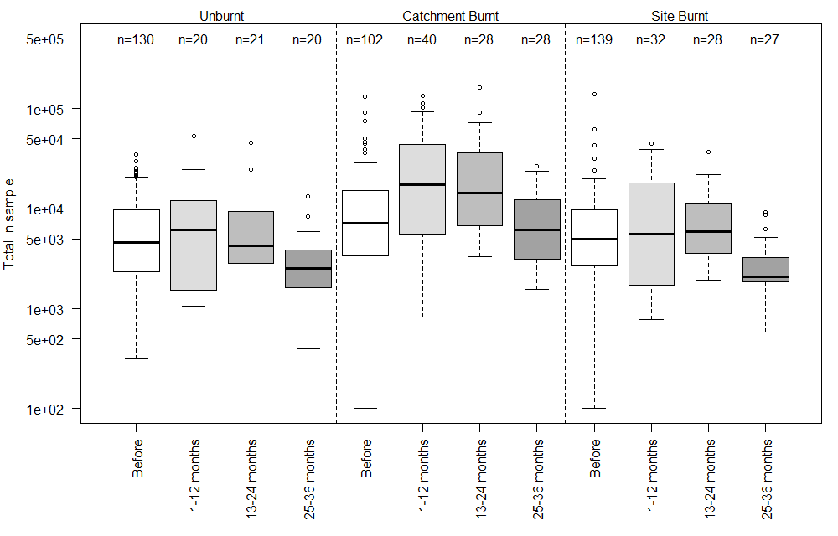
Figure S1. Macroinvertebrate total abundance (log vertical scale), showing increasing trend at catchment burnt sites for 24 months post-fire.

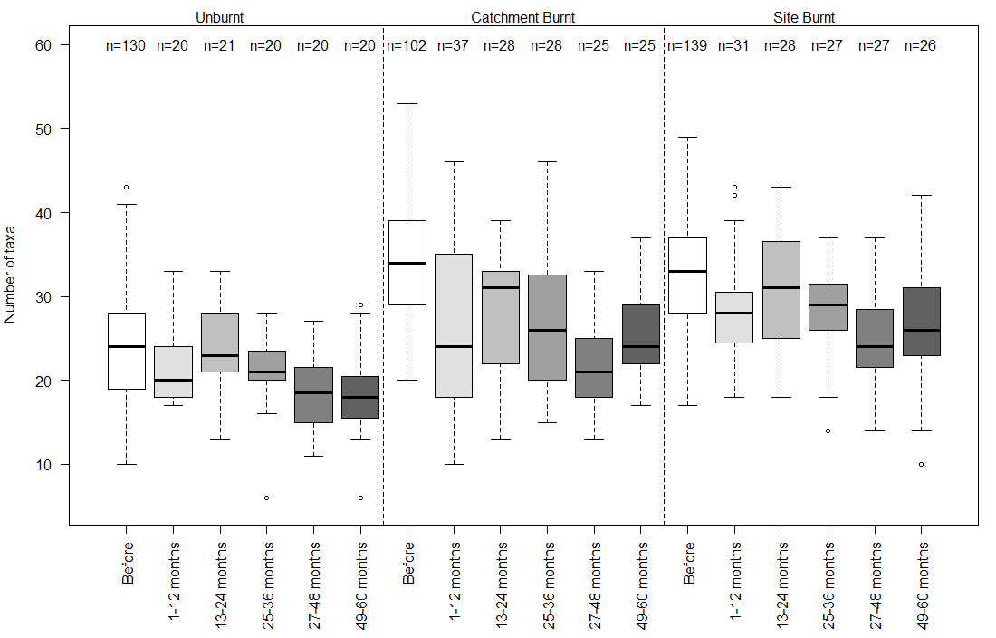

Figure S2. Macroinvertebrate taxa richness (S), showing decreasing trend at catchment burnt sites for 48 months post-fire.
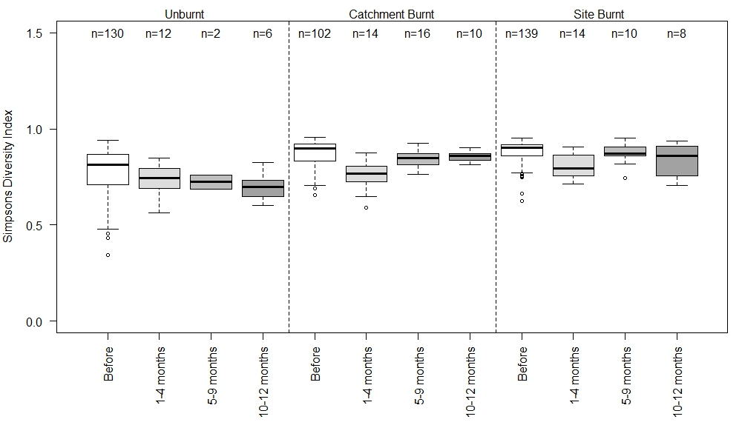
Figure S3. Simpson’s diversity index (1-D), showing decreasing trend at catchment burnt sites for 6 months post-fire.

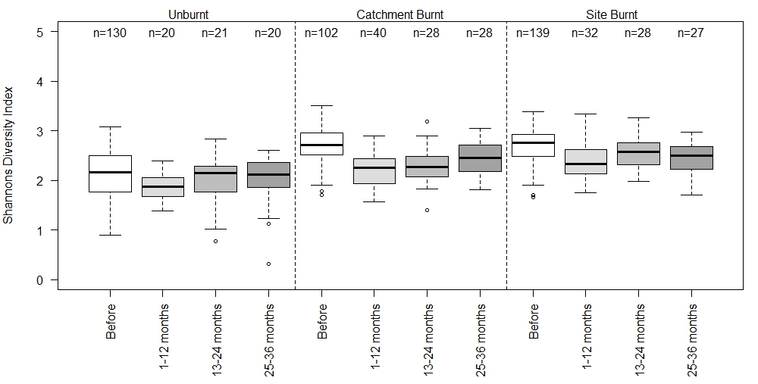
Figure S4. Shannon’s diversity index (H’), showing decreasing trend at catchment burnt sites for 24 months post-fire, and up to 6 months post-fire at site burnt sites.

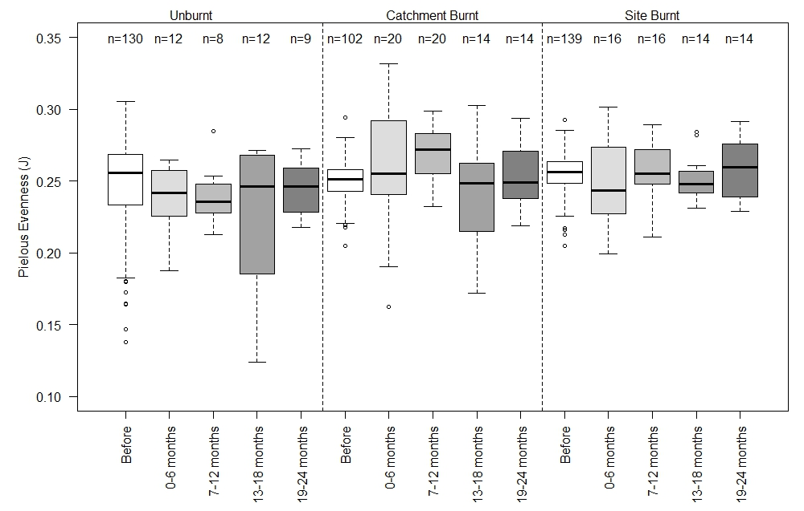
Figure S5. Pielous Evenness (J), showing an increasing trend at catchment burnt sites for 18 months post-fire.

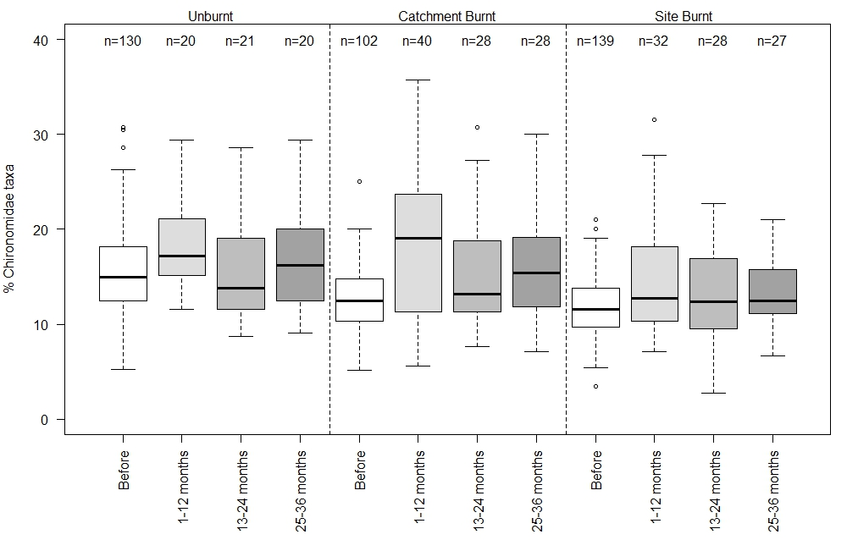
Figure S6. Chironomid taxa richness (%C), showing an increasing trend at catchment burnt sites for 24 months post-fire.
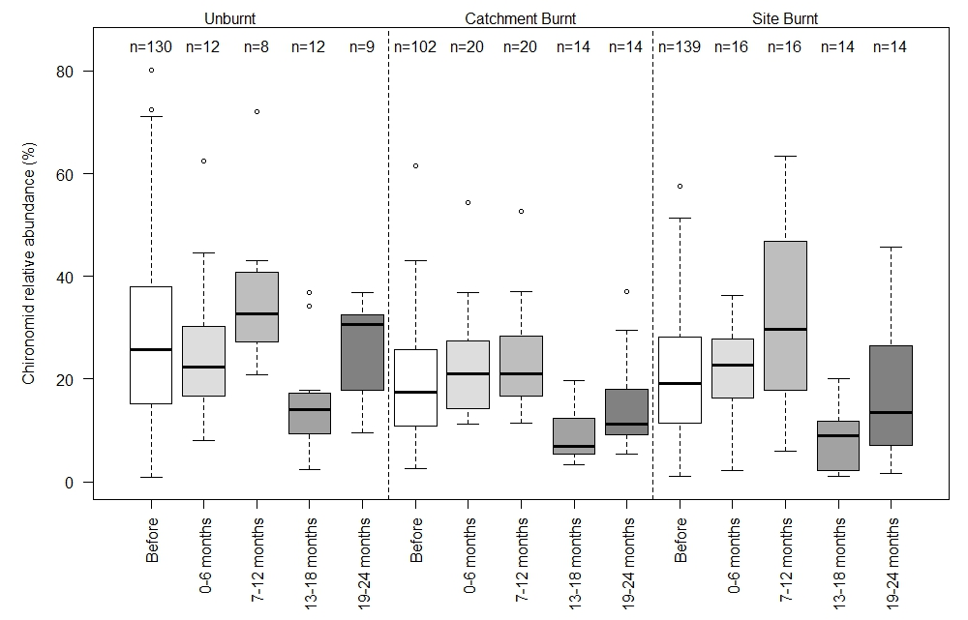
Figure S7. Chironomid relative abundance (%), no significant trend.
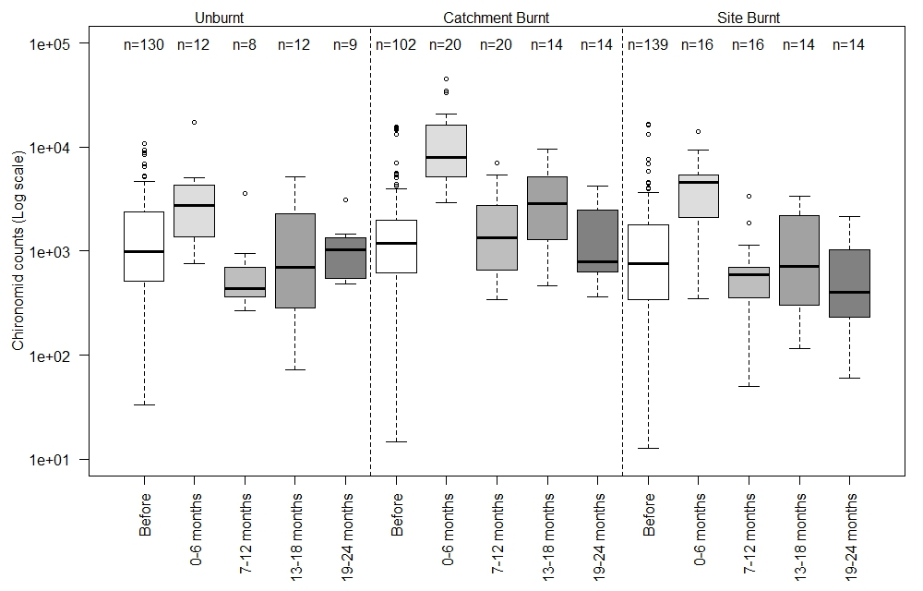
Figure S8. Chironomid total abundance (log vertical scale), showing increasing trend at catchment burnt sites for 18 months post-fire.

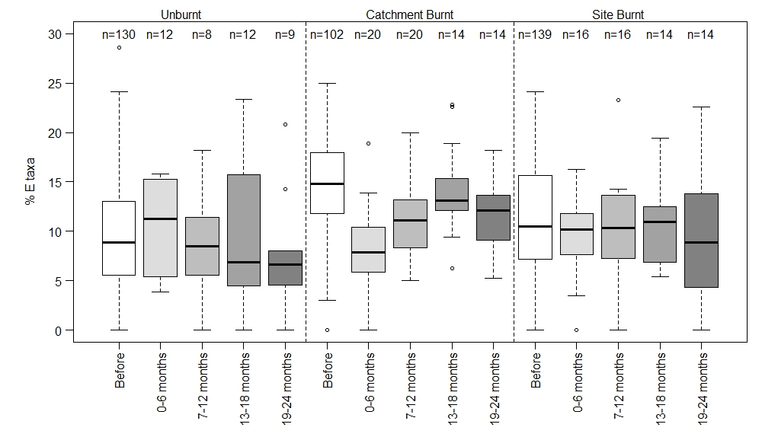
Figure S9. % Ephemeroptera taxa (%E) showing decreasing trend at catchment burnt sites for 18 months post-fire, and burnt sites for 12 months post fire.
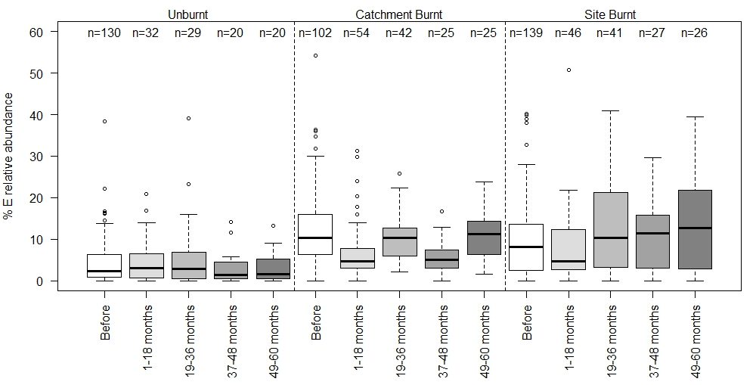
Figure S10. Ephemeroptera relative abundance (%), showing decreasing trend at catchment burnt sites for 48 months post-fire, and burnt sites for 6 months post fire.

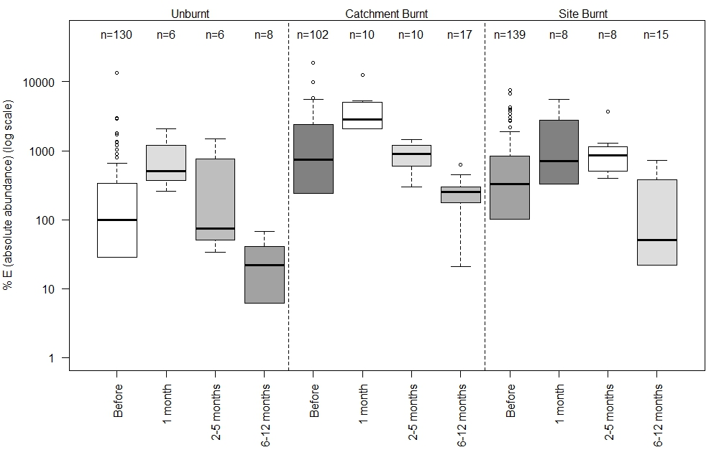
Figure S11. Ephemeroptera total abundance (log vertical scale). No differences in trends between factor burn category (treatments).

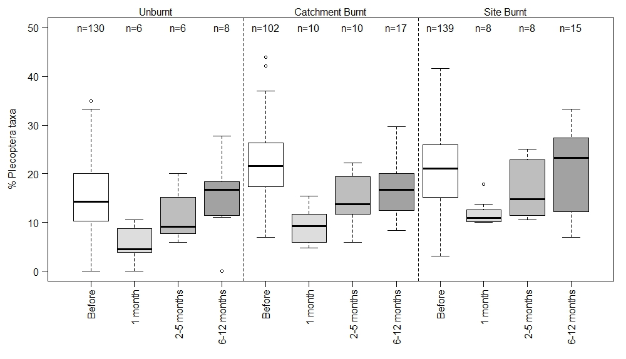
Figure S12. Plecoptera taxa richness (%P). No differences in trends between factor burn category (treatments).

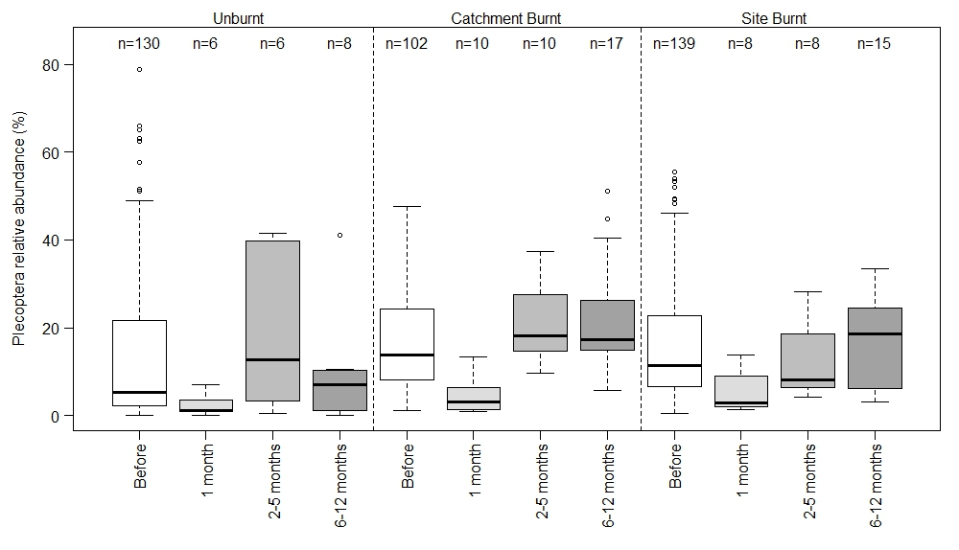
Figure S13. Plecoptera relative abundance (%). No differences in trends between factor burn category (treatments).

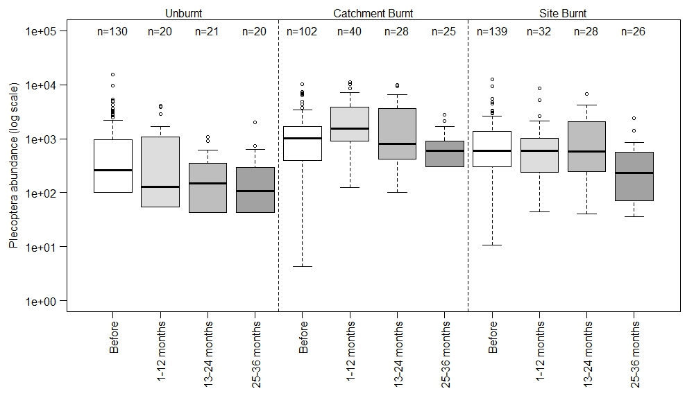

Figure S14. Plecoptera total abundance (log vertical scale) showing an increasing trend at catchment burnt sites for 24 months post-fire.
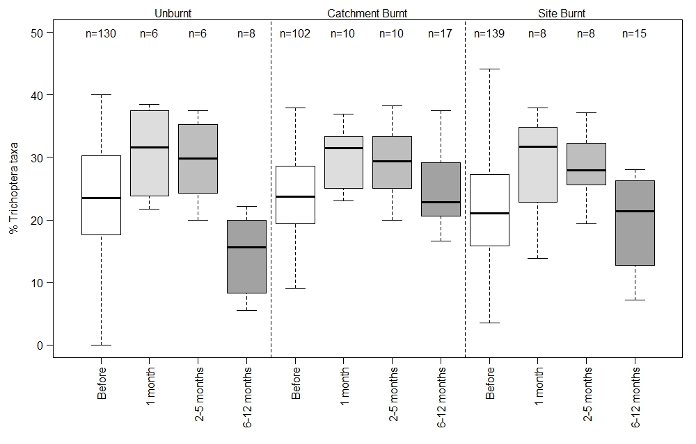
Figure S15. Trichoptera taxa richness (%T). No differences in trends between factor burn category (treatments).
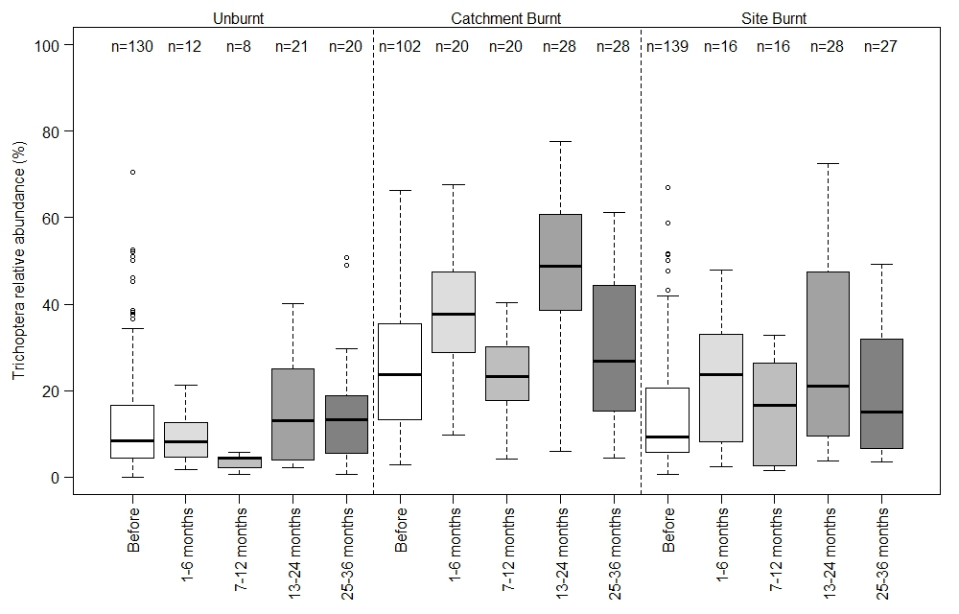
Figure S16. Trichoptera relative abundance (%), showing an overall increasing trend at catchment burnt sites for 24 months post-fire, and an increasing trend at sit burnt sites for 6 months post-fire.
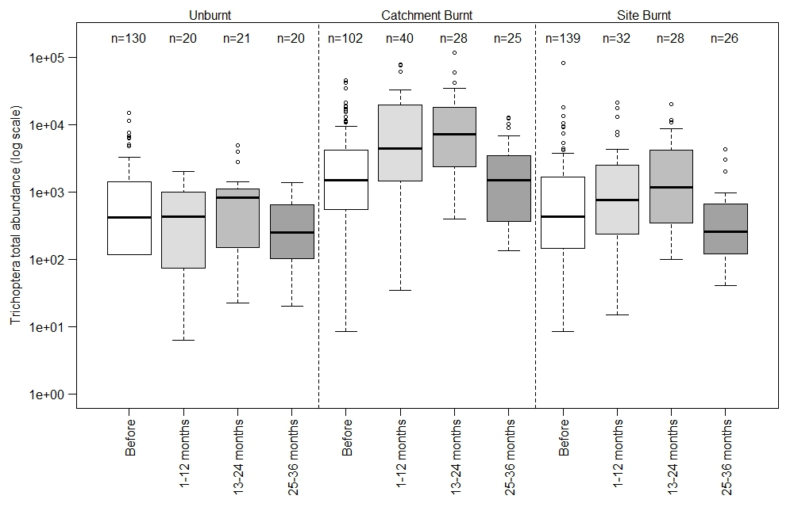
Figure S17. Trichoptera total abundance (log vertical scale) showing an increasing trend at catchment burnt sites for 24 months post-fire.

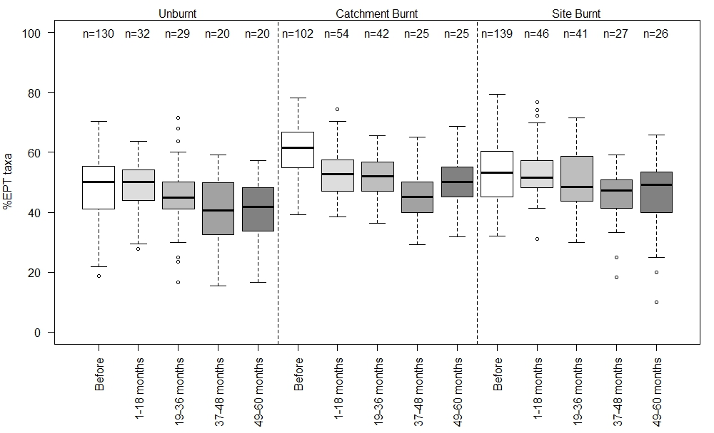
Figure S18. EPT Taxa richness (%EPT) showing a decreasing trend for 48 months post-fire at catchment burnt sites.

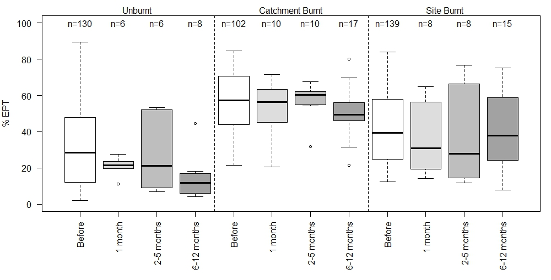
Figure S19. EPT relative abundance (%). No differences in trends between factor burn category (treatments).

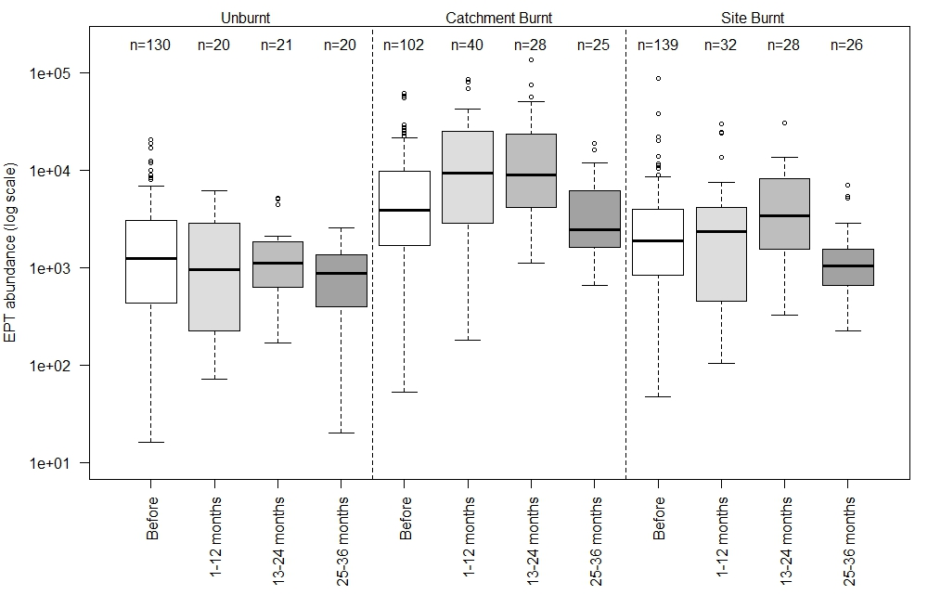
Figure S20. EPT total abundance (log vertical scale) showing an increasing trend for 24 months post-fire at catchment burnt sites.
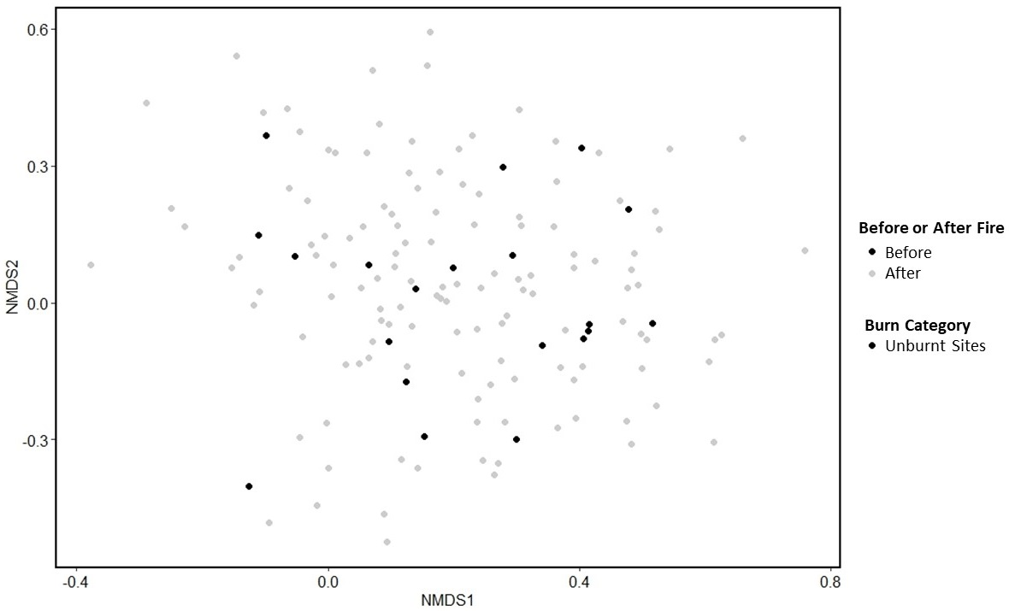
Figure S21. nMDS comparing similarity (Bray-Curtis distances) of communities at unburnt sites for the first 12 months following fire (stress =0.30). Data for all burn categories were analysed together but plotted individually to reduce clutter.
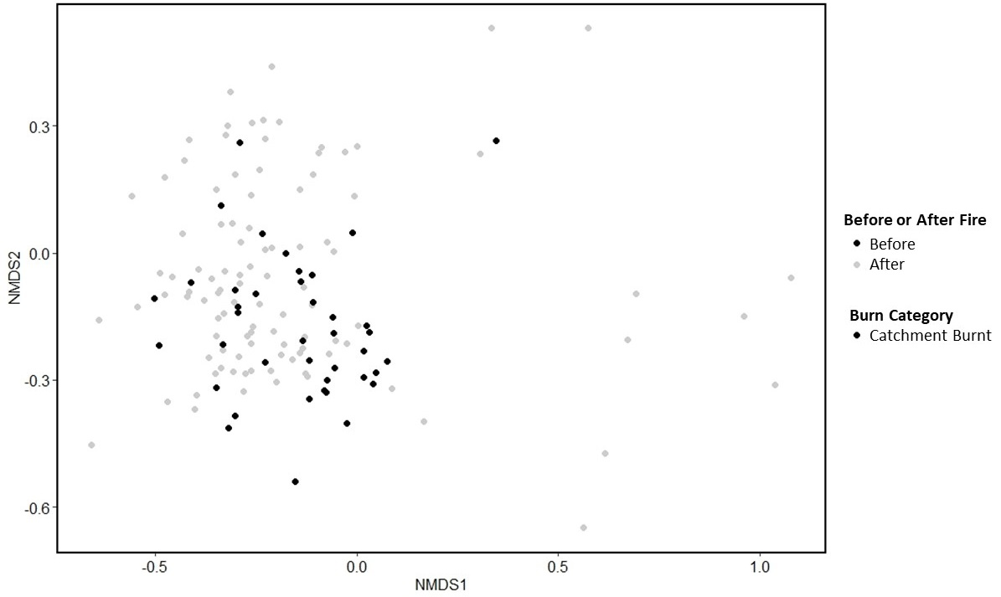
Figure S22. nMDS comparing similarity (Bray-Curtis distances) of communities at catchment burnt sites for the first 12 months following fire (stress =0.30). Data for all burn categories were analysed together but plotted individually to reduce clutter.
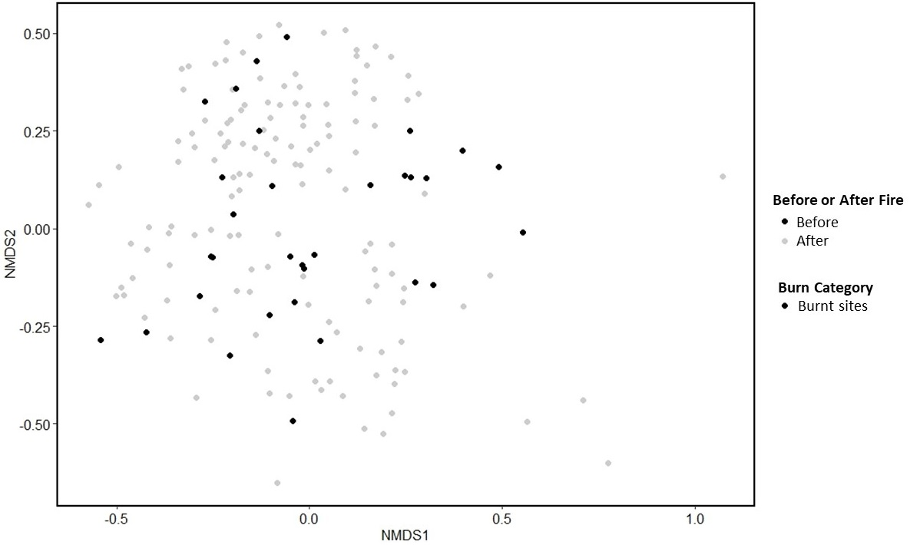
Figure S23. nMDS comparing similarity (Bray-Curtis distances) of communities at burnt sites for the first 12 months following fire (stress =0.30). Data for all burn categories were analysed together but plotted individually to reduce clutter.
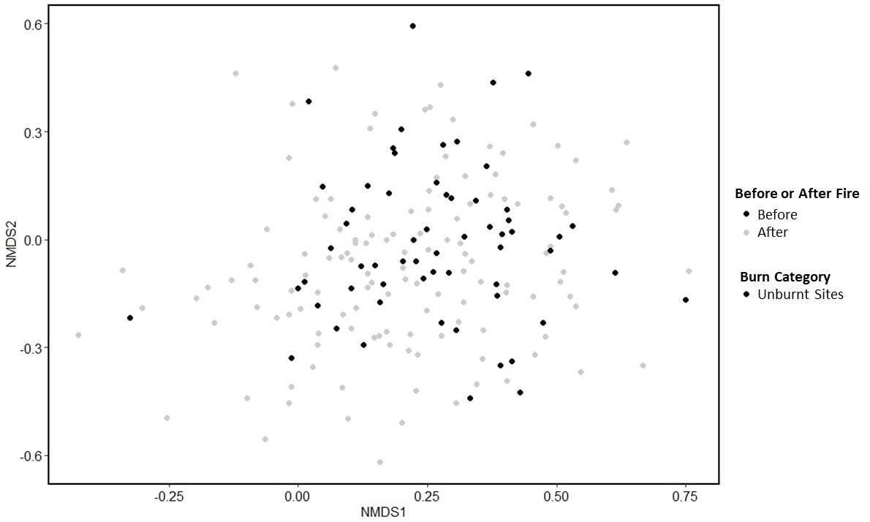
Figure S24. nMDS comparing similarity (Bray-Curtis distances) of communities at unburnt sites for the first 3 years following fire (stress =0.31). Data for all burn categories were analysed together but plotted individually to reduce clutter.
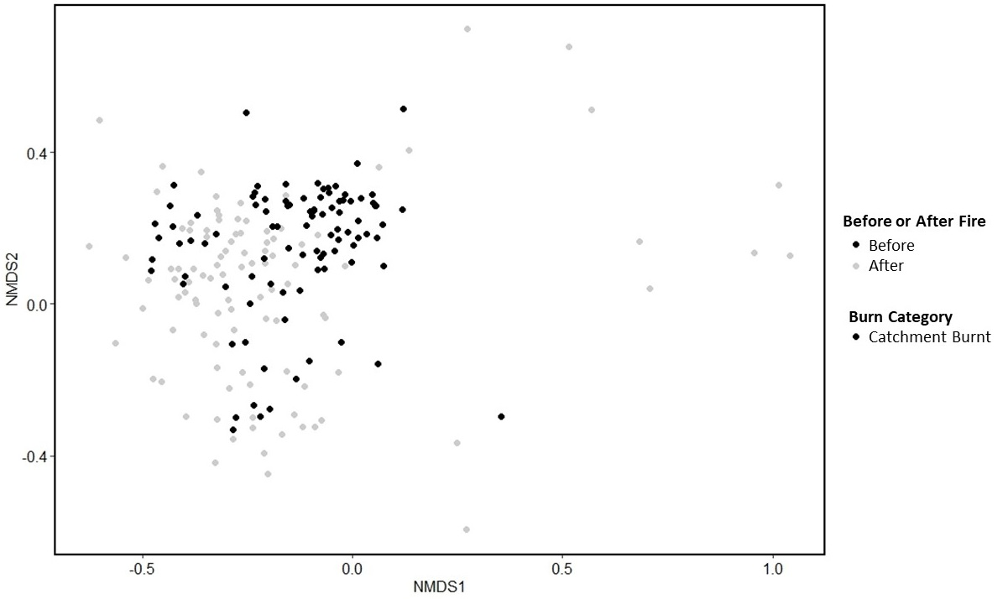
Figure S25. nMDS comparing similarity (Bray-Curtis distances) of communities at catchment burnt sites for the first 3 years following fire (stress =0.31). Data for all burn categories were analysed together but plotted individually to reduce clutter.
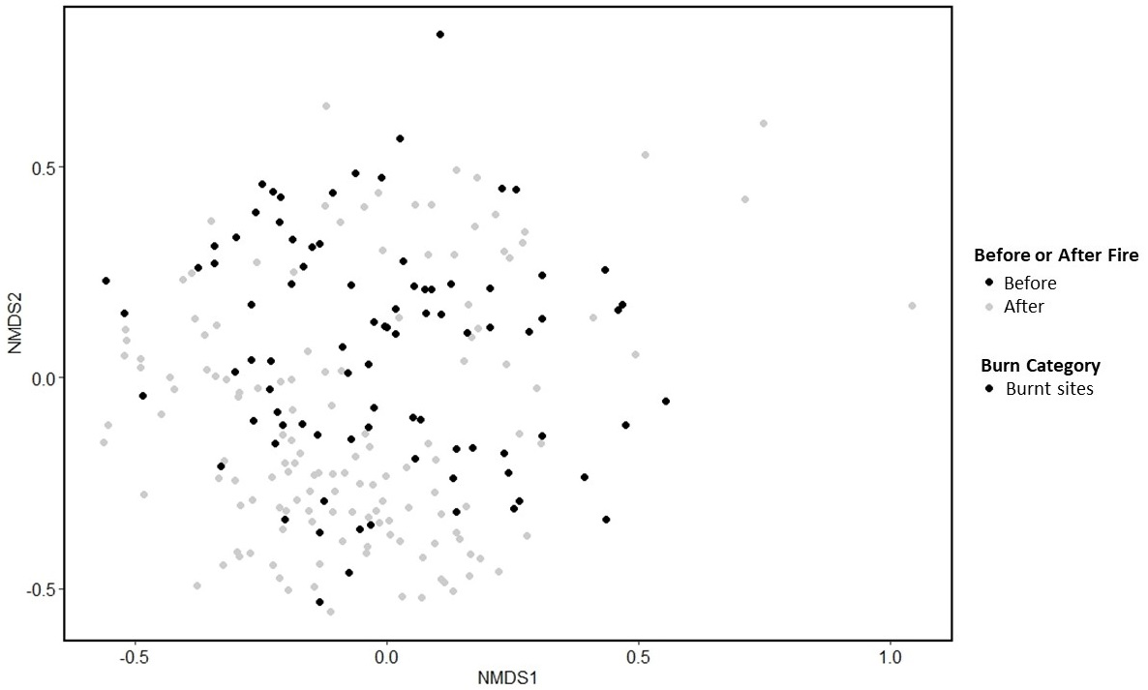
Figure S26. nMDS comparing similarity (Bray-Curtis distances) of communities at burnt sites for the first 3 years following fire (stress =0.31). Data for all burn categories were analysed together but plotted individually to reduce clutter.

Supplementary Table S23. Summary of SIMPER results between unburnt site and catchment burnt site categories, during the pre-fire period. For brevity, the table only includes results where column “average” has a value ≥ 0.01 which were also statistically significant (p= < 0.05). The “average” column lists the average contribution of each taxon to the average dissimilarity between observations from the two groups (larger numbers mean greater dissimilarity). Taxa are listed in descending order, meaning taxa that contribute the most to dissimilarity are listed first.
Year | Contrast | Taxa name | Average | sd | ratio | ava | avb | P-value
Pre-fire | CB vs Unburnt | Leptoceridae | 0.018291 | 0.012113 | 1.51 | 2.4251 | 0.8966 | 0.027
Pre-fire | CB vs Unburnt | Baetidae | 0.013405 | 0.009769 | 1.3721 | 1.6709 | 0.528 | 0.047
Pre-fire | CB vs Unburnt | Leptophlebiidae | 0.0132 | 0.009477 | 1.3928 | 2.1491 | 1.2389 | 0.067
Pre-fire | CB vs Unburnt | Aphroteniinae | 0.012525 | 0.009431 | 1.3281 | 1.4717 | 0.1813 | 0.086
Pre-fire | CB vs Unburnt | Dinotoperla fontana (Gripopterygidae) | 0.012507 | 0.009379 | 1.3336 | 1.4228 | 0.1994 | 0.104
Pre-fire | CB vs Unburnt | Conoesucidae | 0.012295 | 0.010296 | 1.1941 | 0.8081 | 1.3984 | 0.122
Pre-fire | CB vs Unburnt | Gripopterygidae | 0.011912 | 0.009341 | 1.2753 | 1.4697 | 0.9992 | 0.14
Pre-fire | CB vs Unburnt | Riekoperla sp. (Gripopterygidae) | 0.011647 | 0.010339 | 1.1264 | 1.1861 | 0.8884 | 0.158
Pre-fire | CB vs Unburnt | Diamesinae | 0.011173 | 0.009705 | 1.1513 | 1.0486 | 0.9421 | 0.174
Pre-fire | CB vs Unburnt | Austrolimnius | 0.011063 | 0.009251 | 1.1958 | 1.277 | 0.405 | 0.191
Pre-fire | CB vs Unburnt | Austrolimnius sp. (Elmidae) | 0.010998 | 0.008609 | 1.2775 | 1.3391 | 0.6794 | 0.207
Pre-fire | CB vs Unburnt | Athericidae | 0.010149 | 0.007943 | 1.2777 | 1.1678 | 0.0102 | 0.254
Pre-fire | CB vs Unburnt | Austrophleboides sp. (Leptophlebiidae) | 0.010115 | 0.009021 | 1.1213 | 1.1357 | 0.1389 | 0.269
Pre-fire | CB vs Unburnt | Notalina sp. (Leptoceridae) | 0.010107 | 0.010194 | 0.9914 | 1.0851 | 0.2717 | 0.284

Supplementary Table S24. Summary of SIMPER results between unburnt site and catchment burnt site categories, during the pre-fire period. For brevity, the table only includes results where column “average” has a value ≥ 0.01 which were also statistically significant (p= < 0.05). The “average” column lists the average contribution of each taxon to the average dissimilarity between observations from the two groups (larger numbers mean greater dissimilarity). Taxa are listed in descending order, meaning taxa that contribute the most to dissimilarity are listed first.
Year | Contrast | Taxa name | Average | sd | ratio | ava | avb | P-value
Pre-fire | SB vs Unburnt | Conoesucidae | 0.012452 | 0.009979 | 1.2478 | 0.8436 | 1.3984 | 0.019
Pre-fire | SB vs Unburnt | Leptophlebiidae | 0.012311 | 0.009411 | 1.3082 | 1.5773 | 1.2389 | 0.038
Pre-fire | SB vs Unburnt | Austrolimnius sp. (Elmidae) | 0.012214 | 0.009176 | 1.331 | 1.477 | 0.6794 | 0.057
Pre-fire | SB vs Unburnt | Gripopterygidae | 0.011721 | 0.009097 | 1.2884 | 1.2791 | 0.9992 | 0.075
Pre-fire | SB vs Unburnt | Dinotoperla fontana (Gripopterygidae) | 0.011295 | 0.009248 | 1.2213 | 1.2055 | 0.1994 | 0.11
Pre-fire | SB vs Unburnt | Nousia sp. (Leptophlebiidae) | 0.011047 | 0.009183 | 1.203 | 1.1651 | 0.8553 | 0.144
Pre-fire | SB vs Unburnt | Austrolimnius | 0.010767 | 0.009649 | 1.1158 | 1.135 | 0.405 | 0.161
Pre-fire | SB vs Unburnt | Scirtidae sp. | 0.010684 | 0.008909 | 1.1993 | 1.0706 | 0.8742 | 0.177
Pre-fire | SB vs Unburnt | Hydrobiosidae (Taschorema complex) | 0.010448 | 0.009378 | 1.114 | 0.615 | 1.0541 | 0.226
Pre-fire | SB vs Unburnt | Tipulidae | 0.010424 | 0.008454 | 1.2329 | 1.0985 | 0.6874 | 0.242
Pre-fire | SB vs Unburnt | Tanypodinae | 0.010291 | 0.008321 | 1.2368 | 1.2871 | 1.1856 | 0.258
Pre-fire | SB vs Unburnt | Sclerocyphon sp. (Psephenidae) | 0.010203 | 0.008968 | 1.1377 | 0.8179 | 0.9417 | 0.289

Supplementary Table S25. Summary of SIMPER results between unburnt site and catchment burnt site categories, for the first year following fire. For brevity, the table only includes results where column “average” has a value ≥ 0.01 which were also statistically significant (p= < 0.05). The “average” column lists the average contribution of each taxon to the average dissimilarity between observations from the two groups (larger numbers mean greater dissimilarity). Taxa are listed in descending order, meaning taxa that contribute the most to dissimilarity are listed first.
Year | Contrast | Taxa name | Average | sd | ratio | ava | avb | P-value
1-12 months | CB vs Unburnt | Leptoceridae | 0.02915 | 0.015894 | 1.834 | 3.262 | 0.645 | 0.001
1-12 months | CB vs Unburnt | Gripopterygidae | 0.018944 | 0.014033 | 1.35 | 2.656 | 1.296 | 0.001
1-12 months | CB vs Unburnt | Caolocidae | 0.018513 | 0.013427 | 1.3788 | 1.754 | 0.154 | 0.001
1-12 months | CB vs Unburnt | Aphroteniinae | 0.017012 | 0.011947 | 1.4239 | 1.801 | 0.39 | 0.001
1-12 months | CB vs Unburnt | Elmidae | 0.015768 | 0.013679 | 1.1527 | 1.474 | 0.447 | 0.001
1-12 months | CB vs Unburnt | Tanypodinae | 0.012764 | 0.010683 | 1.1947 | 0.962 | 1.349 | 0.005
1-12 months | CB vs Unburnt | Austrocercella sp. (Notonemouridae) | 0.012462 | 0.010052 | 1.2397 | 0.595 | 1.204 | 0.01
1-12 months | CB vs Unburnt | Diamesinae | 0.012066 | 0.010054 | 1.2002 | 1.104 | 1.024 | 0.007
1-12 months | CB vs Unburnt | Scirtidae | 0.011555 | 0.008736 | 1.3227 | 0.626 | 1.29 | 0.007
1-12 months | CB vs Unburnt | Notonemouridae | 0.011354 | 0.013713 | 0.8279 | 0.974 | 0.054 | 0.017
1-12 months | CB vs Unburnt | Empididae | 0.01096 | 0.009635 | 1.1375 | 1.139 | 0.201 | 0.015
1-12 months | CB vs Unburnt | Tipulidae | 0.010785 | 0.009883 | 1.0913 | 0.845 | 0.879 | 0.032

Supplementary Table S26. Summary of SIMPER results between unburnt site and site burnt site categories, for the first year following fire. For brevity, the table only includes results where column “average” has a value ≥ 0.01 which were also statistically significant (p= < 0.05). The “average” column lists the average contribution of each taxon to the average dissimilarity between observations from the two groups (larger numbers mean greater dissimilarity). Taxa are listed in descending order, meaning taxa that contribute the most to dissimilarity are listed first.
Year | Contrast | Taxa name | Average | sd | ratio | ava | avb | P-value
1-12 months | SB vs Unburnt | Tanypodinae | 0.012829 | 0.009861 | 1.301 | 0.9824 | 1.349 | 0.006
1-12 months | SB vs Unburnt | Reikoperla sp. (Gripopterygidae) | 0.012475 | 0.011537 | 1.0813 | 0.8471 | 0.941 | 0.005
1-12 months | SB vs Unburnt | Austrolimnius sp. (Elmidae) | 0.012064 | 0.009348 | 1.2906 | 1.1257 | 0.913 | 0.027
1-12 months | SB vs Unburnt | Scirtidae | 0.011617 | 0.008566 | 1.3562 | 1.0763 | 1.29 | 0.009
1-12 months | SB vs Unburnt | Tipulidae | 0.010819 | 0.009901 | 1.0927 | 0.6609 | 0.879 | 0.033
1-12 months | SB vs Unburnt | Simuliidae | 0.010626 | 0.010663 | 0.9966 | 0.9653 | 0.278 | 0.045

Supplementary Table S27. Summary of SIMPER results between unburnt site and catchment burnt site categories, for the second year following fire. For brevity, the table only includes results where column “average” has a value ≥ 0.01 which were also statistically significant (p= < 0.05). The “average” column lists the average contribution of each taxon to the average dissimilarity between observations from the two groups (larger numbers mean greater dissimilarity). Taxa are listed in descending order, meaning taxa that contribute the most to dissimilarity are listed first.
Year | Contrast | Taxa name | Average | sd | ratio | ava | avb | P-value
13-24 months | CB vs Unburnt | Leptoceridae | 0.025652 | 0.014373 | 1.7848 | 3.275 | 0.874 | 0.001
13-24 months | CB vs Unburnt | Aphroteniinae | 0.016623 | 0.010447 | 1.5912 | 2.041 | 0.484 | 0.001
13-24 months | CB vs Unburnt | Baetidae | 0.016332 | 0.010973 | 1.4885 | 1.828 | 0.243 | 0.001
13-24 months | CB vs Unburnt | Caolocidae | 0.01561 | 0.011706 | 1.3335 | 1.616 | 0.174 | 0.001
13-24 months | CB vs Unburnt | Gripopterygidae | 0.015584 | 0.011047 | 1.4106 | 2.315 | 1.103 | 0.001
13-24 months | CB vs Unburnt | Leptophlebiidae | 0.012725 | 0.009793 | 1.2994 | 2.829 | 1.605 | 0.002
13-24 months | CB vs Unburnt | Elmidae | 0.012326 | 0.013011 | 0.9474 | 1.116 | 0.417 | 0.021
13-24 months | CB vs Unburnt | Athericidae | 0.01189 | 0.008501 | 1.3987 | 1.27 | 0 | 0.001
13-24 months | CB vs Unburnt | Empididae | 0.010577 | 0.008545 | 1.2378 | 1.239 | 0.448 | 0.006

Supplementary Table S28. Summary of SIMPER results between unburnt site and site burnt site categories, for the second year following fire. For brevity, the table only includes results where column “average” has a value ≥ 0.01 which were also statistically significant (p= < 0.05). The “average” column lists the average contribution of each taxon to the average dissimilarity between observations from the two groups (larger numbers mean greater dissimilarity). Taxa are listed in descending order, meaning taxa that contribute the most to dissimilarity are listed first.
Year | Contrast | Taxa name | Average | sd | ratio | ava | avb | P-value
13-24 months | SB vs Unburnt | Empididae | 0.011605 | 0.007317 | 1.586 | 1.3925 | 0.448 | 0.001
13-24 months | SB vs Unburnt | Conoesucus sp.AV1 (Conoesucidae) | 0.010748 | 0.009185 | 1.1701 | 1.1082 | 0.769 | 0.015
13-24 months | SB vs Unburnt | Tanypodinae | 0.010724 | 0.008381 | 1.2796 | 1.1555 | 1.062 | 0.027
13-24 months | SB vs Unburnt | Scirtidae | 0.010675 | 0.008399 | 1.2709 | 1.2106 | 0.814 | 0.033
13-24 months | SB vs Unburnt | Asmicridea sp.AV1 (Hydropsychidae) | 0.010524 | 0.009345 | 1.1262 | 0.9285 | 0.817 | 0.022
13-24 months | SB vs Unburnt | Chironominae | 0.010291 | 0.008708 | 1.1817 | 2.0506 | 2.262 | 0.037
13-24 months | SB vs Unburnt | Siphlonuridae | 0.010193 | 0.008269 | 1.2327 | 1.1005 | 0.75 | 0.013

Supplementary Table S29. Summary of SIMPER results between unburnt site and catchment burnt site categories, for the third year following fire. For brevity, the table only includes results where column “average” has a value ≥ 0.01 which were also statistically significant (p= < 0.05). The “average” column lists the average contribution of each taxon to the average dissimilarity between observations from the two groups (larger numbers mean greater dissimilarity). Taxa are listed in descending order, meaning taxa that contribute the most to dissimilarity are listed first.
Year | Contrast | Taxa name | Average | sd | ratio | ava | avb | P-value
25-36 months | CB vs Unburnt | Leptoceridae | 0.025335 | 0.014226 | 1.7809 | 2.4821 | 0.5376 | 0.001
25-36 months | CB vs Unburnt | Baetidae | 0.022906 | 0.012234 | 1.8723 | 2.333 | 0.5219 | 0.001
25-36 months | CB vs Unburnt | Gripopterygidae | 0.01997 | 0.012796 | 1.5607 | 2.0435 | 0.5607 | 0.001
25-36 months | CB vs Unburnt | Acarina | 0.016362 | 0.012222 | 1.3387 | 2.4933 | 1.3041 | 0.001
25-36 months | CB vs Unburnt | Aphroteniinae | 0.016151 | 0.01124 | 1.4369 | 1.4448 | 0.1309 | 0.001
25-36 months | CB vs Unburnt | Elmidae | 0.015304 | 0.01099 | 1.3926 | 1.5984 | 0.7011 | 0.001
25-36 months | CB vs Unburnt | Calocidae | 0.015276 | 0.011885 | 1.2853 | 1.3347 | 0.1604 | 0.001
25-36 months | CB vs Unburnt | Simuliidae | 0.013416 | 0.009149 | 1.4665 | 0.618 | 1.3552 | 0.002
25-36 months | CB vs Unburnt | Tanypodinae | 0.012258 | 0.008792 | 1.3942 | 0.378 | 1.1527 | 0.001
25-36 months | CB vs Unburnt | Diamesinae | 0.012051 | 0.010443 | 1.154 | 1.0456 | 0.5086 | 0.014
25-36 months | CB vs Unburnt | Siphlonuridae | 0.011946 | 0.009185 | 1.3006 | 1.1624 | 0.9999 | 0.036

Supplementary Table S30. Summary of SIMPER results between unburnt site and site burnt site categories, for the third year following fire. For brevity, the table only includes results where column “average” has a value ≥ 0.01 which were also statistically significant (p= < 0.05). The “average” column lists the average contribution of each taxon to the average dissimilarity between observations from the two groups (larger numbers mean greater dissimilarity). Taxa are listed in descending order, meaning taxa that contribute the most to dissimilarity are listed first.
Year | Contrast | Taxa name | Average | sd | ratio | ava | avb | P-value
25-36 months | SB vs Unburnt | Baetidae | 0.017664 | 0.013355 | 1.3227 | 1.4848 | 0.5219 | 0.006
25-36 months | SB vs Unburnt | Simuliidae | 0.014782 | 0.009656 | 1.5309 | 0.4489 | 1.3552 | 0.001
25-36 months | SB vs Unburnt | Chrionominae | 0.013866 | 0.011138 | 1.245 | 1.2152 | 1.7016 | 0.006
25-36 months | SB vs Unburnt | Leptophlebiidae | 0.012821 | 0.012103 | 1.0593 | 1.8739 | 1.72 | 0.01
25-36 months | SB vs Unburnt | Tanypodinae | 0.012483 | 0.009515 | 1.3119 | 0.5834 | 1.1527 | 0.001
25-36 months | SB vs Unburnt | Scirtidae | 0.012081 | 0.009549 | 1.2652 | 1.0348 | 0.5229 | 0.037
25-36 months | SB vs Unburnt | Eustheniidae | 0.011523 | 0.014781 | 0.7796 | 0.5432 | 0.6136 | 0.012
25-36 months | SB vs Unburnt | Tipulidae | 0.011314 | 0.009627 | 1.1752 | 0.7909 | 0.6456 | 0.004
25-36 months | SB vs Unburnt | Austrocercella sp. (Notonemouridae) | 0.011033 | 0.011732 | 0.9404 | 0.4576 | 0.7532 | 0.002
25-36 months | SB vs Unburnt | Conoesucus sp.AV2 (Conoesucidae) | 0.01018 | 0.012843 | 0.7927 | 0.6514 | 0.307 | 0.011
25-36 months | SB vs Unburnt | Oligochaeta | 0.010037 | 0.008725 | 1.1503 | 2.3396 | 2.772 | 0.005

Supplementary Table S31 Summary of SIMPER results between unburnt site and catchment burnt site categories, for the fourth year following fire. For brevity, the table only includes results where column “average” has a value ≥ 0.01 which were also statistically significant (p= < 0.05). The “average” column lists the average contribution of each taxon to the average dissimilarity between observations from the two groups (larger numbers mean greater dissimilarity). Taxa are listed in descending order, meaning taxa that contribute the most to dissimilarity are listed first.
Year | Contrast | Taxa name | Average | sd | ratio | ava | avb | P-value
37-48 months | CB vs Unburnt | Baetidae | 0.028364 | 0.016961 | 1.6723 | 2.632 | 0.7672 | 0.001
37-48 months | CB vs Unburnt | Elmidae | 0.023131 | 0.012597 | 1.8362 | 2.323 | 0.6155 | 0.001
37-48 months | CB vs Unburnt | Gripopterygidae | 0.019785 | 0.014672 | 1.3485 | 2.619 | 1.4186 | 0.001
37-48 months | CB vs Unburnt | Leptophlebiidae | 0.018586 | 0.011276 | 1.6483 | 2.326 | 1.1481 | 0.001
37-48 months | CB vs Unburnt | Aphroteniinae | 0.017653 | 0.012235 | 1.4428 | 1.66 | 0.5547 | 0.001
37-48 months | CB vs Unburnt | Baetidae | 0.016881 | 0.012906 | 1.3081 | 1.461 | 0.4126 | 0.001
37-48 months | CB vs Unburnt | Acarina | 0.016672 | 0.010736 | 1.5529 | 2.653 | 1.5059 | 0.001
37-48 months | CB vs Unburnt | Calocidae | 0.014388 | 0.013853 | 1.0386 | 1.119 | 0.121 | 0.001
37-48 months | CB vs Unburnt | Diamesinae | 0.014289 | 0.012217 | 1.1695 | 1.171 | 0.6005 | 0.004
37-48 months | CB vs Unburnt | Simuliidae | 0.01425 | 0.011655 | 1.2227 | 0.798 | 1.1182 | 0.027
37-48 months | CB vs Unburnt | Tanypodinae | 0.014014 | 0.010084 | 1.3897 | 0.749 | 1.2897 | 0.002
37-48 months | CB vs Unburnt | Orthocladiinae | 0.013099 | 0.009334 | 1.4033 | 2.276 | 2.1825 | 0.005
37-48 months | CB vs Unburnt | Siphlonuridae | 0.011343 | 0.010077 | 1.1257 | 0.787 | 0.5692 | 0.041

Supplementary Table S32. Summary of SIMPER results between unburnt site and site burnt site categories, for the fourth year following fire. For brevity, the table only includes results where column “average” has a value ≥ 0.01 which were also statistically significant (p= < 0.05). The “average” column lists the average contribution of each taxon to the average dissimilarity between observations from the two groups (larger numbers mean greater dissimilarity). Taxa are listed in descending order, meaning taxa that contribute the most to dissimilarity are listed first.
Year | Contrast | Taxa name | Average | sd | ratio | ava | avb | P-value
37-48 months | SB vs Unburnt | Gripopterygidae | 0.018846 | 0.014164 | 1.3306 | 2.2823 | 1.4186 | 0.002
37-48 months | SB vs Unburnt | Leptophlebiidae | 0.018691 | 0.011724 | 1.5942 | 2.1727 | 1.1481 | 0.001
37-48 months | SB vs Unburnt | Elmidae | 0.017612 | 0.010942 | 1.6096 | 1.7924 | 0.6155 | 0.001
37-48 months | SB vs Unburnt | Baetidae | 0.016088 | 0.013234 | 1.2156 | 1.35 | 0.4126 | 0.002
37-48 months | SB vs Unburnt | Austrolimnius sp. (Elmidae) | 0.01603 | 0.011039 | 1.4521 | 1.6845 | 0.9479 | 0.026
37-48 months | SB vs Unburnt | Scirtidae | 0.014728 | 0.011123 | 1.3241 | 1.3109 | 0.659 | 0.014
37-48 months | SB vs Unburnt | Simuliidae | 0.014448 | 0.012207 | 1.1836 | 0.7201 | 1.1182 | 0.023
37-48 months | SB vs Unburnt | Tanypodinae | 0.013535 | 0.009913 | 1.3654 | 0.9084 | 1.2897 | 0.01
37-48 months | SB vs Unburnt | Sclerocyphon sp. (Psephenidae) | 0.013435 | 0.011601 | 1.1581 | 1.0462 | 0.7434 | 0.004
37-48 months | SB vs Unburnt | Hydropsychidae | 0.010847 | 0.012083 | 0.8977 | 0.7875 | 0.3359 | 0.031

Supplementary Table S33. Summary of SIMPER results between unburnt site and catchment burnt site categories, for the fifth year following fire. For brevity, the table only includes results where column “average” has a value ≥ 0.01 which were also statistically significant (p= < 0.05). The “average” column lists the average contribution of each taxon to the average dissimilarity between observations from the two groups (larger numbers mean greater dissimilarity). Taxa are listed in descending order, meaning taxa that contribute the most to dissimilarity are listed first.
Year | Contrast | Taxa name | Average | sd | ratio | ava | avb | P-value
49-60 months | CB vs Unburnt | Leptoceridae | 0.02446 | 0.018118 | 1.35 | 2.0859 | 0.222 | 0.001
49-60 months | CB vs Unburnt | Baetidae | 0.01987 | 0.01296 | 1.5333 | 1.733 | 0.194 | 0.001
49-60 months | CB vs Unburnt | Elmidae | 0.01806 | 0.012743 | 1.4173 | 1.7847 | 0.805 | 0.001
49-60 months | CB vs Unburnt | Gripopterygidae | 0.017299 | 0.012494 | 1.3845 | 2.1155 | 1.451 | 0.031
49-60 months | CB vs Unburnt | Leptophlebiidae | 0.016915 | 0.012706 | 1.3313 | 2.4307 | 1.294 | 0.02
49-60 months | CB vs Unburnt | Podonominae | 0.016732 | 0.012924 | 1.2946 | 1.5223 | 0.642 | 0.023
49-60 months | CB vs Unburnt | Scirtidae | 0.01658 | 0.011903 | 1.3929 | 1.9118 | 0.853 | 0.003
49-60 months | CB vs Unburnt | Aphroteniinae | 0.015788 | 0.01097 | 1.4392 | 1.6954 | 0.618 | 0.001
49-60 months | CB vs Unburnt | Notonemouridae | 0.013736 | 0.010761 | 1.2765 | 0.454 | 1.297 | 0.018
49-60 months | CB vs Unburnt | Calocidae | 0.013496 | 0.012541 | 1.0762 | 1.0971 | 0.171 | 0.005
49-60 months | CB vs Unburnt | Helicopsychidae | 0.011146 | 0.012249 | 0.9099 | 0.8906 | 0 | 0.008

Supplementary Table S34. Summary of SIMPER results between unburnt site and site burnt site categories, for the fifth year following fire. For brevity, the table only includes results where column “average” has a value ≥ 0.01 which were also statistically significant (p= < 0.05). The “average” column lists the average contribution of each taxon to the average dissimilarity between observations from the two groups (larger numbers mean greater dissimilarity). Taxa are listed in descending order, meaning taxa that contribute the most to dissimilarity are listed first.
Year | Contrast | Taxa name | Average | sd | ratio | ava | avb | P-value
49-60 months | SB vs Unburnt | Leptophlebiidae | 0.017191 | 0.013261 | 1.2964 | 1.8088 | 1.294 | 0.013
49-60 months | SB vs Unburnt | Austrolimnius sp. (Elmidae) | 0.016911 | 0.013312 | 1.2703 | 1.5812 | 0.933 | 0.004
49-60 months | SB vs Unburnt | Notonemouridae | 0.016024 | 0.013325 | 1.2026 | 0.5947 | 1.297 | 0.001
49-60 months | SB vs Unburnt | Simuliidae | 0.014812 | 0.012395 | 1.195 | 0.9522 | 1.003 | 0.012
49-60 months | SB vs Unburnt | Chrionominae | 0.013815 | 0.015911 | 0.8683 | 1.9958 | 2.338 | 0.012
49-60 months | SB vs Unburnt | Acarina | 0.01365 | 0.012081 | 1.1299 | 1.6711 | 1.522 | 0.026
49-60 months | SB vs Unburnt | Oligochaeta | 0.012914 | 0.012465 | 1.0361 | 2.4646 | 3.203 | 0.001
49-60 months | SB vs Unburnt | Tanypodinae | 0.012689 | 0.011786 | 1.0767 | 1.054 | 1.253 | 0.026
49-60 months | SB vs Unburnt | Ceratopogonidae | 0.011998 | 0.010419 | 1.1516 | 0.8443 | 0.991 | 0.003
49-60 months | SB vs Unburnt | Tipulidae | 0.010561 | 0.009804 | 1.0772 | 0.7777 | 0.35 | 0.02

Supplementary Table S35. Summary of SIMPER results between unburnt site and catchment burnt site categories, for the sixth year following fire. For brevity, the table only includes results where column “average” has a value ≥ 0.01 which were also statistically significant (p= < 0.05). The “average” column lists the average contribution of each taxon to the average dissimilarity between observations from the two groups (larger numbers mean greater dissimilarity). Taxa are listed in descending order, meaning taxa that contribute the most to dissimilarity are listed first.
Year | Contrast | Taxa name | Average | sd | ratio | ava | avb | P-value
61-72 months | CB vs Unburnt | Baetidae | 0.020816 | 0.010876 | 1.9139 | 1.8472 | 0.1328 | 0.001
61-72 months | CB vs Unburnt | Austrolimnius sp. (Elmidae) | 0.017977 | 0.012039 | 1.4932 | 1.8371 | 0.6045 | 0.001
61-72 months | CB vs Unburnt | Aphroteniinae | 0.016524 | 0.010313 | 1.6023 | 1.7595 | 0.5483 | 0.003
61-72 months | CB vs Unburnt | Riekoperla sp. (Gripopterygidae) | 0.015954 | 0.014449 | 1.1042 | 1.1854 | 0.5931 | 0.009
61-72 months | CB vs Unburnt | Dinotoperla fontana (Gripopterygidae) | 0.015014 | 0.014326 | 1.048 | 1.2807 | 0.0661 | 0.001
61-72 months | CB vs Unburnt | Edmundsiops sp. (Baetidae) | 0.013424 | 0.012464 | 1.0771 | 1.2131 | 0 | 0.001
61-72 months | CB vs Unburnt | Empididae | 0.011411 | 0.008477 | 1.3461 | 1.0985 | 0.3874 | 0.031
61-72 months | CB vs Unburnt | Notalina sp. (Leptoceridae) | 0.011091 | 0.013097 | 0.8469 | 0.8995 | 0.0854 | 0.001
61-72 months | CB vs Unburnt | Calocidae | 0.010632 | 0.011319 | 0.9393 | 0.8127 | 0.3595 | 0.044

Supplementary Table S36. Summary of SIMPER results between unburnt site and site burnt site categories, for the sixth year following fire. For brevity, the table only includes results where column “average” has a value ≥ 0.01 which were also statistically significant (p= < 0.05). The “average” column lists the average contribution of each taxon to the average dissimilarity between observations from the two groups (larger numbers mean greater dissimilarity). Taxa are listed in descending order, meaning taxa that contribute the most to dissimilarity are listed first.
Year | Contrast | Taxa name | Average | sd | ratio | ava | avb | P-value
61-72 months | SB vs Unburnt | Baetidae | 0.018227 | 0.012373 | 1.4731 | 1.4697 | 0.1328 | 0.001
61-72 months | SB vs Unburnt | Leptophlebiidae | 0.017943 | 0.012272 | 1.4621 | 2.0529 | 1.0756 | 0.001
61-72 months | SB vs Unburnt | Aphroteniinae | 0.017689 | 0.01155 | 1.5314 | 1.7379 | 0.5483 | 0.001
61-72 months | SB vs Unburnt | Gripopterygidae | 0.017465 | 0.014162 | 1.2332 | 2.2326 | 1.4732 | 0.015
61-72 months | SB vs Unburnt | Scirtidae | 0.017047 | 0.013736 | 1.241 | 1.4539 | 0.5432 | 0.002
61-72 months | SB vs Unburnt | Elmidae | 0.016377 | 0.013534 | 1.2101 | 1.7907 | 1.1395 | 0.013
61-72 months | SB vs Unburnt | Hydropsychidae | 0.015322 | 0.012059 | 1.2706 | 1.1964 | 0.529 | 0.002
61-72 months | SB vs Unburnt | Oligochaeta | 0.014369 | 0.013972 | 1.0284 | 2.1212 | 2.7159 | 0.014
61-72 months | SB vs Unburnt | Tanypodinae | 0.013699 | 0.010642 | 1.2873 | 1.3493 | 0.7967 | 0.001
61-72 months | SB vs Unburnt | Hydrobiosidae | 0.013307 | 0.011124 | 1.1962 | 0.9862 | 1.3188 | 0.023
61-72 months | SB vs Unburnt | Acarina | 0.011865 | 0.011602 | 1.0227 | 2.0631 | 1.6434 | 0.002
61-72 months | SB vs Unburnt | Notonemouridae | 0.011511 | 0.010872 | 1.0588 | 0.8048 | 0.6033 | 0.028
61-72 months | SB vs Unburnt | Sclerocyphon sp. (Psephenidae) | 0.011265 | 0.012268 | 0.9183 | 0.6013 | 0.4941 | 0.009
61-72 months | SB vs Unburnt | Empididae | 0.01106 | 0.010285 | 1.0754 | 0.8642 | 0.3874 | 0.042
Supplementary Table S37. Summary of SIMPER results between unburnt site and catchment burnt site categories, for the seventh year following fire. For brevity, the table only includes results where column “average” has a value ≥ 0.01 which were also statistically significant (p= < 0.05). The “average” column lists the average contribution of each taxon to the average dissimilarity between observations from the two groups (larger numbers mean greater dissimilarity). Taxa are listed in descending order, meaning taxa that contribute the most to dissimilarity are listed first.
Year | Contrast | Taxa name | Average | sd | ratio | ava | avb | P-value
73-84 months | CB vs Unburnt | Leptoceridae | 0.02151 | 0.014524 | 1.481 | 2.2521 | 0.9748 | 0.006
73-84 months | CB vs Unburnt | Austrolimnius sp. (Elmidae) | 0.01868 | 0.011993 | 1.5576 | 1.6717 | 0 | 0.001
73-84 months | CB vs Unburnt | Elmidae | 0.018618 | 0.009343 | 1.9926 | 0.7797 | 1.7002 | 0.01
73-84 months | CB vs Unburnt | Conoesucus sp. (Conoesucidae) | 0.015912 | 0.011793 | 1.3494 | 1.4158 | 0 | 0.001
73-84 months | CB vs Unburnt | Aphroteniinae | 0.015877 | 0.011202 | 1.4173 | 1.6174 | 0.5477 | 0.002
73-84 months | CB vs Unburnt | Calocidae | 0.014106 | 0.011269 | 1.2518 | 1.357 | 0.6284 | 0.033
73-84 months | CB vs Unburnt | Tanypodinae | 0.013459 | 0.009224 | 1.4591 | 0.7284 | 1.583 | 0.044
73-84 months | CB vs Unburnt | Dinotoperla fontana (Gripoterygidae) | 0.012545 | 0.010649 | 1.178 | 1.1322 | 0 | 0.001
73-84 months | CB vs Unburnt | Notalina bifaria (Leptoceridae) | 0.011575 | 0.012979 | 0.8918 | 1.0623 | 0 | 0.001
73-84 months | CB vs Unburnt | Notalina sp. (Leptoceridae) | 0.010932 | 0.013949 | 0.7837 | 0.9953 | 0 | 0.006
73-84 months | CB vs Unburnt | Austrophleboides sp. (Leptophlebiidae) | 0.010333 | 0.011328 | 0.9122 | 0.8792 | 0 | 0.001
73-84 months | CB vs Unburnt | Matasia santana (Conoesucidae) | 0.010032 | 0.012413 | 0.8082 | 0.913 | 0 | 0.001

Supplementary Table S38. Summary of SIMPER results between unburnt site and site burnt site categories, for the seventh year following fire. For brevity, the table only includes results where column “average” has a value ≥ 0.01 which were also statistically significant (p= < 0.05). The “average” column lists the average contribution of each taxon to the average dissimilarity between observations from the two groups (larger numbers mean greater dissimilarity). Taxa are listed in descending order, meaning taxa that contribute the most to dissimilarity are listed first.
Year | Contrast | Taxa name | Average | sd | ratio | ava | avb | P-value
73-84 months | SB vs Unburnt | Baetidae | 0.016645 | 0.013132 | 1.2675 | 1.4324 | 0.99 | 0.003
73-84 months | SB vs Unburnt | Leptophlebiidae | 0.016457 | 0.016383 | 1.0045 | 1.0266 | 0.6501 | 0.011
73-84 months | SB vs Unburnt | Scirtidae | 0.015882 | 0.013356 | 1.1891 | 1.1445 | 0.7737 | 0.021
73-84 months | SB vs Unburnt | Acarina | 0.015016 | 0.012647 | 1.1873 | 2.0399 | 1.4922 | 0.047
73-84 months | SB vs Unburnt | Notonemouridae | 0.014729 | 0.012593 | 1.1696 | 0.9021 | 0.9166 | 0.012
73-84 months | SB vs Unburnt | Oligochaeta | 0.014383 | 0.011902 | 1.2085 | 2.7533 | 3.1072 | 0.004
73-84 months | SB vs Unburnt | Leptophlebiidae | 0.013889 | 0.013872 | 1.0012 | 2.1253 | 1.9831 | 0.008
73-84 months | SB vs Unburnt | Sclerocyphon sp. (Psephenidae) | 0.013659 | 0.011604 | 1.1771 | 0.8463 | 1.0515 | 0.025
73-84 months | SB vs Unburnt | Chrionominae | 0.01281 | 0.011516 | 1.1124 | 1.9645 | 2.1064 | 0.003
73-84 months | SB vs Unburnt | Ecnomidae | 0.010944 | 0.013125 | 0.8338 | 0.4208 | 0.5949 | 0.018

Supplementary Table S39. Summary of SIMPER results between unburnt site and site burnt site categories, for the eighth year following fire. For brevity, the table only includes results where column “average” has a value ≥ 0.01 which were also statistically significant (p= < 0.05). The “average” column lists the average contribution of each taxon to the average dissimilarity between observations from the two groups (larger numbers mean greater dissimilarity). Taxa are listed in descending order, meaning taxa that contribute the most to dissimilarity are listed first.
Year | Contrast | Taxa name | Average | sd | ratio | ava | avb | P-value
85-96 months | CB vs Unburnt | Austrolimnius sp. (Elmidae) | 0.019252 | 0.009637 | 1.9976 | 1.6962 | 0 | 0.001
85-96 months | CB vs Unburnt | Leptoceridae | 0.018962 | 0.012322 | 1.5389 | 2.8706 | 1.3525 | 0.018
85-96 months | CB vs Unburnt | Dinotoperla fontana (Gripopterygidae) | 0.016248 | 0.012358 | 1.3148 | 1.4738 | 0 | 0.003
85-96 months | CB vs Unburnt | Simsonia sp. (Elmidae) | 0.016058 | 0.007977 | 2.0131 | 1.4408 | 0 | 0.001
85-96 months | CB vs Unburnt | Notalina bifaria (Leptoceridae) | 0.015623 | 0.009878 | 1.5816 | 1.4144 | 0 | 0.001
85-96 months | CB vs Unburnt | Austrophleboides sp. (Leptophleb.) | 0.014507 | 0.010748 | 1.3497 | 1.2082 | 0 | 0.006
85-96 months | CB vs Unburnt | Hydrobiosidae | 0.013769 | 0.009552 | 1.4414 | 0.4782 | 1.3244 | 0.011
85-96 months | CB vs Unburnt | Acarina | 0.010549 | 0.007722 | 1.366 | 2.3539 | 1.47 | 0.042

Supplementary Table S40. Summary of SIMPER results between unburnt site and site burnt site categories, for the eighth year following fire. For brevity, the table only includes results where column “average” has a value ≥ 0.01 which were also statistically significant (p= < 0.05). The “average” column lists the average contribution of each taxon to the average dissimilarity between observations from the two groups (larger numbers mean greater dissimilarity). Taxa are listed in descending order, meaning taxa that contribute the most to dissimilarity are listed first.
Year | Contrast | Taxa name | Average | sd | ratio | ava | avb | P-value
85-96 months | SB vs Unburnt | Aphroteniinae | 0.018218 | 0.010494 | 1.7361 | 1.4727 | 0.3369 | 0.001
85-96 months | SB vs Unburnt | Conoesucidae | 0.017952 | 0.014102 | 1.273 | 1.2727 | 1.3653 | 0.023
85-96 months | SB vs Unburnt | Scirtidae | 0.016558 | 0.011612 | 1.426 | 1.0639 | 1.3092 | 0.013
85-96 months | SB vs Unburnt | Podonominae | 0.014413 | 0.011164 | 1.2911 | 0.9516 | 0.945 | 0.02
85-96 months | SB vs Unburnt | Leptophlebiidae | 0.013287 | 0.012222 | 1.0871 | 2.1977 | 1.8048 | 0.04
85-96 months | SB vs Unburnt | Orthocladiinae | 0.012853 | 0.009908 | 1.2973 | 1.7778 | 2.5857 | 0.003
85-96 months | SB vs Unburnt | Tipulidae | 0.012133 | 0.011123 | 1.0908 | 0.5125 | 0.7605 | 0.046
85-96 months | SB vs Unburnt | Simuliidae | 0.012065 | 0.009931 | 1.215 | 0.4856 | 0.8676 | 0.009
85-96 months | SB vs Unburnt | Coloburiscoides sp. (Coloburiscidae) | 0.012028 | 0.01099 | 1.0945 | 0.0885 | 0.8671 | 0.001
85-96 months | SB vs Unburnt | Sclerocyphon sp. (Psephenidae) | 0.011084 | 0.009732 | 1.1389 | 0.4545 | 0.7098 | 0.032
85-96 months | SB vs Unburnt | Notonemouridae | 0.010604 | 0.010175 | 1.0421 | 0.5683 | 0.5557 | 0.032

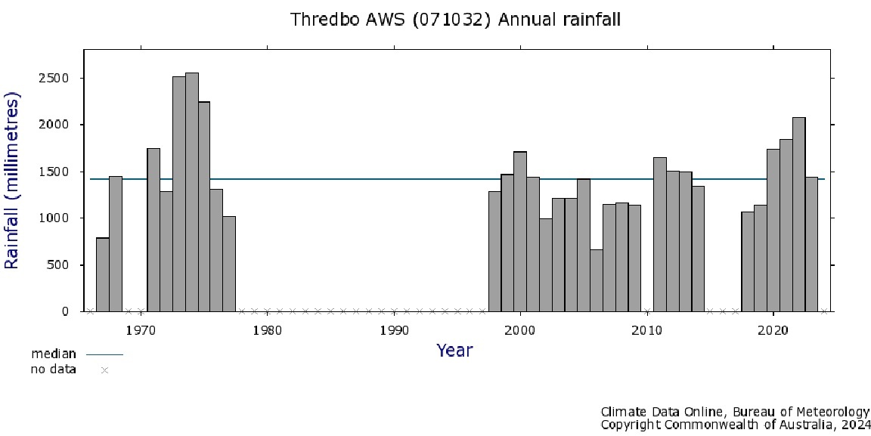
Figure S27. Mean annual rainfall recorded at the Thredbo Automatic Weather Station (071032). The horizontal line in the centre of the graph area shows mean rainfall calculated by the Bureau of Meteorology (www.bom.gov.au). For the period 2002 to 2009 inclusive this station recorded below average annual rainfall, except for 2005 which was an average rainfall year.

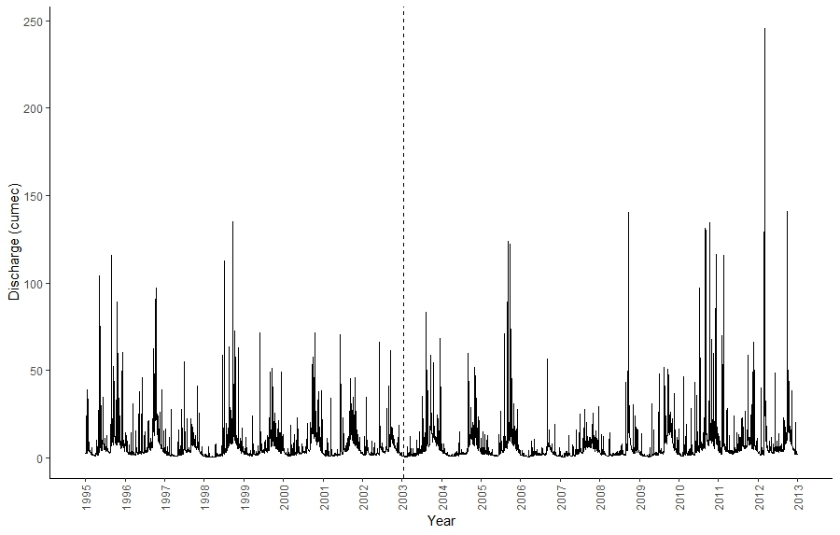
Figure S28. Daily stream discharge (cumec) of the Thredbo River (Gauging Station 222541) from 1995 to 2012 inclusive. The vertical dashed line shows the time when wildfire occurred in this study. Data available from Bureau of Meteorology (www.bom.gov.au/waterdata/).

