Efficacy of oseltamivir and baloxavir against A(H5N1)-contaminated bovine milk in mice

Jeremy C. Jones¹, Konstantin Andreev¹, Thomas Fabrizio¹, Andrew S. Bowman², Elena A. Govorkova¹, Richard J. Webby¹

¹Department of Host–Microbe Interactions, St. Jude Children’s Research Hospital; Memphis, TN, 38120, USA
²Department of Veterinary Preventive Medicine, College of Veterinary Medicine, The Ohio State University, Columbus, OH, 43219, USA.

Corresponding Author:
Richard J. Webby
Department of Host–Microbe Interactions, St. Jude Children’s Research Hospital,
262 Danny Thomas Place, Memphis, Tennessee 38105-3678, USA
Phone: +1 (901) 595-3014; E-mail: richard.webby@stjude.org
SUPPLMENTARY APPENDIX
- Supplementary Figure 1: 50% mouse lethal dose analysis of virus-contaminated milk by different routes of inoculation
- Supplementary Figure 2: Mouse morbidity after virus-contaminated milk challenge
- Supplementary materials and methods

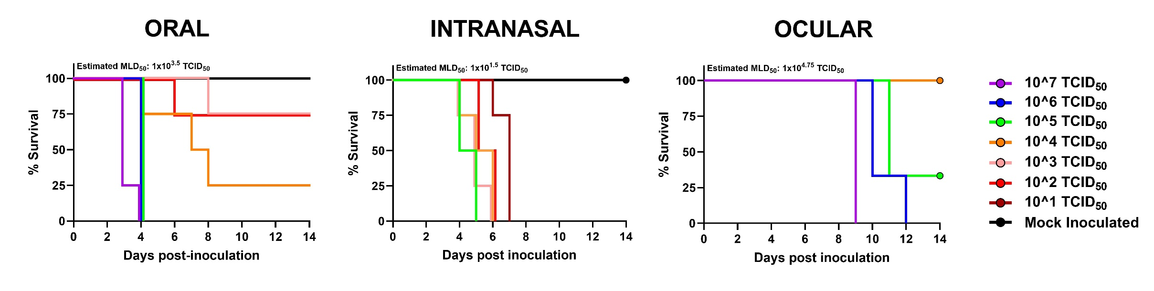
SUPPLEMENTARY FIGURE 1: 50% Mouse Lethal Dose (MLD₅₀) of A/bovine/Ohio/B24OSU-439/2024 contaminated milk by multiple routes. Mice (n = 3 to 4 per dilution) were inoculated with the indicated virus-contaminated milk dose in total volume of 50 μL (oral), 30 μL (intranasal), or 10 μL (ocular, 5 μL per eye). Survival was monitored for 14 days post-inoculation. MLD₅₀ values were estimated by method of Reed and Meunch³. Mock inoculated animals received an equal dose of influenza A, M gene real-time PCR negative milk (Ct ≥ 36). The full dilution series was not used for each route.

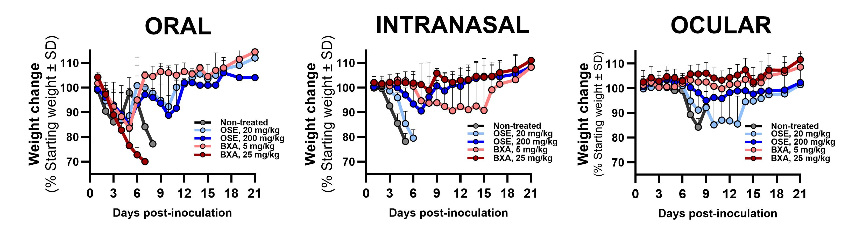
SUPPLEMENTARY FIGURE 2: Effects of OSE and BXA treatment on morbidity in mice inoculated with A/bovine/Ohio/B24OSU-439/2024 contaminated milk. Mice (n = 8 / survival group) were inoculated by the indicated route and treated with OSE or BXA at the indicated dose beginning 24 hpi. Animals were weighed daily to assess morbidity.

SUPPLEMENTARY MATERIALS AND METHODS
CELLS: Madin-Darby canine kidney cells (MDCKs) (ATCC, #CCL-34) were maintained in Modified Eagle’s Medium (MEM) (CellGro) supplemented with 5% fetal bovine serum (FBS) (HyClone), 1 mM L-glutamine, and 1× penicillin/streptomycin/amphotericin B (Gibco) at 37°C, 5% CO₂.
MILK AND VIRUS: Milk samples were collected from an A(H5N1) affected dairy herd, and A/bovine/Ohio/B24OSU-439/2024 was identified and isolated in a milk specimen collected from a mildly febrile (39.7°C; normal bovine range 38.0 – 39.3 °C) dairy cow with marked decreased milk production. Viral RNA was extracted from the raw milk sample and confirmed as influenza A positive by M-gene targeted real-time PCR. The virus infectivity titer in the raw milk was determined to be 10^{8.5} TCID₅₀/mL, determined on MDCK cells as described subsequently. For each in vivo study, inoculums were diluted into ultra pasteurized whole milk confirmed as influenza A negative by M-gene targeted real-time PCR.
ANIMALS: 6-to-8-week-old female BALB/c mice (Jackson Laboratory, median mass 18.3 g) were used for all challenge studies. Animal studies were approved by the St. Jude Children’s Research Hospital Institutional Animal Care and Use Committee (IACUC, protocols #428 and 003) under Institute of Laboratory Animal Resources and Governing Board of the US National Research Council guidelines. Animal holding room conditions were as follows: 12 h light/12 h dark cycle, dry-bulb temperatures set below the lower critical temperature to minimize potential heat stress (71 °C ± 1 °C with alarm points beyond this value), humidity to 45% with active humidification available allowing ≥ 40% humidity during colder months. Post-inoculation, all animals were monitored for clinical disease at least twice daily and weighed daily.
ORAL INOCULATION OF MICE: Oral inoculations were performed as described previously⁴ by lightly anesthetizing mice with 4% isoflurane and slowly delivering 50 μL of inoculum into mouth and throat with a micropipette using the hard palate as a guide for the pipette tip. Mice were allowed to swallow the inoculum in small volumes (approximately 5-10 uL) before more was dispensed. We observed small amounts of aspiration of the inocula visualized by 1-2 small bubbles in the nostrils as the animals recovered from anesthesia. Preliminary 50% mouse lethal dose (MLD₅₀) estimates for each route were conducted (Fig. S1). The oral inoclua contained 1x10^{4.5} TCID₅₀, 10x MLD₅₀.
INTRANASAL INOCULATION OF MICE: Mice were anesthetized as described previously and 30 µL inoculum was dispensed onto the nostrils. Animals were observed to quickly and completely inhale the inocula. Based on MLD₅₀s (Fig. S1), the intranasal inocula contained 1x10^{2.2} TCID₅₀, 5x MLD₅₀.
OCULAR INOCULATION OF MICE: Ocular inoculations were performed as described previously⁵ without scarification and with minor modifications. Mice were deeply anesthetized with 4% isoflurane. 10 µL (5 µL per eye) of inoculum was dispensed onto the eye with a micropipette directed towards medial canthus and slowly coating the surface of the eye. The volume of inoculum was observed to slowly absorb into the ocular space within 3-5 minutes. Mice were not observed to scratch or paw at the eyes during this time, but their movement was overall slow and cautious likely due to temporary vision impairment. During this time, care was taken to ensure they did not bump into cage mates or the sides of the cages to disturb their inoculum. All animals recovered to normal activity within 5 minutes with no signs of vision impairment or distress. Based on MLD₅₀s (Fig. S1), the ocular inocula included 1x10⁶ TCID₅₀, ≈18x MLD₅₀.
VIRUS TITRATION IN TISSUES: Mice (n = 3/challenge route) were sacrificed at 3 dpi (oral), 5 dpi (IN), or 8 dpi (ocular) near time of peak-morbidity (Fig. S1). Eyes, nasal turbinates, total brain, intestine (starting approximately at the duodenum and ending just before the colon), stomach, lung lobes, and whole blood (≈ 300 µL) were collected with the disinfection of instruments between all tissues (excluding between the intestine and stomach). All tissues were bead-homogenized in 1 mL infection medium with concentrated antibiotics (MEM, 1% bovine serum albumin [BSA, Sigma-Aldrich], 2× penicillin/streptomycin/amphotericin B, 1x gentamicin [Gibco]). Serial log₁₀ dilutions were prepared in infection medium and inoculated into confluent MDCKs in 96-well plates for 72 hr. Supernatants were subjected to standard hemagglutination assay with chicken red blood cells (cRBCs) to determine presence of virus⁶. 50% tissue culture infectious doses (TCID₅₀) were determined by the method of Reed and Muench³. The lower limit of virus detection was 1.0 log₁₀ TCID₅₀/mL.
IN VITRO NAI AND CENI SUSCEPTIBILITY: Phenotypic susceptibilities to oseltamivir carboxylate (OSE) and baloxavir acid (BXA) were determined by fluorogenic and cell-based Influenza Replication Inhibition NA-based Assays (IRINA) respectively, using 2′−[4-methylumbelliferyl]-α-D-N-acetylneuraminic acid (MUNANA) substrate^{7,8}. After standardizing NA activity, the virus-contaminated milk was incubated with OSE (5 pM - 50 µM) for 30 min or inoculated onto MDCK cell monolayers with BXA (6 pM - 111 nM) overnight at 37 °C. The fluorescent NA-cleaved MUNANA substrate was measured at excitation/emission of 360/460 nm. 50% inhibitory concentrations (IC₅₀s) and effective concentrations (EC₅₀s) of OSE and BXA respectively were derived from the dose–response curves using sigmoidal, four-parameter logistic non-linear regression equation (GraphPad Prism v.10.1.2).
STATISTICAL ANALYSIS: All statistical analyses were performed in GraphPad Prism v 10.1.2. Survival analysis was determined by the method of Kaplan-Meier. For titers (log₁₀), a value of 0.01 was used in place of 0 to facilitate statistical comparisons. Comparison of virus titers from triplicate limiting dilutions per sample was determined by 2-way ANOVA with Dunnett’s post-test for multiple comparisons. In vitro IC₅₀ and EC₅₀ data are representative of mean values from three independent dose-response curves ± the standard deviation (SD).

REFERENCES
1. Nguyen HT, Chesnokov A, De La Cruz J, et al. Antiviral susceptibility of clade 2.3.4.4b highly pathogenic avian influenza A(H5N1) viruses isolated from birds and mammals in the United States, 2022. Antiviral Res 2023;217:105679. DOI: 10.1016/j.antiviral.2023.105679.
2. Andreev K, Jones JC, Seiler P, et al. Antiviral Susceptibility of Highly Pathogenic Avian Influenza A(H5N1) Viruses Circulating Globally in 2022-2023. J Infect Dis 2024;229(6):1830-1835. DOI: 10.1093/infdis/jiad418.
3. Reed LJM, H. A simple method of estimating fifty percent endpoints. The American Journal of Hygiene 1938;27:493-497.
4. Guan L, Eisfeld AJ, Pattinson D, et al. Cow's Milk Containing Avian Influenza A(H5N1) Virus - Heat Inactivation and Infectivity in Mice. N Engl J Med 2024;391(1):87-90. DOI: 10.1056/NEJMc2405495.
5. Belser JA, Wadford DA, Xu J, Katz JM, Tumpey TM. Ocular infection of mice with influenza A (H7) viruses: a site of primary replication and spread to the respiratory tract. J Virol 2009;83(14):7075-84. DOI: 10.1128/JVI.00535-09.
6. Organization WH. WHO manual on animal influenza diagnosis and surveillance. In: Response DoCDSa, ed. 2 ed. Geneva, Switzerland2002:28-36.
7. Leang SK, Hurt AC. Fluorescence-based Neuraminidase Inhibition Assay to Assess the Susceptibility of Influenza Viruses to The Neuraminidase Inhibitor Class of Antivirals. J Vis Exp 2017(122). DOI: 10.3791/55570.
8. Patel MC, Flanigan D, Feng C, et al. An optimized cell-based assay to assess influenza virus replication by measuring neuraminidase activity and its applications for virological surveillance. Antiviral Res 2022;208:105457. DOI: 10.1016/j.antiviral.2022.105457.

