Supplementary Fig.1 Therapeutic approach distribution according to age
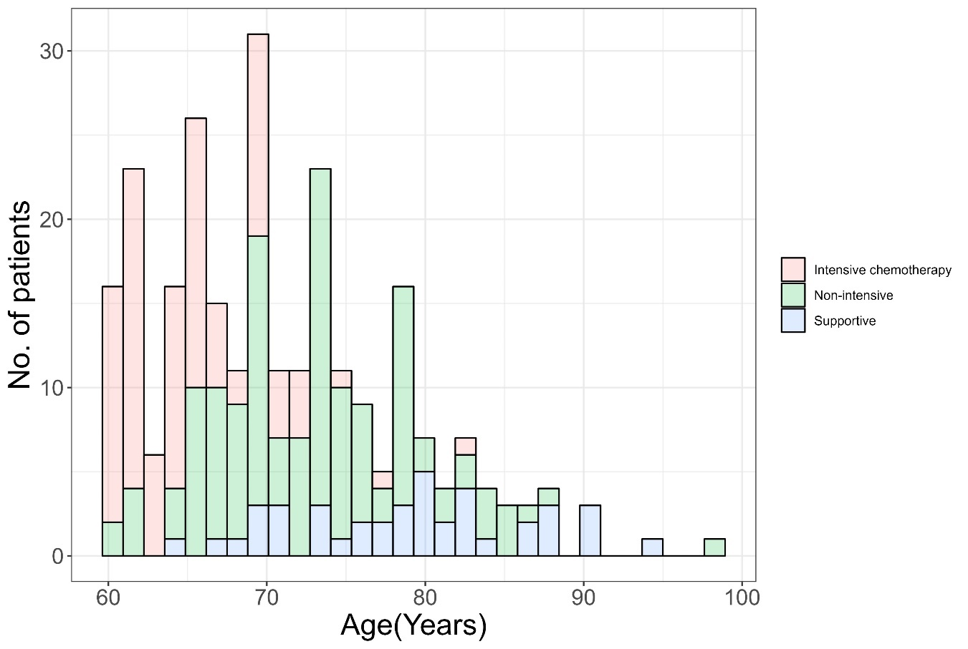

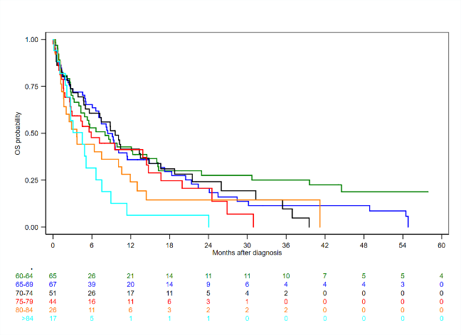
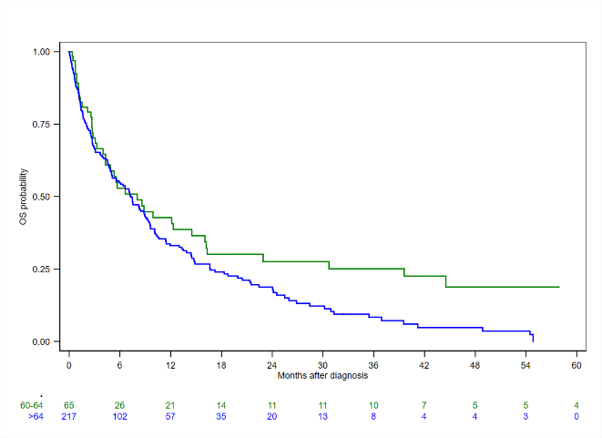
Supplementary Fig.2 OS, graph of age groups by five-year intervals (left) and classified into two groups: 60-64 and >64 (right)

