Interaction between LdCen1 and LdDRP in Leishmania donovani is crucial for survival in host by facilitating the parasite’s UV-induced DNA damage repair
Roshanara¹, Rati Tandon¹, Niti Puri² and A. Selvapandiyan^{1*}

¹Department of Molecular Medicine, Jamia Hamdard, New Delhi 110062, India
²School of Life Sciences, Jawaharlal Nehru University, New Delhi 110067, India

*Corresponding author: selvapandiyan@jamiahamdard.ac.in

Supplementary Information

Table S1: List of primers used for the overexpression of HA-tagged LdDRP in L. donovani and their respective annealing temperatures.
LdDRPN F | ACTAGTATGGCCATGGTGACATCCGC | 62
LdDRPN R | ACTAGTCTACGCGTAGTCCGGCACGTCGTAAGAATTCGCAGCGGCCGGCGAGTGC | 65
LdDRPC F | ACTAGTATGTCCATTTTTGAAGGCCGCGAGAAGCGC | 62
LdDRPC R | ACTAGTCTACGCGTAGTCCGGCACGTCGTATCACTGCATCGGCATCGCGCCGGC | 60
LdDRP F | ACTAGTATGATGGCCATGGTGACATCCGCCAGCG | 65
LdDRP R | ACTAGTCTACGCGTAGTCCGGCACGTCGTA TCACTGCATCGGCATCGCGCCGGCGCCG | 65

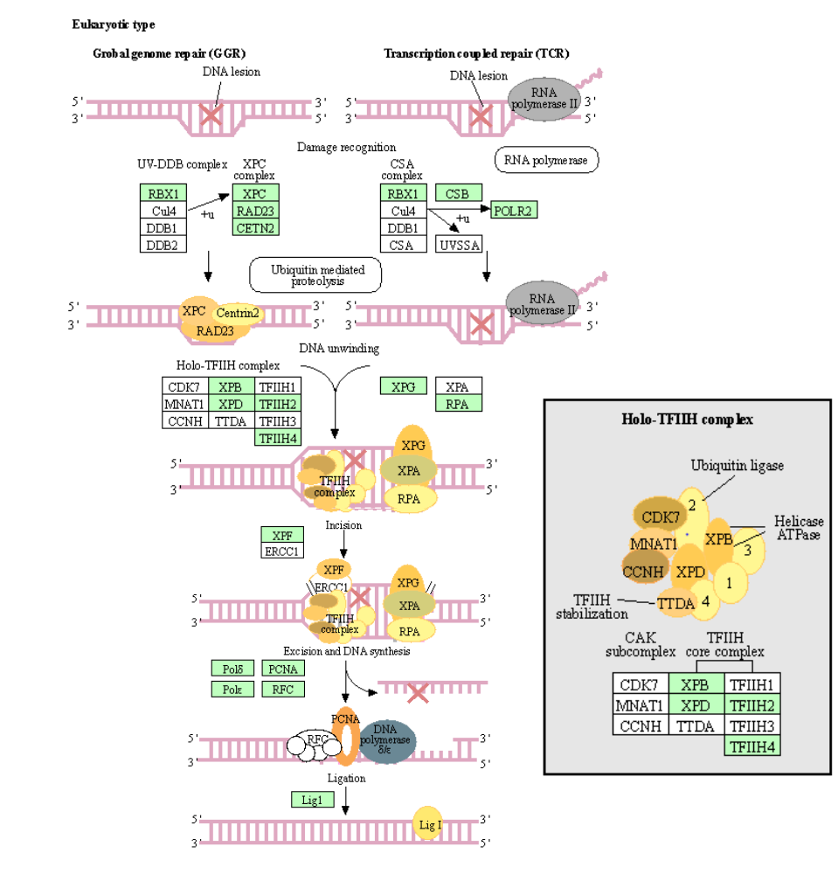

Fig. S1 The Nucleotide excision repair pathways in Leishmania donovani were predicted using STRING analysis. The prediction was based on human DNA damage repair by the interaction of XPC and centrin 2 proteins with other proteins.

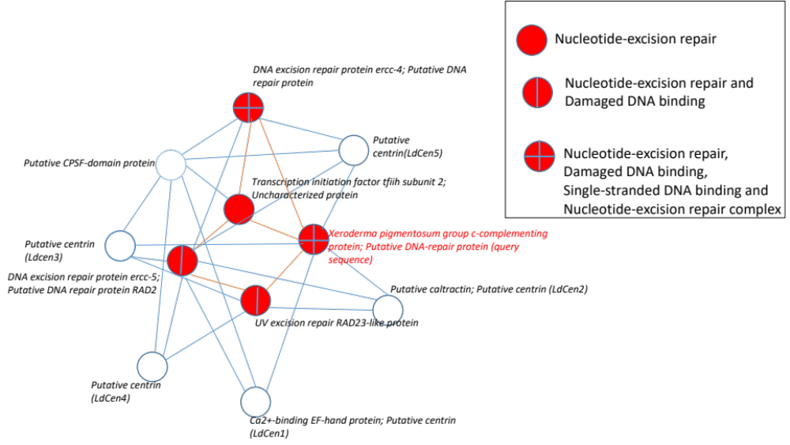

Fig. S2 STRING analysis predicted the biological and molecular functions of LdDRP with its functional partners in DNA damage binding, nucleotide excision repair, and forming nucleotide excision repair complex, Here LdDRP (Query sequence) and its binding proteins are all centrins, CPSF domain, Transcription initiation factor and some DNA repair proteins of L. donovani.

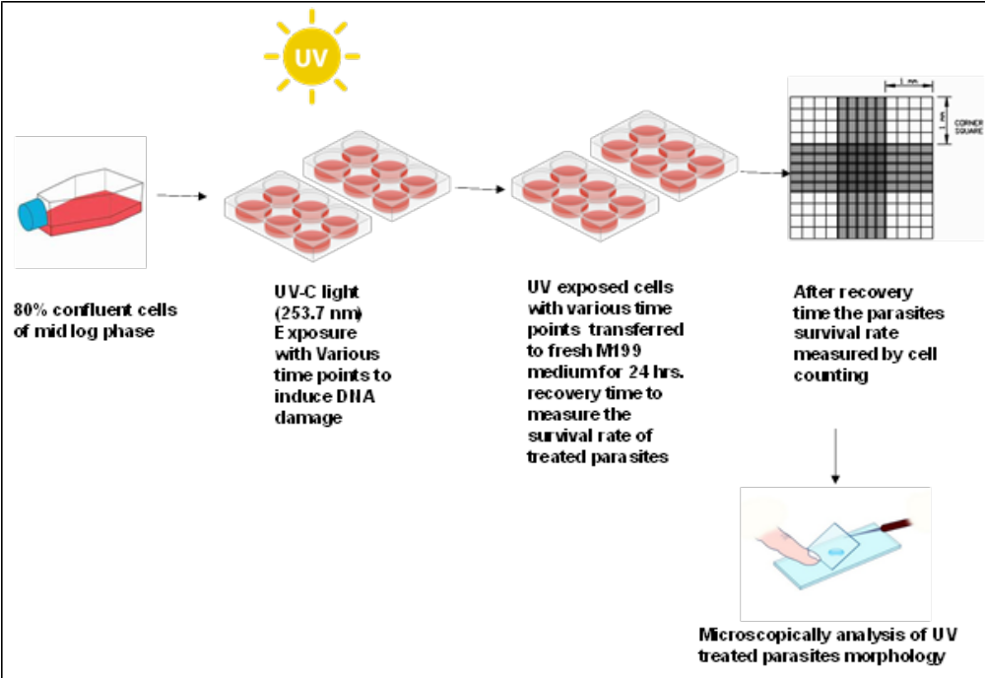

Fig. S3 Experimental design of UV-induced DNA damage and survival rate of LdDRP overexpressing parasites

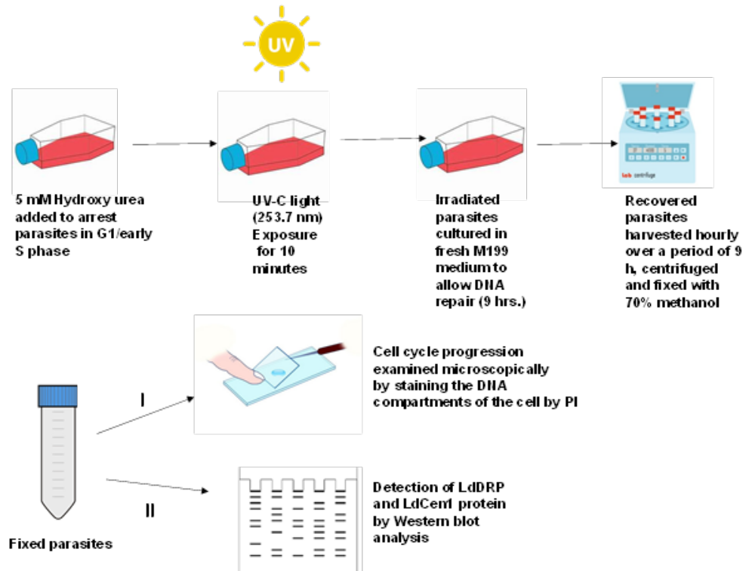

Fig. S4 Experimental design for the HU-treated cell synchronization of parasites, after that UV irradiation and parasites recovery for the Western blot and microscopic analysis.

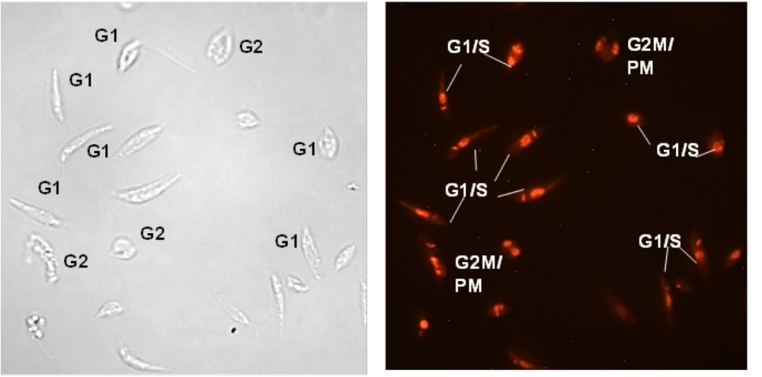
5A

Fig. S5A After HU treatment ~80% of cells are in G1/early S stages of cell cycle and displayed 1K1N.

5B
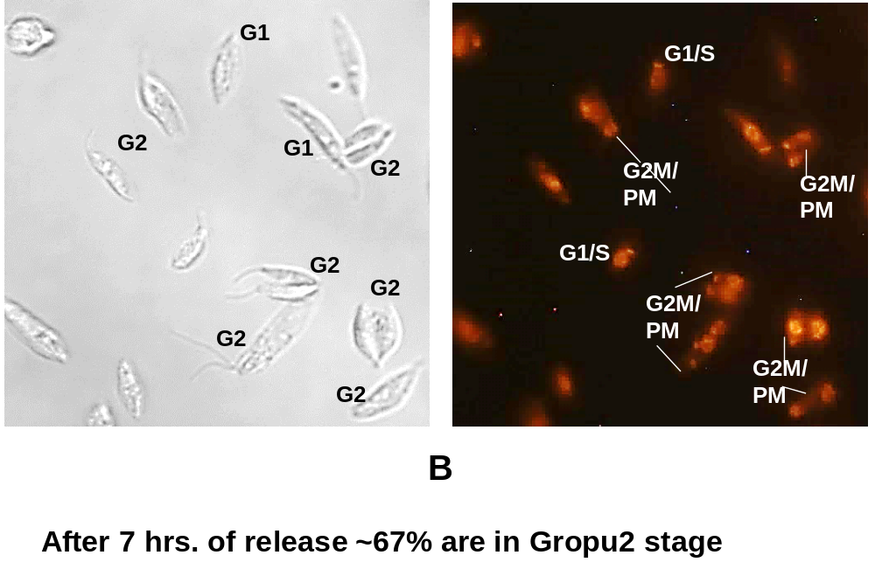

Fig. S5B Approximately 67% of synchronised UV-C treated parasites were in the G2/M phase and post-mitotic , displayed 2K2N after 7 hours of recovery time.

