Supplementary Material to

Geological and experimental evidence of bioavailable phosphite during the Great Oxygenation Event

Abu Saeed Baidya¹, Joanne Boden¹, Yuhao Li², Albertus J.B. Smith^{3,4}, Kurt Konhauser², Eva E. Stüeken¹,

¹School of Earth and Environmental Sciences, University of St. Andrews, St Andrews KY16 9TS, United Kingdom
²Department of Earth and Atmospheric Sciences, University of Alberta, Earth Sciences Building, Edmonton, Alberta T6G 2E3, Canada
³Department of Science and Innovation-National Research Foundation Centre of Excellence in Integrated Mineral and Energy Resource Analysis, Department of Geology, University of Johannesburg, Auckland Park, 2092, Johannesburg, South Africa
⁴Palaeoproterozoic Mineralisation Research Group, Department of Geology, University of Johannesburg, Auckland Park, 2092, Johannesburg, South Africa

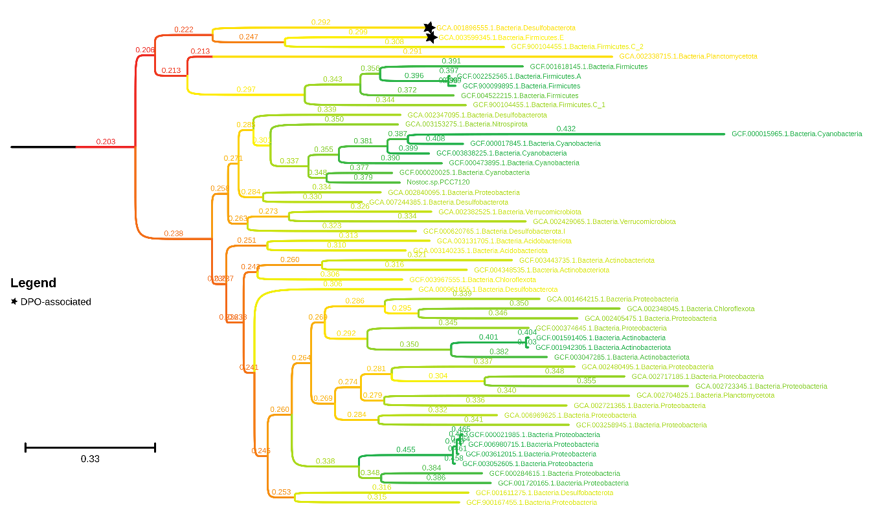

Figure S1: Evolutionary tree of the enzyme responsible for microbial phosphite oxidation (namely phosphite dehydrogenase; PtxD).
Enzymes found in organisms with genes for dissimilatory phosphite oxidation (DPO) are annotated with black stars, whereas all others are associated with assimilatory phosphite oxidation due to the lack of genes known to be required for DPO (namely one or more of ptxE, ptdC, ptdG, ptdH, ptdI and ptdF). Numbers on branches and their colours represent ancestor deviation values estimated by MAD (Tria et al., 2017). They indicate where the tree is rooted, so values closer to zero (in red colours) are more likely to represent the tree’s root. Leaf labels describe the microbial organism within which the phosphite oxidation gene was found in the format; GTDB release 95 identification number ‘.’ Domain ‘.’ Phylum. The scale bar represents the average number of amino acid substitutions per site.

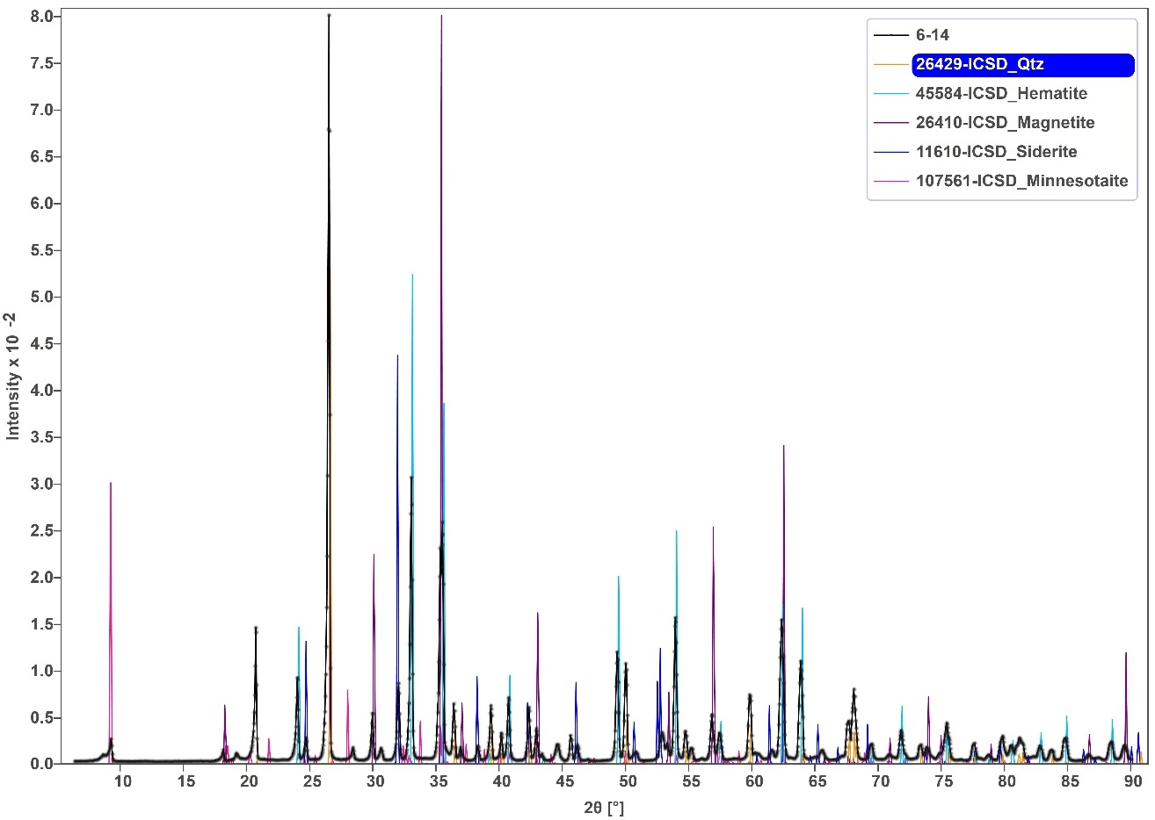
Figure S2A: Typical XRD pattern of Kuruman BIF.
The XRD pattern of the BIF sample is shown by black line. The patterns of the minerals are taken from Inorganic Crystal Structure Database (ICSD) database. The numbers shown in the legend are the ICSD code of the respective minerals. The pattern matching is done by the CrystalDiffract software.

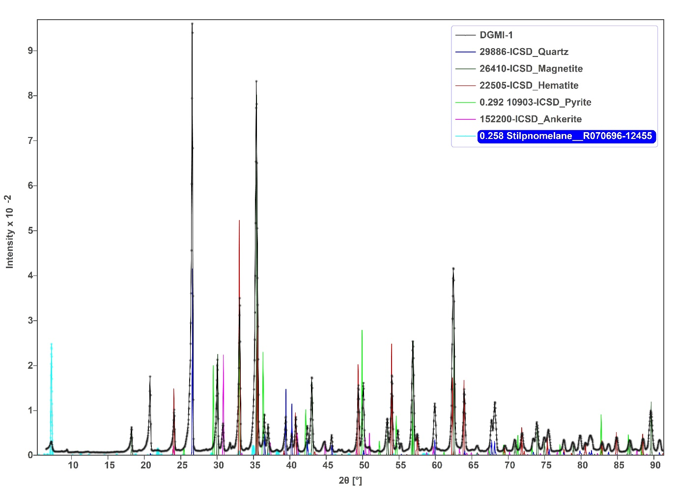
Figure S2B: Typical XRD pattern of Dales Gorge BIF.
The XRD pattern of the BIF sample is shown by black line. The patterns of the minerals are taken from Inorganic Crystal Structure Database (ICSD) database. Numbers shown in the legend are the ICSD code of the respective minerals. Heights of the pyrite and stilponomelane peaks are diminished for better visualization. The pattern matching is done by the CrystalDiffract software.

