Supplementary material

Facile and rapid preparation of magnetic imprinted adsorbent for specific separation and capture of liquid-crystal monomers pollutants in environmental water and soil samples

YueYue Zhang ¹, Dingliang Tang ², Yuanfei Wu ², Xiaojia Huang ^{1*}
1. College of the Environment and Ecology, Xiamen University, Xiamen 361005, China
2. College of Chemistry and Chemical Engineering, Xiamen University, Xiamen 361005, China

Table S1. The chemical properties of studied LCMs
Full name | Abbreviation | Chemical Structures | Molecular formula | Molecular  weight | log K_{ow}ª
4-[Difluoro(3,4,5-trifluorophenoxy)methyl]-3,5-  difluoro-4'-ethyl-biphenyl | DTMDEB | 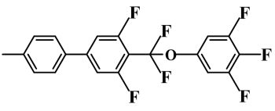 | C₂₁H₁₃F₇O | 414.32 | 7.89
2',3,4,5-Tetrafluoro-4''-propyl-1,1':4',1''-terphenyl | TePT | 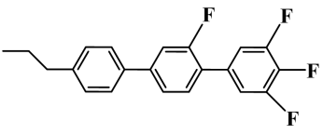 | C₂₁H₁₆F₄ | 344.35 | 7.47
4''-Ethyl-2'-fluoro-4-propyl-1,1':4',1''-terphenyl | EFPT | 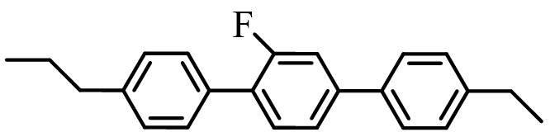 | C₂₃H₂₃F | 318.44 | 8.62
3,4-Difluoro-4'-(trans-4-propylcyclohexyl)biphenyl | DPrB | 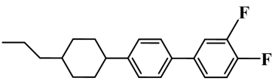 | C₂₁H₂₄F₂ | 314.41 | 7.92
3,4-Difluoro-4'-[(trans,trans)-4'-propyl[1,1'-  bicyclohexyl]-4-yl]biphenyl | DPrBB | 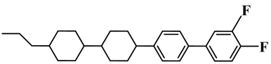 | C₂₇H₃₄F₂ | 396.56 | 10.47
- LogK_{ow} values were found from ChemSpider: http://www.chemspider.com.
Table S2. Kinetic parameters of MIA and MNNS towards DTMDEB
 | Pseudo-first-order |  |  |  | Pseudo-second-order
 | R² | K₁ (min⁻¹) | Q_{e} (mg/g) |  | R² | K₂ (g/(mg∙min)) | Q_{e} (mg/g)
MIA | 0.9413 | 0.3233 | 0.5654 |  | 0.9963 | 0.7220 | 0.9400
MNNS | 0.8221 | 0.0287 | 0.7272 |  | 0.9741 | 1.5095 | 0.3190

Table S3. Isotherm parameters of MIA and MNNS towards DTMDEB
 | Langmuir equation |  |  |  | Freundlich equation
 | Q_{max} (mg/g) | K_{L} (L/mg) | R² |  | n | K_{F} | R²
MIA | 88.50 | 0.03 | 0.0884 |  | 0.97 | 2.27 | 0.9577
MNNS | 5.14 | 0.16 | 0.7836 |  | 1.48 | 0.71 | 0.8137

Table S4. Confirmatory study about the determination of LCMs
Samples | Methods | Concentrations (μg/L) / (%RSD, n=3)
Samples | Methods | DFBP | TePT | EFPT | DPrB | DPrBB
Lake water | Presented method | ND ª | 0.10 (4.5) | ND | 0.030 (3.1) | 0.050 (7.7)
Lake water | LLE-GC/MS ^{b} | ND | 0.11 (4.0) | ND | 0.028 (2.1) | 0.047 (3.7)
Farmland soil | Presented method | ND | ND | ND | 1.54 (7.2) | ND
Farmland soil | SPE-GC/MS ^{c} | ND | ND | ND | 1.47 (3.6) | ND
a: Not detected; b: Water Research 247 (2023) 120784; c: Science of the Total Environment 909 (2024) 168428.

Figure S1. SEM image of MIA at 100000×magnification

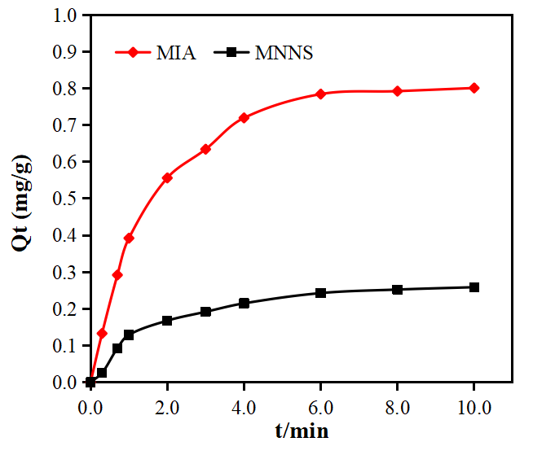
Figure S2. Adsorption kinetic curves of DFBP on MIA and MNNS

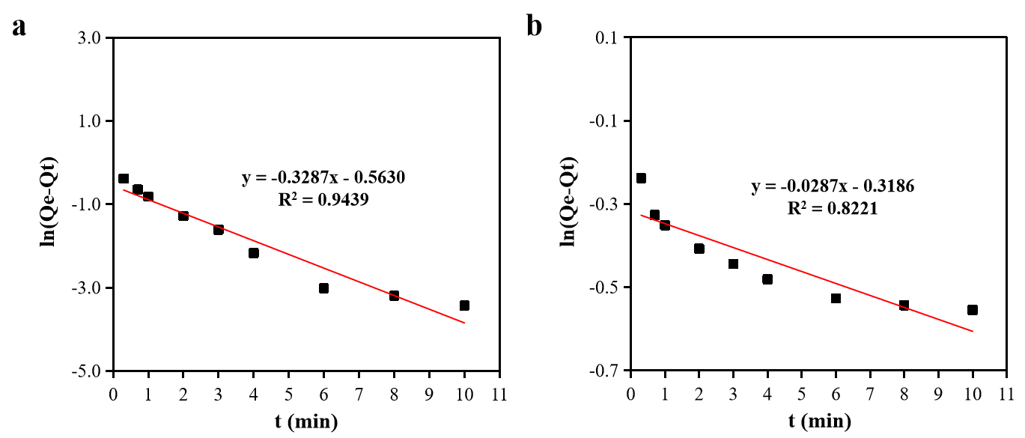
Figure S3. Pseudo-first-order kinetic model fitting curves of DFBP on MIA (a) and MNNS (b)

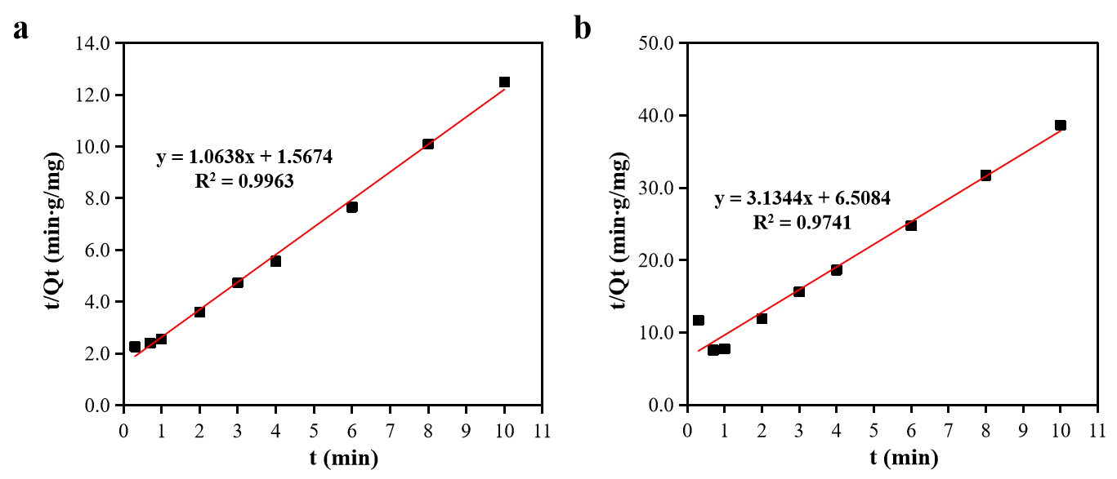
Figure S4. Pseudo-second-order kinetic model fitting curves of DFBP on MIA (a) and MNNS (b)

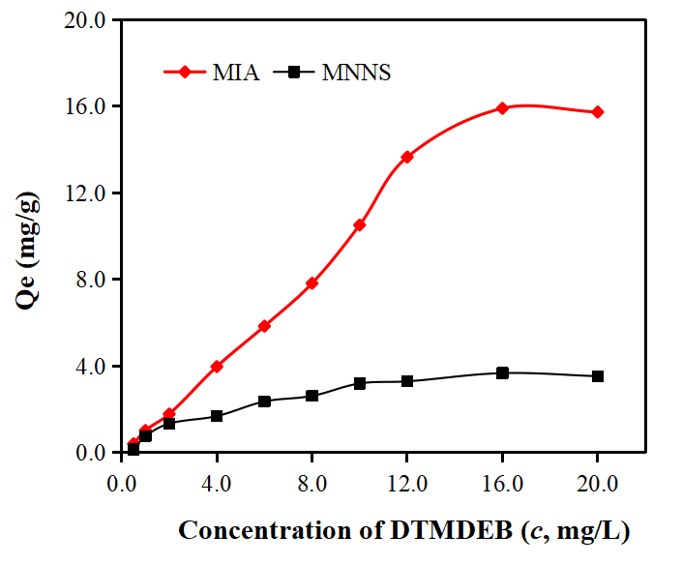
Figure S5. Static adsorption curves of DFBPB on MIA (a) and MNNS (b)

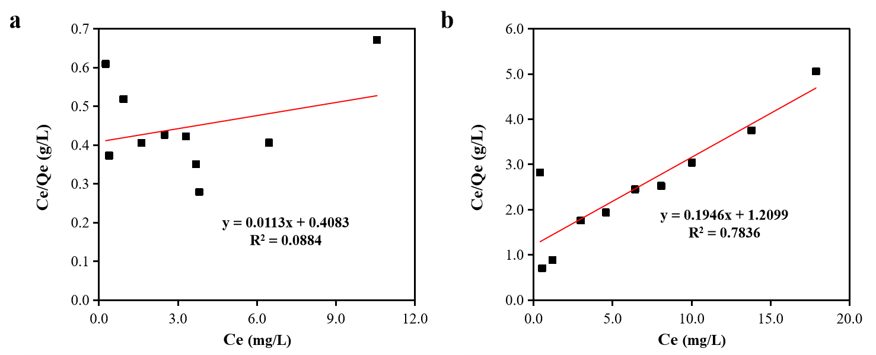
Figure S6. Langmuir isotherm adsorption model of DFBP on MIA (a) and MNNS (b)

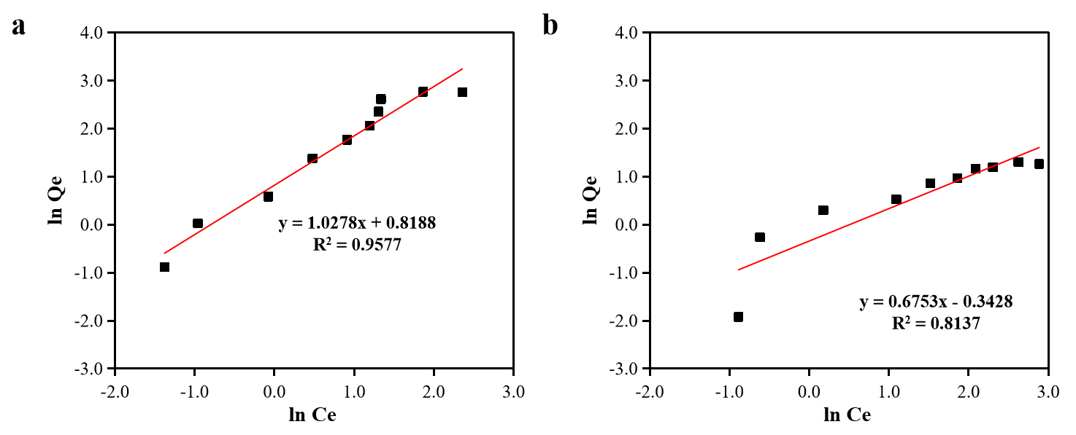
Figure S7. Freundlich isotherm adsorption model of DFBP on MIA (a) and MNNS (b)

Figure S8. Reusability investigation of MIA
Symbols: DFBP; TePT; EFPT; DPrB; DPrBB

Information about the suppliers of chemicals
Iron (III) chloride hexahydrate (FeCl₃∙6H₂O, 99%), iron (II) chloride tetrahydrate (FeCl₂∙4H₂O, 98%), ammonia (28%, v/v), 2,2'-azobis (2-methylpropionitrile) (AIBN, 97%), N,N-dimethylformamide (DMF, 99.5%), NaCl (99.5%) and toluene (TL, 99.5 %) were purchased from Xilong Sci. Co. Ltd (Guangzhou, China). VA (97%), fluorobenzene (FB, 99.9 %), trifluoroacetic acid (TFA, 99 %) and dichloromethane (DCM, 99 %) were bought from Macklin Biochemical Technology Co., Ltd (Shanghai, China). HFA (97%), 4,4'-biphenol (BP, 97 %) and ethylene dimethacrylate (EDMA, 98%) were obtained from Tokyo Chemical Industry Co., Ltd (Shanghai, China), Sigma-Aldrich Co., Ltd (Shanghai, China) and Alfa aesar Ltd (Tianjin, China), respectively. The HPLC grade methanol (MeOH) and acetonitrile (ACN) were purchased from Thermo Fisher Sci. Ltd. (Sichuan, China).

Detailed information about characterization instruments
The instruments used for the material characterization are as follows: the morphology, the nano-size and element contents of the prepared MIA was investigated with a scanning electron microscopy (SEM, Zeiss supra 55, Zeiss, Germany) equipped with energy dispersive spectroscopy (EDS), transmission electron microscopy (TEM, JEM-1400, JEOL, Japan) and X-ray Photoelectron Spectroscopy (XPS, Quantum 2000, Physical electronics, USA). The Fourier transform infrared (FT-IR) spectra were recorded on a FT-IR spectrophotometer (Avatar-360, Shimadzu, Japan). A Malvern Zetasizer Nano ZS Particle and Zeta Potential Analyzer (MPT-2, Malvern, UK) were used to investigate the Zeta potential. The magnetization measurement was studied by vibrating sample magnetometer (VSM, PPMS-9, Quantom, USA). The surface areas of MIA were measured by BET technique (Micromeritics TriStar II 3020, USA).

Experiments about adsorption and specific recognition
The adsorption kinetic studies were investigated by adding 30 mg MIA or MNNs to 50 mL solution (the concentration of DFBP was 500 µg/L), and the sample was shaken at 240 rpm in a thermostat oscillator for different time (0.30, 0.70, 1.0, 2.0, 3.0, 4.0, 6.0, 8.0 and 10 min). After adsorption, the MIA retained the analyte were magnetically separated from the solution, and MIA residue in the supernatant was quantified by HPLC/DAD.
Equilibrium adsorption studies were exerted by using a series of DFBP initial concentrations (0.50, 1.0, 2.0, 4.0, 6.0, 8.0, 10, 12, 16 and 20 mg/L). All experiments were carried out in 50 mL solution and 30 mg MIA or MNNs were employed. The adsorption was realized at 240 rpm. After adsorption equilibrium (8.0 min) was found, the DFBP concentration in the sample was measured by HPLC/DAD.
The adsorption capacities of template molecule DFBP in MIA or MNNs were calculated according to equations (1) and (2):
(1)
(2)
Where Q_{t} and Q_{e} were the amounts of DFBP retained by MIA or MNNs at time t and equilibrium, respectively; C₀, C_{t} and C_{e} (μg/L) were the concentrations of DFBP at initial stage, time t and equilibrium, respectively; V (mL) and m (mg) were the sample volume and amount of adsorbent, respectively.
Pseudo first-order (3) and pseudo second-order (4) kinetic models were employed to simulate the data.
(3)
(4)
Where k₁ (min⁻¹) and k₂ (μg/(g∙min)) were the rate constants of pseudo first-order and pseudo second-order equation, respectively.
Langmuir (5) and Freundlich (6) models were used to simulate the equilibrium adsorption data.
(5)
(6)
Where Q_{m} and k_{L} (L/μg) were the maximum adsorption capacity and equilibrium constant of Langmuir model, respectively; k_{F} and n were the equilibrium constants about the adsorption capacity and intensity of Freundlich model, respectively.
In the studies about the recognition performance of MIA, the concentration for each compound was 500 μg/L. Extraction selectivity was evaluated based on imprinting factor (ɑ) (7).
$α=\frac{Q_{MIA}}{Q_{MNNs}}$ (7)
Where Q_{MIA} and Q_{MNNs} were the extraction amounts of LCMs or non-structural analogues on MIA and MNNs, respectively.

