Supplementary Figures

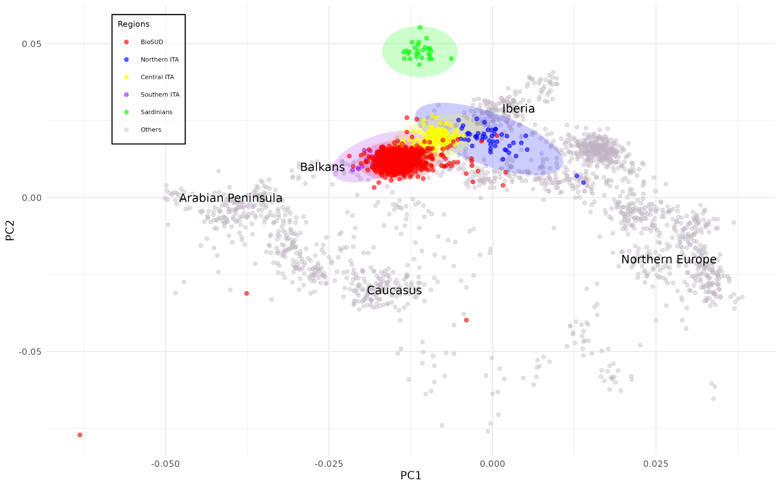
Fig. S1: Principal Component Analysis (PCA) Plot Showing Data with Outliers Included.
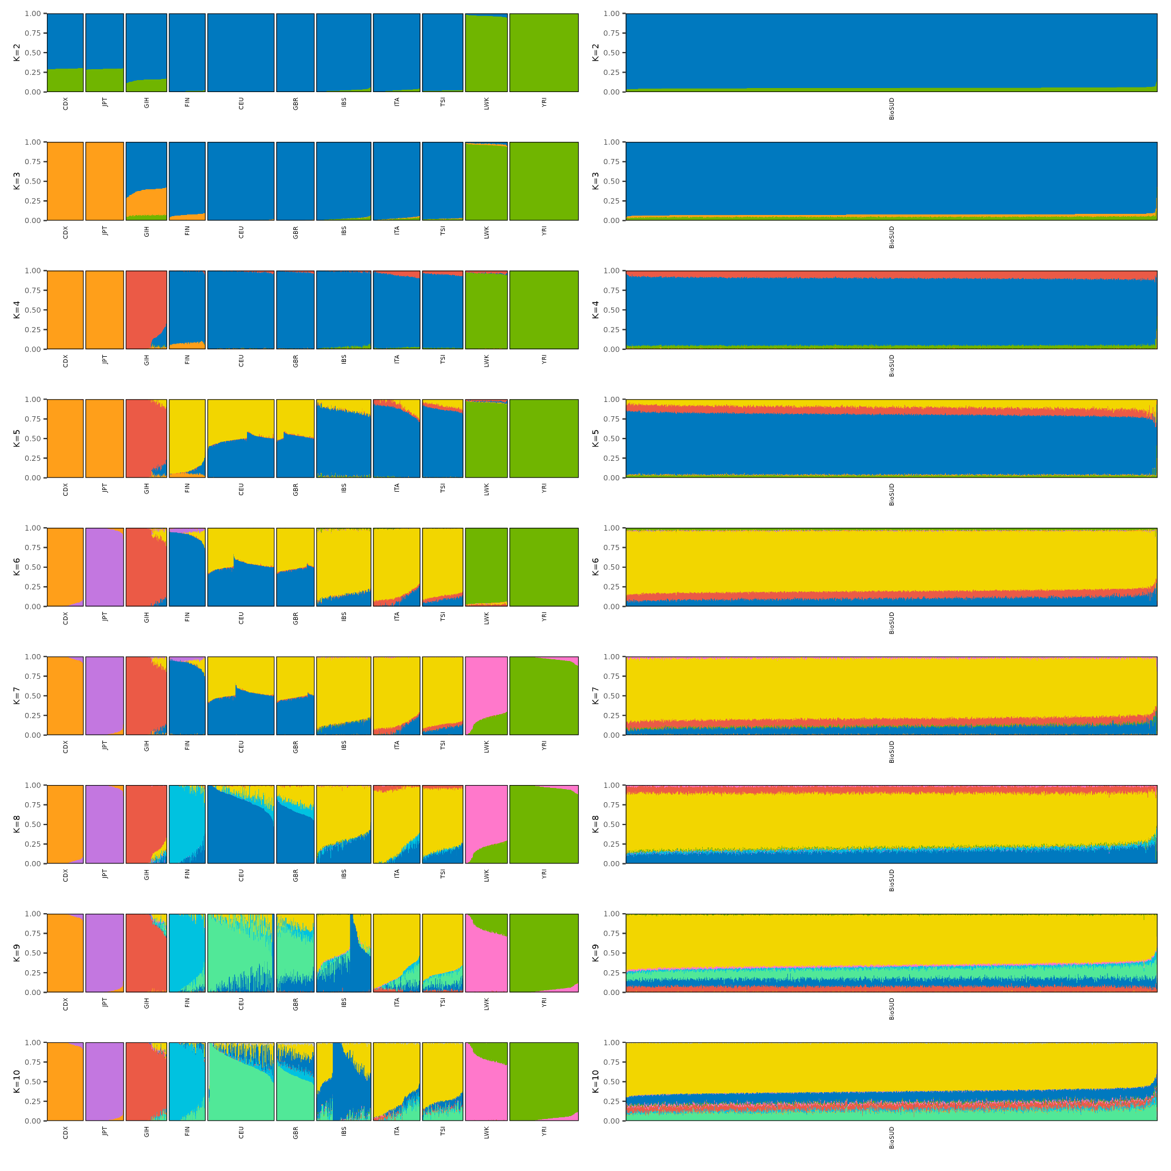
Fig. S2: Results of the ADMIXTURE clustering analysis using K from 2 to 7. Panels on the left show the ancestral composition of the reference dataset, and panels on the right the projected ancestral proportions for the BioSUD cohort. CDX: Dai Chinese; CEU: Central Europeans; FIN: Finnish; GBR:British from England and Scotland; GIH: Gujarati Indians from Houston; IBS: Iberians from Spain; ITA: Italians; JPT: Japanese from Tokyo; LWK: Luhya from Webuye Kenya; TSI: Tuscans; YRI: Yoruba from Nigeria

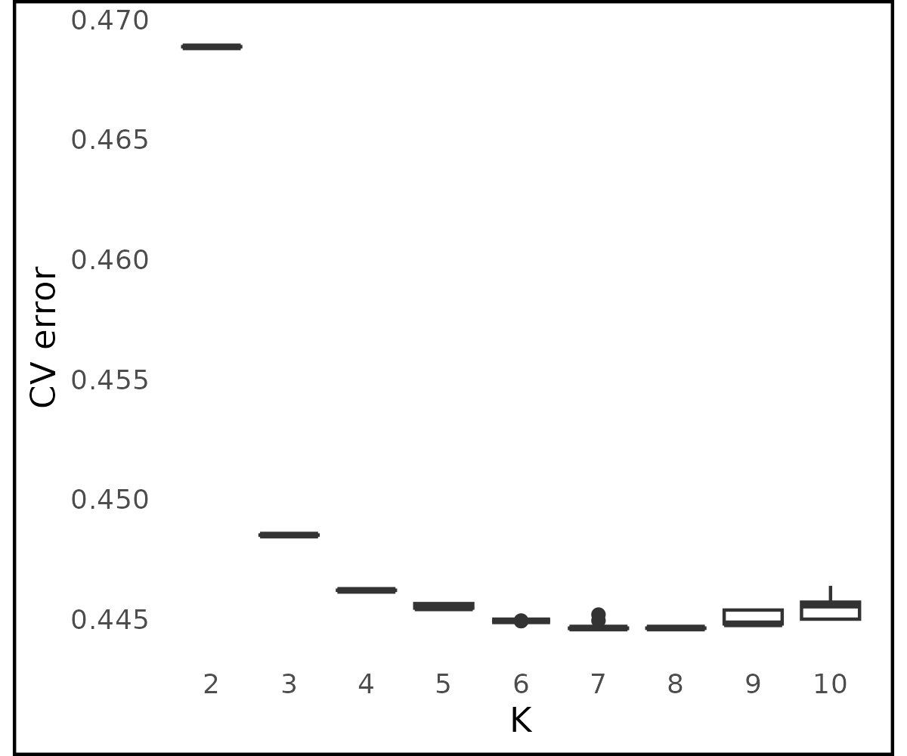

Fig. S3: Cross-Validation Plot Across Different K Values for ten ADMIXTURE replicates.

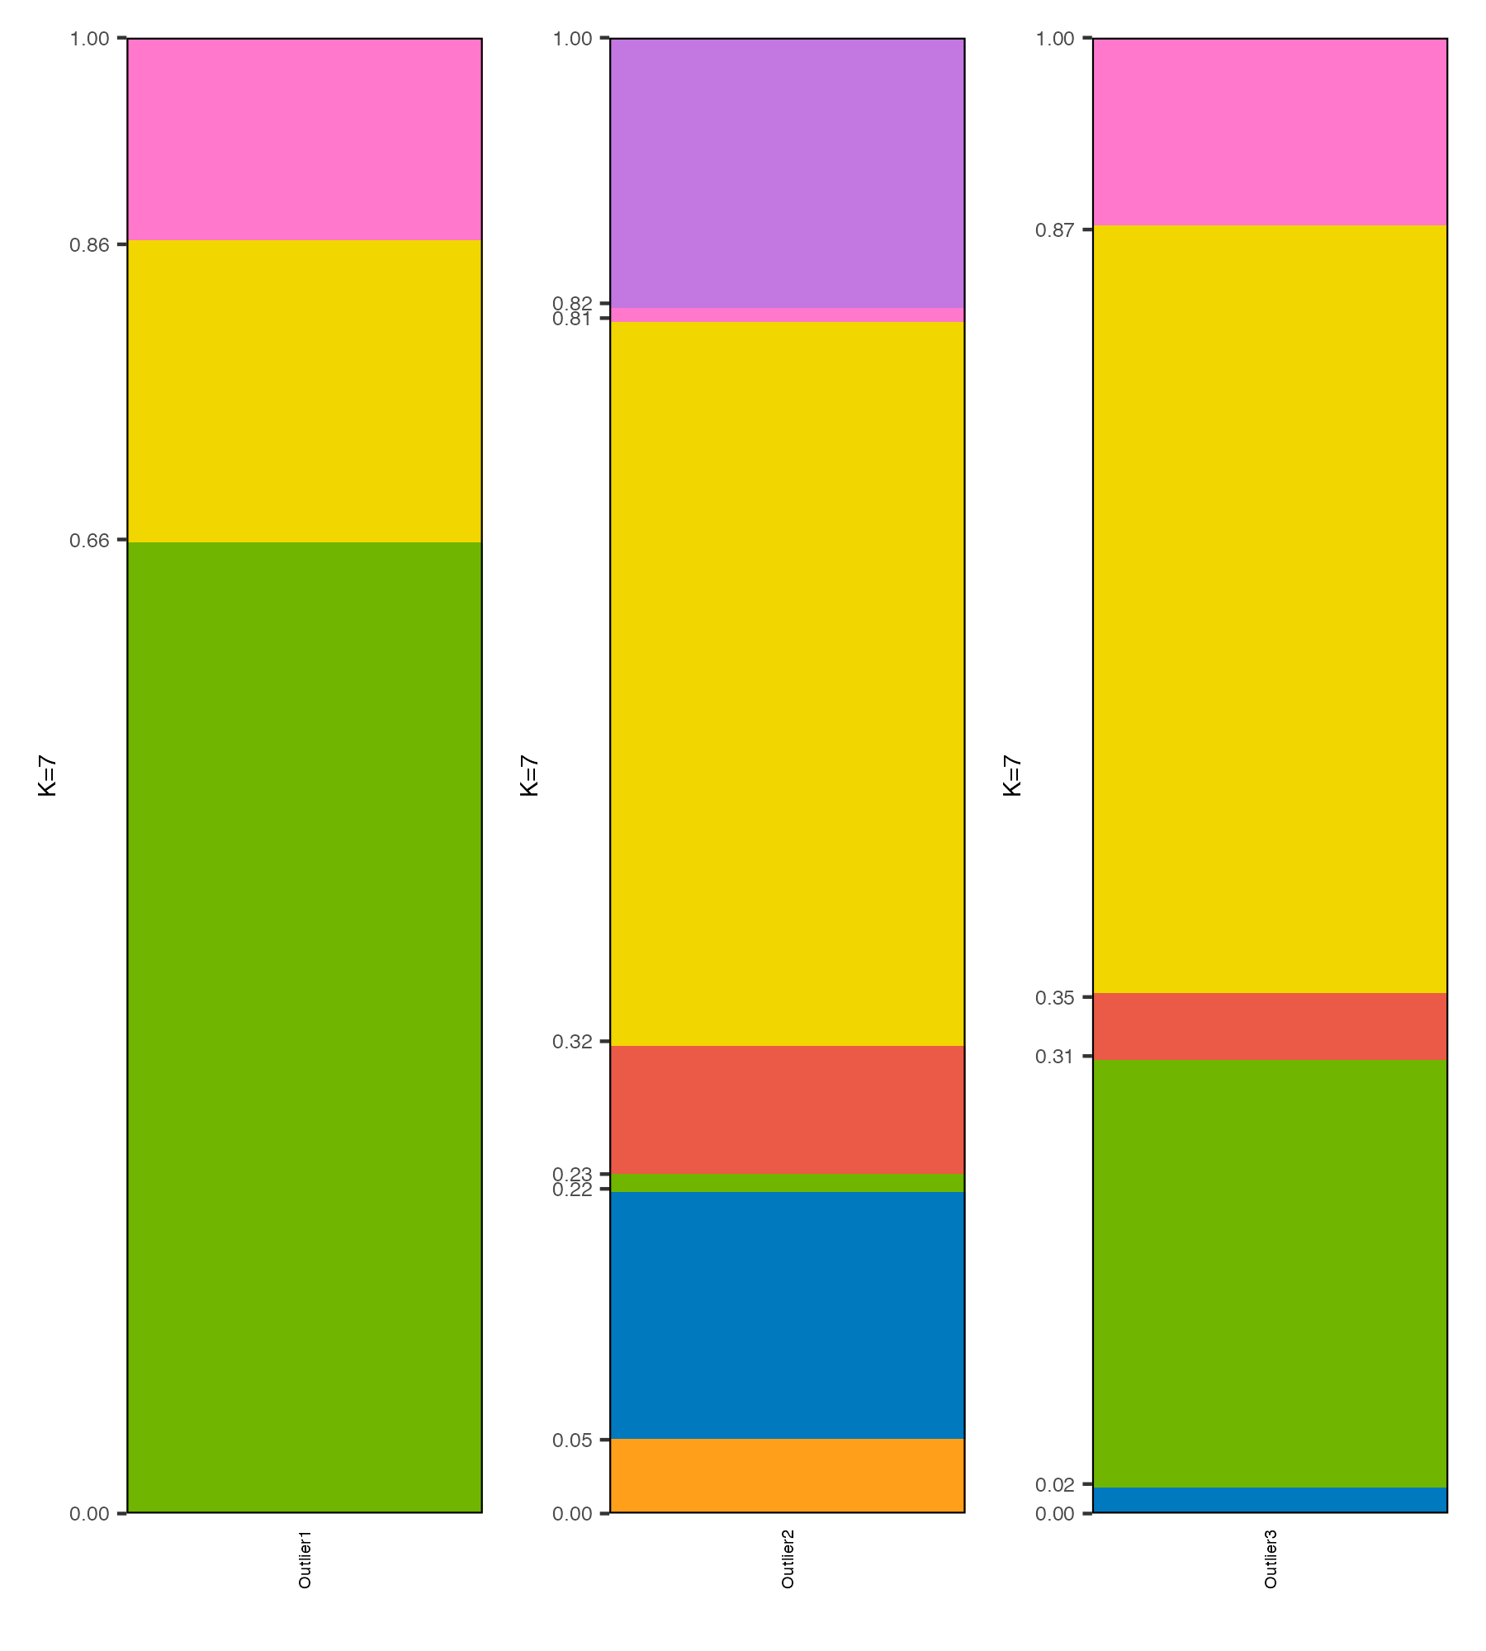
Fig. S4: Results of the ADMIXTURE for the three individuals marked as outliers in the BioSUD sample. Yellow: modal component in Southern European populations; Blue: modal component in Northern European populations; Green: modal component in Western African populations; Pink: modal component in Eastern African populations; Purple: modal component in Japanese populations; Red: modal component in South-East Asian populations; Orange: modal component in East Asian populations.

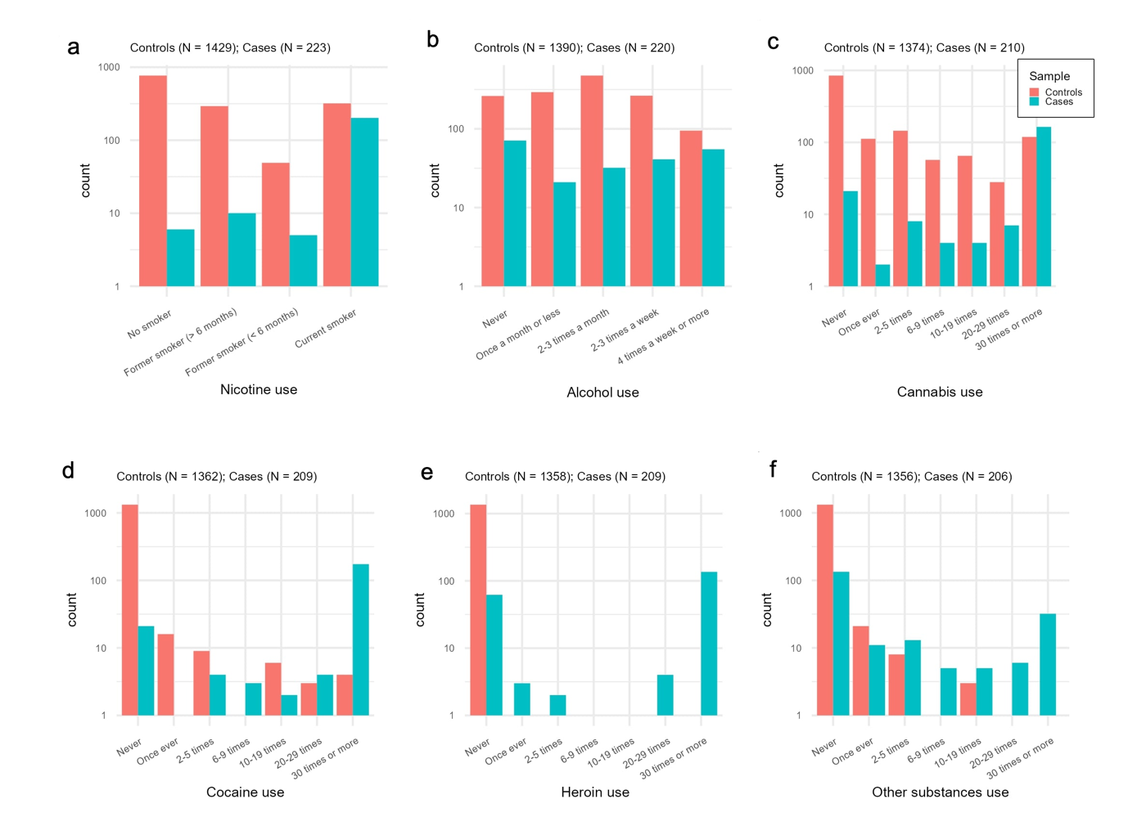

Fig. S5: Frequency distributions and descriptive statistics for substance use variables, stratified by Controls and Case groups (represented graphically as red and blue, respectively). From left to right: a. Nicotine use; b. Alcohol use; c. Cannabis use; d. Cocaine use; e. Heroin use; f. Other substances use.

