Supporting information
Construction of a Dual-Mode Sensing Platform for Ultra-fast and Real-time Detection of Bisulfite in Food and Environmental Systems

Xiaoyu Huang, jiaxing Li, Qiutong Chen, Mingyu Tian,* Tianyu Liang, Lijun Tang*

College of Chemistry and Materials Engineering, Bohai University, Jinzhou, 121013, China

Contents
Fig S1. ¹H NMR spectra of probe Rh-QL in Methanol-d_{4。}
Fig S2. ¹³C NMR spectra of probe Rh-QL in Methanol-d_{4。}
Fig S3. HRMS spectra of probe Rh-QL.
Fig S4. MS spectra of compound Rh-QL-HSO₃⁻.

Materials and Instruments.
The UV-Vis absorption spectra were tested using a U-T1810DS dual-beam UV-Vis spectrophotometer (Yi Spectrum Instrument Manufacturing Co., Ltd., China), the fluorescence emission spectra were tested using an F-4700 fluorescence spectrophotometer (Hitachi, Japan), the NMR spectra were tested with TMS as an internal standard using an Agilent 400 MHz NMR instrument (Agilent Instruments Ltd., USA), the mass spectra were performed on a Bruker micrOTOF-Q mass spectrometer (Bruker, Germany) with DMSO as the mobile phase, the pH was adjusted using an S-25 pH meter (Shanghai Dapu Instrument Co., Ltd., China), and the products were subjected to column chromatography using 100-200 mesh column chromatography silica gel (Qingdao Yumingyuan Chemical Factory, China). Ltd., China) was used to separate and purify the products by column chromatography, and an ultrasonic cleaner (Jiangsu Kunshan Ultrasonic Instrument Factory, China) was used to prepare the food samples as well as the test master batches. Unless otherwise stated, all reagents used in the synthesis were purchased from regular commercial suppliers from Anegi (Shanghai) Medicinal Chemicals Co. and Inocet (Beijing) Technology Co. and were used without further purification. Solvents were purified by conventional methods before use. All syntheses were carried out under nitrogen atmosphere with magnetic stirring and monitored by thin layer chromatography (TLC). Separation and purification was carried out using silica gel columns.
Synthesis of probe Rh-QL
Synthesis of compound 2
Cyclohexanone was added dropwise to 14 ml of concentrated sulphuric acid, cooled to 0°C and stirred for 30 min, then 4-diethylamino ketoacetic acid was added to the flask, mixed well and then stirred at 90°C for 2 h. After completion of the reaction, the mixture was poured into 100 ml of ice water, 1.4 ml of perchloric acid was added, filtered and washed with cold water to obtain a red powder.
Synthesis of compound 3
A mixture of compound 2 and 3-quinolinecarboxaldehyde was added to an appropriate amount of acetic acid and the reaction was carried out under nitrogen protection at 80 °C for 5 hours. At the end of the reaction, the mixture was cooled to room temperature and the solvent acetic acid was removed under reduced pressure and purified by silica gel chromatography (CH₂Cl₂:CH₃OH=20:1) to give a purple solid.
Synthesis of probe Rh-QL
Methyl trifluoromethanesulfonate was added dropwise to the DCM solution of compound 3, and after the reaction was complete at room temperature, the reaction product was washed three times with ice DCM to give a pure purple solid. Melting point: >300℃. ¹H NMR (400 MHz, Methanol-d₄) δ 9.60 (s, 1H), 9.33 (s, 1H), 8.51-8.46 (m, 2H), 8.30 (m, 3H), 8.06 (t, J = 7.6 Hz, 1H), 7.86 (t, J = 7.6 Hz, 1H), 7.77 (t, J = 8.0 Hz, 1H), 7.38 (d, J = 7.2 Hz, 1H), 7.33-7.30 (m, 2H), 4.74 (s, 1H), 2.46-2.40 (m, 2H), 1.91-1.86 (m, 1H), 1.33 (s, 6H). ¹³C NMR (101 MHz, Methanol-d₄) δ 164.19, 161.45, 157.50, 156.92, 155.32, 149.77, 149.68, 144.50, 144.14, 136.17, 134.59, 134.29, 133.62, 132.89, 132.73, 131.74, 129.39, 129.33, 129.17, 128.89, 128.79, 128.72, 128.51, 128.43, 128.29, 128.24, 127.98, 127.96, 127.42, 127.20, 125.14, 122.37, 117.57, 117.53, 116.83, 94.09, 93.91, 59.97, 57.96, 56.95, 52.93, 51.92, 50.20, 49.91, 47.90, 44.88, 43.88, 43.84, 43.51, 43.43, 431.86, 40.86, 39.85, 36.84, 35.83, 33.82, 24.79, 24.68, 23.87, 19.74, 19.49, 9.90. HRMS (ESI+): Calcd C₃₅H₃₅N₂O₃⁺ ([M-TfO-ClO-H]⁺): m/z = 529.2558, found: m/z = 529.2903.

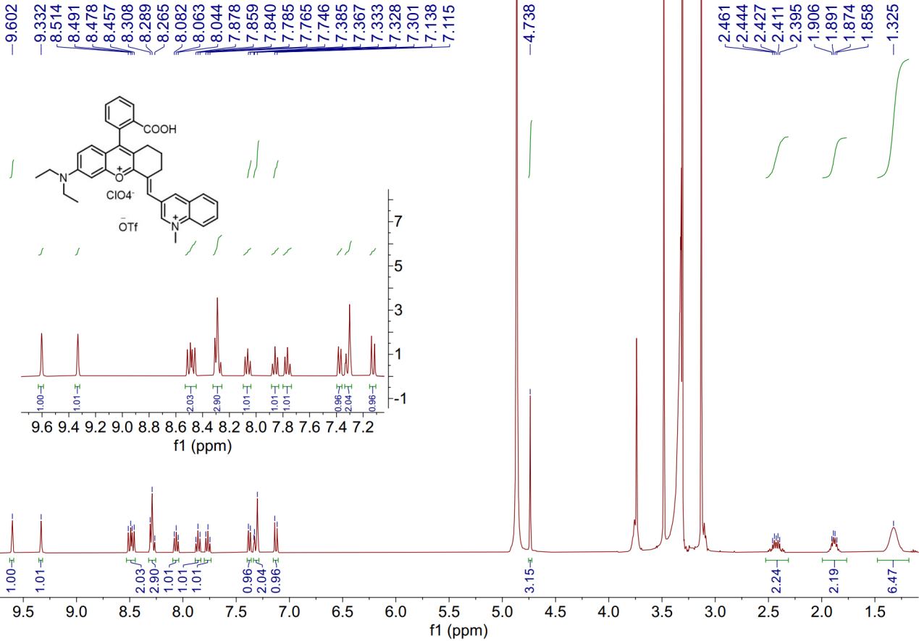
Fig S1. ¹H NMR spectra of probe Rh-QL in Methanol-d_{4。}
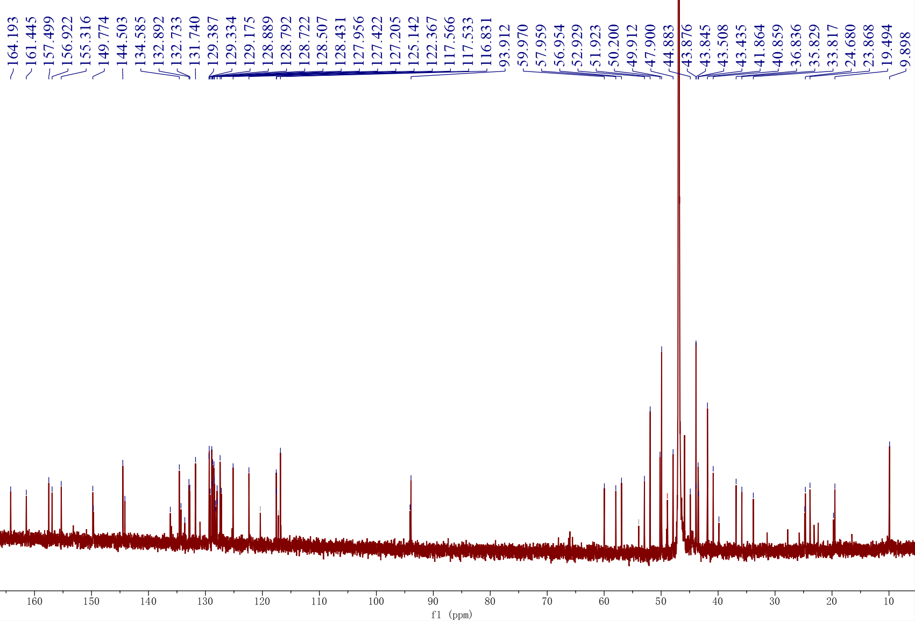
Fig S2. ¹³C NMR spectra of probe Rh-QL in Methanol-d_{4。}

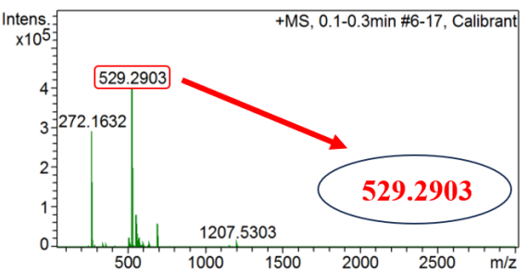
Fig S3. HRMS spectra of probe Rh-QL.

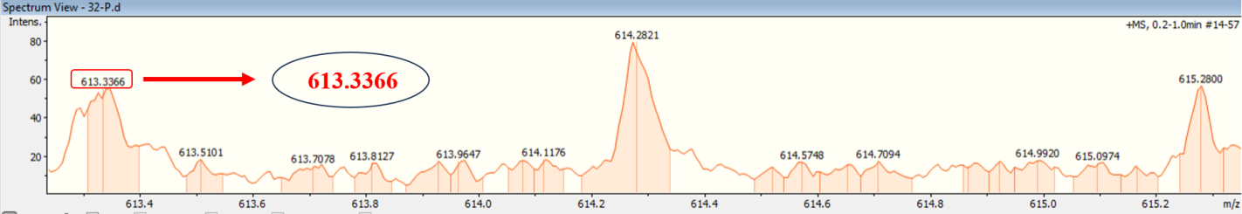
Fig S4. MS spectra of compound Rh-QL-HSO₃⁻.

