Supplementary Materials
Increasing summertime penetrative shortwave radiation and its weakening effect on the seasonal cycle in mid-latitude oceans
Feng Tian ^{1,3*} and Rong-Hua Zhang ^{2,3*}
1 Key Laboratory of Ocean Observation and Forecasting and Key Laboratory of Ocean Circulation and Waves, Institute of Oceanology, Chinese Academy of Sciences, Qingdao, China
2 School of Marine Sciences, Nanjing University of Information Science and Technology, Nanjing, 210044, China
3 Laoshan Laboratory, Qingdao 266237, China

*Corresponding author email:

Rong-Hua Zhang: rzhang@nuist.edu.cn;

Feng Tian: tianfeng@qdio.ac.cn;

Contents
Table S1
Figure S1-S11
Table S1 |The models analyzed in this study, the modeling centers that contributed them.
Model | Modelling center | Interactive chlorophyll-induced shortwave penetration
ACCESS-ESM1-5 | CSIRO | NO
CanESM5 | CCCma | NO
CESM2 | NCAR | Yes
CNRM-ESM2 | CNRM-CERFACS | Yes
GFDL-ESM4 | GFDL | Yes
IPSL-CM6A-LR | IPSL | Yes
MIROC | MIROC-ES2L | No
MPI-ESM1-2-HR | MPI | No
NorESM2-MM | NCC | No
UKESM1-0-LL | MOHC | No

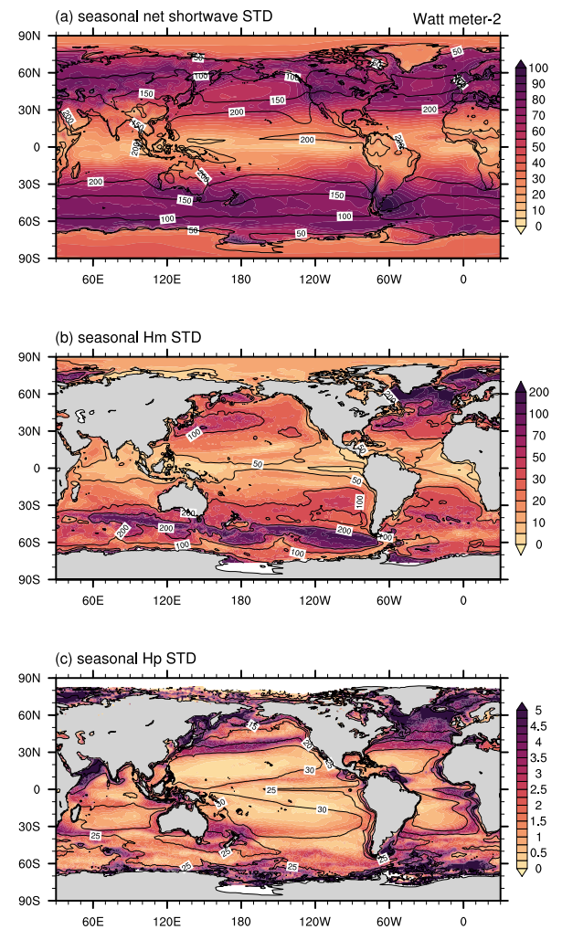
Figure S1 | Spatial pattern in seasonal standard deviation (STD). (a) SW, (b) MLD, and (c) Hp

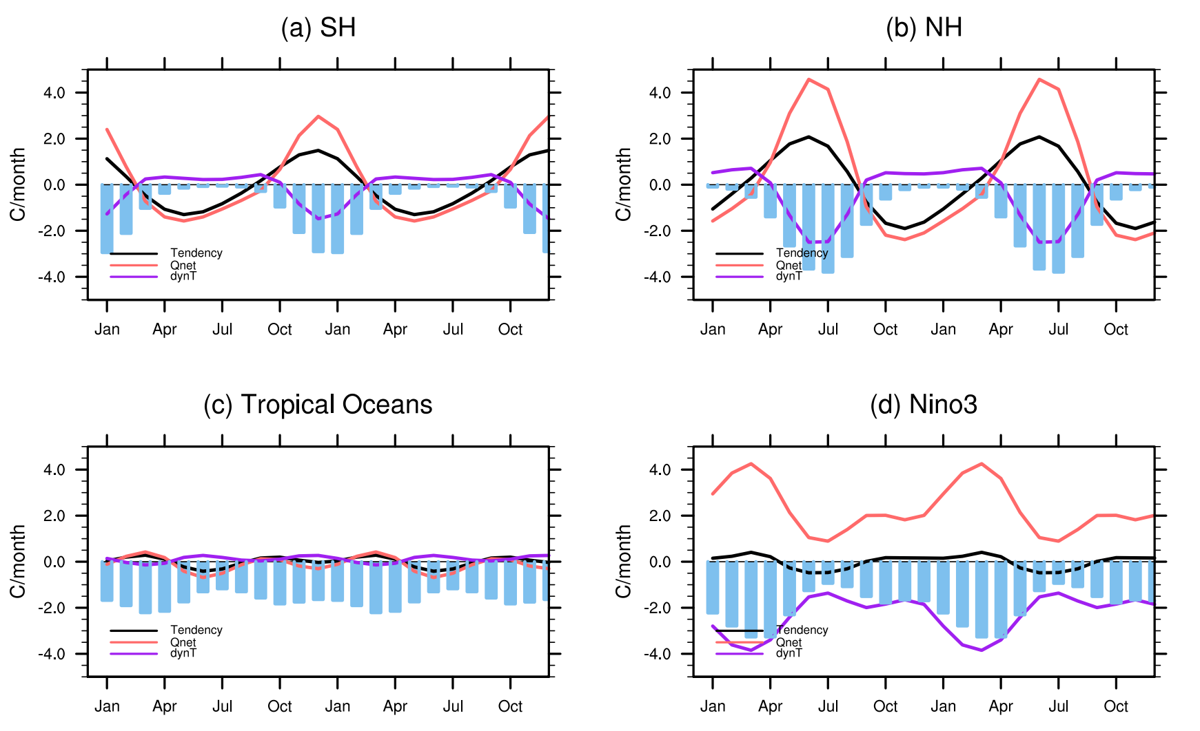
Figure S2 | Seasonal heat budget within the mixed layer temperature under historical scenario. (a) SH, (b) NH, (c) tropical oceans, and (d) Nino3 region. Blue bars denote the contribution of Q_{pen} to the mixed layer heat budget. Here, the $Q_{net}=\frac{hflx-Q_{pen}}{ρ_{0}C_{p}H_{m}}$, and $Q_{pen }effect=\frac{hflx}{ρ_{0}C_{p}H_{m}}-\frac{hflx-Q_{pen}}{ρ_{0}C_{p}H_{m}}=\frac{Q_{pen}}{ρ_{0}C_{p}H_{m}}$; H_{m} is the mixed layer depth; ρ₀ (=1030 kg m⁻³) is the density of seawater; and c_{p} (=4000 J kg⁻¹ °C⁻¹) is the heat capacity.

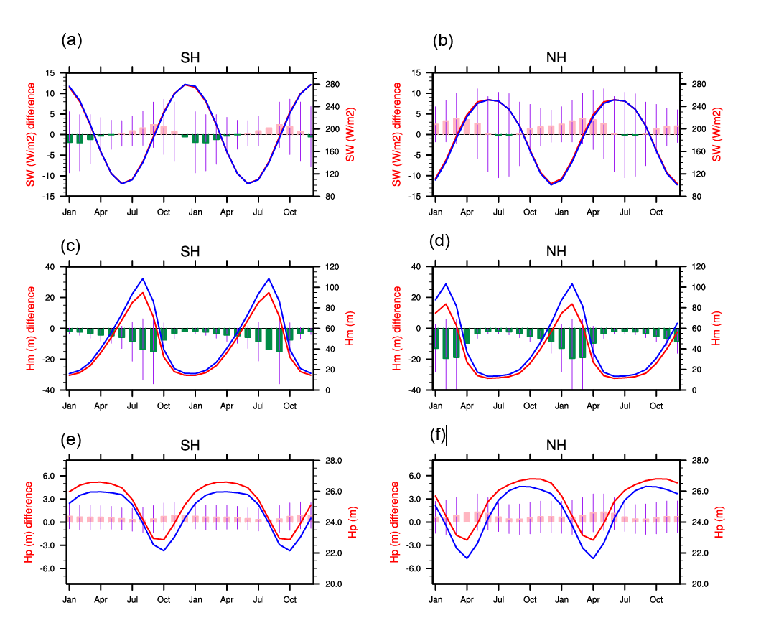
Figure S3 | Seasonal cycle of factors affecting Qpen under a warmer climate. The simulated seasonal cycle of SW (a-b), MLD (c-d), and Hp (e-f) in NH and SH during the historical scenario (1951-2000, blue lines) and SSP5-8.5 scenario (2051-2100, red lines) and the Qpen change indicated by the pink bars with 1. s.d of intermodel spread (blue short lines). The change denotes the differences between SSP5-8.5 and the historical scenario.

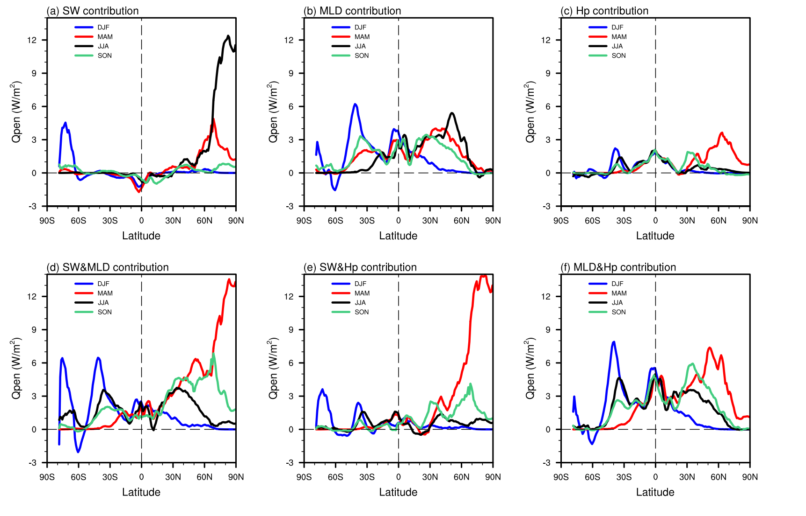
Figure S4 |The individual and combined effect of factors change to determine Qpen change during four seasons (DJF, MAM, JJA, SON) under a warmer climate. (a) SW, (b) MLD, (c) Hp, (d) SW and MLD, (e) SW and Hp, and (f) MLD and Hp.
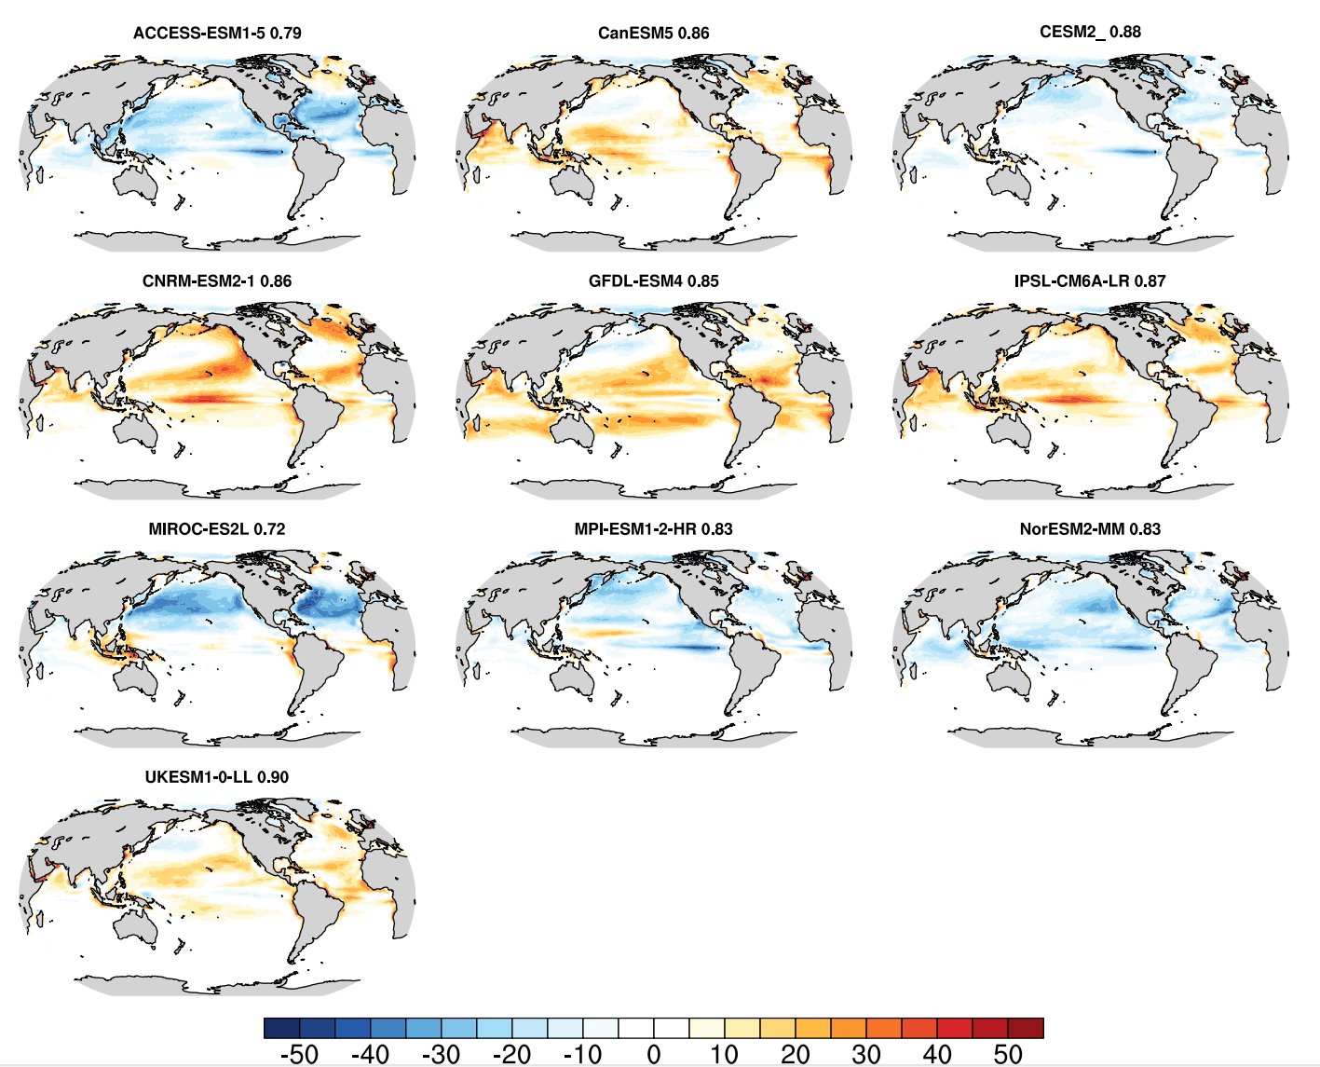
Figure S5 | Modelled seasonal biases in Qpen during JJA among ten selected models. The pattern correlation is indicated in the subtitle of each model.
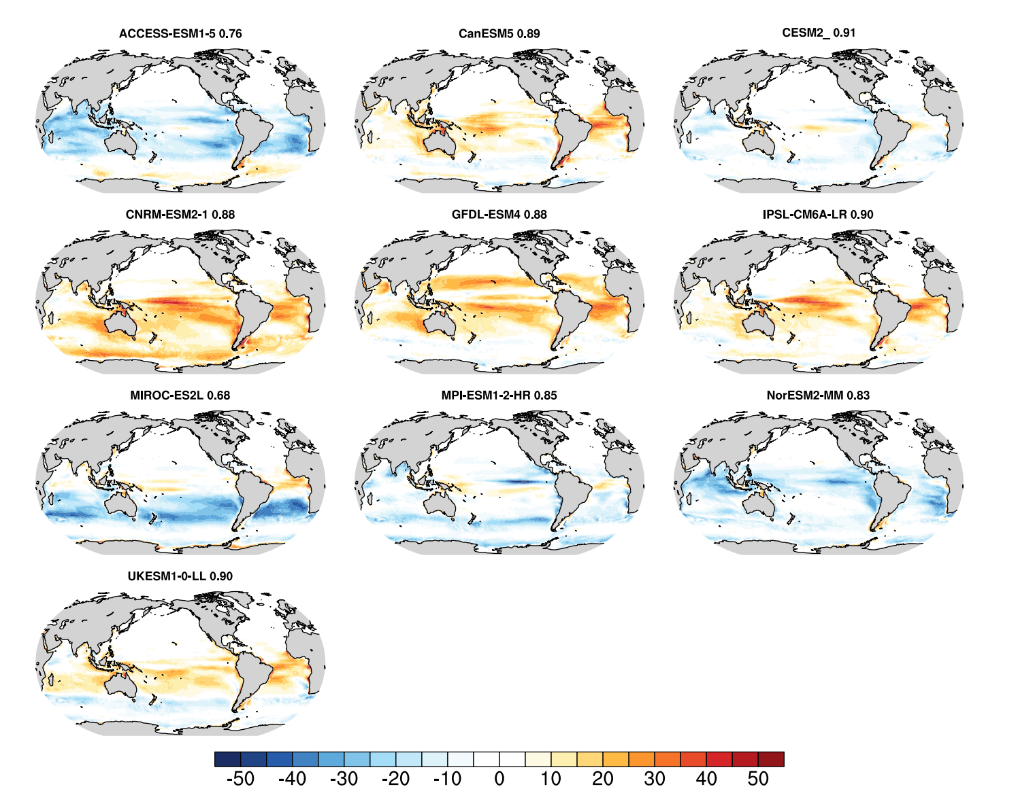
Figure S6 | Modelled seasonal biases in Qpen during DJF among ten selected models. The pattern correlation is indicated in the subtitle of each model.
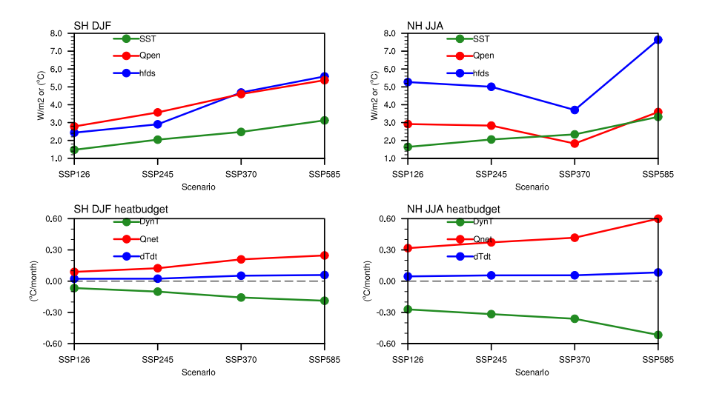
Figure S7 | Variables change under four emission scenarios from CESM2. (a-b) SST, Qpen, and hfds change during DJF in SH (a) and JJA in NH (b) under SSP1-2.6, SSP2-4.5, SSP3-7.0, and SSP5-8.5. (c) and (d) Mixed layer heat budget under four emission scenarios.
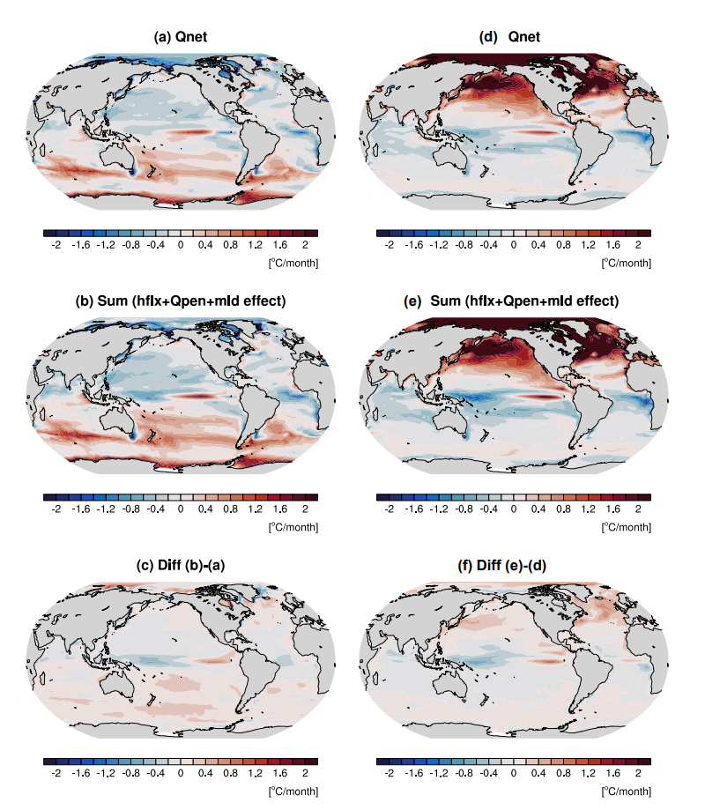
Figure S8 | Linear decomposition of Q_{net} during summertime. (a) Direct Q_{net} change. (b) The sum of linear decomposition of hflx, Q_{pen}, and MLD. (c) The calculation errors due to linear decomposition during DJF. (d-f) same as (a-c) but during JJA.

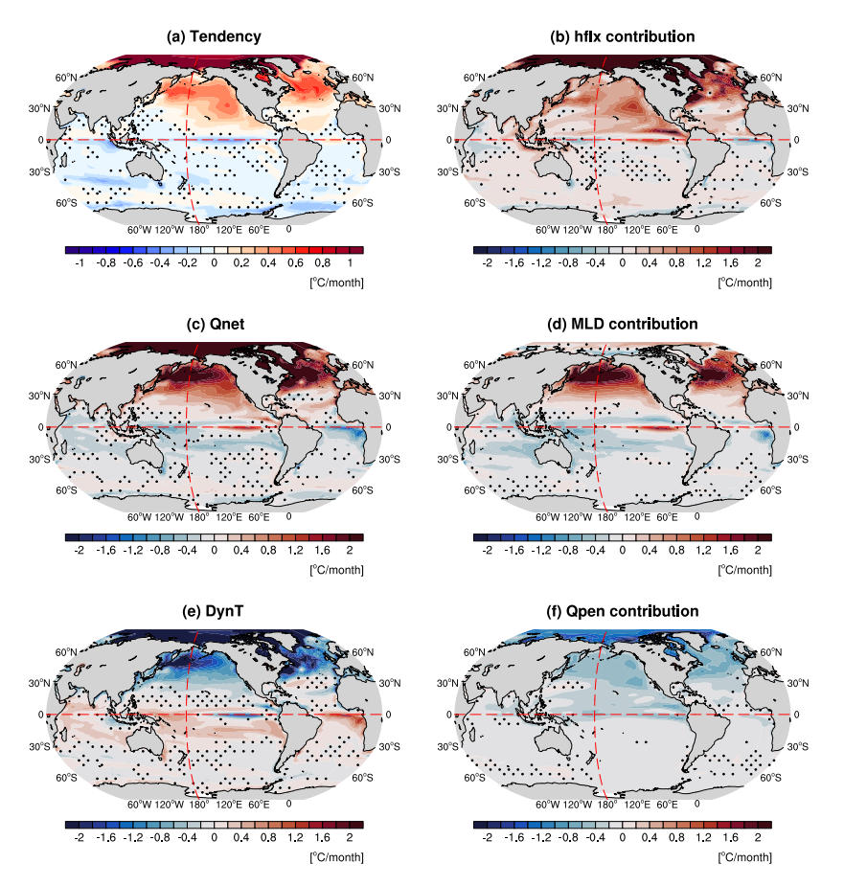
Figure S9 |Spatial pattern change in mixed layer (ML) heat budget under SSP5-8.5 relative to the historical scenario during JJA. (a), (c) and (e) the MME changes (black lines) in ML temperature tendency, Qnet, and dynamical processes-induced temperature, respectively; (b) hflx contribution to Qnet; (d) MLD contribution to Qnet; (f) Qpen contribution to Qnet. Stippling indicates regions where less than 70% of models agree on the sign of the difference between historical and future runs.
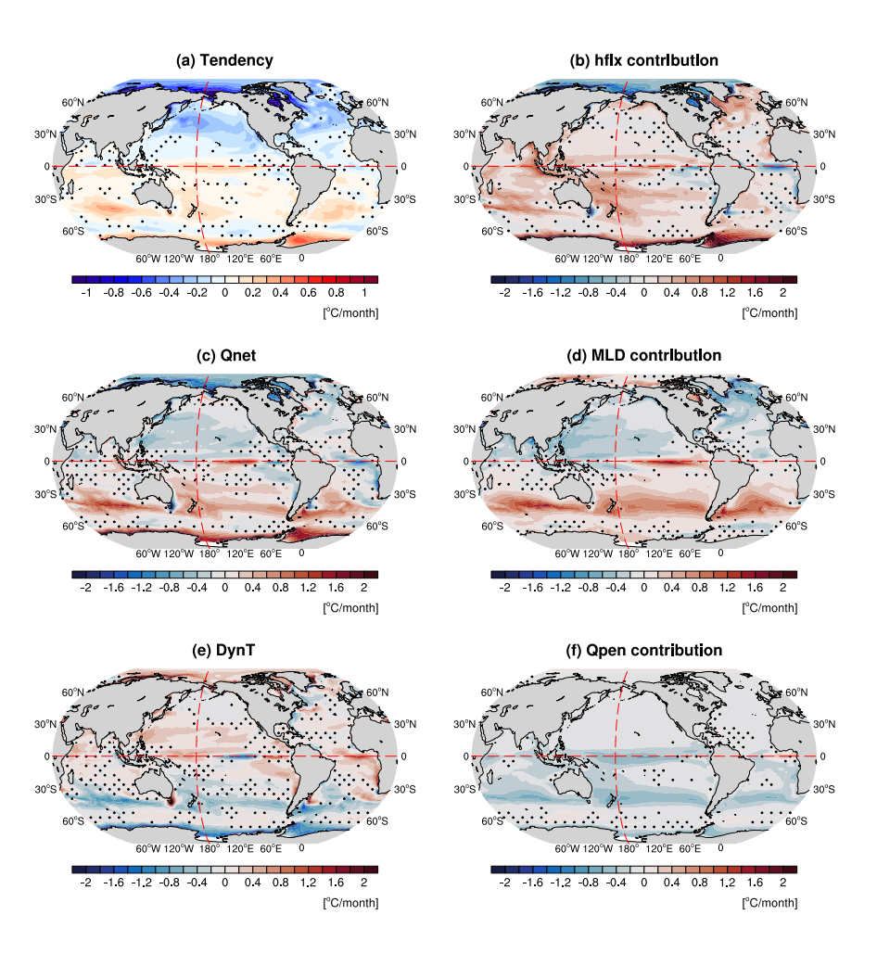
Figure S10 |The same as Figure S9 but during DJF

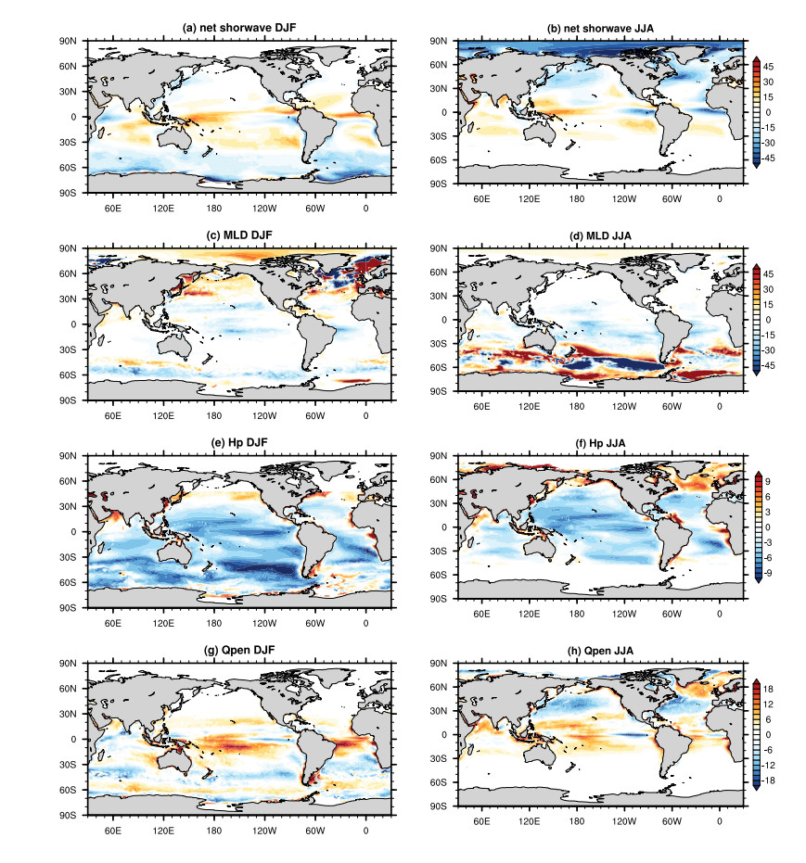
Figure S11 |The seasonal bias of selected variables in CMIP6 historical MME compared to observation. (a-b) SW, (c-d) MLD, (e-f) Hp, and (g-h) during DJF and JJA, respectively.

