Supplemental Material
Table of Contents

- Description of outcome measures
Table S1: Description of outcome measures | 1
- Summary of Findings
Table S2: Summary of findings | 9
- Forest plots
Figure S1: Forest plot for Teacher measure (Waitlist control) | 6
Figure S2: Forest plot for Adolescent social-knowledge measure (Active control) | 6
Figure S3: Forest plot for Adolescent social-performance measure (Active control) | 6
Figure S4: Forest plot for Parent measure (Active control) | 7
Figure S5: Forest plot for Teacher measure (Active control) | 7
Figure S6: Forest plot for the Follow-up measure based on Adolescent social-performance scores (Active control) | 7
- Publication bias assessment
Figure S7: Funnel plot assessing asymmetry of social skills outcomes between SSI and Waitlist control, using the adolescent social-knowledge measure | 8
Figure S8: Funnel plot assessing asymmetry of social skills outcomes between SSI and Waitlist control, using the adolescent social-performance measure | 8
Figure S9: Funnel plot assessing asymmetry of social skills outcomes between SSI and Waitlist control, using the Parent measure | 9

- Description of outcome measures
Table S1: Description of outcome measures
Afsharnejad (2022) | Observed measure: none  Adolsecent social knowledge (SK) measure: none  Adolescent social performance (SP) measure: none  Parent measure: none  Teacher measure: Participants identified three personal social goals that were operationalised on the Goal Attainment Scale (GAS). Progress was then scored based on whether or not they met their goal, and if this was above expected level.
Chou (ref) | Observed: none  Adolsecent SK: none  Adolescent SP: Social problem solving was divided into awareness and self-directed problem-solving. Social problem awareness consists of eight items, measuring the student's ability to identify the social problem and associated cues. The self-directed measure consists of 12 items measuring their ability to provide solutions to the issue. A 5-point Likert scale is used to rate each item  Parent: none  Teacher: Social problem solving
Gantman 2012 (ref) | Observed: none  Adolescent SK: Test of Young Adult Social skills Knowledge (TYASSK) consists of 23 items, based on the Test of Adolescent Social Skills Knowledge (TASSK) to assess young adults' social knowledge.  Adolescent SP: none  Parent: Social Skills Rating system (SSRS) consists of 52 items requiring parents to rate the frequency of different social skills occurence at home  Teacher: none
Hume 2022 (ref) | Observed: none  Adolsecent SK: none  Adolescent SP: none  Parent: none  Teacher: GAS
Idris 2022 (ref) | Observed: Contextual assessment of social skills is a live role-play assessment of conversational skills.  Adolescent SK: none  Adolescent SP: The social skills improvement system (SSIS) is a standardized rating scale that assesses global social competence  Parent: SSIS  Teacher: SSIS
Ko 2018 (reference) | Observed: Mutual engagement was one of the three measures used to record social performance, based on five minute sections of video-recorded conversations. Mutual engagement was used as an indicator of social reciprocity, hence was used in this review as a marker for social performance. The other two measures in the study were, questions asked and positive facial expressions.  Adolescent SK: none  Adolescent SP: none  Parent: none  Teacher: none
Laugeson 2009 (ref) | Observed: none  Adolescent SK: Test of Adolescent Social Skills Knowledge (TASSK) is a 22 item used to assess social knowledge. Teens are presented with sentence stems and asked to choose the best option from two options.  Adolescent SP: The Quality of Play Questionnaire (QPQ) is a 12 item questionnaire to assess frequency of get-togethers and level of conflict in these get-togethers. There are two components, where the participant was the host or the guest, for the review the QPQ-host measure was used.  Parent: SSRS  Teacher: none
Laugeson 2014 | Observed: TASSK  Adolescent SK: none  Adolsecent SP: QPQ-host  Parent: none  Teacher: Social Responsiveness scale (SRS) is a 65 item rating scale that measures social performance, bsaed on social awareness, reciprocity, avoidance, and information processing
Laugeson 2015 (ref) | Observed: none  Adolescent SK: none  Adolescent SP: Quality of socialization questionnaire (QSQ) is a 12 item measure that is adapted from the QPQ, used to assess the frequency of social interaction during hosted and invited get-togethers. The QSQ-host measure was used in this review.  Parent: SSRS  Teacher: none
Matthews 2018 (ref) | Observed: none  Adolescent SK: TASSK  Adolescent SP: QSQ-host  Parent: SSIS  Teacher: none
Matthews 2020 (reference) | Observed: none  Adolescent SK: none  Adolescent SP: QSQ-host  Parent: SSIS  Teacher: SSIS
Rabin 2018 (reference) | Observed: CASS  Adolescent SK: TASSK  Adolescent SP: QSQ-host  Parent: SSIS  Teacher: none
Rabin 2020 (ref) | Observed: CASS  Adolescent SK: TASSK  Adolescent SP: none  Parent: SSIS  Teacher: SSIS
Vernon 2018 (ref) | Observed: none  Adolescent SK: none  Adolescent SP: SSIS  Parent: SSIS  Teacher: none
Yoo 2014 (reference) | Observed: Autism Diagnostic Observation Schedule (ADOS) is a play-based, semistructured, standardized assessment of communication, social interaction, and play. Subdomain scores of social interaction was used as an outcome measure. Though ADOS is a diagnostic tool, the authors used the raw scores as a measure of change  Adolescent SK: TASSK-revised  Adolescent SP: QPQ-Host  Parent: QPQ-Host  Teacher: none

- Summary of findings

Table S2: Summary of findings
Outcome measure | Study design | No. of participants (studies) | Effect size  SMD (95% CI) | p-value | I² | Egger's test p-value | GRADE | Comments
Observed | Intervention vs. waitlist control | 193 | 0.49 (0.20, 0.78) | 0.0008 | 0% | NA | ⊕⊕◯◯ | Low quality secondary to serious risk of bias (only one of the five studies reported on randomisation processes), and small sample sizes
Observed | Intervention vs. active control | 77 | -0.03 (-0.48, 0.42) | 0.89 | NA | NA | ⊕⊕◯◯
Adolescent (social knowledge) | Intervention vs. waitlist control | 250 | 2.03 (1.15, 2.91) | 0.00001 | 86% | 0.677 | ⊕◯◯◯ | Very low quality due to very serious risk of bias (only three of the 13 studies had similar baseline characteristics between the groups, and only five completed an intention to treat analysis), inconsistency, and indirectedness (significant heterogeneity between the studies)
Adolescent (social knowledge) | Intervention vs. active control | 94 | 0.93 (-0.90, 2.75) | 0.32 | 92% | NA | ⊕◯◯◯
Adolescent (social performance) | Intervention vs. waitlist control | 693 | 0.56 (0.19, 0.93) | 0.003 | 48% | 0.207 | ⊕◯◯◯
Adolescent (social performance) | Intervention vs. active control | 268^{39-41,43} | 0.22 (-0.21, 0.65) | 0.32 | 64% | NA | ⊕◯◯◯
Parent | Intervention vs. waitlist control | 245^{11,42,45,47-50} | 0.42 (0.13, 0.71) | 0.004 | 18% | 0.278 | ⊕⊕◯◯ | Low quality due to very serious risk of bias (unclear randomisation and concealment processes, lack of blinding, and per-protocol analysis)
Parent | Intervention vs. active control | 100^{41,43} | 0.08 (-0.52, 0.68) | 0.79 | 41% | NA | ⊕⊕◯◯
Teacher | Intervention vs. waitlist control | 662^{30,45,46} | 0.35 (-0.09, 0.79) | 0.12 | 71% | NA | ⊕◯◯◯ | Very low quality due to very serious indirectness (substantial heterogeniety) and imprecision (due to variable effect size)
Teacher | Intervention vs. active control | 120^{39,41} | -0.03 (-1.22, 1.17) | 0.96 | 90% | NA | ⊕◯◯◯

- Forest plots
Figure S1: Forest plot for Teacher measure (Waitlist control)
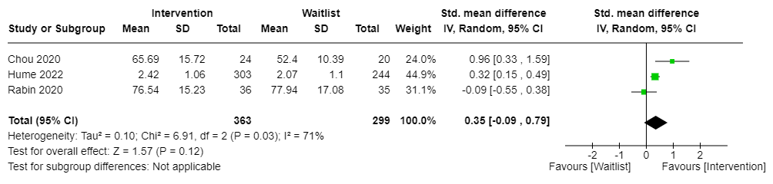

Figure S2: Forest plot for Adolescent social-knowledge measure (Active control)

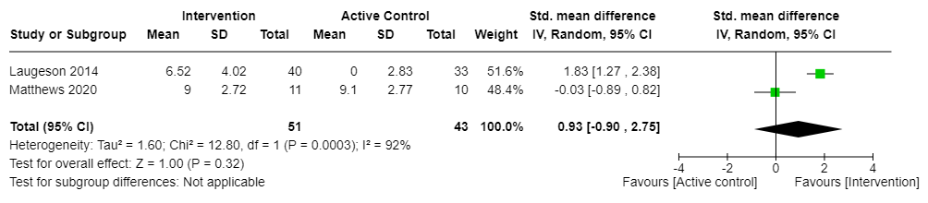

Figure S3: Forest plot for Adolescent social-performance measure (Active control)
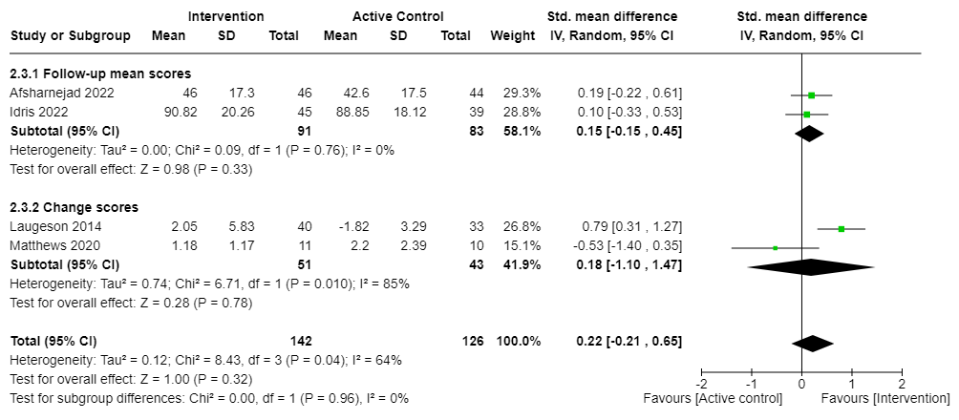

Figure S4: Forest plot for Parent measure (Active control)
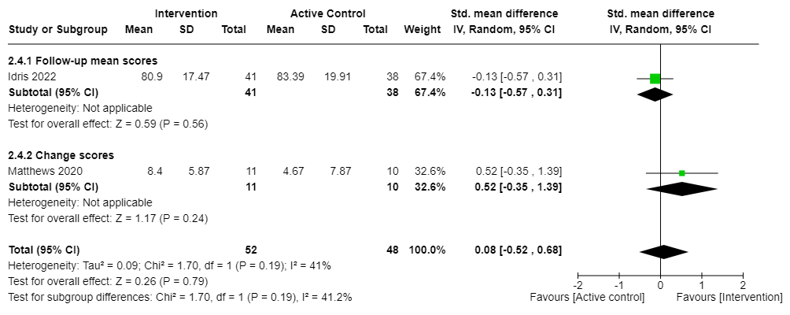

Figure S5: Forest plot for Teacher measure (Active control)
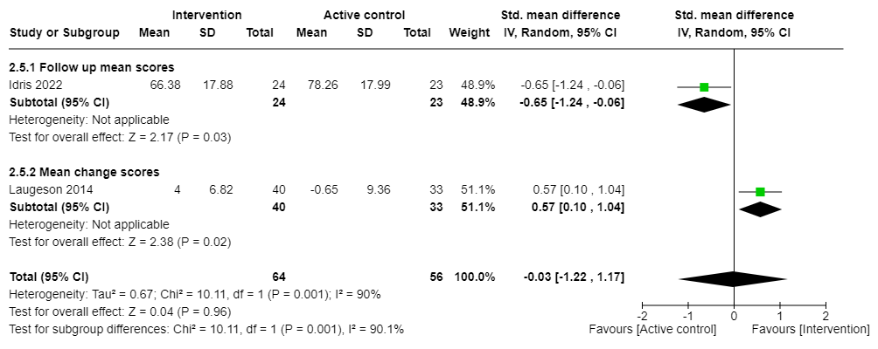

Figure S6: Forest plot for the Follow-up measure based on adolescent social-performance scores (Active control)
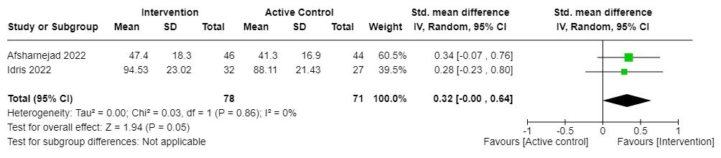

- Publication bias assessment

Figure S7: Funnel plot assessing asymmetry of social skills outcomes between SSI and Waitlist control, using the adolescent social-knowledge measure
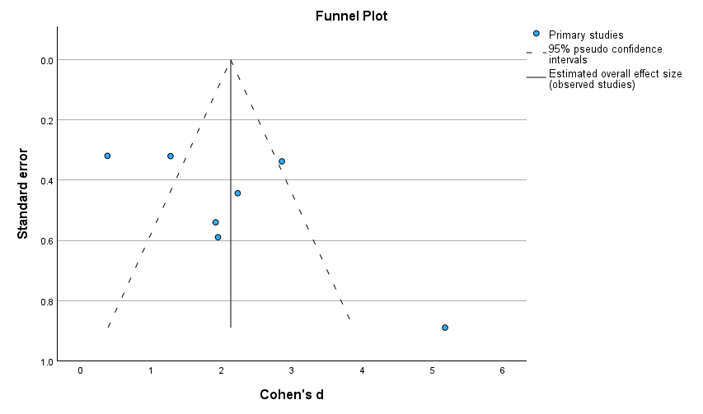

Figure S8: Funnel plot assessing asymmetry of social skills outcomes between SSI and Waitlist control, using the adolescent social-performance measure
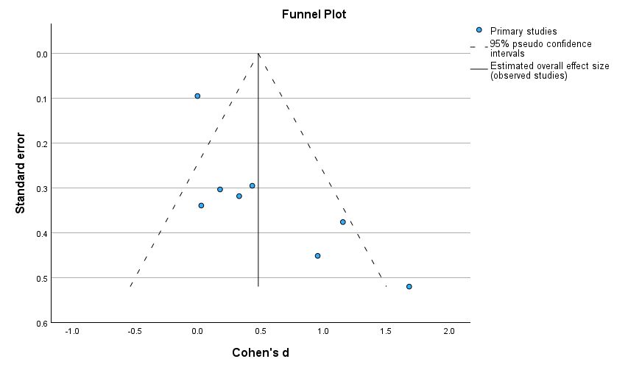

Figure S9: Funnel plot assessing asymmetry of social skills outcomes between SSI and Waitlist control, using the Parent measure

