Supplementary Table S1-main reagents and the apparatus employed in the experiments
Material / Instrument | Model | Company | Country
DNA Extraction Kit | MagAttract®PowerSoil® Pro DNA Kit | QIAGEN | USA
Agarose | Biowest agArose | Biowest | Spain
FastPfu Polymerase | TransGen AP221-02
AxyPrep DNA Gel Extraction Kit | Axygen Biosciences | Axygen | USA
Library Building Kits | NEXTFLEX Rapid DNA-Seq Kit | Bioo Scientific | USA
Sequencing Kits | MiSeq Reagent Kit v3 | Illumina | USA
Transferpettor | Eppendorf N13462C | Eppendorf | GER
Mini-Centrifuge | ABSON MiFly-6 | ABSON Scientific Instruments Group | CHN
High-speed Tabletop Refrigerated Centrifuge | Eppendorf 5424R | Eppendorf | GER
Ultra-micro Spectrophotometer | NanoDrop2000 | Thermo Fisher Scientific | USA
Enzyme marker | BioTek ELx800 | Biotek | USA
Vortex Mixers | QL-901 | Haimen Kylin-Bell Lab Instruments Co., Ltd | CHN
Crushing and Grinding Instrument | TL-48R | Shanghai Wonbio Biotechnology CO., LTD | CHN
MP Grinder | FastPrep-24 5G | MP | USA
Microfluorometer | Quantus™ Fluorometer | Promega | USA
Magnetic Frame |  | Sangon Biotech | CHN
Electrophoresis Apparatus | DYY-6C | BEIJING LIUYI BIOTECHNOLOGY CO.,LTD | CHN
PCR Instrument | ABI GeneAmp® 9700 | ABI | USA
Sequencer | Illumina Miseq | Illumina | USA

Supplementary Table S2- Variable assignment
Variable | Assignment
Group | 0=control group, 1=intervention group
Age | Continuous variable
Gender | 0=male 1=female
Educational attainment | 0=illiteracy 1=primary school 2=junior high school 3=senior high school 4=university and above
Annual family income (CNY) | 1=≤100,000 2=＞100,000
Registered permanent residence | 0=rural area 1=urban area
Course of disease | Continuous variable
Remaining natural teeth | Continuous variable

Supplementary Table S3- Oral Health Impact Profile-14
 | β | Std | t | P | 95%LCI | 95%UCI
Group | 4.482 | 2.017 | 2.22 | 0.032 | 0.408 | 8.556
Age | -0.208 | 0.162 | -1.28 | 0.208 | -0.535 | 0.120
Gender | -2.087 | 1.872 | -1.11 | 0.272 | -5.868 | 1.694
Registered permanent residence | -3.16 | 2.268 | -1.39 | 0.171 | -7.741 | 1.421
Annual family income | 0.186 | 1.277 | 0.15 | 0.885 | -2.394 | 2.765
Course of disease | 0.156 | 0.115 | 1.36 | 0.182 | -0.076 | 0.387
Remaining natural teeth | -0.103 | 0.235 | -0.44 | 0.665 | -0.578 | 0.372
Constant | 20.656 | 14.549 | 1.42 | 0.163 | -8.726 | 50.038
Note: F=1.226, R²=0.173

Supplementary Table S4- Dental Plaque Index
 | β | Std | t | P | 95%LCI | 95%UCI
Group | 1.371 | 0.274 | 5.00 | 0.000 | 0.817 | 1.925
Age | 0.013 | 0.023 | 0.57 | 0.573 | -0.034 | 0.060
Gender | -0.024 | 0.280 | -0.08 | 0.933 | -0.589 | 0.542
Remaining natural teeth | 0.000 | 0.034 | 0.01 | 0.992 | -0.069 | 0.070
Course of disease | 0.025 | 0.016 | 1.59 | 0.120 | -0.007 | 0.056
Educational attainment | -0.061 | 0.124 | -0.49 | 0.627 | -0.310 | 0.189
Constant | -1.948 | 2.095 | -0.93 | 0.358 | -6.175 | 2.279
Note: F= 6.030, R²=0.463

Supplementary Table S5- mastery of oral health knowledge
 | β | Std | t | P | 95%LCI | 95%UCI
Group | -0.316 | 0.072 | -4.38 | 0.000 | -0.461 | -0.170
Age | 0.001 | 0.005 | 0.12 | 0.904 | -0.010 | 0.012
Gender | -0.088 | 0.064 | -1.37 | 0.179 | -0.218 | 0.042
Educational attainment | -0.001 | 0.029 | -0.03 | 0.974 | -0.059 | 0.057
Annual family income | 0.043 | 0.045 | 0.96 | 0.342 | -0.047 | 0.133
Course of disease | 0.006 | 0.004 | 1.48 | 0.147 | -0.002 | 0.013
Constant | -0.148 | 0.385 | -0.38 | 0.703 | -0.925 | 0.629

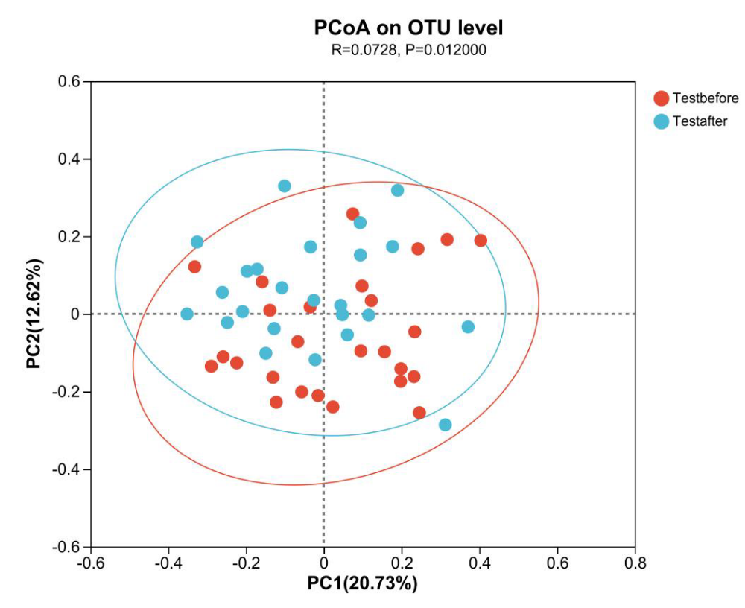
Figure S1. PCoA analysis at T0 and T1 in the intervention group
The horizontal and vertical coordinates represent two selected principal axes; The red dot is pretest of intervention group, the blue dot is posttest of intervention group, and the X and Y axis values are the relative distance between species

Supplementary Table S6-Similarity analysis at T0 and T1 in the intervention group
 | F | R² | P
PCoA | / | 0.072 | 0.012
Adonis | 2.137 | 0.042 | 0.026
PERMANOVA | 2.156 | 0.045 | 0.026

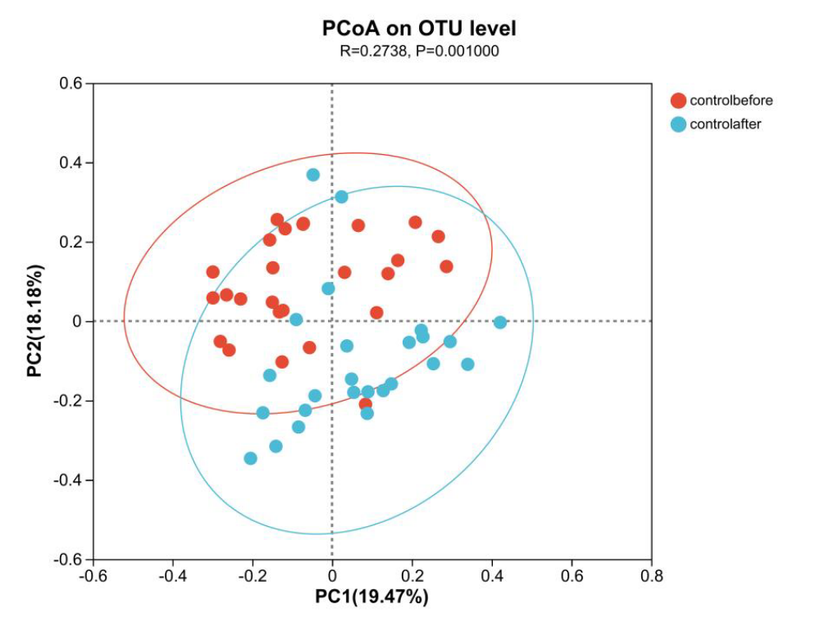
Figure S2. PCoA analysis at T0 and T1 in the control group
The horizontal and vertical coordinates represent two selected principal axes; The red dot is pretest of control group, the blue dot is posttest of control group, and the X and Y axis values are the relative distance between species

Supplementary Table S7-Similarity analysis at T0 and T1 in the control group
 | F | R² | P
PCoA | / | 0.073 | 0.012
Adonis | 2.137 | 0.043 | 0.026
PERMANOVA | 5.448 | 0.101 | 0.001

