Supplemental Materials

Graph Neural Networks-Based Dynamic Water Quality State Estimation in Water Distribution Networks

Aly K. Salem¹, Ahmad F. Taha², Ahmed A. Abokifa^{3, *}

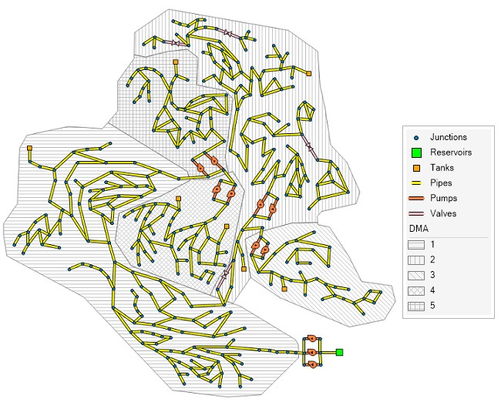
Figure S1: C-town network model layout

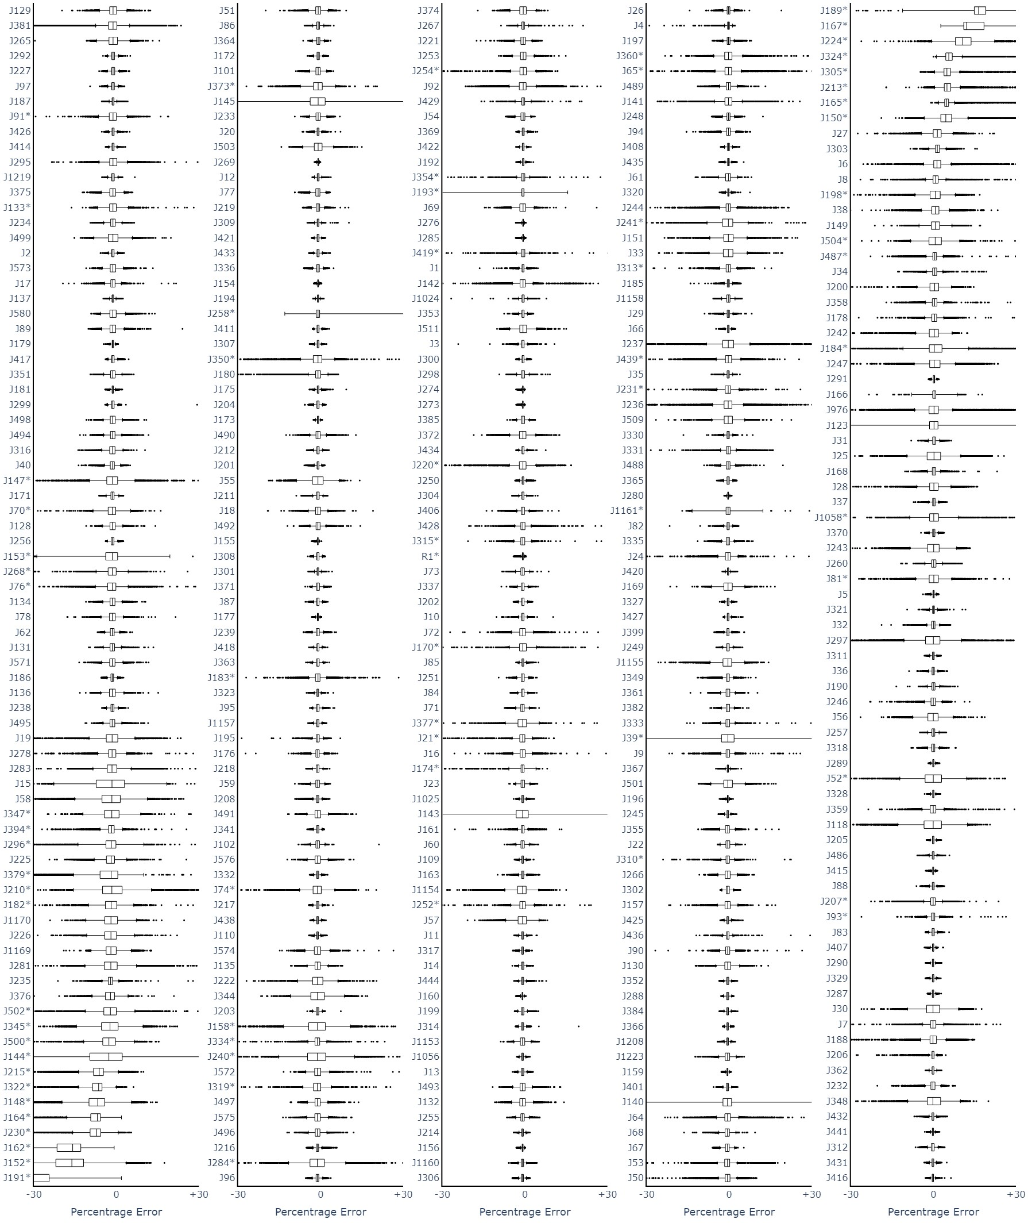
Figure S2: Percentage error distribution of the SP model predictions for all junctions

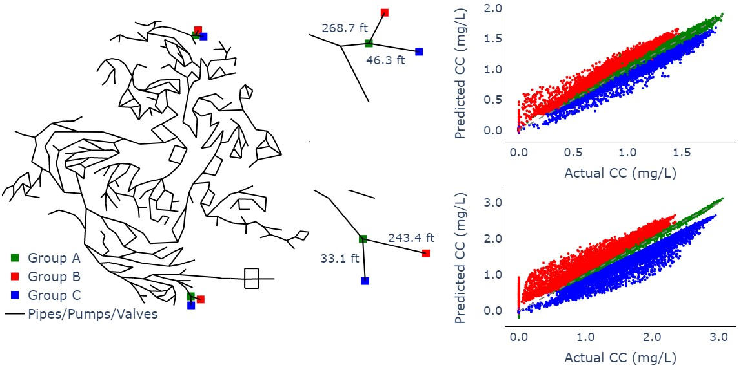
Figure S3: The percentage error distribution of two regions with pipe lengths and one-to-one plot for the relevant junctions

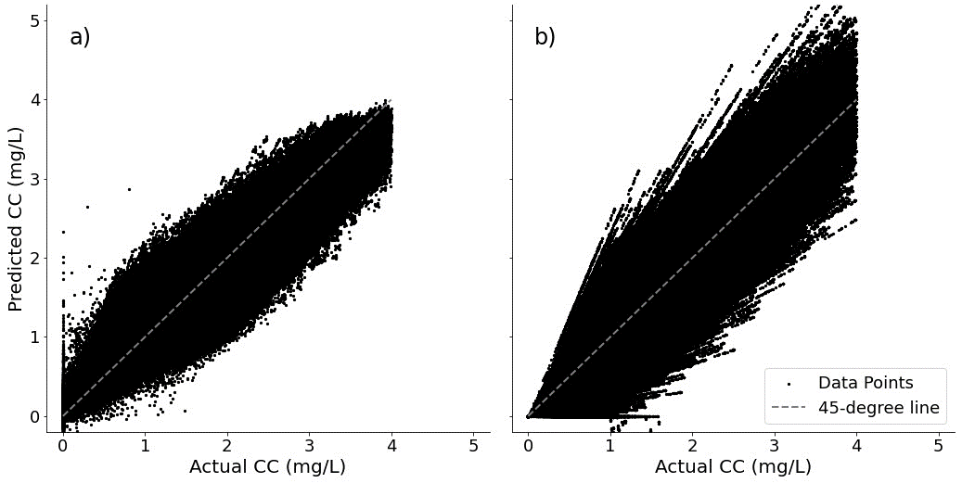
Figure S4: One-to-one plot for sensor and non-sensor junctions for noise SD of 0.5 mg/L for a) SP model predictions, and b) EPANET simulations
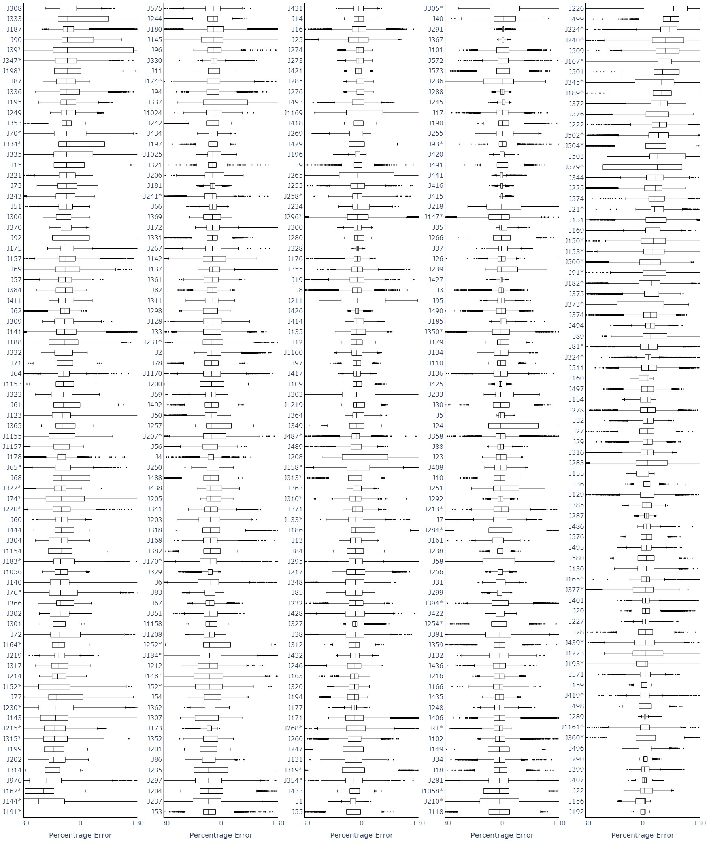
Figure S5: Percentage error distribution of the DP model predictions for all junctions

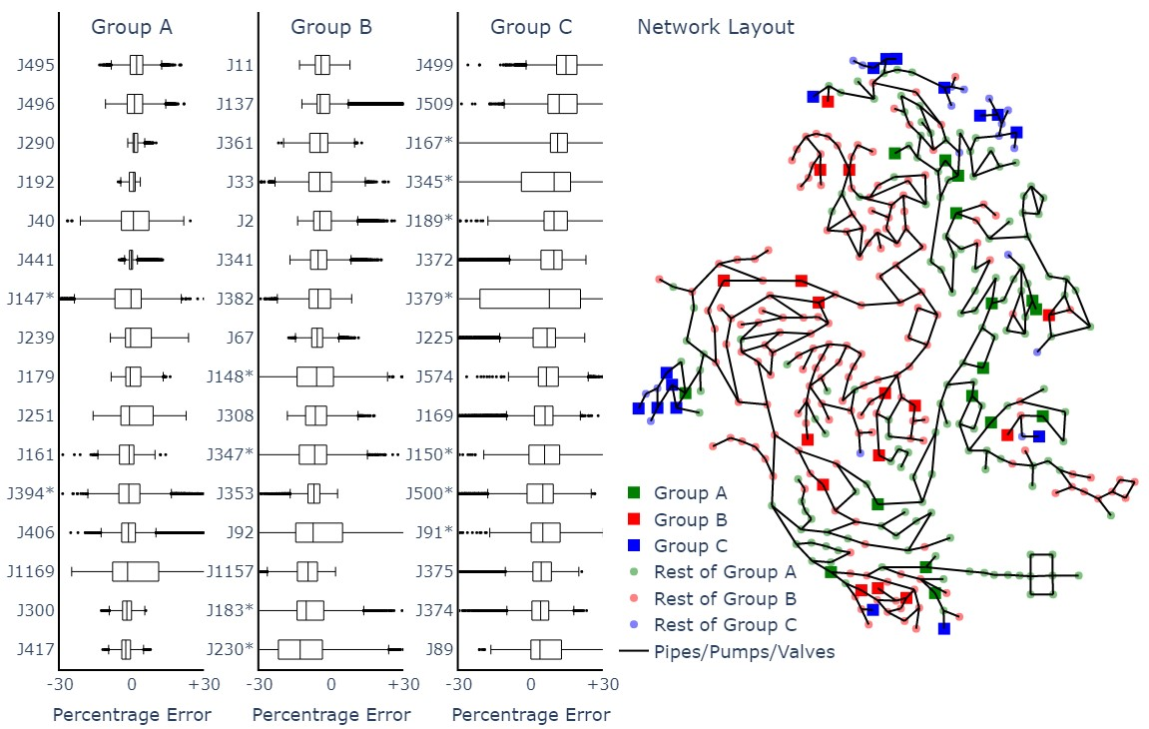
Figure S6: The percentage error distribution of the DP model predictions for the three groups projected on the network layout (*: dead-end junction)

