Supplementary Figures
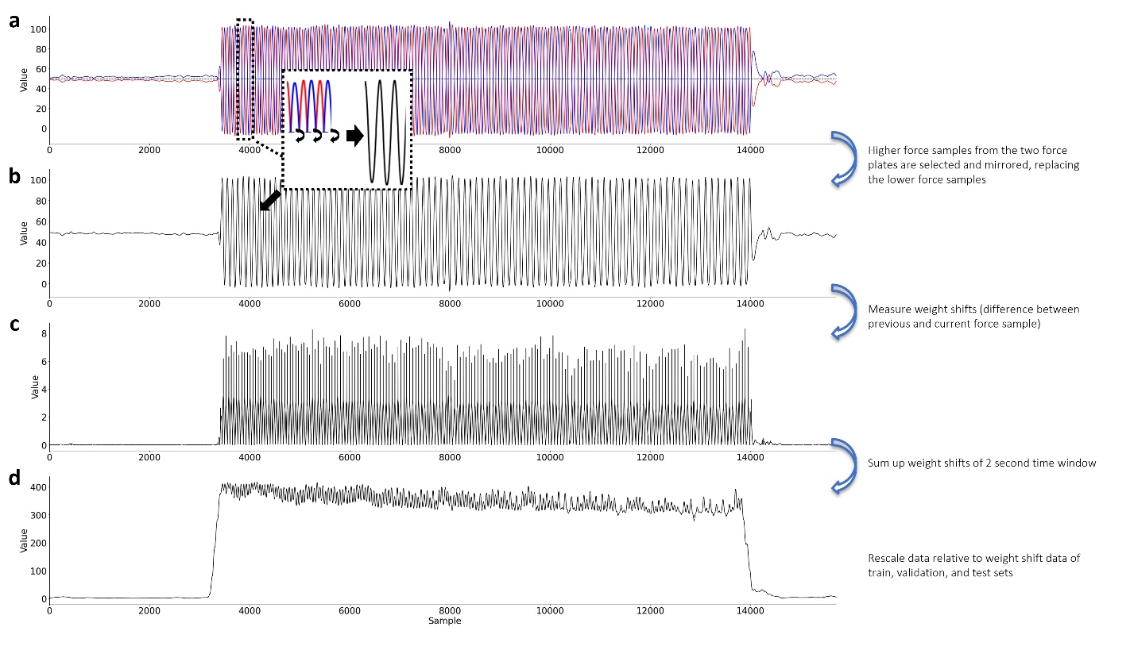
Supplementary Fig. 1. Procedure for weight shift calculation from the reaction force data. a) The rescaled data from the two force plates considering the weight of the patient. The data from the two force plates are inversely proportional to each other when both feet were in contact to the force plates, showing a symmetrical pattern with respect to the dotted middle line representing half the participant's weight. b) The two force plate data samples from each time point were merged by selecting the sample with greater value, and samples from one of the force plates were mirrored symmetrically with respect to the aforementioned dotted middle line. This was done considering that no force measure would be provided when the leg is completely off the force plate, while the other force plate may still exhibit changes in its force measure. c) The weight shift for each sample time point was then measured by calculating the difference between it and the previous sample. d) The weight over the last 2-second time window was summed to retrieve the weight shift measure of the corresponding time interval. The measure was further rescaled relative to the training, validation, and test datasets, to consistently have a range of 0 and 1 for each participant’s weight shift labels.
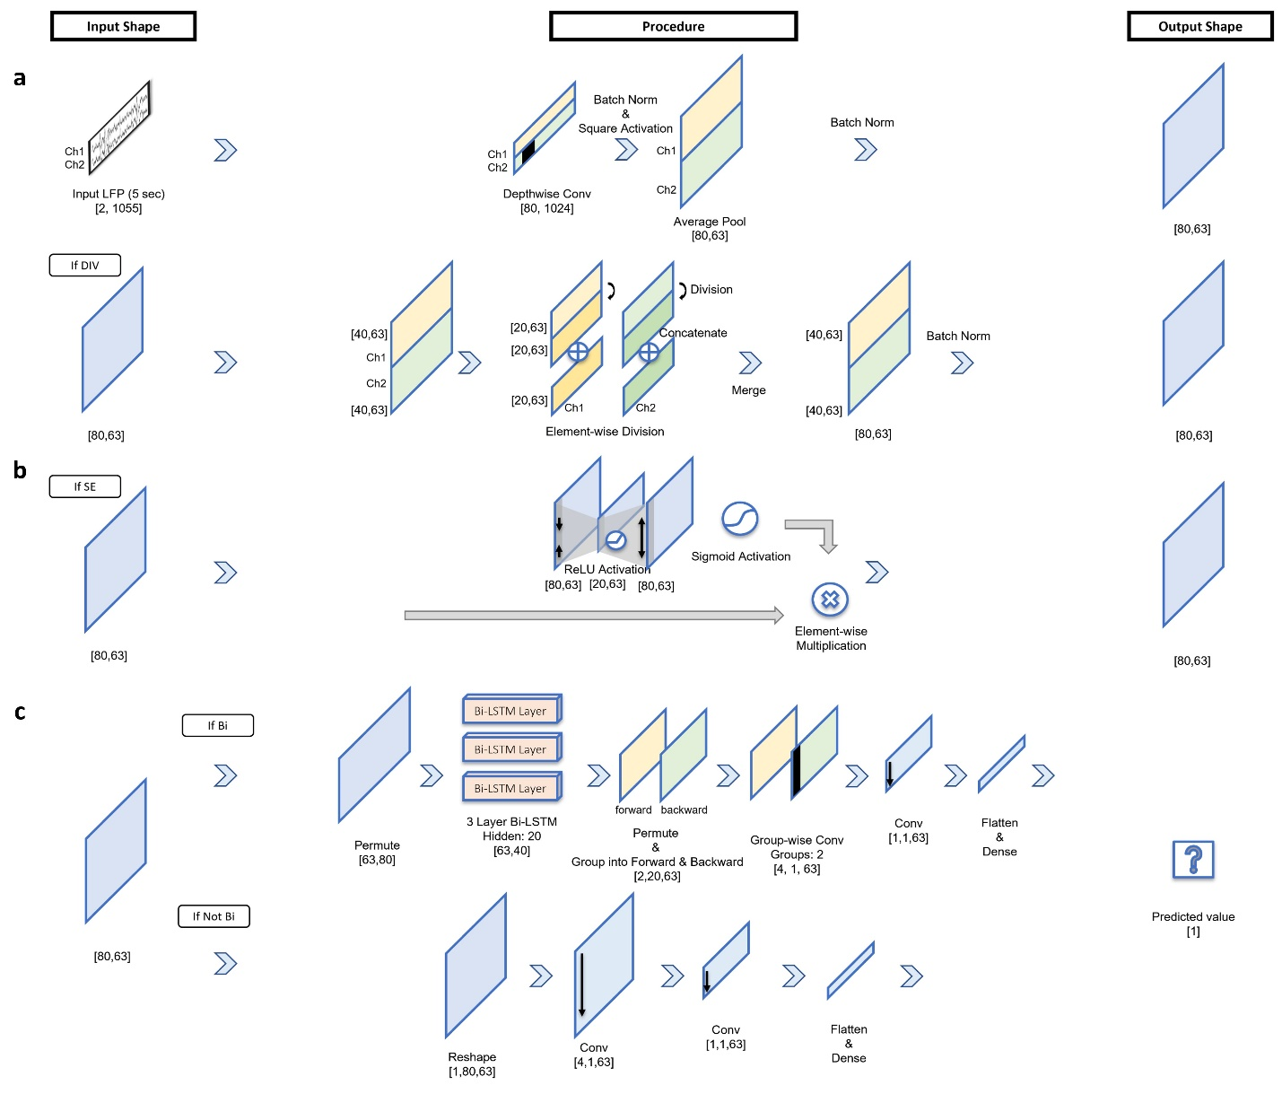Supplementary Fig. 2. A detailed flow of the models used in our model's ablation study. a) All the models used in our study first proceeded through feature extraction with the inputted LFP signals. The model underwent element-wise division if it included the division process (FExt), or it was neglected in models that did not include division (FExt-Div). b) For the models that contained the feature squeeze and excitation block as one of their components (+SE), the output from the feature extraction block was rescaled based on the features produced through the encoding and decoding layers. c) The resulted features finally went through either one of the two procedures: if the model considered bi-directional LSTM as its component (+Bi), the model sequentially proceeded through a 3-layer Bi-LSTM, a group-wise convolutional layer, and through convolutional and dense layers. If the model did not include bi-directional LSTM, the model proceeded through convolutional and dense layers. The ReLU activation was used to finalize regression that outputted a single value representing the weight shift.

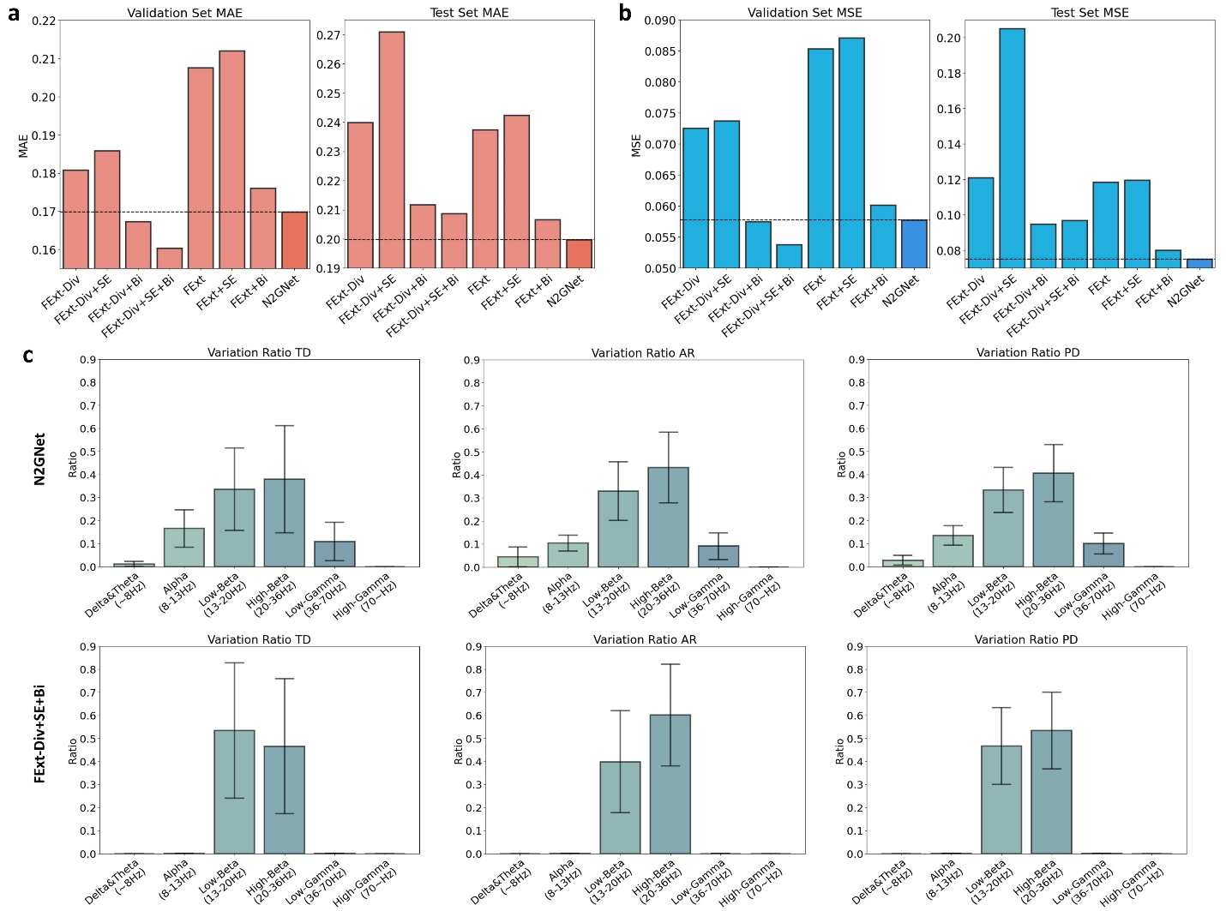Supplementary Fig. 3. Model ablation study results and analysis with models trained, validated and tested with beta band-pass filtered LFP signals (13-36 Hz). The average error rates using a) MAE and b) MSE were obtained from validation and test datasets for eight different model designs derived from our proposed N2GNet. c) Variation ratio results quantifying the impact the data of certain frequency bands had on the model's output. Both N2GNet and our proposed architecture without the element-wise division process from the feature extraction block (FExt-Div+SE+Bi) were analyzed to explore the effect of considering relative oscillatory features in our model. The error bars represent 95% confidence intervals.

