Supplementary Information
Coalescence of Water Droplets at 125 K
Johannes Giebelmann¹, Tobias Eklund^{2,3,4}, Ulrike Boesenberg³, Jan-Etienne Pudell³, Wonhyuk Jo³, Johannes Möller³, Angel Rodriguez-Fernandez³, James Wrigley³, Alexey Zozulya³, Anders Madsen³, Pit Bartl¹, Fiona Berner^{2,4}, Robert P.C. Bauer^{5,6}, Niels C. Giesselmann⁵, Alexander Gierke^{3,5}, Radim Štůsek⁷, Lukáš Veselý⁷, Dominik Heger⁷, Claudia Goy⁵, Gerhard Grübel^{3,5}, Felix Lehmkühler^{5,8}, Katrin Amann-Winkel^{2,4}, and Thomas Loerting¹

¹ Institute of Physical Chemistry, University of Innsbruck, Innrain 52c, 6020 Innsbruck, Austria
² Max Planck Institute for Polymer Research, Ackermannweg 10, Mainz 55128, Germany
³ European X-ray Free-Electron Laser Facility, Holzkoppel 4, 22869 Schenefeld, Germany
⁴Institute of Physics, Johannes Gutenberg University Mainz, Staudingerweg 7, 55128 Mainz, Germany
⁵Deutsches Elektronen-Synchrotron DESY, Notkestraße 85, 22607 Hamburg, Germany
⁶Freiberg Center for Water Research, Winklerstraße 5, 09599 Freiberg, Germany
⁷Department of Chemistry, Masaryk University, Žerotínovo nám. 617/9, 601 77 Brno, Czechia
⁸The Hamburg Centre for Ultrafast Imaging, Luruper Chaussee 149, 22761 Hamburg, Germany.

S1 Supplementary Information Description
This supplementary material contains a list of samples, wide-angle X-ray scattering (WAXS) data, details regarding the temperature correction procedure, supplemental small-angle X-ray scattering (SAXS) data, details on the normalization procedure, additional scanning electron microscopy (SEM) data, and data from preliminary experiments at the P10 beamline (PETRA III, DESY). The temperate-dependent WAXS data include the observation of the polyamorphic transition and crystallization as well as an analysis of possible beam damage for different attenuation settings.

S2 Samples
S.2.1 Overview
Table S1 gives an overview of samples including their type and identifier. Micron-sized vitrified droplets are referred to as hyperquenched glassy water (HGW). Densified HGW (dHGW) is equivalent¹ to high-density amorphous ice (HDA). Low-density amorphous ice (LDA) was prepared in situ by heating sample 02, dHGW. The identifier is used in the figures below to distinguish between the individual samples. Details on the sample preparation are given in the methods section of the main text.

Table S1: Overview of samples including name, type and method.
Identifier | Type | Used For
Sample 01 | HGW on Cu grid | SAXS/WAXS Testing
Sample 02 | dHGW (HDA) on Cu grid | SAXS/WAXS 10 Hz
Sample 02.5 | LDA on Cu grid | SAXS/WAXS 10 Hz
Sample 03 | HGW on Cu grid | SAXS/WAXS 10 Hz
Sample 04 | HGW on Cu grid | SAXS/WAXS 10 Hz
Sample 05 | HGW on Cu grid | SAXS/WAXS 118 kHz
Sample 06 | HGW | SEM
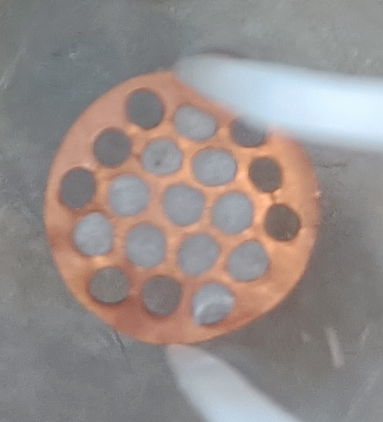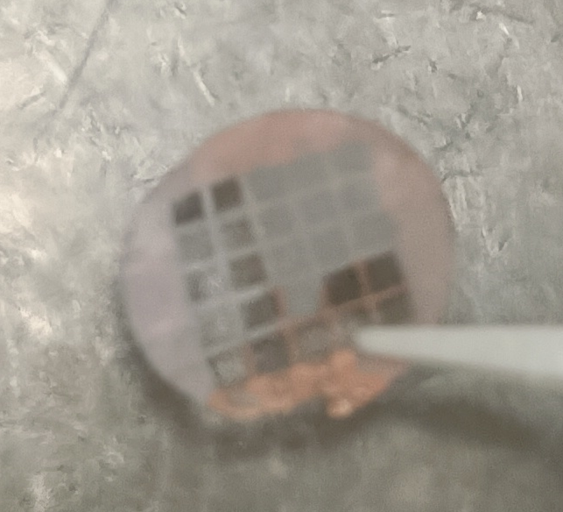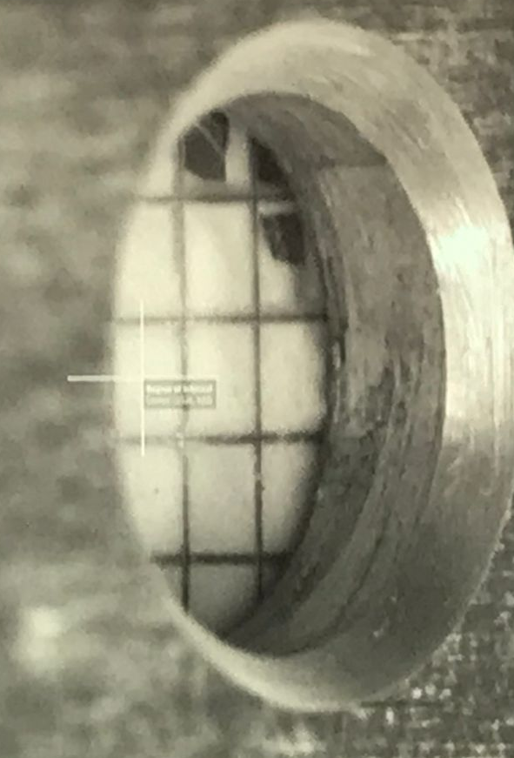
C)
B)
A)

Figure S1: A) Densified HGW (HDA) on Cu grid (200 µm thick, 10 mm diameter). B) HGW on Cu grid (50 µm thick, 10 mm diameter). C) HGW on Cu grid (50 µm thick, 10 mm diameter) mounted on the sample holder at the MID² instrument.
The samples were placed on Cu grids for SAXS/WAXS. HGW was directly deposited on commercially available Cu grids (Gilder SEMF3; 50 µm thick, 10 mm diameter; see figure S1B/C) while dHGW (HDA) powder was pressed into Cu grids (200 µm thick, 10 mm diameter, see figure S1A), custom-made in Mainz.

S2.2 Preliminary Characterization of Vitrified Water Droplets (HGW) on Cu Grids
Hyperquenching requires very fast cooling induced by heat transfer from the micron-sized water droplets to the copper substrate and subsequently, to the cooling medium (liquid nitrogen).³ Even small variations of the experimental parameters such as size of individual droplets, flow of carrier gas, distance between orifice and substrate, pressure in the vacuum chamber, thermal conductivity of the substrate, thermal contact of sample with substrate or thickness of deposit can cause partial crystallization instead of vitrification. In the present study we have for the first time used the procedure of a direct deposition into a grid. To verify that hyperquenching for direct deposition into a copper grid yields sufficiently pure (i.e. glassy, ice-free) samples, differential scanning calorimetry (DSC) was used to quantify the amorphicity of the samples. To this end, a small splinter of sample (< 10 mg) was detached from the Cu-grid (see figure S1B) and transferred to an aluminum crucible under liquid nitrogen. Then, the crucible was loaded at 90 K into a PerkinElmer DSC 8000, calibrated with indium, cyclopentane, and adamantane for heating and cooling rates of 10 and 30 K min⁻¹. The samples were heated from 90 K to ambient temperature at a heating rate of 30 K min⁻¹.

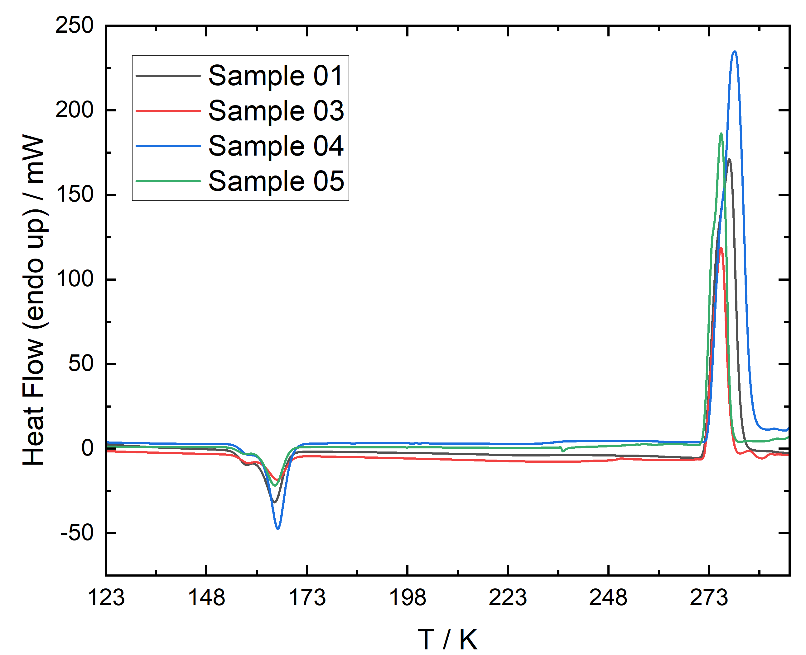
Figure S2: Raw DSC traces of HGW deposited on Cu grids. The samples were loaded at 90 K and heated to ambient temperature at 30 K min⁻¹.
Figure S2 shows the DSC traces, all of which feature a large exotherm followed by a massive endotherm. Upon comparison to literature data⁴, the exotherm at 160 K is identified as the cold crystallization of HGW (vitrified droplets) to ice I. The endotherm at 273 K indicates the melting of ice I and represent the heat of fusion. The area of the exotherm indicates how much glassy water is present that crystallizes upon heating. The area of the endotherm indicates how much hexagonal ice is present that melts. Table S2 shows the transition enthalpies obtained by integration of the peaks in figure S2. By comparing the known enthalpy of fusion for ice I (6012 J mol⁻¹)⁵ with the measured one, the amount of sample was calculated. By comparing the heat of cold-crystallization (as deduced from the area of the exotherm, in J/mol) with the literature value of -1330 J/mol⁴ for pure HGW the amorphicity was calculated.

 |  | Heat of Fusion  / mJ | Heat of Cold Crystallization  / mJ | Sample Amount  / mmol | Molar Heat of Cold Crystallization  / J mol⁻¹ | % amorphous
Sample 01 |  | 1972 | -385 | 0.328 | -1175 | 88
Sample 03 |  | 955 | -200 | 0.159 | -1257 | 95
Sample 04 |  | 2833 | -543 | 0.471 | -1152 | 87
Sample 05 |  | 1491 | -270 | 0.248 | -1090 | 82
Table S2: Heat of melting and heat of crystallization as determined from the DSC traces shown in figure S2. From these values, the amount of sample inside the crucible and the amorphicity were deduced. The error-bar of the amorphicity is ~ ±5 % based on reproducibility studies by Kohl et al. (ref. 3).
As seen in table S2, the samples are still largely amorphous even when hyperquenching directly onto the Cu grids.

S3 Avoiding X-ray-induced Sample Changes
S3.1 Preventing Crystallization
To prevent X-ray induced damage to the sample, the incident pulses were attenuated. However, strong attenuation lowers the signal to noise ratio (S/N). To find the optimal transmission setting, the attenuation was lowered stepwise (see figure S3) while observing the WAXS intensity I(q). Up to a transmission of 9.5 * 10⁻⁴, a pronounced halo peak centered at a momentum transfer q of 1.7 Å⁻¹ is observed. This indicates that the sample is amorphous and LDA-like⁶. Apart from this halo peak, a few tiny Bragg-peaks indicate contamination with stacking disordered ice I⁷, consistent with the characterization by calorimetry in section S2. After increasing the transmission to 4.85 * 10⁻³, the sample crystallized fully, which is indicated by the absence of the halo peak, but presence of pronounced Bragg-peaks of hexagonal ice I⁷. The S/N ratio is easily sufficient down to a transmission of 6 * 10⁻⁵, while for a transmission of 1 * 10⁻⁵ artifacts start to appear (e.g., at 2.1 Å⁻¹). To prevent beam damage and to ensure a good S/N ratio, the transmission was set to 4.6 * 10⁻⁴ or lower for the actual measurements.

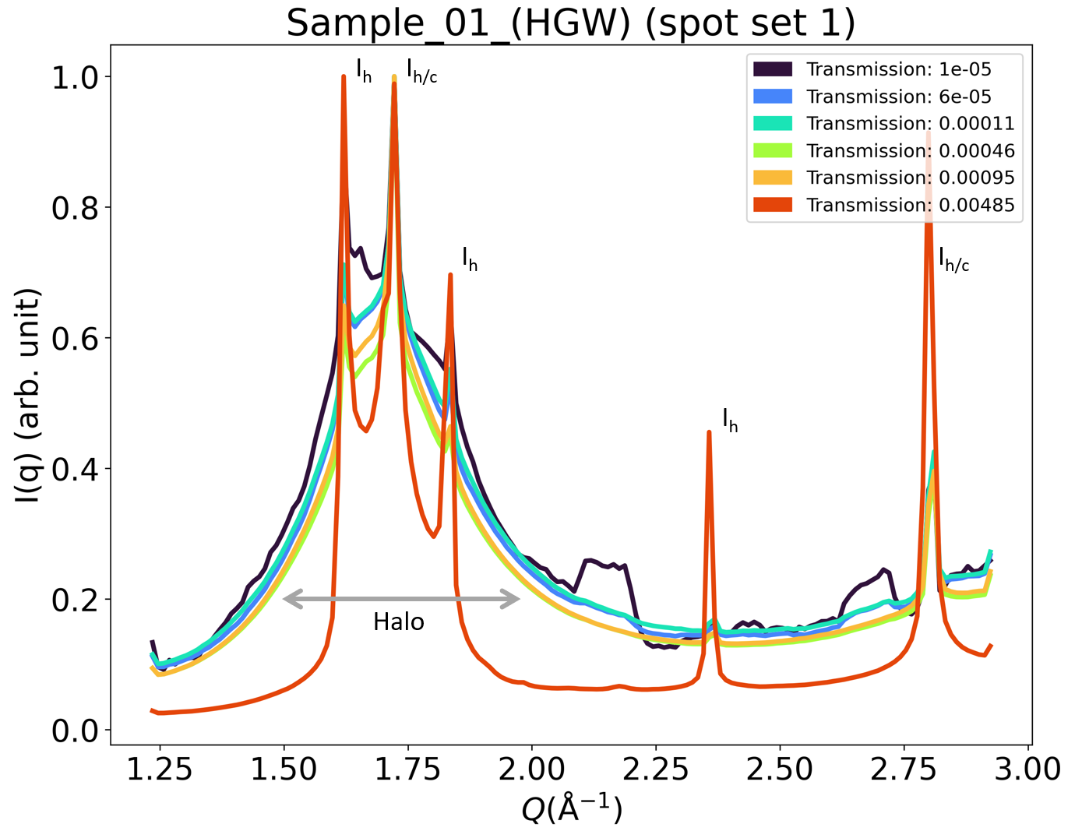
Figure S3: WAXS I(q) (intensity as a function of the momentum transfer q) for different transmission settings (see legend). For comparability, the curves were normalized to their respective maximum. Bragg-peaks of ice I_{h} and ice I_{c} are marked accordingly. The label ‘spot set 1’ indicates that the data shown correspond to the first spot that was measured after each temperature increase.
S3.2 Excluding X-ray Induced Coalescence
As stated in the methods section of the main text, the reduced pulse energy (i.e., the pulse energy after attenuation) was ~140 nJ (4.6 * 10⁻⁴ * 300 µJ), which converts to a fluence of 0.2 mJ mm⁻² (26x26 µm beam) or 0.6 mJ mm⁻² (15x15 µm beam). Thus the fluence is still below values relevant for X-ray induced heating of water.⁸ To exclude the possibility of X-ray induced effects, we compare the single pulse data (sample 05) with the 10 Hz static data (other samples). For the single shot data (colored green in Figure S4), only the 1st pulse of each train consisting of 16 pulses was used for evaluation. After each train, the spot was changed, which means that the single pulse data in figure S4 (and most of the data in the main text) correspond to single shots at a fresh sample spot but averaged over all spots. Due to the low fluence, using these single shots excludes the possibility of any beam-driven effects. Furthermore, no systematical difference between the single-shot and the static data (blue points) are visible in figure S4. This shows that even the static 10 Hz data that were taken at single spot, displays no sign of beam-induced coalescence. For comparison, we repeated the evaluation procedure using only the last pulse of each train (16th pulse at each spot). The resulting surface to volume ratio S/V is also displayed in figure S4 as red dots. The overall trend is the same as for the 1st pulse and static measurements but the S/V tends to be slightly lower for the last pulse when compared to the first pulse each. However, based on the experimental error, this effect is barely significant in most cases. Only the 1st pulse single shot data and the 10 Hz static data were used for the manuscript and the rest of the SI (green and blue points in figure S4).
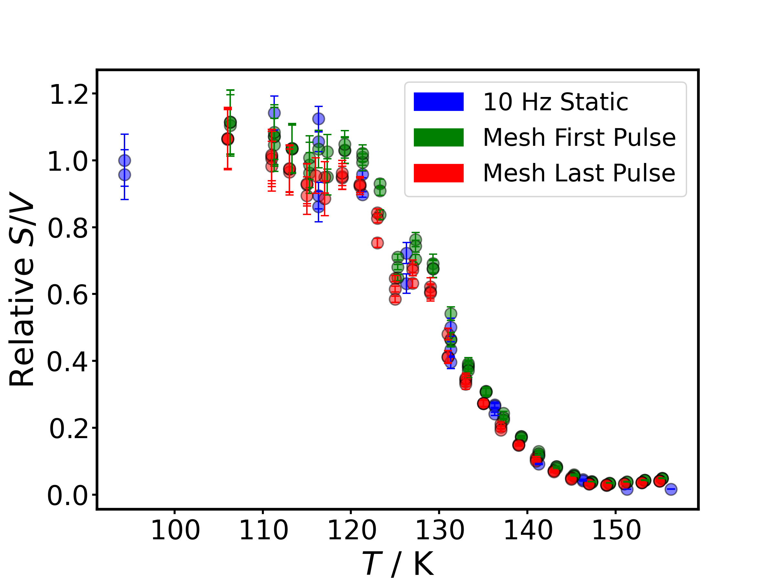
Figure S4: Relative S/V as shown in figure 3 in the main text but comparing between single-shot and static measurements (methods section for further details). For the manuscript and the rest of the SI, only the 1st pulse single shot data and the 10 Hz static data were used (green and blue data points).

S4 Temperature Correction
S4.1 Temperature Correction for SAXS
For SAXS the sample inside the grid is squeezed by a copper door that is itself mounted at the bottom of the JANIS cryostat. The SAXS sample environment employed typically shows an offset between nominal and true sample temperature. To assess this offset the WAXS data were used and compared to literature values. The onset crystallization temperature of HGW is 156.3 ± 0.5 K according to Bachler et al.¹ at a heating rate of 10 K min⁻¹ based on calorimetry data. We here observe crystallization under isothermal conditions (step-wise heating; average heating rate ~5-10 K h⁻¹) at a nominal temperature 140 K based on the formation of pronounced Bragg peaks of ice I in the WAXS data along with the vanishing of the halo peak of LDA (see figure S5). By comparing the observed crystallization temperature with the literature value, we estimate an offset of ~16 K, i.e., the true temperature is 16 K higher than the nominal temperature inside the mounted grids. All data shown in the main text and in section S7 have been corrected for this offset. The second transformation that can be used to calibrate is the polyamorphic transition, which also results in an offset of ~16 K (see section S5).

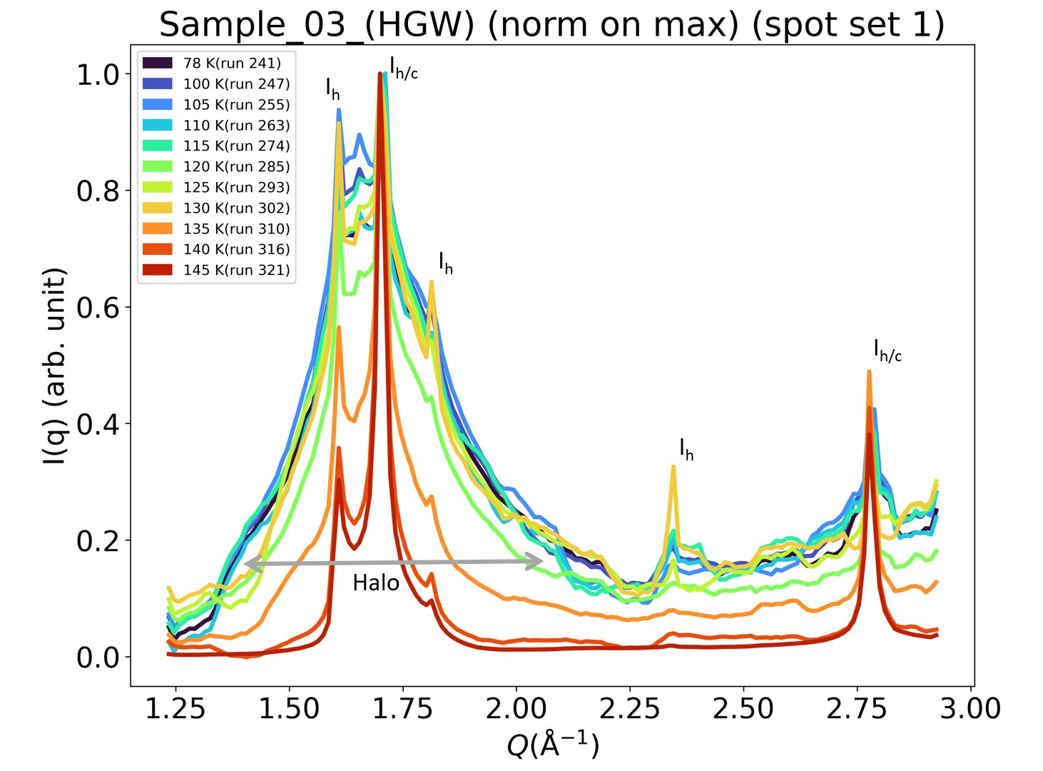
Figure S5: WAXS I(q) (intensity as a function of the momentum transfer q) for HGW for different temperatures. The temperatures shown are not offset-corrected (see text). The label ‘spot set 1’ indicates that the data shown correspond to the first spot that was measured after each temperature increase. The labels I_{h} and I_{h/c} mark reflexes corresponding to hexagonal and stacking disordered ice I respectively.
S4.2 Temperature Correction for SEM
The SEM sample environment is known to show nominal temperatures that are higher than the true temperature, i.e., the offset has a negative sign. A similar procedure as described in section S4.1 has been used to estimate this offset. Crystallization was observed at 171 K. Comparing this value to the literature value of 156.3 ± 0.5 K¹ leads to an estimated offset of ~ -15 K. The SEM data shown in the main text and in section S8 were corrected for this offset.

S5 Wide Angle X-ray Scattering (WAXS)
The following figures (S6-S8) show the WAXS intensity (simultaneously recorded with the SAXS signal) as a function of the momentum transfer q. WAXS calibration was carried out using LaB₆. The 2D data recorded on the detector were integrated azimuthally using the data analysis tool DAMNIT. The integrated scattering profiles were normalized to the maximum value in the observation range for better comparability. Temperatures were corrected for the offset, which is 16 K for the SAXS/WAXS measurements (see section S4.1). The WAXS data are only available for the static 10 Hz experiments. They are shown for various spots, where ‘spot set 1’ corresponds to the first spot that has been measured after temperature increase and ‘spot set 2’ to the second one.

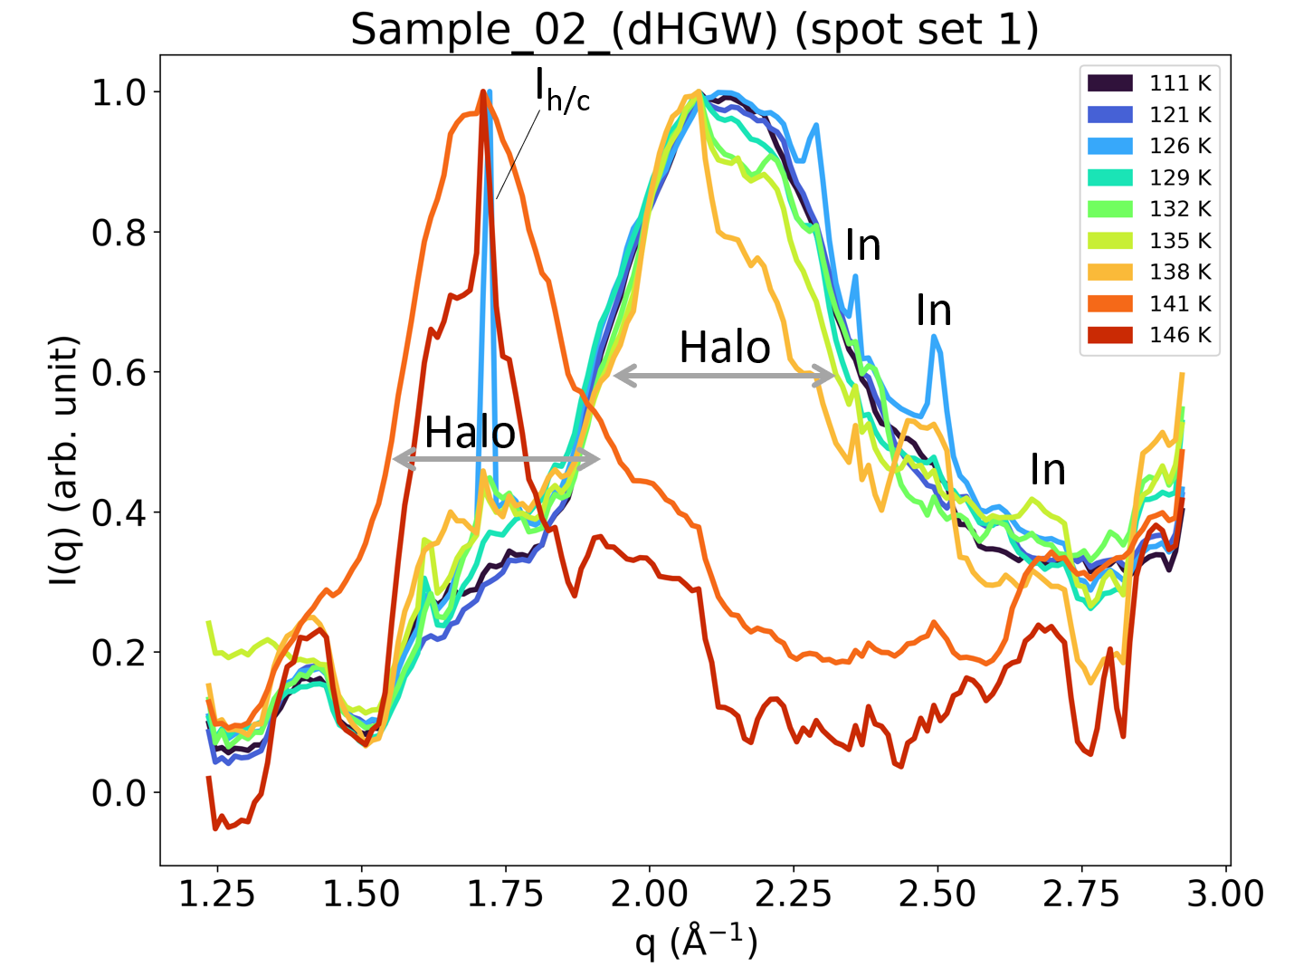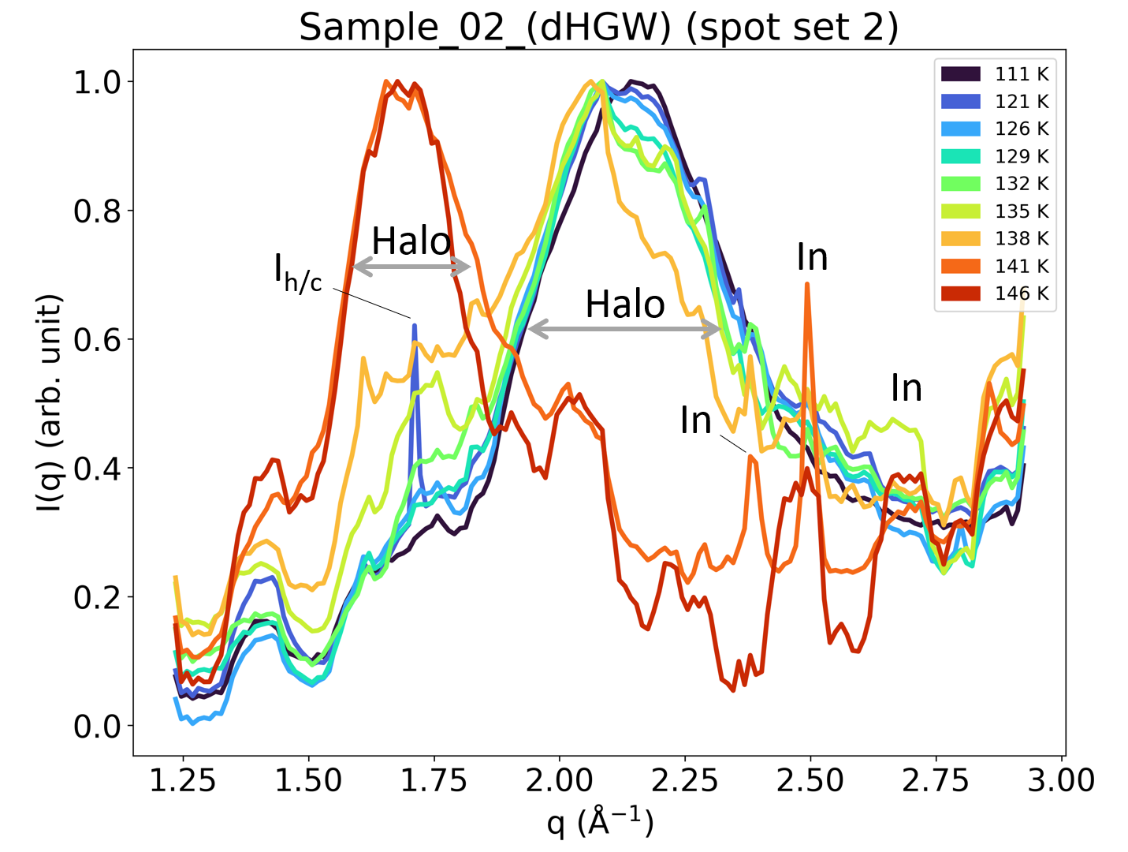
Figure S6: WAXS data for dHGW (HDA) for different temperatures and spots. Bragg peaks originating from ice I (hexagonal I_{h} and cubic I_{c}) and indium (In) are marked accordingly. The data are normalized with respect to each maximum.
Figure S6 shows the WAXS data for dHGW (called HDA in the main text). The data are rather noisy due to the large attenuation that had to be used to prevent beam damage. Besides small amounts of crystalline contamination of cubic ice (Bragg peak at 1.7 Å⁻¹), the sample is identified as a high-density amorphous type of ice based on the halo peak centered at 2.2 Å⁻¹ as observed in earlier scattering studies⁹. Additionally, there is a shoulder at 1.7 Å⁻¹, which likely indicates the presence of low-density domains¹⁰. Upon stepwise heating with an average rate of 5-10 K h⁻¹, the position of the maximum of the halo peak shifts to 1.7 Å⁻¹ at a temperature of 141 K, indicating the formation of low-density amorphous ice from dHGW^{1,9}. This transition temperature is consistent with literature¹¹ (heating rate 30 K min⁻¹), confirming the assessment of the temperature offset.

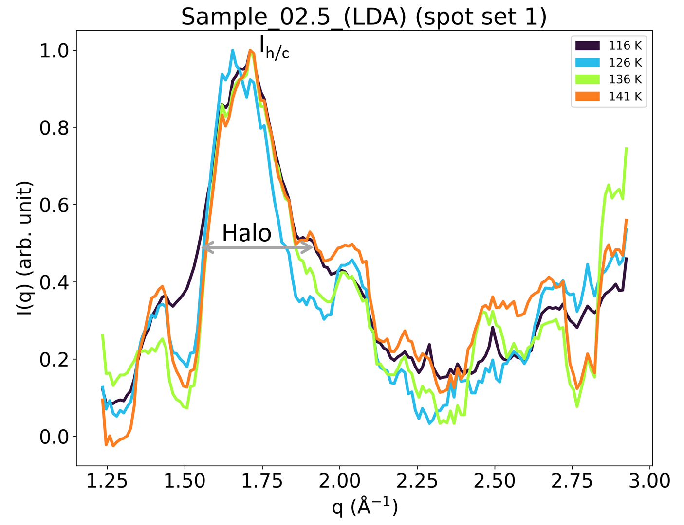
Figure S7: WAXS data for LDA made in situ from dHGW for different temperatures and spots. Peaks are marked accordingly. The data are normalized with respect to each maximum.
After the polyamorphic transition of dHGW (sample 02) to LDA, it was recooled (= sample 02.5). As seen by the halo peak centered at 1.7 Å⁻¹ in figure S7, the LDA stayed amorphous at all temperatures up to 141 K.

Figure S8 shows the WAXS data for the HGW samples at different temperatures and spots. At temperatures below 156 K, a pronounced halo peak centered at 1.7 Å⁻¹ is observed for all samples, confirming the low-density amorphous nature of the HGW samples. Additionally, contaminations of stacking disordered and hexagonal ice I are found as indicated by the corresponding Bragg peaks. Contamination of stacking disordered ice I typically forms during hyperquenching, while hexagonal ice I usually forms by condensation of water vapor from the atmosphere during sample handling. Crystallization occurs at 156 K, where the sample fully transforms to stacking disordered ice I.
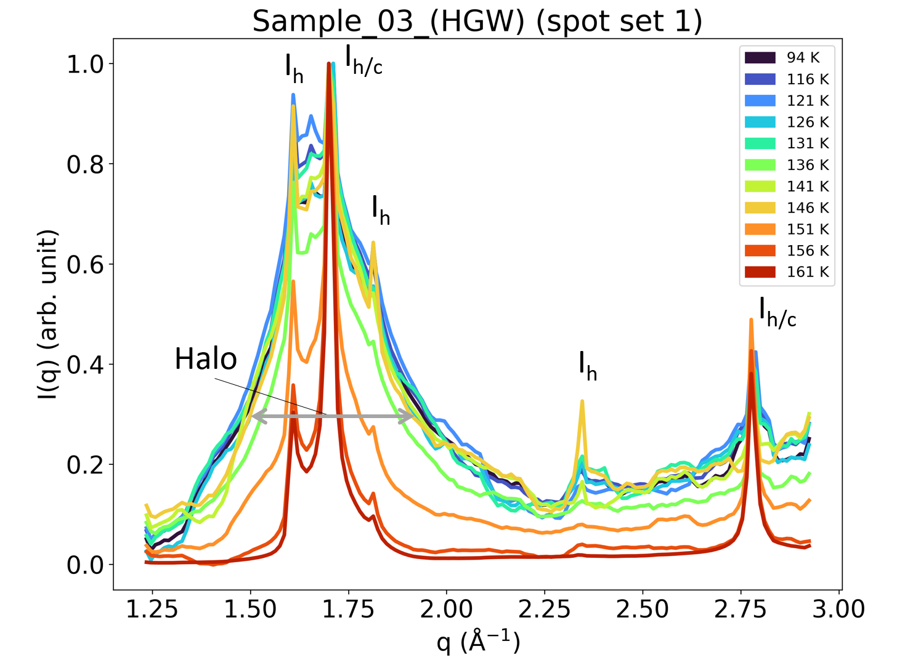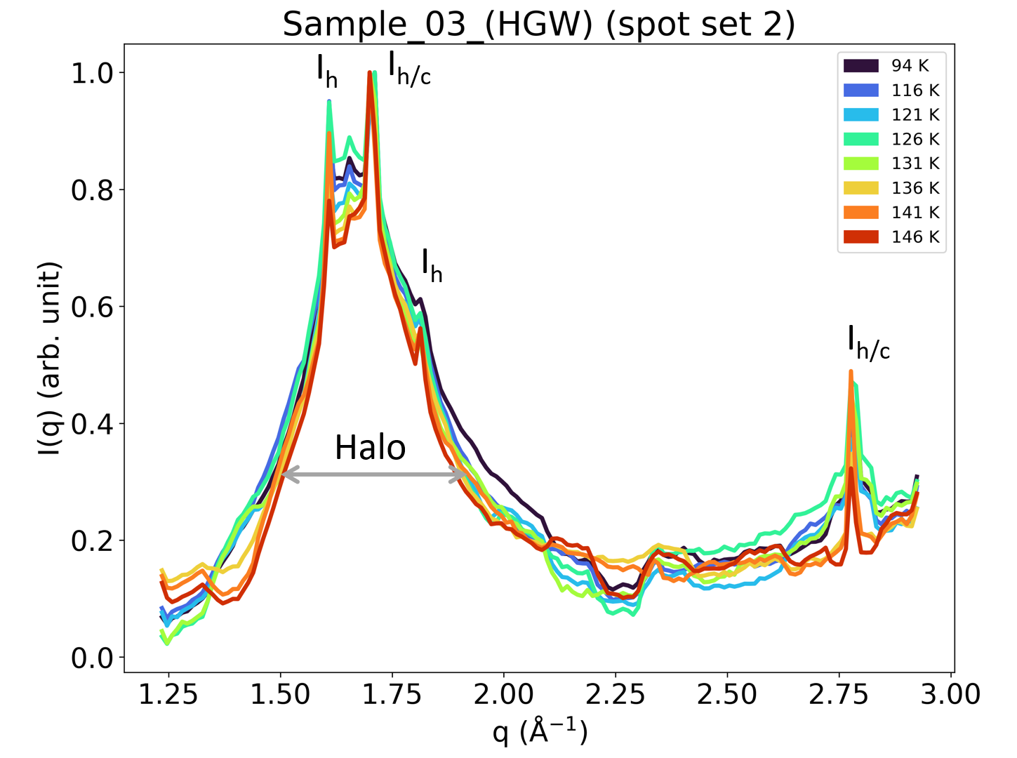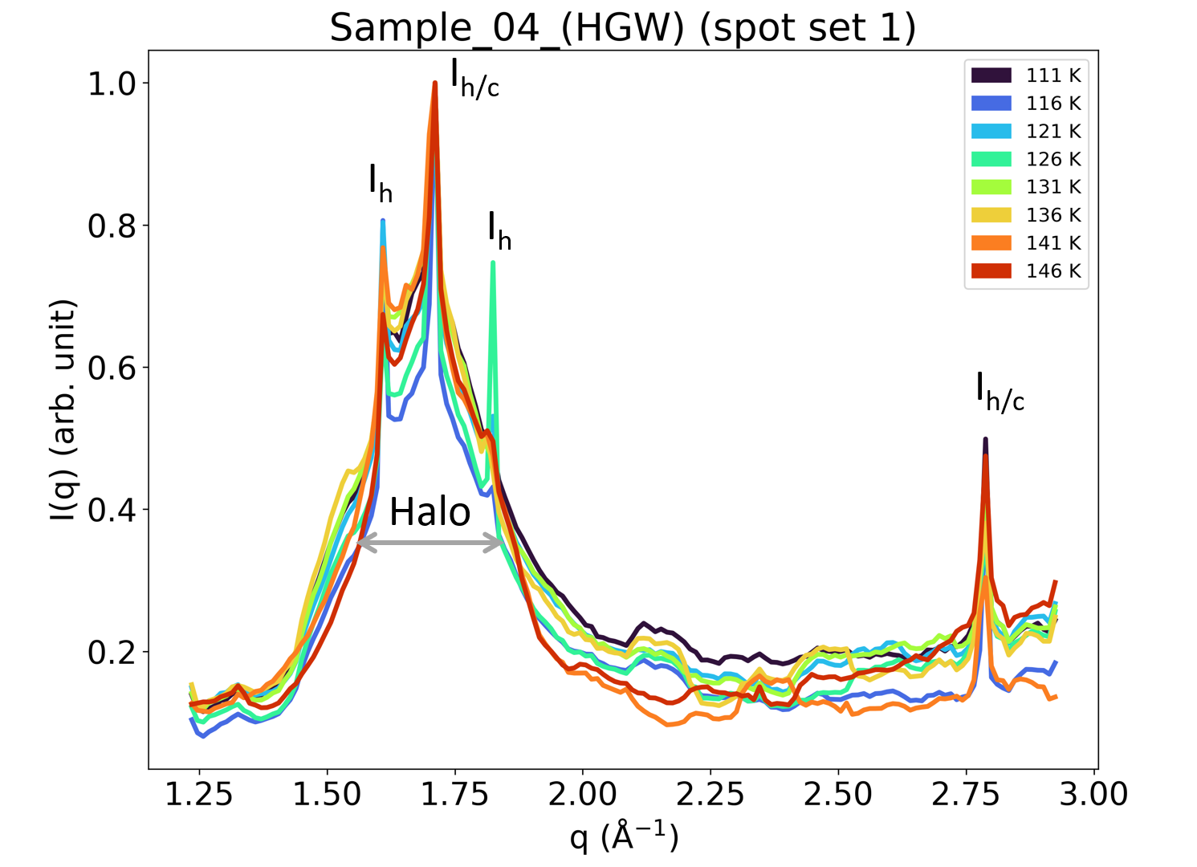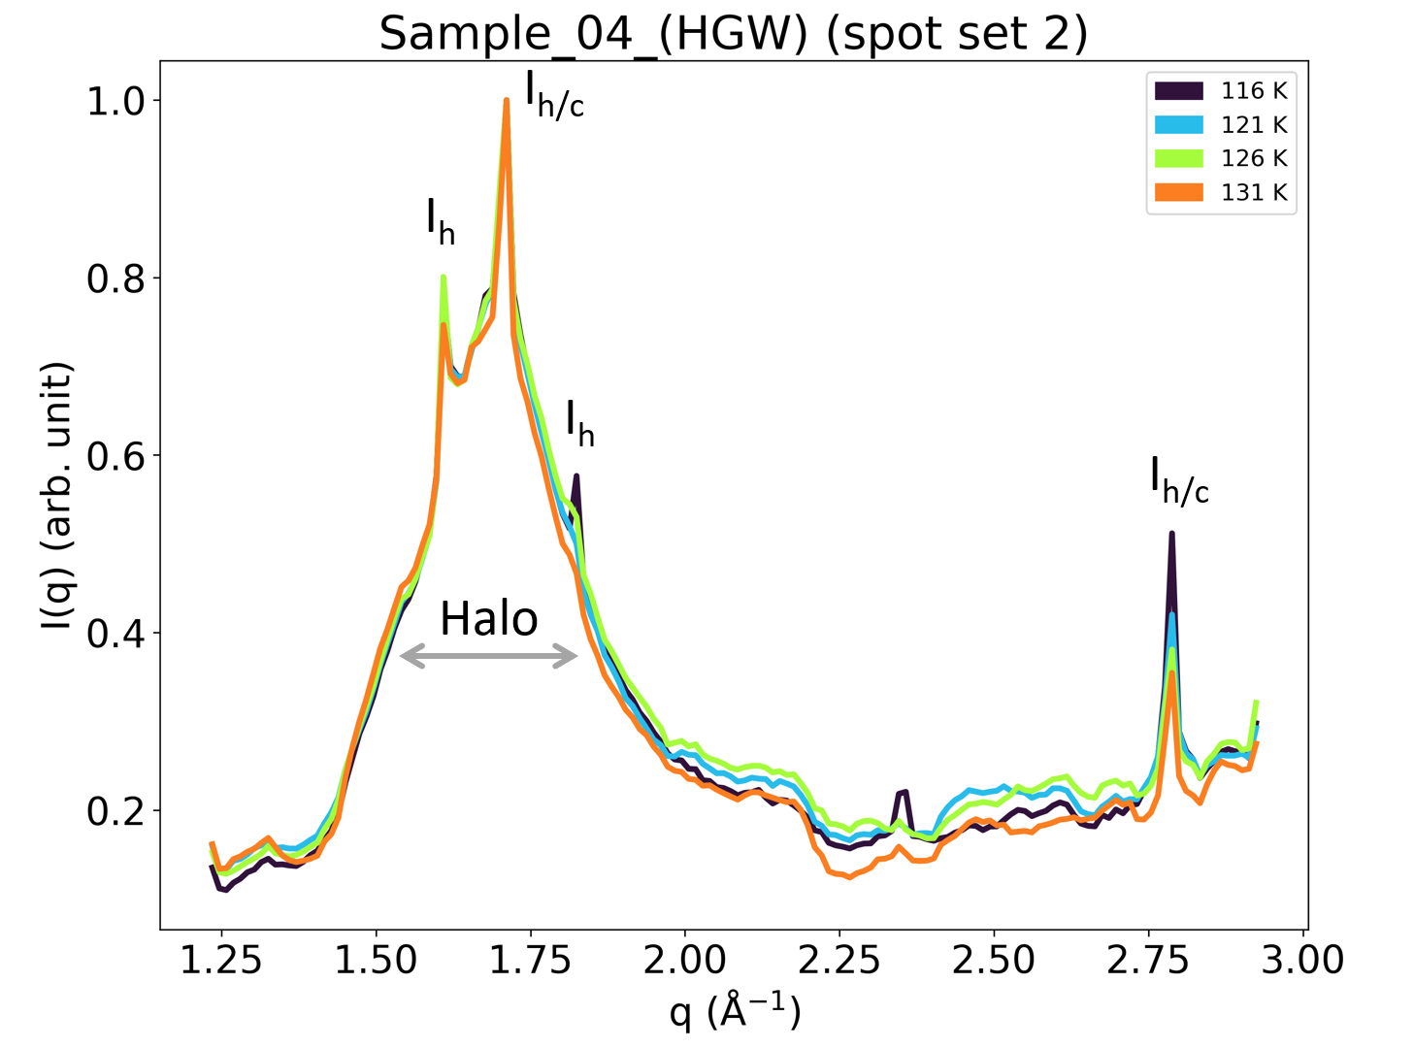
Figure S8: WAXS data for HGW for different temperatures and spots. Bragg peaks are caused by contamination with ice I and are marked accordingly. The data are normalized with respect to each maximum. Due to a change in the setup during the beamtime at MID, no WAXS data are available for sample 05.

S6 Supplemental SAXS Data and Evaluation Details
S6.1 Raw I(q) Data
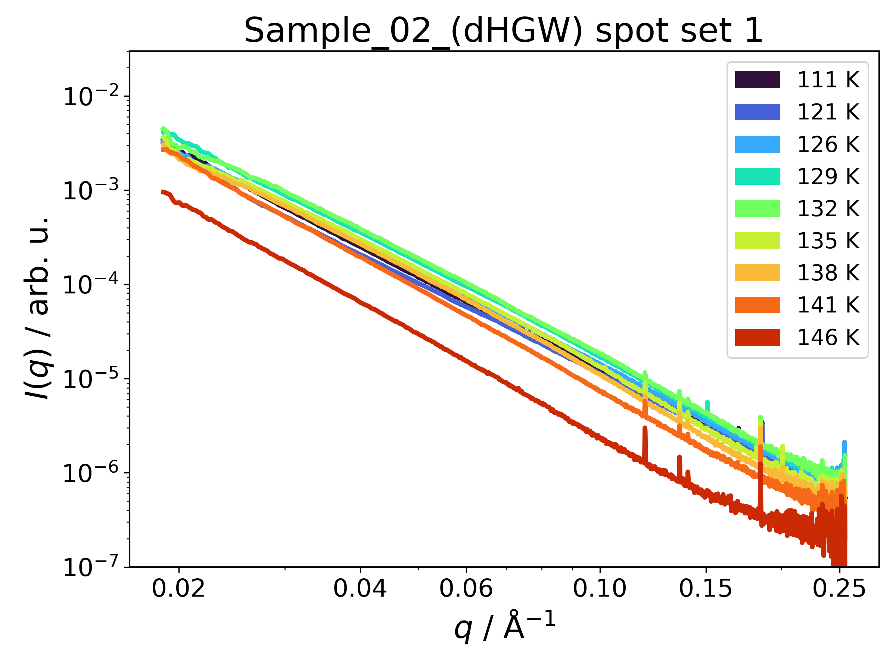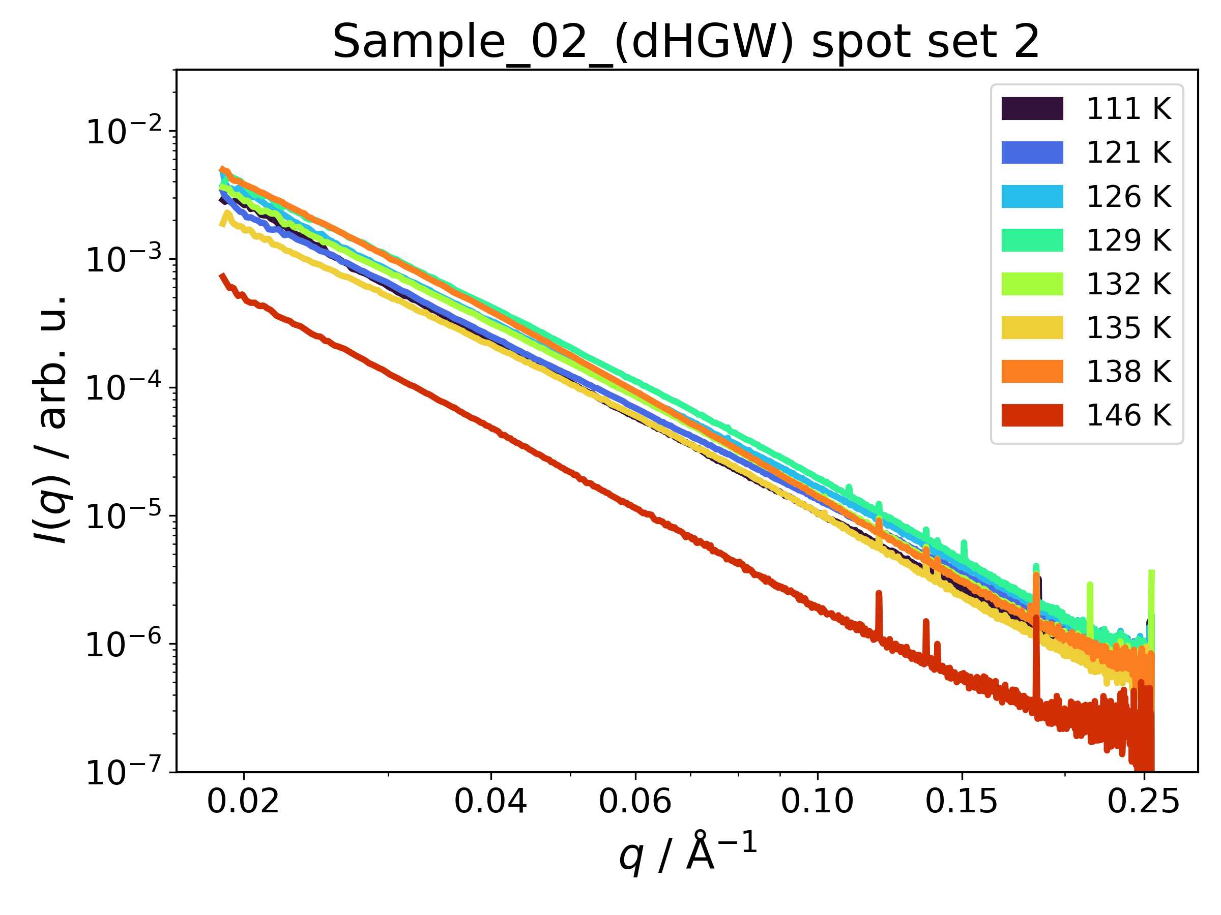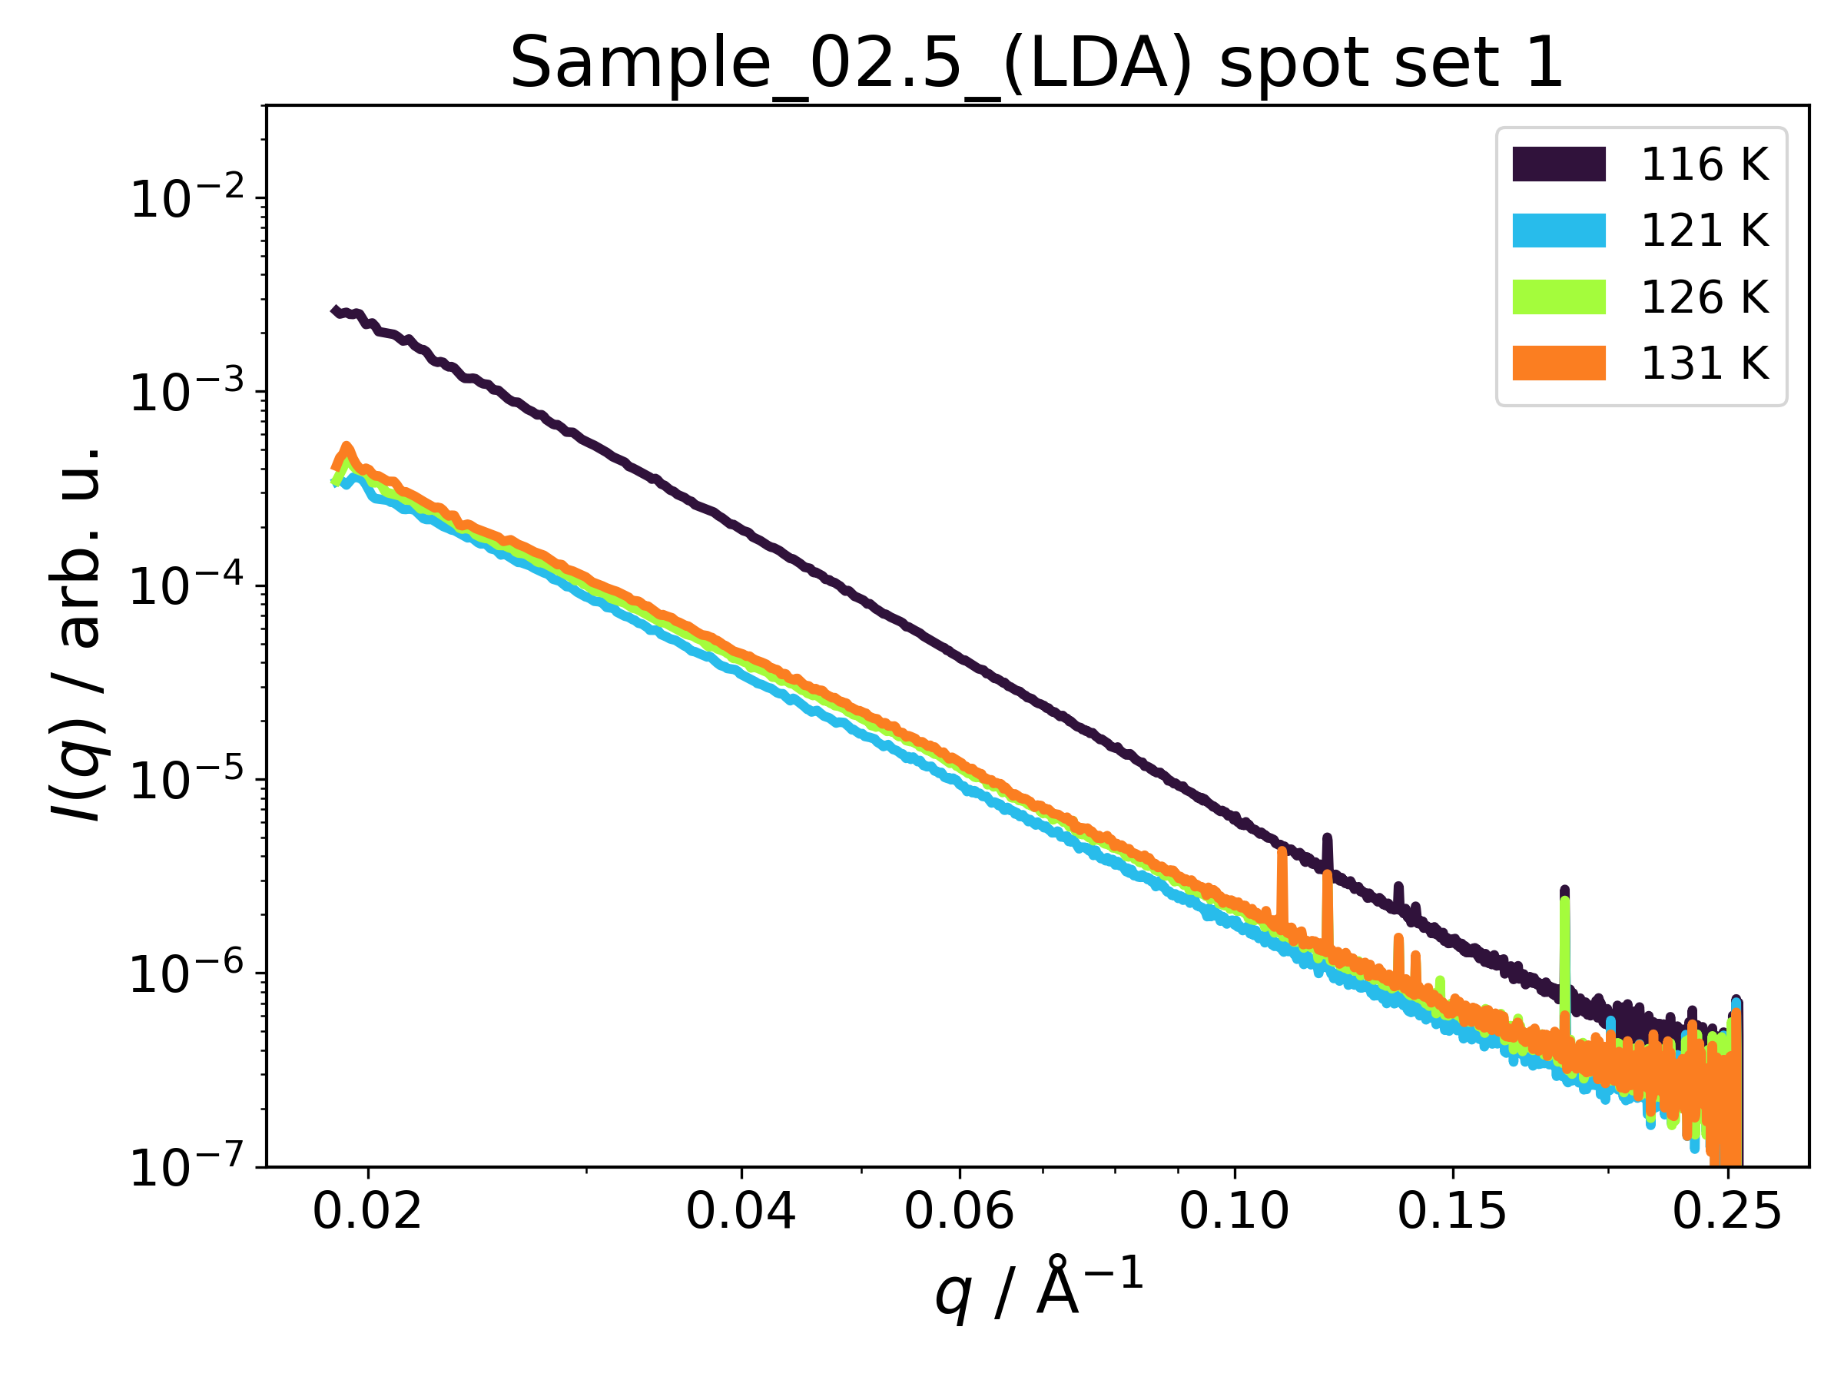
10 Hz static
10 Hz static
10 Hz static
Figure S9: Raw azimuthally integrated SAXS data for dHGW (HDA, sample 02) and LDA (sample 02.5) made in situ from dHGW. The data were normalized to the intensity of the incident beam measured by an X-ray gas monitor (XGM) upstream of the sample.
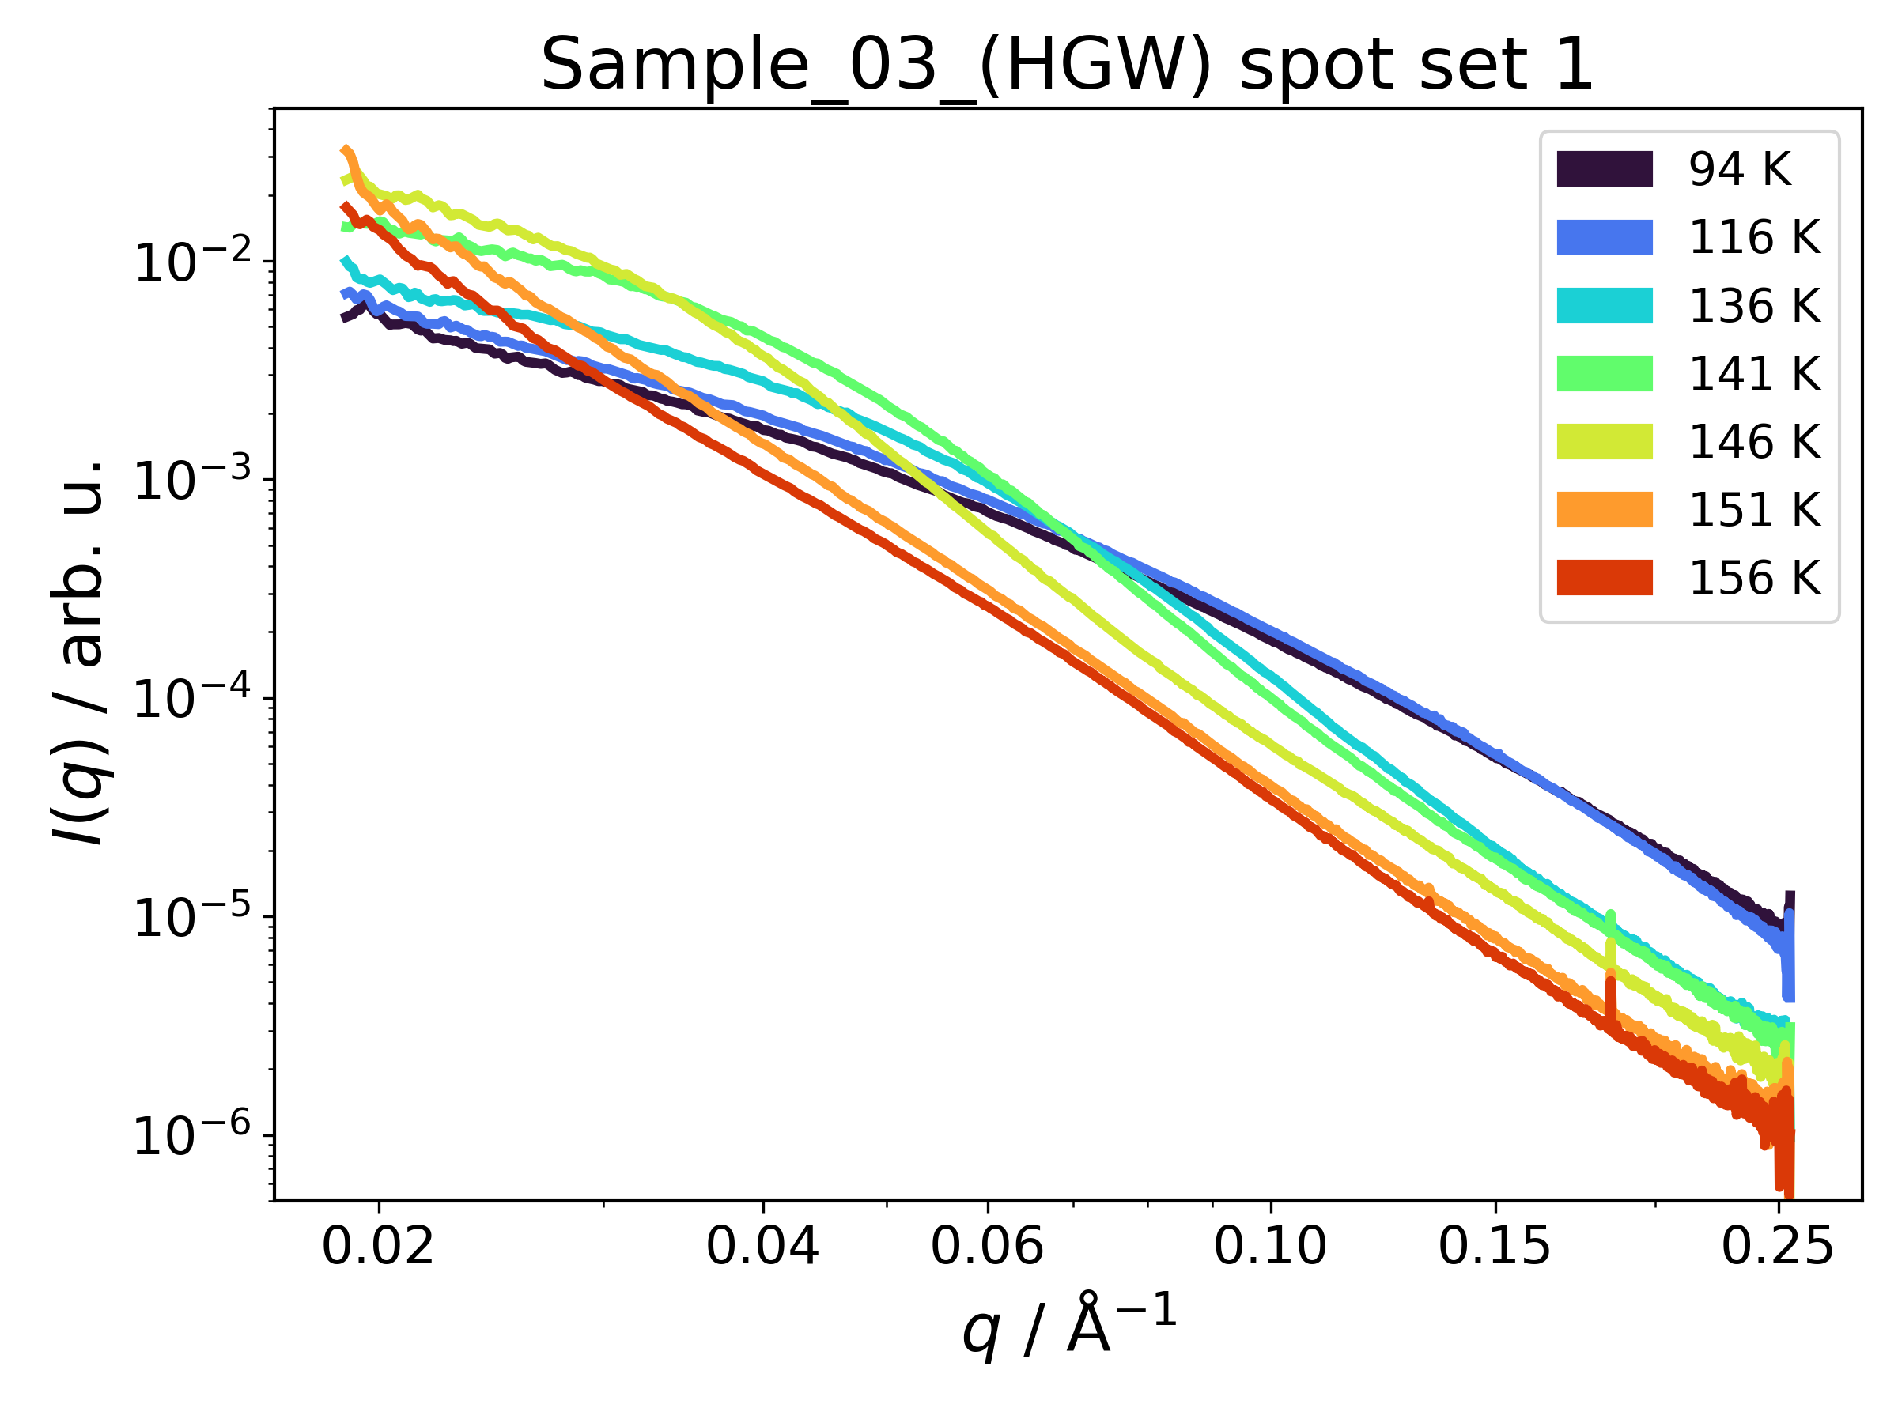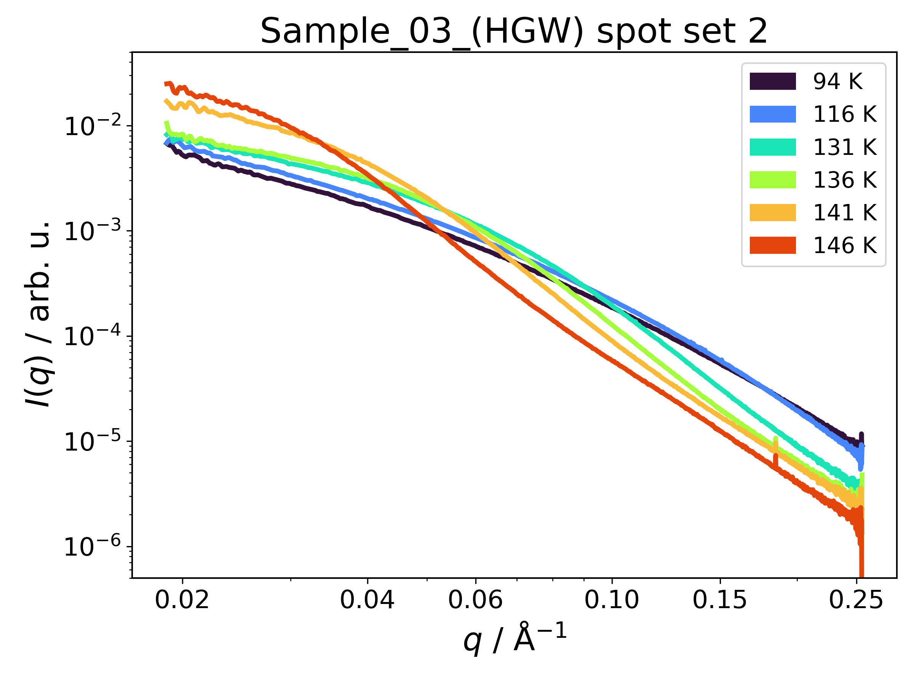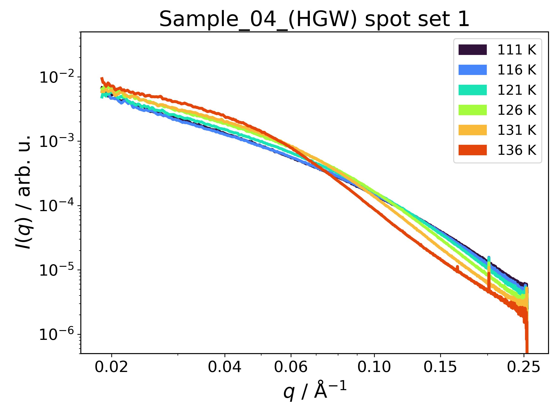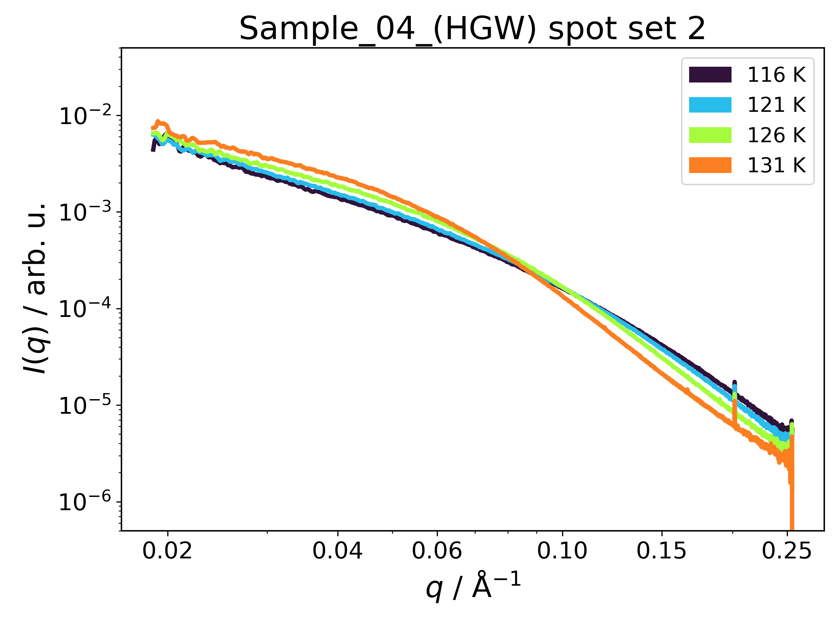
10 Hz static
10 Hz static
10 Hz static
10 Hz static
Figure S10: Raw azimuthally integrated SAXS data for different HGW samples. The data were normalized to the intensity of the incident beam measured by an X-ray gas monitor (XGM) upstream of the sample. The single shot data correspond to the first pulse of each train (green points in figure S4). Continued on next page.
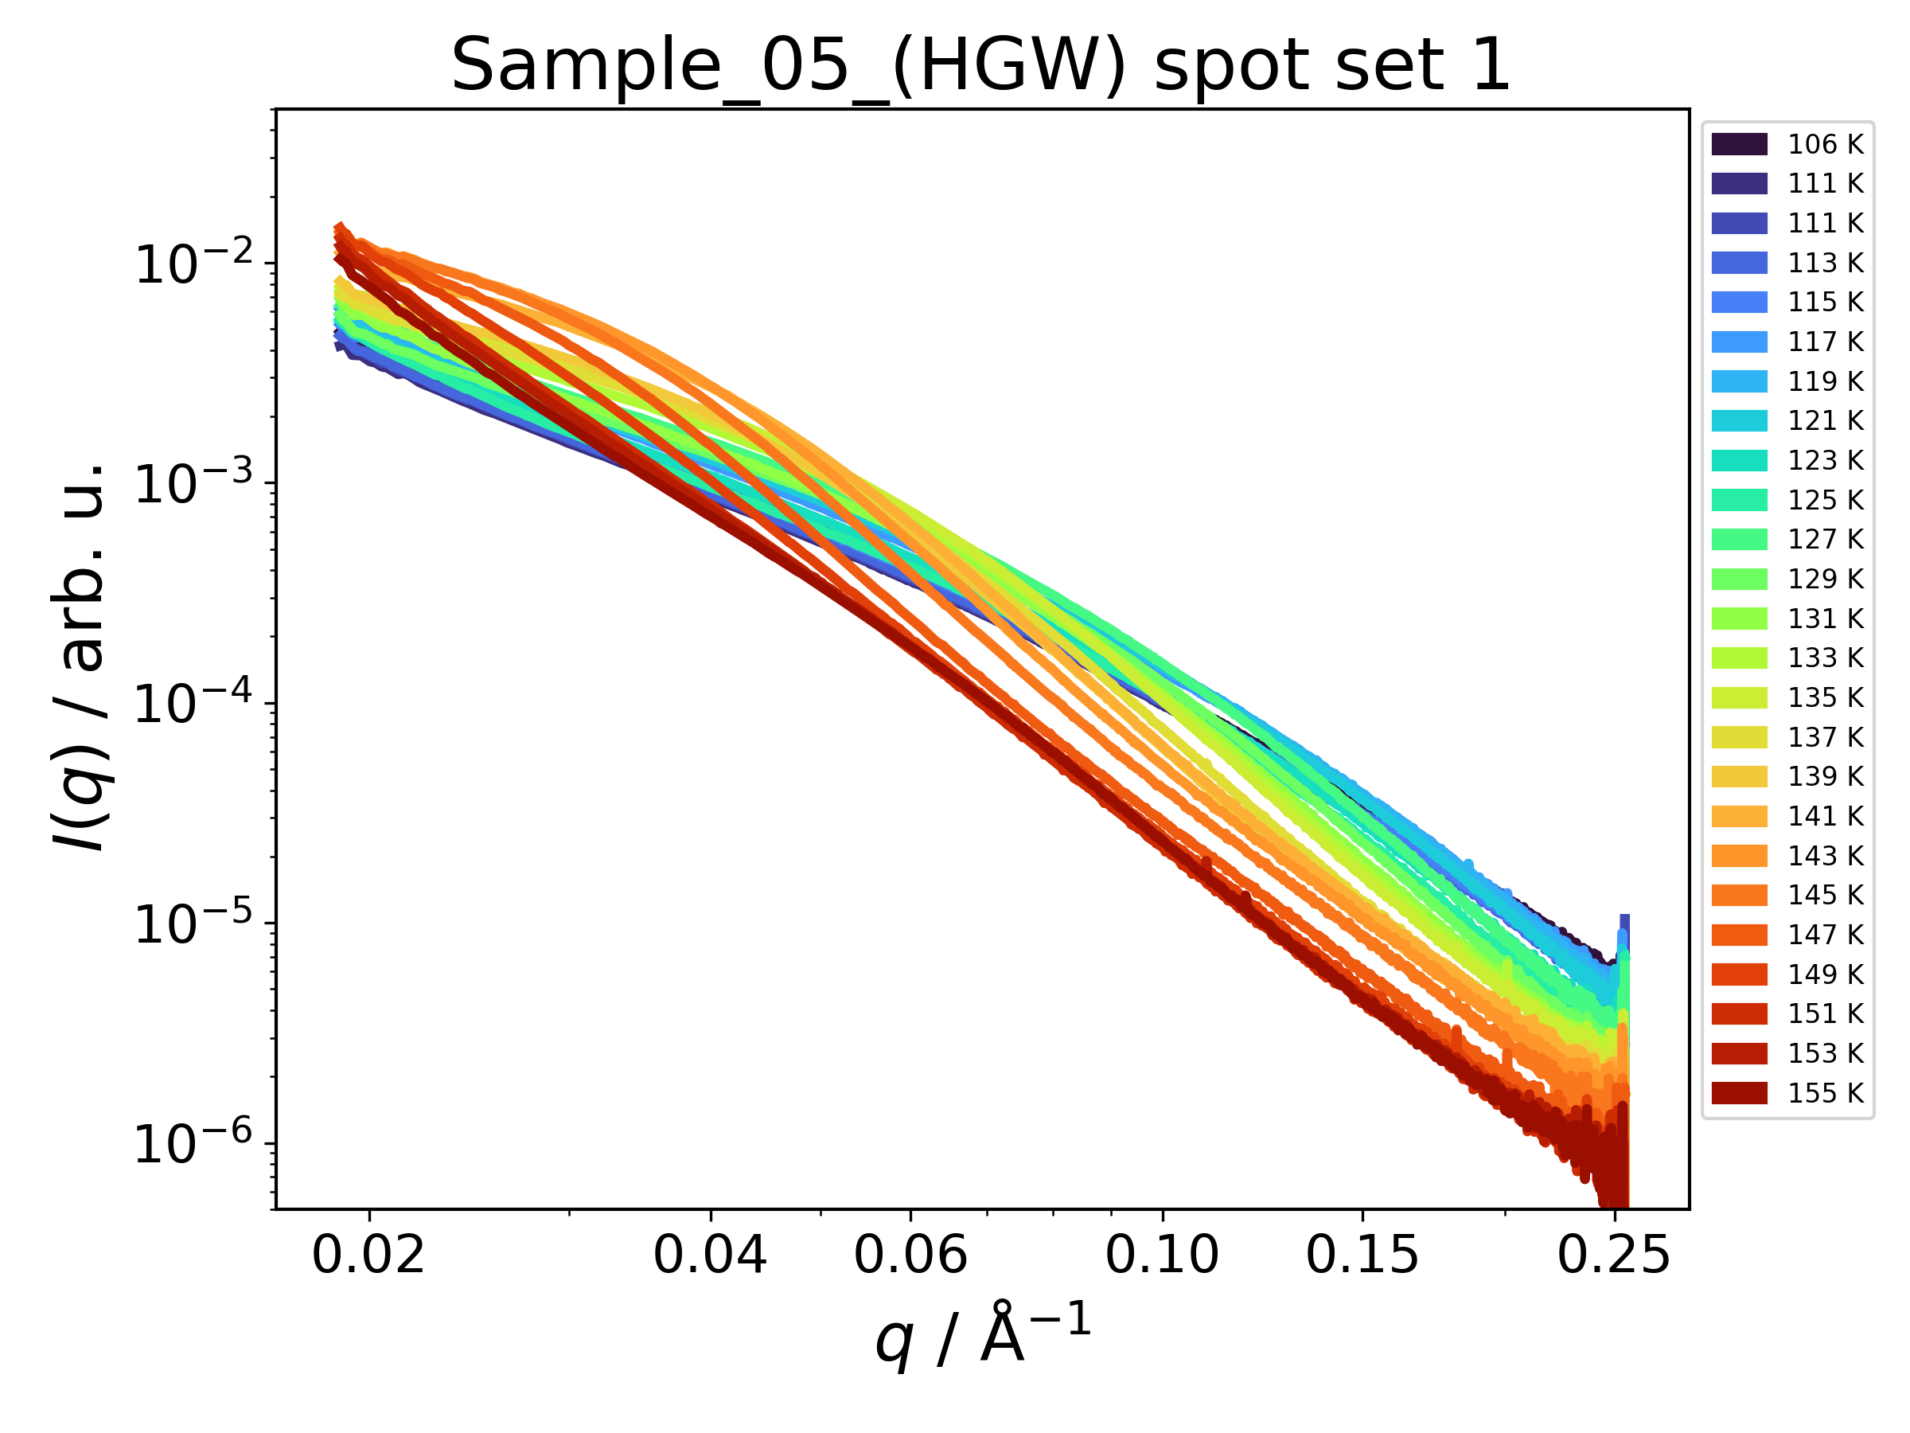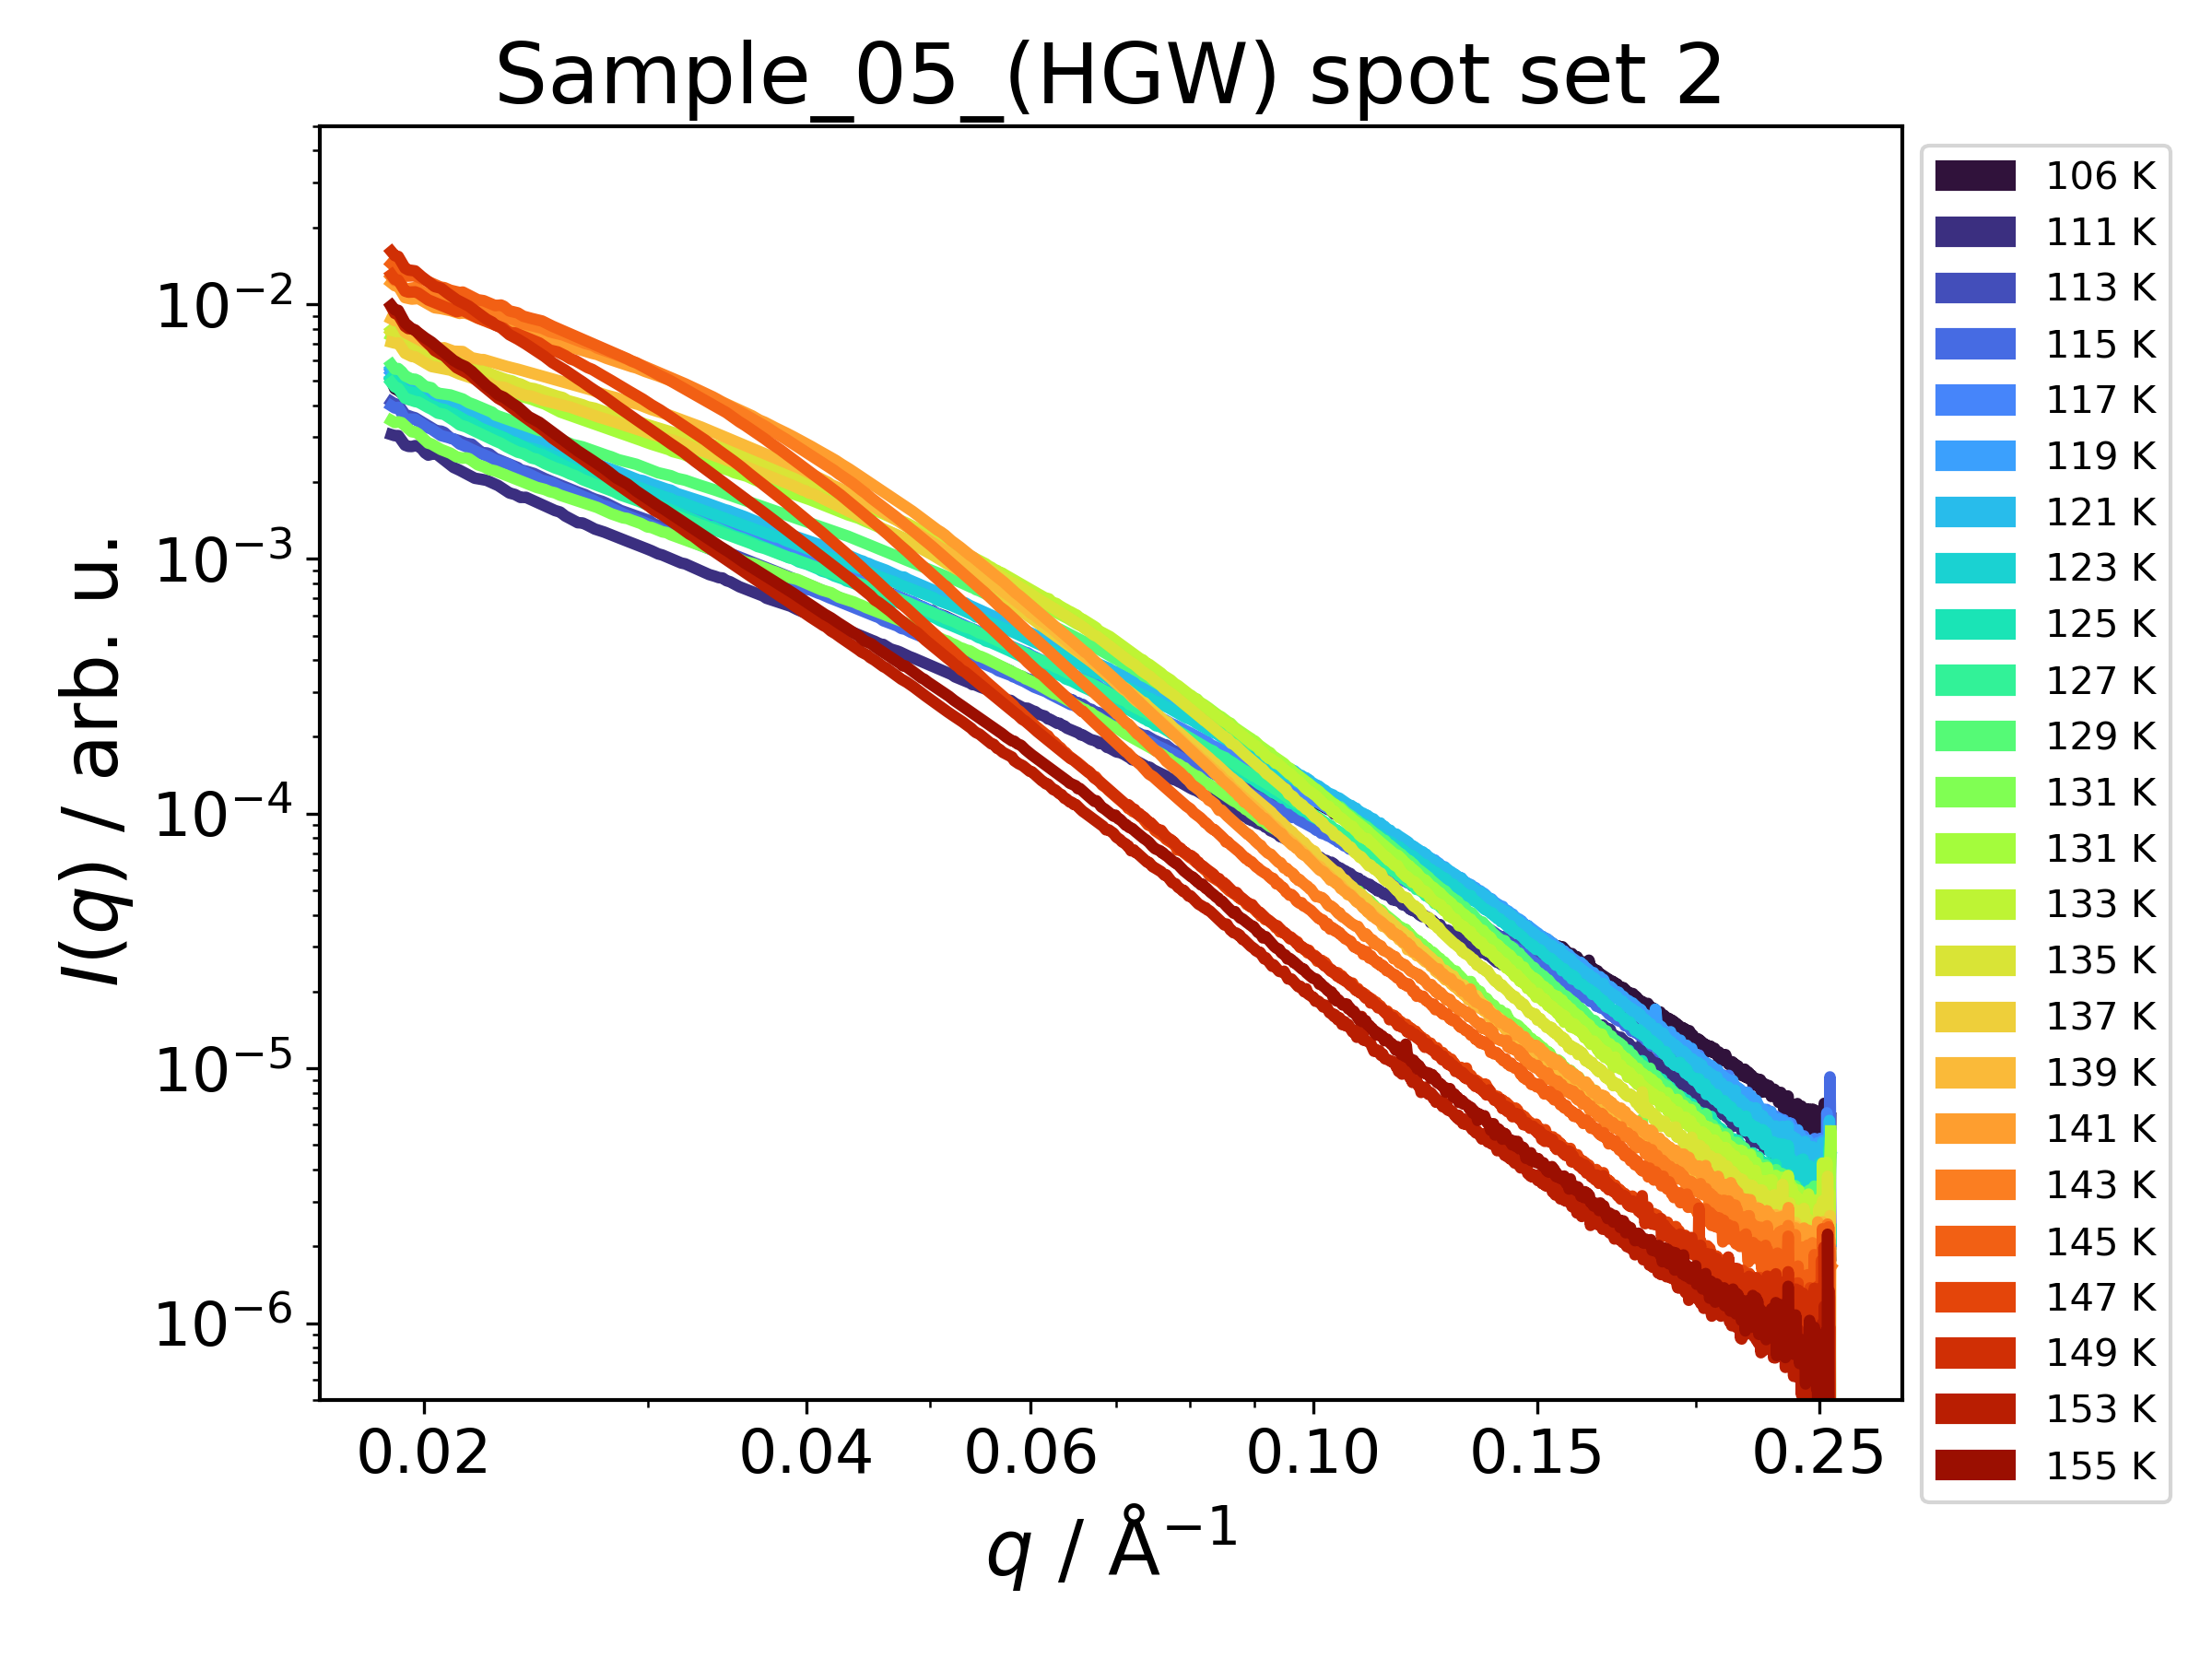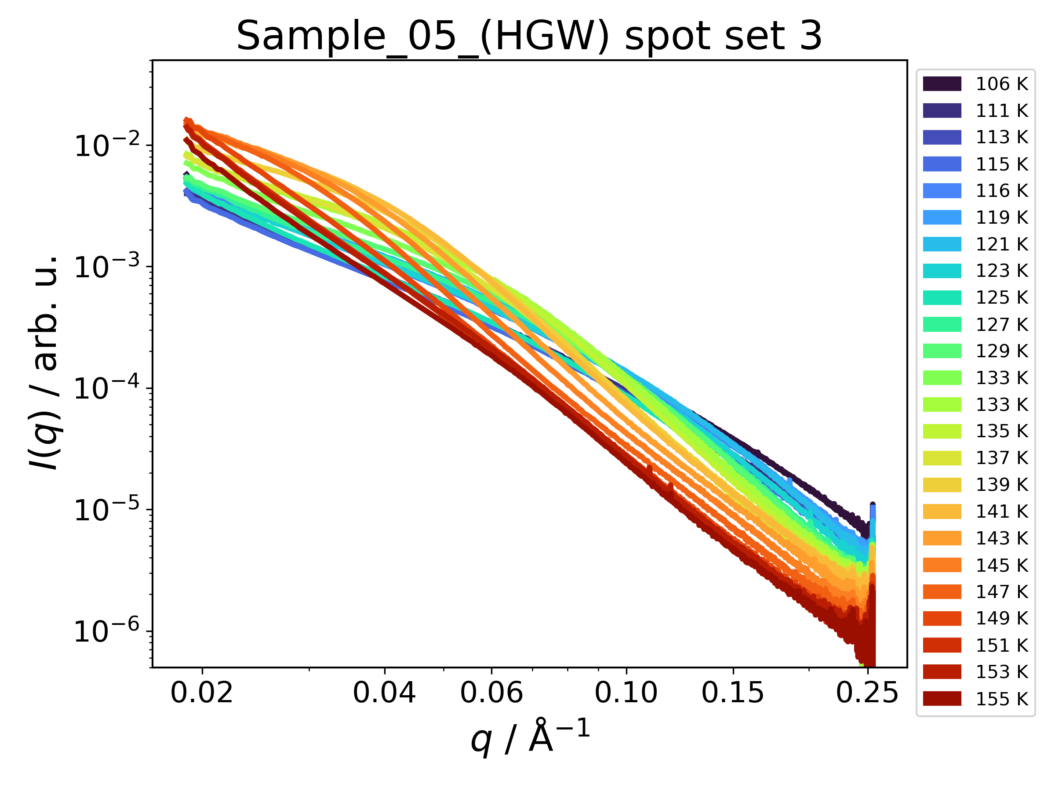
Avg. over single shots
Avg. over single shots
Avg. over single shots
Mesh Scan 3
Mesh Scan 1
Mesh Scan 2

Figure S10: Continued from previous page.
Figure S9 and S10 show the raw SAXS I(q) data for single-shot mesh scans (sample 05) and static exposure at 10 Hz (samples 02-04). Besides azimuthal integration and normalization using the intensity of the incident beam along with the processing pipeline of the MID instrument², the data underwent no further treatment. We note that the data are not given on an absolute scale as the precise amount of illuminated sample is unknown. Therefore, the data are not normalized, where sample thickness varies slightly at different spots and/or temperatures. Large offsets in some of the I(q) curves indicate that, e.g., the sample has partly fallen out of the grid. Such data are excluded from analysis.

Most notably, all scattering profiles recorded for HGW show a ‘knee’ at around ~0.8 Å⁻¹ below 100 K that shifts to lower q as the temperature is increased. Such knee is not observed after crystallization, and also not seen for the dHGW and LDA samples. This points to differences in the morphology between HGW and dHGW/LDA.

S6.2 Porod Scaling and Porod Constant

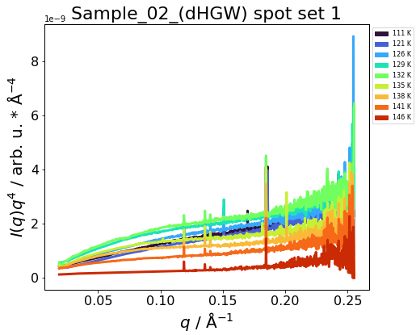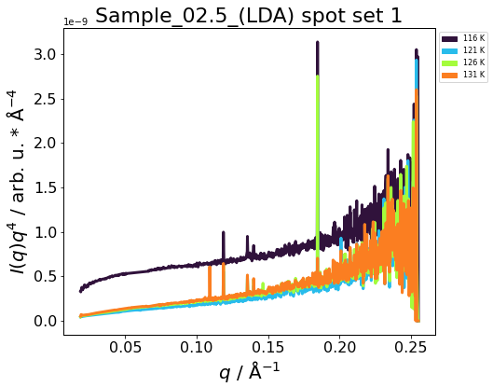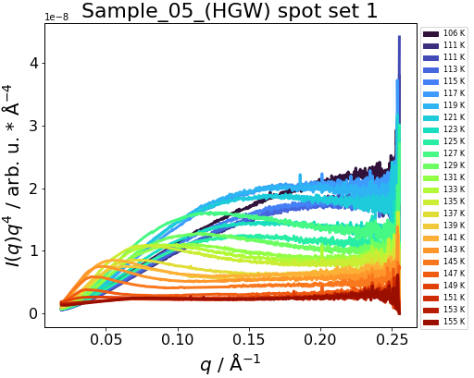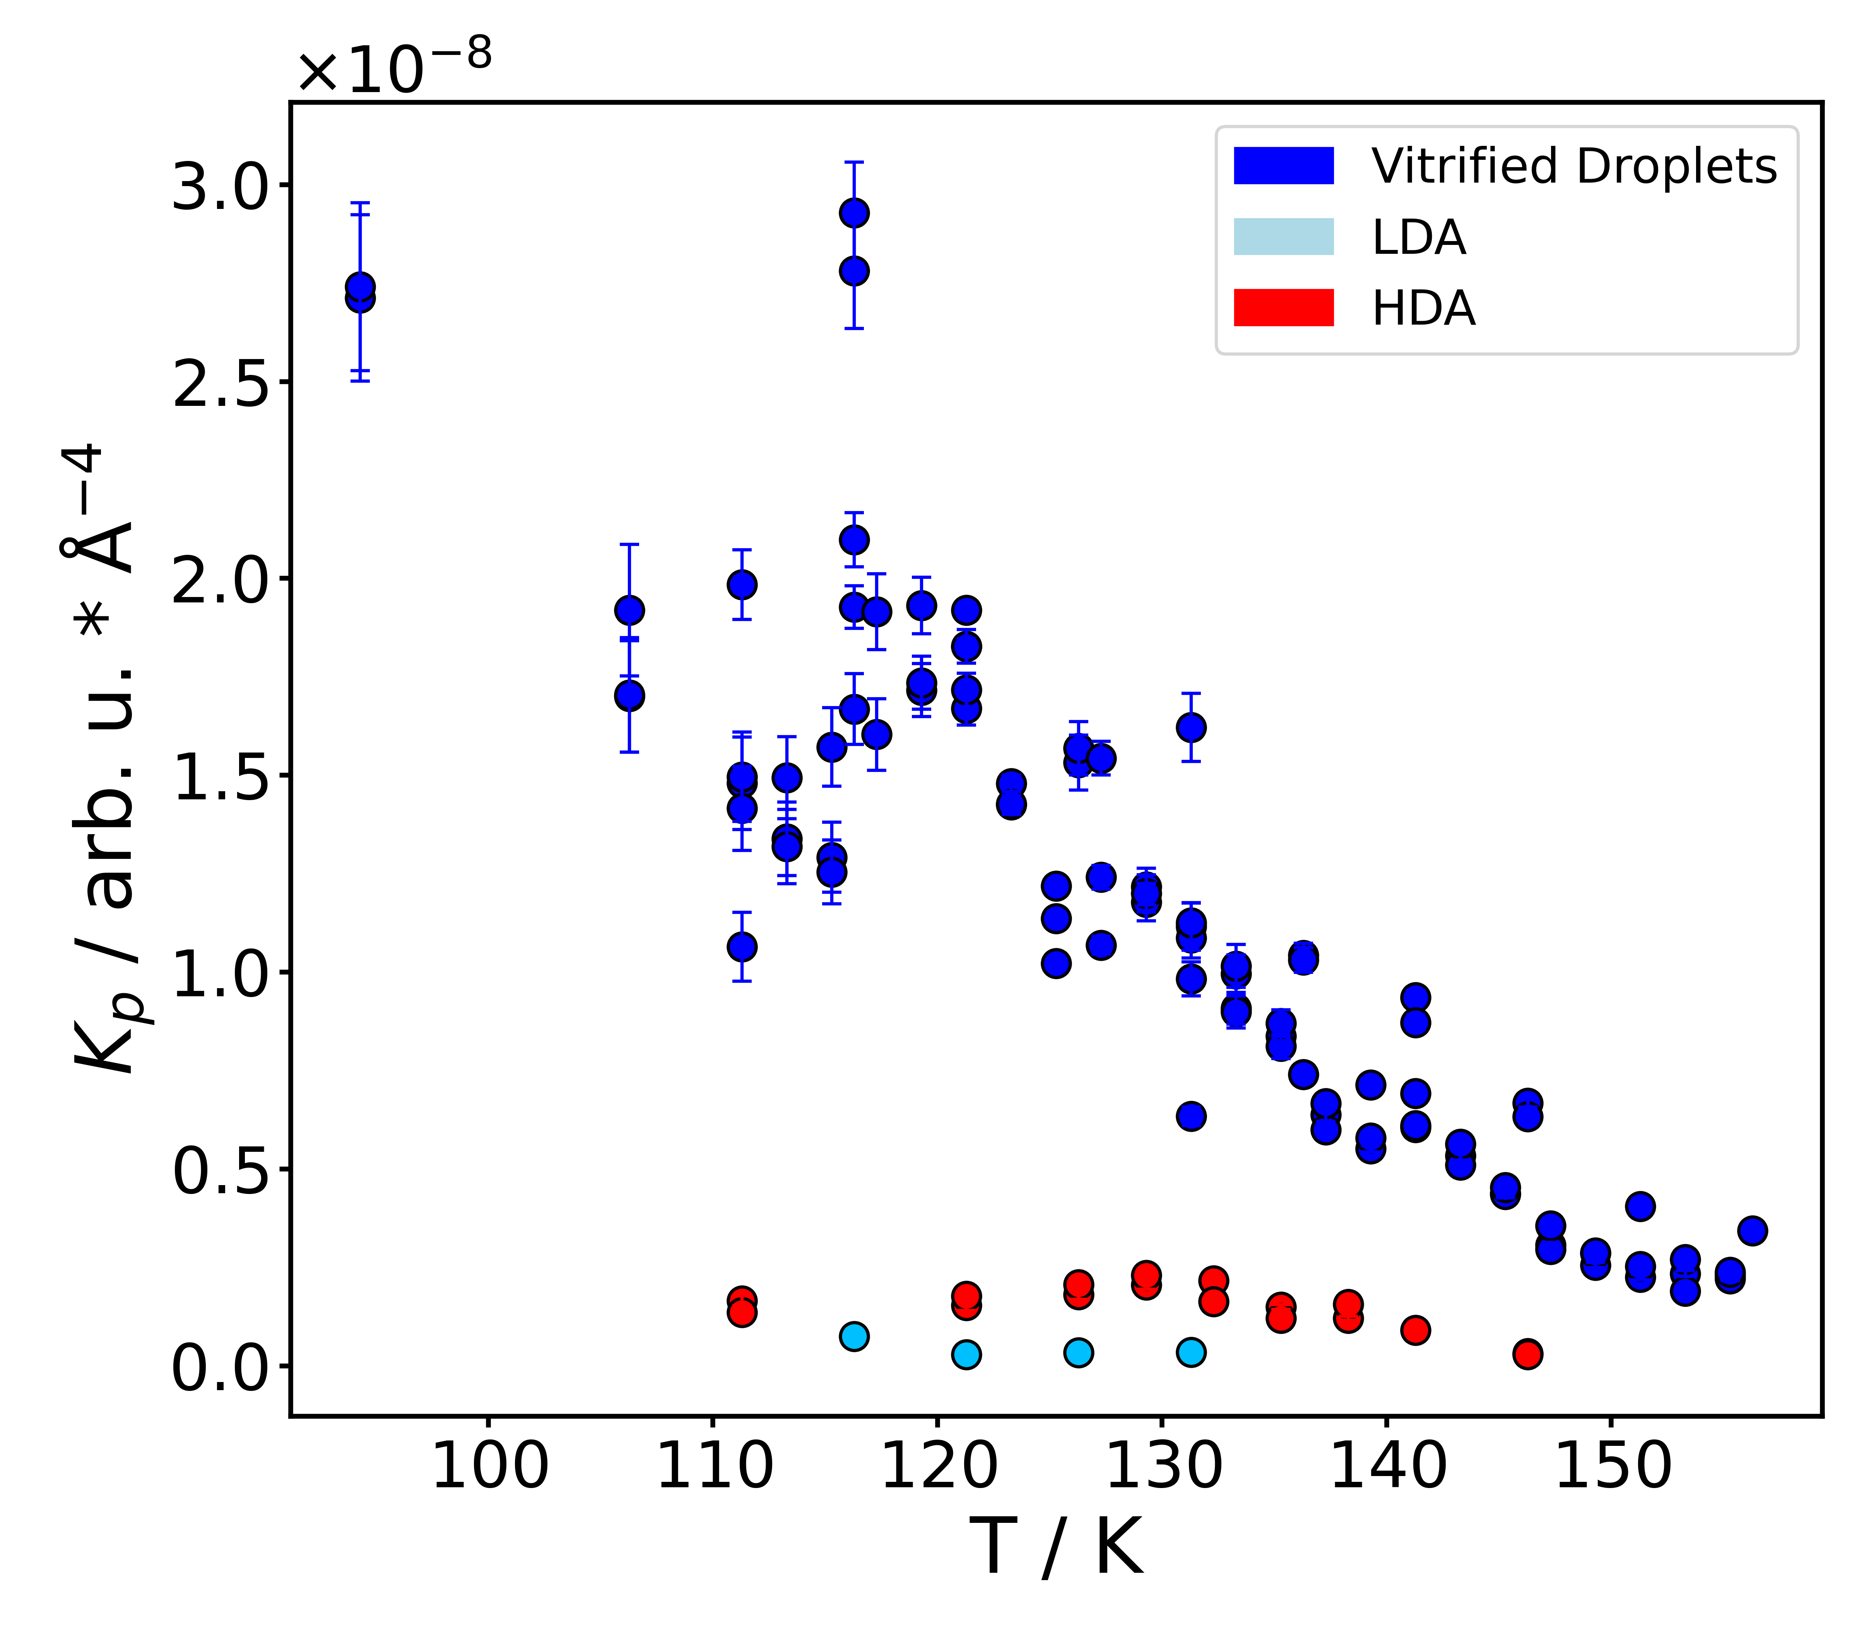
Mesh Scan 1
D)
C)
B)
A)
Figure S11: Panels A)-C): Selected SAXS profiles scaled by I(q)*q⁴ according to the Porod law for dHGW, LDA made from dHGW and HGW. Panel D): Porod constants K_{p}, determined from the scaled curves by reading off I(q)*q⁴ at the respective plateau, as a function of the temperature for all samples.
Small angle scattering profiles can often be described as a power law in the high-q limit according to Porod’s law¹² (equation S1).

$I\left(q\right)=K_{p}q^{-m}+B$ (S1)

Here, K_{p} is the Porod constant, m is the Porod exponent, and B is the background. K_{p} is defined according to equation S2 and is proportional to the surface to volume ratio S/V.¹²

$K{}_{p}=\lim_{q→∞}{I\left(q\right)*q^{4}}∝\frac{S}{V}$ (S2)

Equation S2 implies that scaling I(q) by q⁴ (also called Porod scaling) should lead to a plateau at large q values (in our case q > 0.125 Å⁻¹). Figure S11 shows the Porod scaled I(q) data of three exemplary samples from figure S10 along with the K_{p} values as a function of the temperature. In all cases K_{p} was calculated by reading off I(q)*q⁴ at the corresponding plateau.

HGW (Figure S11C) shows a clear plateau of I(q)*q⁴ at q > 0.125 Å⁻¹, indicating the validity of applying Porod’s law on this data. The plateau clearly moves to lower I(q)*q⁴ values when increasing the temperature, leading to decreasing K_{p} values. K_{p} is proportional to the surface to volume ratio, which means that for HGW the surface to volume ratio decreases with increasing temperature.

dHGW (HDA) and LDA (figure S11A/B) also show such plateaus but much lower K_{p} values with a much weaker change upon heating when compared to HGW (figure S11D). This implies that the surface to volume ratio changes less when compared to HGW. Even though the I(q) data are not normalized on the illuminated sample volume (or sample thickness), this inference is likely to be true since the sample thickness is similar for all samples (see section S2). To remove the effect of varying sample volumes, we applied a normalization procedure, which is described in section S6.3.

S6.3 Normalization of SAXS I(q) and Calculation of the Surface to Volume Ratio
For calculating the surface to volume ratio, the SAXS I(q) was normalized to the intensity of the forward scattered beam I(0). Since I(0) was not measured directly, we had to calculate it from the available I(q) data. Therefore, a fit of the classical Guinier model¹² (equation S3) was applied in the low-q range of the scattering profiles (e.g. 0.025-0.035 Å⁻¹; depending on the sample).

$I\left(q\right)=I(0)\exp\left(\frac{-q^{2}R_{g}^{2}}{3}\right)$ (S3)

Here, R_{g} is the radius of gyration. Figure S12 shows an example of such a Guinier fit for HGW.


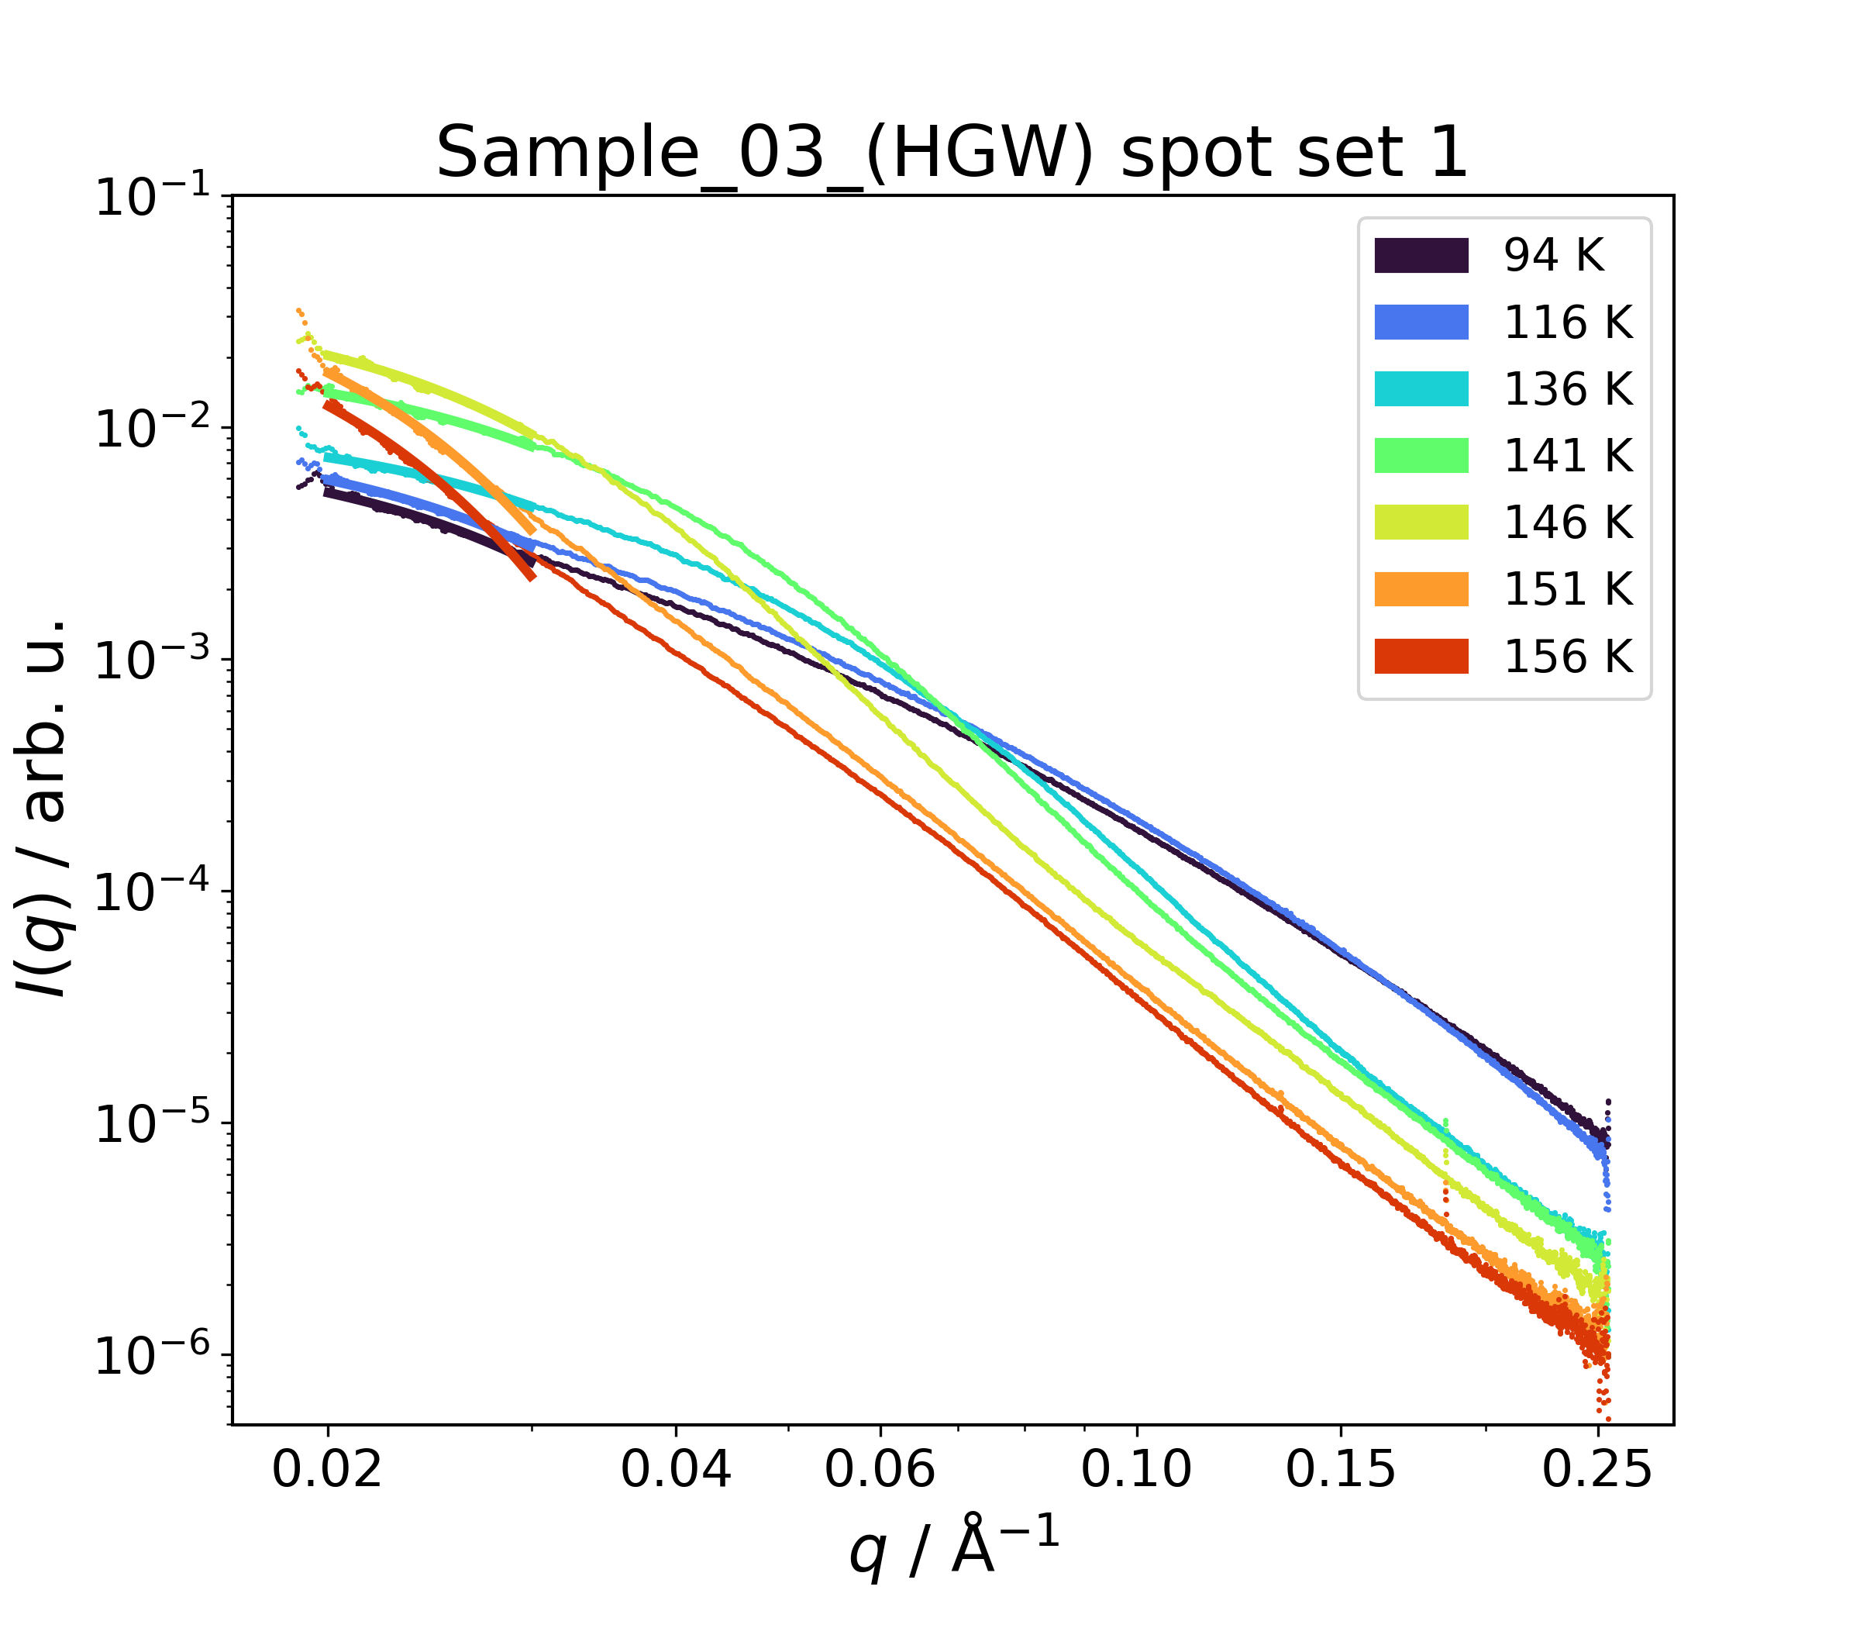
Figure S12: Exemplary SAXS I(q) of HGW including Guinier fit according to equation S3. The fits are shown as bold lines.
I(0) can now be acquired by extrapolating the Guinier fits to q = 0. Normalization also requires knowing the forward scattering intensity I(0)_{lit} in absolute units (i.e., units of inverse length) as shown in equation S3, where I(q)_{abs} is the normalized intensity on an absolute scale.

$I{\left(q\right)}_{abs}=I\left(q\right)\frac{I{\left(0\right)}_{lit}}{I{\left(0\right)}_{\begin{aligned} \\ \end{aligned}}}$ (S3)

I(0)_{lit} was calculated using equation S4¹³, where $Δρ^{ }$is the scattering length density (9.388 * 10¹⁰ cm⁻² for water)¹⁴, k is the Boltzmann constant, T is the temperature, and κ_{T} is the isobaric compressibility.

$I{\left(0\right)}_{lit}=Δρ^{2}kTκ_{T}$ (S4)

κ_{T} for HGW or even LDA is currently unknown, which is why the compressibility of hexagonal ice was used instead. This is a valid approximation given the similarities in local structure and density between LDA type amorphous ices and ice I. In ref. 15, equation S5 is presented to calculate κ_{T} of ice I_{h} at a given temperature.

$κ_{T}\left(\frac{1}{bar}\right)=1.398427*{10}^{-3}-1.121305*{10}^{-5}*T+2.258122*{10}^{-8}*T^{2}$ (S5)

Using this equation, κ_{T} was calculated at all sample temperatures. Using these values, I(0)_{lit} was calculated at each sample temperature.

Finally, each scattering profile was normalized (i.e., converted to I(q)_{abs}) by multiplying the raw scattering profile I(q) with the normalization factor I(0)_{lit}/I(0) according to equation S3. For that, the I(0) obtained from the Guinier extrapolation of each raw scattering profile and the I(0)_{lit}, calculated for the corresponding sample temperature according to equation S4, was used.

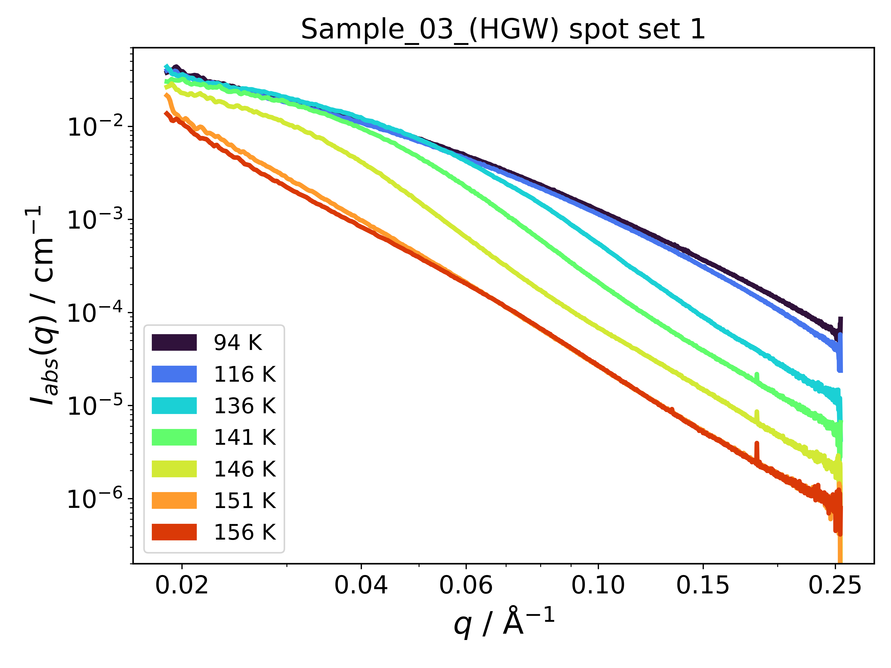
Figure S13: Exemplary Normalized intensity I(q)_{abs} of HGW. The normalization procedure is explained in detail in the text.
Figure S13 shows an exemplary set of normalized scattering profiles for HGW. This normalization procedure does remove the effects of varying illuminated sample amounts as can nicely be seen by comparison of the raw K_{p} values (figure S11D) and the ones obtained from the normalized profiles (see figure 3A in the main text). The latter values scatter less and all lie on a well-defined curve regardless of the sample amount. However, this procedure heavily relies on the assumption that the classical Guinier law is followed, that equation S4 holds for HGW, and that κ_{T} of hexagonal ice I is the same for HGW. Due to the complex morphology of the sample, especially the first assumption may only apply partially. For this reason, the resulting surface to volume ratio should not be taken as absolute values, which is why we only look at relative changes.

S6.4 Fit of I(q) Using a Guinier-Porod Model
The model-based analysis employs a generalized Guinier-Porod model developed by Hammouda¹⁶. It contains no assumptions regarding the shape of the scatterers, only the existence of one Guinier region at low q and one Porod region at high q. The Guinier region is described with a modified Guinier law (see eq. S6), where s is a dimensionality parameter, R_{g} is the radius of gyration and G is a scaling factor. Equation S7 shows the Porod part, where m is the Porod exponent and D is a parameter.¹⁶

$I\left(q\right)=\frac{G}{q^{s}}\exp\left(\frac{-q^{2}R_{g}^{2}}{3-s}\right) for q≤q_{1}$ (S6)
$I\left(q\right)=\frac{D}{q^{m}} for q≥q_{1}$ (S7)

q₁ locates the q value, where the Guinier and Porod part switch over. Enforcing continuity between both parts yield the following expressions for q₁ and D (eqs. S8 and S9)¹⁶:

$q_{1}=\frac{1}{R_{g}}{\left(\frac{\left(m-s\right)\left(3-s\right)}{2}\right)}^{\frac{1}{2}}$ (S8)
$D=\frac{G}{R_{g}^{m-s}}{\left(\frac{\left(m-s\right)\left(3-s\right)}{2}\right)}^{\frac{m-s}{2}}\exp\left(-\frac{\left(m-s\right)}{2}\right)$ (S9)

Thus, q₁ is calculated internally from the other parameters and does not need to be set. The parameters shown in figure 3B-D in the main text were obtained by a least square fit of eqs. S6 and S7 (with eq. S9 for D in eq. S7) to the raw small-angle scattering profiles. Figure S14 shows exemplary fits of this model to the small-angle I(q) data for a HGW sample. Obtaining reasonable fits required to restrict the fitted q-range to 0.025-0.1 Å⁻¹.

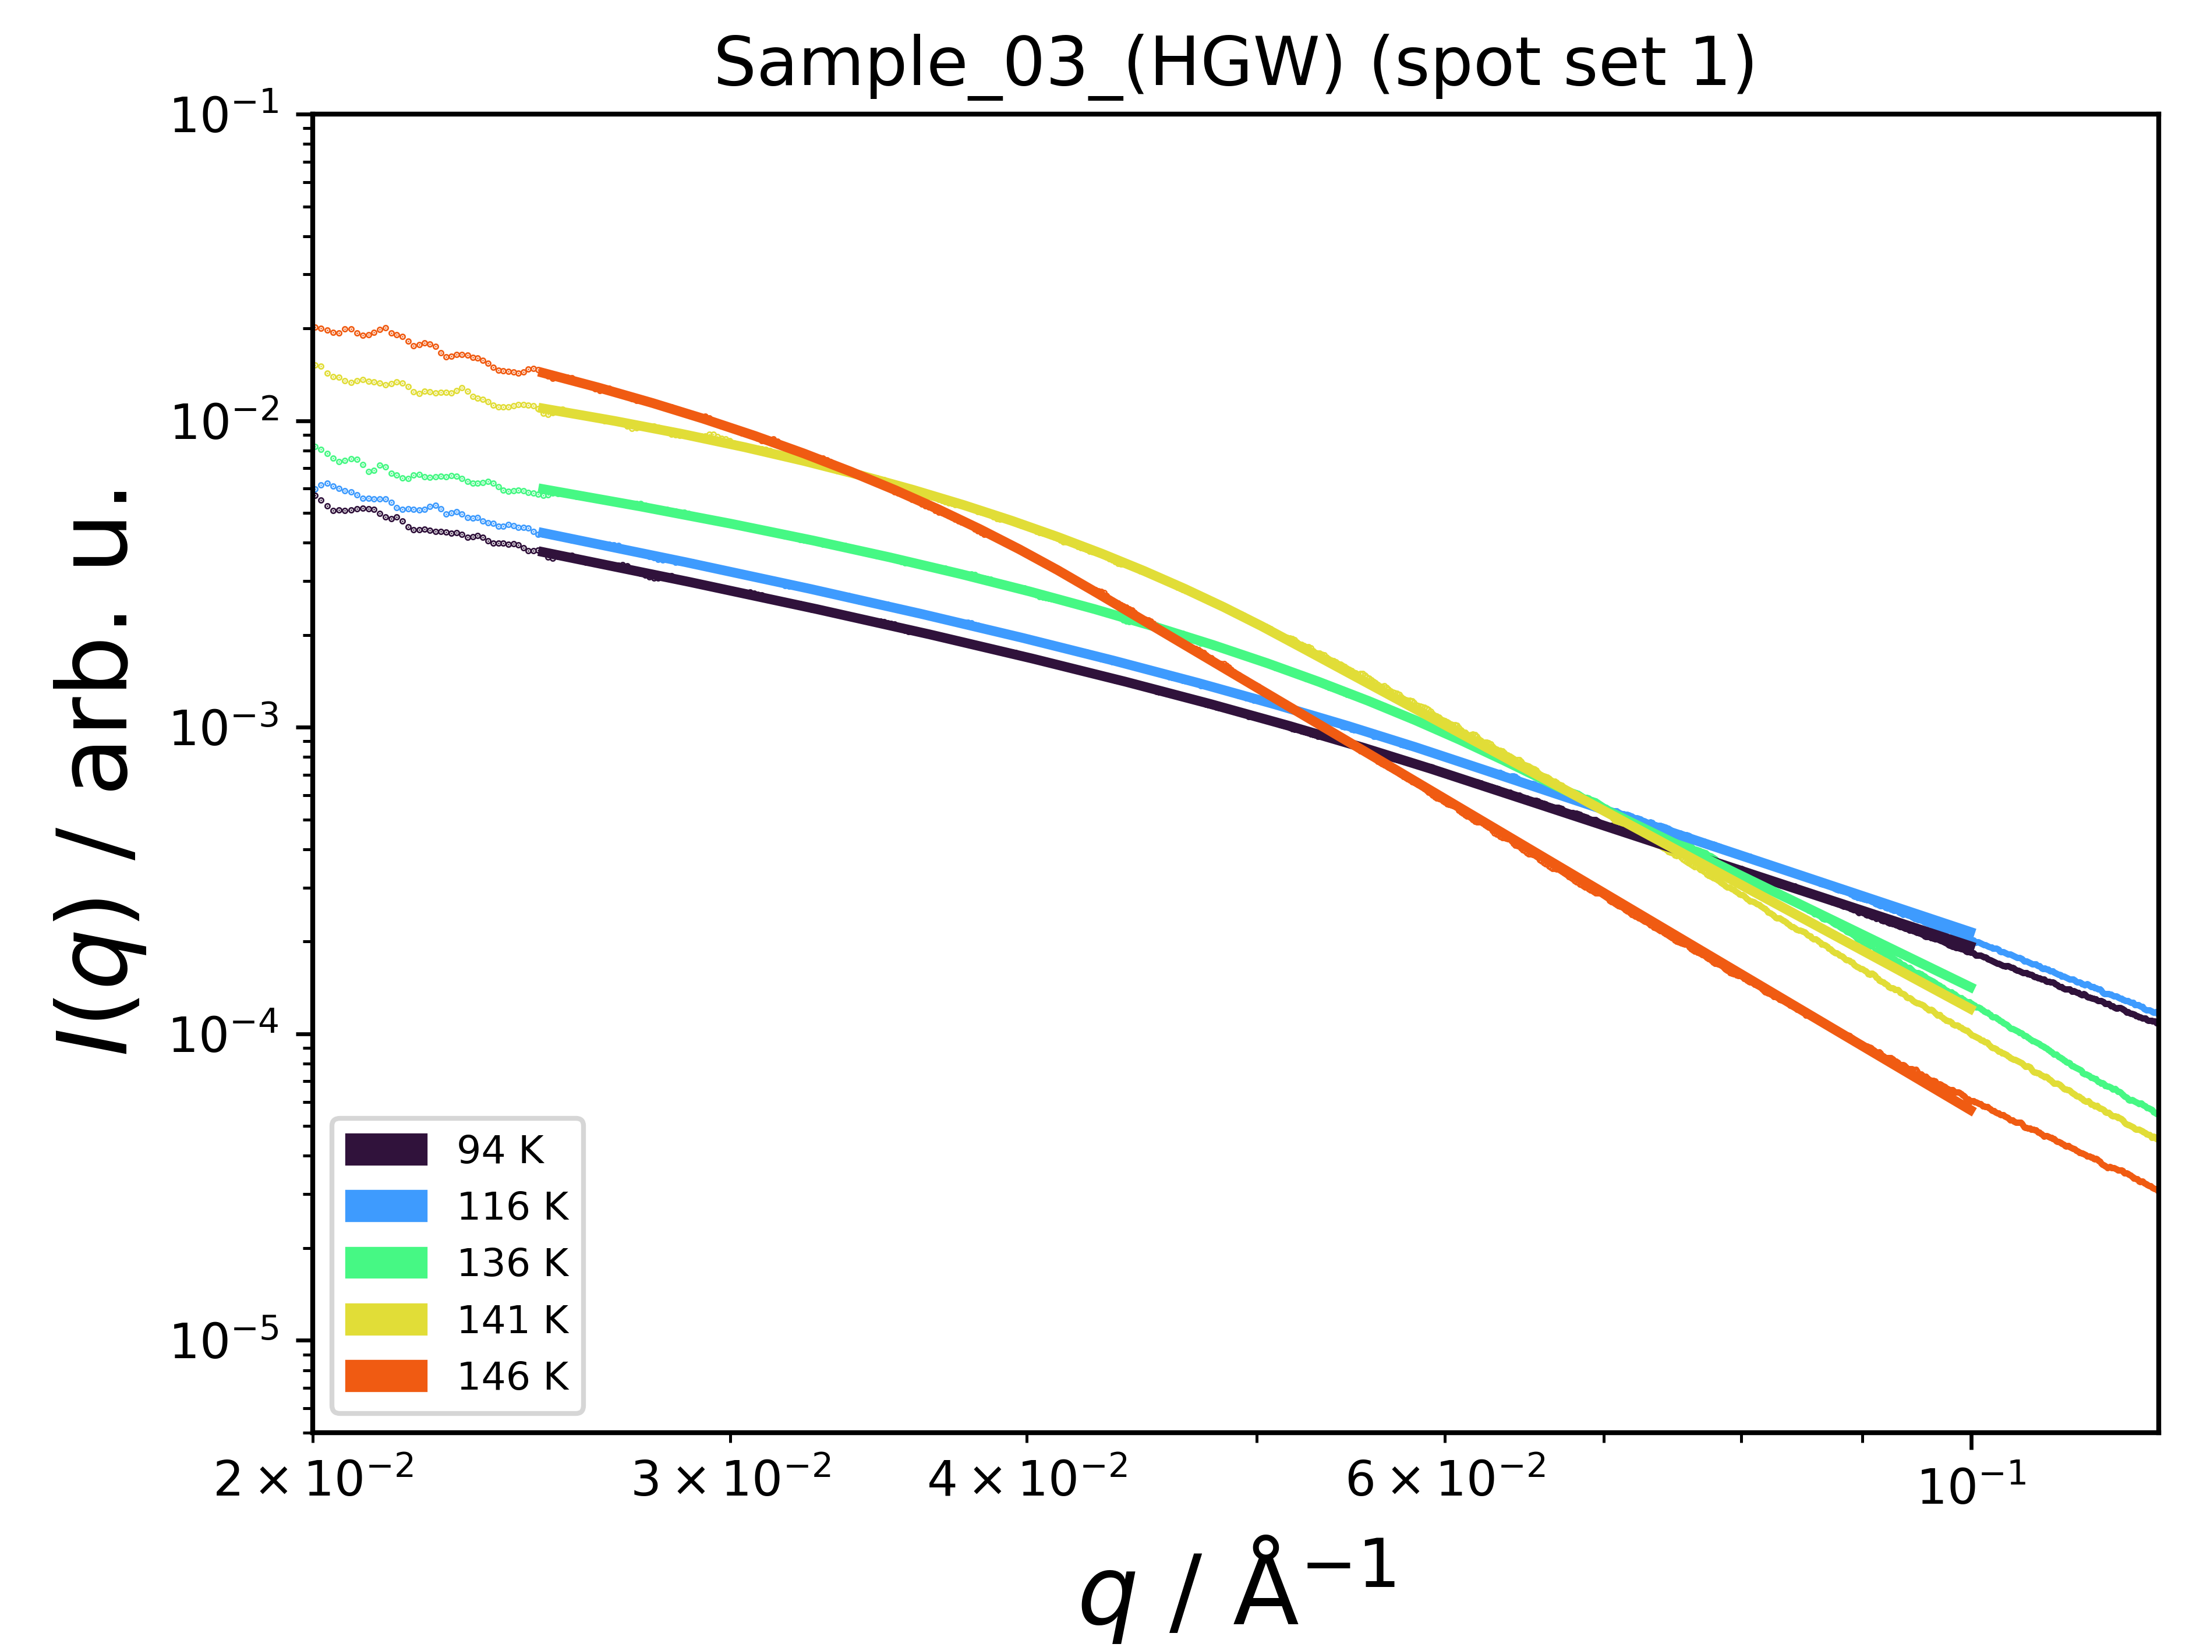
Figure S14: Exemplary Normalized fits (bold lines) of the Guinier-Porod model by Hammouda¹⁶ to the raw small-angle I(q) (thin lines) of a HGW sample.

S7 Supplementary SEM Data and Analysis
S7.1 Time Resolved SEM data
The fast scan rate of the SEM (20s per micrograph) allows tracking changes of the sample’s morphology over time. Movie S1 (see ‘MovieS1.mp4’ in the supplementary information folder) shows the sample’s surface over the duration of 5 min at each temperature (except for 77 K, there the duration is 2.3 min). At 77 K, the droplet interfaces are clearly visible and besides a small drift, no pronounced temporal changes are visible. More specifically, the observed morphological features are retained over the full measurement time, indicating the absence of flow at these timescales. This is still the case even after heating to 120 K. Upon further increasing the temperature to 125 K, the morphology changes drastically when compared to lower temperatures. More specifically, the surface evolves with time indicating flowing of the sample. Along with that, the droplet interfaces disappear (see also figure 1 in the main text), implying that the onset of liquid dynamics causes the vanishing of these interfaces. At 145 K, the sample’s surface looks almost like a boiling liquid. We assume, at this point water is evaporating in the high-vacuum environment and creating bubbles in the liquid matrix, which appears to have rather fast dynamics. This changes drastically after heating the sample to 155 K, where it crystallizes. In contrast to the previous temperature, no macroscopic dynamics are observed anymore. This rapid slowing down caused by crystallization corroborates the idea that the amorphous state, from which ice I crystallizes is a viscous liquid.

S7.2 Raw SEM Images and Processing
Figure S15 shows the raw SEM images at 4 different temperatures. The pictures at 120 and 145 K are used for figure 1 in the main text.

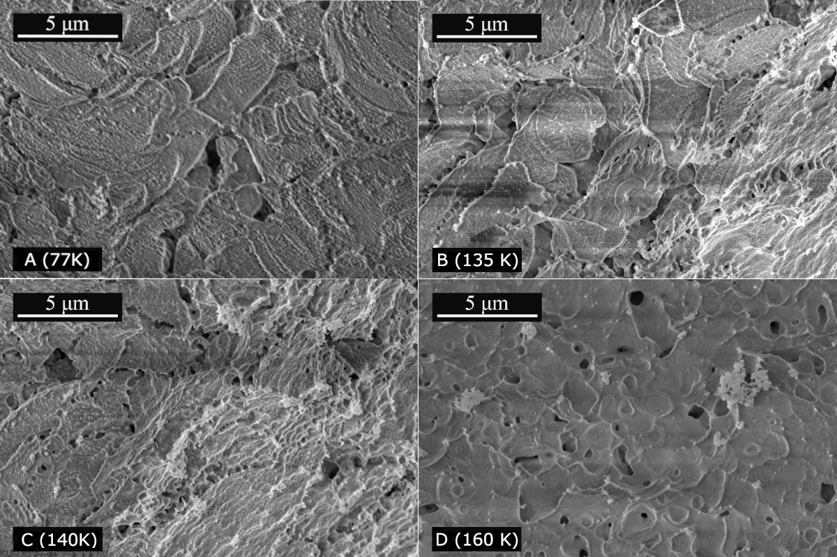
145 K
125 K
120 K
77 K

Figure S15: Raw SEM micrographs at 4 different temperatures.
Further processing of the images was performed using the scikit-image¹⁷ package for python. Detailed descriptions of the used algorithms are found at the scikit homepage (https://scikit-image.org/). As mentioned in the main text, a Sato ridge operator¹⁸ was used to detect the droplet interfaces. More specifically, this algorithm detects curvilinear features. Before applying this algorithm, the input image (figure S15 at 120 K) was denoised using a median filter and a local threshold algorithm was applied. The latter produces a binary picture, where values that exceed the threshold are set to 1 and ones that do not are set to 0. The result of this procedure is shown in figure S16A. This image then was used as input to produce figure 1C in the main text, using the Sato ridge operator. The same procedure was repeated for the image at 140 K and results in figure 1D in the main text.

Additionally, a Sobel edge detection algorithm¹⁹ was used to convert the denoised input image to a gradient map, which is shown in figure S16B. The intensity of each pixel in this figure corresponds to the gradient in the input image. Figure S16B was used for the watershed segmentation, the result of which is shown in figure 1 in the main text. This algorithm partitions the input image into segments based on the topography, where the pixel values are treated as elevation.
A
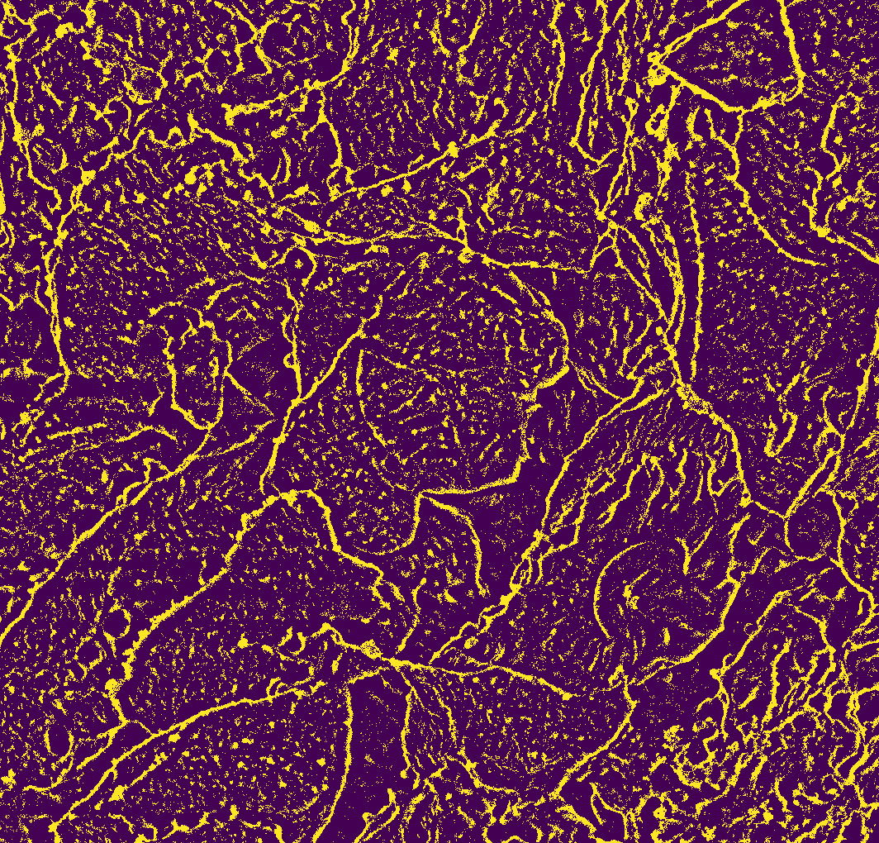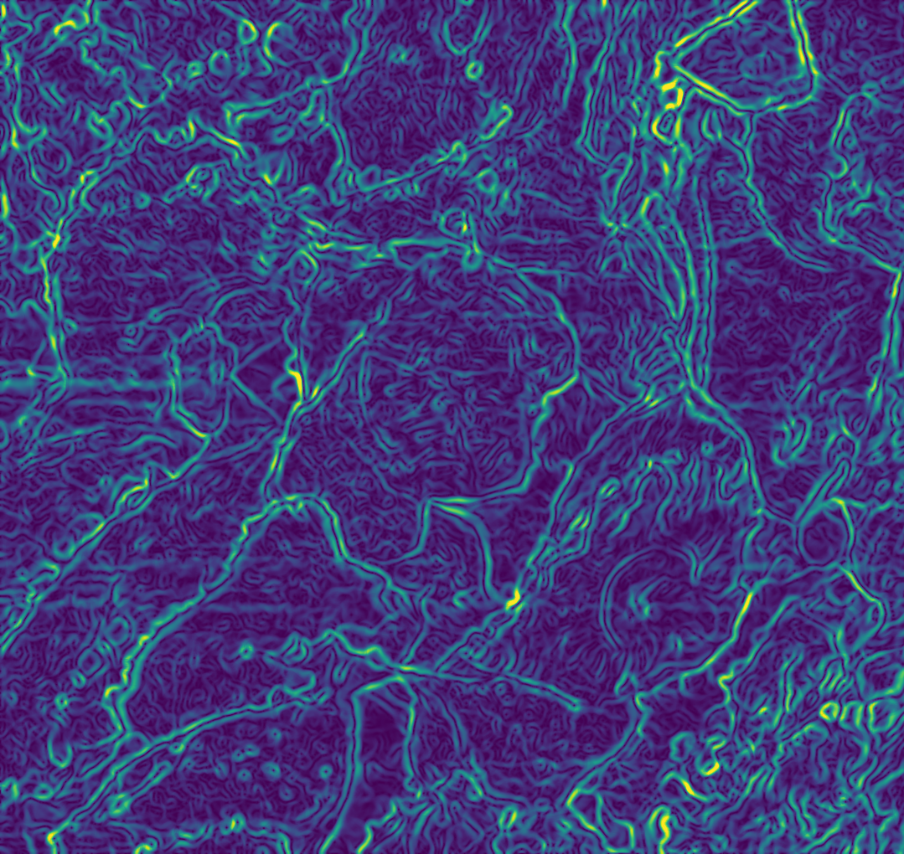
B

Figure S16: A: Denoised SEM image at 120 K (see figure S15) after applying a local thresholding algorithm (see text). B: Gradient image of the denoised SEM image at 120 K. In both images, yellow color indicates large and blue color indicates low intensity.

S8 Preliminary Measurements and Tests at P10 (PETRA III, DESY)
Prior to the experiments at the MID instrument at European XFEL, we tested the sample environment and preparation procedure during a beamtime at P10 (PETRA III, DESY; Proposal T-20220749 EC). A similar WAXS/SAXS setup as described in the methods section of the main text was used. More precisely, we used a beam focused on a 12 x 16 µm spot with a photon energy of 8.7 keV and a flux of 4 x 10¹⁰ photons per second, attenuated by silicon absorbers to prevent beam-induced effects. The WAXS was detected by an Eiger 500K and the SAXS using an Eiger X4M detector. The data were acquired for 1000 s each at a detector refresh rate of 1 Hz. The sample environment (JANIS cryostat) was identical to the one used at MID.

Initially, we powdered HGW and sandwiched it between two diamond windows, which were mounted on the cryostat. Since this process has to be conducted under liquid nitrogen, loading the sample that way takes quite long (> 20 min). As seen from the pronounced Bragg peaks in the WAXS data (figure S17), a substantial amount of ice I condensed on the sample during this procedure. However, these impurities have to be minimized to ensure that effects that are studied originate from the glassy part of the sample.
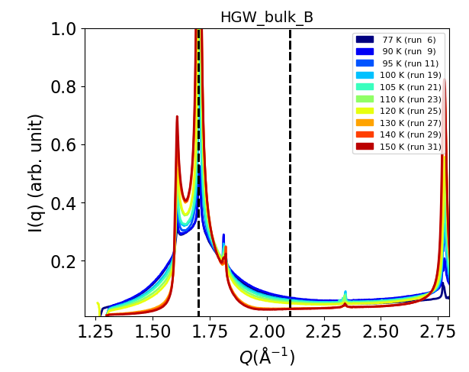
Figure S17: Preliminary WAXS data from P10 of powdered HGW sandwiched between diamond windows (~10-15 K temperature offset).

To facilitate the loading procedure, we moved to using grids, on which the sample is already pre-loaded. More precisely, HGW powder was pressed into the holes of a Cu grid (200 µm thick, 10 mm diameter) using the exact same procedure as described in section S2 and the methods section in the main text. Besides other advantages like consistent sample thickness and improved thermal contact, this procedure minimizes the amount of ice that condenses on the sample during loading. This is confirmed by the WAXS data shown in figure S18, where much less intense Bragg peaks of ice I are observed when compared to figure S17. Additionally, the sample stays amorphous until at least 130 K (not corrected for the ~10-15 K temperature offset), which provides a large temperature range to study coalescence, especially because this range includes water’s glass transition temperature at 124-136 K.

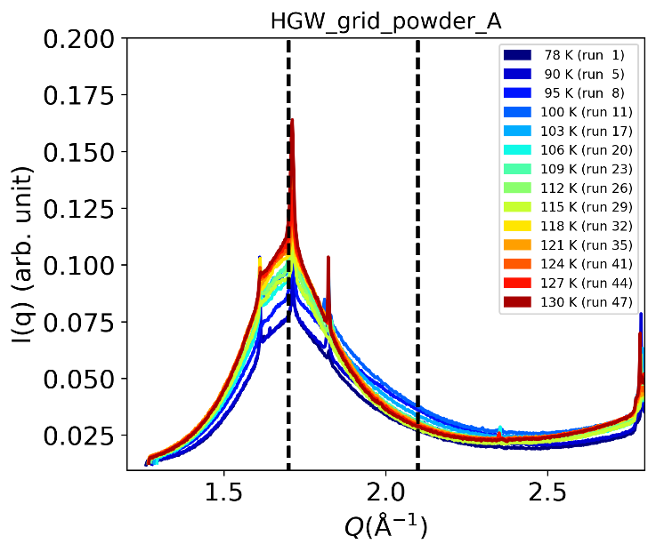
Figure S18: Preliminary WAXS data from P10 of powdered HGW pressed on a Cu grid (200 µm thick, 10 mm diameter). The temperature offset is ~10-15 K.
Preliminary SAXS data using a grid sample (powder pressed into the grid holes) is shown in figure S19. The raw I(q) data show that especially for very low temperatures (close to liquid nitrogen temperature), the ‘knee’-like feature is partly outside the upper end of the SAXS q-range of 0.1 Å⁻¹. This is an important observation for setting a suitable q-range for the MID experiment. However, this feature seems to differ from the knee observed in the HGW data in figure S10. More precisely, fitting the Hammouda model (see section S6.4) is unsuccessful here, even when restricting the fitted region between 0.02 and 0.1 Å⁻¹. Also fitting just the Gunier part of this model does not work. Additionally, an unexpected trend upon heating is observed for the Porod-scaled data: A decrease in S/V is usually indicated by a decrease of I(q)*q⁴ in the high-q limit. However, we here observe an increase followed by a decrease, which is not consistent with the idea of droplet coalescence. This is because the procedure of pressing the HGW powder into the grid already causes coalescence/sintering of the sample before it is even inside the cryostat at the beamline. For this reason, we switched to directly depositing HGW on thin Cu grids as described section S2 for the experiment at MID. This ensures that HGW is measured in its native state.

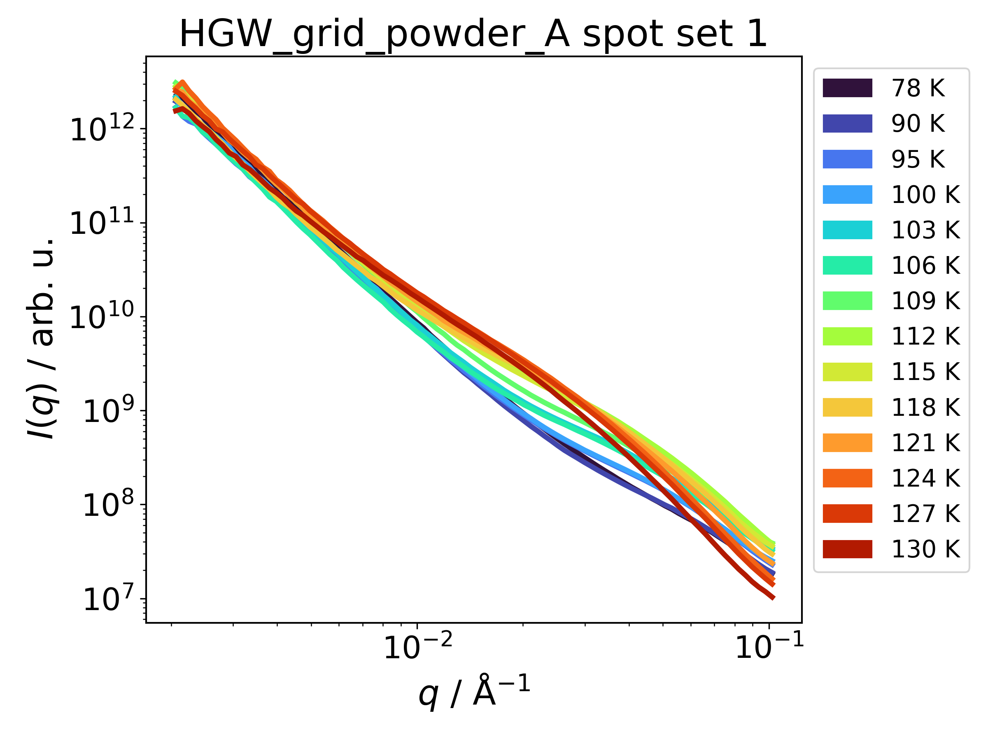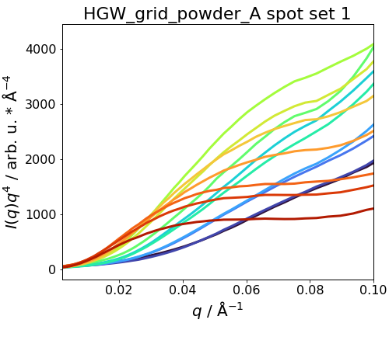
Figure S19: Raw SAXS I(q) (left panel) and Porod-scaled data (right panel) for HGW powder pressed into a Cu grid for different temperatures (offset ~10-15 K).

Supplementary References
1. Bachler, J., Giebelmann, J. & Loerting, T. Experimental evidence for glass polymorphism in vitrified water droplets. Proc. Natl. Acad. Sci. USA 118, e2108194118; 10.1073/pnas.2108194118 (2021).
2. Madsen, A. et al. Materials Imaging and Dynamics (MID) instrument at the European X-ray Free-Electron Laser Facility. J. Synchrotron Rad 28, 637–649; 10.1107/S1600577521001302 (2021).
3. Kohl, I., Bachmann, L., Hallbrucker, A., Mayer, E. & Loerting, T. Liquid-like relaxation in hyperquenched water at ≤ 140 K. Phys. Chem. Chem. Phys. 7, 3210–3220; 10.1039/b507651j (2005).
4. Johari, G. P., Hallbrucker, A. & Mayer, E. Isotope effect on the glass transition and crystallization of hyperquenched glassy water. J. Chem. Phys. 92, 6742–6746; 10.1063/1.458593 (1990).
5. Feistel, R. & Wagner, W. A New Equation of State for H2O Ice Ih. JPCRD 35, 1021–1047; 10.1063/1.2183324 (2006).
6. Bowron, D. T. et al. The local and intermediate range structures of the five amorphous ices at 80 K and ambient pressure: a Faber-Ziman and Bhatia-Thornton analysis. J. Chem. Phys. 125, 194502; 10.1063/1.2378921 (2006).
7. Malkin, T. L. et al. Stacking disorder in ice I. Phys. Chem. Chem. Phys. 17, 60–76; 10.1039/c4cp02893g (2015).
8. Lehmkühler, F. et al. Emergence of anomalous dynamics in soft matter probed at the European XFEL. Proc. Natl. Acad. Sci. USA 117, 24110–24116; 10.1073/pnas.2003337117 (2020).
9. Tulk, C. A. et al. Structural studies of several distinct metastable forms of amorphous ice. Science (New York, N.Y.) 297, 1320–1323; 10.1126/science.1074178 (2002).
10. Li, H. et al. Intrinsic Dynamics of Amorphous Ice Revealed by a Heterodyne Signal in X-ray Photon Correlation Spectroscopy Experiments. J. Phys. Chem. Lett. 14, 10999–11007; 10.1021/acs.jpclett.3c02470 (2023).
11. Bachler, J., Giebelmann, J., Amann-Winkel, K. & Loerting, T. Pressure-annealed high-density amorphous ice made from vitrified water droplets: A systematic calorimetry study on water's second glass transition. J. Chem. Phys. 157, 64502; 10.1063/5.0100571 (2022).
12. Feign, L. A. & Svergun, D. I. Structure Analysis by Small-Angle X-Ray and Neutron Scattering (Springer US, Boston, MA, 1987).
13. Gunier, A. & Fournet, G. Small-angle Scattering of X-rays (John Wiley & Sons, Ltd, New York, 1955).
14. Orthaber, D., Bergmann, A. & Glatter, O. SAXS experiments on absolute scale with Kratky systems using water as a secondary standard. J Appl Crystallogr 33, 218–225; 10.1107/S0021889899015216 (2000).
15. Marion, G. & Jakubowski, S. The compressibility of ice to 2.0 kbar. Cold Regions Science and Technology 38, 211–218; 10.1016/j.coldregions.2003.10.008 (2004).
16. Hammouda, B. A new Guinier–Porod model. J Appl Crystallogr 43, 716–719; 10.1107/S0021889810015773 (2010).
17. van der Walt, S. et al. scikit-image: image processing in Python. PeerJ 2, e453; 10.7717/peerj.453 (2014).
18. Sato, Y. et al. Three-dimensional multi-scale line filter for segmentation and visualization of curvilinear structures in medical images. Med. Image Anal. 2, 143–168; 10.1016/S1361-8415(98)80009-1 (1998).
19. Irwin Sobel & Gary Feldman. An Isotropic 3x3 Image Gradient Operator; 10.13140/RG.2.1.1912.4965 (2015).

