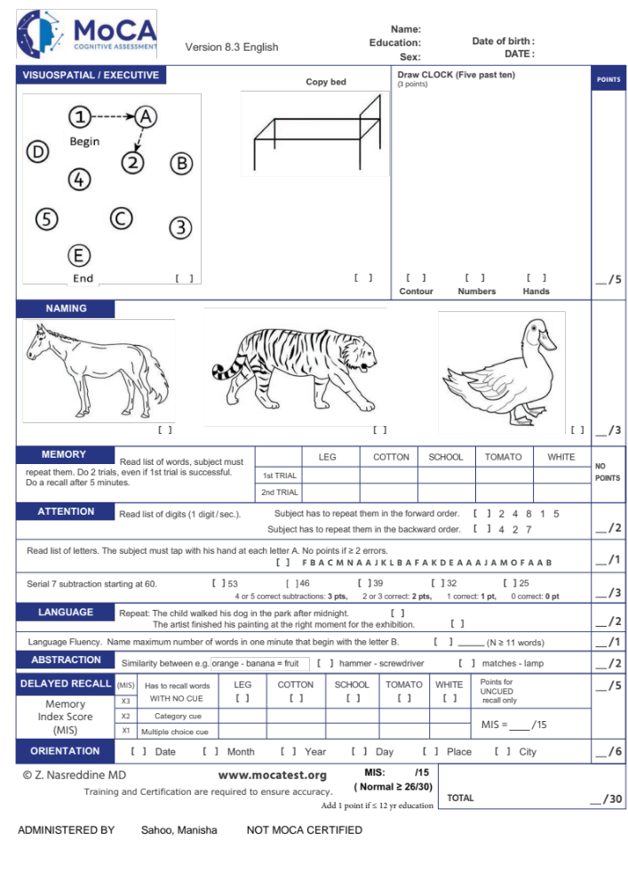
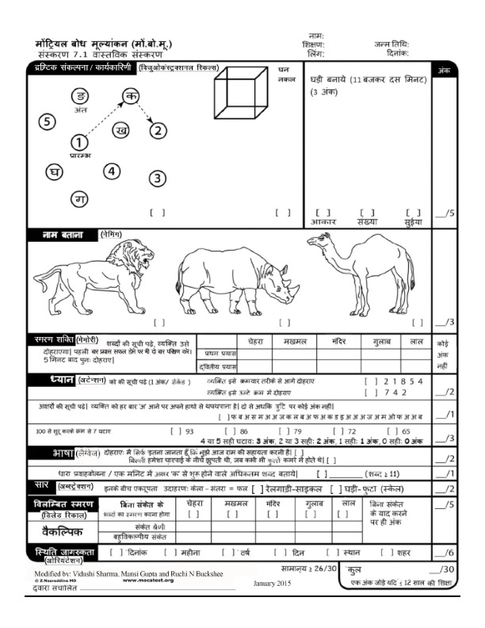

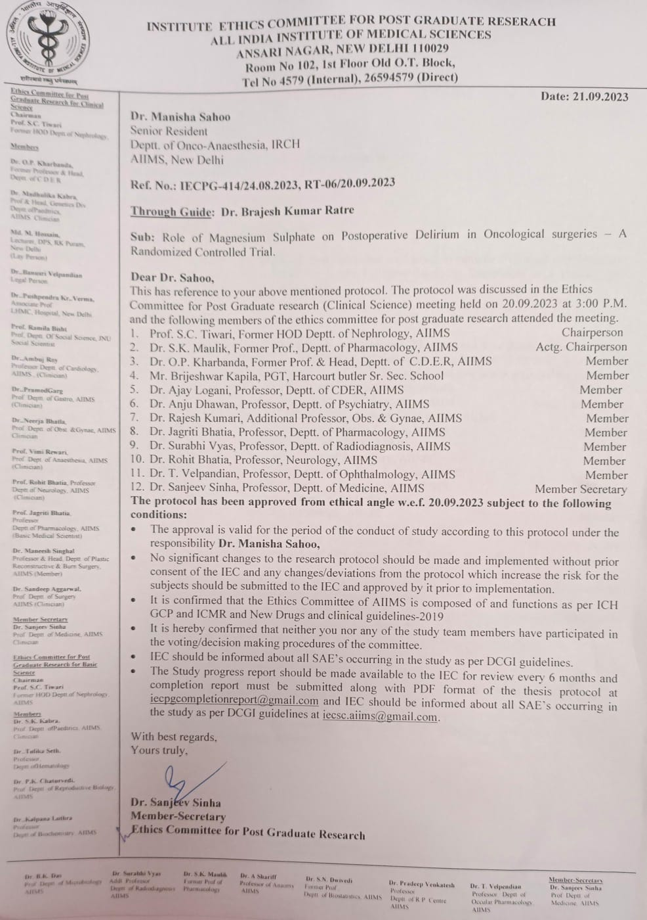
Participant Information Sheet (PIS) English
Dear Sir/Madam,
You have been approached with regards to possible participation in a study titled
“Role of Magnesium Sulphate on Postoperative Delirium in Oncological surgeries- A Randomized Controlled trial”
(I)Aims and Methods of research:
To study whether Magnesium Sulphate infusion in oncological surgeries helps to improve post- operative delirium, inflammation and also its effect on length of hospital/ICU stay. The intervention is a well-tested in other surgeries with mixed results. Before the day of surgery, during the pre-anaesthesia check-up we will ask you to fill a 10 minutes questionnaire. You have a 50% chance of being allocated into either of the groups- study drug or placebo, depending on the random code picked via the sealed opaque envelope containing the random number for group allocation. The study drug after you are under general anaesthesia via IV cannula after taking 2 ml blood sample. After surgery, you will be asked to fill the same questionnaire twice on different days. Blood samples will be collected again for inflammatory markers while sending for other routine investigations. The optic nerve will be measured using ultrasound after putting you under anaesthesia and before waking you up. You will be assessed for pain relief, any complications, length of ICU and hospital stay. If we find any delirium then we will get a proper psychiatric consultation done for you.
(II) Expected duration of study participation:
From the 1 day prior to surgery till Post-operative day 3 or discharge whichever is earlier.
(III) The benefits to be expected from the research to the subject or to others:.
Instillation of drugs, with minimum complications which can reduce cognitive decline and help in better recovery of the patient, hence reducing the mental and financial distress of the patient and their family members.
(IV) Any risk to the subject associated with the study:
General surgical and anaesthesia risks.
(V) Side effects of the drugs and the procedure:
The interventional drugs to be employed is routinely used in intra-operative anaesthetic practice – with zero to minimal side effects like allergic reactions, transient muscle weakness, abnormal cardiac rhythm and absent reflexes.
(VI) Maintenance of confidentiality of records:
Your information will not be used for any purpose other than that of the study and publication in a scientific journal. The collected information will be kept securely under lock and key and in a password protected computer. Conditions of anonymity and confidentiality will be ensured during the study and publication.
(VII) Provision of free treatment for research related injury:
Free treatment will be provided within the facilities of the Institute.
(VIII) Compensation of subjects for disability or death resulting from such injury:
No compensation will be provided for disability or death resulting from research related injury.
(IX) Freedom of individual to participate and to withdraw from research at any time without penalty or loss of benefits to which the subject would otherwise be entitled:
Yes, at any time you can withdraw from the study. By taking such a decision you will not incur any penalty or loss of benefits which you would otherwise be entitled.
(X) Amount of blood sample to be taken during the study:
Blood samples- 4-6ml (1 teaspoon) will be taken during this study.
(XI) Costs and source of investigations, disposables, implants, and drugs / contrast media must be mentioned in the PIS:
You will not be asked to procure any item required in the study and the blood investigation is free.
(XII) In case of drug trials: The chemical name of the drug, date of its manufacturing and batch number must be mentioned, Initial Bio equivalent study of the drug / references should be provided:
Not a drug trial
You are free to contact the investigator for clarification on the contact details mentioned:
Principal investigator: Dr. Manisha Sahoo, Senior Resident, Department of Onco- Anaesthesia and Palliative Medicine, Dr B.R.A.IRCH,AIIMS, New Delhi . Contact- 9438833219, manisha.1223s@gmail.com
Co-Investigator: Dr. Brajesh Kumar Ratre, Assistant Professor, Department of Onco- Anaesthesia and Palliative Medicine, Dr B.R.A.IRCH, AIIMS, New Delhi. Contact- 8696156799

Participant Consent Form (PCF) English
Participant identification number for this trial: _______________________
Title of project: Role of Magnesium Sulphate on Postoperative Delirium in Oncological
surgeries- A Randomized Controlled trial
Name of Principal Investigator: Dr. Manisha Sahoo, 9438833219, manisha.1223s@gmail.com
Co-Investigator: Dr. Brajesh Kumar Ratre, 8696156799
The contents of the information sheet dated .................... that was provided have been read carefully by me / explained in detail to me, in a language that I comprehend, and I have fully understood the contents. I confirm that I have had the opportunity to ask questions. The nature and purpose of the study and its potential risks / benefits and expected duration of the study, and other relevant details of the study have been explained to me in detail. I understand that my participation is voluntary and that I am free to withdraw at any time, without giving any reason, without my medical care or legal right being affected.
I understand that the information collected about me from my participation in this research and sections of any of my medical notes may be looked at by responsible individuals from AIIMS. I give permission for these individuals to have access to my records.
I agree to take part in the above study.
--------------------------------------------- Date:
(Signatures / Left Thumb Impression) Place:
Name of the Participant: _________________________________________________________
Son / Daughter / Spouse of: _______________________________________________________
Complete postal address: _________________________________________________________
This is to certify that the above consent has been obtained in my presence.
------------------------------
Signatures of the Principal Investigator
1) Witness – 1 ------------------------------
Signature
Name:
Address
2) Witness – 2
--------------------------------
Signature
Name
Address:

