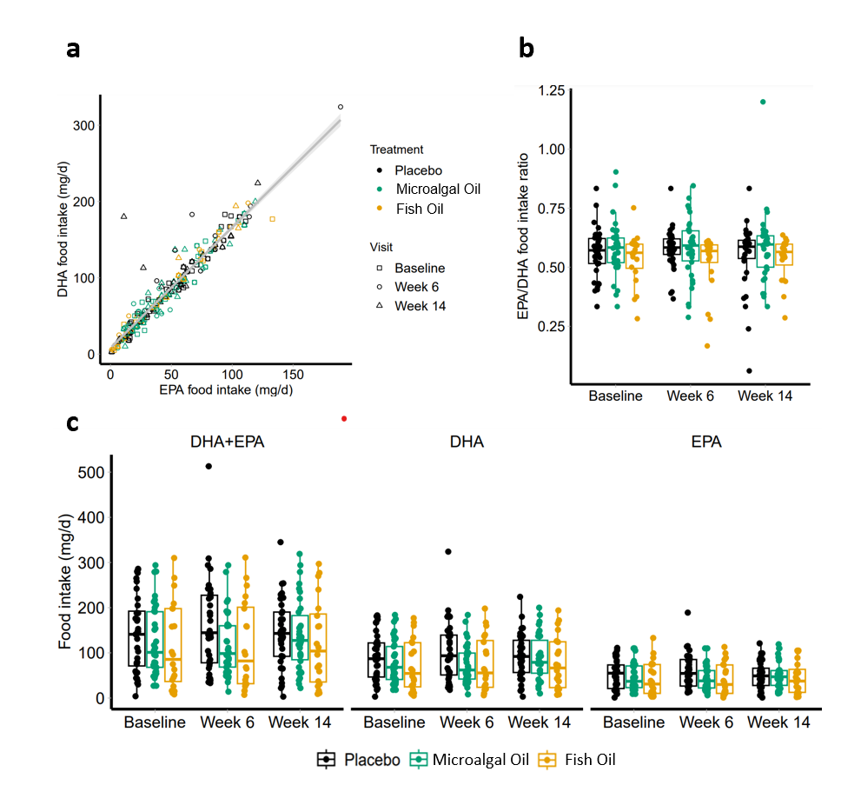
Supplementary Figure S1. DHA and EPA intake from Food
DHA and EPA intake from food was evaluated from food frequency questionnaires at baseline, week 6, and week 14. (A) There was a significant correlation between DHA and EPA food intake (r = 0.96). (B) The EPA to DHA ratio from food source was approximately 1:2, taking into account both weeks 6 and 14 data. (C) No significant differences in DHA and/or EPA from food intake were detected across groups. Box plots represent the median and 25th and 75th percentile. Each dot represents individual subjects. Placebo data points = black circles and lines; microalgal data points = green circles and lines; fish data point = orange circles and lines.

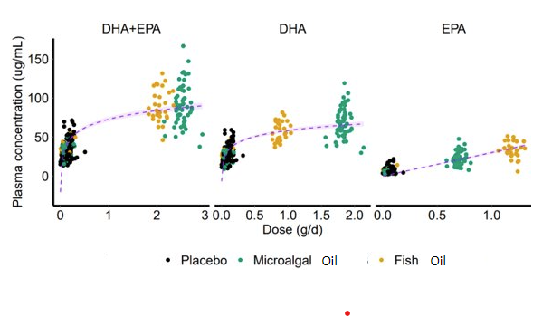

Supplementary Figure S2. Dose effect analysis
Total DHA and EPA intake was calculated as the sum of dietary intake estimated from the food frequency questionnaire and the microalgal or fish oil supplement intake. The compliance and the actual number of capsules taken by each subject was taken into consideration to simulate the dose effect analysis. Logarithmic fits are presented for (A) DHA+EPA (y = 36.90 log(x) – 37.96 (R² = 0.65)), (B) DHA (y = 25.81 log(x) – 19.05 (R² = 0.63)), and (C) EPA (y = 0.03 x (R² = 0.83)). Purple dotted lines are logarithmic fits with 90% confidence intervals shown as shaded light purple area. Black circles represent the individual subjects in placebo group. Green circles represent the microalgal group. Orange circles represent the fish group.

Supplementary Table S1. Product Content
 | Placebo | fish | Microalgal
EPA | <1.0 mg/g | 280.7 mg/g | 164 mg/g
DHA | <1.0 mg/g | 199.2 mg/g | 443 mg/g
Omega 3 FA | <1.0 mg/g | 530.3 mg/g | 598 mg/g
Saturated FA
8:0 Caprylic | <0.10% | <0.10% | <0.10%
10:0 Capric | <0.10% | <0.10% | <0.10%
12:0 Lauric | <0.10% | <0.10% | <0.10%
14:0 Myristic | <0.10% | 0.44% | 1.5%
15:0 Pentadecanoic | <0.10% | <0.10% | 0.2 - 2.0%
16:0 Palmitic | 10.88% | 2.25%
  18.6%
17:0 Margaric | 0.14% | 0.23% | 0.1%
18:0 Stearic | 3.06% | 3.77% | 1.3%
20:0 Arachidic | 0.40% | 0.49% | 0.4%
21:0 Henicosanoic | <0.10% | 0.14% | <0.10%
22:0 Behenate | 0.26% | 0.3% | 0.1%
23:0 Tricosanoic | <0.10% | <0.10% | <0.10%
24:0 Lignoceric | 0.14% | 0.16% | <0.10%
Monosaturated FA
14:1 Myristoleic | <0.10% | <0.10% | <0.10%
15:1 Pentadecenoic | <0.10% | <0.10% | <0.10%
16:1 Palmitoleic | 0.14% | 1.02% | <0.10%
17:1 Heptadecenoic | <0.10% | 0.12% | <0.10%
18:1n-9 Oleic Acid | 28.14% | 12.07% | 3.5%
18:1n-7 Vaccenic | 1.14% | 2.34% | 0.1%
20:1n-9 Eicosenoic | 0.55% | 2.58% | <0.10%
22:1n-9 Erucic | <0.10% | 2.62% | <0.10%
24:1 Nervonic | <0.10% | 0.61% | <0.10%
Polyunsaturated FA
18:2n-6 Linoleic | 49.53% | 1.55% | 0.6%
18:3n-3 α-Linolenic | 2.67% | 0.72% | <0.1%
18:3n-6 ϒ-Linolenic | 0.61% | 0.17% | <0.10%
20:2n-6 Eicosadienoic | <0.10% | 1.89% | <0.10%
20:3n-3 | <0.10% | 0.16% | <0.10%
20:3n-6 dihomo-ϒ-Linolenic | <0.10% | 0.43% | <0.10%
20:4n-6 Arachidonic | <0.10% | 1.75% | 1.3%
20:5n-3 EPA | <0.10% | 31.10% | 19.8%
22:2n-6 Docosadienoate | <0.10% | 1.48% | <0.10%
22:5n-3 DPAn-3 | <0.10% | 3.89% | 4.7%
22:5n-6 DPAn-6 | <0.10% | 0.84% | 1.3%
C22:6n-3 DHA | <0.10% | 22.31% | 35.2%

Supplementary Table S2. DHA and EPA intake from food
 |  | Placebo | Microalgal Omega 3 | Fish Omega 3
DHA + EPA intake (mg/d)
Baseline | N  Mean (SD)  Median [range] | 36  142.0 (84.2)  141.0 [4.0 - 286.0] | 37  122.8 (75.7)  101.0 [27.0 - 294.0] | 20  114.8 (95.9)  85.5 [8.0 - 310.0]
Week 6 | N  Mean (SD)  Median [range] | 34  161.6 (103.6)  144.5 [33.0 - 513.0] | 34  117.4 (68.7)  98.5 [14.0 - 294.0] | 20  116.1 (97.2)  82.0 [7.0 - 311.0]
Week 14 | N  Mean (SD)  Median [range] | 34  143.1 (77.2)  143.0 [3.0 - 345.0] | 34  139.1 (78.6)  127.5 [22.0 - 319.0] | 20  121.9 (95.6)  104.0 [9.0 - 297.0]
DHA intake (mg/d)
Baseline | N  Mean (SD)  Median [range] | 36  90.2 (52.9)  87.0 [3.0 - 183.0] | 37  77.6 (47.1)  68.0 [18.0 - 184.0] | 20  72.4 (58.1)  54.5 [5.0 - 177.0]
Week 6 | N  Mean (SD)  Median [range] | 34  102.7 (65.6)  93.5 [18.0 - 324.0] | 34  73.9 (42.1)  79.0 [8.0 - 184.0] | 20  74.6 (61.1)  55.5 [12.0 - 189.0]
Week 14 | N  Mean (SD)  Median [range] | 34  92.5 (50.6)  92.0 [3.0 - 224.0] | 34  88.4 (49.3)  79.0 [10.0 - 200.0] | 20  77.9 (60.3)  49.0 [1.0 - 121.0]
EPA intake (mg/d)
Baseline | N  Mean (SD)  Median [range] | 36  51.8 (31.7)  55.0 [1.0 - 111.0] | 37  45.2 (29.0)  37.0 [9.0 - 110.0] | 20  42.4 (38.2)  31.0 [3.0 - 133.0]
Week 6 | N  Mean (SD)  Median [range] | 34  58.9 (38.7)  54.5 [12.0 - 189.0] | 34  43.6 (27.3)  38.0 [6.0 - 110.0] | 20  41.2 (36.3)  30.0 [1.0 - 113.0]
Week 14 | N  Mean (SD)  Median [range] | 34  50.6 (30.1)  49.0 [1.0 - 121.0] | 34  50.7 (30.0)  47.0 [10.0 - 119.0] | 20  44.0 (55.6)  37.5 [2.0 - 105.0]
EPA:DHA ratio
Baseline | N  Mean (SD)  Median [range] | 36  0.56 (0.10)  0.57 [0.33 - 0.83] | 37  0.58 (0.11)  0.58 [0.33 - 0.90] | 20  0.54 (0.11)  0.56 [0.28 - 0.75]
Week 6 | N  Mean (SD)  Median [range] | 34  0.58 (0.09)  0.58 [0.37 - 0.83] | 34  0.58 (0.13)  0.59 [0.29 - 0.84] | 20  0.52 (0.13)  0.57 [0.17 - 0.61]
Week 14 | N  Mean (SD)  Median [range] | 34  0.55 (0.14)  0.59 [0.06 - 0.83] | 34  0.58 (0.15)  0.60 [0.33 - 1.20] | 20  0.54 (0.09)  0.56 [0.29 - 0.64]

Supplementary Table S3. Plasma DHA and EPA concentrations before normalization to intake of food & dietary supplements
 |  | Placebo | Microalgal Oil | Fish Oil
Plasma DHA + EPA (μg/mL)
Baseline | N  Mean (SD)  Median [range] | 31  34.0 (12.9)  30.2 [14.2 - 56.9] | 28  30.4 (8.5)  31.1 [14.0 - 50.3] | 15  36.5 (8.9)  35.1 [26.7 - 57.8]
Week 6 | N  Mean (SD)  Median [range] | 31  36.6 (14.4)  32.4 [15.7 - 71.4] | 28  91.1 (28.0)  91.1 [37.5 - 147.1] | 15  90.4 (22.8)  84.0 [46.0 - 131.6]
Week 14 | N  Mean (SD)  Median [range] | 31  35.3 (14.7)  33.6 [13.6 - 69.6] | 28  90.4 (24.7)  85.4 [53.4 - 166.6] | 15  89.7 (18.3)  87.0 [63.0 - 117.5]
Plasma DHA (μg/mL)
Baseline | N  Mean (SD)  Median [range] | 31  26.5 (10.5)  23.1 [12.1 - 47.6] | 28  23.8 (9.9)  23.5 [8.9 - 41.9] | 15  28.6 (7.5)  27.3 [18.9 - 47.1]
Week 6 | N  Mean (SD)  Median [range] | 31  28.9 (12.6)  26.3 [12.1 - 59.1] | 28  69.5 (20.4)  70.2 [29.8 - 106.2] | 15  56.5 (13.3)  54.4 [36.9 - 72.7]
Week 14 | N  Mean (SD)  Median [range] | 31  28.0 (12.2)  24.5 [9.9 - 59.0] | 28  67.7 (17.6)  61.8 [36.5 - 119.0] | 15  56.8 (11.9)  54.4 [36.9 - 72.7]
Plasma EPA (μg/mL)
Baseline | N  Mean (SD)  Median [range] | 31  7.4 (4.1)  6.4 [2.1 - 21.8] | 28  6.6 (2.5)  6.6 [3.0 - 10.7] | 15  7.9 (2.5)  7.9 [4.5 - 14.2]
Week 6 | N  Mean (SD)  Median [range] | 31  7.8 (3.5)  7.7 [2.3 - 19.7] | 28  21.6 (8.9)  20.3 [7.8 - 40.9] | 15  33.9 (11.8)  35.4 [5.8 - 51.1]
Week 14 | N  Mean (SD)  Median [range] | 31  7.2 (3.6)  7.2 [2.4 - 19.1] | 28  22.7 (8.0)  21.5 [10.9 - 47.6] | 15  32.9 (8.3)  32.7 [18.2 - 45.7]

Supplementary Table S4. Treatment effect of microalgal and fish oil on plasma DHA and EPA
Linear mixed effect model [Estimate (SE)]
Biomarker | intercept | Baseline | Statin | Treatment  Microalgal | Treatment  Fish
DHA+EPA | 62.6 (22.1)  p = 0.0050 | -1.6 (0.6)  p = 0.0058 | -17.6 (24.1)  p = 0.4667 | 129.0 (14.0)  p < 0.0001 | 106.9 (17.3)  p < 0.0001
DHA | 59.6 (19.6)  p = 0.0026 | -2.0 (0.7)  p = 0.0028 | -9.8 (22.4)  p = 0.6621 | 124.4 (13.0)  p < 0.0001 | 71.9 (16.1)  p < 0.0001
EPA | 101.2 (32.7)  p = 0.0029 | -12.2 (3.7)  p = 0.0014 | -49.6 (46.5)  p = 0.2902 | 165.7 (26.7)  p < 0.0001 | 247.5 (33.2)  p < 0.0001
ANCOVA
Biomarker | df | N | Chi2 | p-value
DHA+EPA | 2 | 74 | 96.01 | p < 0.0001
DHA | 2 | 74 | 94.04 | p < 0.0001
EPA | 2 | 74 | 70.75 | p < 0.0001

Supplementary Table S5. Percent change from baseline in plasma DHA and EPA concentrations before normalization to intake of food & dietary supplements
 |  | Placebo | Microalgal Oil | Fish Oil
Plasma DHA + EPA (μg/mL)
Week 6 | N  Mean (SD)  Median [range] | 31  10% (24)  4% [-42 - 54%] | 28  212% (106)  182% [92 - 563%] | 15  161% (89)  163% [29 - 332%]
Week 14 | N  Mean (SD)  Median [range] | 31  7% (31)  6% [-47 - 105%] | 28  213% (102)  199% [77 - 531%] | 15  154% (61)  236% [79 - 280%]
Plasma DHA (μg/mL)
Week 6 | N  Mean (SD)  Median [range] | 31  10% (26)  7% [-33 - 69%] | 28  207% (107)  189% [79 - 604%] | 15  109% (69)  92% [17 - 250%]
Week 14 | N  Mean (SD)  Median [range] | 31  8% (29)  10% [-44 - 92%] | 28  203% (98)  179% [53 - 508%] | 15  107% (59)  82% [42 - 259%]
Plasma EPA (μg/mL)
Week 6 | N  Mean (SD)  Median [range] | 31  15% (38)  16% [-68 - 89%] | 28  270% (229)  198% [51 - 993%] | 15  369% (254)  315% [16 - 1003%]
Week 14 | N  Mean (SD)  Median [range] | 31  6% (46)  -2% [-58 - 147%] | 28  289% (206)  215% [55 - 856%] | 15  348% (185)  293% [153 - 905%]

Supplementary Table S6. Changes in plasma DHA and EPA normalized to intake of food & dietary supplements
 |  | Microalgal Oil | Fish Oil
Plasma DHA + EPA (μg/mL/mg intake/day)
Week 6 | N  Mean (SD)  Median [range] | 28  1.03 (0.22)  1.03 [0.59 - 1.46] | 15  1.05 (0.19)  1.00 [0.68 - 1.38]
Week 14 | N  Mean (SD)  Median [range] | 28  1.02 (0.20)  0.98 [0.71 - 1.63] | 15  1.04 (0.15)  1.04 [0.83 - 1.28]
Plasma DHA (μg/mL /mg intake/day)
Week 6 | N  Mean (SD)  Median [range] | 28  1.05 (0.24)  1.06 [0.57 - 1.48] | 15  0.99 (0.17)  0.95 [0.78 - 1.32]
Week 14 | N  Mean (SD)  Median [range] | 28  1.03 (0.21)  0.96 [0.65 - 1.64] | 15  1.00 (0.15)  0.99 [0.75 - 1.22]
Plasma EPA (μg/mL /mg intake/day)
Week 6 | N  Mean (SD)  Median [range] | 28  1.04 (0.41)  1.01 [0.33 - 1.81] | 15  0.96 (0.34)  1.01 [0.16 - 1.48]
Week 14 | N  Mean (SD)  Median [range] | 28  1.08 (0.37)  1.03 [0.53 - 2.27] | 15  0.92 (0.23)  0.95 [0.49 - 1.32]

