Supplementary Information
Stress Landscape of Folding Brain Serves as a Map for Axonal Pathfinding

Akbar Solhtalab¹, Ali H. Foroughi¹, Lana Pierotich², Mir Jalil Razavi¹

¹Department of Mechanical Engineering, State University of New York at Binghamton, Binghamton, NY, USA
²Division of Newborn Medicine, Boston Children’s Hospital, Harvard Medical School, Boston, MA, USA

*Corresponding Author: mrazavi@binghamton.edu
ORCID of M.J. Razavi: https://orcid.org/0000-0002-8421-9688

Table S1. The timeline for the development of thalamocortical fiber tracts. GW: gestational week.
GWs | Process
10 | Axon outgrowth starts
10-11.5 | Axons form massive bundles that traverse the diencephalic-telencephalic boundary
11.5-13 | Axons pass the periventricular area at the pallial-subpallial boundary and enter intermediate zone in radiating fashion.
14-16 | Axons, aligned along the fibers from the basal forebrain, continue to grow for a short distance within the deep intermediate zone and enter the deep CP, parallel with SP expansion.
16-20 | Axons interdigitate with callosal fibers, running shortly in the sagittal stratum and spreading through the deep SP (“waiting” phase).
21-24 | Axons accumulate in the superficial SP below the somatosensory cortical area*
25-26 | Axons penetrate the CP concomitantly with its initial lamination.
27-36 | Reactivity of the CP exhibits an uneven pattern suggestive of vertical banding, showing a basic 6-layer pattern. Settlement stage.
* This occurs 2 weeks earlier than in the frontal and occipital cortices.

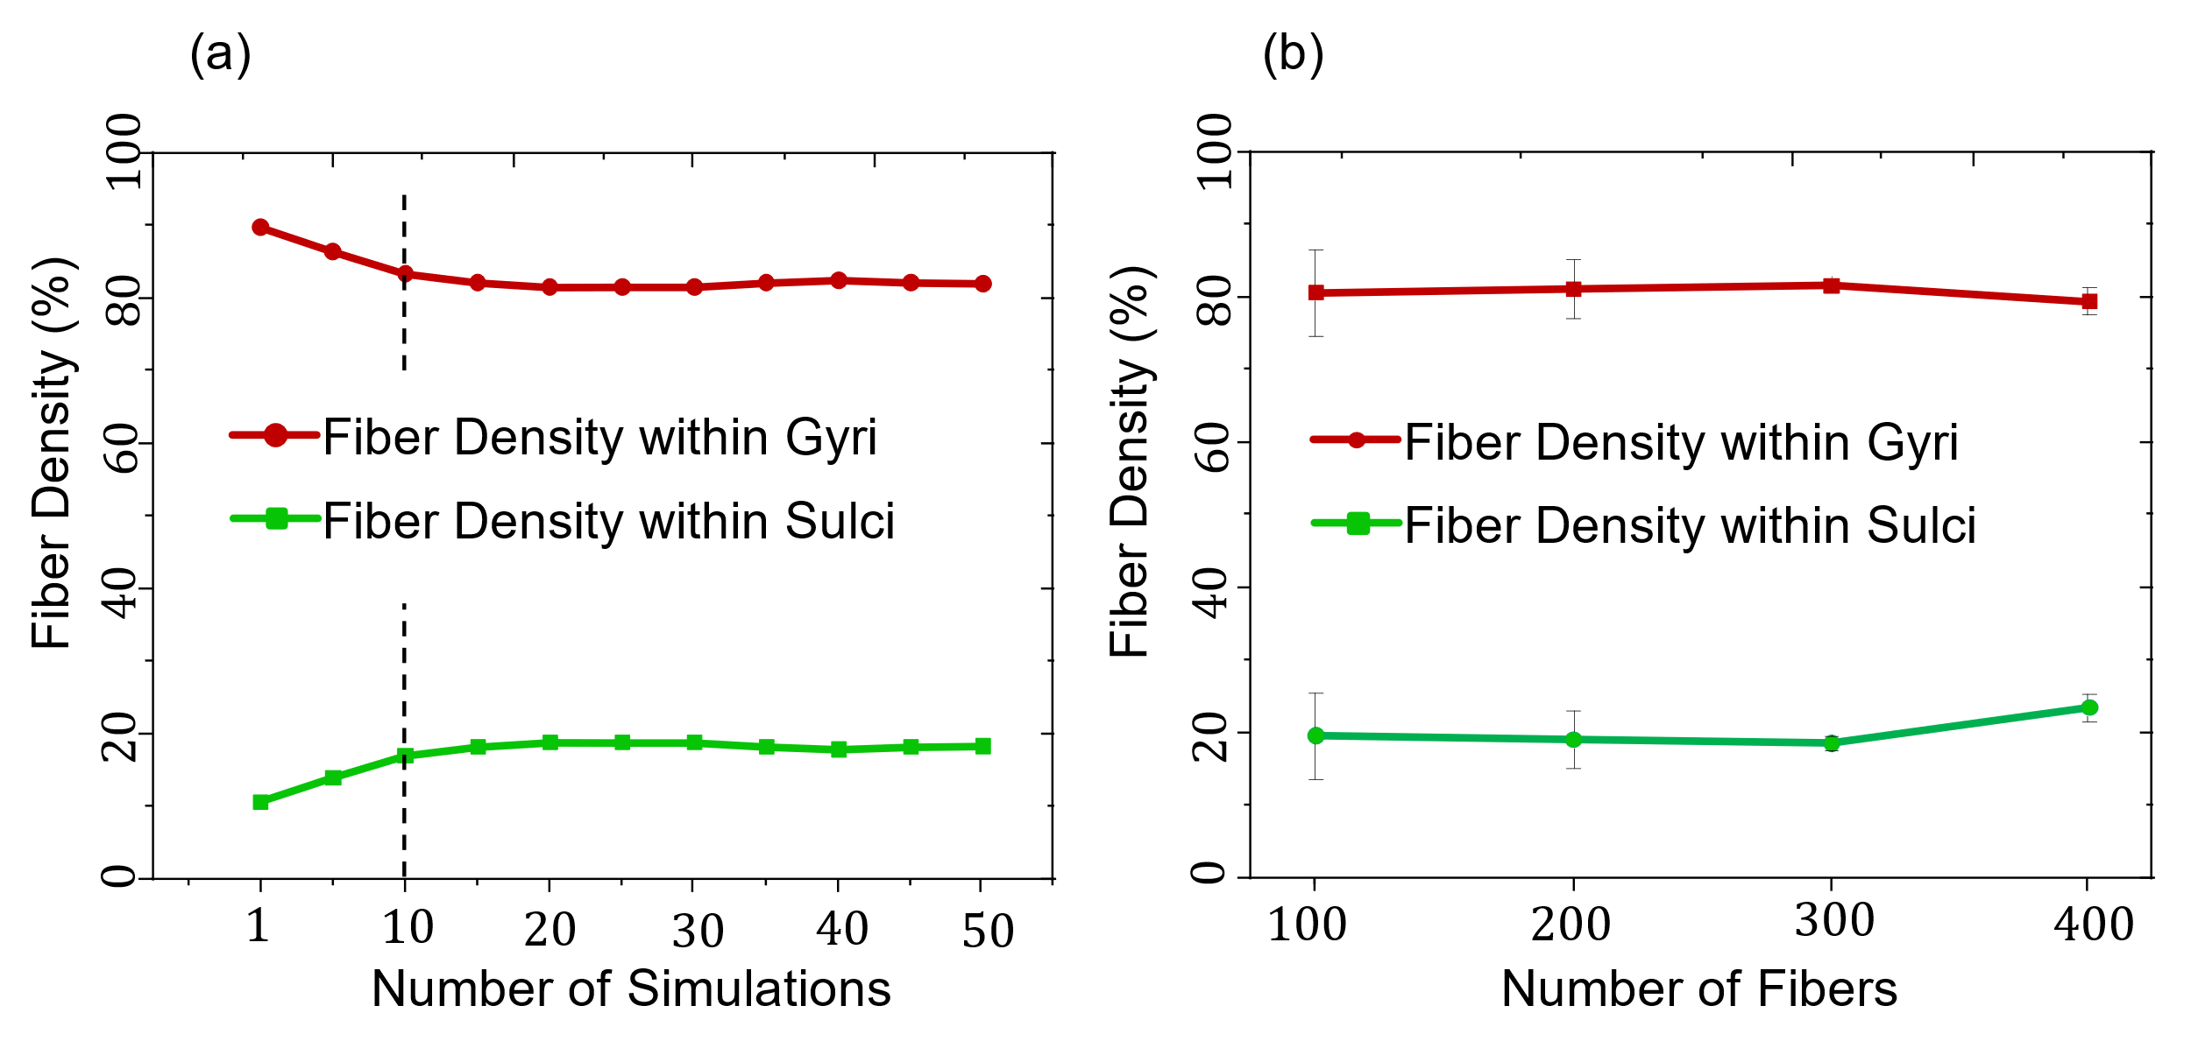
Fig. S1 (a) The impact of varying simulation counts on fiber density within gyri and sulci regions. Results demonstrate stability in fiber density beyond a threshold of 10 simulations. (b) Relationship between the number of fiber bundles and the resulting fiber density. The number of fibers doesn’t significantly impact the fiber density within gyri and sulci. The used parameters in these figures are: $μ_{f}/μ_{s}=2$, $μ_{c}/μ_{s}=2$, $a=0.015 {mm Pa}^{-1} d^{-1}$, $G^{axn}=0.8 mm/d$.

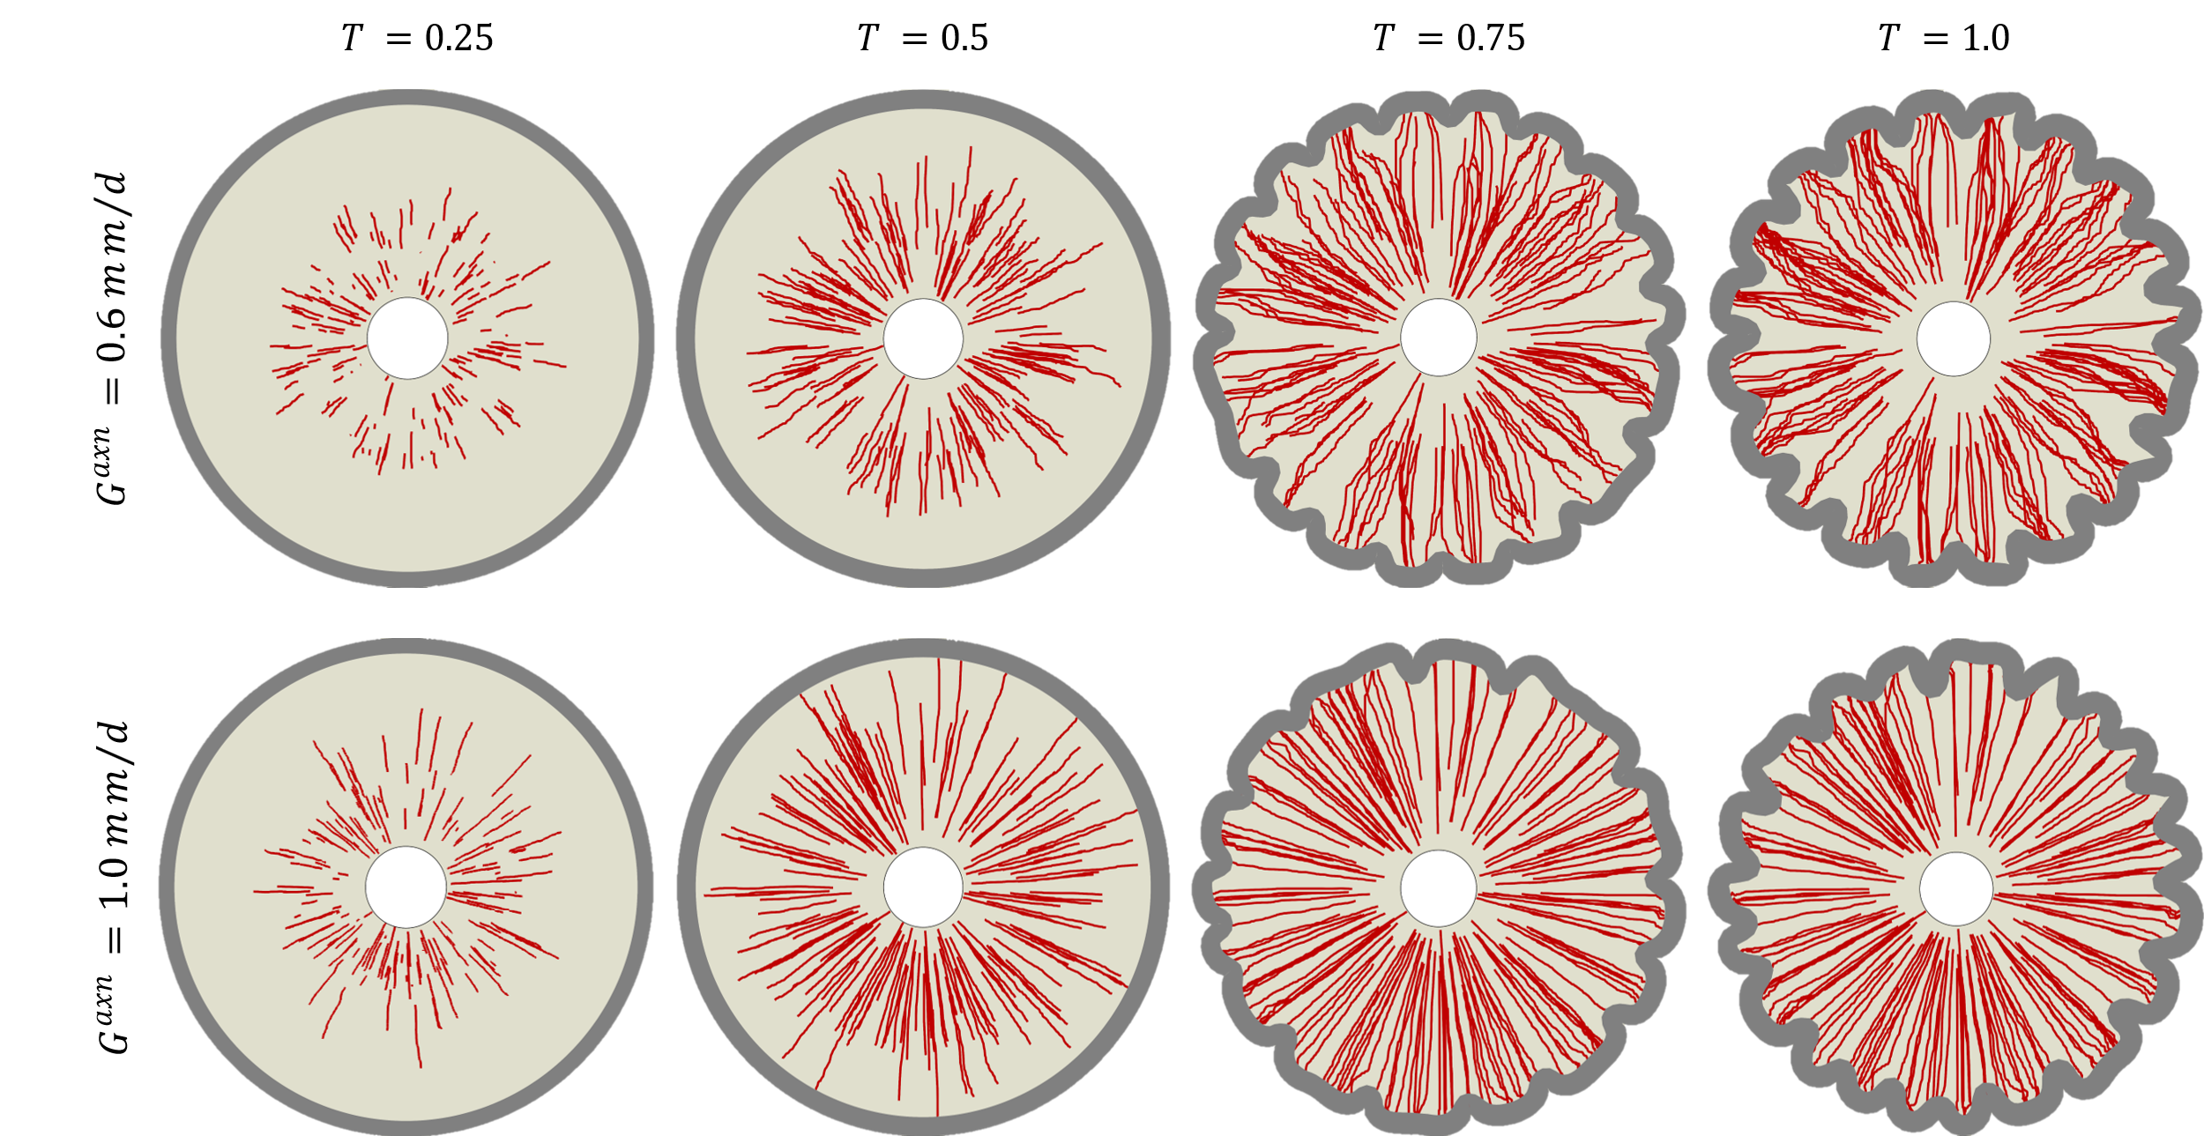
Fig. S2 Dynamic growth and pathfinding of fibers within a growing and folding 2D circular system for two different growth rates (a) $0.6 mm/d$, and (b) $1.0 mm/d$. As shown, the fibers grow and orient more toward the gyri than the sulci, consistent with the behavior observed in the rectangular models.

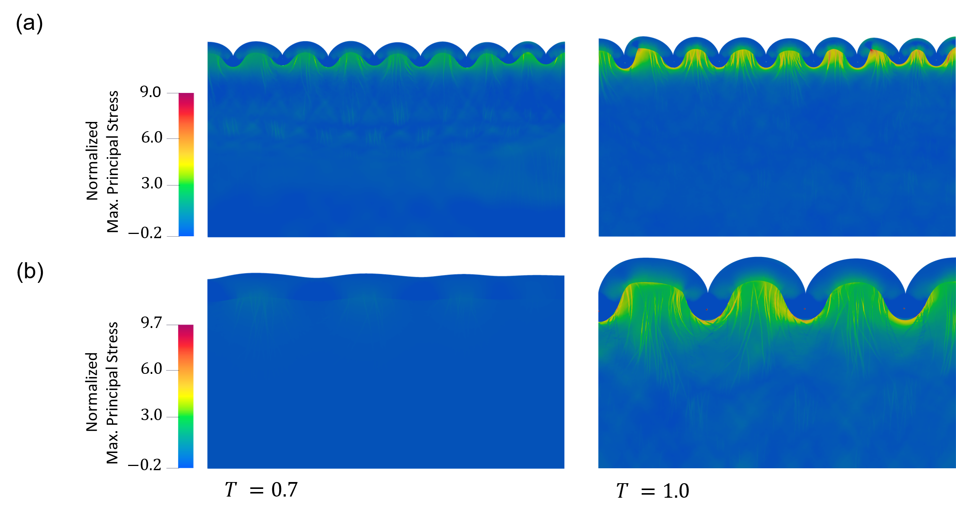
Fig. S3 Cortical folding and normalized maximum principal stress map for an initial cortex layer thickness of (a) 1.5 mm, and (b) 3 mm. In both scenarios, all other parameters remained constant ($G^{axn}=0.8 mm/d$, $μ_{c}/μ_{s}=2$, $a=0.015 {mm Pa}^{-1} d^{-1}$). As shown, increasing the cortex layer thickness leads to a longer folding wavelength and the emergence of larger folds. Additionally, the maximum principal stress increases slightly with the thicker cortex layer.

Fig. S4 Dynamic growth of fibers for the growth rate of $1.2 mm/d$ in models with and without reorientation process. The used parameters in these figures are: $μ_{f}/μ_{s}=2$, $μ_{c}/μ_{s}=2$, $a=0.015 {mm Pa}^{-1} d^{-1}$, $G^{axn}=1.2 mm/d$.
Table S2. Fiber density within gyri and sulci for ten random brains
Case number | Fiber Density within Gyri (%) |  |  | Fiber Density within sulci (%)
Case number | Left | Right |  | Left | Right
#877168 | 82.65 | 64.57 |  | 17.35 | 35.43
#917255 | 78.25 | 87.20 |  | 21.75 | 12.80
#861456 | 85.73 | 75.01 |  | 14.27 | 24.99
#859671 | 89.11 | 86.91 |  | 10.89 | 13.09
#103818 | 80.39 | 71.00 |  | 19.61 | 19.00
#111312 | 83.69 | 73.65 |  | 16.31 | 26.35
#115320 | 79.93 | 74.80 |  | 20.07 | 25.20
#125525 | 86.08 | 79.59 |  | 13.92 | 20.41
#137128 | 88.85 | 78.18 |  | 11.15 | 21.82
#144226 | 87.34 | 68.09 |  | 12.66 | 31.91
Average | 80.05 |  |  | 19.95

