Supplementary Information

Is ultrasound suited to probe electrochemical processes in batteries? An operando multiprobe investigation of NMC/graphite commercial cell
Corentin Renaisª, Benjamin Mercier-Guyonª, David Wasylowski^{b,c,d}, Morian Sonnet^{b,c,d}, Phillip Dechent^{b,c,d}, Maxime Servajonª, Nils Blanc^{d}, Sandrine Lyonnard^{c}, Dirk Uwe Sauer^{b,c,d} and Claire Villevieille^{a,*}
- LEPMI, Univ. Grenoble Alpes, Univ. Savoie Mont Blanc, CNRS, Grenoble INP, LEPMI, Grenoble, France
- Chair for Electrochemical Energy Conversion and Storage Systems, Institute for Power Electronics and Electrical Drives (ISEA), RWTH Aachen University, Campus Boulevard 89, 52074 Aachen, Germany
- Juelich Aachen Research Alliance, JARA-Energy, Germany
- Center for Ageing, Reliability and Lifetime Prediction of Electrochemical and Power Electronic Systems (CARL), RWTH Aachen University, Germany
- Université Grenoble Alpes, CEA, CNRS, IRIG, SyMMES, Grenoble, France
- ESRF, Experimental and Research Division, Grenoble, France

Claire.Villevieille@grenoble-inp.fr

Note 1. Temperature sensor
As the ultrasound signal can be influenced by the temperature, the cell was also equipped with a temperature sensor on the cell casing to probe the hutch fluctuations and the cell’s temperature during (dis-)charging. Within the BM02 hutch, the cell’s temperature (see Figure S1) is rather constant, its impact on the US signal is minimal.
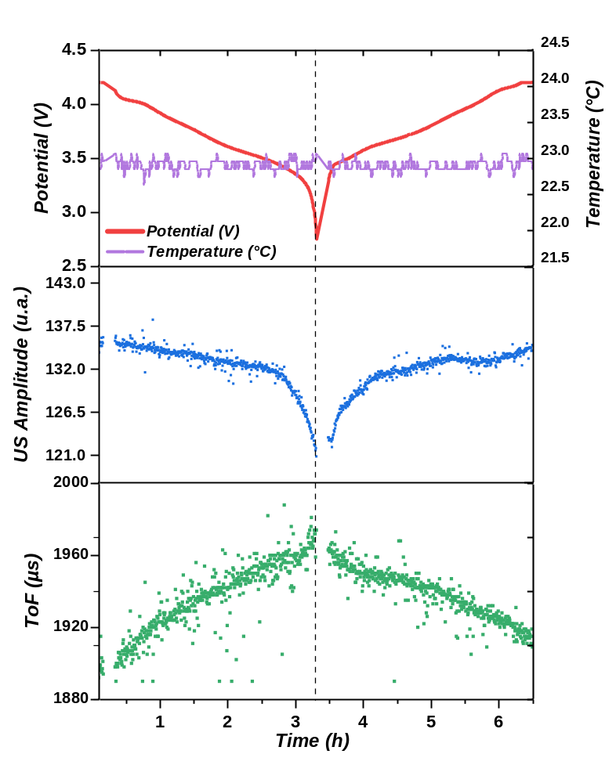
Figure S1: Ultrasound signals evolution, potential and cell temperature as a function of time, during C/3 cycling.

Note 2. Cycling outside the beam

Figure S2 represents the evolution of cell voltage, temperature of the cell casing and time of flight at several rates with relaxation periods. The same evolution of ToF as the one obtained at beamline BM02 was observed. It indicates, that the ToF is not impacted by the X-ray beam. In addition, one can notice that the ToF evolution is not due to room temperature variations, this one being stable during the cycling.
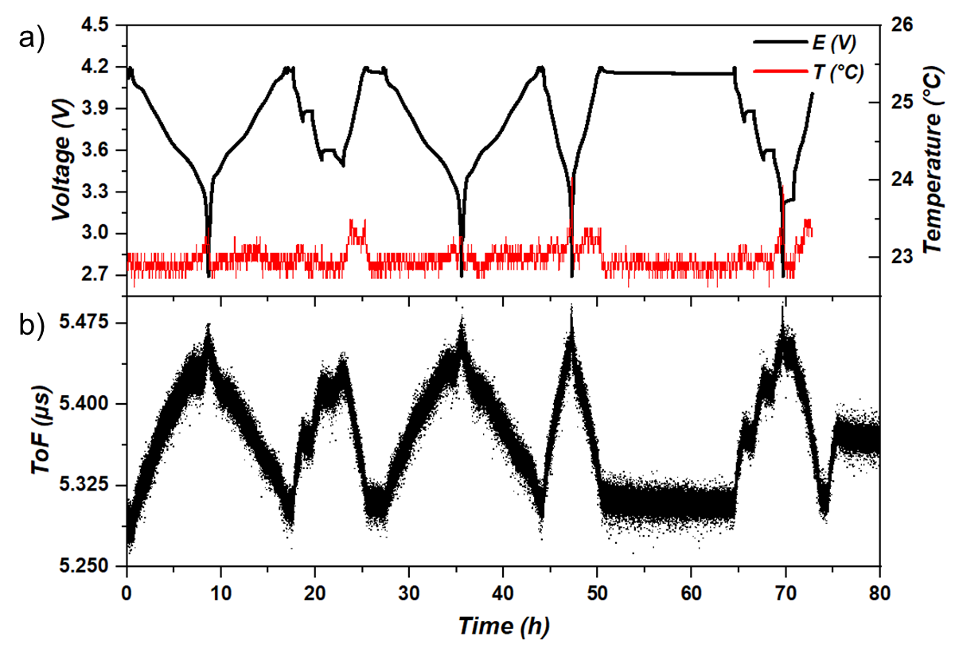
Figure S2 : Cycling of the cell outside the beam in classical environment @RT. a) Evolution of cell voltage and temperature taken on the cell casing; b) Time of flight evolution.

Note 3. Beam damage check
To check the eventuality of beam damage on the cell during the X-ray experiment, several positions of the pouch cell were probed and compared. Two lines containing 10 positions were probed successively, for a total of 20 probing points. For all those positions, mass center was calculated for each diffractogram of the experiment, by extracting an average peak position. Those mass centers and the cell potential are plotted in Figure S3 for the 20 positions as a function of time. The evolution of graphite mass center is similar for all the positions probed demonstrating a high reproducibility during cycling. Similar experience was performed by changing the probing time and since both measurements can be compared (long exposure and short exposure), we concluded that beam damage is not interfering in our data measurement). Additionally, no artefact was found on the electrochemical signature nor on the diffractograms during cycling and the electrochemical processes are perfectly correlated to structural changes leading us to conclude that no significative or apparent beam damage is occurring in the cell.
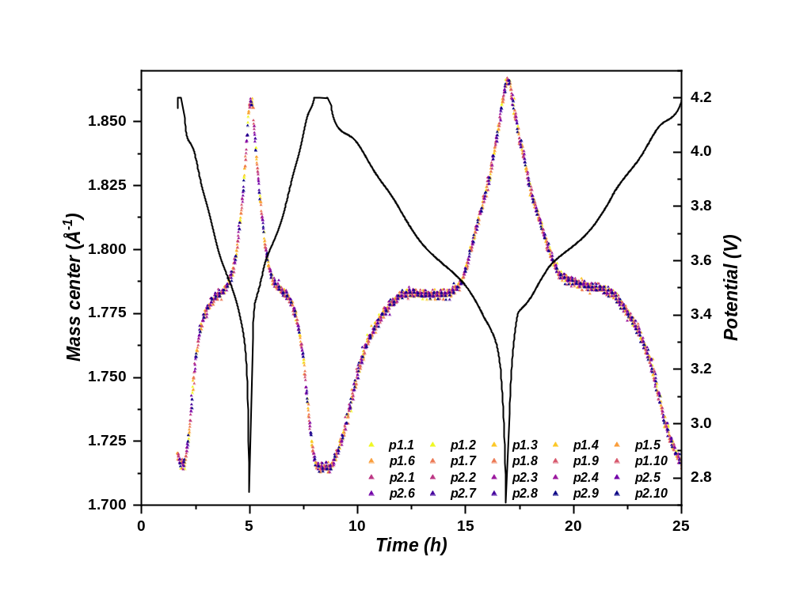
Figure S3 : Mass center of (002) graphite Bragg reflection evolution with time for all the positions scanned on the commercial pouch cell.

Note 4. Ultrasound signal evolution and interpretation
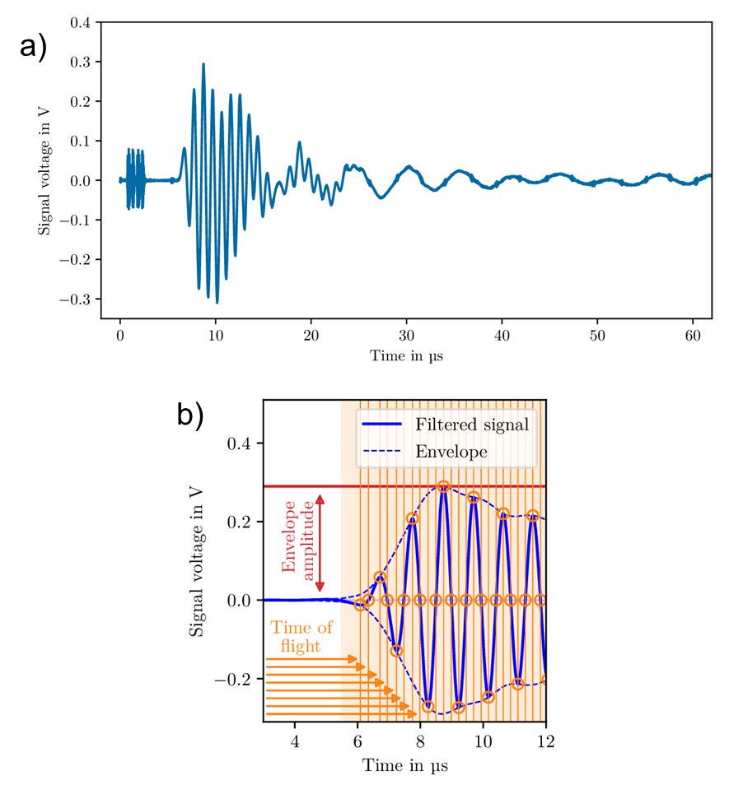
Figure S4: Ultrasound amplitude and time of flight measurements.

Ultrasound is a mechanical and elastic wave that propagates through a body, whether solid, liquid, or gaseous, at a frequency above 20 kHz. This study, however, only considers ultrasound with a frequency of 1 MHz. After the transmission of the ultrasound wave through the battery cell the raw signal shown in Figure S4a is received, which is then filtered by a digital bandpass filter with medium frequency 1 MHz. Two quantities can be extracted from the filtered signal which can be seen in Figure S4b, i) the amplitude of the received signal due to attenuation as a function of the medium crossed, so called (envelope) amplitude and ii) the time of flight (ToF), which represents the time taken for the ultrasound to pass through the material in question. The latter tends to be more reproducible and is therefore mainly used to correlate its variation with the de/lithiation processes.

Note 5. Electrochemical dilatometric measurement
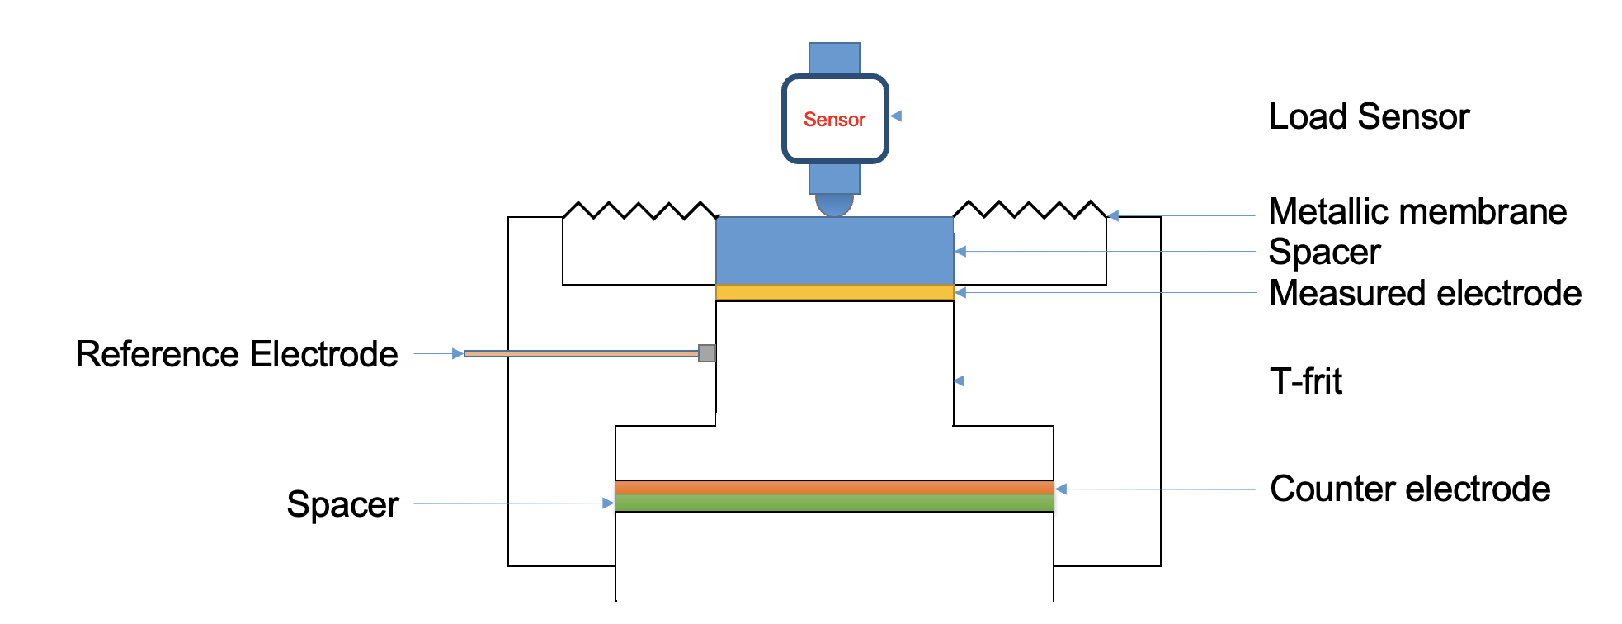
Figure S5 : El Cell ECD-3 nano set up. Adapted from [13].

The electrodes (NMC811 and graphite) were mounted in an EL-CELL ECD-3 nano dilatometer, presented in Figure S5, allowing a three-electrode electrochemical measurement with the monitoring of one electrode expansion at a time. The graphite was used as working electrode, NMC811 as counter electrode and lithium metal was selected as reference electrode. Be aware that the electrochemical dilatometer uses a T-frit as separator, generating important polarization due to the high thickness, that are corrected by cycling at low cycling rates such as C/40.

Note 6. Raw diffraction patterns obtained from the experiment at BM02
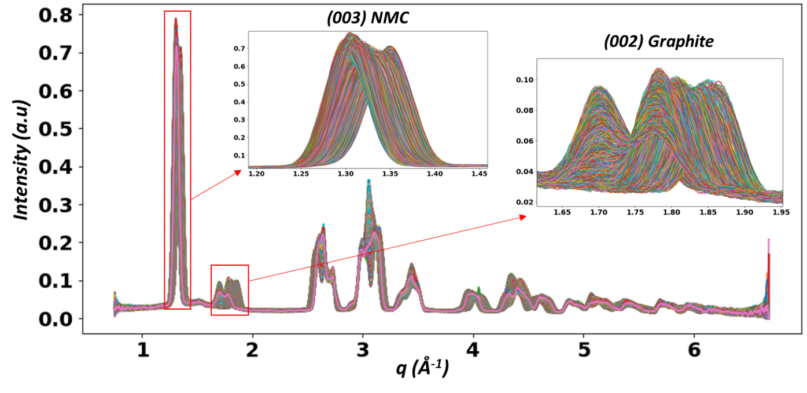
Figure S6: Raw diffractograms obtained from BM02 experiment during cycling of a commercial NMC811 vs graphite cell at C/8 rate.

Note 7. Diffraction patterns evolution during the relaxation periods
Figure S7 to Figure S11 represent the diffraction patterns evolution during the relaxation periods R₁ to R₅ as mentioned in Figure 7 of the paper. For all the relaxations periods, the Bragg reflection of NMC811 is stable with no shift of the peak. Concerning the reflections of graphite, the very small variations observed are noise-related. In all the cases, the structural state of each electrode does not evolve during the relaxation.
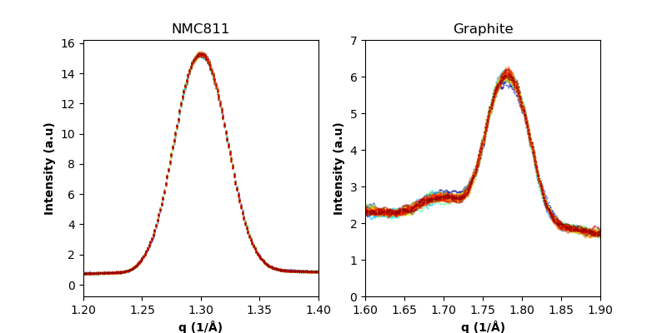
a)
b)
Figure S7 : Diffraction patterns during R₁ period. a) (003) NMC811 Bragg reflection; b) (002) graphite Bragg reflection.

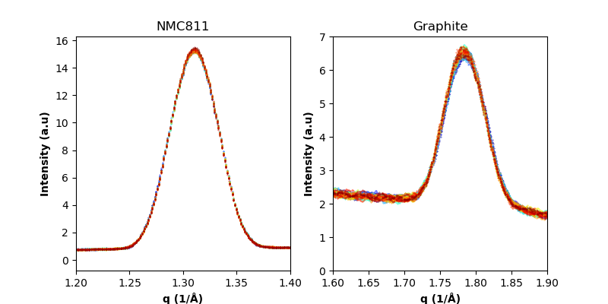
a)
b)
Figure S8 : Diffraction patterns during R₂ period. a) (003) NMC811 Bragg reflection; b) (002) graphite Bragg reflection.

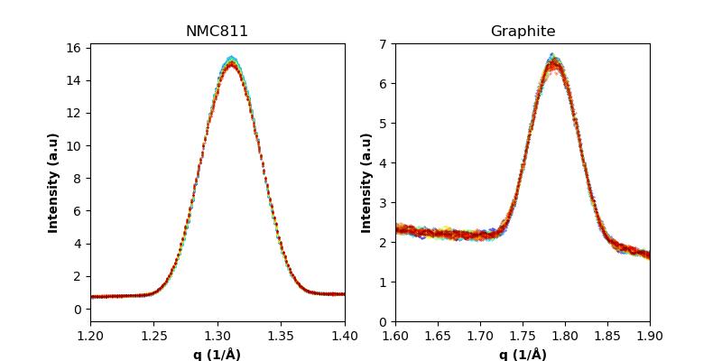
a)
b)
Figure S9 : Diffraction patterns during R₃ period. a) (003) NMC811 Bragg reflection; b) (002) graphite Bragg reflection.

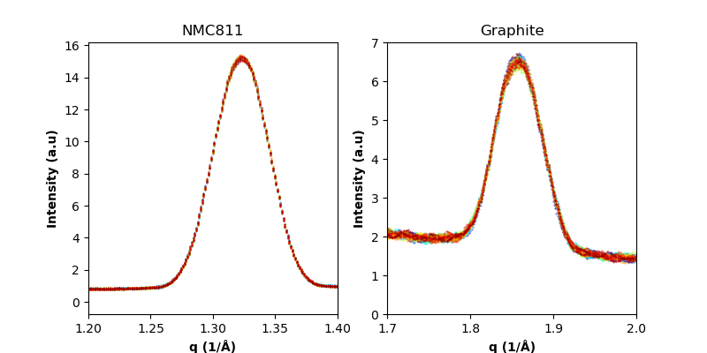
a)
b)
Figure S10 : Diffraction patterns during R₄ period. a) (003) NMC811 Bragg reflection; b) (002) graphite Bragg reflection.
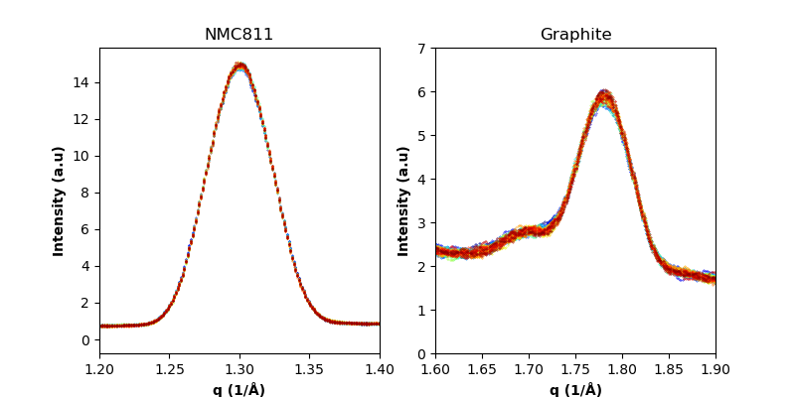
a)
b)
Figure S11 : Diffraction patterns during R₅ period. a) (003) NMC811 Bragg reflection; b) (002) graphite Bragg reflection.

