Supplementary Materials for

Bridging perception and landscape structure: mapping urban streetscape aesthetics as nature’s contributions to people

Douglas W. Cirino et al.

*Corresponding author. Email: douglas.cirino@usp.br

This PDF file includes:

Supplementary Text
Figs. S1 to S23
Tables S1 to S4

Supplementary Text
No effect of socioeconomic profile:
In general lines, different groups of respondents agree in terms of what streets are more beautiful or less beautiful, as exemplified in the Figs. S1 to S11. There is no effect of age, sex, education or origin in the scores attributed to the images. For each group we divided the dataset and re-computed the Elo score. As there is no clear pattern of vias by group, for the final analysis we calculated a global Elo score considering all the respondents together.

Principal Component Analysis (PCA) for color distance:
We ran a PCA analysis using the color distances matrix calculated through the R package colordistance v. 1.1.2. Each axis represents dominant color and/or color mixtures on Figs S14 – S16.

Comparing Geen View Index (GVI) with aesthetic score:
There is a correlation between the Green View Index (GVI) (Li et al. 2015) and the aesthetic values, indicating that a portion of the variability in aesthetic perception can be attributed to the amount of greenery visible in the Street View images. However, this correlation is relatively low, with a pearson coefficient of only 0.39 and R² of 0.153 (Fig. S17). These findings suggest that while the presence of green elements contributes to the overall aesthetic values, it is not solely determined by the extent of greenery.

Moran’s I test:
Moran’s I test for the linear model considering the variables from above (landscape) showing a significative difference between the correlation expected and observed, keeping the alternative hypothesis of distance-based autocorrelation:
DHARMa Moran's I test for distance-based autocorrelation
data: model_residuals
observed = 0.0222103, expected = -0.0023866, sd = 0.0054933, p-value = 7.548e-06
alternative hypothesis: Distance-based autocorrelation

Moran’s I test for the linear model considering the variables from the front (image’s features) showing a significative difference between the correlation expected and observed, keeping the alternative hypothesis of distance-based autocorrelation:
DHARMa Moran's I test for distance-based autocorrelation
data: model_residuals
observed = 0.0663262, expected = -0.0023866, sd = 0.0054907, p-value < 2.2e-16
alternative hypothesis: Distance-based autocorrelation

The Moran’s test showed the need to consider space in the models, for that reason we performed a model that uses the pairs of coordinates as random effect to take in consideration in the model.

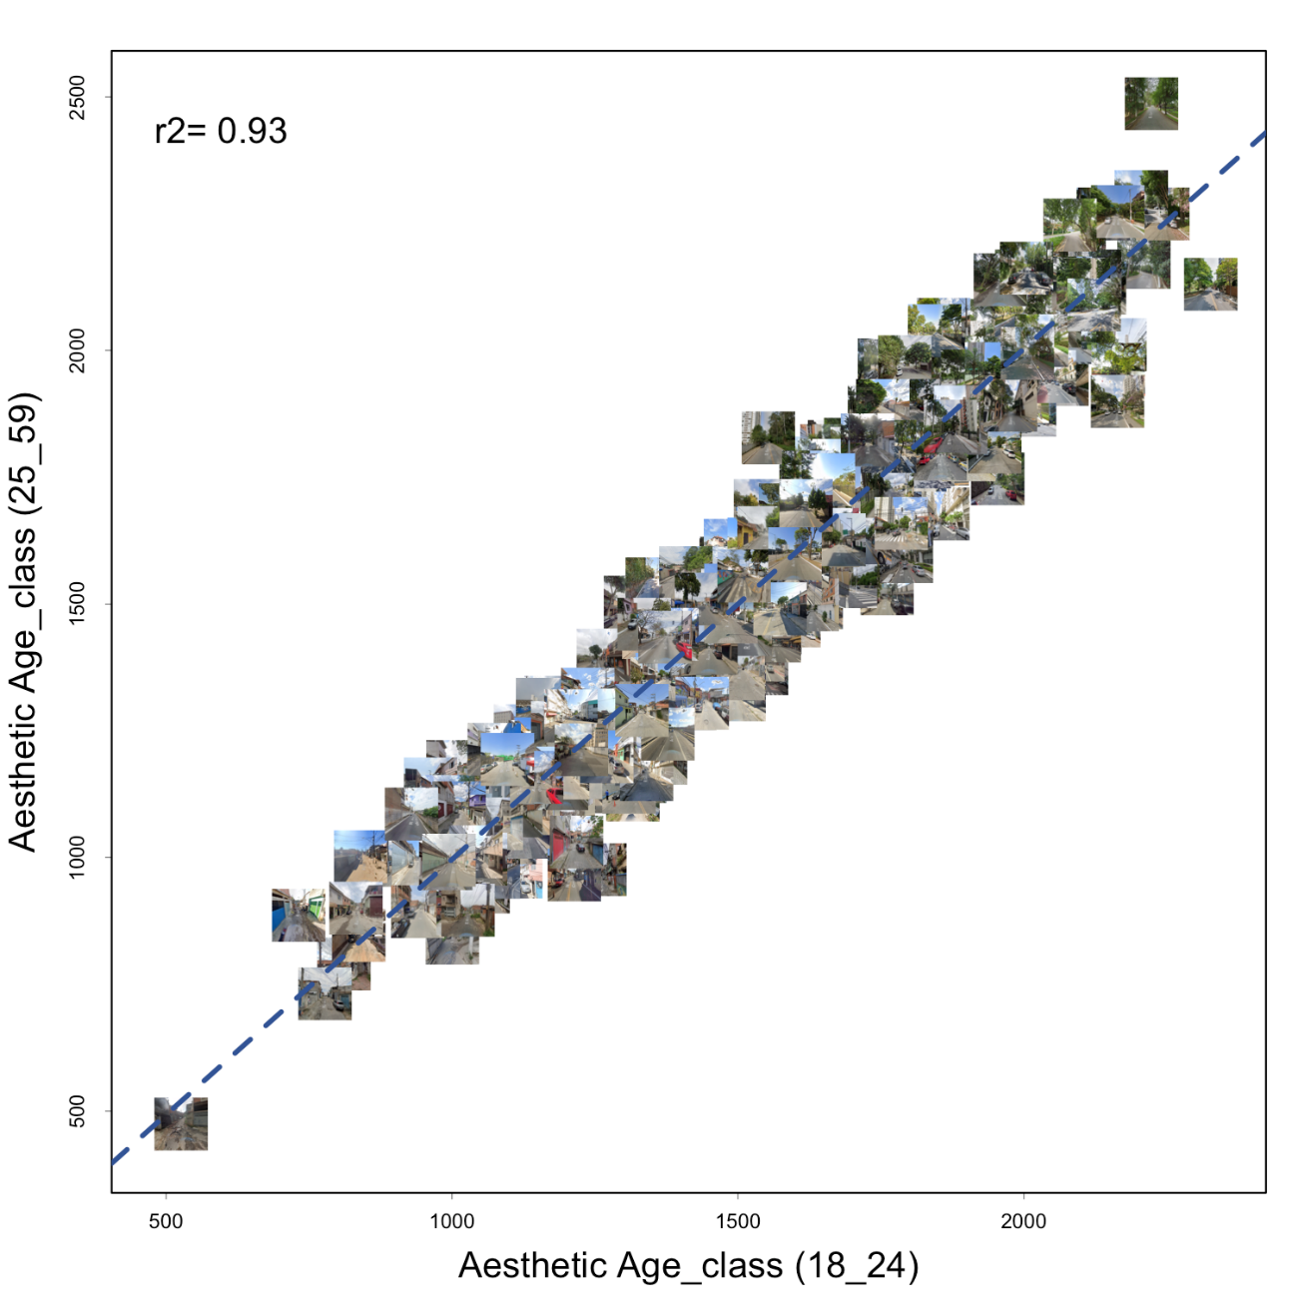

Fig. S1.
Correlation between the aesthetic values of two age categories of the respondents of the study (18 to 24 and 25 to 59 years old). Imagery © 2024 Google

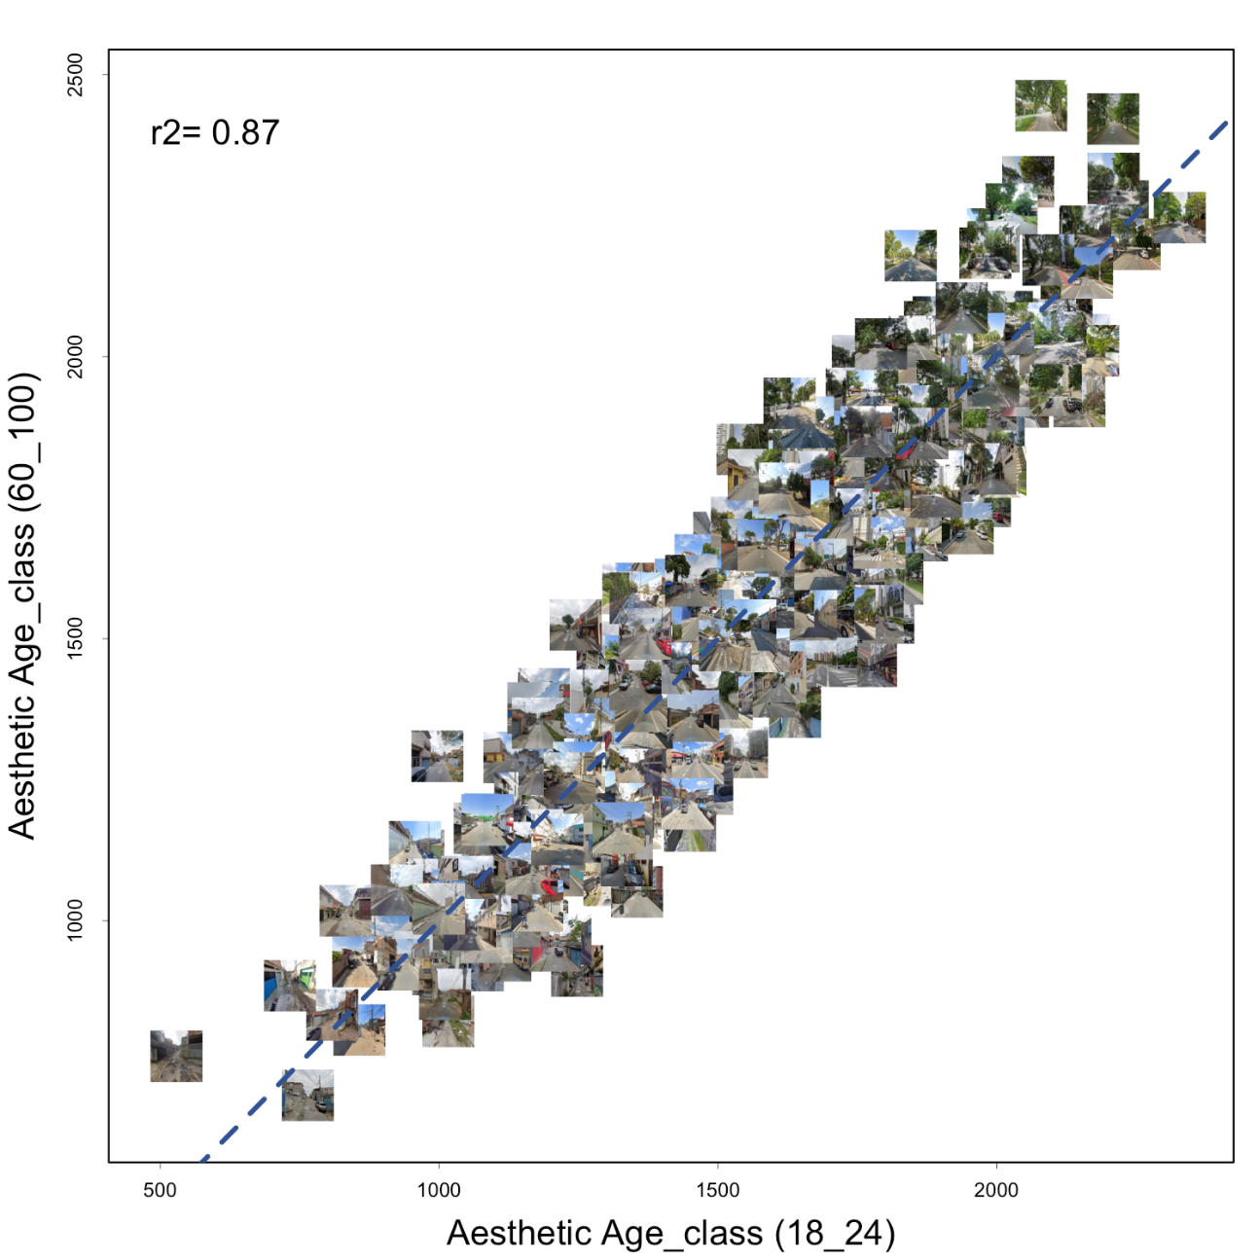

Fig. S2.
Correlation between the aesthetic values of two age categories of the respondents of the study (18 to 24 and 60 to 100 years old). Imagery © 2024 Google

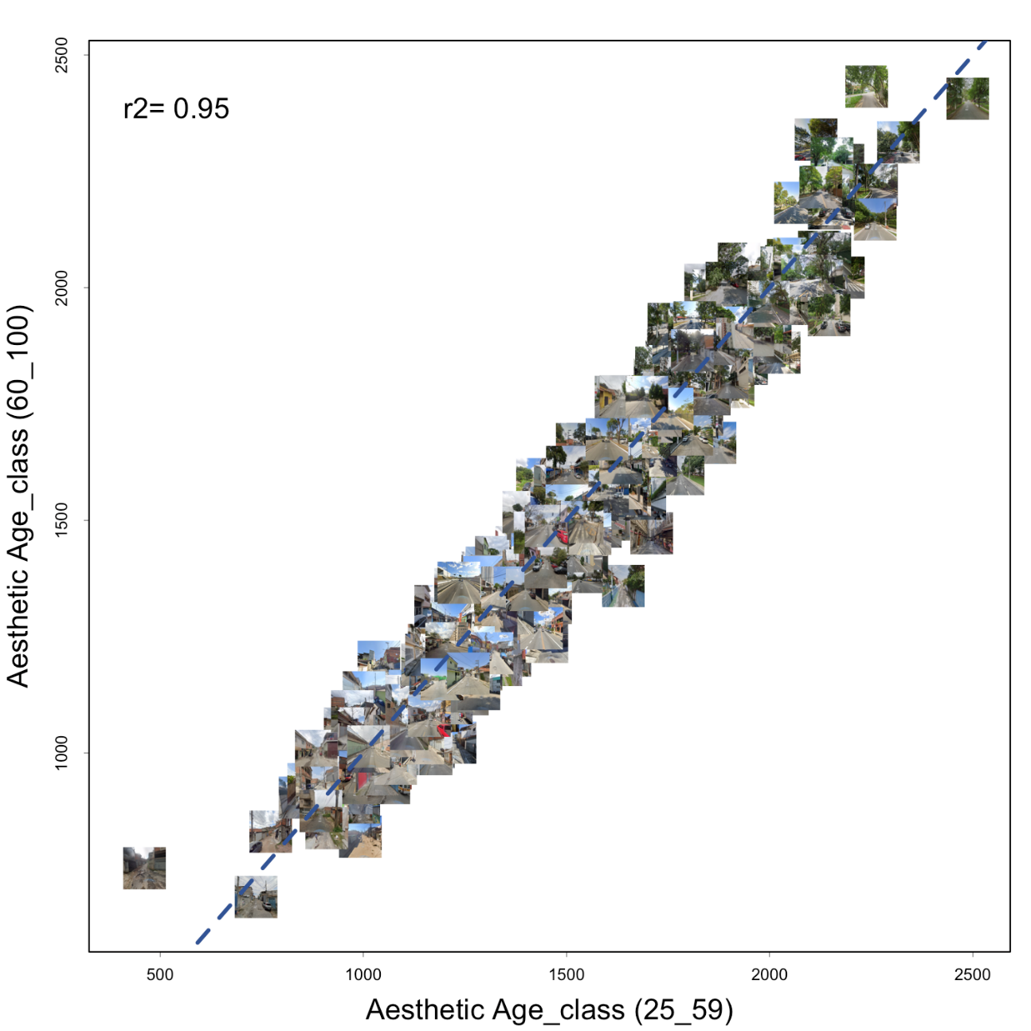

Fig. S3.
Correlation between the aesthetic values of two age categories of the respondents of the study (60 to 100 and 25 to 59 years old) Imagery © 2024 Google

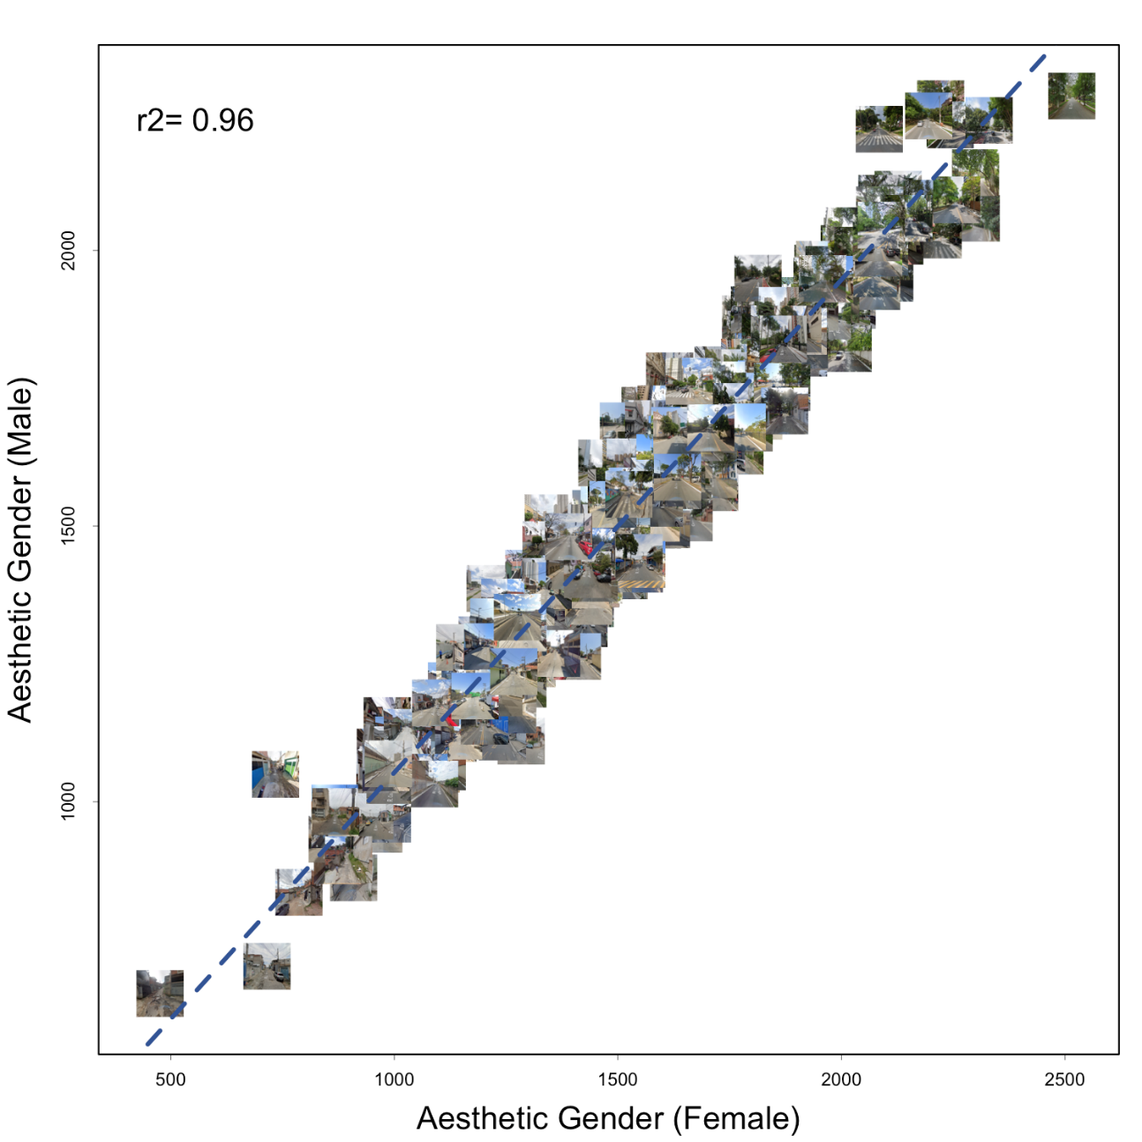

Fig. S4.
Correlation between the aesthetic values of two gender categories of the respondents of the study. Imagery © 2024 Google

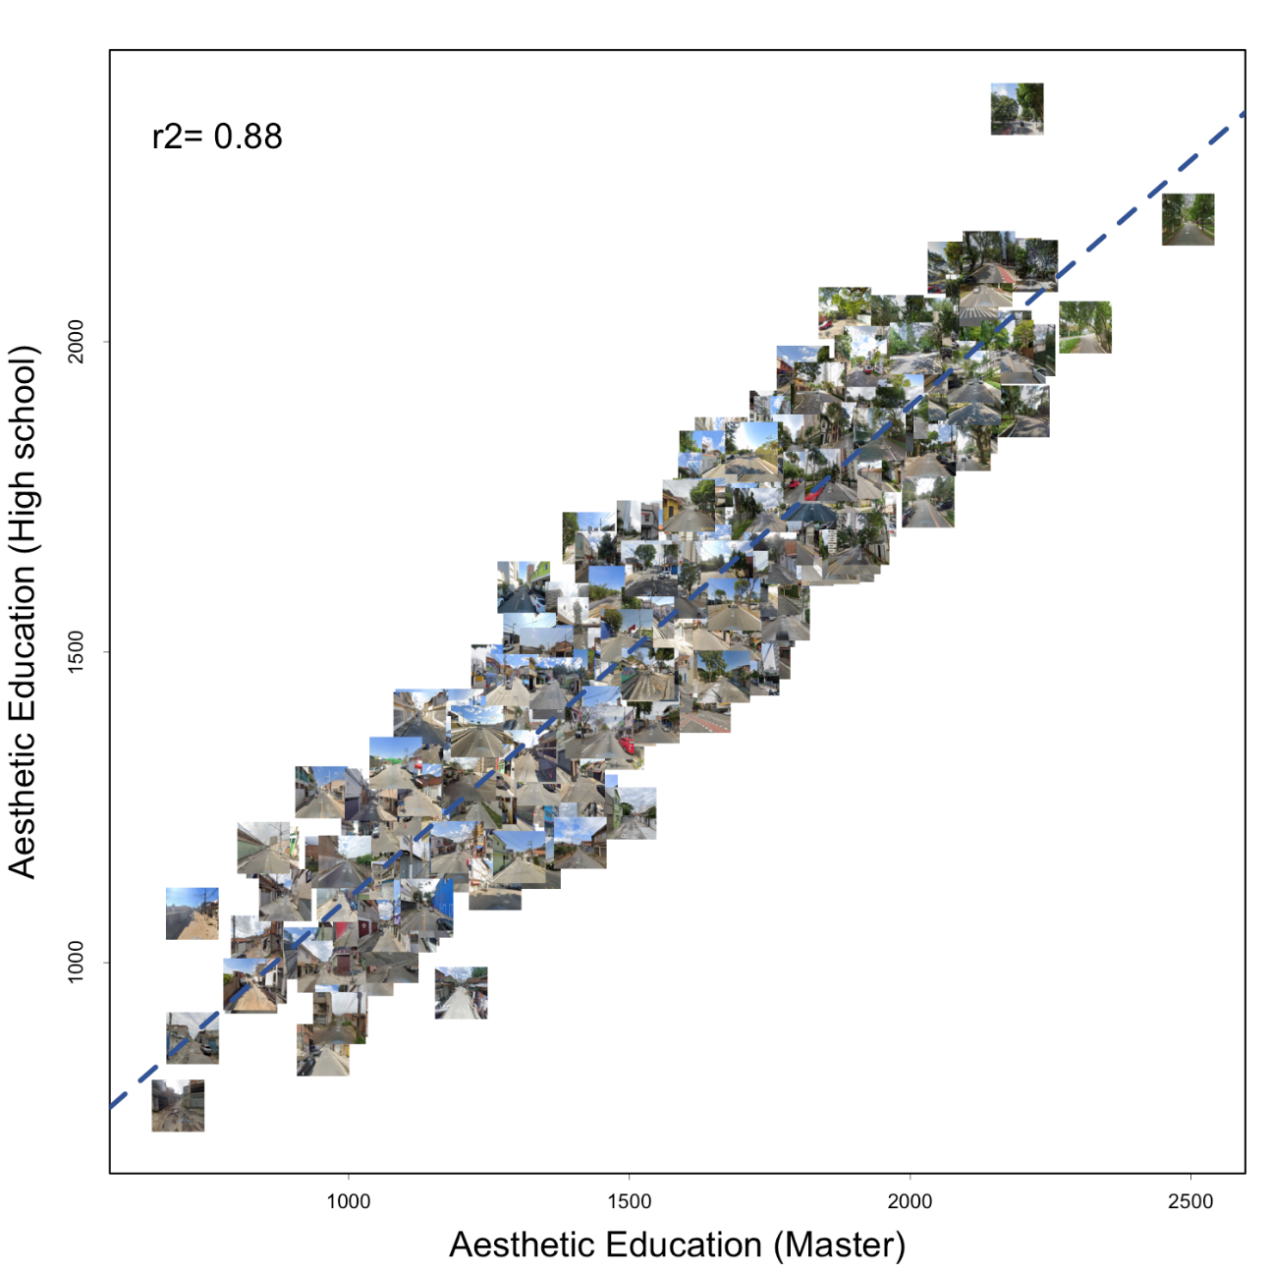

Fig. S5.
Correlation between the aesthetic values of two educational categories of the respondents of the study. Imagery © 2024 Google

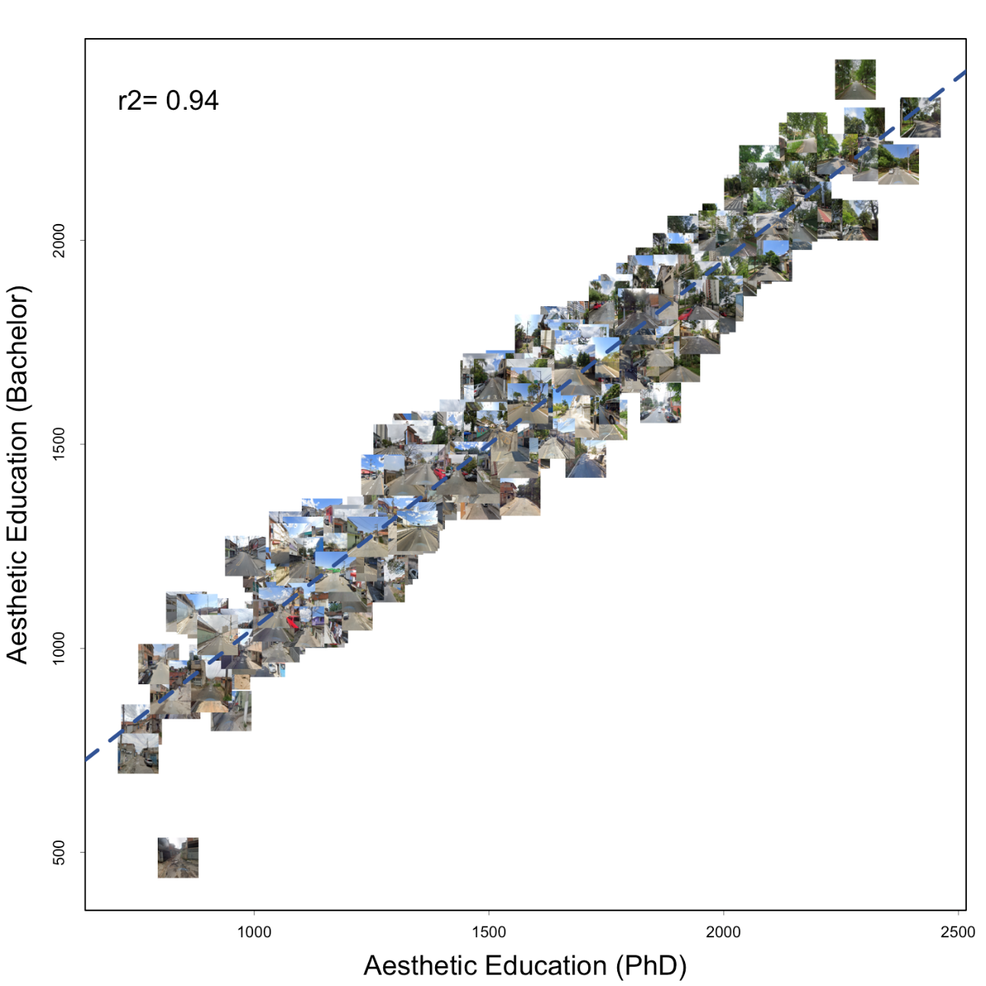

Fig. S6.
Correlation between the aesthetic values of two educational categories of the respondents of the study – Bachelor and PhD. Imagery © 2024 Google

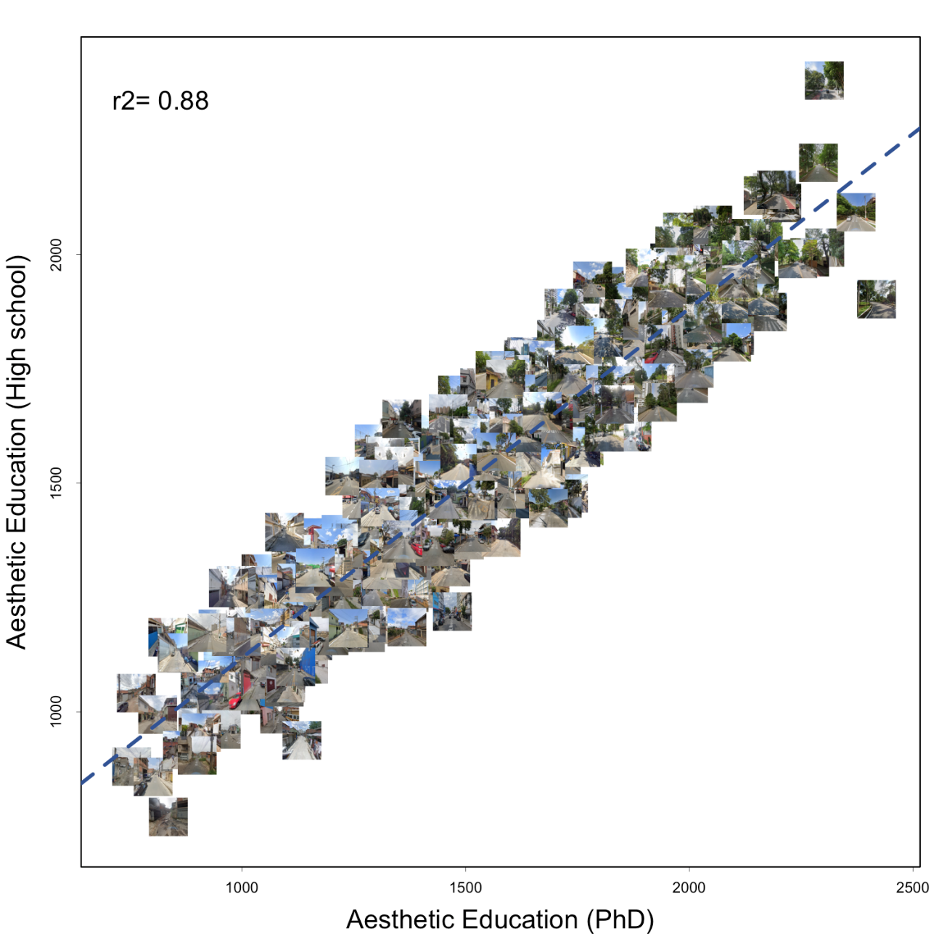

Fig. S7.
Correlation between the aesthetic values of two educational categories of the respondents of the study – High-school and PhD. Imagery © 2024 Google

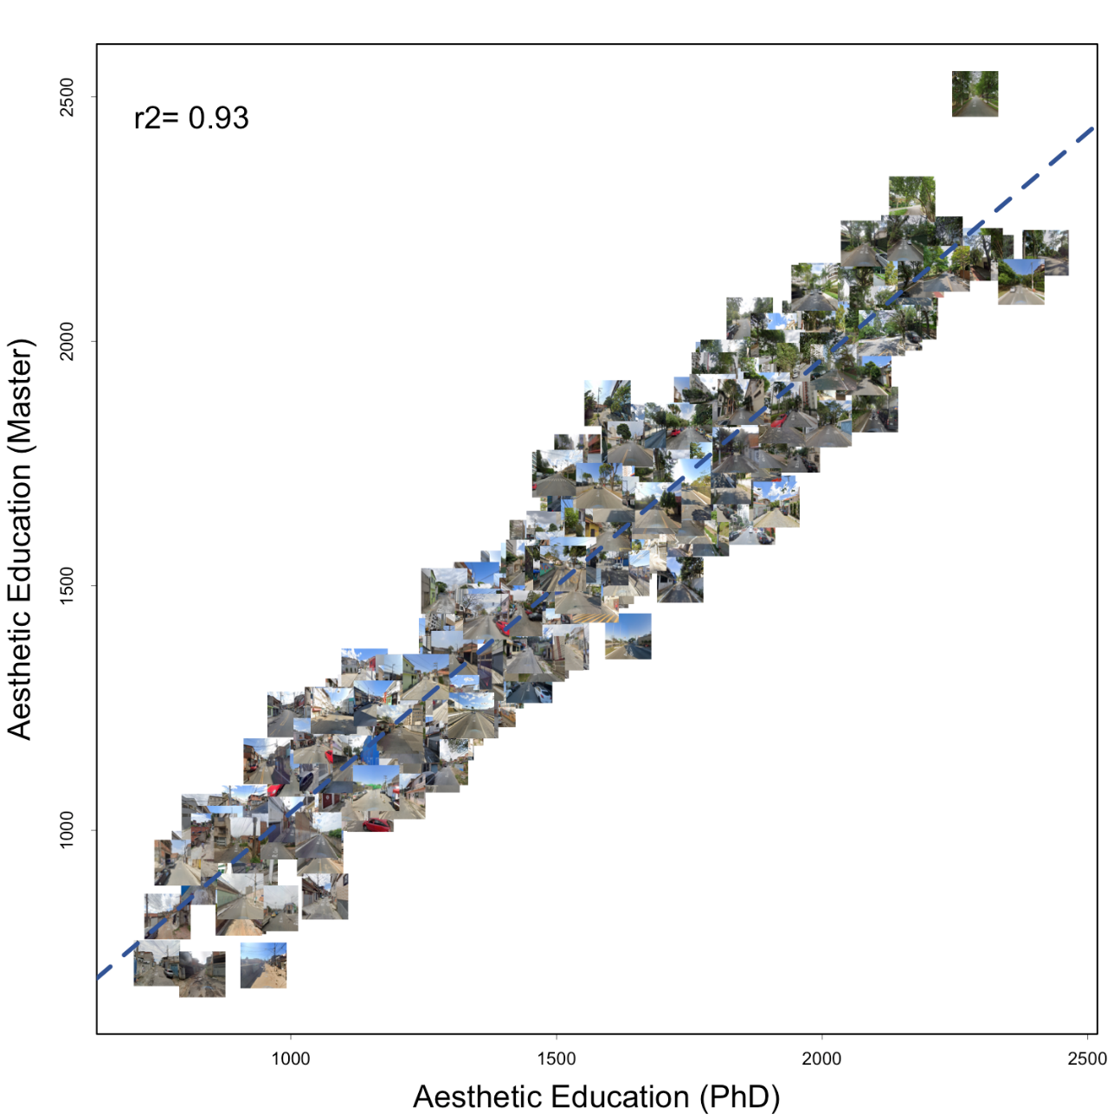

Fig. S8.
Correlation between the aesthetic values of two educational categories of the respondents of the study – PhD and Master. Imagery © 2024 Google

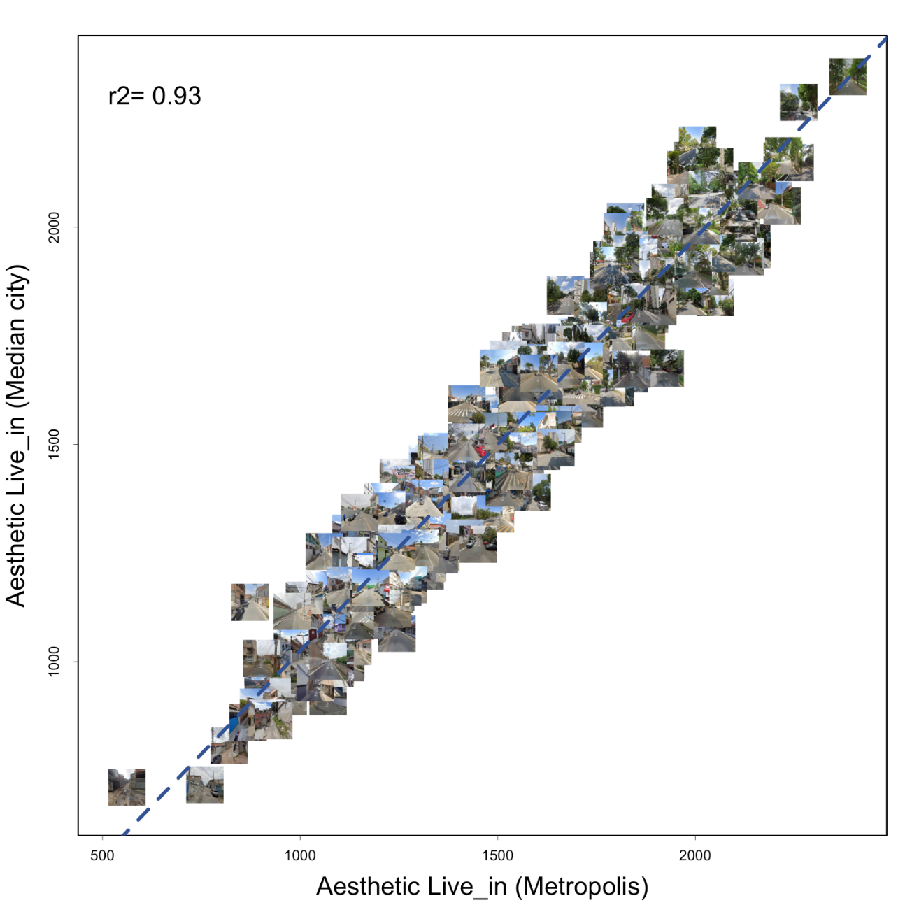

Fig. S9.
Correlation between the aesthetic values of two origin categories of the respondents of the study (live in a metropolis vs. medium city). Imagery © 2024 Google

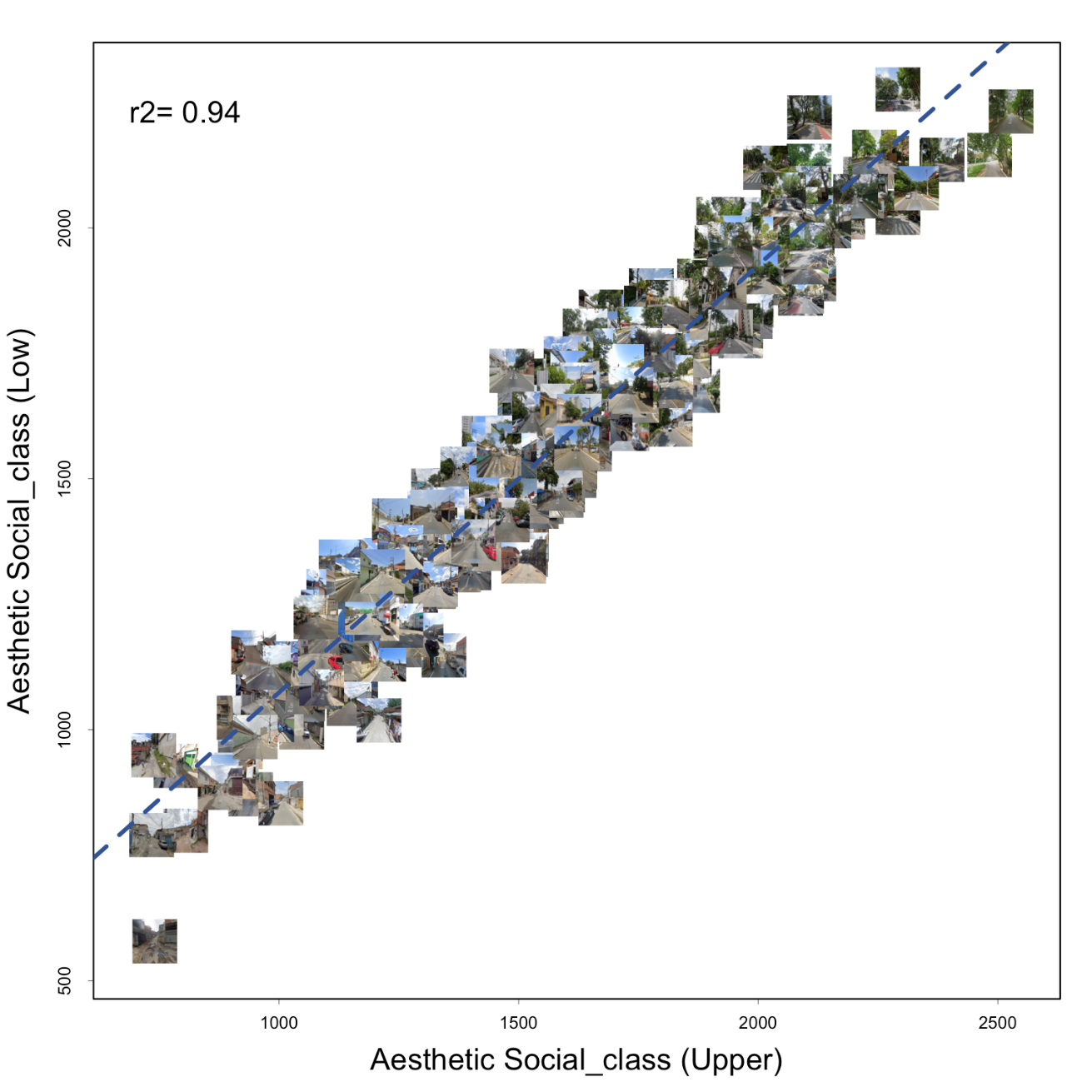

Fig. S10.
Correlation between the aesthetic values of two social classes categories of the respondents of the study. Imagery © 2024 Google

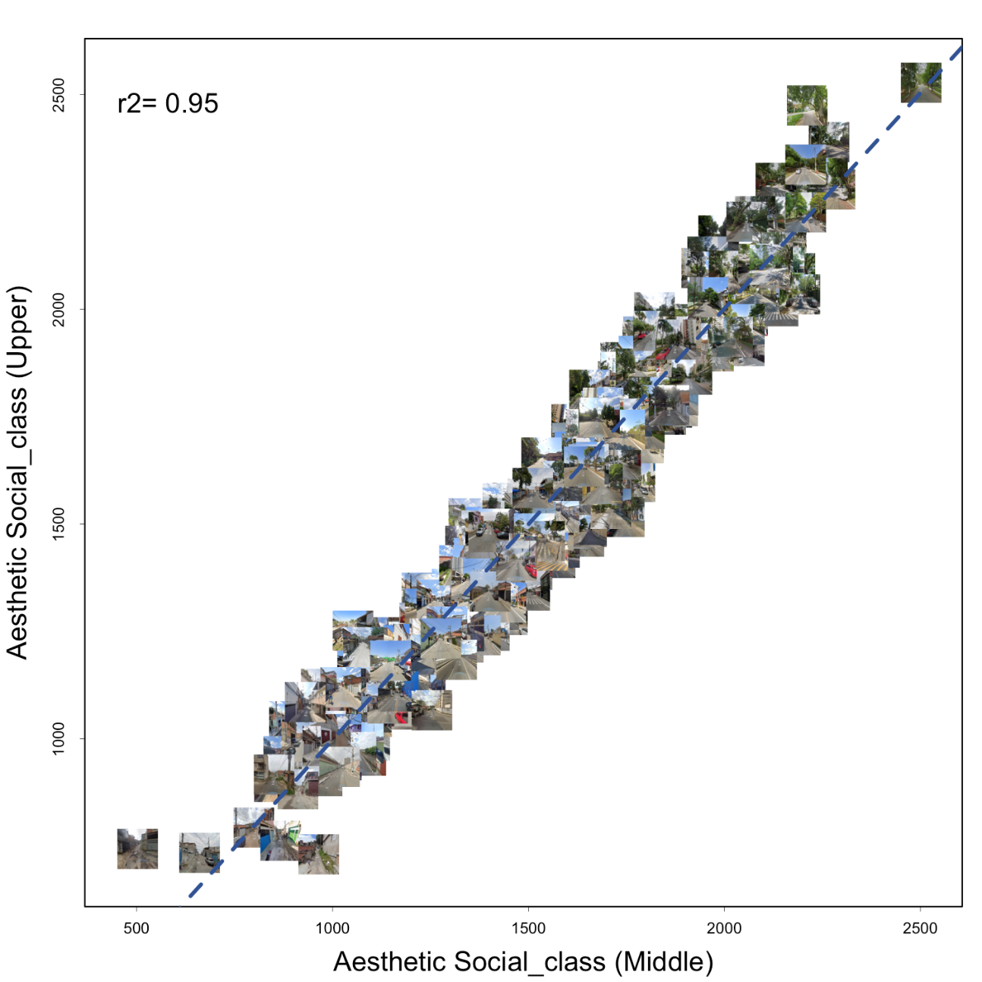

Fig. S11.
Correlation between the aesthetic values of two social classes categories of the respondents of the study. Imagery © 2024 Google

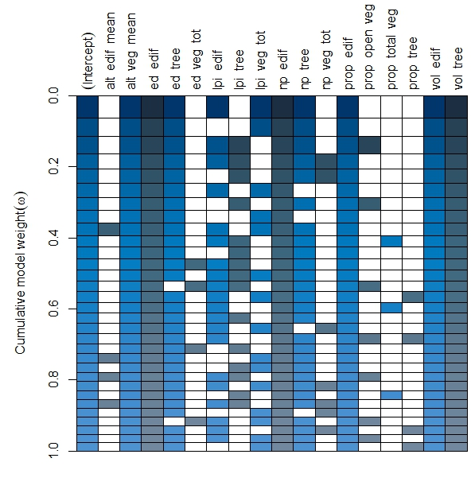

Fig. S12.
Dredge result of the model selection for the landscape variables – from above. The thickness of the line on the table represents the AIC weight. The painted boxes represent the variables retained. We considered just the first model as the best one, used in the analysis. The dredge process was applied to a linear model (LM). Each line of the table represents a model with a different set of variables.

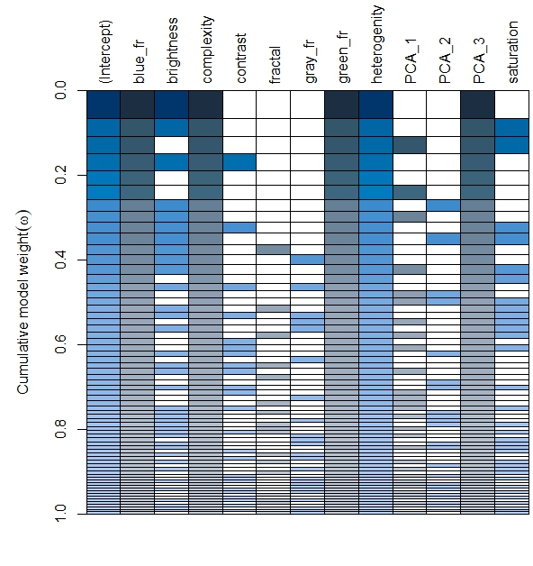

Fig. S13.
Dredge result of the model selection for the picture’s features – from the front. The thickness of the line on the table represents the AIC weight. The painted boxes represent the variables retained. We considered just the first model as the best one, used in the analysis. Each line of the table represents a model with a different set of variables.

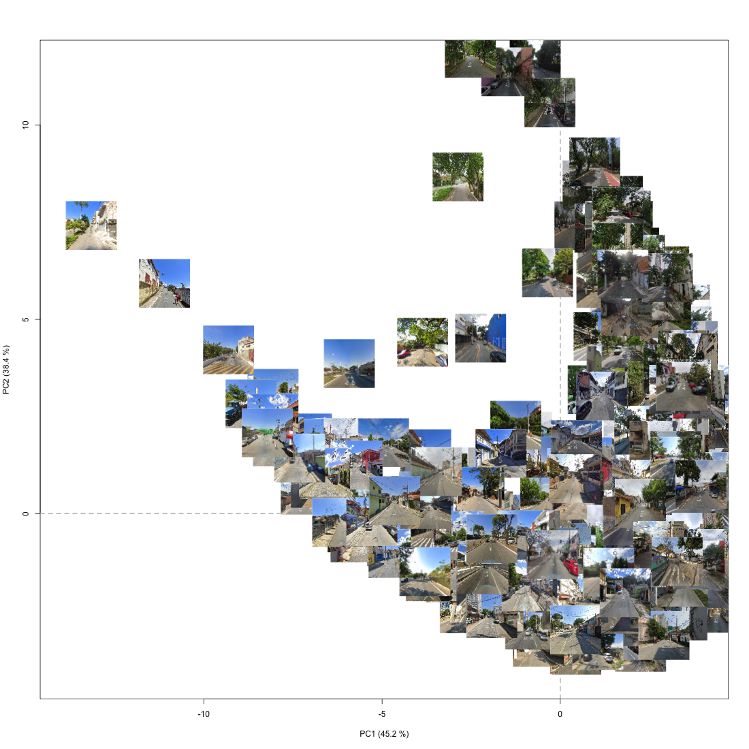

Fig. S14.
PC2 (Y axis) and PC1 (X axis), showing green and shadows mixture and gray and darkness/shadows mixture, respectively in the images. Imagery © 2024 Google

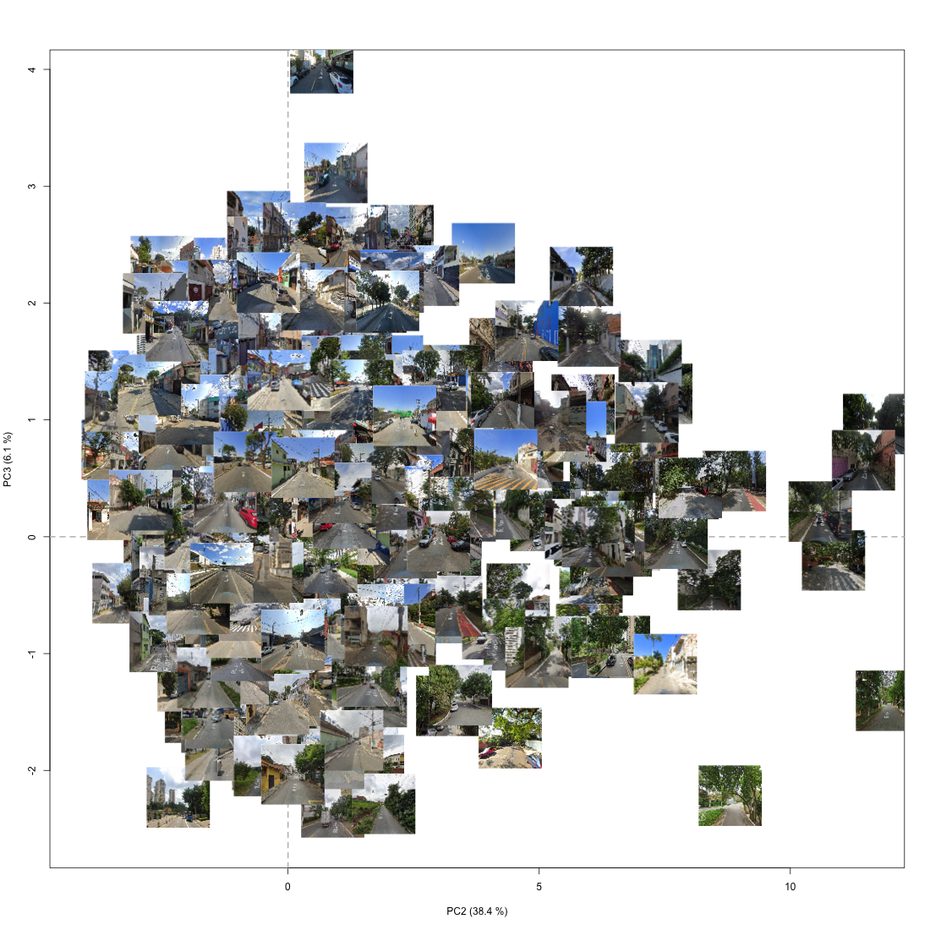

Fig. S15.
PC3 (Y axis) and PC2 (X axis), representing gray and blue colors/mixture and green and shadows mixture, respectively. Imagery © 2024 Google

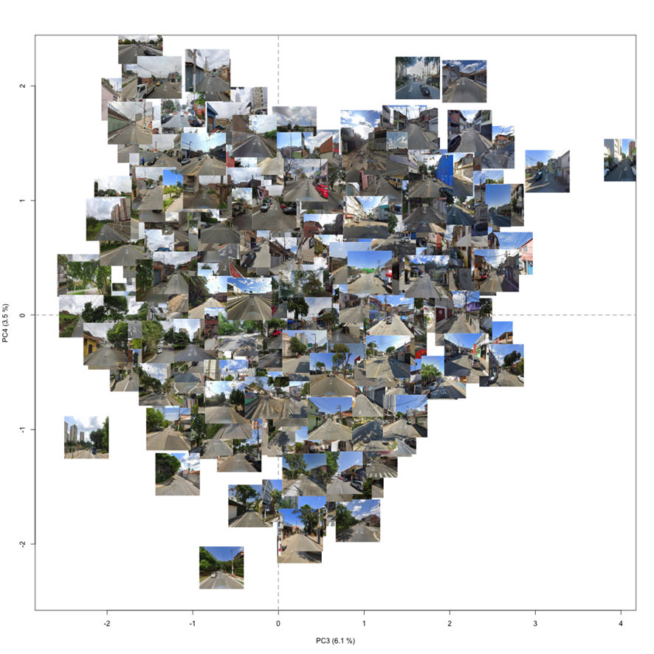

Fig. S16.
PC4 (Y axis) and PC3 (X axis), showing the gray and green mixture and the gray and blue mixture, respectively. Imagery © 2024 Google

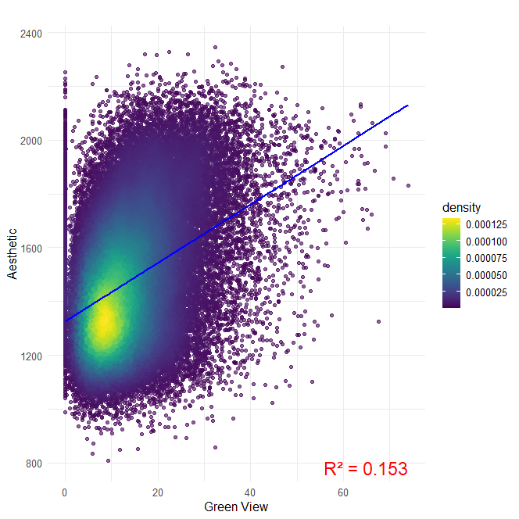

Fig. S17.
Correlation between Green View Index (GVI) (Li et al. 2015) and aesthetic score, using correlation of pearson. The R² value presented is of 0.153 and correlation value of 0.390.

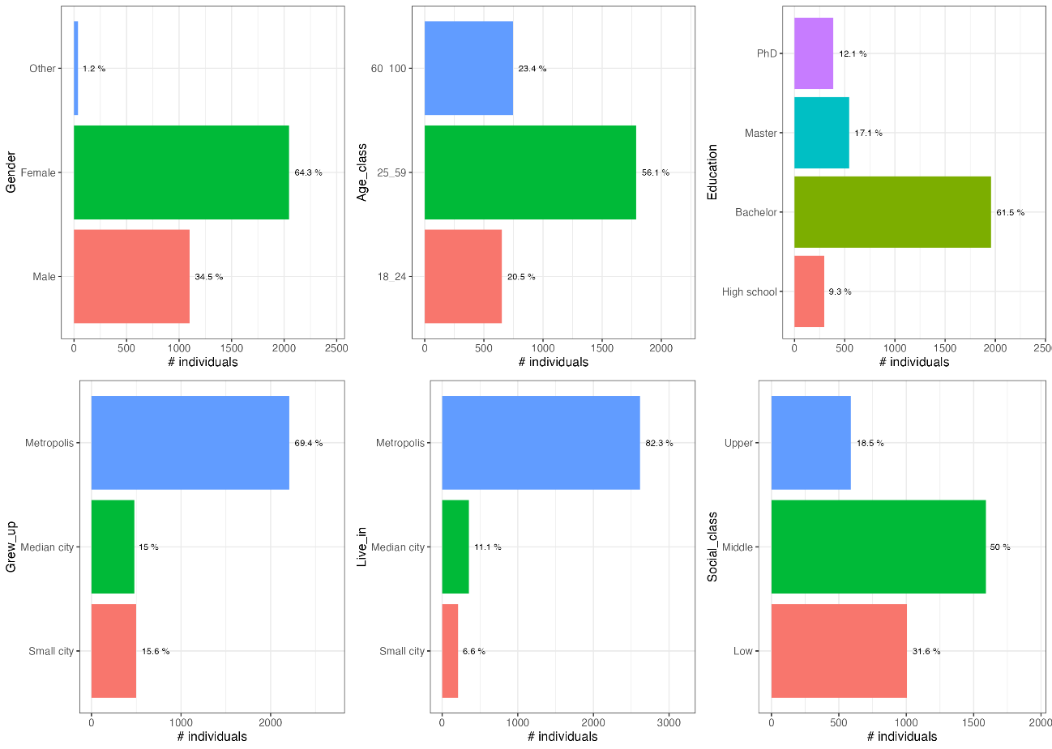

Fig. S18.
Profile of the respondents on the online survey. Distribution of different social characteristics of the respondents of the survey divided in categories.

Table S1.
Estimates, standard errors (SE), t-value and p-value from the FitMe model from above (landscape features) selected presented three non-significative variables (p-value > 0.05).
 | Estimate | SE | t-value | p.value
(Intercept) | 1438.37800 | 62.45525 | 23.03054 | < 0.001
ed_edif | -29.24345 | 13.80605 | -2.11816 | 0.0374
np_edif | -34.27471 | 11.16056 | -3.07106 | 0.003
np_tree | 20.42760 | 14.17754 | 1.440842 | 0.1537
vol_edif | -0.00017 | 0.000234 | -0.70742 | 0.4815
prop_edif | -140.54100 | 80.21576 | -1.75204 | 0.0838
vol_tree | 151.59390 | 13.53598 | 11.19933 | <0.001

Table S2.
Estimates, standard errors (SE), t-value and p-value from the FitMe model from the front (images features) selected presented just significative variables (p-value < 0.05).
 | Estimate | SE | t-value | p.value
(Intercept) | 1414.231 | 58.72344 | 24.0829 | <0.001
blue_fr | 99.10543 | 13.17843 | 7.520278 | <0.001
brightness | -91.2309 | 14.31073 | -6.375 | <0.001
complexity | 150.5502 | 12.237 | 12.30287 | <0.001
heterogenity | 42.78207 | 8.88695 | 4.814034 | <0.001
PCA_3 | -57.0049 | 11.33194 | -5.03047 | <0.001

Table S3.
Estimates, standard errors (SE), t-value and p-value from the combining FitMe model (front and above) presenting all the variables in only one final model.
 | Estimate | SE | t-value | p.value
(Intercept) | 1464.4040 | 45.5684 | 32.13638 | < 0.001
blue_fr | 61.5855 | 12.0767 | 5.099532 | < 0.001
brightness | -46.4127 | 13.0816 | -3.54795 | 0.0007
complexity | 120.6141 | 11.0799 | 10.88586 | < 0.001
heterogenity | 39.6128 | 7.7971 | 5.080458 | < 0.001
PCA_3 | -25.8518 | 10.2550 | -2.52089 | 0.0138
ed_edif | -34.7471 | 11.3744 | -3.05485 | 0.0031
np_edif | -18.3721 | 9.2902 | -1.97758 | 0.0516
np_tree | 23.1169 | 11.6558 | 1.983286 | 0.0509
vol_edif | -0.0001 | 0.0002 | -0.43311 | 0.6662
prop_edif | -63.4220 | 67.8334 | -0.93497 | 0.3528
vol_tree | 88.6182 | 12.5303 | 7.072295 | < 0.001

Table S4.
Comparison between different Local Climate Zones (LCZ) through the ANOVA and tukey test. LCZ represents the pair of LCZ compared. Diff is the difference between them; lwr and upr represents the standard errors. The p adj represents the p-value adjusted.
LCZ | diff | lwr | upr | p adj
2-1 | -143,864 | -305,403 | 17,675 | 0,117
3-1 | -249,532 | -411,070 | -87,993 | 0,000
4-1 | -140,466 | -302,671 | 21,739 | 0,139
5-1 | 85,700 | -77,191 | 248,590 | 0,709
6-1 | -40,871 | -203,761 | 122,020 | 0,990
8-1 | -260,981 | -423,186 | -98,776 | 0,000
3-2 | -105,668 | -266,538 | 55,202 | 0,451
4-2 | 3,398 | -158,141 | 164,937 | 1,000
5-2 | 229,563 | 67,336 | 391,791 | 0,001
6-2 | 102,993 | -59,234 | 265,221 | 0,494
8-2 | -117,117 | -278,655 | 44,422 | 0,327
4-3 | 109,066 | -52,473 | 270,604 | 0,416
5-3 | 335,231 | 173,004 | 497,459 | 0,000
6-3 | 208,661 | 46,434 | 370,888 | 0,003
8-3 | -11,449 | -172,988 | 150,090 | 1,000
5-4 | 226,165 | 63,275 | 389,056 | 0,001
6-4 | 99,595 | -63,295 | 262,486 | 0,541
8-4 | -120,515 | -282,720 | 41,690 | 0,297
6-5 | -126,570 | -290,144 | 37,003 | 0,250
8-5 | -346,680 | -509,571 | -183,790 | 0,000
8-6 | -220,110 | -383,001 | -57,220 | 0,001

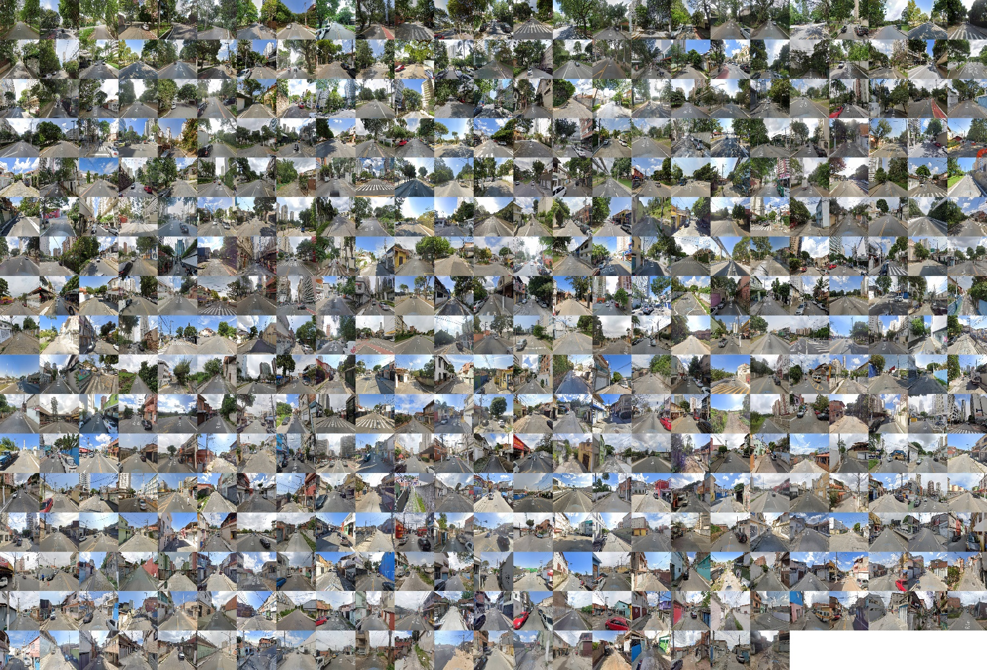

Fig. S19.
The 420 street view images (SVI) sampled ranked by aesthetic values (from left to right and up to bottom). Imagery © 2024 Google

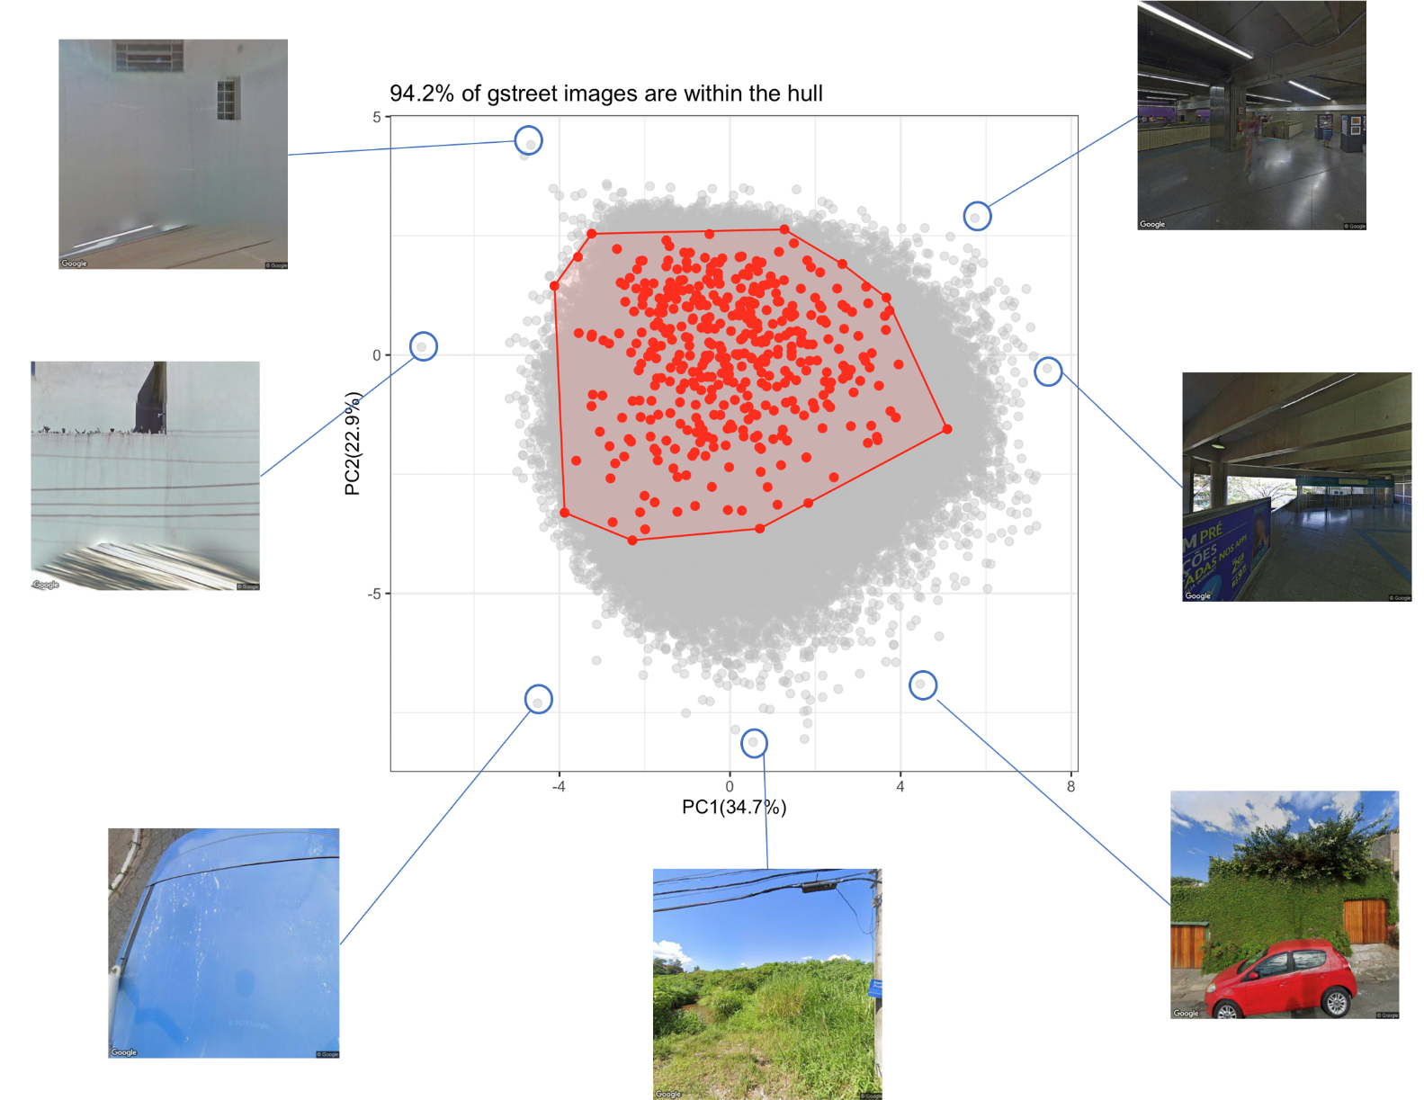

Fig. S20.
The 420 street view images (SVI) PCA of the image attributes (in red) and the 355,168 used in the mapping (in gray) over the hull of the original 420. Some SVI far from the hull the exemplify their remotion. Note that most of the images (94.2%) are in the sampled hull. Imagery © 2024 Google

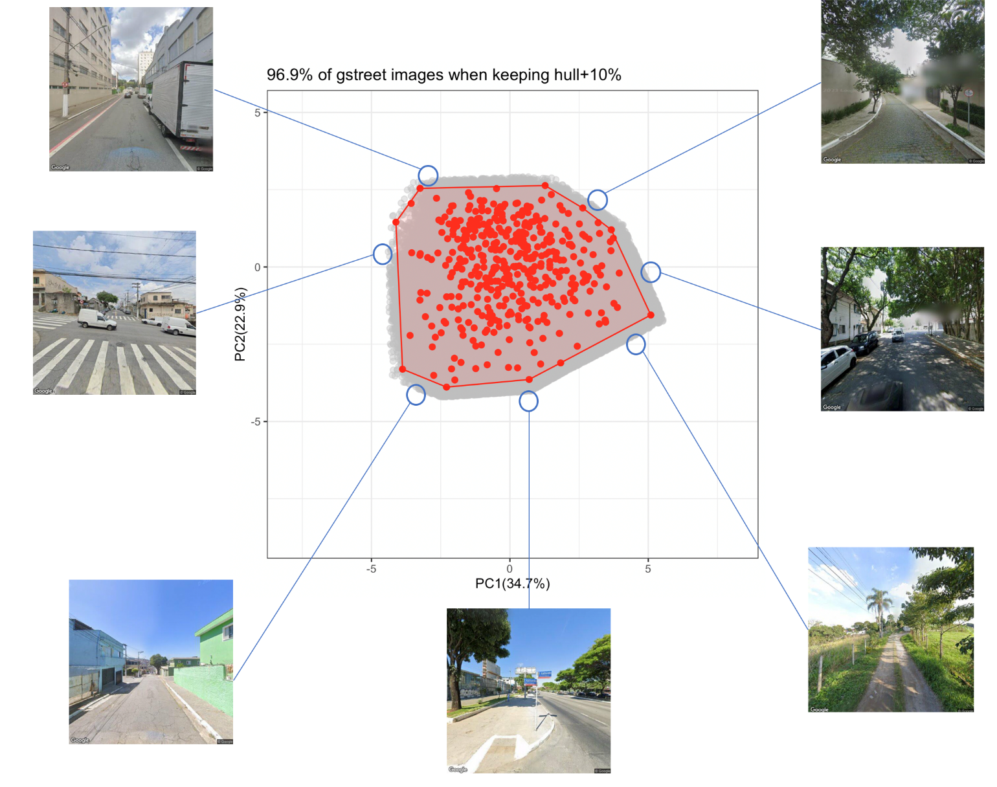

Fig. S21.
The 420 street view images (SVI) PCA of the image attributes (in red) and the hull+10% images (in gray). Some SVI far into the hull+30 exemplify how they match with the pattern, and are keep. Note that most of the images (96.9%) are kept. Imagery © 2024 Google

Fig. S22.
Training and validation curves for mean absolute relative error (MARE), mean squared error (MSE), median absolute error (MEDAE), and R² score over training epochs. Blue lines represent training data, orange lines represent validation data. Each subplot includes a text box indicating the final metric values at the last epoch.
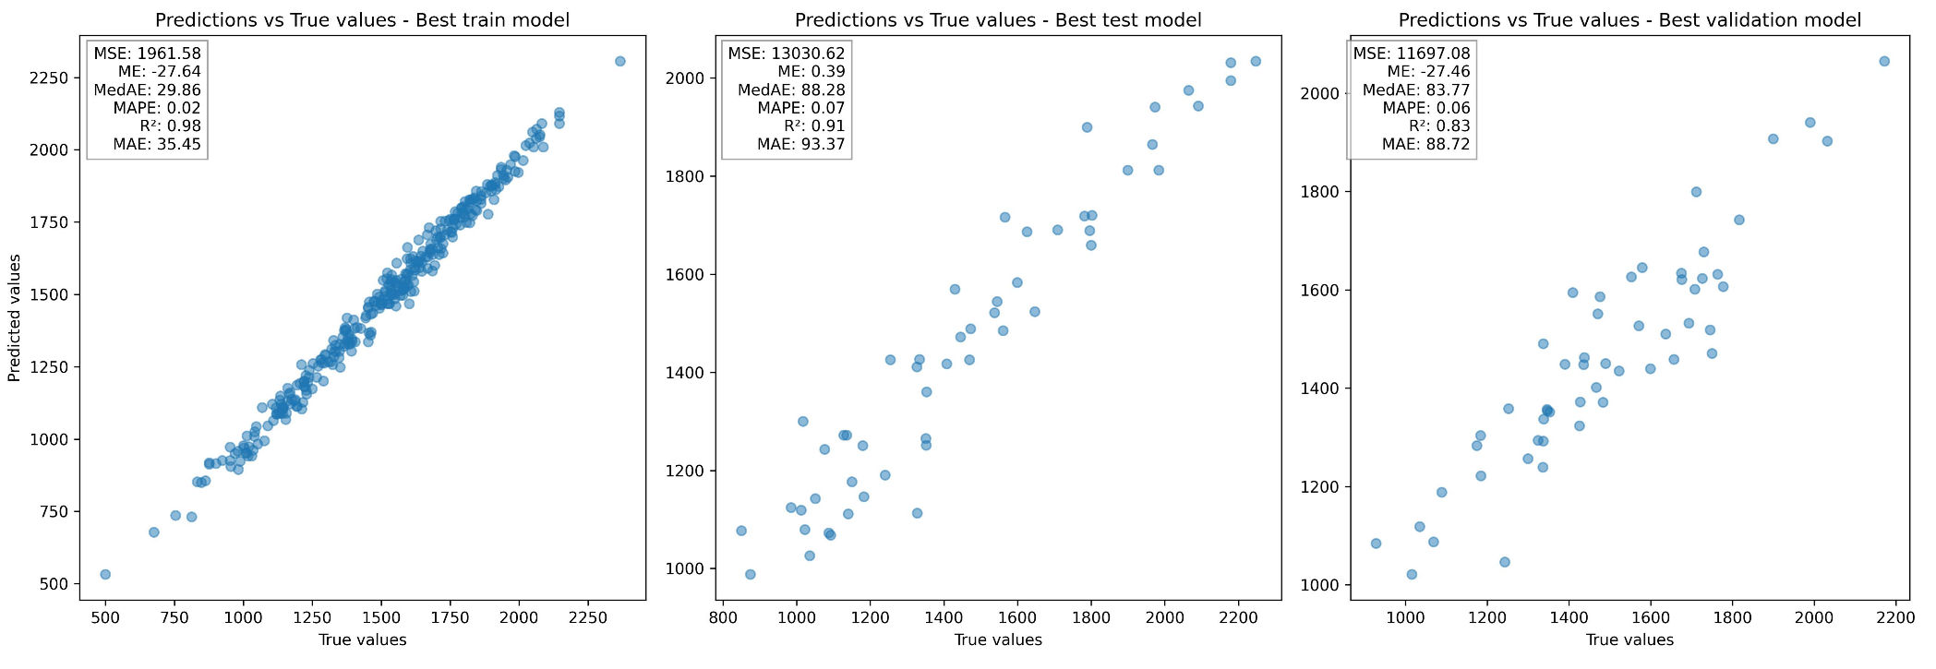

Fig. S23.
Predicted versus true values for the best models on the training, validation, and test sets. Each subplot displays scatter plots comparing predicted and true values, along with performance metrics: mean squared error (MSE), mean error (ME), median absolute error (MedAE), mean absolute percentage error (MAPE), coefficient of determination (R²), and mean absolute error (MAE). The training set shows close agreement between predictions and true values (R² = 0.98), while the validation (R² = 0.83) and test sets (R² = 0.91) indicate good but slightly lower predictive performance, reflecting model generalization.

