Figure 2c

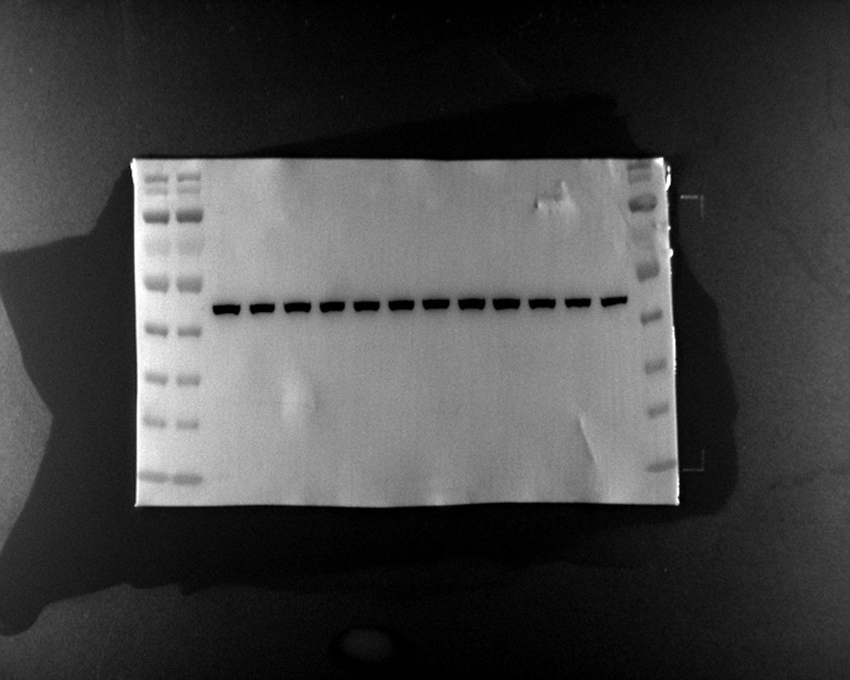
β-actin

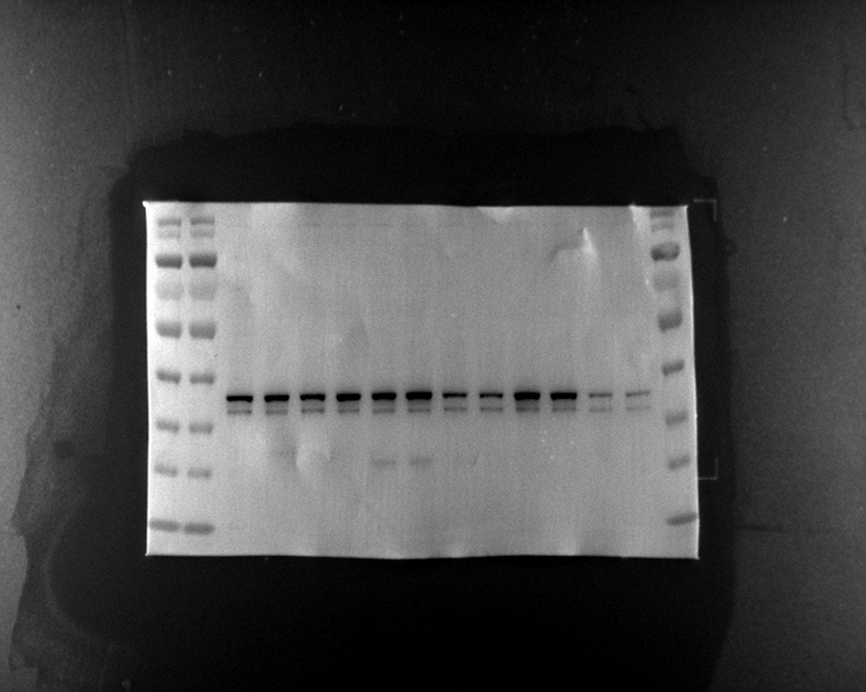
Prolactin (PRL)

Figure S4c
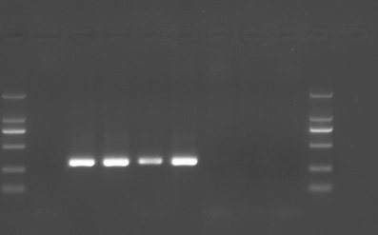
1 2 3 3 3 4 4 4

1: Blank control
2: C57BL/6 mice
3: Wild type mice
4: PRL KO mice

