Supplemental materials

Alcanivorax beigongshangi sp. nov., isolated from the fermented grains of Chinese baijiu
Tong-Xi Zhang¹, Yi-Ming Li¹, Hao-Yue Gu¹, Ru Zhang¹, Zhan-Bin Sun¹, Han-Xu Pan^{1*} and Qing Ren^{1*}
¹Key Laboratory of Brewing Molecular Engineering of China Light Industry, Beijing Technology and Business University, Beijing, China
*Authors for correspondence:
Hanxu Pan, e-mail: phx@btbu.edu.cn
Qing Ren, e-mail: renqing@th.btbu.edu.cn

Table. S1 Comparison of cellular fatty acid between REN37^{T} and type strains of the genus.
Strains: 1. REN37^{T}; 2. A. dieselolei B-5^{T}; 3. A. indicus SW127^{T}; 4. A. venustensis ISO4^{T}; 5. A. mobilis MT13131^{T}; 6. A. nanhaiticus 19-m-6^{T}; 7. A. pacificus W11-5^{T}; 8. A. profundi MTEO17^{T}; 9. A. sediminis PA15-N-34^{T}; 10. A. xenomutans JC109^{T}.
 | 1 | 2 | 3 | 4 | 5 | 6 | 7 | 8 | 9 | 10
C_{14:0} iso | 1.7 | ND | ND | ND | ND | ND | ND | ND | ND | ND
C_{14:0} anteiso | 0.1 | ND | ND | ND | ND | ND | ND | ND | ND | ND
C_{14:0} | 0.1 | 0.6 | 2.0 | 1.4 | TR | 1.1 | 2.5 | 1.2 | 1.6 | 1.0
C_{15:1} anteiso A | 0.1 | ND | ND | ND | ND | ND | ND | ND | ND | ND
C_{15:0} iso | 9.5 | ND | ND | ND | ND | ND | ND | ND | ND | ND
C_{15:0} anteiso | 49.4 | ND | ND | ND | ND | ND | ND | ND | ND | ND
C_{16:0} iso | 18.1 | ND | ND | ND | ND | ND | ND | ND | ND | ND
C_{16:0} | 2.1 | 32.1 | 25.2 | 20.2 | 31.7 | 26.0 | 29.1 | 30.7 | 25.0 | 31.0
C_{15:0} 3OH | 0.1 | ND | ND | ND | ND | ND | ND | ND | ND | ND
C_{17:0} iso | 1.6 | ND | ND | ND | ND | ND | ND | ND | ND | ND
C_{17:0} anteiso | 16.5 | ND | ND | ND | ND | ND | ND | ND | ND | ND
C_{17:1} ω5ϲ | 0.1 | ND | ND | ND | ND | ND | ND | ND | ND | ND
C_{17:0} | 0.1 | 0.3 | TR | 2.8 | ND | TR | 0.8 | ND | ND | ND
C_{18:0} | 0.1 | 0.6 | 3.0 | 0.9 | ND | 6.8 | 3.5 | TR | 2.9 | 0.9
C_{18:1} ω7ϲ | ND | ND | 44.9 | 1.2 | ND | 30.8 | 27.4 | 30.6 | 31.2 | 7.8
C_{17:0} 3OH | 0.2 | ND | ND | ND | ND | ND | ND | ND | ND | ND
C_{19:0} anteiso | 0.2 | ND | ND | ND | ND | ND | ND | ND | ND | ND
TR, trace amount (values lower than 1 %); ND, no data available. Values >5% are shown in bold type.

Table. S2 16S rRNA gene similarity between REN33^{T} and other closely related species in the genus Alcanivorax.
Strains: 1. REN37^{T}; 2. A. dieselolei B-5^{T}; 3. A. indicus SW127^{T}; 4. A. venustensis ISO4^{T}; 5. A. mobilis MT13131^{T}; 6. A. nanhaiticus 19-m-6^{T}; 7. A. pacificus W11-5^{T}; 8. A. profundi MTEO17^{T}; 9. A. sediminis PA15-N-34^{T}; 10. A. xenomutans JC109^{T}.
 | 1 | 2 | 3 | 4 | 4 | 5 | 6 | 7 | 9 | 10
REN37T | 100%
A. dieselolei B-5T | 92.69% | 100%
A. indicus SW127T | 94.39% | 93.74% | 100%
A. venustensis ISO4^{T} | 91.19% | 95.29% | 93.84% | 100%
A. mobilis MT13131T | 92.83% | 96.17% | 94.53% | 96.03% | 100%
A. nanhaiticus 19-m-6T | 92.76% | 94.99% | 93.50% | 93.84% | 94.19% | 100%
A. pacificus W11-5T | 96.10% | 93.74% | 96.79% | 93.22% | 94.60% | 94.39% | 100%
A. profundi MTEO17T | 93.19% | 94.40% | 93.84% | 92.95% | 94.40% | 97.88% | 94.53% | 100%
A. sediminis PA15-N-34T | 92.83% | 94.92% | 93.84% | 93.57% | 93.85% | 97.33% | 93.64% | 97.68% | 100%
A. xenomutans JC109T | 92.71% | 99.85% | 93.58% | 94.13% | 95.65% | 95.01% | 93.58% | 94.15% | 94.58% | 100%

Table. S3 Comparison of OrthoANI and dDDH between strain REN37^{T} and type strains in the genus Alcanivorax.
Strains: 1. REN37^{T}; 2. A. dieselolei B-5^{T}; 3. A. indicus SW127^{T}; 4. A. venustensis ISO4^{T}; 5. A. mobilis MT13131^{T}; 6. A. nanhaiticus 19-m-6^{T}; 7. A. pacificus W11-5^{T}; 8. A. profundi MTEO17^{T}; 9. A. sediminis PA15-N-34^{T}; 10. A. xenomutans JC109^{T}.
 | 1 | 2 | 3 | 4 | 5 | 6 | 7 | 8 | 9 | 10
REN37^{T} |  | 18.5 | 18.6 | 18.4 | 18.0 | 18.8 | 19.2 | 18.7 | 18.6 | 18.8
A. dieselolei B-5^{T} | 71.1 |  | 18.8 | 22.0 | 21.9 | 20.4 | 19.3 | 20.2 | 20.6 | 51.9
A. indicus SW127^{T} | 72.7 | 72.1 |  | 18.6 | 18.9 | 19.3 | 20.1 | 19.2 | 18.8 | 18.9
A. venustensis ISO4^{T} | 71.7 | 77.6 | 72.6 |  | 23.3 | 20.4 | 19.4 | 19.9 | 20.0 | 21.3
A. mobilis MT13131^{T} | 71.4 | 76.9 | 72.1 | 80.0 |  | 20.5 | 19.5 | 20.3 | 20.2 | 20.6
A. nanhaiticus 19-m-6^{T} | 70.1 | 72.8 | 71.1 | 73.3 | 73.0 |  | 19.5 | 23.8 | 25.2 | 20.7
A. pacificus W11-5^{T} | 74.0 | 72.3 | 75.9 | 73.0 | 72.6 | 71.0 |  | 19.4 | 18.7 | 19.4
A. profundi MTEO17^{T} | 70.1 | 73.0 | 70.9 | 73.6 | 73.1 | 78.9 | 71.0 |  | 23.2 | 20.1
A. sediminis PA15-N-34^{T} | 70.0 | 73.0 | 70.9 | 73.5 | 72.9 | 81.8 | 70.9 | 78.6 |  | 20.4
A. xenomutans JC109^{T} | 70.9 | 93.5 | 72.0 | 77.2 | 76.4 | 72.9 | 72.3 | 73.0 | 72.9

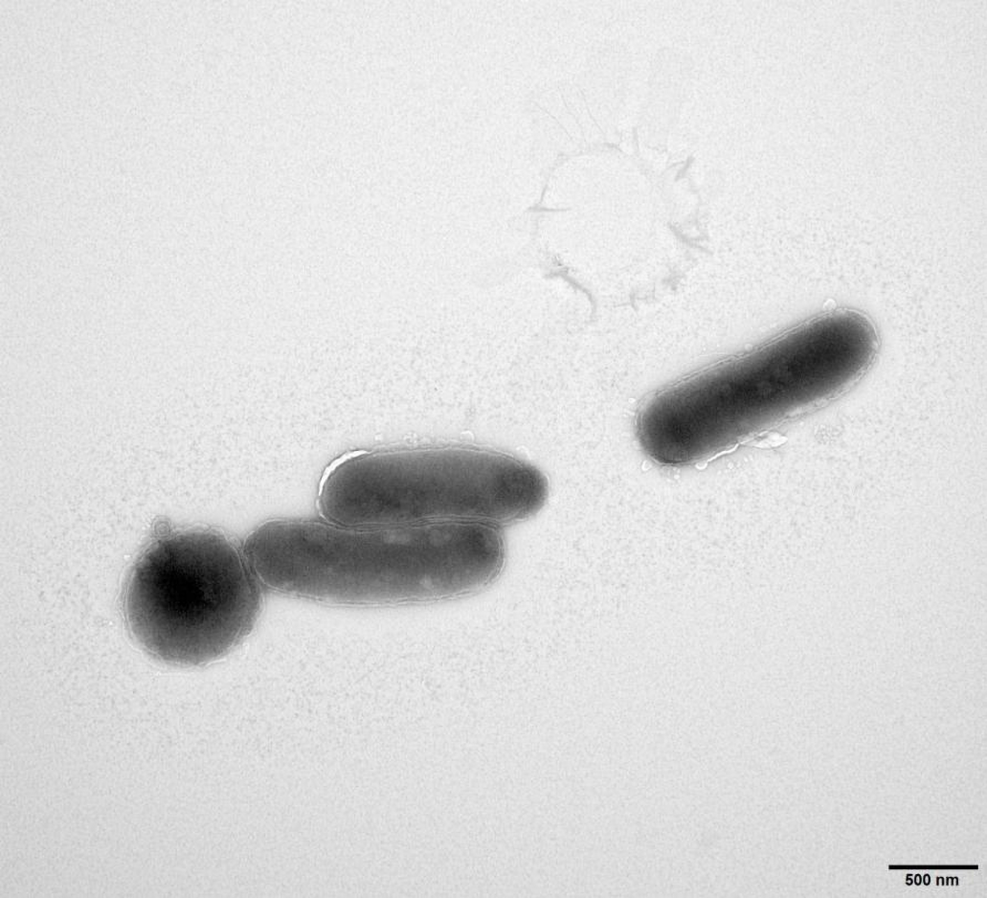
Fig. S1. Cellular morphology of strain REN37^{T}. Bar, 500nm.
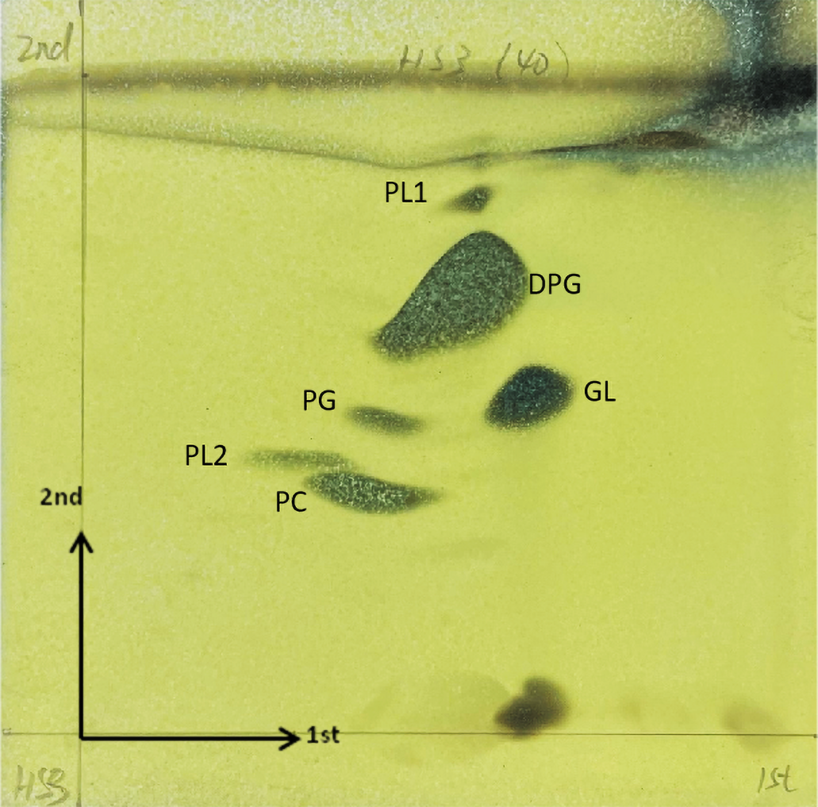
Fig. S2 Two-dimensional TLC of the total polar lipids of strain REN37^{T}. DPG, diphosphatidylglycerol; PG, phosphatidylglycerol; PL1-2, unidentified phospholipids; PC, phosphatidylcholine; GL, unidentified glycolipid.
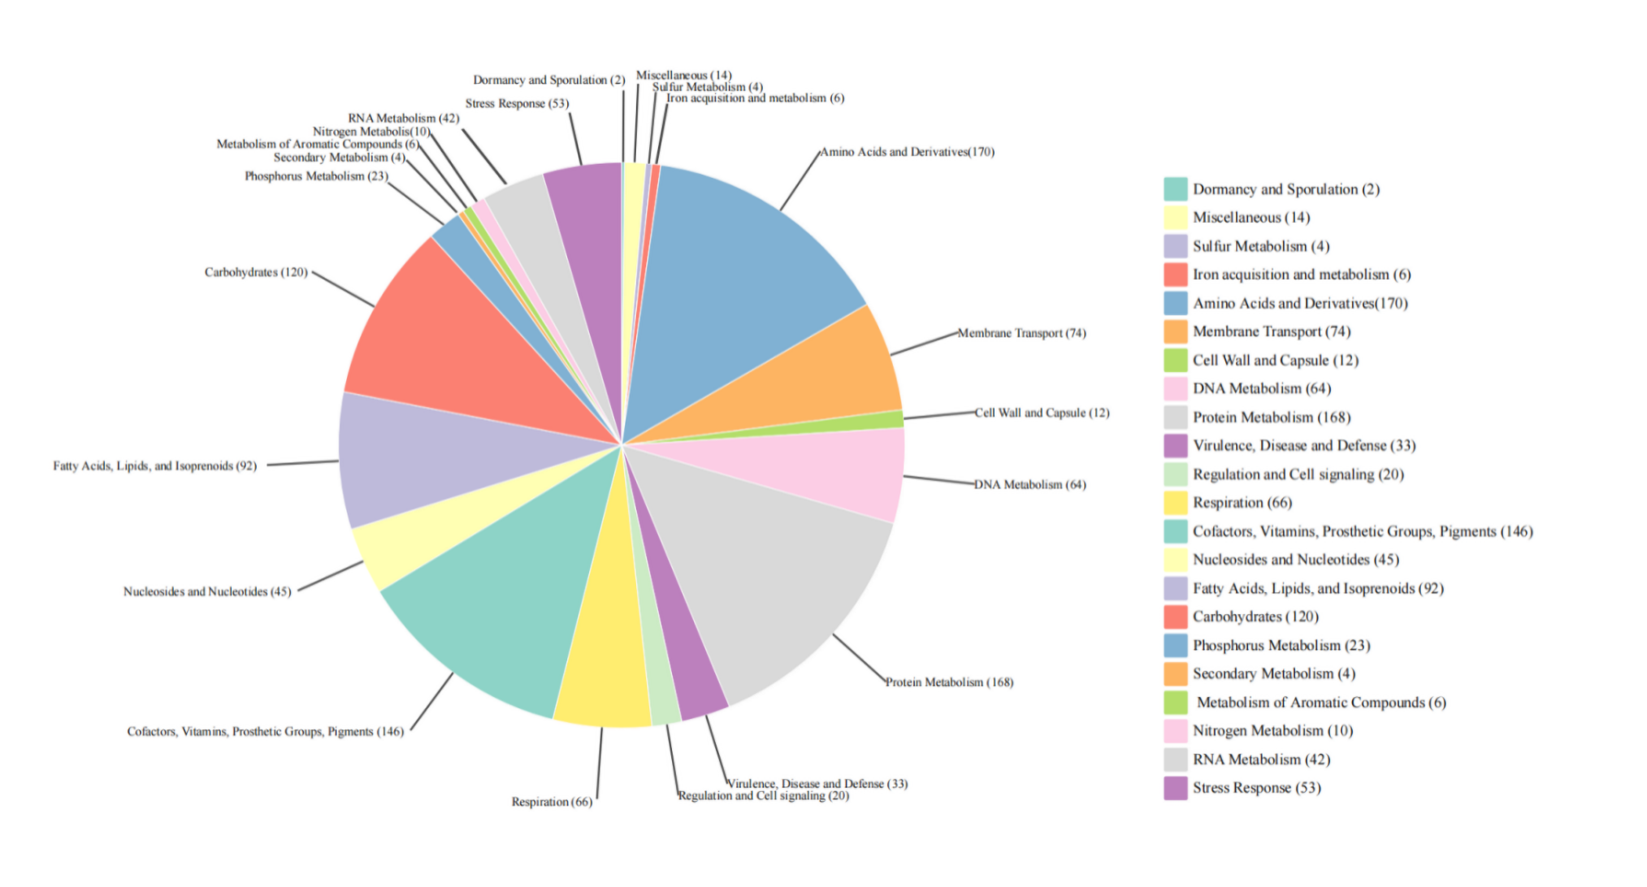
Fig. S3. The RAST subsystem category distribution of REN37^{T}.

