Supplemental Material

Black Carbon (PM_{2.5} Component) and Acute Myocardial Infarction Risk: A Time-stratified Case-crossover Study in Japan

Authors: Kojima et al.

TABLE OF CONTENTS

Supplementary Material, Section 1: Identification of acute myocardial infarction (AMI) in the Japanese Registry Of All Cardiac and Vascular Disease-diagnosis Procedure Combination (JROAD-DPC) Database…………….…………..…………………...….p3
Supplementary Material, Section 2: Patients’ information obtained from the JROAD-DPC database.....................................................................................................p4
Supplementary Figure 1: Percent increase and 95% confidence intervals of the association between PM_{2.5} and AMI hospitalization...………………..……..……..…...p5
Supplementary Figure 2: Estimated effects of an increase in pollutant concentrations at lag0-1 on AMI hospitalization………………….………...…………………………….p6
Supplementary Figure 3: Monitoring sites by ACSA…………………………………p7
Supplementary Figure 4: Study flow chart………………………………..……….….p8
Supplementary Table 1. Estimated effects of %increase for an IQR increase of total PM_{2.5} after adjustment for co-pollutants…………………………………………..…....p9
Supplementary Table 2. Estimated effects of %increase for an IQR increase of individual PM_{2.5} composition with single- and multi-component models…........……..p10
Supplementary Table 3. Estimated effects of %increase for a 1-μg/m³ increase of total PM_{2.5} after adjustment for co-pollutants........................................................................p11
Supplementary Table 4. Estimated effects of %increase for a 1-μg/m³ increase of individual PM_{2.5} composition with single- and multi-component models…...……….p12

Supplementary Material, Section 1: Identification of acute myocardial infarction (AMI) in the Japanese Registry Of All Cardiac and Vascular Disease-diagnosis Procedure Combination (JROAD-DPC) Database
During the study period between April 2017 and December 2019 (before the coronavirus pandemic), we extracted the data of 102,233 patients with AMI along with the International Classification of Disease, Tenth Revision (ICD-10) codes for AMI (I21·0, I21·1, I21·2, I21·3, I21·4, and I21·9) in the fields for the main diagnosis, admission-precipitating diagnosis, and/or most resource-consuming diagnosis from the Japanese Registry of all Cardiac and Vascular Diseases (JROAD)–Diagnostic Procedure Combination (DPC) discharge database. We selected 101,124 patients aged ≥40 years and identified 52,157 patients admitted to hospitals located in seven prefectures (Hokkaido, Niigata, Tokyo, Aichi, Osaka, Hyogo, and Fukuoka) where Aerosol Chemical Speciation Analyzers were installed. After excluding 3,166 patients without emergency hospitalization, 4,488 patients who had not undergone coronary angiography (procedure code [claim code]; D206-2 [170020710]) and/or re-vascularization (procedure code [claim code]; K5461 [150374910], K5462 [150375010], K5463 [150375110], K547 [150260350], K5481 [150284310], K5482 [150359310], K5491 [150375210], K5492 [150375310], K5493 [150375410], K550 [160107550], K550-2 [150318310]), and 271 patients who were not assigned concentration of PM_{2.5} total mass and/or its components, a total of 44,232 patients with AMI (33,143 men and 11,089 women) were included in the present analysis.

Supplementary Material, Section 2: Patients’ information obtained from the JROAD-DPC database
From the JROAD-DPC discharge database, we extracted information on the date of admission, the prefecture code of residence, age, sex, height, weight, Brinkman index (number of cigarettes per day multiplied by smoking year), and comorbidities (including hypertension, diabetes, and hyperlipidemia). We categorized the hospitalization season into warm (May to October) and cold (November to April). Body mass index was calculated by dividing weight in kilograms by height in meters squared and categorized into two groups (<25 and ≥25 kg/m²). Smokers were defined as patients who had a Brinkman index of >0.

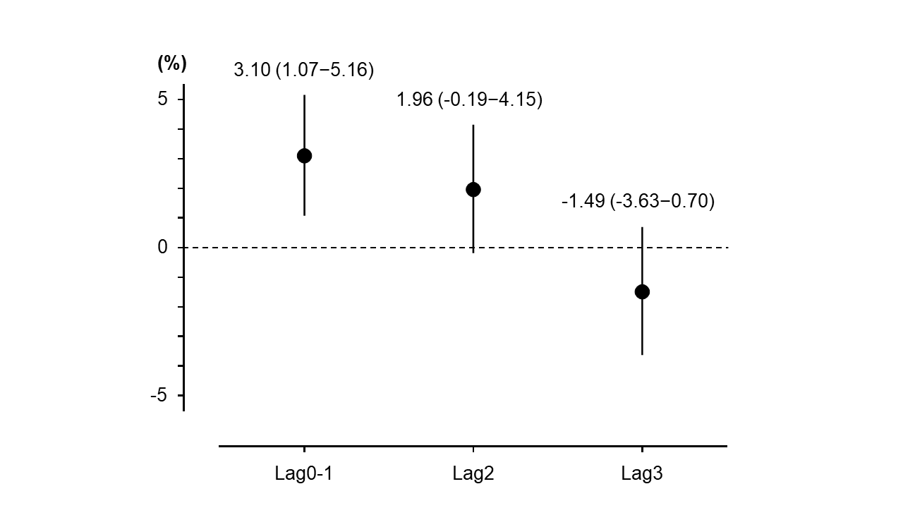
Supplementary Figure 1: Percent increase and 95% confidence intervals of the association between PM_{2.5} and AMI hospitalization
This figure presents %increase and 95% confidence intervals of estimated effects for every 10-μg/m³ increase in total PM_{2.5} concentration using a model that has been adjusted for ambient temperature, relative humidity, and incidence of the influenza epidemic. This indicates that there is a significant effect of short-term exposure to PM_{2.5} at lag0-1.
AMI, acute myocardial infarction; PM_{2.5}, particulate matter with an aerodynamic diameter of ≤2.5 µm.

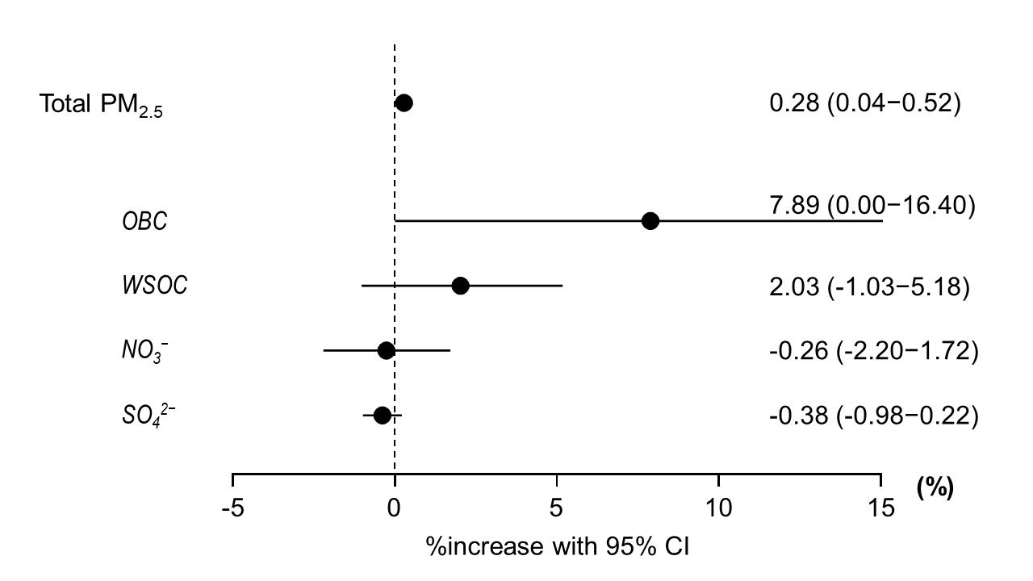
Supplementary Figure 2: Estimated effects of an increase in pollutant concentrations at lag0-1 on AMI hospitalization
Estimated effect of %increase (95% CI) of total PM_{2.5} for a 1-µg/m³ increase after adjustment for PM_{10-2.5} at lag0-1 and estimated effect of %increase (95% CI) of individual PM_{2.5} components for a 1-µg/m³ increase after mutual adjustment for four component concentrations at lag0-1.
AMI, acute myocardial infarction; CI, confidence interval; PM_{2.5}, particulate matter with an aerodynamic diameter of ≤2.5 µm; PM_{10–2.5}, particulate matter concentrations with an aerodynamic diameter of >2.5 µm and ≤10 µm.

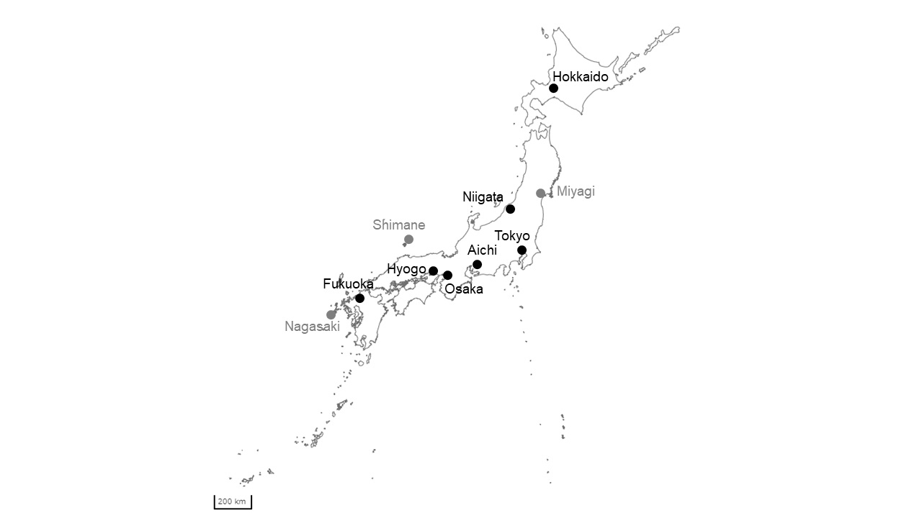
(Source: topographic map published by the Geospatial Information Authority of Japan)
Supplementary Figure 3: Monitoring sites by ACSA
This figure illustrates the 10 monitoring sites in Japan where ACSA has been installed. The seven sites marked with black dots were included in this study. The three sites marked with gray dots were excluded because ACSA were located in the countryside, mountains, and islands.
ACSA, Aerosol Chemical Speciation Analyzer.

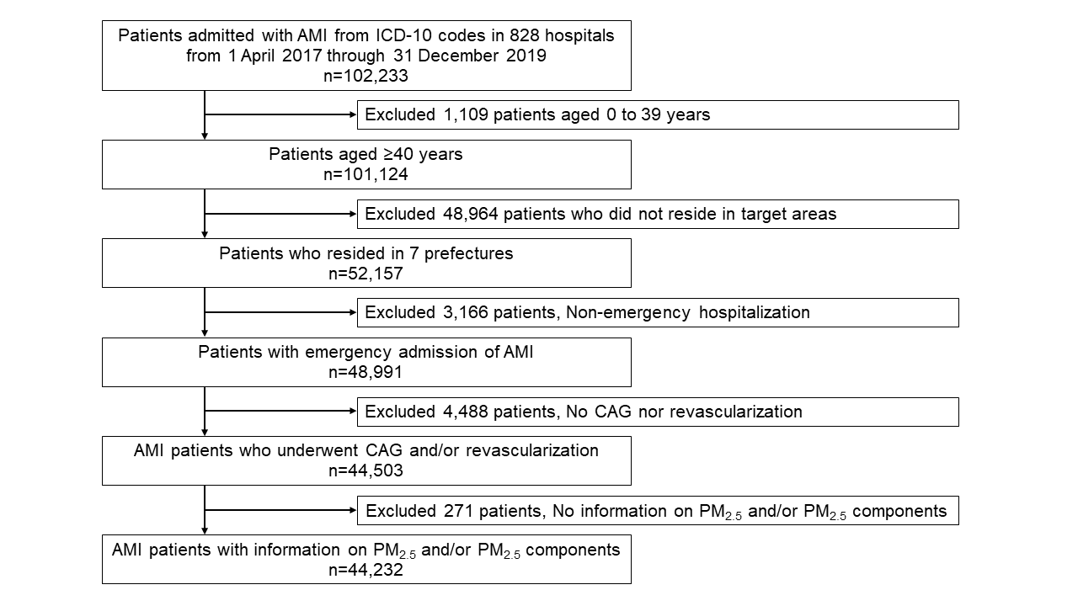
Supplementary Figure 4: Study flowchart
This figure illustrates the enrolment criteria and flow of patients.
AMI, acute myocardial infarction; CAG, coronary angiography; ICD-10, International Classification of Diseases (10th edition); PM_{2.5}, particulate matter with an aerodynamic diameter of ≤2.5 µm.

Supplementary Table 1. Estimated effects of %increase for an IQR increase of total PM_{2.5} after adjustment for co-pollutants
Covariates |  | %increase for an IQR increase |  | 95% CI
Temperature, humidity, and influenza adjusted |  | 2.44 |  | 0.85–4.07
Temperature, humidity, influenza + PM_{10–2.5} adjusted |  | 2.22 |  | 0.30–4.19
Temperature, humidity, influenza, PM_{10–2.5} + SO₂ adjusted |  | 2.31 |  | 0.14–4.53
Temperature, humidity, influenza, PM_{10–2.5} + NO₂ adjusted |  | 1.53 |  | -0.30–3.40
Temperature, humidity, influenza, PM_{10–2.5} + O₃ adjusted |  | 1.91 |  | 0.18–3.66
CI, confidence interval; IQR, interquartile range; NO₂, nitrogen dioxide; O₃, ozone; PM_{10–2.5}, particulate matter concentrations with an aerodynamic diameter of >2.5 µm and ≤10 µm; SO₂, sulfur dioxide.

Supplementary Table 2. Estimated effects of %increase for an IQR increase of individual PM_{2.5} composition with single- and multi-component models
 |  | Single-component model |  |  |  | Multi-component model
PM_{2.5} components |  | %increase for an IQR increase |  | 95% CI |  | %increase for an IQR increase |  | 95% CI
OBC |  | 2.75 |  | 0.96–4.57 |  | 2.54 |  | 0.00–5.14
WSOC |  | 1.13 |  | -0.12–2.39 |  | 1.21 |  | -0.62–3.08
NO₃– |  | 0.89 |  | 0.02–1.76 |  | -0.18 |  | -1.54–1.20
SO₄^{2–} |  | 0.31 |  | -0.96–1.58 |  | -0.91 |  | -2.34–0.54
CI, confidence interval; IQR, interquartile range; NO₃⁻, nitrate ion; OBC, optically measured black carbon; PM_{2.5,} particulate matter with an aerodynamic diameter of ≤2.5 µm; SO₄²⁻, sulfate ion; WSOC, water-soluble organic compound.

Supplementary Table 3. Estimated effects of %increase for a 1-μg/m³ increase of total PM_{2.5} after adjustment for co-pollutants
Covariates |  | %increase for a 1-μg/m³ increase |  | 95% CI
Temperature, humidity, and influenza adjusted |  | 0.31 |  | 0.11–0.51
Temperature, humidity, influenza + PM_{10–2.5} adjusted |  | 0.28 |  | 0.44–0.52
Temperature, humidity, influenza, PM_{10–2.5} + SO₂ adjusted |  | 0.29 |  | 0.02–0.56
Temperature, humidity, influenza, PM_{10–2.5} + NO₂ adjusted |  | 0.19 |  | -0.04–0.42
Temperature, humidity, influenza, PM_{10–2.5} + O₃ adjusted |  | 0.24 |  | 0.02–0.46
CI, confidence interval; NO₂, nitrogen dioxide; O₃, ozone; PM_{10–2.5}, particulate matter concentrations with an aerodynamic diameter of >2.5 µm and ≤10 µm; SO₂, sulfur dioxide.

Supplementary Table 4. Estimated effects of %increase for a 1-μg/m³ increase of individual PM_{2.5} composition with single- and multi-component models
 |  | Single-component model |  |  |  | Multi-component model
PM_{2.5} components |  | %increase for a 1-μg/m³ increase |  | 95% CI |  | %increase for a 1-μg/m³ increase |  | 95% CI
OBC |  | 8.56 |  | 2.94–14.49 |  | 7.89 |  | 0.00–16.40
WSOC |  | 1.88 |  | -0.20–4.01 |  | 2.03 |  | -1.03–5.18
NO₃– |  | 1.27 |  | 0.03–2.53 |  | -0.26 |  | -2.20–1.72
SO₄^{2–} |  | 0.13 |  | -0.40–0.65 |  | -0.38 |  | -0.98–0.22
CI, confidence interval; NO₃⁻, nitrate ion; OBC, optically measured black carbon; PM_{2.5,} particulate matter with an aerodynamic diameter of ≤2.5 µm; SO₄²⁻, sulfate ion; WSOC, water-soluble organic compound.

