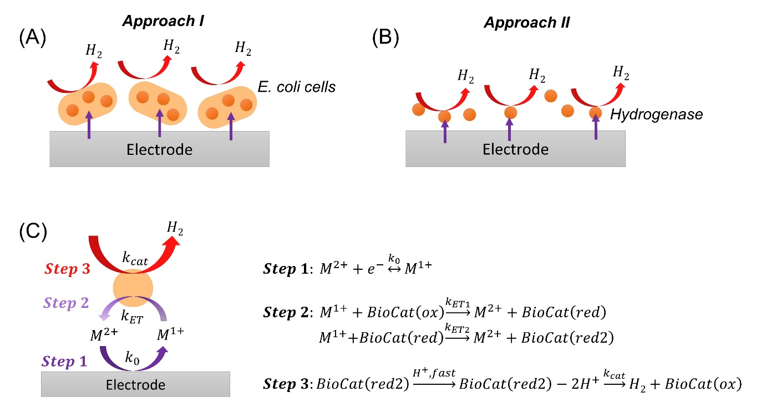
Scheme 1. Schematic representation of the kinetic models used for cyclic voltammetry data simulations. (A) Approach I, (B) Approach II, (C) Steps used for data simulation.

