Supplementary Information
Electrodriven H₂ Production in Escherichia coli: Rational Design and Mechanistic Studies of the Electron Uptake Process

Sagar Ganguli,ª Larissa Kurth,ª Mira Gamache,ª Olha Pavliukª Afridi Zamader,ª Nikolaos Kostopoulos,ª Dawit T. Filmon,^{b} Nicolas Plumere,^{b} Sandra Ortega Ugalde,^{c} Gustav Berggren,ª Alina Sekretarevaª

ª Department of Chemistry─Ångström, Molecular Biomimetics, Uppsala University, Box 523, 75120 Uppsala, Sweden
^{b} TUM Campus Straubing for Biotechnology and Sustainability, Technical University of Munich, Uferstrasse 53, 94315 Straubing, Germany
^{c} Directorate of Technology, Engineering and Quality, European Space Agency, Noordwijk, Netherlands

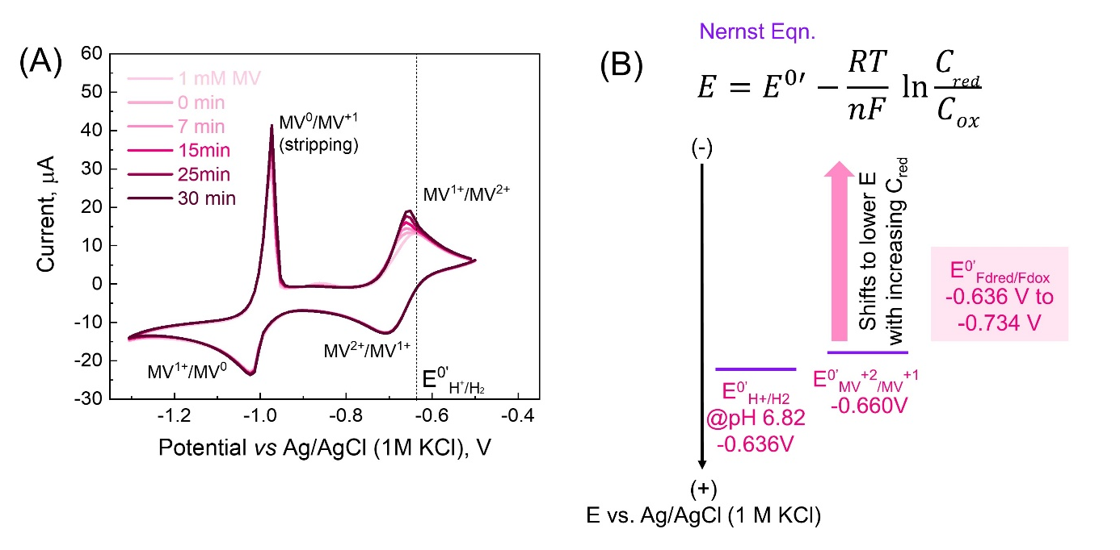
Figure S1. CVs of MV (2 mM) in the absence and presence of E. coli (CrHydA1) recorded at the scan rate of 5 mV s⁻¹ to verify the efficiency of MV as an electron transfer mediator. An increase in the anodic peak current at -0.620 V vs. Ag/AgCl was observed with no changes in the corresponding cathodic peak current. The black dashed line represents the formal reduction potential of H⁺/H₂ interconversion at -0.636 V vs. Ag/AgCl. (B) Schematic showing that intracellular ferredoxin having E0′<-0.636V vs. Ag/AgCl is capable of reducing MV²⁺ into MV^{1+.} This leads to an incremental increase in MV¹⁺ concentration near the electrode surface and is reflected in the increase of the anodic peak current of MV.

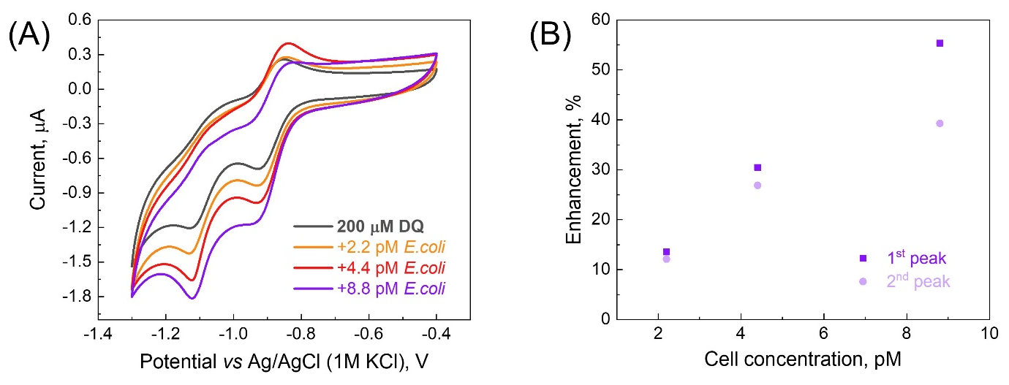

Figure S2. (A) CVs recorded at different concentrations (0, 2.2, 4.4, and 8.8 pM) of E. coli (CrHydA1) in the presence of 200 µM Diquat in 150 mM PBS at 5 mV s⁻¹. (B) The relative enhancements of both the first and second cathodic peaks at different E. coli (CrHydA1) concentrations.

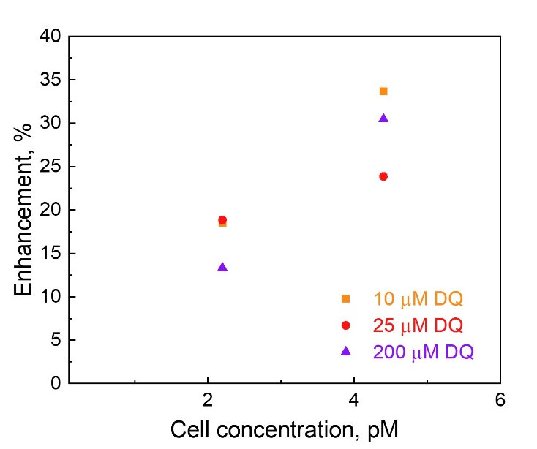
Figure S3. Relative enhancements of the first reduction peak of DQ at -0.925 V vs Ag/AgCl were found to be nearly identical at different DQ concentrations for the same concentration of E. coli (CrHydA1).

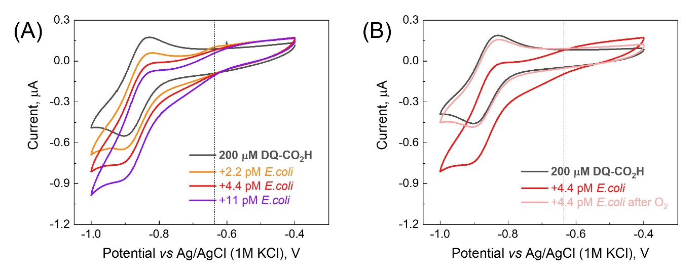
Figure S4. (A) CVs recorded at different concentrations (0, 2.2, 4.4, and 8.8 pM) of E. coli (CrHydA1) in the presence of 200 µM Diquat-CO₂H in 150 mM PBS at 5 mV s⁻¹. At all concentrations, enhancement of cathodic current was observed to start from -0.636 V vs. Ag/AgCl, i.e. the formal redox potential of H⁺/H₂. (B) Exposure of the electrolyte containing Diquat-CO₂H and E. coli (CrHydA1) led to the disappearance (pink trace) of the enhancement before oxygen exposure (red trance) suggesting the observed enhancement occurred due to DET between the electrode and CrHydA1 released in the electrolyte from cell lysis. The black dashed line represents the formal reduction potential of H⁺/H₂ interconversion at -0.636 V vs. Ag/AgCl.

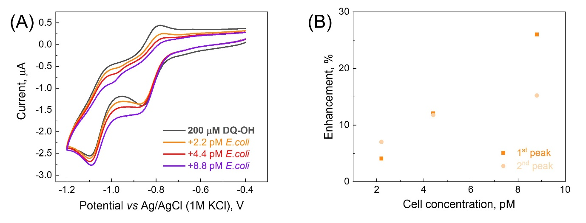
Figure S5. (A) CVs recorded at different concentrations (0, 2.2, 4.4, and 8.8 pM) of E. coli (CrHydA1) in the presence of 200 µM Diquat-OH in 150 mM PBS at 5 mV s⁻¹. (B) The relative enhancements of both the first and second cathodic peaks at different E. coli (CrHydA1) concentrations.

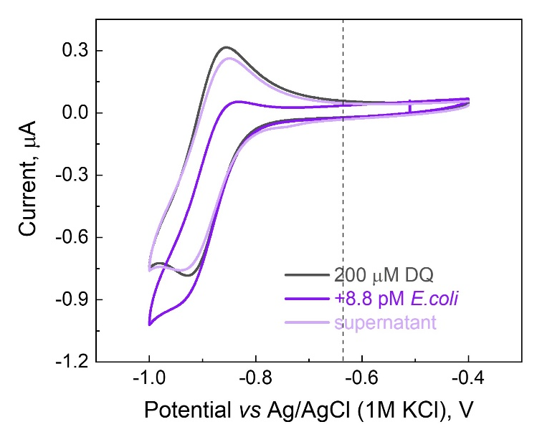
Figure S6. CVs recorded with 8.8 pM of E. coli (CrHydA1) in the presence of 200 µM DQ (purple) in 150 mM PBS and the supernatant collected through centrifugation of the E. coli containing electrolyte (light purple trace) at 5 mV s⁻¹. The enhancement observed in the presence of 8.8 pM E. coli (CrHydA1) disappeared in the supernatant suggesting that the observed enhancement was arising from the interaction between DQ and cytoplasmic hydrogenase present in E. coli (CrHydA1), and no hydrogenase is present in the electrolyte. The black dashed line represents the formal reduction potential of H⁺/H₂ interconversion at -0.636 V vs. Ag/AgCl.

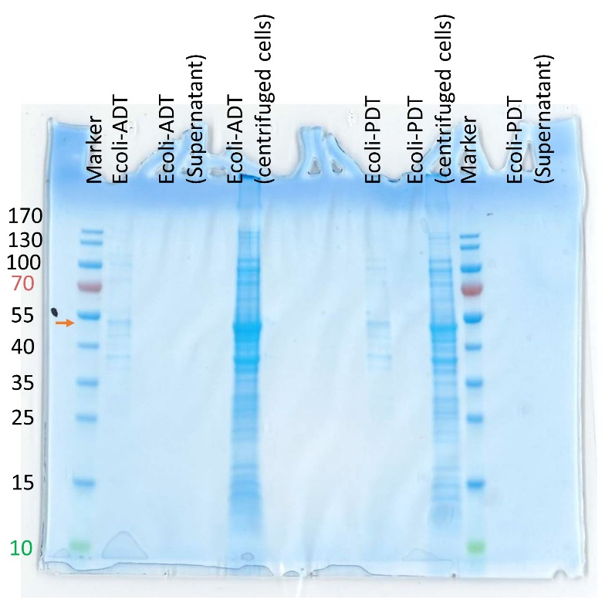
Figure S7. SDS-PAGE analysis on both the supernatant and the centrifuged cells was performed to check the presence of hydrogenase. While the centrifuged cells showed a strong band close to 50 kDa corresponding to hydrogenase, no band was present in the supernatant. This further confirms that in measurements using DQ as a mediator, the observed current enhancements are entirely due to MET between the electrode and cytoplasmic hydrogenases.

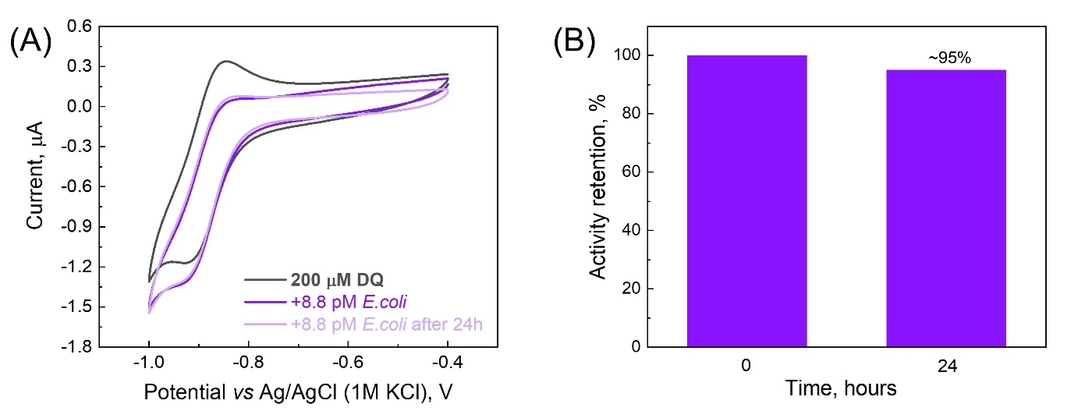
Figure S8. (A) CVs recorded with 8.8 pM of E. coli (CrHydA1) in the presence of 200 µM DQ in 150 mM PBS (purple trace) and after storing the solution for 24 hours (light purple trace) at 4 ˚C at 5 mV s⁻¹. (B) Bar diagram showing that the solution retains approximately 95% of its initial activity after storing the electrolyte for 24 hours at 4 ˚C.

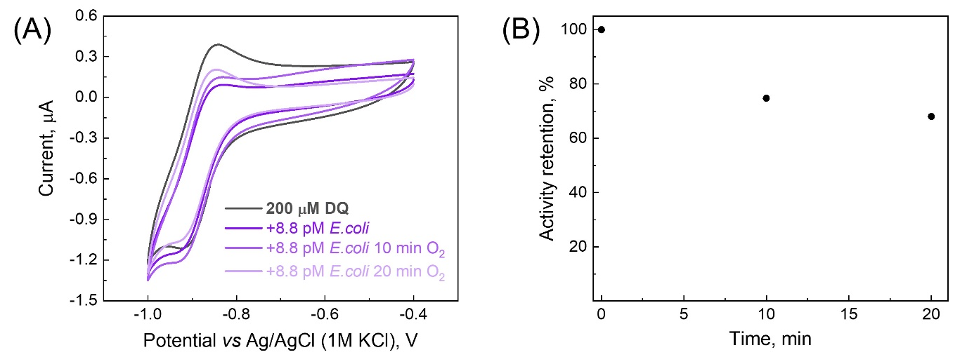
Figure S9. (A) CVs recorded with 8.8 pM of E. coli (CrHydA1) in the presence of 200 µM DQ in 150 mM PBS (purple trace) and after exposing the solution to air for 10 and 20 minutes (light purple traces) at 5 mV s⁻¹. (B) The activity dropped to 74% and 70% of the initial enhancement after 10 and 20 minutes, respectively.

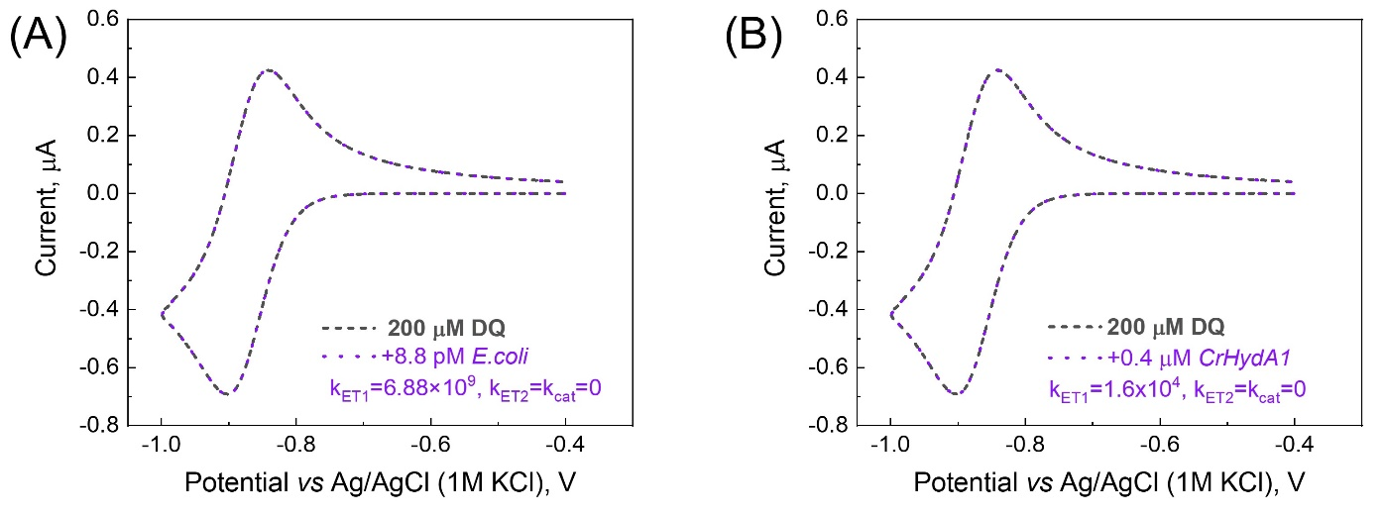
Figure S10. (A) Simulated CV at 200 µM DQ and 8.8 pM E. coli (CrHydA1) concentrations showing that if k_{ET1} = 500×1.72×10⁷= 6.88×10⁹ s⁻¹, and k_{ET2} = k_{cat} = 0, no enhancement is observed in CV compared to the response of only the mediator (DQ). Individual E. coli (CrHydA1) cells were considered as the catalyst. (B) Simulated CV at 200 µM DQ and 0.4 µM CrHydA1 concentrations showing that if k_{ET1} = 400×400=1.6x10⁴ s⁻¹, and k_{ET2} = k_{cat} = 0, no enhancement is observed in CV compared to the response of only the mediator (DQ). Individual CrHydA1 enzymes were considered as the catalyst.

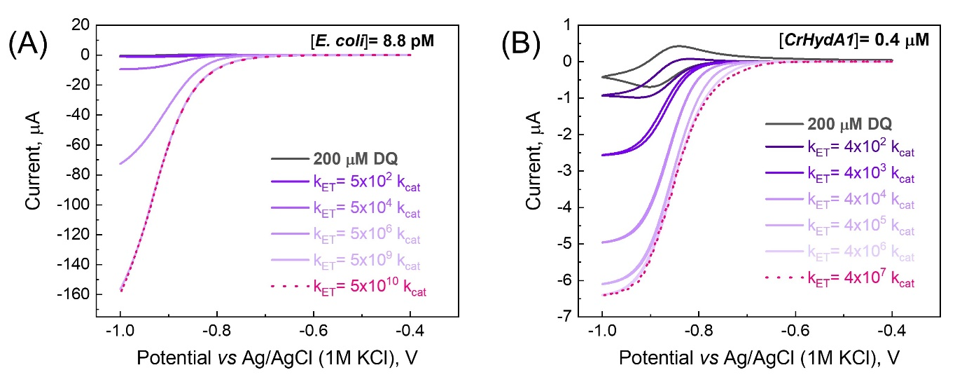
Figure S11. Simulated CVs showing that the current enhancement increased with increasing the value of k_{ET} relative to k_{cat} (up to very large values of k_{ET} shown as pink traces, at which point k_{cat} became limiting). (A) simulations performed with 200 µM DQ and 8.8 pM E. coli; (B) simulations performed with 200 µM DQ and 0.4 µM CrHydA1.

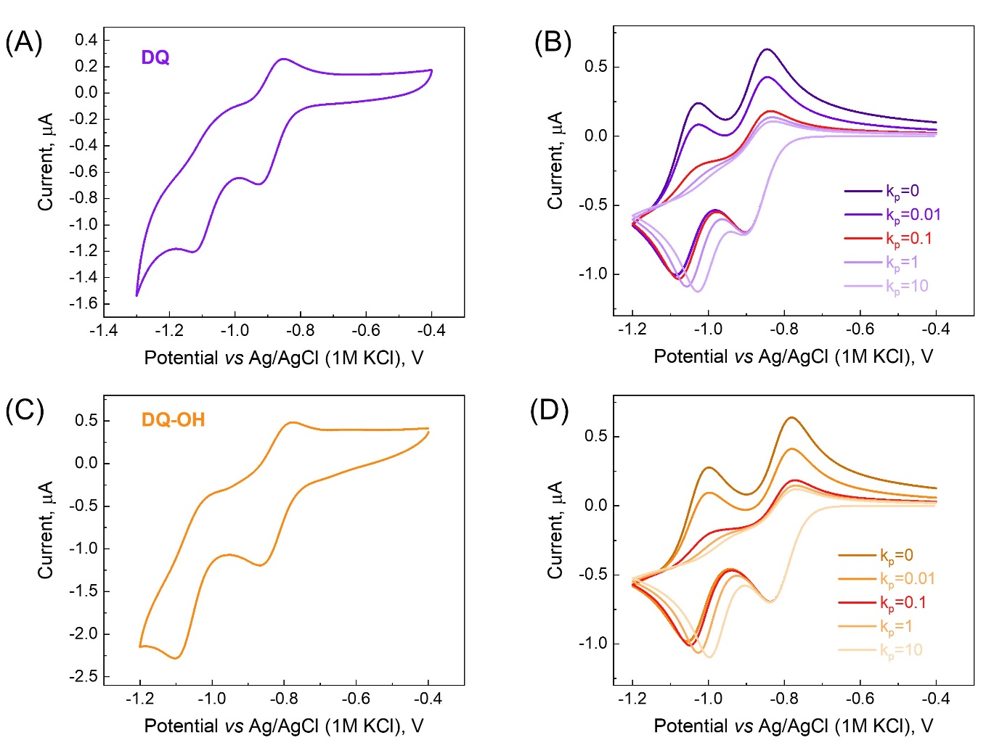
Figure S12. Experimental CVs of (A) 200 µM DQ, and (C) 200 µM DQ-OH in 150 mM PBS at 5 mV s⁻¹. Simulated CVs of (B) 200 µM DQ, and (D) 200 µM DQ-OH with different k_{p} values (Note S2) to simulate the insolubility of the 0 oxidation state of the diquats and its effect on the CVs. Red traces for both mediators show simulated curves reproducing experimental CVs.

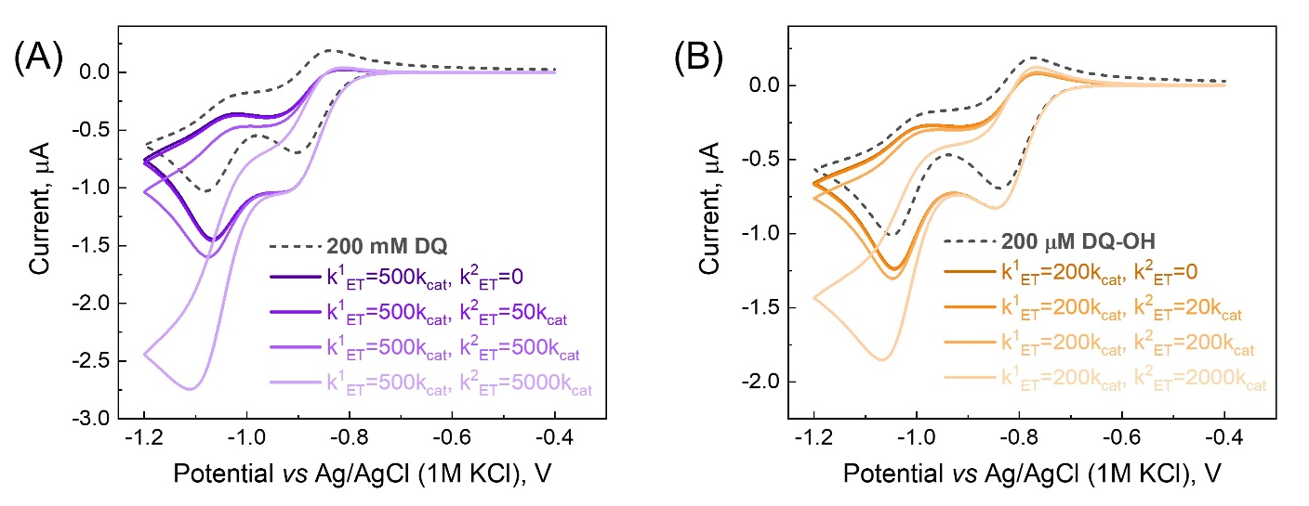
Figure S13. Simulations reflecting the effect of the individual ratio of k¹_{ET} (electron transfer rate from M¹⁺ to cells) and k²_{ET} (electron transfer rate from M⁰ to cells) to k_{cat} on the CVs at 8.8 pM E. coli (CrHyDA1) concentration with (A) 200 µM DQ, and (B) 200 µM DQ-OH as mediators.

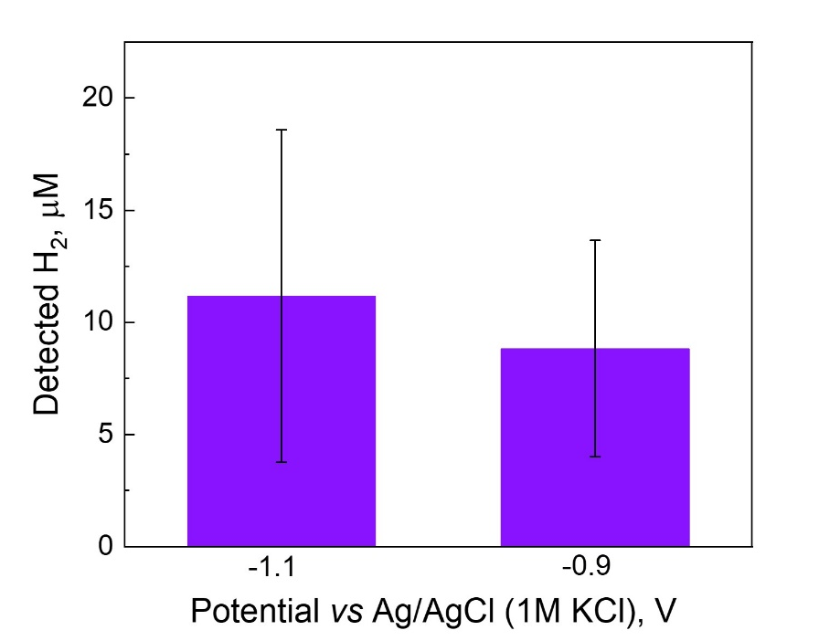
Figure S14. Effect of the applied potential on the amount of H₂ detected by gas chromatography after 30 minutes of bulk electrolysis using DQ as the mediator. Error bars indicate the standard deviation from 4 biological replicates.
Table S1. Parameters used for simulating experimental CV data in Fig. 2 in the main manuscript. The results of the simulations are shown in Fig. 3.
Parameter | Value | Source/comments
D_{DQ,} cm² s⁻¹ | 6.7×10⁻⁶ | ¹
D_{BioCat,} cm² s⁻¹ | 5×10⁻⁶ | ²
D_{H2,} cm² s⁻¹ | 4×10⁻⁵ | ³
E⁰′_{DQ(2+)/DQ(1+)} (V vs Ag/AgCl) | -0.873 | Fig. 1
Electron transfer coefficient, α | 0.5 | ¹
k₀, _{DQ(2+)/DQ(1+)} cm s⁻¹ | 0.03 | ⁴ and simulation of Fig. 1B
k_{cat}, s⁻¹
Approach I
Approach II
k_{cat}, s⁻¹  Approach I  Approach II | 1.72×10⁷ | calculated based on ⁵
k_{cat}, s⁻¹  Approach I  Approach II | 400 | ⁵
Initial [DQ], M | 2×10⁻⁴ | experimental
Initial [BioCat(Ox)], M
Approach I
Approach II
Initial [BioCat(Ox)], M  Approach I  Approach II | 2.2 to 8.8 ×10⁻¹² | experimental
Initial [BioCat(Ox)], M  Approach I  Approach II | 1.0 to 4.0×10⁻⁷ | experimental
Initial [BioCat(Red)], M | 0 | ^{6,7}
Initial [BioCat(Red2)], M | 0 | ^{6,7}
Initital [H₂], M | 0 | experimental

Table S2. Parameters used for simulating experimental CV of DQ and DQ-OH.

Parameter | Value | Source/comments
D_{DQ,} cm² s⁻¹ | 6.7×10⁻⁶ | ¹, the same D was used for all forms of the mediator as an approximation
D_{DQ-OH,} cm² s⁻¹ | 6.7×10⁻⁶ | as an approximation, the same D was used for the DQ
Electron transfer coefficient, α | 0.5 | ¹, the same for both redox couples and both mediators
$k_{0}^{1}$, _{DQ(2+)/DQ(1+)} cm s⁻¹ | 0.03 | ⁴ and simulation of Fig. S12A
$k_{0}^{2}$, _{DQ(1+)/DQ(0)} cm s⁻¹ | 0.03 | simulation of Fig. S12A
$k_{0}^{1}$, _{DQ-OH(2+)/DQ-OH(1+)} cm s⁻¹ | 0.03 | simulation of Fig. S12C
$k_{0}^{2}$, _{DQ-OH(1+)/DQ-OH(0)} cm s⁻¹ | 0.03 | simulation of Fig. S12C
E⁰′_{DQ(2+)/DQ(1+)} (V) | -0.873 | Fig. S12A, Table 1
E⁰′_{DQ(1+)/DQ(0)} (V) | -1.065 | Fig. S12A, Table 1
E⁰′_{DQ-OH(2+)/DQ-OH(1+)} (V) | -0.808 | Fig. S12C, Table 1
E⁰′_{DQ-OH(1+)/DQ-OH(0)} (V) | -1.035 | Fig. S12C, Table 1
k_{p}, DQ | 0.1 | simulation of Fig. S12A
k_{p}, DQ-OH | 0.1 | simulation of Fig. S12C

Note S1. Calculation of the rate of the electron transfer reaction
The initial rate of the electron transfer reaction was calculated using the first equation of Step 2:
M¹⁺ + BioCat(Ox) → M²⁺+ BioCat(Red) (S1)
The rate of the reaction, v, can be expressed as:
$v=k_{ET}\left[{DQ}^{1+}\right]\left[BioCat(ox)\right]$ (S2)
where k_{ET} is the electron transfer rate constant obtained from the simulations, $\left[{DQ}^{1+}\right]$ is the concentration of ${DQ}^{1+}$, $\left[BioCat(ox)\right]$ is the concentration of the BioCat(Ox).
DQ²⁺/DQ⁺¹ redox reaction is fast and therefore DQ⁺¹ concentration can be calculated using the Nernst equation:
$E=E_{DQ2+/DQ+1}^{0'}-\frac{RT}{F}ln\frac{\left[{DQ}^{1+}\right]}{\left[{DQ}^{2+}\right]}$ (S3)
Where E is the applied potential, $E_{DQ2+/DQ1+}^{0'}$ is the formal reduction potential of the DQ^{2+/}DQ¹⁺ redox couple (-0.873 V vs Ag/AgCl), R is the gas constant, T is the temperature (298 K), F is the Faraday constant, [DQ²⁺] is the concentration of the DQ²⁺.
$\left[{DQ}^{1+}\right]+\left[{DQ}^{2+}\right]={\left[{DQ}^{2+}\right]}_{0}$ (S4)
Where ${\left[{DQ}^{2+}\right]}_{0}$ is the initial concentration of DQ used in the experiments (2x10⁻⁴ M).
At the applied potential of -0.9V vs. Ag/AgCl (potential where current enhancement becomes observable) concentration of DQ¹⁺ was calculated to be 1.48 x10⁻⁴ M.

In Approach I the initial rate of the electron transfer step then can be calculated using the following expression:
$$v=500×k_{cat}×\left[{DQ}^{1+}\right]×\left[Cells\right]=$$
$=500×1.72×{10}^{7} ×1.48×{10}^{-4}×8.8×{10}^{-12}=1.1×{10}^{-5} M/s$ (S5)
In Approach II the initial rate of the electron transfer step is:
$$v=400×k_{cat}×\left[{DQ}^{1+}\right]×\left[Enzyme\right]=$$
$=400×400×1.48×{10}^{-4}×4×{10}^{-7}=0.95×{10}^{-5} M/s$ (S6)

Note S2. Simulating current responses of DQ and DQ-OH
In order to simulate current enhancements for both redox couples of DQ and DQ-OH (Fig. 4A and B in the main text, respectively), we first simulated CVs without the addition of the cells. Table S2 summarizes the parameters that were used for simulations. Mediator oxidation and reduction at the electrode surface were modeled using Butler-Volmer formalism: ⁸
$M^{2+}+e^{-}\underset{↔}{k_{0}^{1}}M^{1+}$ (S7)
$M^{1+}+e^{-}\underset{↔}{k_{0}^{2}}M^{0}$ (S8)
Mass transport of the mediator was modeled using Fick’s law of diffusion, ⁸ parametrized by the corresponding values of the diffusion coefficients (D) (Table S2). To reproduce the flattening of the oxidation peak for M⁰ → M¹⁺ redox transformation observed for both DQ (Fig. S12A) and DQ-OH (Fig. S12C), an additional chemical step including precipitation of M⁰ species was added to the model:
$M_{aq}^{0}\underset{→}{k_{p}}M_{s}^{0}$ (S9)
Increasing the value of k_{p} results in stronger flattening of the oxidation peak for both mediators (Fig. S12) and a slight shift of the cathodic peak at larger values of k_{p} (k_{p}=1 or higher) (Fig. S12B for DQ and Fig. S12D for DQ-OH). To reproduce experimental CVs of DQ and DQ-OH k_{p} value of 0.1 s⁻¹ was used.
The introduction of Eq. S9 did not affect further modeling of the catalytic current enhancements, as those were observed for cathodic currents, but it allowed for a better reproduction of the shape of the CVs. Additionally, as the rate constant k_{p} was modeled on CVs without the cells, it did not add extra parameters to the model of the catalytic response.
To model the catalytic response for both redox couples of the mediators, modifications to the model presented in Scheme 1 in the main text were introduced. In Step 1, Eqs. S8 and S9 were added to account for the second reduction event M¹⁺/M⁰ and the poor solubility of the fully reduced form, respectively. For Step 2, the following equations were added to account for the possible electron transfer from M⁰ to the biocatalyst:
$M^{0}+BioCat(ox)\underset{→}{k_{ET}^{2}}M^{1+}+BioCat(red)$ (S10)
$M^{0}+BioCat(red)\underset{→}{k_{ET}^{2}}M^{1+}+BioCat(red2)$ (S11)

Note S3. Dependence of the electron transfer rate on the driving force.
Marcus theory was used to estimate the ratio of the electron transfer rate constants (k_{ET}) from DQ¹⁺ and DQ-OH¹⁺ to the active site of CrHydA1. Marcus theory predicts how the electron transfer rate constant depends on the coupling between the electron donor and acceptor, reorganization energy (λ), and the driving force (ΔG) of electron transfer. In our calculations, the coupling between the hydrogenase and mediator was assumed to be the same for both mediators as they have similar structures. The ratio of the rate constants is then:
$\frac{k_{ET}(DQ)}{k_{ET}(DQ-OH)}=\frac{exp⁡\left[-(∆G_{DQ}+λ_{DQ})/(4λ_{DQ}k_{B}T)\right]}{exp⁡\left[-(∆G_{DQ-OH}+λ_{DQ-OH})/(4λ_{DQ-OH}k_{B}T)\right]}$ (S12)
where k_{B} is the Boltzmann constant and T is the temperature.
The reorganization energy term includes the reorganization energy of the hydrogenase active site, which does not depend on the mediator used, and the reorganization energy of the mediator. Reorganization energy of 0.9 eV for the hydrogenase active site was used for calculations. ⁹ $λ_{DQ}$of 0.54 eV value reported in the literature was used in the calculations. ⁴ $λ_{DQ-OH}$should be similar to $λ_{DQ}$ or slightly higher due to similar structure and presence of additional -OH group. The driving force for electron transfer from DQ is 0.065 eV higher compared to DQ-OH (see Table 1).
For $λ_{DQ-OH}$equal to $λ_{DQ}$the ratio of the rate constant calculated using eqn S12 was 4.2 which is higher than the value obtained from simulations of experimental cyclic voltammetry data (2.5). However, by using a slightly higher value of the reorganization energy $λ_{DQ-OH}$=0.59−0.6 eV, the ratio of the electron transfer rate constants matches the value obtained from simulations.

References:
1. Y, L., Jt, M. & Ae, K. Inclusion complexation of diquat and paraquat by the hosts cucurbit[7]uril and cucurbit[8]uril. Chem. Weinh. Bergstr. Ger. 13, (2007).
2. Berg, H. C. & Turner, L. Chemotaxis of bacteria in glass capillary arrays. Escherichia coli, motility, microchannel plate, and light scattering. Biophys. J. 58, 919–930 (1990).
3. Wang, S., Zhou, T., Pan, Z. & Trusler, J. P. M. Diffusion Coefficients of N2O and H2 in Water at Temperatures between 298.15 and 423.15 K with Pressures up to 30 MPa. J. Chem. Eng. Data 68, 1313–1319 (2023).
4. Lv, Y. et al. Structure reorganization-controlled electron transfer of bipyridine derivatives as organic redox couples. J. Mater. Chem. A 7, 27016–27022 (2019).
5. Gamache, M. T. et al. Elucidating Electron Transfer Kinetics and Optimizing System Performance for Escherichia coli-Based Semi-Artificial H2 Production. ACS Catal. 13, 9476–9486 (2023).
6. Mészáros, L. S. et al. Spectroscopic investigations under whole-cell conditions provide new insight into the metal hydride chemistry of [FeFe]-hydrogenase. Chem. Sci. 11, 4608–4617 (2020).
7. Mészáros, L. S., Németh, B., Esmieu, C., Ceccaldi, P. & Berggren, G. In Vivo EPR Characterization of Semi-Synthetic [FeFe] Hydrogenases. Angew. Chem. Int. Ed. 57, 2596–2599 (2018).
8. Bard, A.J., Faulkner, L.R. Electrochemical Methods: Fundamentals and Applications. (Wiley, 2001).
9. McCullagh, M. & Voth, G. A. Unraveling the Role of the Protein Environment for [FeFe]-Hydrogenase: A New Application of Coarse-Graining. J. Phys. Chem. B 117, 4062–4071 (2013).

