Supplementary Information

Nonlocal Electrical Detection of Reciprocal Orbital Edelstein Effect
Weiguang Gao¹, Liyang Liao¹, Hironari Isshiki¹, Junyeon Kim^{2,3}, Dongwook Go⁴, Yuriy Mokrousov^{4,5}, Kyung-Jin Lee⁶, Hyun-Woo Lee^{7,8}, and Yoshichika Otani^{1,2,9}
- Institute for Solid State Physics, The University of Tokyo, Kashiwa, Chiba 277–8581, Japan
- Center for Emergent Matter Science, RIKEN, Wako, Saitama 351-0198, Japan
- National Institute of Advanced Industrial Science and Technology (AIST), Research Center for Emerging Computing Technologies, Tsukuba, Ibaraki 305-8568, Japan
- Institute of Physics, Johannes Gutenberg University Mainz, Mainz 55099, Germany
- Peter Grünberg Institut and Institute for Advanced Simulation, Forschungszentrum Jülich and JARA, Julich 52428, Germany
- Department of Physics, Korea Advanced Institute of Science and Technology, Daejeon 34141, Korea
- Department of Physics, Pohang University of Science and Technology, Pohang 37673, Korea
- Asia Pacific Center for Theoretical Physics, Pohang 37673, Korea
- Trans-scale Quantum Science Institute, The University of Tokyo, Bunkyo-ku, Tokyo 113-0033, Japan
- These authors contributed equally.
e-mail: yotani@issp.u-tokyo.ac.jp

- The anisotropic magnetoresistance (AMR) of ferromagnets (FMs)
The anisotropic magnetoresistances (AMR) were measured to estimate the saturation field of magnetization by using the four-probe measurements method and applying an external magnetic field along the hard axis of ferromagnets (FMs). The AMR signals of Co₂₅Fe₇₅, Co₅₀Fe_{50,} and Ni₈₁Fe₁₉ are shown in Fig. S1a, S1b, and S1c, respectively. In nonlocal transport measurements, the amplitude of external magnetic fields is set to 1.25T, which is large enough to saturate the magnetizations.
- The nonlocal orbital distribution model that considers bypass current
Consider our direct orbital Edelstein effect (DOEE) measurement (direct measurement) structure (see Fig. 1a in main text). When a charge current density j_{c} flows in the longitudinal Al₂O₃/Cu nanowire, which lies along the y-axis (denoted as Cu_{y} nanowire), it shunts to the transverse Al₂O₃/Cu nanowire which lies on x-axis (denoted as Cu_{x} nanowire), as shown in the left panel of Fig. S2a. The magnitude of bypass charge current density j_{by} can be sizeable when the separation distance d between generator and detector is comparable to the width of Cu_{x} nanowire W^{1,2} and induce a significant error in our evaluation of the lateral decay length of orbital accumulation λ_{o}.
The bypass current can induce both y-polarized and x-polarized orbital angular momenta (OAM), as shown in the middle panel of Fig. S2a. Although the y-polarized orbital accumulation can be generated by the x-component of bypass current density $j_{by}^{x}$ through DOEE, the positive (induced by $j_{by}^{+x}$) and negative polarized component (induced by $j_{by}^{-x}$) neutralize each other, leaving no net impact. Therefore, only the y-component of bypass current density $j_{by}^{y}$ give rise to the net contribution to the detected signals in our experiments, as shown in the right panel of Fig. S2a.

The COMSOL stimulation of bypass current density
We first performed the COMSOL stimulation to study the flow of charge current density, as shown in Fig. S2b. The $j_{by}^{y}$ (average value over the cross section of Cu nanowire) as a function of d is summarized in Fig. S2c. Assuming the $j_{by}^{y}$ decays exponentially as $j_{by}^{y}∝\exp\left(-\frac{d}{λ_{by}}\right)$, the fitting yields a decay length of bypass current $λ_{by}≅48 nm$ (Fig. S2c). And fitting the results of nonlocal transport measurement to $ΔR_{NL}∝\exp\left(-\frac{d}{λ_{NL}}\right)$ gives rise to a lateral decay length $λ_{NL}≅110 nm$, as shown in the Fig. S2d and S2e. The stimulated results of bypass current show a decay two times faster than observed signals and suggest that the bypass current is not the main origin of the signals. Therefore, we believe the signals are the combination of bypass effect of charge current and the lateral distribution of OAM.

The analytical model of lateral distribution of orbital accumulation considering bypass current
We hereby analyze λ_{o} by considering the combined contribution of the bypass effect of charge current and the nonlocal distribution of orbital accumulation. We assume the y-component charge current density is uniform in the Cu cross region, which can be expressed as:
$$\begin{aligned}j_{c}^{y}(0)=\frac{I_{c}ξ_{by}}{W_{y}t_{Cu}}.\#\left(S2-1\right)\end{aligned}$$where $I_{c}$ is the applied current, $ξ_{by}$ is a shutting constant, $W_{y}$ is the width of Cu_{y} nanowire, $t_{Cu}$ is the thickness of the Cu. To provide a simple picture of the charge bypass and orbital decay joint effect, we consider an effective one-dimensional model, where the y-component of bypass current density $j_{by}^{y}$ is solely a function of the distance x from the center of Cu_{y} nanowire (left panel of Fig. S2a). Its magnitude can be written as^{1,2}:
$$\begin{aligned}j_{by}^{y}\left(x\right)=j_{c}^{y}(0)\exp\left(-\frac{πx}{W_{x}}\right),\#\left(S2-2\right)\end{aligned}$$where W_{x} is the width of the Cu_{x} nanowire. $ξ_{by}$ can be self-consistently determined as follows:
$$2t_{Cu}\int_{0}^{+∞}{j_{by}^{y}\left(x\right)dx}=2t_{Cu}\int_{0}^{+∞}{\frac{I_{c}ξ_{by}}{W_{y}t_{Cu}}\exp\left(-\frac{πx}{W_{x}}\right)dx}=I_{c},$$
$$\begin{aligned}ξ_{by}=\left(\frac{πW_{y}}{{2W}_{x}}\right).\#\left(S2-3\right)\end{aligned}$$Here, the influence of FM (because the resistance of FM nanowire is much more significant than that of Cu nanowire) and the difference in width between Cu_{y} and Cu_{x} are ignored. A factor 2 is included since the bypass effect has two sides. The generated orbital accumulation $a_{o}^{x}$ can be induced by $j_{by}^{y}$ at x as following (y-polarized OAM cancel out each other, middle panel of Fig. S2a):
$$\begin{aligned}a_{o}^{g}(x)&=q_{ICO}t_{CuO}j_{by}^{y}\left(x\right)\#\left(S2-4\right)\end{aligned}$$where $t_{CuO}$ is the interfacial oxidization thickness, and $q_{ICO}$ is the interfacial charge-to-orbital conversion efficiency similar to the spin Rashba counterpart in topological insulator^{3–5}. Subsequently, $a_{o}^{g}(x)$ undergoes a decay from x to d (from its generation location to the center of FM). Thus, the contribution from $a_{o}^{g}(x)$ to the orbital accumulation at d can be expressed as following if we assume it decays exponentially (right panel of Fig. S2a):
$$\begin{aligned}{Δα}_{o}^{d}(d,x)&=a_{o}^{g}\left(x\right)\exp\left(-\frac{d-x}{λ_{o}}\right)\#\left(S2-5\right)\end{aligned}$$where $λ_{o}$ is the lateral decay length of orbital accumulation. The overall orbital accumulation $α_{o}^{x}$ at d is an integration of ${Δα}_{o}^{d}(d,x)$ over the area from the center of Cu cross to the center of FM given by:
$$\begin{aligned}α_{o}^{x}\left(d\right)&=\int_{0}^{d}{\int_{-W_{x}/2}^{+W_{x}/2}{{Δα}_{o}^{d}(d,x)}dx}dy \\ &=\int_{0}^{d}{\int_{-W_{x}/2}^{+W_{x}/2}{q_{ICO}t_{CuO}\frac{I_{c}}{t_{Cu}}\frac{π}{{2W}_{x}}\exp\left(-\frac{πx}{W_{x}}\right)\exp\left(-\frac{d-x}{λ_{o}}\right)}dx}dy \\ &=\frac{{πI}_{c}q_{ICO}t_{CuO}}{{2t}_{Cu}\left(\frac{1}{λ_{o}}-\frac{π}{W_{x}}\right)}\left[\exp\left(-\frac{πd}{W_{x}}\right)-\exp\left(-\frac{d}{λ_{o}}\right)\right].\#\left(S2-6\right)\end{aligned}$$
The nonlocal voltage generated from the chemical potential is proportional to $α_{o}^{x}\left(d\right)$. Suppose $V=A_{o}α_{o}^{x}\left(d\right)$, where the coefficient $A_{o}$ depends on the thickness of the Cu layer, the orbital polarization of the FM, the interfacial orbital transmission efficiency and the area of the FM/Cu junction, the nonlocal direct orbital Edelstein resistance can then be described as:
$$\begin{aligned}2ΔR_{DOEE}=\frac{V}{I_{c}}&=\frac{πq_{ICO}t_{CuO}}{{2t}_{Cu}\left(\frac{1}{λ_{o}}-\frac{π}{W_{x}}\right)}\left[\exp\left(-\frac{πd}{W_{x}}\right)-\exp\left(-\frac{d}{λ_{o}}\right)\right] \\ &=\frac{A}{\left(\frac{1}{λ_{o}}-\frac{π}{W_{x}}\right)}\left[\exp\left(-\frac{πd}{W_{x}}\right)-\exp\left(-\frac{d}{λ_{o}}\right)\right],\#\left(S2-7\right)\end{aligned}$$
where $2ΔR_{DOEE}$ represents the overall change of nonlocal direct orbital Edelstein effect, and $A$ is the fitting parameter containing the orbital Edelstein length $q_{ICO}$ and the orbital absorption efficiency $A_{o}$.
- Orbital accumulation measured in local transport structure
To explore solely the local distribution of orbital accumulation, we conducted the measurements exploiting a local transport structure⁶ consisting of an Al₂O₃/Cu nanowire (lays in the x-axis) on top of two separate FM nanowires (lays in the y-axis). The FM electrodes are patterned differently to have different switching fields. For the DOEE measurement (Fig. S3a), the nonequilibrium OAM are induced by charge current via DOEE (charge-to-orbital conversion). In FMs, the orbital accumulation converts to spin accumulation (orbital-to-spin conversion) due to the spin-orbit coupling (SOC) of FMs and shifts the chemical potential in FMs. The difference of chemical potentials in FM gives rise to the output voltage V. In contrast, in the inverse orbital Edelstein effect (IOEE) measurement (Fig. S3b), all processes are reversed. The nonequilibrium spin accumulation induced by charge current convert to orbital accumulation due to SOC in FM (spin-to-charge conversion). The orbital accumulation converts to the charge current via IOEE (orbital-to-charge conversion), inducing a charge current and causing an output voltage of V. However, the spin current remains unaffected because of the lack of SOC in the Al₂O₃/Cu nanowire. In both measurement configurations, the sweeping external magnetic field B_{ext} is applied along the easy axis of FMs (y-axis). The local direct (R(0) DOEE) and inverse (R(0) IOEE) orbital Edelstein resistance are defined as $R^{(0)}≡V/I_{c}$, where R⁽⁰⁾ refers to both R(0) DOEE and R(0) IOEE. The absolute value |2ΔR(0) DOEE| and |2ΔR(0) IOEE| refer to the overall change of R(0) DOEE and R(0) IOEE. In local transport measurement, the orbital generator and detector are vertically separated in space, which allows the detection of pure vertical distribution of OAM.
The samples for local transport measurement were microfabricated on SiO₂/Si substrates through the electron beam lithography on polymethyl-methacrylate (PMMA) resist, develop, deposition, and lift-off processes. All devices share the same design with specific variations explicitly noted. The 100 nm wide and 20 nm thick FM nanowire pairs with 50 nm gap were deposited by electron beam deposition. Before the Cu deposition, an Ar-ion milling process was carefully conducted to the FM surface. The 200 nm wide and 40 nm thick Cu nanowires were deposited by Joule heat evaporator (also 30 nm, 50 nm Cu were employed in Cu thickness dependence experiments). The 15 nm thick Al₂O₃ capping layers were deposited on the Cu nanowires by electron beam deposition. As clearly shown in the following sections, the local transport structure exhibits a great feasibility for measuring orbital accumulation distribution, offering a method for probing other phenomena of orbital accumulation. Our local measurement experiments certify the presence of orbital accumulation and provide the evidence of Onsager reciprocal relationships of orbital.

FM dependence
To seek the corroboration of orbital accumulation, we conducted the FM dependence experiments by employing various FMs, such as Co₂₅Fe₇₅, Co₅₀Fe_{50,} and Ni₈₁Fe₁₉. Several samples with the same geometry are measured as shown in Fig. S3c ~ S3h, suggesting the following relationship |2ΔR⁽⁰⁾|(Co₂₅Fe₇₅)$>$|2ΔR⁽⁰⁾|(Co₅₀Fe₅₀)$\text{≫}$|2ΔR⁽⁰⁾|(Ni₈₁Fe₁₉). The variations in R(0) DOEE and R(0) IOEE are caused by the magnetization switching in the electrodes, as indicated by the single-headed arrow pairs in the figures. The FM dependence experiments consistently correlate with the nonlocal measurements. The results show a strong dependence on FMs, suggesting that the measured signals originate from orbital response instead of spin response.

Cu thickness dependence
We conducted experiments to examine the dependency of Cu thickness by using local transport measurement. The samples measured share the same geometry except the Cu thickness. R(0) DOEE and R(0) IOEE for Cu thicknesses of 30 nm, 40 nm, and 50 nm are shown in Fig. S4a ~ S4f, while 2ΔR(0) DOEE and 2ΔR(0) IOEE are summarized in Fig. S4g and S4h. The signals 2ΔR(0) DOEE and 2ΔR(0) IOEE decrease as Cu thickness increases because of the longer transport distance, which is consistent with the results obtained in nonlocal measurements. By assuming the orbital accumulation distribution decays exponentially in local transport, the signal can be expressed as ${|2ΔR}_{DOEE}^{(0)}|={|2ΔR}_{IOEE}^{(0)}|=A_{Cu}^{(0)}\exp\left(-{t_{cu}}/{λ_{o}^{z}}\right)$. Fitting the data to the equation yields that $λ_{o}^{z} \sim 36 nm$, which is consistent with the value (~ 25 nm) obtained from the nonlocal Cu thickness dependence experiment.

Temperature dependence
We performed temperature dependence experiments on samples with 40 nm and 50 nm thick Cu employing Co₂₅Fe₇₅. The measurement results for the 40 nm Cu sample at various temperature are shown in Fig. S5a and S5b. 2ΔR(0) DOEE and 2ΔR(0) IOEE are shown in Fig. S5c and S5d. For the 50 nm Cu sample, 2ΔR(0) DOEE and 2ΔR(0) IOEE are shown in Fig. S5e and S5f. A consistent reduction in 2ΔR(0) DOEE and 2ΔR(0) IOEE with decreasing temperature was observed, aligning with results from nonlocal measurement experiments, showing a special temperature dependence of orbital accumulation distribution.

Comparison of charge-to-orbital conversion efficiency in two different structures
By utilizing the stimulation value of bypass current density, we can roughly compare the charge-to-orbital conversion efficiency in nonlocal and local measurements. The signal $ΔR$ is the overall change of output voltage $ΔV$ normalized by current amplitude as $ΔR={ΔV}/{I_{c}},$where $ΔV$ is proportional to the current density. In the nonlocal measurement, sample A with $t_{Cu}=40 nm$, FM = Co₂₅Fe₇₅, and d = 140 nm, the signal is $\left|2ΔR_{DOEE}\right|=|2ΔR_{IOEE}|≈0.22 mΩ$ while the average value of y-component bypass current density obtained from COMSOL simulation is $j_{by}^{y}=7.11×{{10}^{9}A}/{m^{2}}$. In the local measurement, for the sample with $t_{Cu}=40 nm$ and FM = Co₂₅Fe₇₅, the signal is $\left|2ΔR_{DOEE}^{(0)}\right|= |2ΔR_{IOEE}^{(0)}|≈1.70 mΩ$ while the (y-component) current density is calculated as $j^{(0)}=6.25×{{10}^{10}A}/{m^{2}}$ (the influence of FM is ignored). Comparing the signal/current density ratio obtained from the nonlocal and local measurements results in ${ΔR_{DOEE}}/{j_{by}^{y}}≈{ΔR_{DOEE}^{(0)}}/{j^{(0)}}$ (${ΔR_{IOEE}}/{j_{by}^{y}}≈{ΔR_{IOEE}^{(0)}}/{j^{(0)}}$) implying a consistent charge-to-orbital conversion efficiency in two different structures.
- The analysis of the angle dependence
Here, we discuss the deviation between experimental data and the cosine curves shown in Fig. 2c and 2d in the main text. The deviation can be explained if we make the following two assumptions:
- Angular dependence is governed by the direction of magnetization m rather than the external magnetic field $B_{ext}$. Thus, $2ΔR_{DOEE}$ and $2ΔR_{IOEE}$can be written as:
$$\begin{aligned}2ΔR_{DOEE}=|2ΔR_{IOEE}|=f_{1}\cos\left(ϕ_{m}\right)\#\left(S4-1\right)\end{aligned}$$where the $ϕ_{m}$ denotes the in-plane angle of m to the x-axis.
- Ferromagnet (FM) has an easy axis along the y-axis. Therefore, we have:
$$\begin{aligned}F=-B_{ext}⋅m-K{\left(m⋅\hat{y}\right)}^{2},\#\left(S4-2\right)\end{aligned}$$where F denotes the free energy density of FM and K denotes the in-plane easy-axis anisotropy along the y-axis.
Thus, Assumption 1 implies that 2ΔR_{OEE} depends on φ_{m} rather than Φ (the angle of $B_{ext}$ from the y-axis). When $B_{ext}$ is sufficiently strong, φ_{m} will be close to Φ, but there will be a slight deviation between φ_{m} and Φ, which decays with increasing $B_{ext}$. The in-plane magnetic anisotropy will determine the amount of the deviation. In Assumption 2, the difference between φ_{m} and Φ can be determined by minimizing F with respect to φ_{m}. For the minimization, we rewrite Eqs. S4-2 as follows:
$$\begin{aligned}F=-B_{\text{ext}}⋅m-K{\left(m⋅\hat{y}\right)}^{2}=-B_{\text{ext}}\cos\left(ϕ_{m}-Φ\right)-K{\sin^{2}{ϕ}}_{m}.\#\left(S4-3\right)\end{aligned}$$
From ∂F/∂φ_{m} = 0, we obtain:
$$\begin{aligned}B_{\text{ext}}\sin\left(ϕ_{m}-Φ\right)=K\sin{2}ϕ_{m}.\#\left(S4-4\right)\end{aligned}$$
When B_{ext} is much larger than K, we may take:
$$\begin{aligned}ϕ_{m}=Φ+δϕ_{m}.\#\left(S4-5\right)\end{aligned}$$
By inserting Eqs. S4-5 into Eqs. S4-3, one obtains:
$$\begin{aligned}δϕ_{m}=\frac{K}{B_{\text{ext}}}\sin{2Φ}+O{\left(\frac{K}{B_{\text{ext}}}\right)}^{2}.\#\left(S4-6\right)\end{aligned}$$
From Eqs. S4-1, S4-5 and S4-6, one obtains:
$$\begin{aligned}2ΔR_{DOEE}=|2ΔR_{IOEE}|=f_{1}{cos\left(Φ+\frac{K}{B_{\text{ext}}}\sin{2Φ}\right)}\#\left(S4-7\right)\end{aligned}$$which can be modified as
$$\begin{aligned}2ΔR_{DOEE}=|2ΔR_{IOEE}|&=f_{1}{cos\left(Φ+\frac{{|f}_{2}|}{2f_{1}}\sin{2Φ}\right)} \\ &=f_{1}\cos\left(Φ-\frac{f_{2}}{f_{1}}\sin{Φ}\cos{Φ}\right) \\ &≈f_{1}\left(\cos{Φ}+\frac{f_{2}}{f_{1}}\sin^{2}{Φ}\cos{Φ}\right) \\ &=f_{1}\cos{Φ}+f_{2}\sin^{2}{Φ}\cos{Φ}\#\left(S4-8\right)\end{aligned}$$
if the ratio |f₂|/f₁ satisfies the following relation,
$$\begin{aligned}\frac{\left|f_{2}\right|}{2f_{1}}=\frac{K}{B_{\text{ext}}}.\#\left(S4-9\right)\end{aligned}$$
Fitting the deviation value $2ΔR_{OEE}-2ΔR_{fit}$ to Eqs. (S4-8) shows a high consistency, as shown in Fig. S6 and S6, where K is estimated as 0.20 ~ 0.26 T with Eqs. (S4-9). The value is reasonable for 100 nm wide and 20 nm thick Co₂₅Fe₇₅ nanowires, implying that the deviation may originate from the magnetization anisotropy of FM.
In addition to the magnetization anisotropy, the orbital anisotropy may also contribute to the deviation via the orbital-spin conversion process. Eqs. (S4-8) can be rewritten as:
$$\begin{aligned}2ΔR_{DOEE}=|2ΔR_{IOEE}|=\left(f_{1}+f_{2}\right)m⋅B-f_{2}{\left(m⋅B\right)}^{2}m⋅B,\#\left(S4-10\right)\end{aligned}$$
where the f₂ term is a high-order contribution in the orbital-spin conversion that comes from the orbital anisotropy. Similar orbital anisotropy was reported in an orbital torque study, where the torque efficiency shows a sizable high-order term in the angular dependence of the orbital torque generated by OEE⁷. As both mechanisms may contribute to the f₂ term, the observed slight deviation in the angular dependence is reasonable.
- The temperature dependence results of inverse measurement
The temperature dependence results of inverse measurement are shown in the Fig. S7a. The data are fitted to Equation (1) as shown in the Fig. S7b.
- The temperature-dependent resistivity of Cu and Co₂₅Fe₇₅
The resistivities of Cu and Co₂₅Fe₇₅ at various temperature were measured using four-terminal methods. The Cu is 100 nm wide and 40 nm thick. The Co₂₅Fe₇₅ is 100 nm wide and 20 nm thick. The results are shown in Fig. S8. The mean free path of electron ($l_{e}$) in Cu can be calculated as follows:
$$\begin{aligned}l_{e}=v_{F}⋅τ,\#\left(S6-1\right)\end{aligned}$$where $v_{F}$ is the electron velocity at the Fermi surface, $τ$ is the relaxation time.
According to Drude model and Ohm’s law, $τ$ can be calculated as follows:
$$\begin{aligned}τ=\frac{m_{e}}{ρne^{2}},\#\left(S6-2\right)\end{aligned}$$where $m_{e}$ is the mass of electron, $ρ$ is the resistivity of Cu, $n$ is the free electron density of Cu, and $e$ is the electron charge. Taking $n=8.49×{10}^{28} m^{-3}$ and $v_{F}=1.57×{10}^{8}cm/s ADDIN ZOTERO_ITEM CSL_CITATION \{"citationID":"k4gMmTrt","properties":\{"formattedCitation":"\backslash \backslash super 8\backslash \backslash nosupersub\{\}","plainCitation":"8","noteIndex":0\},"citationItems":[\{"id":1936,"uris":["http://zotero.org/users/9932408/items/7S5PS7MJ"],"itemData":\{"id":1936,"type":"book","abstract":"Kittel's Introduction to Solid State Physics, Global Edition, has been the standard solid state physics text for physics majors since the publication of its first edition over 60 years ago. The emphasis in the book has always been on physics rather than formal mathematics. This book is written with the goal that it is accessible to undergraduate students and consistently teachable. With each new edition, the author has attempted to add important new developments in the field without impacting its inherent content coverage. This Global Edition offers the advantage of expanded end-of-chapter problem sets.","edition":"8 edn","ISBN":"978-1-119-45416-8","language":"en","note":"Google-Books-ID: nNpVEAAAQBAJ","number-of-pages":"722","publisher":"Wiley","source":"Google Books","title":"Introduction to Solid State Physics","author":[\{"family":"Kittel","given":"Charles"\}],"issued":\{"date-parts":[["2005"]]\}\}\}],"schema":"https://github.com/citation-style-language/schema/raw/master/csl-citation.json"\}$⁸, we obtained that $l_{e}\left(T=300K\right)=19 nm$ and $l_{e}\left(T=300K\right)=38 nm$.

Reference
1. Chen, C., Tian, D., Zhou, H., Hou, D. & Jin, X. Generation and Detection of Pure Spin Current in an H -Shaped Structure of a Single Metal. Phys. Rev. Lett. 122, 016804 (2019).
2. Mihajlović, G., Pearson, J. E., Garcia, M. A., Bader, S. D. & Hoffmann, A. Negative Nonlocal Resistance in Mesoscopic Gold Hall Bars: Absence of the Giant Spin Hall Effect. Phys. Rev. Lett. 103, 166601 (2009).
3. Zhang, S. & Fert, A. Conversion between spin and charge currents with topological insulators. Phys. Rev. B 94, 184423 (2016).
4. Kondou, K. et al. Fermi-level-dependent charge-to-spin current conversion by Dirac surface states of topological insulators. Nat. Phys. 12, 1027–1031 (2016).
5. Isshiki, H., Muduli, P., Kim, J., Kondou, K. & Otani, Y. Phenomenological model for the direct and inverse Edelstein effects. Phys. Rev. B 102, 184411 (2020).
6. Pham, V. T. et al. Ferromagnetic/Nonmagnetic Nanostructures for the Electrical Measurement of the Spin Hall Effect. Nano Lett. 16, 6755–6760 (2016).
7. Chen, X. et al. Giant antidamping orbital torque originating from the orbital Rashba-Edelstein effect in ferromagnetic heterostructures. Nat. Commun. 9, 2569 (2018).
8. Kittel, C. Introduction to Solid State Physics. (Wiley, 2005).

Fig. S1 AMR
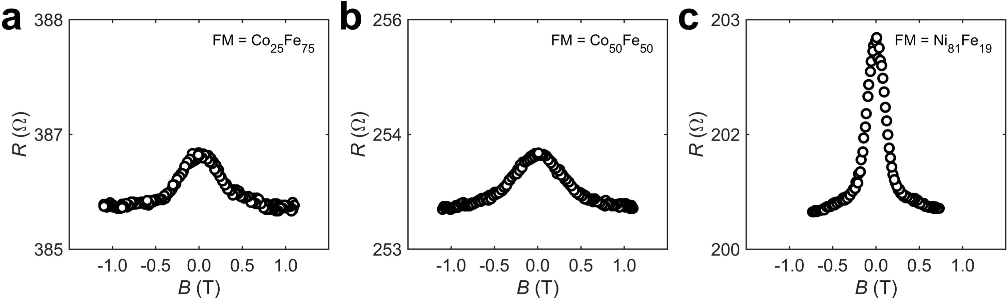
Fig.S1 | The measurement of anisotropic magnetoresistance (AMR) of different FMs. a, b, c The typical AMR result of Co₂₅Fe₇₅ (a), Co₅₀Fe₅₀ (b) and Ni₈₁Fe₁₉ (c).

Fig. S2 Bypass current
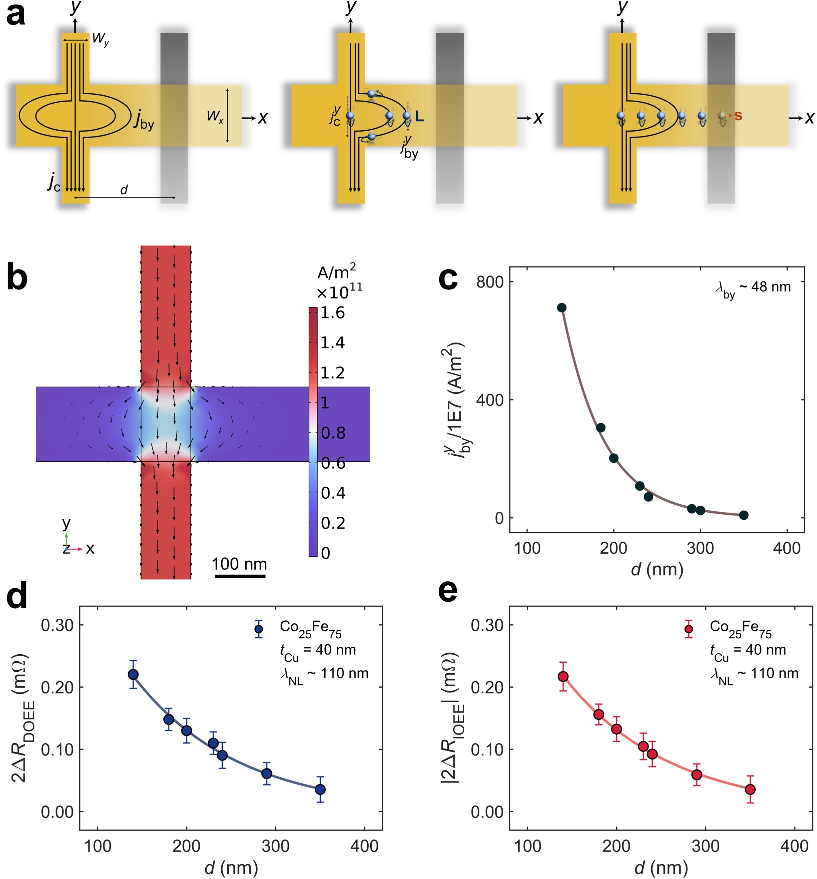
Fig.S2 | The analysis of bypass current. a, The systematic illustration for the combined contribution of bypass effect of charge current and the lateral distribution of OAM. The charge current applied to the Cu_{y} nanowire shuts to the Cu_{x} nanowire (left panel). Subsequently, the bypass current density induces nonequilibrium OAM at location x (middle panel). Lastly, all orbital accumulation undergoes a decay before inducing a nonlocal orbital response in FM (right panel). Thus, the signal (nonlocal OEE resistance) is proportional to the volume integration of the final orbital accumulation density by considering the above three stages. b, The COMSOL stimulation for $j_{by}^{y}$ in our nonlocal transport structure, where FM nanowire is ignored. The color bar denotes the magnitude of the y-component current density ($j_{by}^{y}$). The black arrows denote the flow of the charge current density ($j_{c}$) while their lengths indicate the relative magnitude. c, The exponential fitting results of $j_{by}^{y}$ (the average over the cross-sectional area) to d, suggesting a decay length of bypass current of about 48 nm. d, e, The exponential fitting ($2ΔR=A\exp\left(-d/{λ_{o}}\right)$) result of 2ΔR_{DOEE} (d) and |2ΔR_{DOEE}| (e) measured by nonlocal transport structure, indicating a characteristic length of nonlocal resistance about 110 nm. The distinction implies that bypass current is not the main origin of our nonlocal signal. The error bars indicate the noise level in raw data.

Fig. S3 Local measurement of FM dependence
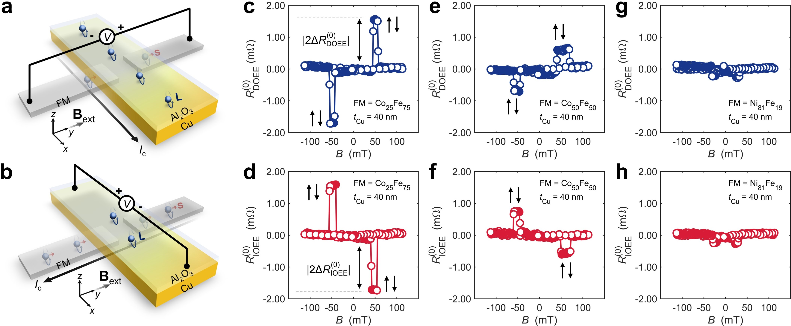
Fig. S3 | Schematic illustrations of local transport structures and verification of orbital accumulation through ferromagnetic materials dependence experiment. a, The local measurement configuration to observe DOEE (direct measurement). The nonequilibrium OAM are generated at Al₂O₃/Cu interface via DOEE. The orbital accumulation converts to spin accumulation in FM and induced a local orbital response. b, The local measurement configuration to observe IOEE (inverse measurement). The spin current is induced by charge accumulation, which further converts to orbital accumulation. The orbital accumulation then induces a charge current in Al₂O₃/Cu nanowire via IOEE. c, d, The local measurements signals of DOEE (c) and IOEE (d), with the Cu thickness t_{Cu} = 40 nm and FM = Co₂₅Fe₇₅, showing that |2ΔR(0) DOEE| = |2ΔR(0) IOEE| ≈ 1.70 mΩ. The double-headed arrows represent the definition of |2ΔR(0) DOEE| and |2ΔR(0) IOEE|. e, f, The local measurements result of DOEE (e) and IOEE (f), with the Cu thickness t_{Cu} = 40 nm and FM = Co₅₀Fe₅₀, showing that |2ΔR(0) DOEE| = |2ΔR(0) IOEE| ≈ 0.80 mΩ. g, h, The local measurements result of DOEE (g) and IOEE (h), with the Cu thickness t_{Cu} = 40 nm and FM = Ni₈₁Fe₁₉, whereas no OEE signals are shown. In c ~ h, the signals are globally offset to position their center at R = 0 Ω. The pairs of one-head arrows represent the magnetization configuration of FMs. The results show good agreement with Onsager’s reciprocal relations.

Fig. S4 Local measurement of Cu thickness dependence
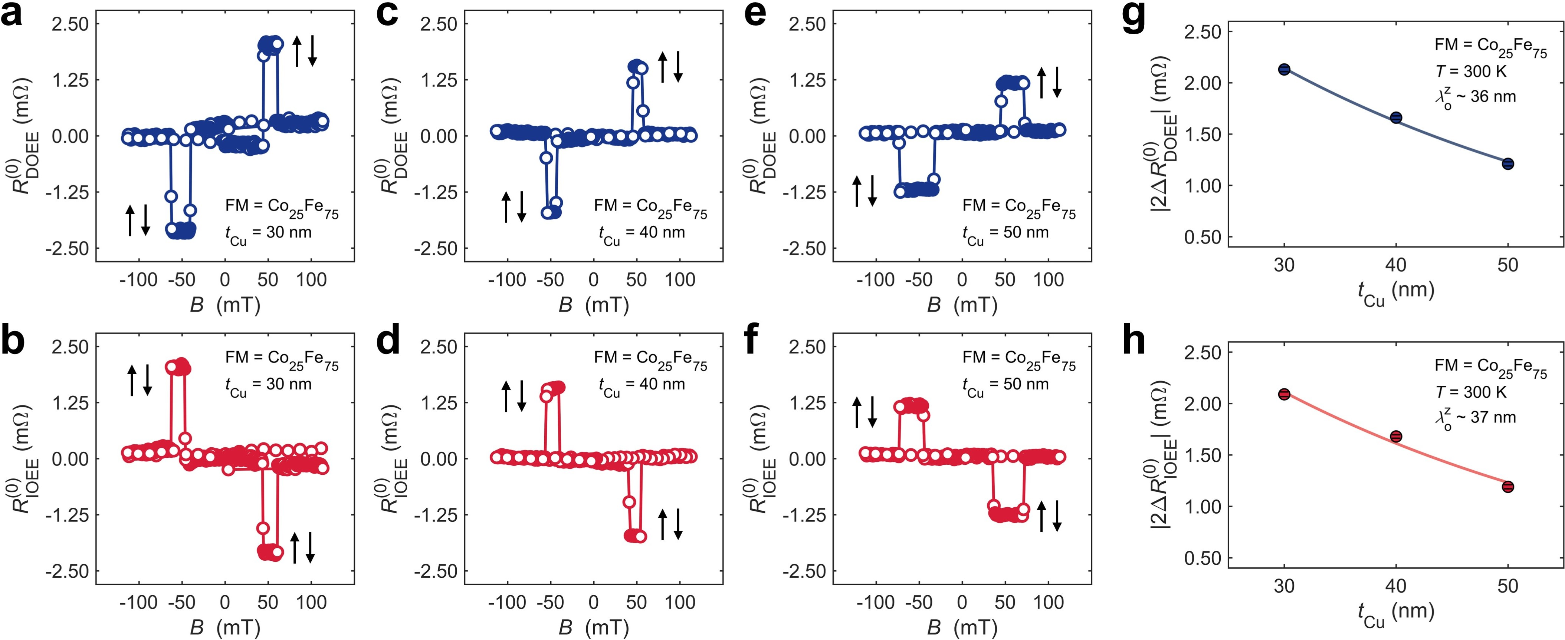
Fig. S4 | Cu thickness dependence experiment exploiting local transport structures. a, b The local transport measurement results of R(0) DOEE and R(0) IOEE with Cu thickness of 30 nm, showing that|2ΔR(0) DOEE| = |2ΔR(0) IOEE| ≈ 2.20 mΩ. c, d The results of R(0) DOEE and R(0) IOEE with Cu thickness of 40 nm, showing that|2ΔR(0) DOEE| = |2ΔR(0) IOEE| ≈ 1.70 mΩ. e, f The results of R(0) DOEE and R(0) IOEE with Cu thickness of 50 nm, showing that|2ΔR(0) DOEE| = |2ΔR(0) IOEE| ≈ 1.20 mΩ. The results are consistent with nonlocal measurement results and show good agreement with Onsager’s reciprocal relations. In a ~ f, the signals are globally offset to position their center at R = 0 Ω. The pairs of one-head arrows represent the magnetization configuration of FMs. g, h, |2ΔR(0) DOEE| and |2ΔR(0) IOEE| with various Cu thickness. The error bars indicating the noise level of raw data are smaller than the range of markers. The solid curves demonstrate the fitting of data to the exponential decay equation, showing a local decay length of orbital accumulation ~ 36 nm. The results show good agreement with Onsager’s reciprocal relations.

Fig. S5 Local measurement of temperature dependence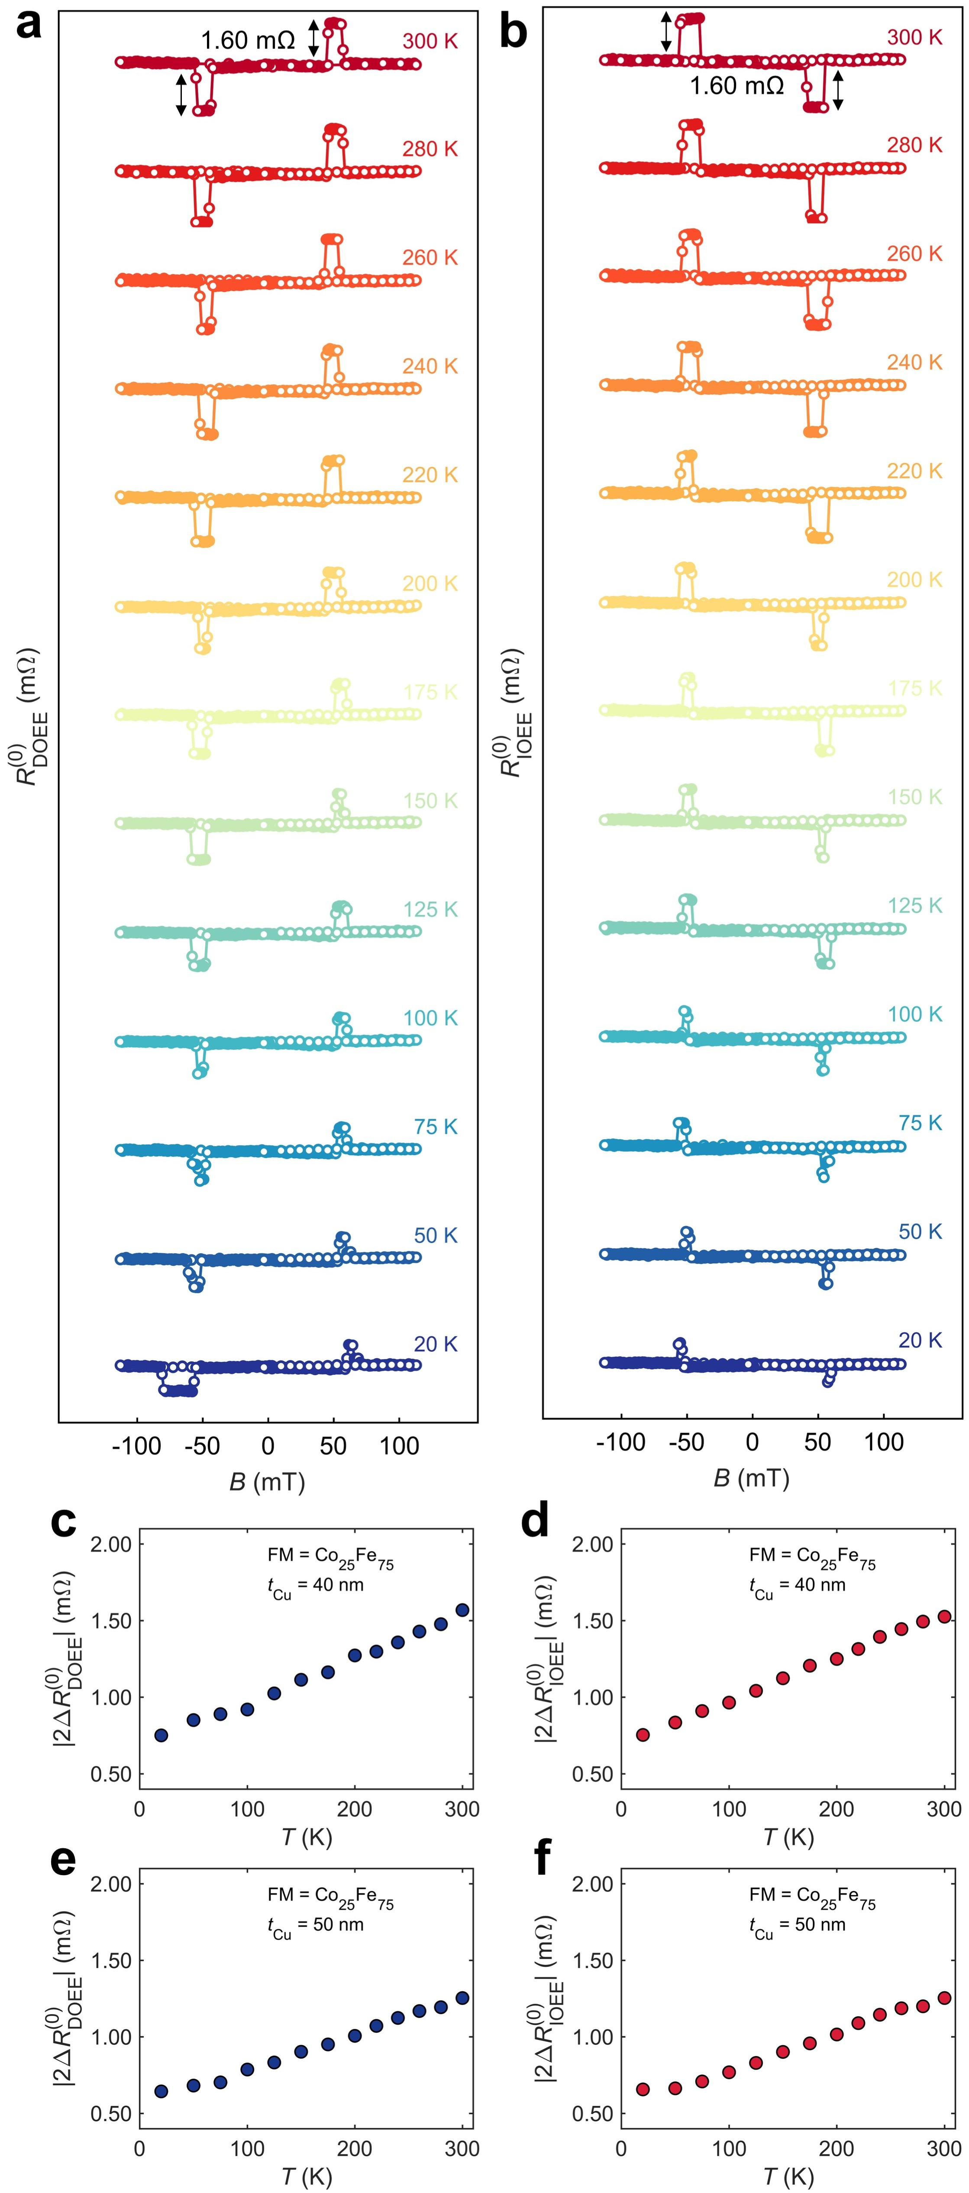
Fig. S5 | Temperature dependence experiment exploiting local transport structures. a, b The results of R_{DOEE} (a) and R_{IOEE} (b) at various temperatures for Cu thickness of 40 nm, respectively. c, d The results of |2ΔR(0) DOEE| and |2ΔR(0) IOEE| measured under various temperatures with Cu thickness of 40 nm, respectively. e, f The results of |2ΔR(0) DOEE| and |2ΔR(0) IOEE| measured under various temperatures for Cu thickness of 50 nm, respectively. The error bars indicating the noise level of raw data are smaller than the range of markers. The temperature dependence of local orbital transport is consistent with nonlocal measurement results and shows good agreement with Onsager’s reciprocal relations.

Fig. S6 Angle dependence
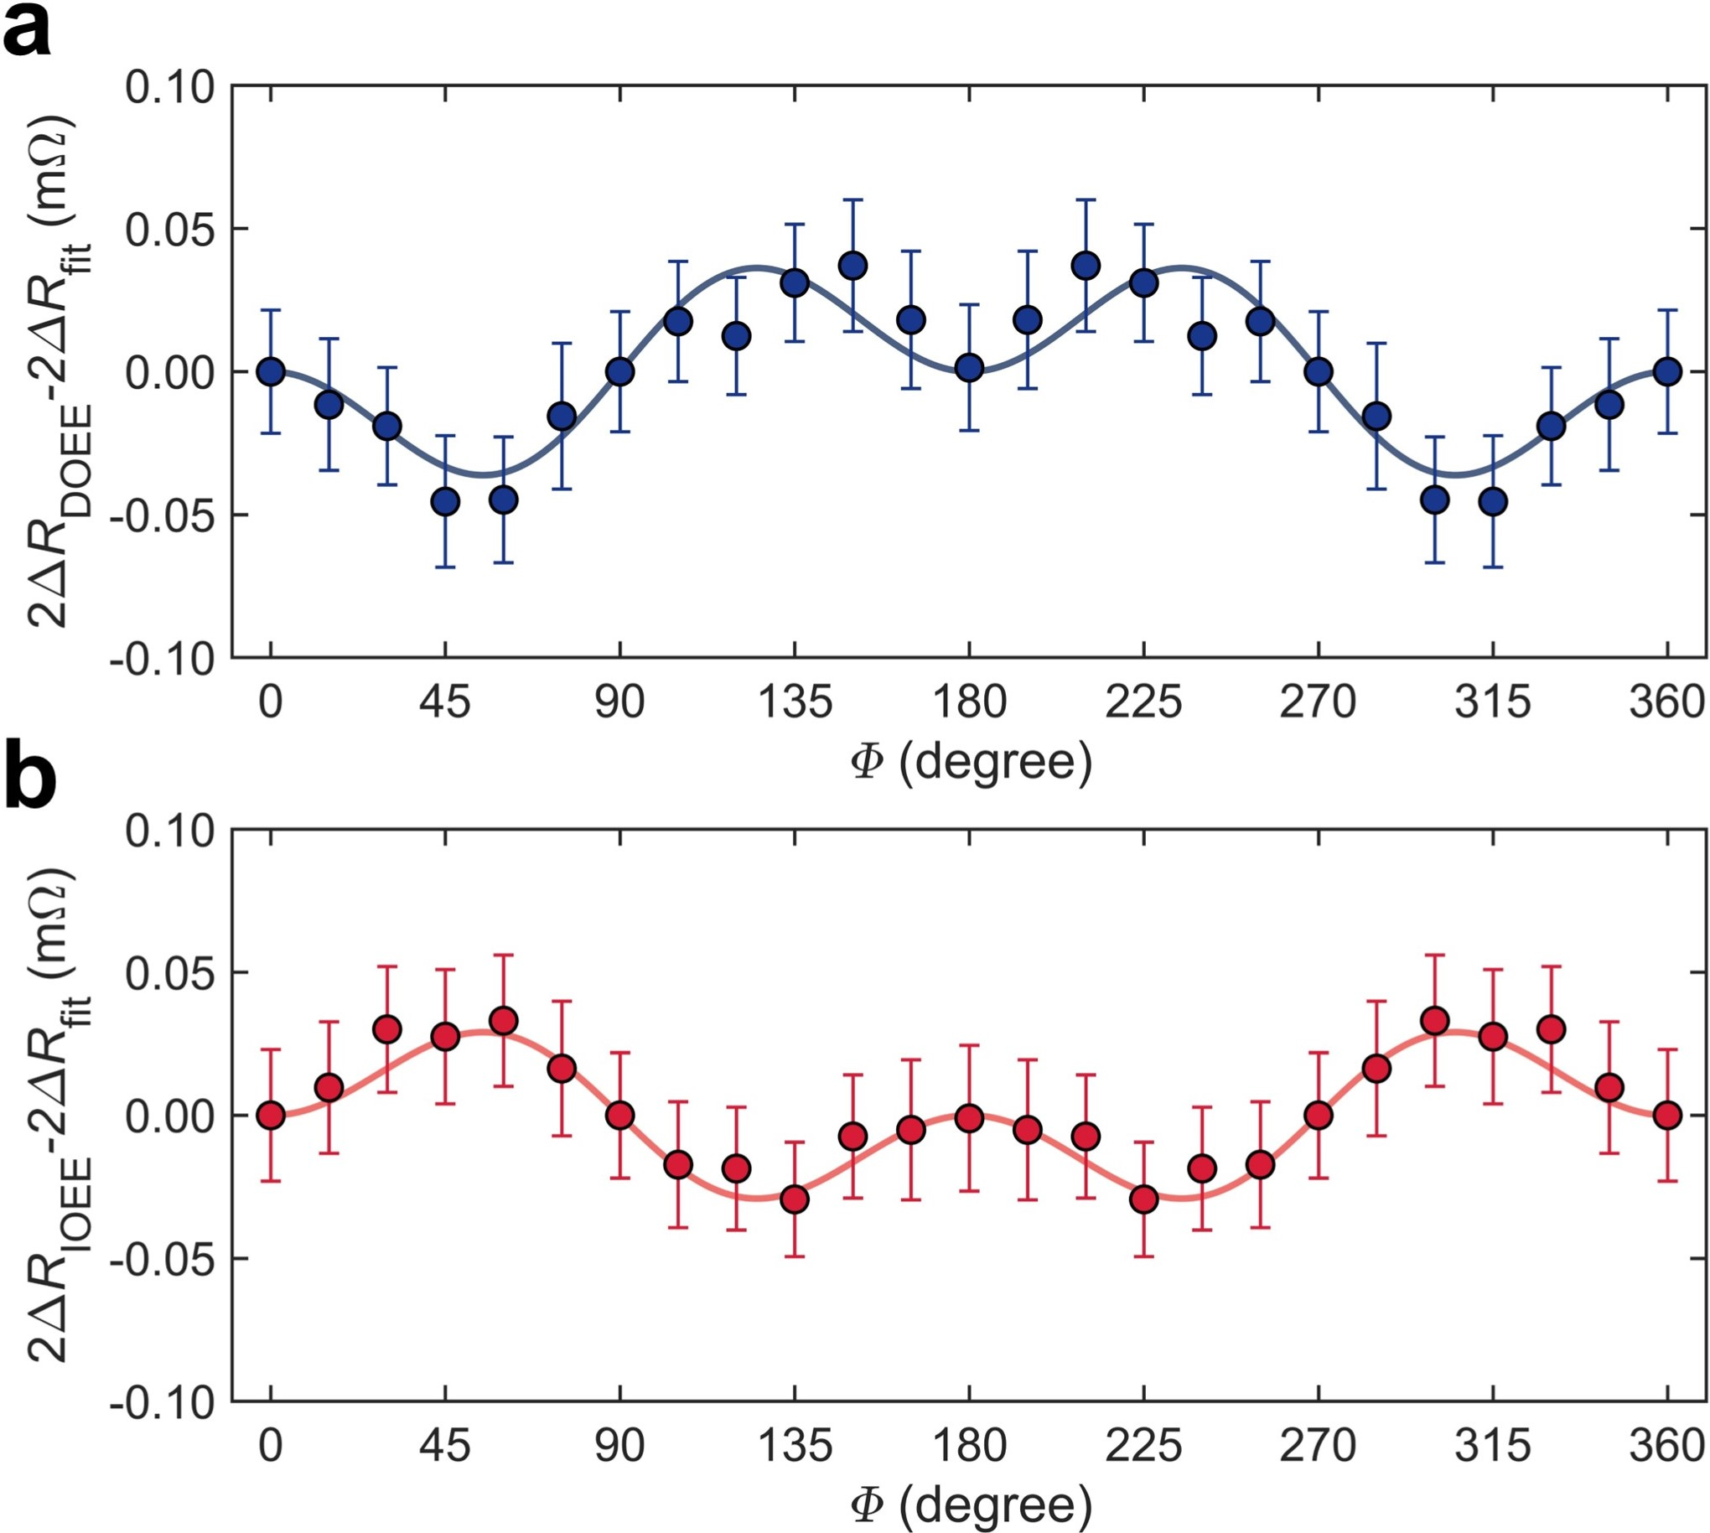
Fig. S6 | The deviation of angle dependence data. a, b, The fitting of the direct measurement (a) and inverse measurement (b) data to Eqs. (S4-8), suggesting the magnetization anisotropy may lead to the deviation in Fig. 2c and 2d (in main text).

Fig. S7 The temperature dependence of inverse measurement
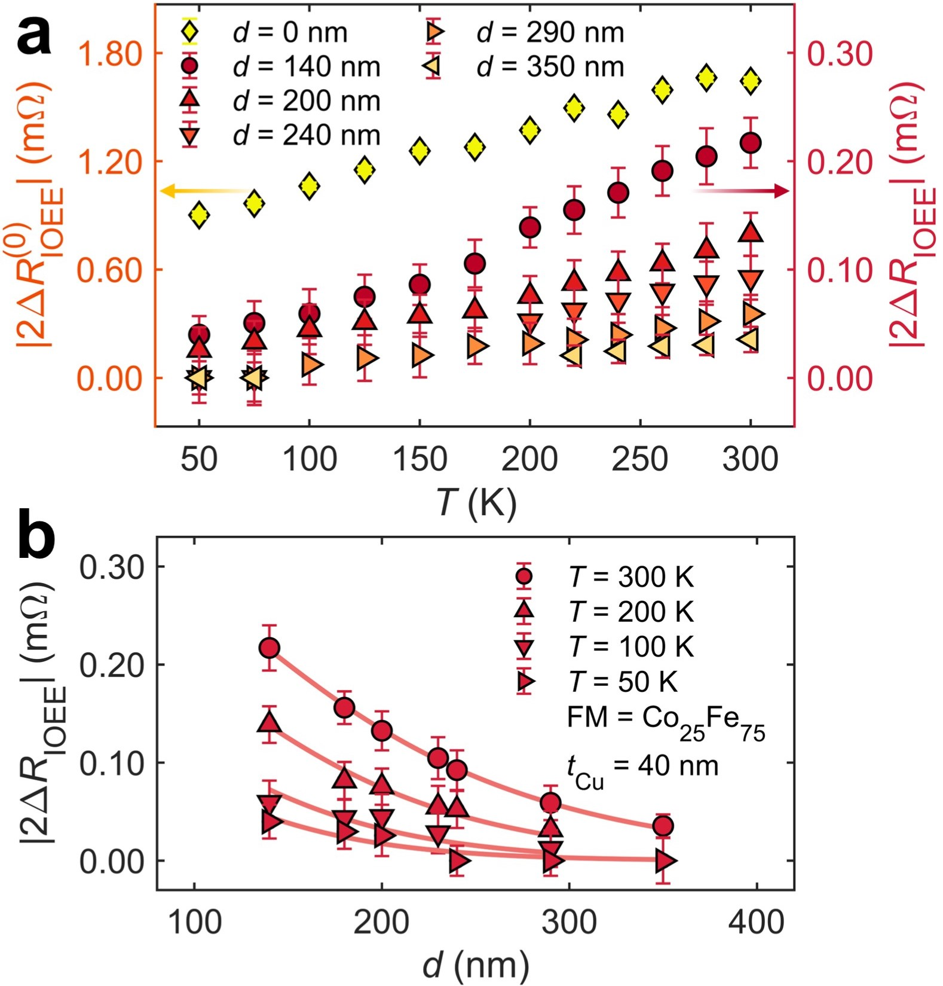
Fig. S7 | The temperature dependence results of inverse measurement. a, The temperature dependence results of 2ΔR_{IOEE} in the nonlocal measurement (red circles and triangles, right y-axis) and $2{ΔR}_{IOEE}^{(0)}$ in the local measurement (yellow diamonds, left y-axis). The error bars indicate the noise levels of R. b, The fitting of the 2ΔR_{IOEE}(T) data with Equation (1) in main text. The error bars indicate the noise levels of R_{IOEE}. The fitting result of λ_{o} for 2ΔR_{IOEE} are shown Fig. 4e in the main text.

Fig. S8 Resistivity
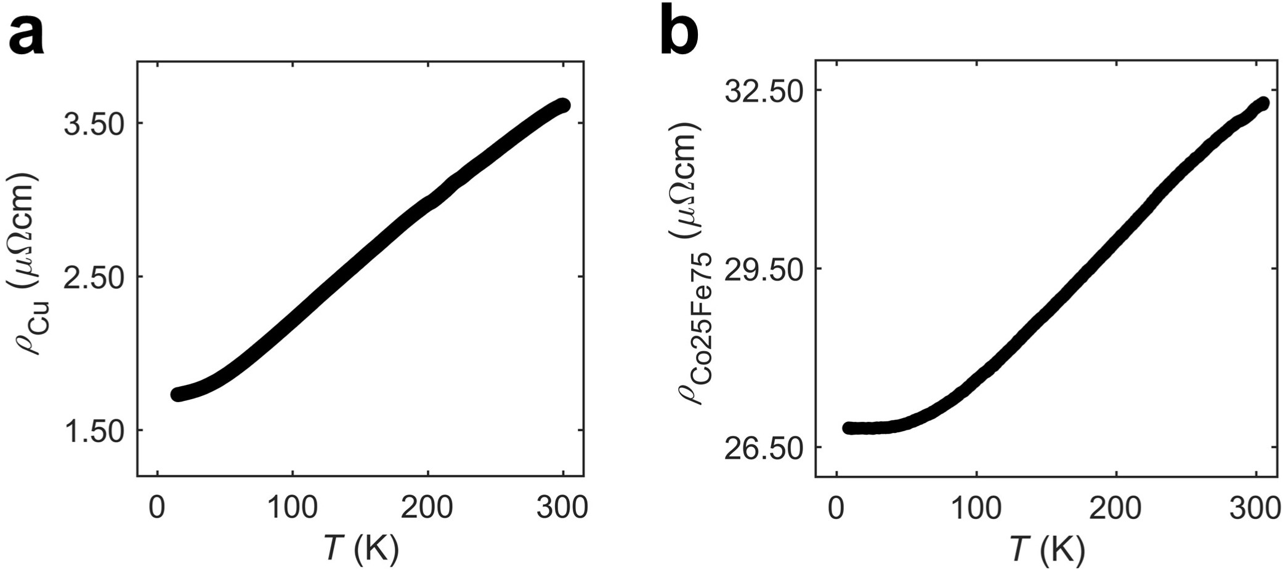
Fig. S8 | Temperature dependence of resistivity of Cu and Co₂₅Fe₇₅. a, b, The resistivity of Cu (a) and Co₂₅Fe₇₅ (b) at various temperature measured using four probe measurements.

