Supplementary Figures
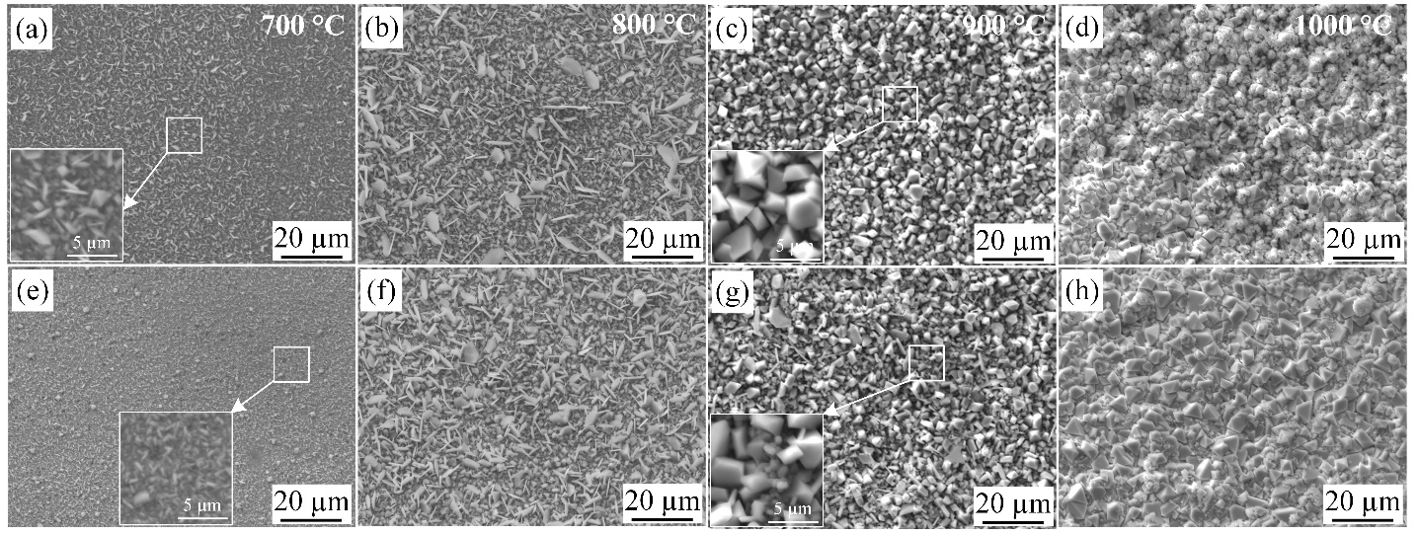
Figure S1. SEM surface images of the CG samples (a–d) and SMRT samples (e–h) after oxidation for 24 h oxidation at 700–1000 °C. (a, e) 700 °C; (b, f) 800 °C; (c, g) 900 °C; (d, h) 1000 °C

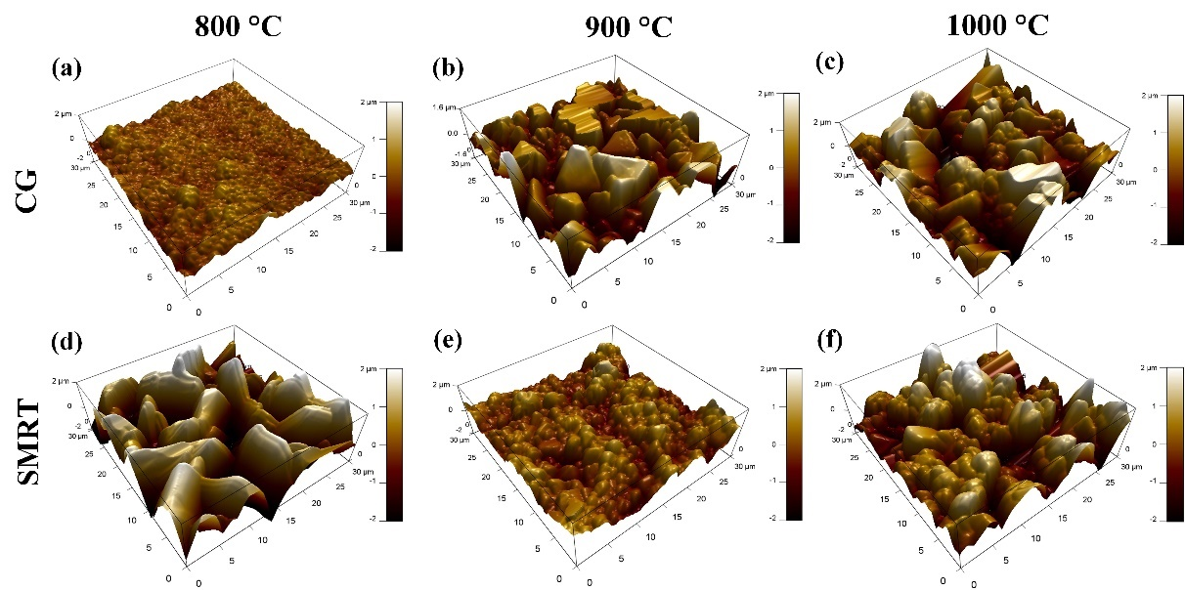
Figure S2. AFM images showing the 3D surface morphology of the oxide scale formed on CG (a-c) and SMRT (d-f) samples after isothermal oxidation at (a, d) 800 °C, (b, e) 900 °C and (c, f) 1000 °C for 100 h.

Table S1. Surface roughness of the oxide scale formed on CG and SMRT samples at different temperatures.
Sample | 800 °C |  |  | 900 °C |  |  | 1000 °C
Sample | Ra/nm | Rq/nm |  | Ra/nm | Rq/nm |  | Ra/nm | Rq/nm
CG | 142.87 | 185.41 |  | 405.20 | 508.57 |  | 644.82 | 805.48
SMRT | 955.39 | 1158 |  | 316.35 | 394.66 |  | 623.09 | 788.76
Note: Ra is the arithmetic mean deviation of the assessed profile, Rq is the root-mean-square deviation of the assessed profile.

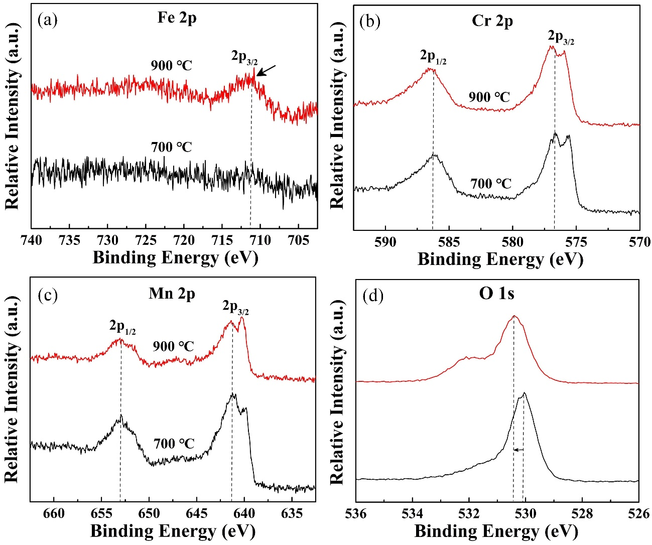
Figure S3. XPS spectra pf core-level electrons (a) Fe-2p, (b) Cr-2p, (c) Mn-2p, (d) O-1s recorded from the surface of oxide scale formed on the CG sample after oxidation at 700 °C and 900 °C for 100 h.

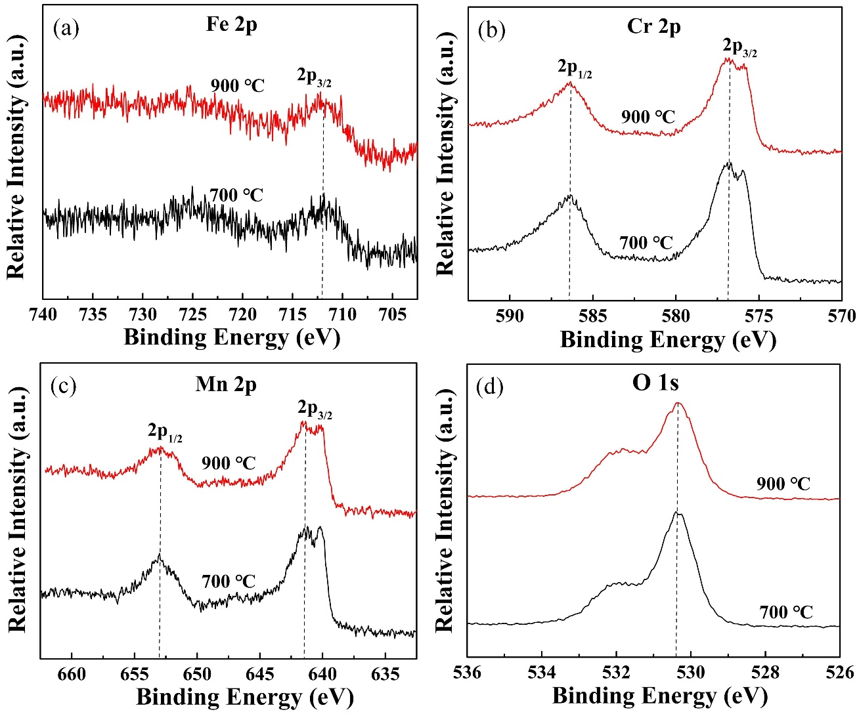
Figure S4. XPS spectra pf core-level electrons (a) Fe-2p, (b) Cr-2p, (c) Mn-2p, (d) O-1s recorded from the surface of oxide scale formed on the SMRT sample after oxidation at 700 °C and 900 °C for 100 h.

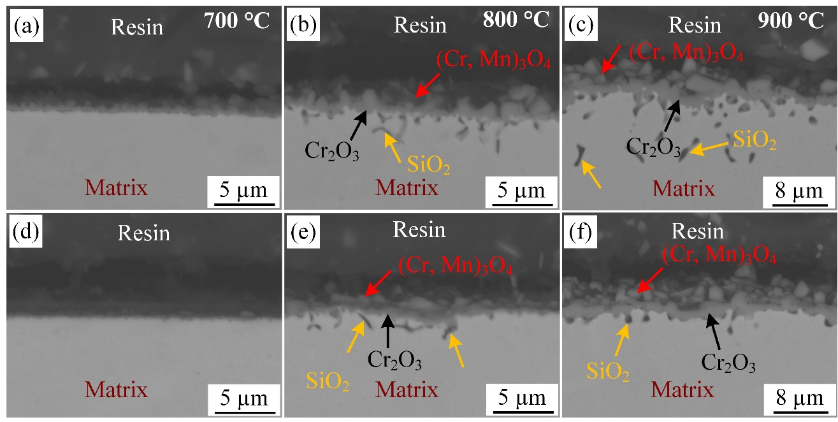
Figure S5. BSE images showing the cross-sectional morphology of the CG (a–c) and SMRT samples (d–f) oxidized at 700–900 °C for 24 h. (a, d) 700 °C; (b, e) 800 °C; (c, f) 900 °C

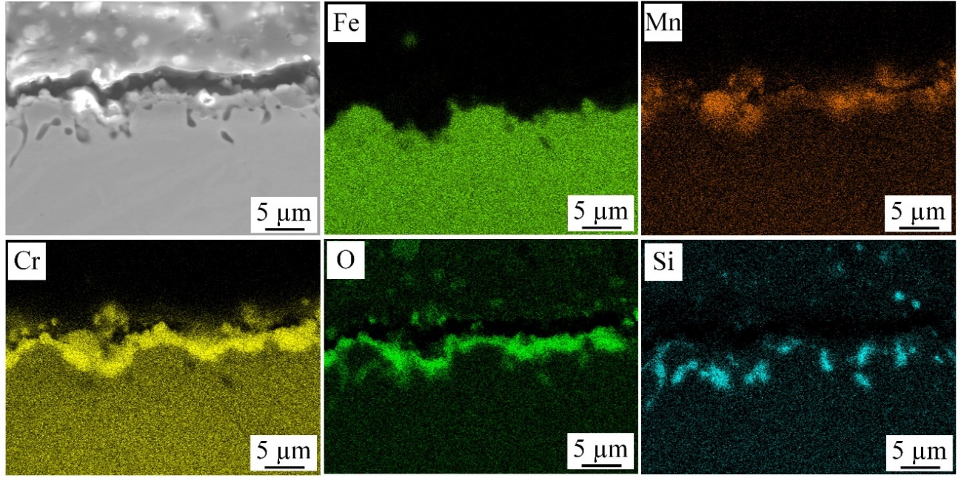
Figure S6. BSE micrograph of the cross section of steel/oxide interface and corresponding EDS element maps of the SMRT sample oxidized at 900 °C for 24 h.

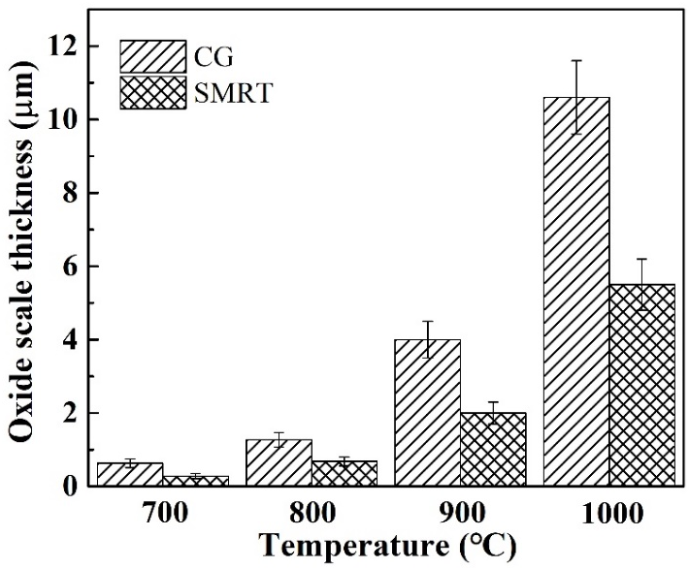
Figure S7. Oxide scale thickness of the CG and SMRT samples after oxidation at 700–1000 °C for 120 h.

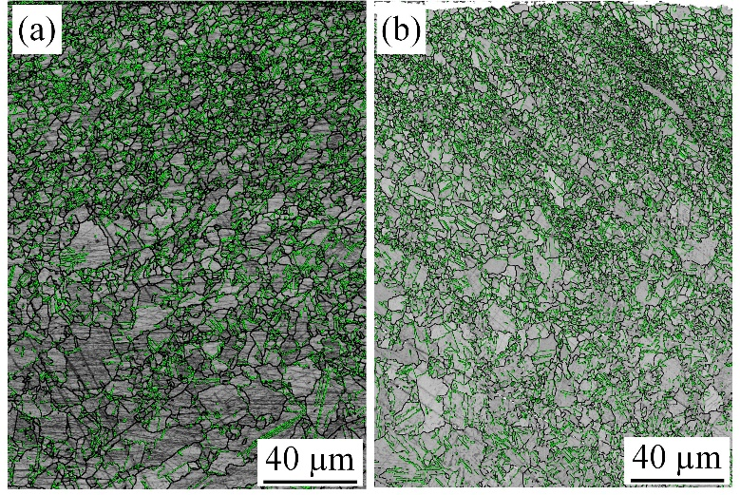
Figure S8. Grain boundary distribution in the GNS layer of the sample oxidized at 800 °C for 24 h (a) and aging at 800 °C for 120 h without oxidation (b). (Black lines: high angle grain boundary (>15°); green lines: Σ3 grain boundary)

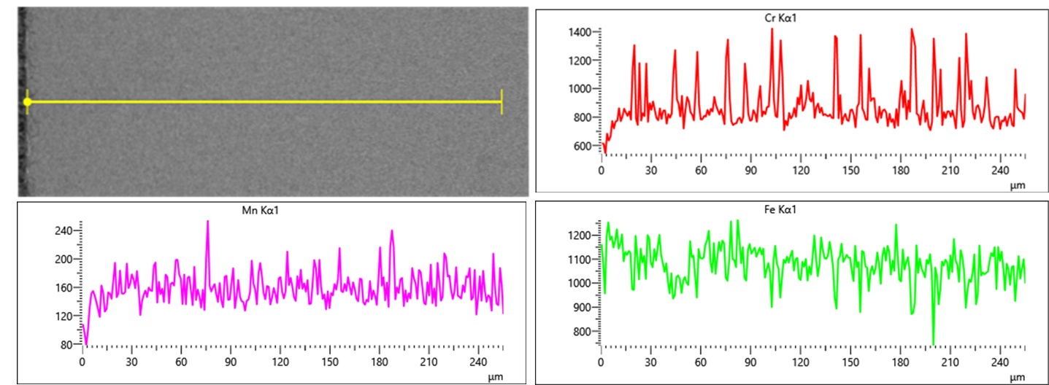
Figure S9. EDS line profiles display the concentration of elements across the GNS layer of the samples oxidized at 800 °C for 120 h.

