Supplementary Information

Phosphorus source and availability modulate the rhizosphere bacterial community assembly in common bean

Chiaramonte, Josiane Barros^{1,2}; Vargas-Hoyos, Harold Alexander^{1,2}; Costa, Lilian Simara Abreu Soares¹; Rossman, Maike¹; Silva, Daiana Alves³; Bulgarelli, Davide⁴; Mendes, Rodrigo^{1*}.

¹ Embrapa Environment - Highway SP-340, Km 127,5, Tanquinho Velho, 13918-110, Jaguariúna, SP- Brazil
² Luiz de Queiroz College of Agriculture - University of São Paulo - Av. Pádua Dias, 13418-900, Piracicaba,SP – Brazil
³ Agronomic Institute – Center of Analysis and Technological Research of the Agribusiness of Grains and Fibers, Av. Dr. Theodureto de Almeida Camargo, 1500 – 13075-630 – Campinas, SP – Brasil
⁴ University of Dundee at the The James Hutton Institute - Errol Road, DD2 5DA, Invergowrie, Dundee – Scotland
*Corresponding author: rodrigo.mendes@embrapa.br

This file contains: Supplementary Figures 1 to 7
Supplementary Tables 1 to 9
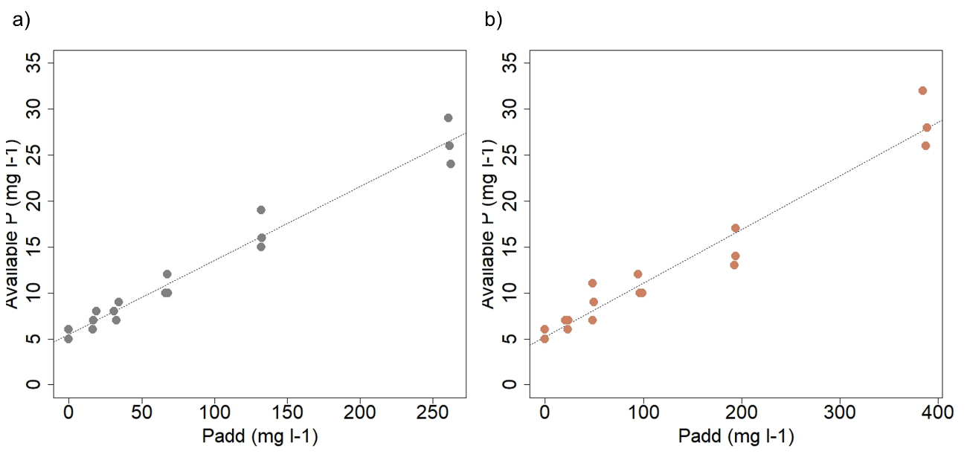
Supplementary Figure 1. Phosphorus fixation potential in the soil used in the experiment a) linear regression of the amount of triple superphosphate added in the soil and the remaining available phosphorus after 10 days incubated in greenhouse conditions (Pdisp=0.0806Padd+5.467; R²=0.97); b) linear regression of the amount of phosphate rock Bayovar added in the soil and the remaining available phosphorus after 10 days incubated in greenhouse conditions (Pdisp=0.0583Padd+5.2194; R²=0.95). X-axis shows the amount of phosphorus added (Padd) in the soil and Y-axis shows the amount of phosphorus available after incubation.

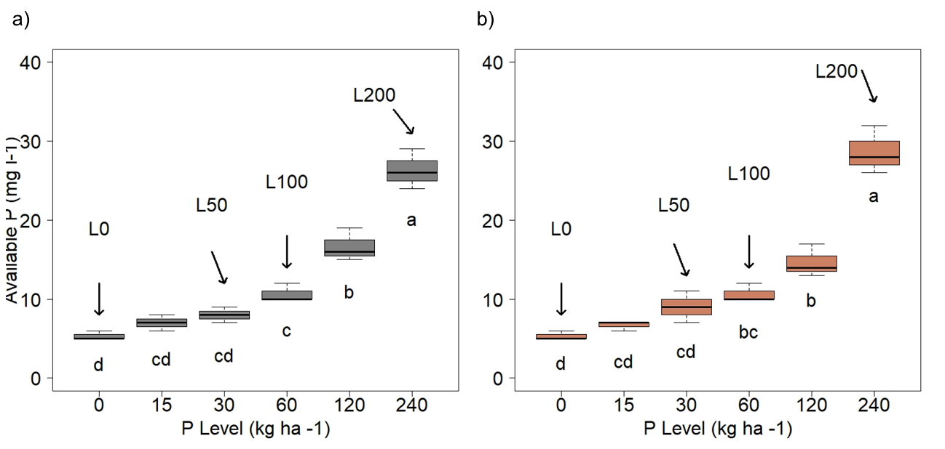
Supplementary Figure 2. Phosphorus gradient selection a) levels of remaining available phosphorus after 10 days of incubation of triple superphosphate in the soil; b) levels of remaining available phosphorus after 10 days of incubation of phosphate rock Bayovar in the soil. Different letters indicate significant differences according to Tukey test considering p<0.05. Arrows indicate the selected phosphorus levels to be used in the experiment.

Supplementary Figure 3. Factorial experimental design. The factors of the experiment consisted in two plant genotypes (IAC Imperador [P-efficient] and Dor-364 [P-inefficient]), two sources of P (Triple Superphosphate [TSP-soluble] and Rock Phosphate Bayovar [RPB-insoluble]), and four-level gradient of P (L0 - no P amendment - and L50, L100 and L200), in completely randomized design with five replicates. As control, we kept the bulk soil with the same amendments and at the same conditions during the time of the experiment.

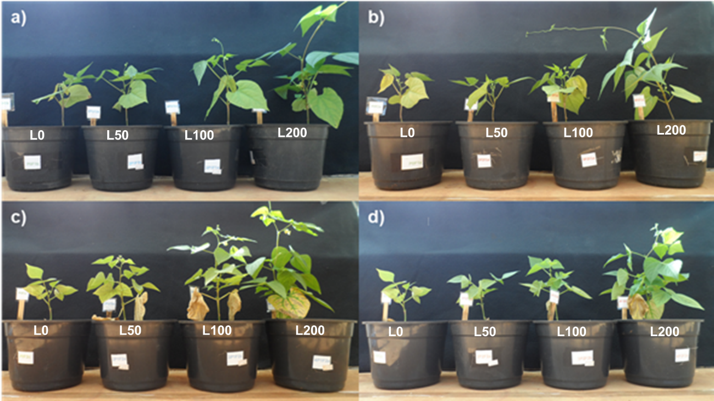
Supplementary Figure 4. Illustration of the genotypes along the phosphate gradient a) IAC Imperador growing in TSP gradient b) IAC Imperador growing in RPB gradient, c) Dor-364 growing in TSP gradient and d) Dor-364 growing in RPB gradient.

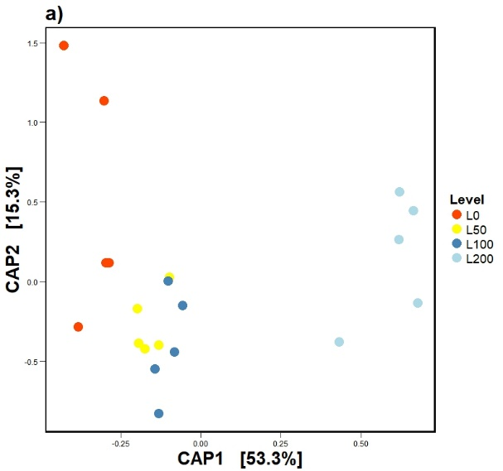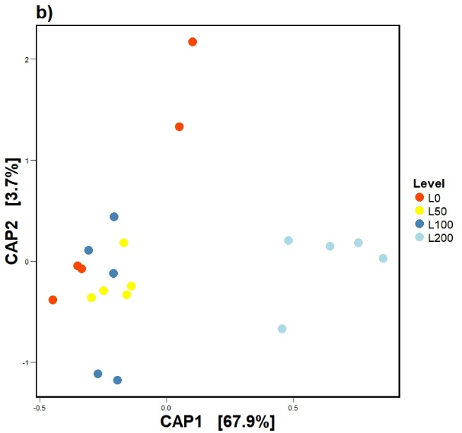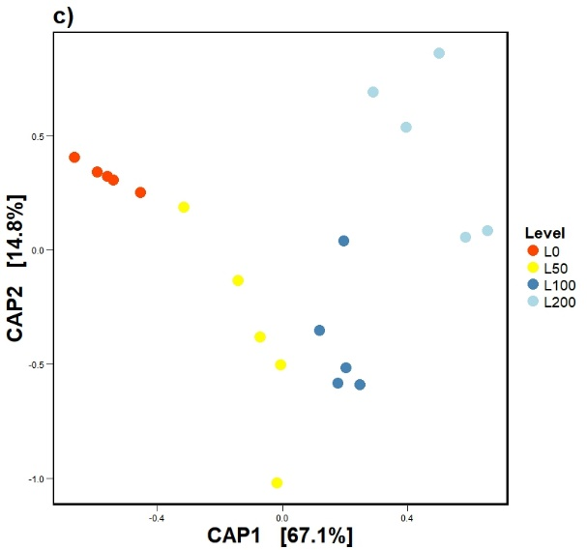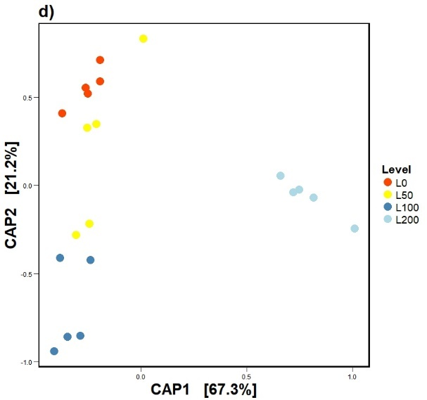

Supplementary Figure 5. Constrained principal coordinates analysis showing the differences in the plant features during R6 stage. a) IAC Imperador growing in TSP gradient (ANOVA, F=16.582, p=0.001), b) IAC Imperador growing in RPB gradient (ANOVA, F=17.254, p=0.001), c) DOR-364 growing in TSP gradient (ANOVA, F=38.865, p=0.001) and d) DOR_364 growing in RPB gradient (ANOVA, F=48.625, p=0.001).

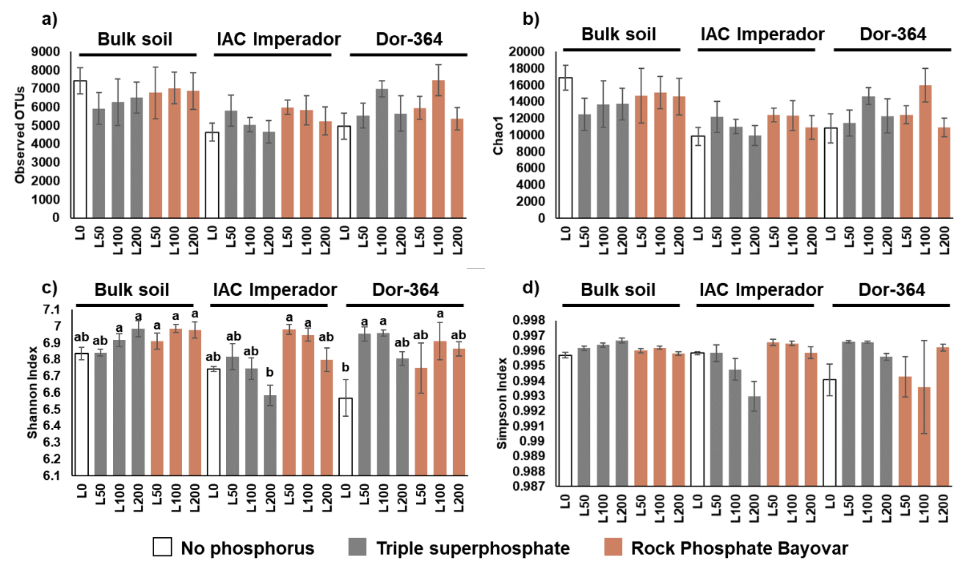

Supplementary Figure 6. Alpha diversity indexes between the treatments a) number of observed OTUs b) richness index Chao1, c) Shannon diversity index and d) Simpson diversity index. Letters shows significance by Tukey test considering p<0.05, Bulk soil, and rhizosphere of IAC Imperador and DOR-364 are identified by upper bars. Different colours show sources of phosphate (white= L0, grey=triple superphosphate source (TSP) and brown= Rock phosphate Bayovar (RPB).

Supplementary Figure 7. Rhizosphere bacterial community structure of common bean growing under different sources of P accessed by 16S rRNA amplicon sequencing. Principal coordinates analysis showing the effect of Triple Superphosphate (TSP, grey) and rock phosphate bayovar (RPB, black) amendment for a) IAC Imperador [P-efficient] b) Dor-364 [P-inefficient]. Different shapes correspond to different levels of phosphorus.
Supplementary Table 1. Levels of available phosphate selected to initiate the assay.

 | Natural | Triple superphosphate |  |  | Phosphate Rock Bayovar
Treatments | L0 | L50 | L100 | L200 |  | L50 | L100 | L200
P amendment | ------------------------------------------kg ha⁻¹-----------------------------------------
P amendment | 0 | 30 | 60 | 240 | 30 |  | 60 | 240
P available | ------------------------------------------mg ml ⁻¹---------------------------------------
P available | 4 | 6 | 10 | 21 | 7 |  | 9 | 23

Supplementary Table 2. Physical and chemical properties of the soil used in the experiment.

Total Sand | Clay | Silt | pH (CaCl₂) | MO  (g dm⁻³) | P_{resin}  (mg dm⁻³) | H+Al | K | Ca | Mg | SB | CTC | V%
--------- g kg⁻¹--------- |  |  | pH (CaCl₂) | MO  (g dm⁻³) | P_{resin}  (mg dm⁻³) | -------------mmole dm⁻³------ |  |  |  |  |  | V%
429 | 528 | 43 | 4.6 | 21 | 4 | 38 | 1 | 17 | 10 | 28.0 | 66.0 | 42

Supplementary Table 3. KEGG Functions involved in P metabolism selected from predicted metagenome to analyse differences in P metabolism among treatments.

KEGG | Function
K00117 | Quinoprotein glucose dehydrogenase [EC:1.1.5.2]
K01077 | Alkaline phosphatase [EC:3.1.3.1]
K01078 | Acid phosphatase [EC:3.1.3.2]
K01079 | Phosphoserine phosphatase [EC:3.1.3.3]
K01083 | 3-phytase [EC:3.1.3.8]
K01085 | Glucose-1-phosphatase [EC:3.1.3.10]
K01087 | Trehalose 6-phosphate phosphatase [EC:3.1.3.12]
K01089 | Imidazoleglycerol-phosphate dehydratase / histidinol-phosphatase [EC:4.2.1.19 3.1.3.15]
K01090 | Protein phosphatase [EC:3.1.3.16]
K01091 | Phosphoglycolate phosphatase [EC:3.1.3.18]
K01092 | Myo-inositol-1(or 4)-monophosphatase [EC:3.1.3.25]
K01093 | 4-phytase / acid phosphatase [EC:3.1.3.26 3.1.3.2]
K01101 | 4-nitrophenyl phosphatase [EC:3.1.3.41]
K01113 | Alkaline phosphatase D [EC:3.1.3.1]
K01114 | Phospholipase C [EC:3.1.4.3]
K01115 | Phospholipase D [EC:3.1.4.4]
K01126 | Glycerophosphoryl diester phosphodiesterase [EC:3.1.4.46]
K02036 | Phosphate transport system ATP-binding protein [EC:3.6.3.27]
K02037 | Phosphate transport system permease protein
K02038 | Phosphate transport system permease protein
K02039 | Phosphate transport system protein
K02040 | Phosphate transport system substrate-binding protein
K02041 | Phosphonate transport system ATP-binding protein [EC:3.6.3.28]
K02042 | Phosphonate transport system permease protein
K02044 | Phosphonate transport system substrate-binding protein
K03306 | Inorganic phosphate transporter, PiT family
K05306 | Phosphonoacetaldehyde hydrolase [EC:3.11.1.1]
K05780 | Putative phosphonate transport system ATP-binding protein
K05781 | Putative phosphonate transport system ATP-binding protein
K05813 | sn-glycerol 3-phosphate transport system substrate-binding protein
K05814 | sn-glycerol 3-phosphate transport system permease protein
K05815 | sn-glycerol 3-phosphate transport system permease protein
K05816 | sn-glycerol 3-phosphate transport system ATP-binding protein [EC:3.6.3.20]
K06162 | PhnM protein
K06163 | PhnJ protein
K06164 | PhnI protein
K06165 | PhnH protein
K06166 | PhnG protein
K06167 | PhnP protein
K07048 | Phosphotriesterase-related protein
K07636 | Two-component system, OmpR family, phosphate regulon sensor histidine kinase PhoR [EC:2.7.13.3]
K07637 | Two-component system, OmpR family, sensor histidine kinase PhoQ [EC:2.7.13.3]
K07657 | Two-component system, OmpR family, phosphate regulon response regulator PhoB
K07658 | Two-component system, OmpR family, alkaline phosphatase synthesis response regulator PhoP
K09474 | Acid phosphatase (class A)
K11929 | Outer membrane pore protein E

Supplementary Table 4 Differences between the genotype features during the early stage V3.

Plant genotype | RChI¹ |  |  | H² |  |  | ShDi³
Plant genotype | Mean±SD | F | p | Mean±SD | F | p | Mean±SD | F | p
IAC Imperador | 34.28±1.32^{a*} | 99.305 | <0.01 | 12.34±1.98ª | 40.06 | <0.01 | 3.41±0.3 | 1.20 | 0.27
Dor-364 | 30.29±1.59^{b} | 99.305 | <0.01 | 9.96±1.02^{b} | 40.06 | <0.01 | 3.33±0.25 | 1.20 | 0.27
¹RChl, Relative chlorophyll index
²H, Height (cm)
³ShDi, shoot diameter (mm)
*Different letters indicate significant differences accord Tukey test considering p<0.05.

Supplementary Table 5. Differences between the genotypes features during the stage V4-R5.

Plant genotype | RChI¹ |  |  | H² |  |  | ShDi³
Plant genotype | Mean±SD | F | p | Mean±SD | F | p | Mean±SD | F | p
IAC Imperador | 27.69±2.98^{a*} | 58.85 | <0.01 | 17.39±5.96 | 2.18 | 0.14 | 4.15±0.68 | 0.026 | 0.87
Dor-364 | 21.46±3.77^{b} | 58.85 | <0.01 | 15.59±4.05 | 2.18 | 0.14 | 4.12±0.55 | 0.026 | 0.87
¹RChl, Relative chlorophyll index
²H, Height (cm)
³ShDi, shoot diameter (mm)
*Different letters indicate significant differences accord Tukey test considering p<0.05.

Supplementary Table 6. Root architectural analysis.

Genotype | Source | Level | Lenght¹ | Area (cm2) | Volume (cm3) | Diameter (mm) | Biomass (g)
IAC-Imperador | L0 | L0 | 4894.53±1215 | 470.10±119.53 | 3.60±0.96 | 0.31±0.01 | 0.19±0.06
IAC-Imperador | TSP | L50 | 5888.11±397 | 553.35±32.53 | 4.14±0.31 | 0.30±0.01 | 0.27±0.05
IAC-Imperador | TSP | L100 | 6067.24±678 | 573.28±75.56 | 4.31±0.66 | 0.30±0.01 | 0.28±0.06
IAC-Imperador | TSP | L200 | 4788.96±657 | 491.23±72.60 | 4.02±0.72 | 0.33±0.02 | 0.35±0.07
IAC-Imperador | RPB | L50 | 5123.47±324 | 476.88±25.75 | 3.54±0.24 | 0.30±0.01 | 0.25±0.02
IAC-Imperador | RPB | L100 | 5426.49±592 | 484.98±119.46 | 4.04±0.43 | 0.31±0.01 | 0.26±0.04
IAC-Imperador | RPB | L200 | 3474.05±449 | 368.77±48.13 | 3.12±0.42 | 0.34±0.01 | 0.17±0.05
Dor-364 | L0 | L0 | 3446.53±252 | 336.31±21.89 | 2.61±0.17 | 0.31±0.01 | 0.22±0.05
Dor-364 | TSP | L50 | 4862.57±931 | 482.94±77.23 | 3.82±0.51 | 0.32±0.01 | 0.26±0.09
Dor-364 | TSP | L100 | 5221.83±793 | 503.32±42.14 | 3.87±0.41 | 0.31±0.01 | 0.32±0.09
Dor-364 | TSP | L200 | 4529.31±417 | 470.26±48.66 | 3.89±0.41 | 0.33±0.01 | 0.34±0.06
Dor-364 | RPB | L50 | 3839.05±817 | 366.13±69.82 | 2.78±0.49 | 0.31±0.01 | 0.26±0.11
Dor-364 | RPB | L100 | 5871.88±1552 | 560.61±72.67 | 4.26±0.56 | 0.30±0.01 | 0.30±0.08
Dor-364 | RPB | L200 | 2114.82±1498 | 226.12±37.14 | 1.94±0.38 | 0.34±0.03 | 0.19±0.03
¹Mean±Standart deviation

Supplementary Table 7. Output data sequencing for 16S rRNA amplicons. Pre-processing in QIIME 1.9.

Number of raw sequences | 8,362,726
Sequences after quality filter (Q20) | 5,416,048
Sequences after Chimera Filter | 5,220,747
Representative Sequences | 125,481
Maximum number of sequences per sample | 113,264
Minimum number of sequences per sample | 13,354
Number of OTUs | 10,655

Supplementary Table 8. Permutational Multivariate Analysis of Variance showing the contribution (R²) and significance (p) of each factor accessed in this study in the rhizosphere community assembly.

 | Df | SumsOfSqs | MeanSqs | F.Model | R² | p
Genotype | 1 | 0.164 | 0.164 | 2.29 | 0.03 | 0.032
Level | 1 | 0.254 | 0.254 | 3.55 | 0.05 | 0.006
Phosphate Source | 2 | 0.181 | 0.090 | 1.26 | 0.03 | 0.192
Genotype*Level | 1 | 0.111 | 0.111 | 1.56 | 0.02 | 0.119
Genotype*Source | 2 | 0.357 | 0.178 | 2.49 | 0.06 | 0.006
Level*Source | 1 | 0.111 | 0.111 | 1.56 | 0.02 | 0.123
Genotype*Level*Source | 1 | 0.109 | 0.109 | 1.52 | 0.02 | 0.131
Residuals | 60 | 4.293 | 0.071 |  | 0.77
Total | 69 | 5.580 |  |  | 1.00

Supplementary Table 9. Differentially enriched functions involved in P metabolism between L0 and RPB-L100¹ for IAC Imperador.

OTU | Function | Test² | p | FDR_P | L0 | L100
K05814 | sn-glycerol 3-phosphate transport system permease protein | 4.668 | 0.005 | 0.046 | 0.00009 | 0.00008
K01092 | myo-inositol-1(or 4)-monophosphatase [EC:3.1.3.25] | 4.219 | 0.006 | 0.046 | 0.00073 | 0.00071
K05306 | phosphonoacetaldehyde hydrolase [EC:3.11.1.1] | -6.098 | 0.008 | 0.046 | 0.00004 | 0.00004
K05813 | sn-glycerol 3-phosphate transport system substrate-binding protein | 3.571 | 0.008 | 0.046 | 0.00015 | 0.00013
K06162 | PhnM protein | 4.718 | 0.008 | 0.046 | 0.00010 | 0.00009
K05816 | sn-glycerol 3-phosphate transport system ATP-binding protein [EC:3.6.3.20] | 5.090 | 0.009 | 0.046 | 0.00011 | 0.00010
K01090 | protein phosphatase [EC:3.1.3.16] | -3.840 | 0.010 | 0.046 | 0.00069 | 0.00075
K02040 | phosphate transport system substrate-binding protein | -5.480 | 0.010 | 0.046 | 0.00067 | 0.00069
K05815 | sn-glycerol 3-phosphate transport system permease protein | 3.458 | 0.012 | 0.046 | 0.00008 | 0.00007
K05780 | putative phosphonate transport system ATP-binding protein | 4.235 | 0.013 | 0.046 | 0.00003 | 0.00003
K06164 | PhnI protein | 3.671 | 0.013 | 0.046 | 0.00005 | 0.00004
K06165 | PhnH protein | 3.450 | 0.013 | 0.046 | 0.00002 | 0.00002
K01087 | trehalose 6-phosphate phosphatase [EC:3.1.3.12] | 2.907 | 0.014 | 0.046 | 0.00019 | 0.00018
K02041 | phosphonate transport system ATP-binding protein [EC:3.6.3.28] | 4.205 | 0.014 | 0.046 | 0.00009 | 0.00008
K02042 | phosphonate transport system permease protein | 3.611 | 0.016 | 0.049 | 0.00013 | 0.00012
¹No functions were enriched with TSP amendment
²Non parametrical Kruskal Wallis Test

