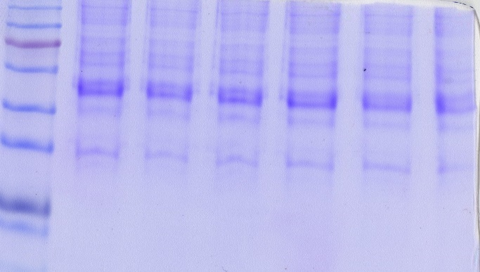
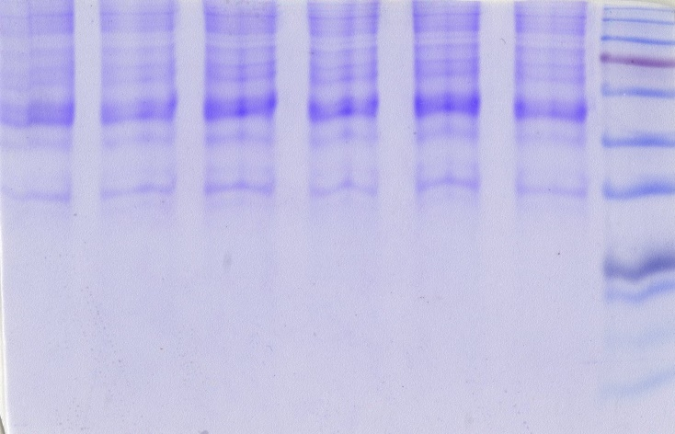
Supplementary Fig. 1: SDS-PAGE followed by Coomassie brilliant blue gel-stained photographs showing protein quality of Old Control and old rats with MHE protein samples.
2
5
6
1
2
3
4
5
6
3
4
Old MHE
Old Control
1
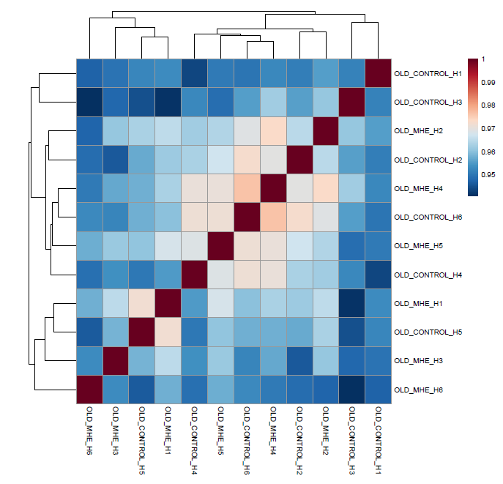

Supplementary Figure 2: Score plot based on Principle component analysis (PCA)showing two separate groups.

Supplementary Fig. 2: showing the overall correlation heatmap

***
***
***
***
**

Supplementary Fig. 3(a)

Supplementary Fig. 3(b)
***
***
***

