Supplementary figure 1.
Cohort flow chart illustrating the inclusion and exclusion of RCC subjects in the study.
Of 148 participants assessed for study eligibility, 132 were included. Reasons for screening
failures are displayed in figure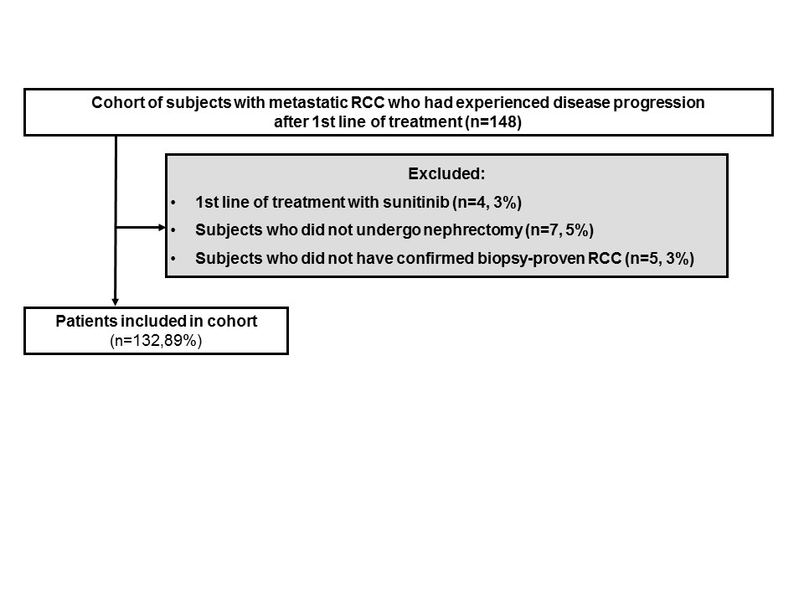.

Supplementary figure 2 Progression-free survival on first-line tyrosine kinase inhibitor (sunitinib) versus second-line treatment with sorafenib

Supplementary figure 3. Progression-free survival on sorafenib in subjects with no risk factors (favorable prognosis) and ≥1 risk factors (intermediate prognosis)

