Supplementary Figure 1: Exoc1 expression in mouse oocytes.
A. X-gal staining of ovaries from Exoc1^{+/LacZ} mice to confirm Exoc1 expression in mouse oocytes. LacZ signals were detected in immature and maturing oocytes. Arrow: oocytes. I- Exoc1^{+/LacZ}: maturing oocyte. II- Exoc1^{+/LacZ}: immature oocyte. Scale bar = 500 μm. B. Expression of exocyst complex in oocytes, confirmed using available RNA-Seq data (GSE143218). All members of the exocyst complex were expressed in various-staged oocytes.
Supplementary Figure 2: Gdf9-Cre knock-in mice generation.
Strategy of generating Gdf9-Cre knock-in mice. To construct the knock-in allele, a P2A connected with NLS-Cre rabbit globin polyadenylation sequence was knocked-in immediately before the Gdf9 stop codon. Knock-in alleles were confirmed via Southern blotting.
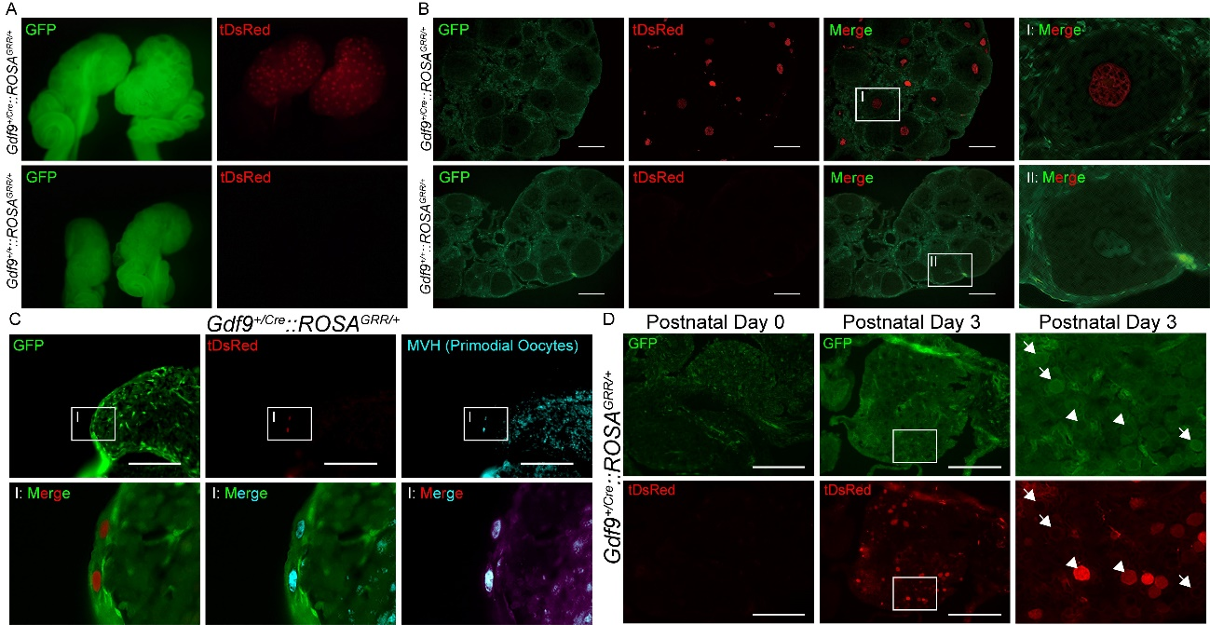

Supplementary Figure 3: Cre recombination activity in Gdf9-Cre mice oocytes.
Gdf9^{+/Cre} mice were crossed with Gt(ROSA)26Sor^{tm1(CAG-EGFP/tDsRed)Utr} referred to ROSA^{GRR} mice carrying a green-to-red fluorescent-convertible Cre reporter. A. A tDsRed signal was observed in the ovaries of Gdf9^{+/Cre};;ROSA^{GRR/+} mice using a fluorescence stereomicroscope. B. The tDsRed signal was present only in oocytes, and not in somatic cells. Scale bar = 50 μm. C. Cre recombination occurred from primordial oocytes. Scale bar = 200 μm. D. The timepoint when Cre recombination began was determined. On postnatal day 0 (P0), no tDsRed signal was detected. On P3, tDsRed-positive oocytes were seen in the Gdf9^{+/Cre};;ROSA^{GRR/+} ovary. Some green fluorescent protein-positive oocytes remained present in this mice line. This confirmed that Cre recombination in Gdf9-Cre mice began from P3, and the oocytes were completely recombined at the adult stage. Arrowheads: oocytes. Scale bar = 200 μm.

Supplementary Figure 4: Cre recombination efficiency in Gdf9-Cre mice.
To verify recombination in oocytes, offspring obtained from crossing Gdf9^{+/Cre};;ROSA^{GRR/+} female mice and wild-type male mice were examined. Four litters were checked. No green fluorescent protein-positive offspring were observed, confirming that recombination occurred in all Gdf9^{+/Cre} female mice oocytes. To verify recombination in sperms, six litters of offspring from Gdf9^{+/Cre};;ROSA^{GRR/+} male crossed with wild-type female were examined. No tDsRed-positive offspring were observed, showing that Cre recombination did not occur in Gdf9^{+/Cre} male mice.
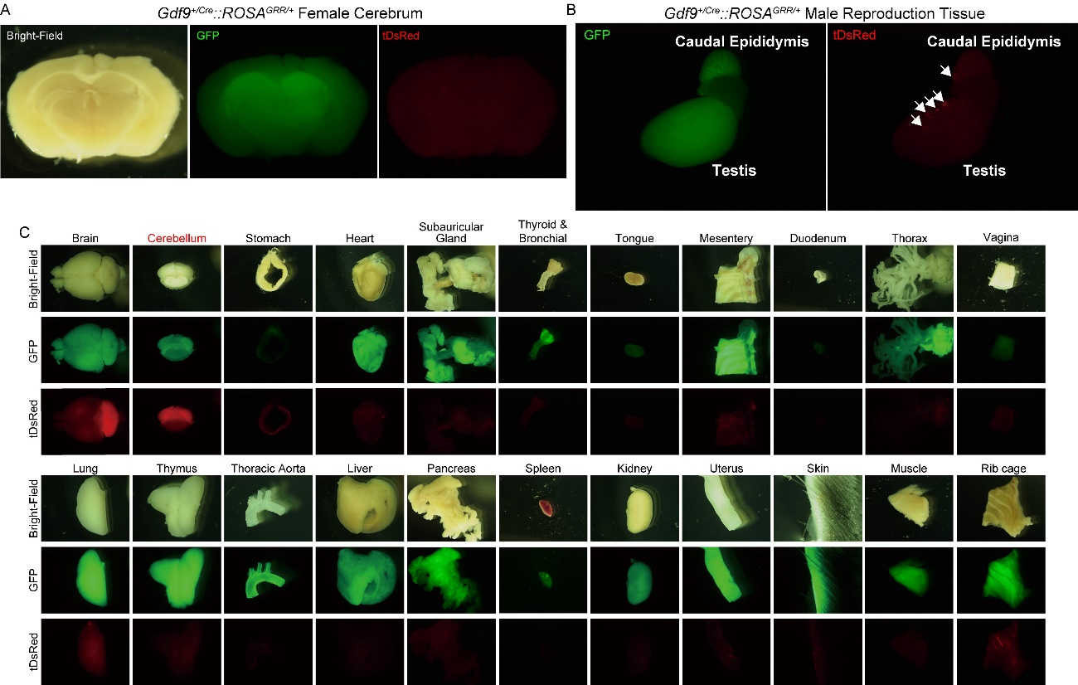
Supplementary Figure 5: Cre recombination in various tissues in Gdf9-Cre mice.
A. Recombination in Gdf9^{+/Cre};;ROSA^{GRR/+} female cerebrum. No recombination was observed in the hypothalamus. B. Recombination in Gdf9^{+/Cre};;ROSA^{GRR/+} male reproduction tissue. The tDsRed signals were found in only in few testis cells. Arrowheads: The tDsRed signal detected in testis. C. Cre recombination in other tissues. The tDsRed signal was found in the cerebellum. No tDsRed signals were detected in other tissues.
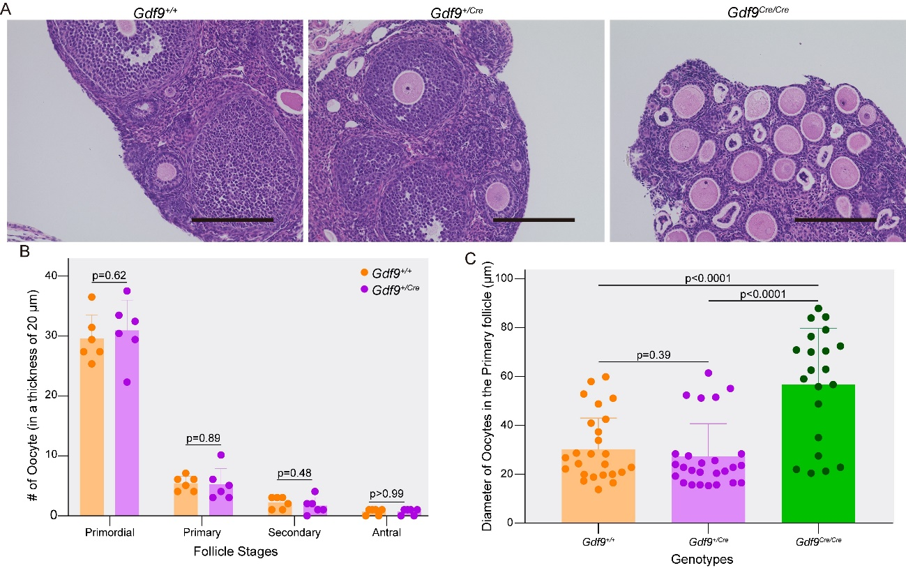
Supplementary Figure 6: Phenotype of Gdf9-Cre female mice.
A. Macroscopic Haematoxylin and Eosin staining images of the ovaries of each genotype mouse. Normal histological morphology was observed in heterozygous Gdf9^{+/Cre} mice. Conversely, in Gdf9^{Cre/Cre} mice, primary oocytes had increased diameters, and secondary oocytes or later stages of oocyte development were absent. Scale bar = 200 μm. B. Number of oocytes at each stage, including primordial, primary, secondary, and antral oocytes, was recorded. The number of oocytes at each stage was comparable between the wildtypes and Gdf9^{+/Cre} mice (n = 5, Student’s t-test). C. The diameter of primary oocytes in Gdf9^{Cre/Cre} mice. Homozygous Gdf9^{Cre/Cre} mice showed a significant increase in oocyte diameter at the primary stage (n = 5, one-way analysis of variance), confirming that these oocytes failed to proceed to further developmental stages beyond the primary stage.

Supplementary Fig 7: Phenotype Exoc3 and Exoc7 conditional knockout female mice.
A. Representative Haematoxylin and Eosin images of adult Exoc3-G-cKO and C. adult Exoc7-G-cKO ovary. Scale bar = 500 µm. B. Oocyte count in ovaries in Exoc3-G-cKO and D. Exoc7-G-cKO mice. No secondary nor antral follicles were observed in both Exoc3-G-cKO and Exoc7-G-cKO mice at the adult stage. n = 3, Student’s t-test.

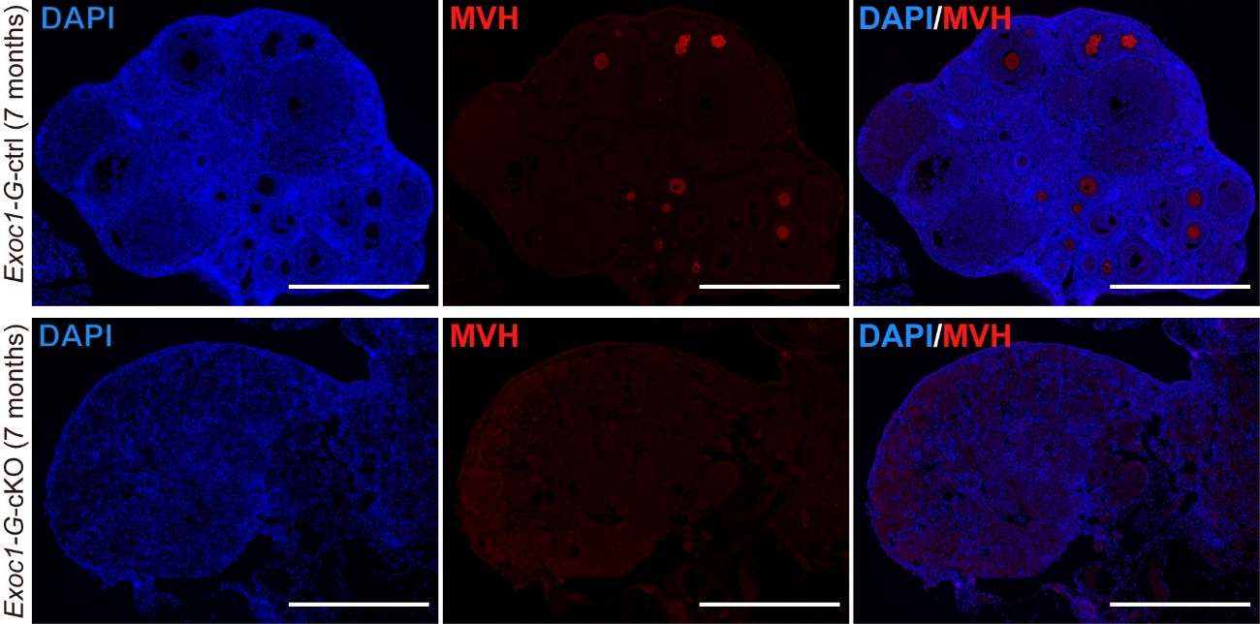

Supplementary Figure 8: No follicles observed in aged Exoc1-G-cKO mice.
To confirm the presence of oocytes, we performed immunofluorescence staining for MVH, a marker of oocytes from seven-month-old Exoc1-G-ctrl and Exoc1-G-cKO mice. No oocytes were found in the ovaries of aged Exoc1-G-cKO mice. Scale bar = 500 μm.
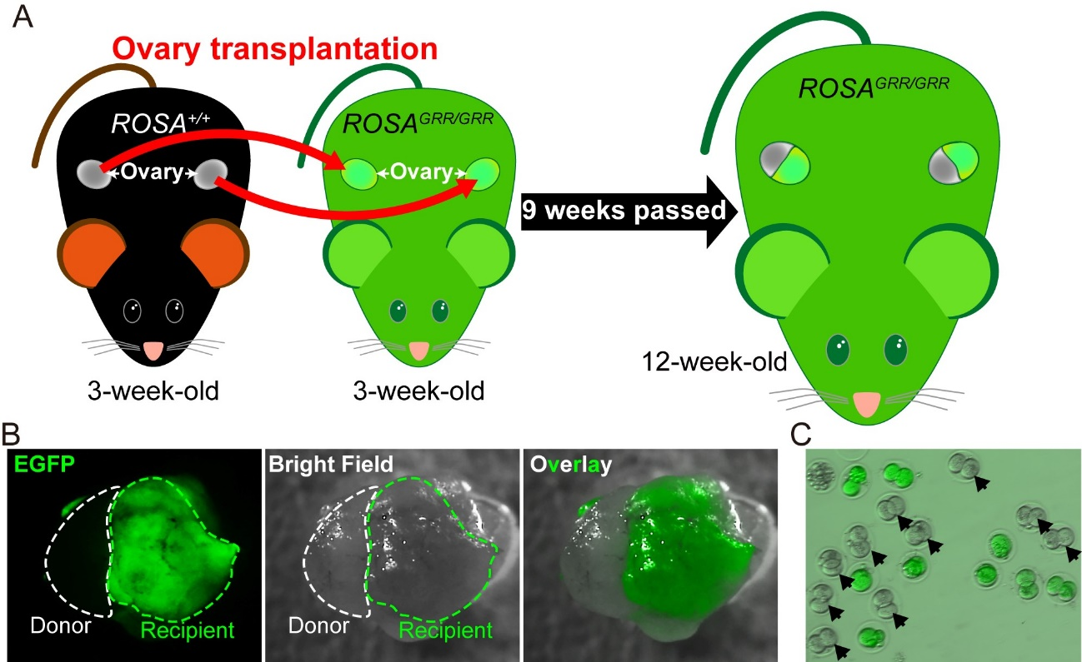

Supplementary Figure 9: Ovarian transplantation of wildtype ovaries into ROSA^{GRR/GRR} ovaries.
A. The ovaries of three-week-old wildtype mice were transplanted into the ovaries of three-week-old ROSA^{GRR/GRR} mice. The viability and ovulation capacity of the donor ovaries were determined nine weeks after the transplantation. B. Donor ovaries from wildtype mice were successfully implanted into recipient ROSA^{GRR/GRR} mice ovaries. Then wildtype sperm were fertilized in vitro with oocytes from the recipient. C. The in vitro fertilization of wildtype sperm with oocytes collected from recipient mice oviducts. Some of the in vitro fertilized embryos at the 2-cell stage showed no fluorescent signals and are indicated by head arrows. This result clearly showed that ovarian transplantation at three weeks of age, when both the donor and recipient were not sexually mature, followed by waiting for the recipient to reach sexual maturity, resulted in the ovulation of fertilizable oocytes from the donor ovary.

Supplementary Figure 10: bpV injection to wildtype mice
To test the inhibitory ability of bpV on PTEN to activate the oocyte, bpV was injected to wildtype mice. A. Representative ovary of 10-week-old wildtype mice injected without or with bpV. Scale bar = 500 µm. Arrows: primordial follicles. B. The number of primordial follicles of each group. n = 6, Student’s t-test. The number of primordial follicles in the wildtype mice injected with bpV was significantly lower than that in the group without bpV injection, which indicates the inhibitory functions of bpV on PTEN during oocyte activation.

Supplementary Figure 11: Efficiency of Cre-recombination induced by tamoxifen during pregnancy
A. Representative ovary collected at postnatal day 0 (P0) of Ddx4^{+/+}::ROSA^{GRR/+} and Ddx4^{+/CreERT2}::ROSA^{GRR/+} female mice. B. Bar chart of the percentage of MVH+/tDsRed- and C. MVH+/tDsRed+ of both Ddx4^{+/+};;ROSA^{GRR/+} and Ddx4^{+/CreERT2};;ROSA^{GRR/+} groups. Only the Ddx4^{+/CreERT2};;ROSA^{GRR/+} ovaries show the conversion from green to red. D. Representative microscopic images of ovaries in Ddx4^{+/+};;ROSA^{GRR/+} and Ddx4^{+/CreERT2};;ROSA^{GRR/+} female mice. Scale bar = 500 µm

