Supporting information

The light : nutrient ratio in alpine lakes: different scenarios of bacterial nutrient limitation and community structure in above and below treeline lakes

Yaling Su, Yingxun Du, Peng Xing*
State Key Laboratory of Lake Science and Environment, Nanjing Institute of Geography and Limnology, Chinese Academy of Sciences, 73 East Beijing Road, Nanjing, 210008, China
*Corresponding author: Prof. Dr. Peng Xing. Address: No.73 East Beijing Road, Nanjing, China. Email: pxing@niglas.ac.cn. Phone: 0086 25 8688 2112; Fax: 0086 25 57714759.

Running head: Bacterial nutrient limitation in alpine lakes

Table S1. Mean values of regular water-quality parameters in lakes above and below tree-line.
Lake | K  (m⁻¹) | Temperature  (ºC) | TN  (mg L⁻¹) | TP  (mg L⁻¹) | Chl a  (µg L⁻¹) | pH | NH₄-N  (mg L⁻¹) | NO₃-N  (mg L⁻¹) | NO₂-N  (mg L⁻¹) | PO₄-P  (mg L⁻¹) | DO  (mg L⁻¹) | DOC  (mg C L⁻¹)
Above-tree-line
Huanghai | 1.25 | 7.10 | 0.26 | 0.006 | 1.3 | 8.60 | 0.14 | 0.18 | 0.001 | 0.003 | 8.55 | 2.02
Heihai | 0.61 | 5.29 | 0.19 | 0.006 | 0.5 | 8.71 | 0.06 | 0.16 | 0.001 | 0.003 | 8.15 | 1.82
Zihai | 0.28 | 7.25 | 0.55 | 0.009 | 1.1 | 7.72 | 0.02 | 0.27 | 0.001 | 0.003 | 8.33 | 2.13
Meihai | 0.37 | 6.20 | 0.23 | 0.004 | 0.3 | 7.57 | 0.07 | 0.19 | 0.003 | 0.004 | 8.06 | 2.17
Fuhai | 1.28 | 5.25 | 1.13 | 0.012 | 1.3 | 8.43 | 0.10 | 0.32 | 0.001 | 0.003 | 9.81 | 2.60
Qihai | 0.65 | 6.78 | 0.57 | 0.01 | 0.9 | 8.61 | 0.04 | 0.16 | 0.001 | 0.003 | 8.18 | 2.62
Zhuhai | 1.36 | 5.28 | 1.00 | 0.011 | 1.8 | 8.81 | 0.11 | 0.18 | 0.002 | 0.003 | 9.13 | 1.63
Below-tree-line
TC | 4.66 | 7.53 | 0.23 | 0.009 | 0.8 | 7.98 | 0.08 | 0.09 | 0.001 | 0.005 | 6.43 | 6.29
RC | 4.54 | 8.51 | 0.19 | 0.010 | 0.4 | 7.96 | 0.09 | 0.07 | 0.001 | 0.004 | 6.07 | 5.66
ZH | 5.70 | 10.02 | 0.22 | 0.008 | 0.5 | 8.20 | 0.10 | 0.09 | 0.001 | 0.004 | 5.79 | 6.76
MH | 5.56 | 10.35 | 0.20 | 0.014 | 0.6 | 8.21 | 0.07 | 0.08 | 0.002 | 0.006 | 6.32 | 6.42
SMH | 4.78 | 9.93 | 0.12 | 0.013 | 0.4 | 8.12 | 0.04 | 0.07 | 0.000 | 0.004 | 5.64 | 6.08
GLH | 4.79 | 11.24 | 0.90 | 0.015 | 0.5 | 7.27 | 0.07 | 0.19 | 0.002 | 0.005 | 7.70 | 4.22
DLH | 5.58 | 10.68 | 0.83 | 0.017 | 0.5 | 7.8 | 0.18 | 0.18 | 0.002 | 0.006 | 8.18 | 5.05
SXH | 10.36 | 10.92 | 0.75 | 0.019 | 0.6 | 7.52 | 0.06 | 0.17 | 0.001 | 0.005 | 7.61 | 9.06

Table S2 The significantly correlated environmental factors with the distribution of bacterioplankton communities in below and above treeline lakes according to RDA analysis.

Order | Factor | Explains % | Contribution % | pseudo-F | P
1 | Chl a | 17.5 | 29.2 | 4.7 | 0.001
2 | TP | 8.3 | 13.9 | 2.4 | 0.002
3 | 1/K:TP | 7.3 | 12.2 | 2.2 | 0.002
4 | DOC:DTN | 5.5 | 9.2 | 1.7 | 0.039

Fig. S1 Sampling sites in Haba Snow Mountain (b) and Laojun Mountain (b)

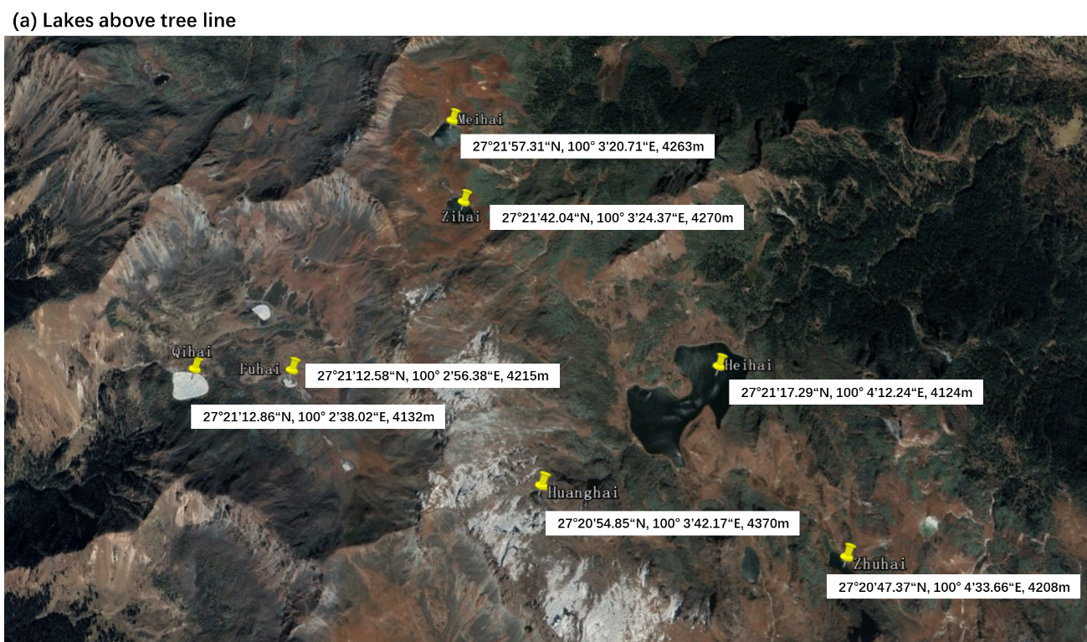

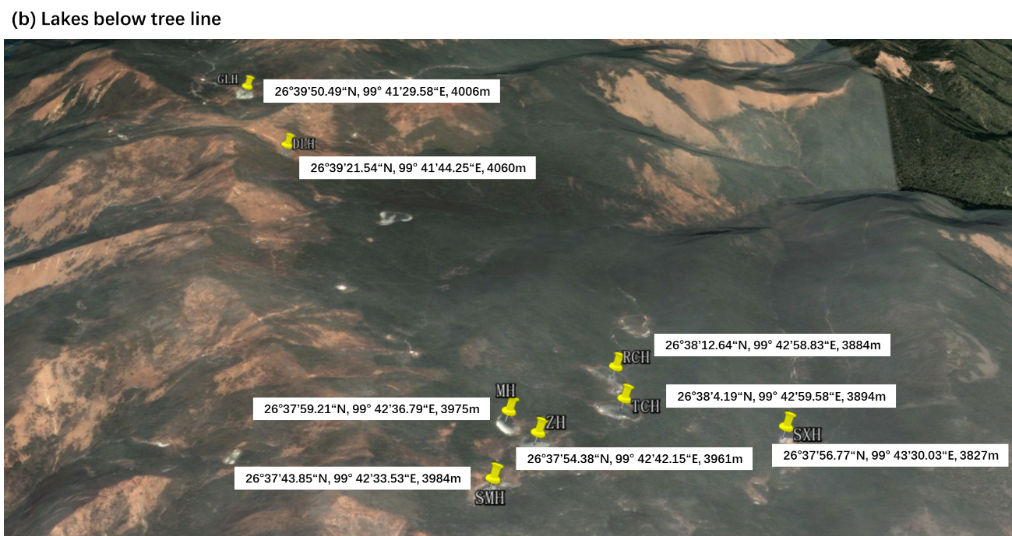

Fig. S2 Profiles of UV-Vis irradiance recorded in the water surface of below and above treeline lakes.
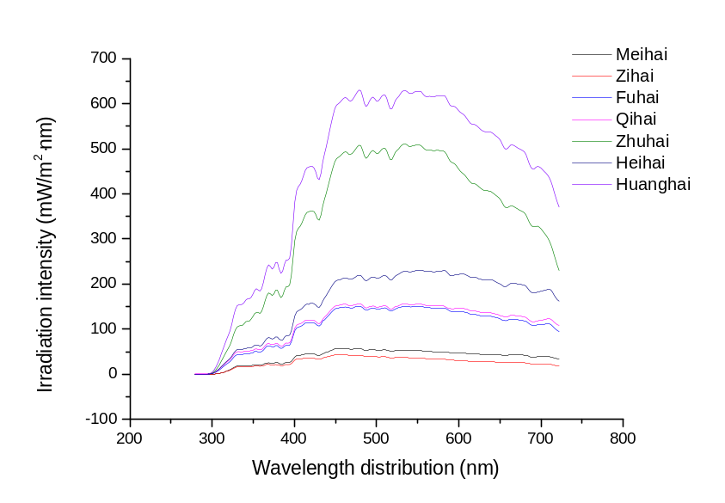

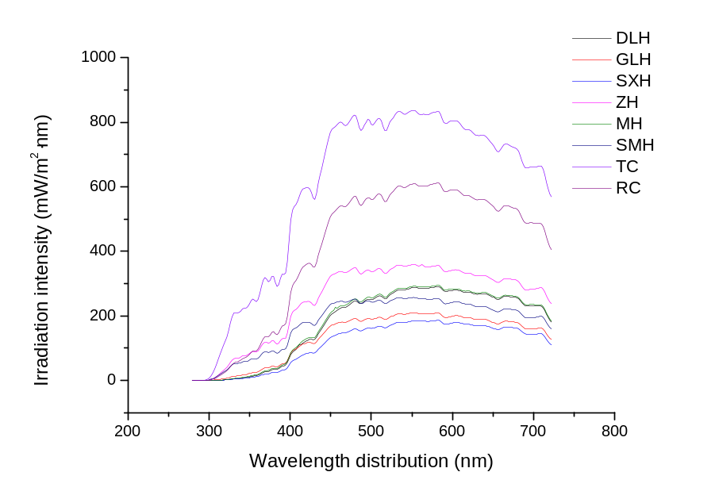

Fig. S3 Comparison of Bray-Curtis similarity within each group and between two groups. Above: above tree-line; Below: below tree-line . One-way ANOVA was applied to identify the significance. ****, p<0.0001, ***, p<0.001
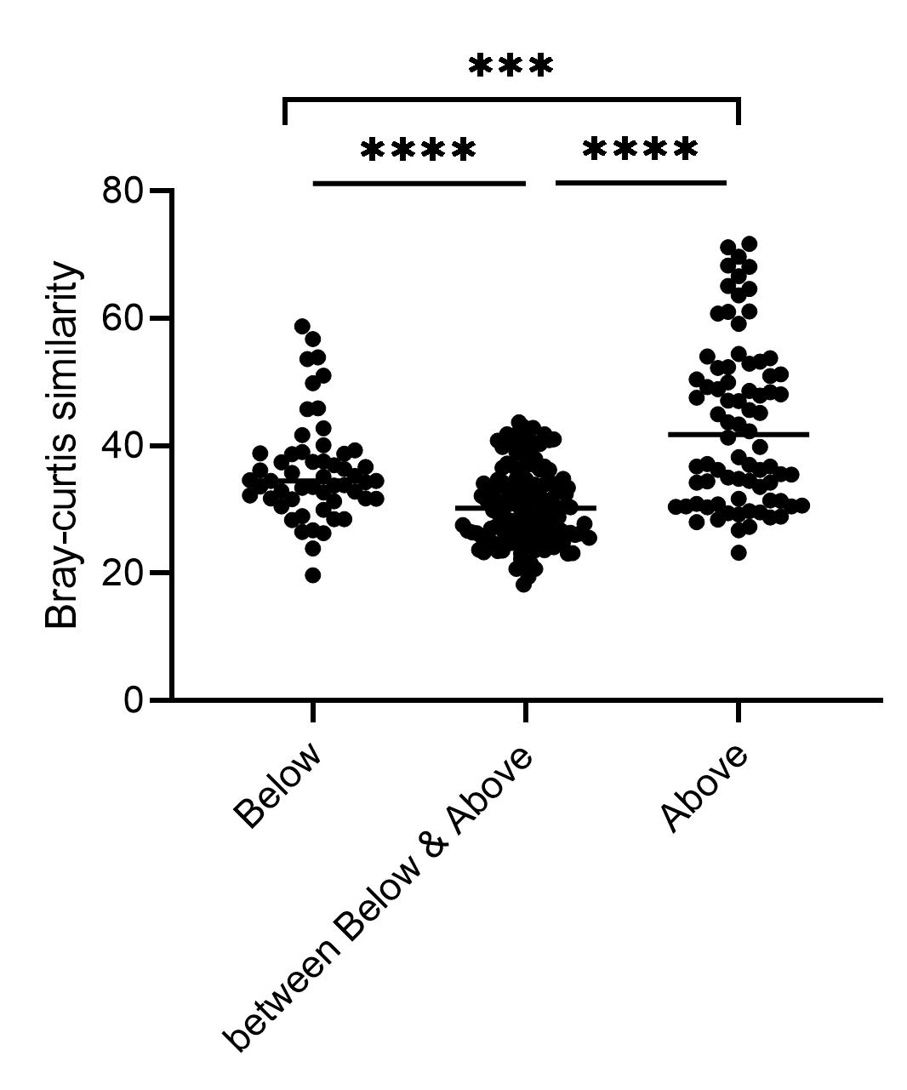

Fig. S4 Bacterial phyla with significant different mean proportion (%) picked up by STAMP with a two-sided Welch’s t-test of a symptomatic confidence intervals (0.95). Phyla overrepresented in the lakes above tree line with a positive value of proportions were indicated by blue filled circles and those overrepresented in the lakes below tree line were indicated by orange filled circles.

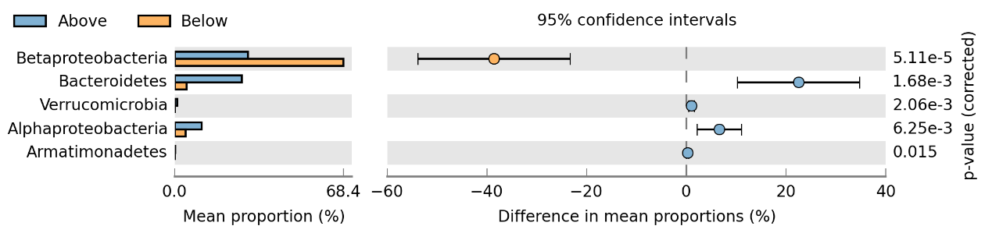

Fig. S5 Bacterial genera with significant different mean proportion (%) picked up by STAMP with a two-sided Welch’s t-test of a symptomatic confidence intervals (0.95). Genera overrepresented in the lakes above tree line with a positive value of proportions were indicated by blue filled circles and those overrepresented in the lakes below tree line were indicated by orange filled circles.

