Supplementary Table S1: List of indirect descriptors related to the One Health model that were used as key words for Boolean searches in WoS and SCOPUS. This information was extracted from Xie et al. (2017).

One Health terminology | References | Cited
Pathology, comparative pathology, genomic biology, food safety***, emerging infectious diseases* | Cardiff RD, Ward JM, Barthold SW. One medicine-one pathology’: are veterinary and human pathology prepared? Laboratory Investigation. 2008; 88(1):18–26. https://doi.org/10.1038/labinvest.3700695 PMID: 18040269. | 33
Veterinary medicine***, food security, food safety***, emerging infectious diseases*, ecosystem protection, experimental medicine, comparative medicine***, human physical/mental health, public health***, human medicine***, bio-engineering, animal science, environmental science, wildlife***. | Frank D. One world, one health, one medicine. Canadian Veterinary Journal-Revue Veterinaire Canadienne. 2008; 49(11):1063 | 12
Veterinary medicine***, food supply, intensive agricultural practices, exotic animals global trade, consumption of “bush meat”, human population pressures, comparative medicine***. | Kahn LHMDMPHMPPF, Kaplan BDVM, Monath TPMD, Steele JHDVMMPH. Teaching "One Medicine, One Health". The American Journal of Medicine. 2008; 121(3):169. | 73
Emerging disease, human medicine***, veterinary medicine***, internal medicine, pediatrics, cardiology, wildlife***, public health***, education**, cross-species disease transmission, media publications. | Gibbs EP, Anderson TC. One World—One Health’ and the global challenge of epidemic diseases of viral aetiology. Veterinaria italiana. 2009; 45(1):35–44. | 24
Zoonotic infections, medical technology, veterinary research, laboratory animal research, public health***, Zoology, chemistry, environmental health, clinical medicine and surgery, biomedical research***, ecosystem management, food and agricultural systems safety, biosecurity**. | Monath TP, Kahn LH, Kaplan B. Introduction: One Health Perspective. ILAR journal. 2010; 51(3):193–8. | 40
Public health***, economic security, social stability, health service organization, patterns and provision and access, science technology, fiscal systems, pharmacology, regulation and governance, information systems. | Coker R, Rushton J, Mounier-Jack S, Karimuribo E, Lutumba P, Kambarage D, et al. Towards a conceptual framework to support one-health research for policy on emerging zoonoses. The Lancet infectious diseases. 2011; 11(4):326–31. | 174
Veterinary medicine***, public health***, wildlife*** | Zinsstag J, Schelling E, Waltner-Toews D, Tanner M. From "one medicine" to "one health" and systemic approaches to health and well-being. Preventive veterinary medicine. 2011; 101(3–4):148–56. | 454
Public health***, clinicians, public health workers, neurosciences, veterinary medicine***, tropical medicine, veterinary public health officials. | Rabozzi G, Bonizzi L, Crespi E, Somaruga C, Sokooti M, Tabibi R, et al. Emerging zoonoses: the "one health approach". Safety and health at work. 2012; 3(1):77–83. | 43
Zoonotic infections***, livestock and wildlife, global public health, livestock production and wildlife conservation. | Zinsstag J, Mackenzie JS, Jeggo M, Heymann DL, Patz JA, Daszak P. Mainstreaming One Health. Eco- Health. 2012; 9(2):107–10. | 44
Infectious diseases***, globalization, animal products trade, wild animals, bush meat, zoonoses*, public health policy, food-agriculture, veterinary medicine***. | Calistri P, Iannetti S, Danzetta ML, Narcisi V, Cito F, Di Sabatino D, et al. The Components of ’One World —One Health’ Approach. Transboundary and emerging diseases. 2013; 60:4–13. | 32
Infectious diseases***, vaccination, epidemiology*, parasitology, medical education and clinical care, entomology, global travel and commerce, virology, molecular biology, medical education and clinical care. | Atlas RM. One Health: Its Origins and Future. One Health: The Human-Animal-Environment Interfaces in Emerging Infectious Diseases: The Concept and Examples of a One Health Approach. Current Topics in Microbiology and Immunology. 3652013. p. 1–13. | 53
Public health***, biomedical research***, global food safety***, food security***, ecosystem health, caring for animals, food science*, epidemiology*, population medicine, foreign animal diseases. | Gibbs SEJ, Gibbs EPJ. The historical, present, and future role of veterinarians in One Health. Current topics in microbiology and immunolog. 2013; 365:31–47. | 24
Zoonoses*, food safety***, agriculture, infectious diseases***, livestock into wildlife, scientific and policy challenges, evolutionary biology, integrative medicine, social sciences, cultural and political norms, veterinary medicine***, public health***, clinical practice. | Bidaisee S, Macpherson CNL. Zoonoses and One Health: A Review of the Literature. Journal of parasitology research. 2014:874345. | 66
Epidemiological globalization, pathogen adaptation, marine biology, changing human demographics, evolving animal production systems, climate change*, water pollution and environmental contaminants, food safety***, food sufficiency and insecurity, the universal global condition of rapid environmental change, life science, new drugs, biodiversity, epidemics, pests, food security***, economic prosperity. | Evans BR, Leighton FA. A history of One Health. Revue scientifique et technique (International Office of Epizootics). 2014; 33(2):413–20. | 45
Veterinary profession, medical profession, wildlife specialists, environmentalists, health policy analysts, social scientists, humanities scholars. | Gibbs EPJ. The evolution of One Health: a decade of progress and challenges for the future. Veterinary Record. 2014; 174(4):85–91. | 229
Infectious diseases***, veterinary, medical and environment sectors, environmental ecology, wildlife***, animal welfare, food safety***, food security***, drugs and vaccines, public health***, training and research. | Stephen C, Karesh WB. Is One Health delivering results? Introduction. Revue Scientifique Et Technique- Office International Des Epizooties. 2014; 33(2):375–9. | 23
Infection biology, contagious diseases, zoonotic infections***, evolutionary medicine, comparative medicine***, translational medicine, innmunology, biology, human medicine***, veterinary medicine***, public health***, environmental chemistry, plant sciences, health economy, epidemics and toxicants, food-producing animals, pet ownership, food science*, education**. | Lerner H, Berg C. The concept of health in One Health and some practical implications for research and education: what is One Health? Infection ecology & epidemiology. 2015; 5:25300. | 65
Medicine, veterinary medicine***, microbiology, applied microbiology, public health***, biogeography, ecology, environmental biology. | Stadtlander CTKH. One Health: people, animals, and the environment. Infection ecology & epidemiology. 2015; 5. | 5
Parasitologists, biosecurity**, infection control risks, vaccine, zoonotic infections***, human medicine***, veterinary medicine***, food security***, healthy diets, climate change*. | Kingsley P, Taylor EM. One Health: competing perspectives in an emerging field. Parasitology. 2016:1–8. Epub 2016/01/29. | 21

* Repeated once
** Repeated twice
*** Repeated three or more times

Supplementary Table S2: Infectious diseases/pathogens that were used as key words for Boolean searches in PubMed.
Infectious diseases | References | Cited
Bovine spongiform encephalopathy **, Campylobacteriosis, Chagas disease ***, Cholera **, Cryptococcus, Cryptosporidiosis, Cyclosporiasis, Cysticercosis **, Dengue fever ***, Diphtheria, Drug-resistant infections (antimicrobial resistance), Escherichia coli **, streptococcus, Hantavirus **, Hendra virus, Hepatitis C, Histoplasmosis, HIV/AIDS, Influenza**, Lassa fever, Legionnaires’ disease, Leptospirosis ***, Listeriosis, Lyme disease **, Malaria, Measles, Monkeypox, MRSA, Nipah virus, Norovirus, Pertussis, Plague, Poliomyelitis, Rabies ***, Rotavirus, Salmonellosis, Severe acute respiratory syndrome, Shigellosis, Sleeping sickness (trypanosomiasis **), Smallpox, Tuberculosis **, Tularemia, Valley fever (coccidioidomycosis), Vancomycin-intermediate or -resistant Staphylococcus aureus, West Nile virus **, Yellow fever **, Bunyaviruses (Rift Valley fever), Filoviruses (Ebola virus **, Marburg virus), Tick-borne hemorrhagic fever viruses, Tick-borne encephalitis viruses, including drug-resistant tuberculosis, Rickettsias, Prions, Chikungunya virus ***, Zika virus, Chlamydia trachomatis, cytomegalovirus, Granuloma inguinale, Haemophilus ducreyi, herpes simplex virus, human papillomavirus, Neisseria gonorrhea, Treponema pallidum, Trichomonas vaginalis. | Tim K. Mackey, Bryan A. Liang, Raphael Cuomo, Ryan Hafen, Kimberly C. Brouwer, Daniel E. Lee. Emerging and Reemerging Neglected Tropical Diseases: a Review of  Key Characteristics, Risk Factors, and the Policy and Innovation  Environment. Clinical Microbiology Reviews (2014). 27(4); 949–979. | 113
Rabies ***, Leptospirosis ***, Brucellosis, Tuberculosis **, Salmonella, Hydatidosis, Campylobacteria, Escherichia coli **, Influenza **, Chagas ***, Leishmaniasis **, Venezuelan Equine Encephalitis, Trichinella spiralis, Hantavirus **, Plague, Anthrax, Chikungunya ***, Helminths, Food Borne Illness, Toxoplasmosis, Fasciolosis, Erysipelas, Burkholderia mallei, Avian Ebola Viral Disease **, Bovine spongiform encephalopathy **, West Nile Virus **, Dengue ***, MERS-CoV1, Lyme disease **, Creutzfeldt Jacob, Saint Louis Encephalitis Virus, Echinococcus, Anthrax, Taenia **, Screwworm, Salmonella. | Maxwell MJ, Freire de Carvalho MH, Hoet AE, Vigilato MAN, Pompei JC, Cosivi O, et al.  (2017) Building the road to a regional zoonoses strategy: A survey of zoonoses programmes in the Americas. PLoS ONE 12(3): e0174175. https://doi.  org/10.1371/journal.pone.0174175 | 13
Dengue *** and Chikungunya fevers ***, Japanese encephalitis, Jungle yellow fever **, Rabies ***, Rift Valley fever, Viral haemorrhagic fevers, Bacterial diseases, Bartonellosis, Bovine tuberculosis in humans, Buruli ulcera, Cholera **, Diarrhoeal diseases (Shigella, Salmonella, E. coli), Leprosya, Leptospirosis ***, Trachoma, Treponematoses (Yaws, Endemic syphilis, Pinta), Dracunculiasis, Echinococcosis, Food-borne trematodiases, Loiasis, Lymphatic filariasis (LF), Onchocerciasis, Schistosomiasis, Soil-transmitted, helminthiases (Ascariasis, Hookworm disease, Trichuriasis, Strongyloidiasis), Taenia solium **, Cysticercosis **/Taeniosis, Toxocariasis and other larva Migrans diseases, Amoebiasis, Balantidiasis, Chagas disease ***, Giardiasis, Human African trypanosomiasis ** (HAT), Leishmaniasis **, Ectoparasitic diseases, Myiasis, Scabies. | Katharina Klohe, John Amuasi, Joyce Moriku Kaducu, Ingeborg Haavardsson, Ekaterina Bogatyreva, Kristine Husøy Onarheim, Wendy Harrison, Frederik Kristensen, Clarissa Prazeres da Costa and Andrea S. Winkler. The 2017 Oslo conference report on neglected tropical diseases and emerging/ re-emerging infectious diseases – focus on populations underserved. Infectious Diseases of Poverty (2019) 8:40. | 7

* Repeated once
** Repeated twice
*** Repeated three or more times

Supplementary Table S3. Official resources and topographies of research institutions based in Panama.
Research Institution | # of Staff scientists / employees | # of visitor scientists * | Annual budget ** | # of facilities or branches *** | Founding time
STRI | 40 / 422 | 1,400 | 35.0 | 15 | 1923
ICGES | 19 / 461 | 150 | 15.2 | 7 | 1928
UP **** | 50 / 9312 | 750 | 240.2 | 17 | 1935
INDICASAT | 16 / 63 | 50 | 4.5 | 2 | 2002

* Visitor scientist are undergraduate and graduate students, interns, postdoctoral fellows and senior researchers. ** The budget is given as an average of last five years in millions of US dollars. *** Facilities or branches refer to fully equipped field stations or buildings to conduct lab experiments and field sampling or teaching activities. **** 90% of the budget of UP is used to pay the salary of professors and administrative personnel, and only 2% goes into research activities.

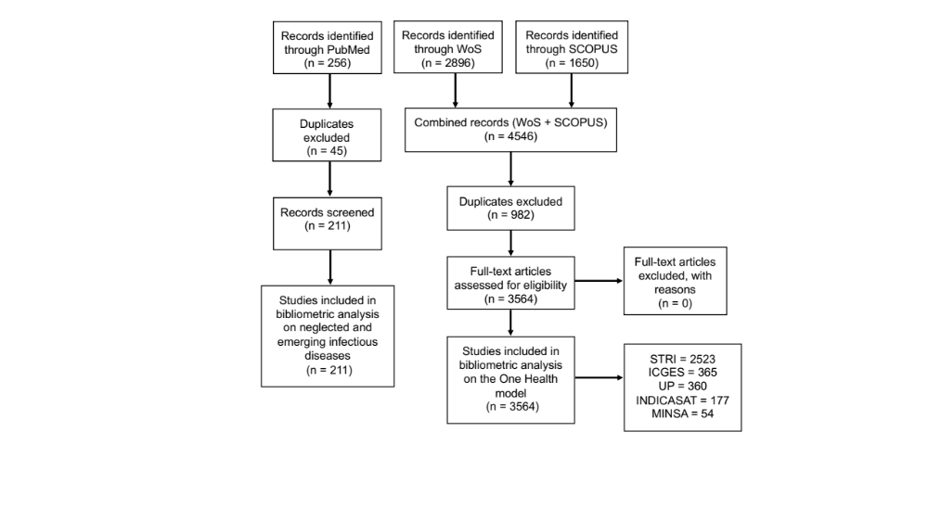

Supplementary Figure S1. Flow chart of the bibliometric evaluation on One Health related subjects and neglected and emerging infectious disease research in Panama (1990 – 2019). The diagram was adapted from Moher et al. (2009) following the PRISMA rules (www.prisma-statement.org). STRI (The Smithsonian Tropical Research Institute); ICGES (Gorgas Memorial Institute for Health Studies); UP (University of Panama); INDICASAT (Institute for Scientific Investigation and Advanced Technology Services); MINSA (Panamanian Ministry of Health).

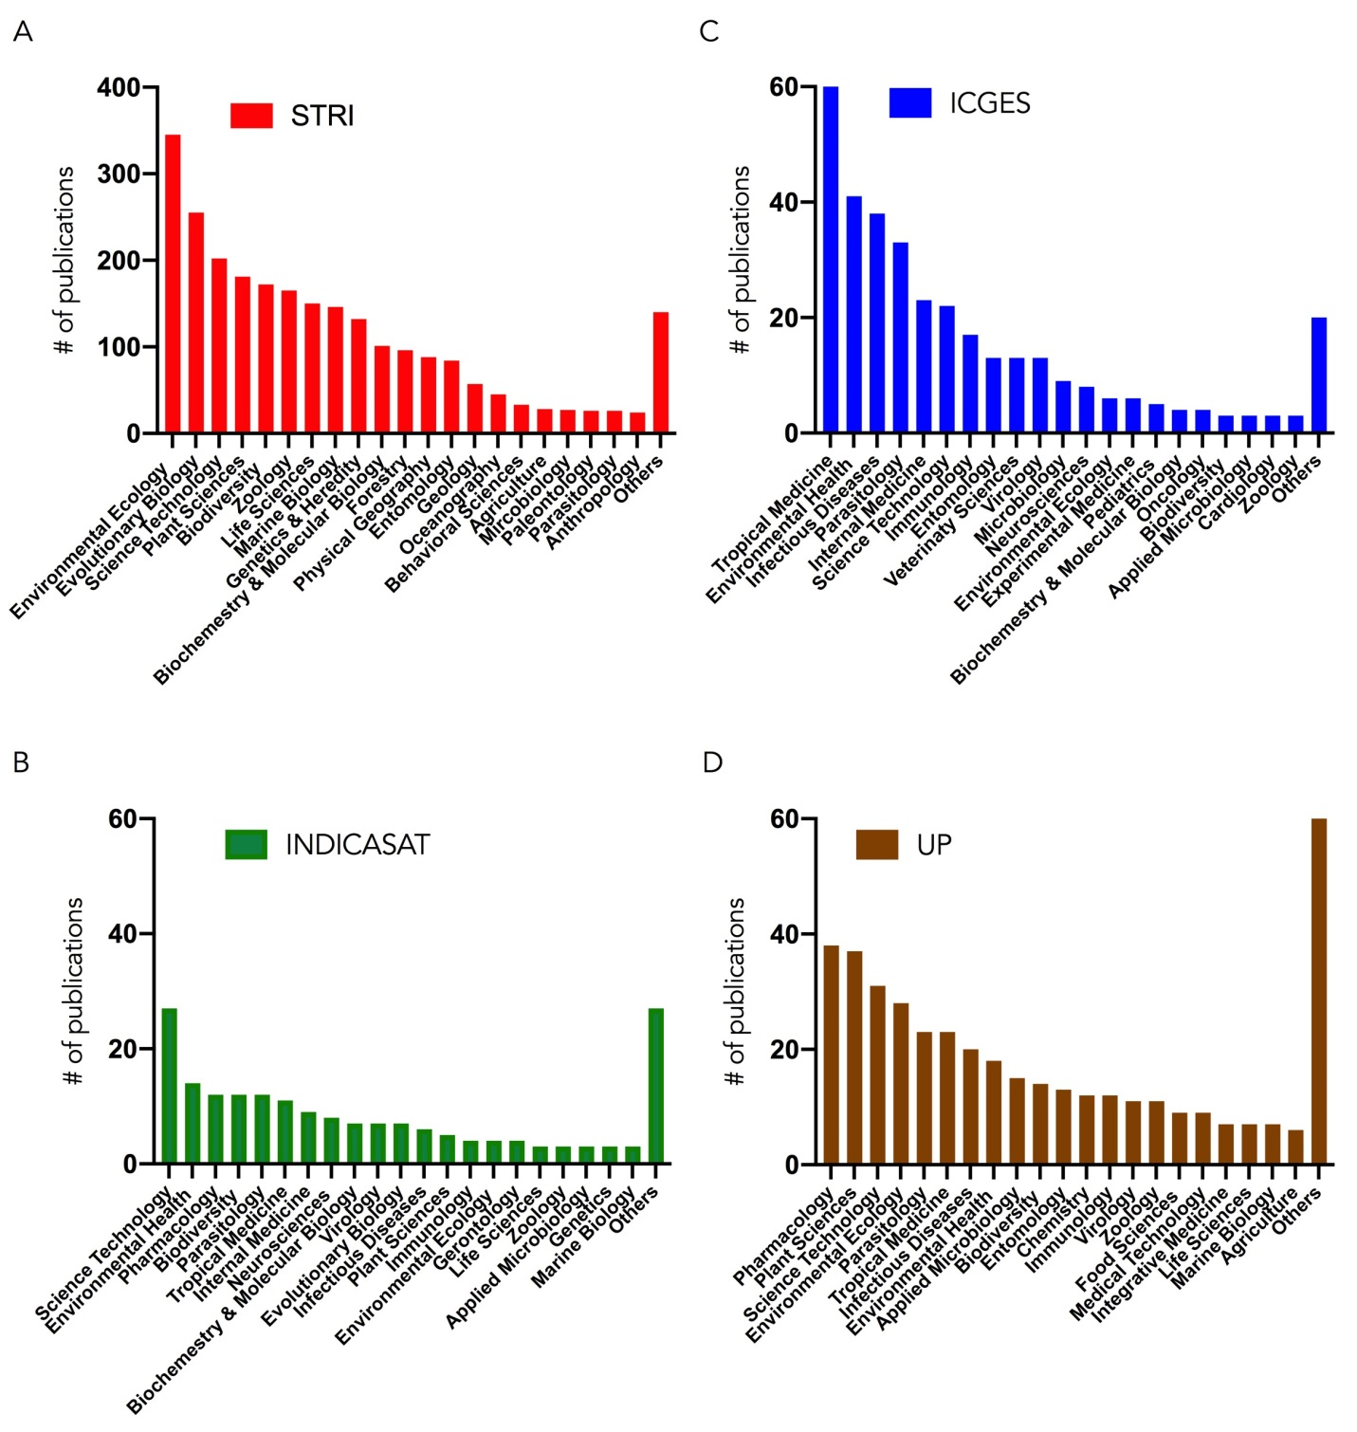
Supplementary Figure S2. Trend of scientific publications on subjects related to the One Health model in the country of Panama, between 1990 and 2019. (A) Total number of publications per subject by STRI (Red); (B) Total number of publications per subject by INDICASAT (Green). (C) Total number of publications per subject by ICGES (Blue); (D) Total number of publications per subject by UP (Brown). At each institution only the first most representative 22 subjects of 41 are shown. Publications were assigned to Category fields or concentration areas from the Web of Science Core collection (https://images.webofknowledge.com/images/help/WOS/hp_subject_category_terms_tasca.html).

