Supplemental text
Radioligand synthesis
¹¹C-Methane (¹¹C-CH₄) was produced in-target via the 14 N(p,α) ¹¹C reaction on nitrogen mixed with 10% of hydrogen, with 16.4 MeV protons using a GEMS PET trace cyclotron (GE, Uppsala, Sweden). Typically the target gas was irradiated for 15–20 min with a beam current of 35 μA. ¹¹C-Labeled methyl iodide, ¹¹C-CH₃I, was produced following the previously published method (1). In short, the produced ¹¹C-CH₄ was released from the target and collected in a Porapak Q trap cooled in liquid nitrogen. After collection, the ¹¹C-CH₄ was released from the trap by heating with flow of helium and subsequently ¹¹C-CH₄ was mixed with iodine vapor from of iodine crystals at 60 °C followed by a free radical reaction at 720 °C. The formed ¹¹C-CH₃I was collected in a porapak Q trap at room temperature and the unreacted ¹¹C-CH₄ was recirculated for 3 min. ¹¹C-CH₃I was released from the Porapak Q trap by heating the trap using a custom-made oven at 180 °C. ¹¹C-CH₃OTf was produced by online transfer of ¹¹C-CH₃I through a glass column packed with silver triflate at 165 °C.
Carbon-11 labeled ¹¹C-PF-06809247 was obtained by trapping ¹¹C-CH₃OTf at room temperature in a reaction vessel containing the desmethyl precursor PF-06819821, (0.5 – 1 mg, 1.2 µmol-2.4 µmol) and Cs₂CO₃ (10mg, 30 μmol) in dimethylformamide (DMF) (300-400 μL). After end of trapping, deprotection was performed by adding trifluoroacetic acid (TFA) with heating at 100°C for 5 minutes. The reaction mixture was diluted with sterile water (500 μL) before injecting to the built-in high performance liquid chromatography (HPLC) system for the purification of the desired radiolabeled product. The HPLC system consisted of a semi-preparative reverse phase (RP) ACE column (C18, 10 × 250 mm, 5 μm particle size) and a Merck Hitachi UV detector (λ = 254 nm) (VWR, International, Stockholm, Sweden) in series with a GM-tube (Carroll-Ramsey, Berkley, CA, USA) used for radioactivity detection. Acetonitrile / 0.1% Trifluoroacetic acid (TFA), 50:50 (v/v) was used as HPLC mobile phase with a flow rate of 6 mL/min. The radioactive fraction corresponding to pure ¹¹C-PF-06809247 was collected and evaporated to dryness. The final purified ¹¹C-PF-06809247 was formulated in 6 mL phosphate buffered saline; PBS (pH7.4) and found to be stable after 1 hour. The formulated product was then sterile filtered through a Millipore Millex® GV filter unit (0.22 μm) for further use in vivo.

1. Andersson J, Truong P, Halldin C. In-target produced [11C]methane: Increased specific radioactivity. Appl Radiat Isot. 2009;67(1):106–10.

The scheme of radiosynthesis of ¹¹C-PF-06809247

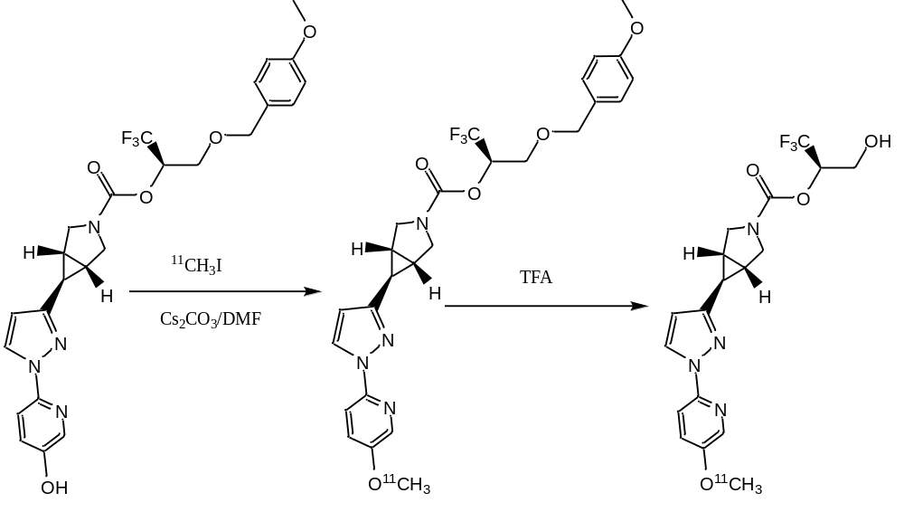

Supplemental Figure 1

Time activity curves of [¹¹C]PF-06809247 in the NHP brain for putamen and frontal cortex at baseline and following pretreatment with a selective MAGL inhibitor (NHP4; 0.42 mg/kg)

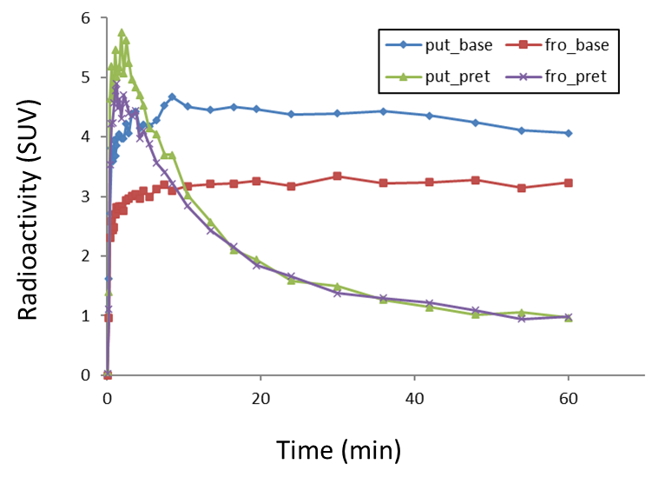

Supplemental Figure 2

The ratio of brain (putamen) uptake to metabolite-corrected plasma on average (N=10) at baseline condition

