Supporting Information
CO₂ adsorption on a water-resist HKUST-1 by incorporation of Graphene Oxide
Sandra Loera-Serna^{a*}, Jonathan Cortés-Suárezª, Roque Sanchez-Salasª, D. Ramírez-Rosales^{b}, M. Oliver-Tolentino^{c}, and Enrique V. Ramos-Fernández^{d}

ª Universidad Autónoma Metropolitana-Azcapotzalco, Área de Química de Materiales, Av. San Pablo 180, Col. Reynosa Tamaulipas, 02200, Ciudad de México, Mexico.
^{b} Instituto Politécnico Nacional, ESFM-Departamento de Física, UPALM Edif. 9 Zacatenco, GAM, Ciudad de México, 07738, Mexico
^{c} CONACYT-Universidad Autónoma Metropolitana-Iztapalapa, Departamento de Química, CP 09340 México, México
^{d} Laboratorio de Materiales Avanzados, Departamento de Química Inorgánica- Instituto Universitario de Materiales, Universidad de Alicante, Ctra. San Vicente- Alicante s/n, E-03690 San Vicente del Raspeig, Spain
*sls@azc.uam.mx
ORCID: SLS: 0000-0001-9562-3195, RSS: 0000-0001-6393-9152, DRR: 0000-0001-7815-2029, MOT: 0000-0001-8454-0837, EVRF: 0000-0001-6357-0383.

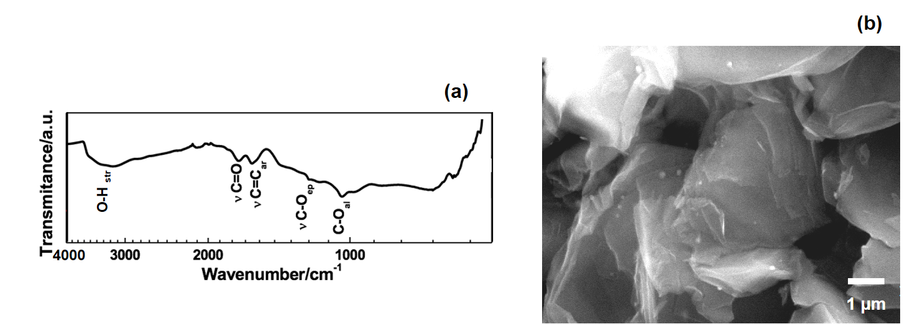

Fig. S1. FTIR, and SEM micrograph from GO. The spectra bands are located at 3430 cm⁻¹ (O-H stretching vibrations), 1726 cm⁻¹ (C=O stretching vibrations from carbonyl and carboxylic groups), 1226 cm⁻¹ (C-OH stretching vibrations) and 1103 cm⁻¹ (C-O in epoxy stretching vibrations); these stretching modes are typically found in GO and are assigned to oxygen species created during the synthesis. SEM morphology from the GO layers shows a heterogeneous distribution at the GO material with the characteristic laminar surface.

Fig. S2. Morphology and EDX scanning micrographs of GO-Cu_{low} mapping of Cu, O, and C.

Sample | C (wt.%) | O (wt.%) | S (wt.%) | Cl (wt.%) | Cu (wt.%)
GO | 62.1 | 33.6 | 3.7 | 0.6
GO-Cu_{low} | 49.4 | 42.8 | 1.0 | 0.2 | 6.6
GO-Cu_{high} | 41.2 | 43.8 | 1.2 | 0.1 | 13.7
Fig. S3. EDX elemental scanning identification measured on GO, GO-Cu_{low}, and GO-Cu_{high} samples where carbon, oxygen, sulfur, chlorine, and copper wt.% peaks signals were detected and quantified.

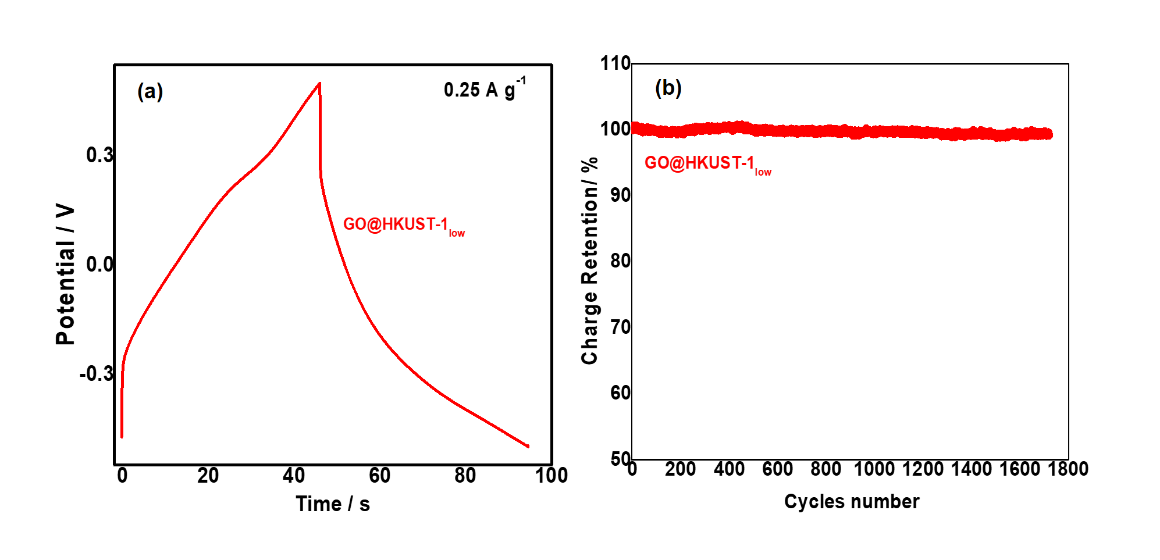
Fig. S4. a) Galvanostatic profile of GO@HKUST-1_{low} at 0.25 Ag⁻¹; b) charge retention for 1700 galvanostatic cycles.

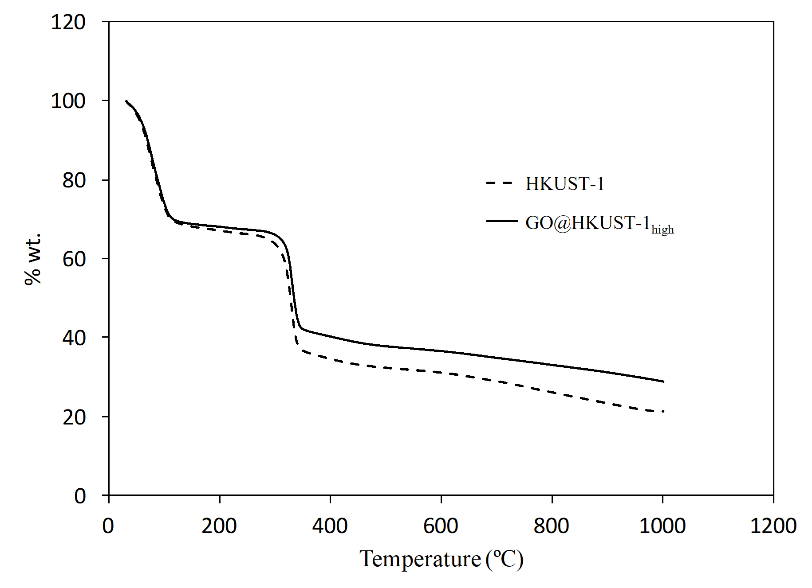
Fig. S5. TGA on air conditions mass loss of HKUST-1 and GO@HKUST-1_{high}.

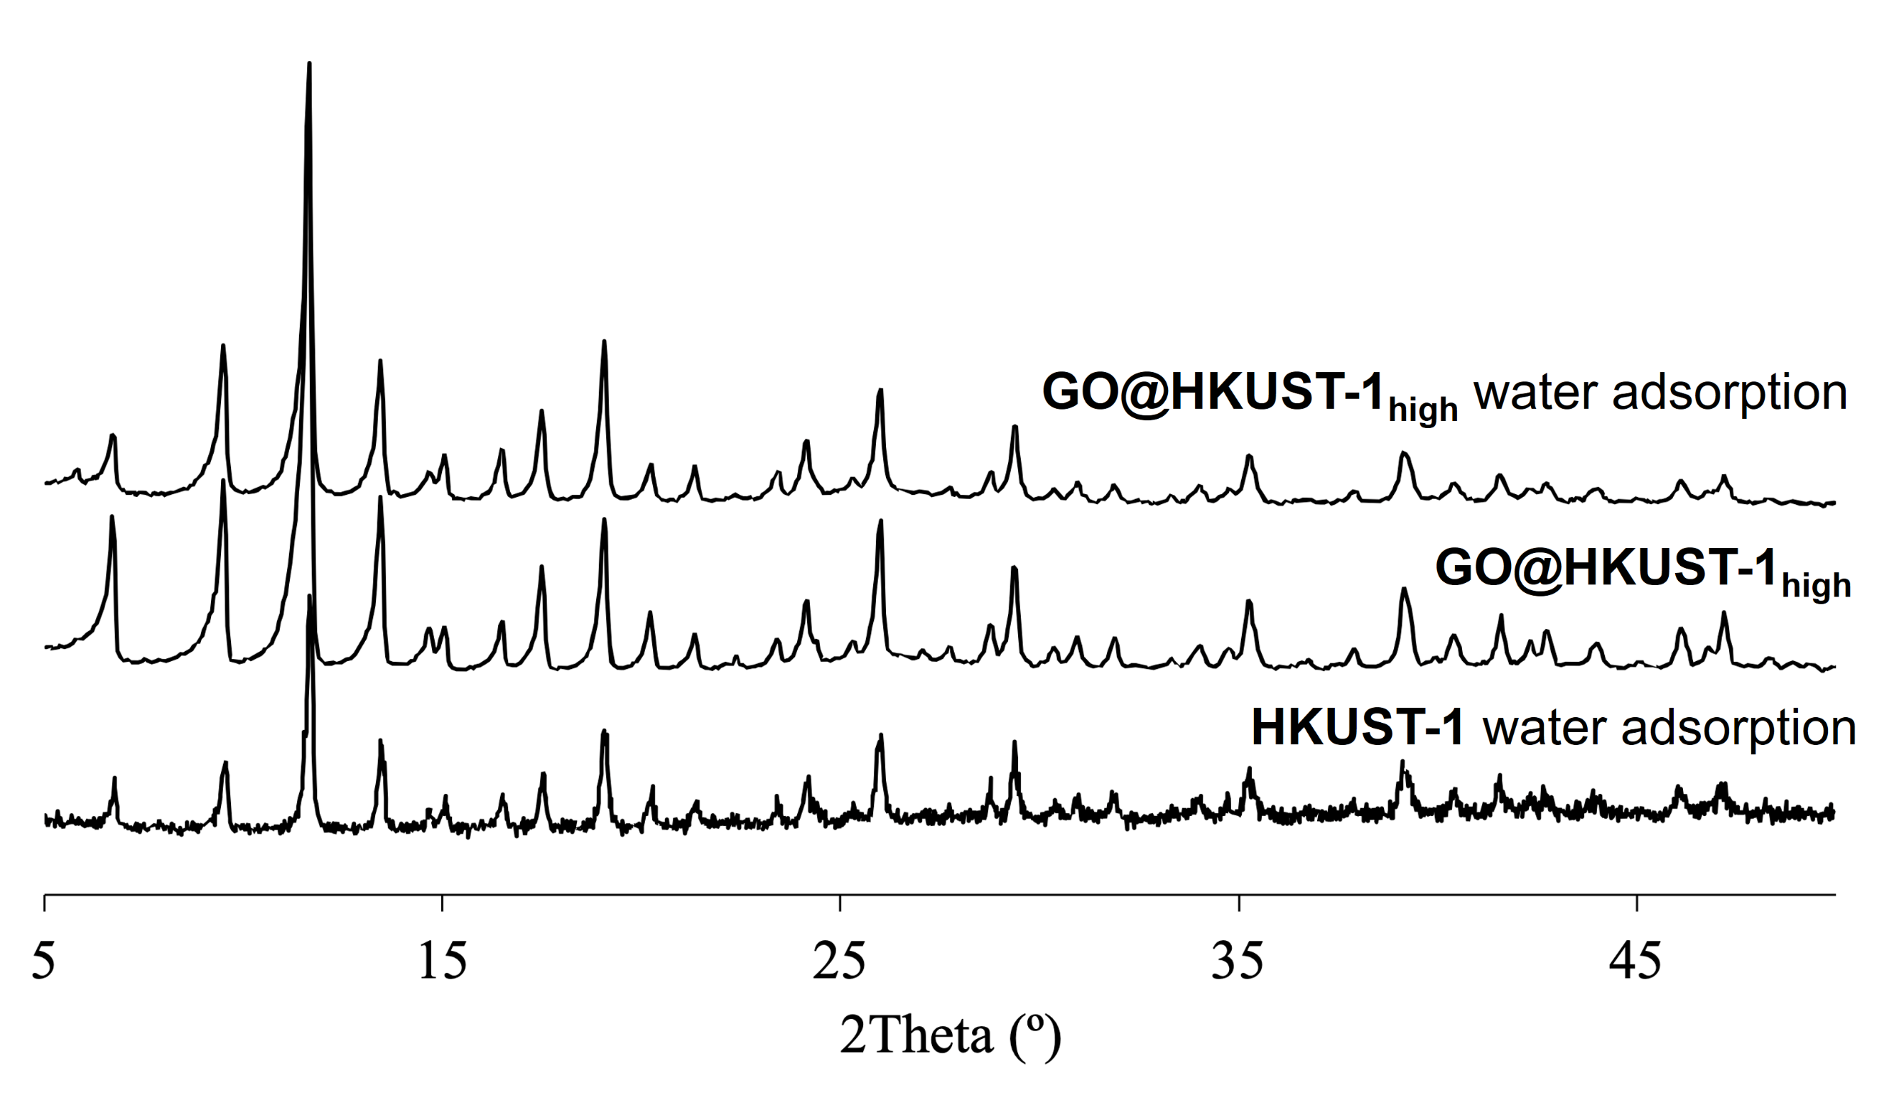
Fig. S6. XDR of HKUST-1 and GO@HKUST-1_{high} after the water adsorption test, moreover GO@HKUST-1_{high} sample before the test is compared.

