Supporting Information

Key residues of Bacillus thuringiensis Cry2Ab for oligomerization and pore-formation activity
Zhi-Zhen Pan ¹, Lian Xu ², Bo Liu ¹, Qing-Xi Chen ² and Yu-Jing Zhu ¹*

¹ Agricultural Bio-Resources Research Institute, Fujian Academy of Agricultural Sciences, Fuzhou 350003, China.
² School of Life Sciences, Xiamen University, Xiamen 361005, China.
* Corresponding authors: Tel/Fax: (+86)059183723032. E-mail: zyjingfz@163.com (Yu-Jing Zhu)
Table S1. Primer sequences used for the generation of mutants Cry2Ab.
primer | primer sequence (5’-3’)
Cry2Ab F | GCAGATCTATGAATAGTGTATTG
Cry2Ab R | CGGAATTCTTAATAAAGTGGTG
T7 F | TAATACGACTCACTATAGGG
T7 R | TGCTAGTTATTGCTCAGCGG
150 F | TCAATAACTTCTTCAgcaAATACAATGCAACAA
150 R | TTGTTGCATTGTATTtgcTGAAGAAGTTATTGA
151 F | ATAACTTCTTCAGTTgcaACAATGCAACAATTA
151 R | TAATTGTTGCATTGTtgcAACTGAAGAAGTTAT
152 F | ACTTCTTCAGTTAATgcaATGCAACAATTATTT
152 R | AAATAATTGTTGCATtgcATTAACTGAAGAAGT
153 F | TCTTCAGTTAATACAgcaCAACAATTATTTCTA
153 R | TAGAAATAATTGTTGtgcTGTATTAACTGAAGA
154 F | TCAGTTAATACAATGgcaCAATTATTTCTAAAT
154 R | ATTTAGAAATAATTGtgcCATTGTATTAACTGA
155 F | GTTAATACAATGCAAgcaTTATTTCTAAATAGA
155 R | TCTATTTAGAAATAAtgcTTGCATTGTATTAAC
156 F | AATACAATGCAACAAgcaTTTCTAAATAGATTA
156 R | TAATCTATTTAGAAAtgcTTGTTGCATTGTATT
157 F | ACAATGCAACAATTAgcaCTAAATAGATTACCC
157 R | GGGTAATCTATTTAGtgcTAATTGTTGCATTGT
158 F | ATGCAACAATTATTTgcaAATAGATTACCCCAG
158 R | CTGGGGTAATCTATTtgcAAATAATTGTTGCAT
159 F | CAACAATTATTTCTAgcaAGATTACCCCAGTTC
159 R | GAACTGGGGTAATCTtgcTAGAAATAATTGTTG
160 F | ACAATTATTTCTAAATgcaTTACCCCAGTTCCAG
160 R | CTGGAACTGGGGTAAtgcATTTAGAAATAATTGT
182 F | TTTGCACAGGCAGCCgcaTTACATCTTTCTTTT
182 R | AAAAGAAAGATGTAAtgcGGCTGCCTGTGCAAA
183 F | GCACAGGCAGCCAATgcaCATCTTTCTTTTATT
183 R | AATAAAAGAAAGATGtgcATTGGCTGCCTGTGC
184 F | CAGGCAGCCAATTTAgcaCTTTCTTTTATTAGA
184 R | TCTAATAAAAGAAAGtgcTAAATTGGCTGCCTG
185 F | GCAGCCAATTTACATgcaTCTTTTATTAGAGAT
185 R | TCTATTTAGAAATAAtgcTTGCATTGTATTAAC
186 F | GCCAATTTACATCTTgcaTTTATTAGAGATGTT
186 R | AACATCTCTAATAAAtgcAAGATGTAAATTGGC
187 F | AATTTACATCTTTCTgcaATTAGAGATGTTATT
187 R | AATAACATCTCTAATtgcAGAAAGATGTAAATT
188 F | TTACATCTTTCTTTTgcaAGAGATGTTATTCTA
188 R | TAGAATAACATCTCTtgcAAAAGAAAGATGTAA
189 F | CATCTTTCTTTTATTgcaGATGTTATTCTAAAT
189 R | ATTTAGAATAACATCtgcAATAAAAGAAAGATG
190 F | CTTTCTTTTATTAGAgcaGTTATTCTAAATGCA
190 R | TGCATTTAGAATAACtgcTCTAATAAAAGAAAG
Enzyme sites Bgl II and EcoR I were underlined. The mutant and replacement nucleotide sequences were shown in lower case text.

Figure. S1.
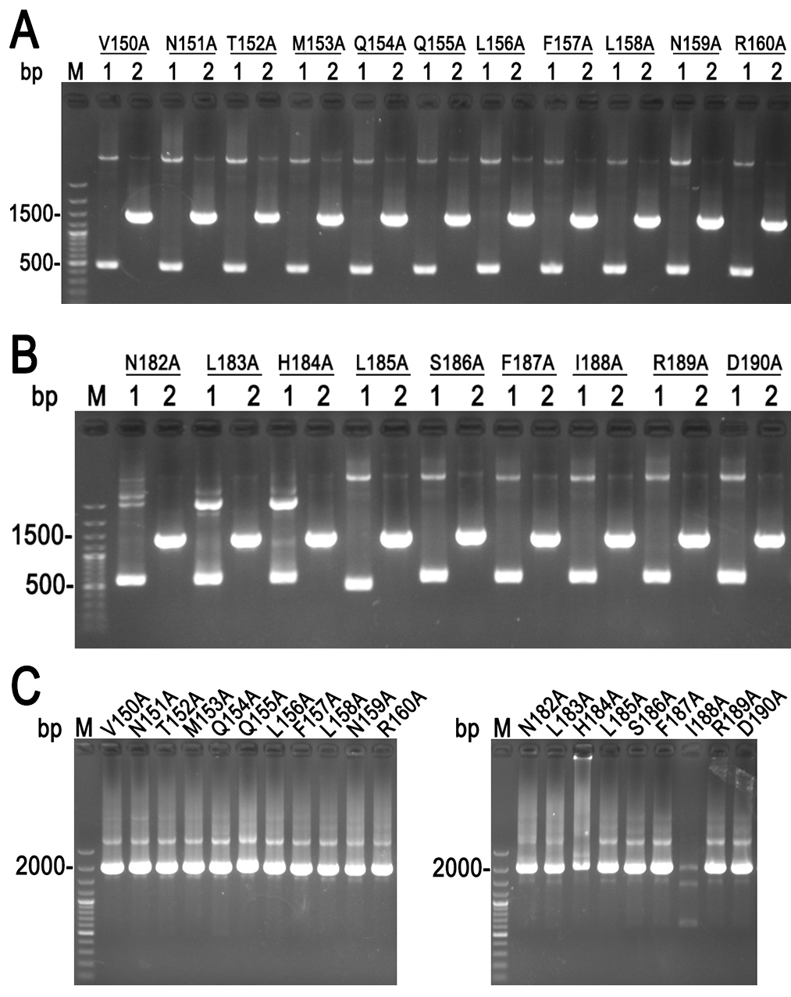
Figure. S1. (A) Amplification of front and rear cry2Ab α-4 helix mutant DNA by PCR; (B) Amplification of front and rear cry2Ab α-5 helix mutant DNA by PCR; (C) Amplification of full-length DNA fragment of cry2Ab mutant by overlap extension PCR.
Figure. S2.
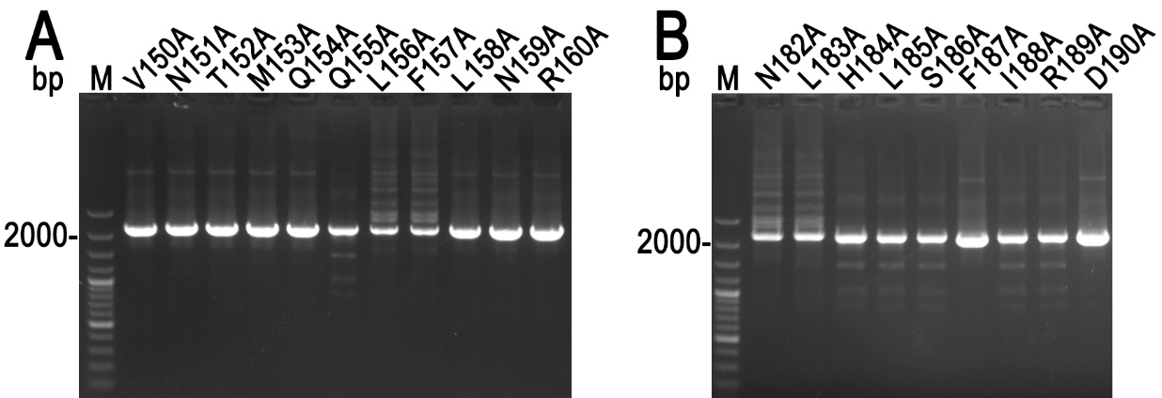
Figure. S2. Verification of recombinant plasmid by colony PCR. (A) Cry2Ab mutants in helix-α4; (B) Cry2Ab mutants in helix-α5.
Figure. S3.
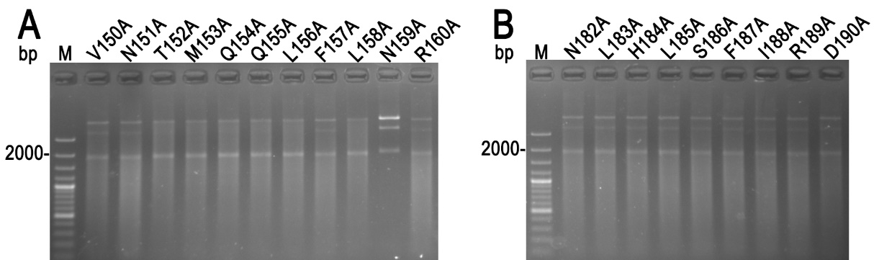
Figure. S3. Verification of recombinant plasmid by restriction enzyme digestion. (A) Cry2Ab mutants in helix-α4; (B) Cry2Ab mutants in helix-α5.

