Supplementary Materials for

Unravelling Emergence of Chirality in
Click-Chemistry Polymers down to the Single-Chain Level

AUTHORS:
Xuecong Li^{1,2}, Sidharam P. Pujari¹, Jasper van der Gucht², Han Zuilhof^{1,3*}, Francesco Simone Ruggeri^{1,2*}

AFFILIATIONS:
¹Laboratory of Organic Chemistry, Wageningen University, Wageningen, 6708 WE, NL
²Physical Chemistry and Soft Matter, Wageningen University, Wageningen, 6708 WE, NL
³School of Pharmaceutical Science and Technology, Tianjin University, 92 Weijin Road, 300072 Tianjin, China
Correspondence to: han.zuilhof@wur.nl; simone.ruggeri@wur.nl

- This PDF file includes:
Supplementary Notes 1-5
Supplementary Materials and Methods 1-7
Supplementary Figures 1-14
References
Supplementary Notes
- Chiral-HPLC
Chiral-HPLC allowed separating and identifying the presence of enantiomers in the monomers and repeating units (SI Figure 1-3), by leveraging the selective retention of enantiomers based on their unique interactions with chiral stationary phases (CSPs). The results of the measurements showed that our rac-monomers had a chromatogram with three peaks, thus each peak corresponded to one of the four possible chiral configurations (R,R) (25%), (R,S)/(S,R) (50%), and (S,S) (25%) where the presence of a plane of symmetry in the molecule renders the (R,S) and (S,R) configurations equivalent. While the rac-repeating units had a chromatogram with four peaks, corresponding to the four possible configurations: (R,S), (S,R), (R,R) or (S,S), where the plane of symmetry is absent resulting in the (S,R) and (R,S) configurations being distinct. Both the χ-monomers and χ-repeating units had a chromatogram with a single peak, demonstrating that they are chirally pure enantiomers. However, while effective at separating enantiomers, Chiral-HPLC alone does not allow to determine the absolute configuration on central chirality, as it only distinguishes them based on their interactions with the CSPs. Via comparison with established literature, which reported similar retention times using the same column¹, we concluded that we have racemic and enantiopure chiral configurations systems.
Chiral-HPLC was not able to separate chiral polymers, as their heterogeneity leads to peak broadening that typically yields significant overlap in the peaks of enantiomeric polymers.
- CD interpretation and Cotton Effect
CD allowed to study the asymmetry of the monomers, repeating units and polymers allowing to identify chirality in bulk, by measuring the difference in absorbance of left- and right-circularly polarized light and thus differentiating chiral asymmetry (Figure 2 and SI Figure 4). The non-enantiospecific monomers, repeating units, and racemic polymers exhibit negligible CD bands with intensity of $\left|{∆ε}_{\text{max}}\right|=24.4$, $\left|{∆ε}_{\text{max}}\right|=25.8$, $\left|{∆ε}_{\text{max}}\right|=8.7$ (Figure 2b, light blue, green blue and blue curves). The absence of a CD response demonstrated a balanced mixture of the enantiomers in our sample, indicating that there was no enrichment of any particular chiral configuration as (R,R), (R,S), (S,R), or (S,S), thus confirming they are racemic species. To confirm the absence of chirality, RS species alone were synthesized, and these also did not exhibit CD peaks (SI Figure 4).
The RR (and SS) χ-monomers, χ -repeating units, and χ -polymers showed two major peaks at 238 nm and 290 nm, demonstrating chiral asymmetry (Figure 2b). The χ-monomers (magenta curve) exhibited a prominent peak with an absorption maximum at 238 nm ($\left|{∆ε}_{\text{max}}\right|=152.8$) indicating the presence of chiral centers and reflecting the asymmetry in the monomer’s structure.² The χ-repeating units (orange curve) demonstrated a similar trend, with an absorption maximum at 234 nm ($\left|{∆ε}_{\text{max}}\right|=156.1)$ which is slightly shifted compared to the monomers. This shift in the absorption peak is indicative of differences in the chemical structure in the repeating units. The χ-polymers (red curve) also exhibited significant peak at 236 nm ($\left|{∆ε}_{\text{max}}\right|=149.3$), though with slightly altered positions and intensities, reflecting the more complex chiral arrangement within the polymers.
We observed that that RR- and SS- monomers showed opposite CD signals due to the Cotton effect (Figure 2d-f). Moreover, the respective χ-monomers exhibited inverse signs of the peaks compared to the corresponding χ-repeating units and χ-polymers. This reversal of the sign of the peaks, attributed to variations in the electronic transitions affecting the differential absorption of circularly polarized light, is commonly known as Cotton effect. The Cotton effects observed in the spectra – a negative effect for the monomers at 238 nm followed by a positive effect at 290 nm, and a reverse-sign cotton effect for the repeating units and polymers – were in accordance with the chiral nature of the molecules. The reversal in the Cotton effects is attributed to the known rearrangement of the chiral center during the S_{N}2 reaction of the SuFEx process.¹
Overall, the comparison of the CD spectra of the racemic and chiral species confirmed the presence or absence of central chirality in the monomers and repeating unit molecules. Minor differences in the spectra of χ-repeating units versus χ-polymers were observed, suggesting the possibility of distinct structural chiral features beyond central chirality. Slight differences in the positions and intensities of peaks in the CD spectra of the χ-repeating units vs. χ-polymers indicate that, in addition to central chirality, there might be distinct structural features leading to chirality. While CD signals suggest the presence of central chirality also in the polymers, they do not provide direct information on the absolute configuration of chiral centers, nor can definitively differentiate between central chirality and backbone chirality.³
- Principal Component Analysis (PCA) of IR Spectra of Polymers
PCA was performed to extract the most relevant spectral features from the Infrared (IR) spectra of the racemic and chiral polymers, focusing on two primary regions: 1800 - 1000 cm⁻¹ and 3500 - 2600 cm⁻¹ (Figure 2 and SI Figure 5). These regions are routinely investigated in IR spectroscopy due to their abundance of spectral information pertaining to the vibrational modes of many common chemical bonds.
- Analysis of the 1800 - 1000 cm⁻¹ Region:
Within this region, PCA was instrumental in highlighting the carbonyl stretching region of 1620-1780 cm⁻¹. In Figure 2, the rac- and χ-polymers were distinctly separated along the first principal component (PC1). The most prominent features of PC1 in this region were an absolute maximum at 1723 cm⁻¹ and a nearby peak at 1656 cm⁻¹. These peaks are indicative of carbonyl stretching vibrations, which are inherent to rac- and χ-polymers.
- Analysis of the 3500 - 2600 cm⁻¹ Region:
PCA similarly studied the methyl stretching region (3020-2800 cm⁻¹) within the broader 3500-2600 cm⁻¹ range. (SI Figure 6) The rac- and χ-polymers exhibited clear separation on PC1, indicating significant differences in the methyl group conformations and their associated stretching vibrations.
In summary, the application of PCA was essential in enabling us to select the most statistically relevant regions from within the broader IR spectral ranges for focused analysis. By directing our attention to the carbonyl stretching region (1620 - 1780 cm⁻¹) within the 1800 - 1000 cm⁻¹ region and the methyl stretching region (3020 - 2800 cm⁻¹) within the 3500 - 2600 cm⁻¹ range, PCA facilitated a more targeted and effective interpretation of the complex IR spectra.
- Infrared Spectroscopy Analysis of Racemic vs Chiral Polymers
We leveraged the molecular information contained in the IR spectra to unravel structural differences between our racemic vs. chiral molecules and polymers (Figure 3). Indeed, thanks to our design of a system with same connectivity but different chirality, the spectral differences between rac- and χ- species were purely associated to their specific structural features. The PCA analysis (Figure 2) focused our analysis on the spectral regions where the largest significant differences were discernible. We thus investigated quantitatively how chemical differences may be related to different forms of chirality for the: i) CH₃ region, 3020-2800 cm⁻¹ (Figure 3a); ii) the C=O region, 1780-1620 cm⁻¹ (Figure 3b).
We first focused on CH₃ groups (Figure 3a, SI Figure 6), because they are abundant and often located directly or closely (i.e. via aromatic rings) to chiral centers of molecules or the backbone of polymers.⁴⁻⁷
Monomers and repeating units can only have central chirality. Thus, the spectral differences between rac- vs. χ- species allowed identifying how the conformation of CH₃ groups correlates to central chirality. To evaluate the changes between rac- and χ-species, we performed a difference spectroscopy analysis (Figure 3c, SI Figure 7). The IR spectra of rac- and χ-monomers showed minor differences, while the repeating units showed statistically significant differences in the aromatic antisymmetric (CH₃as, 2925 cm⁻¹) and symmetric (CH₃^{s}, 2875 cm⁻¹) methyl stretching. The integration of the area of the difference peaks showed that the aromatic CH₃as and CH₃^{s} groups had higher IR intensity for the rac-repeating units than the χ-species (Figure 3c); relative to the absorption of the aliphatic CH₃as stretching (2970 cm⁻¹) in the link-monomer. The weaker IR absorption of χ-repeating units (RR) may be associated with two less co-planar aromatic CH₃ groups, with a fixed angle with respect to the backbone.⁸ The rac-repeating units (RR, SS, RS, SR) had a larger set of conformations, where the increased IR absorption may be instead associated with the RS/SR species with more co-planar aromatic CH₃ groups; as confirmed by similar but enhanced differences between pure RS/SR vs. RR species (SI Figure 8). Thus, central chirality in the χ− vs. rac-species was associated with a different conformational state of aromatic CH₃ groups and increased planarity of racemic (RS/SR) molecules.
Similar differences in the CH₃ groups were observed for the polymers (Figure 3a, SI Figure 6-7), suggesting a more co-planar structure for the racemic polymers compared to chiral ones. However, the differences in the spectra may also arise from polymerisation, affecting the conformation of the methyl groups, and other possible emerging phenomena such as backbone and supramolecular chirality.
We next focused on the C=O stretching (1700-1600 cm⁻¹, Figure 3b), since it is known to be related to the structural conformation of the backbone of (bio)-polymers.^{9,10} We observed two major differences: the C=O peak shifted to lower wavenumbers from 1663 cm⁻¹ for the monomers, via 1655 cm⁻¹ for the repeating units, to 1648 cm⁻¹ for the polymers; chiral species had a single C=O peak, while rac-polymers showed the emergence of a second C=O peak at 1723 cm⁻¹.
The C=O shift to lower wavenumbers is related to electron delocalization, which may be caused by the polymerization and stabilisation of helices;^{11,12} and to the possible supramolecular assembly via π−π stacking of the phenyl groups in our molecules and polymers.¹³ The presence of two C=O peaks for the polymers may further correlate to different structure and assembly states of the rac- vs. χ-species.
To discriminate the origin of the differences between rac- vs. χ- species, we further performed a difference spectroscopy analysis (SI Figure 7). Monomers did not show significant changes. Repeating units showed only minor changes at 1660 cm⁻¹. Polymers showed significant changes between 1780-1620 cm⁻¹ (Figure 3d). The χ-polymers had higher IR absorption than rac-polymers at 1656 cm⁻¹, which is typically associated with helices in bio-polymers, thus suggesting the emergence of a regular helicity in the backbone χ-polymers by reorienting the carbonyl groups.^{9,14,15} Instead, rac-polymers showed the emerging extra C=O absorption at 1723 cm⁻¹. To evaluate if this C=O peak was purely related to RS/SR conformations in the rac-polymers, we compared the IR spectra of the RS/SR vs RR repeating units (SI Figure 8); since it is not possible to produce polymers with a defined RSRS (or SRSR) sequence. The RS repeating units also showed an additional C=O peak at 1723 cm⁻¹. Thus, we suggest that the emergence of the additional C=O peak in the rac-polymer is related to: i) intramolecular interactions in their RS/SR repeating units, via a π−π resonance between the carbonyl groups and phenyl groups, inducing a planar conformation;¹⁶ ii) intermolecular π−π stacking of the RS/SR phenyls leading to supramolecular assembly and possibly inducing chiral order.¹³
Overall, the IR structural analysis identified general key molecular vibrations useful to differentiate central chirality in small molecules (CH₃) and backbone/supramolecular chirality in polymers (C=O). The absorption of aromatic CH₃ groups allowed differentiating the variability in conformation of central chiral groups in rac- vs χ-species, suggesting a more co-planar structure for the racemic molecules and polymers. The IR absorption of the C=O group at 1656 cm⁻¹ could be used to determine the emergence of backbone helical chirality in χ-polymers. While the occurrence of a splitting of the C=O and the appearance of an extra peak at 1723 cm⁻¹ was related to the presence of intramolecular π−π resonances in RS/SR species, and their further supramolecular assembly via π−π stacking intermolecular interactions. Yet, bulk IR does not allow visualizing and differentiating backbone chirality (C=O at 1656 cm⁻¹) from supramolecular assembly and cannot probe sample heterogeneity at the single-molecule level, to determine whether the emergent C=O at 1723 cm⁻¹ is related to an intramolecular planar conformation or supramolecular assembly of the polymers.

- AFM-Based Determination of Polymer Molecular Weight and Polydispersity
To perform a single-molecule estimation of the molecular weight of polymers maps obtained, we utilized AFM volume-based estimation of polymer molecular weight and dispersity method. We used probes with: i) radii equal <7 nm for AFM; radii <30 nm (gold coated) for AFM-IR. To ensure the consistency and reproducibility of our measurements, Phase Control AFM^{17,18} was employed. This technique ensures we avoid applying excessive force on the polymers, facilitating consistent and reliable measurements across different measurements.
The identification of the polymer particles in the maps was conducted through a height filtering algorithm. By employing a threshold that is set at three times the Root Mean Square (RMS) roughness of the surface, we effectively excluded noise, thereby ensuring the selection of features are truly representative body of the polymers. The 3-D volume of the particle was then measured by Scanning Probe Image Processor (SPIP), a software developed by Image Metrology, Denmark. Additionally, the "preserve holes in shapes" function was enabled in the software, considering the possible coiled nature of the polymers and providing a more realistic representation of their morphology.
Lastly, the estimation of the molecular weight was accomplished by multiplying the calculated volume by the density of common sulfonate polymers, typically around 1.2 g/cm³, and then multiplied by using Avogadro's number (6.022 × 10²³ mol⁻¹) to convert to kDa.
Supplementary Materials and Methods
- General Conditions of Materials Synthesis
All commercial chemicals were used as received and stored under argon. Reagents were used without further purification unless otherwise noted.¹ Unless otherwise noted, all reactions were performed using glassware without further preparation. Certain reactions were carried out under anhydrous conditions. For these reactions, glassware was oven-dried at temperatures exceeding 100°C for at least 5 h, or was dried under vacuum with a heat gun (T > 200 °C), under oxygen-free and water-free conditions.
After weighing any solids, the glassware was connected to a Schlenk line and then placed under vacuum and flushed with nitrogen gas (3× purged). Liquids were added via a syringe through a rubber stopper. The following solvent abbreviations are used: n-hexane (n-hex), tetrahydrofuran (THF), ethyl acetate (EA), N,N-dimethylformamide (DMF), and petroleum ether 40-60 (P.E.). For HPLC and GPC analysis, all solvents were purchased from Biosolve®. Extra-dry solvents were purchased from Acros Organics. Commercial solvents were obtained from Honeywell. These solvents were used as received without any distillation.
All reagents were used as received, following the procedure we have used in a previously published method from our group: Benzenesulfinic acid sodium salt (98%), 1,8-diazabicyclo[5.4.0]undec-7-ene (98%), sodium hydride (60% dispersion in mineral oil), 4,4′-oxybis (benzoic acid) (99%), bisphenol A (≥99%), were purchased from Merck Life Science N.V. Oxalyl chloride (98%), p-toluenesulfinic acid sodium salt (97%), triphenyl phosphine (99%), methyl iodide (99%) and potassium carbonate (≥99%) were purchased from Fisher Scientific B.V. and Selectfluor (98%) were purchased from Fluorochem Ltd. Flash column chromatography was performed using a Biotage® system using SiliCycle® precast silica columns (200−300 mesh or 300−400 mesh). TLC analysis was performed on pre-coated, alumina-backed silica gel plates. TLC plates were analyzed by UV fluorescence (254 nm) or I₂ staining.
- Synthesis of Monomers
Synthesis of N',N''-(4,4'-oxybis(benzoyl))bis(4-methylbenzenesulfonimidoyl fluoride) (rac-monomers) and N'(R),N''(R)-(4,4'-oxybis(benzoyl))bis(4-methylbenzenesulfonimidoyl fluoride) (χ-monomers) were synthesized according to reported procedure in previous publication, by reacting 4,4'-oxybis(N-(p-tolylsulfinyl)benzamide) with NaH in THF to form an intermediate, which is then treated with Selectfluor and KOAc in EtOH at 0°C to room temperature.¹
- Characterisation of Monomers
To characterize the purity of the monomers, we performed NMR and HMRS analysis, as reported below:
- rac-monomers:
¹H NMR (400 MHz, CDCl₃): δ 8.18 (d, J = 8.5 Hz,4H), 8.08 (d, J = 8.1 Hz, 4H), 7.48 (d, J = 8.1 Hz, 4H), 7.08 (d, J = 8.5 Hz, 4H), 2.53 (s, 6H); (SI Data Set)
¹³C NMR (101 MHz, CDCl₃): δ 169.2, 160.5, 147.2, 132.3, 131.6 (d, J = 20 Hz), 130.3, 129.9, 128.0, 118.6, 21.8. (SI Data Set)
HRMS (ESI) m/z : [M+Na]⁺ calc. for C₂₈H₂₂F₂N₂O₅S₂Na: 591.0830, found: 591.0834. (SI Data Set)
- χ-monomers:
¹H NMR (400 MHz, CDCl₃): δ 8.09 (d, J = 8.5 Hz,4H), 7.98 (d, J = 8.1 Hz, 4H), 7.36 (d, J = 8.1 Hz, 4H), 6.98 (d, J = 8.5 Hz, 4H), 2.42 (s, 6H); (SI Data Set)
¹³C NMR (101 MHz, CDCl₃): δ 169.2, 160.5, 147.2, 132.3, 131.6 (d, J = 20 Hz), 130.3, 129.9, 128.0, 118.6, 21.9. (SI Data Set)
HRMS (ESI) m/z : [M+Na]⁺ calc. for C₂₈H₂₂F₂N₂O₅S₂Na: 591.0830, found: 591.0830. (SI Data Set)
- Synthesis of the Polymers
The polymer was synthesized using a previously established route¹, with slight modifications as follows. In a 2 mL Biotage microwave glass vial containing a magnetic stir bar, bis(4-methylbenzene sulfonimidoyl fluoride) 1 (100 mg, 1.0 equiv.) and disodium bis-phenolate 2 (47.9 mg, 1.0 equiv.) were added inside an argon-filled glovebox (MBRAUN's MB 20 G-LMF gas purifier with H₂O and O₂ values of <0.1 ppm). The vial was placed on a magnetic stirring plate, and 1.00 mL of anhydrous acetonitrile (Acros organics 99.9+% Extra Dry over Molecular Sieve, AcroSeal®) and 1.00 mL of anhydrous N,N-dimethylformamide (Acros organics 99.9+%, absolute, over molecular sieves (H₂O ≤0.01%), ≥99.8% (GC), AcroSeal®) were added with vigorous stirring. The vial was then sealed with caps. The polymerizations were heated at 80°C. After stirring at 80°C in the glovebox for approximately 24 h, the glass vial was removed from the glovebox, and 0.5 mL of DMF was added. The vial was shaken to facilitate dissolution, and the resulting solution was slowly poured into 50 mL of MeOH while continuously stirring. After precipitation occurred, the stirring was continued for an additional 10 minutes. After allowing the formed precipitate to settle for 10 minutes, the methanol layer was removed, and a minimal amount of DMF was added to redissolve the precipitate. This cycle of precipitation, sedimentation, and redissolution was repeated four times. The resulting white powder/fibrous material was transferred to a 4 mL glass vial and dried at 50°C under vacuum for a minimum of 12 h. GPC measurements of the resulting polymers were conducted using a DMF:LiBr (0.1%) mixture as the eluent solvent.
- Characterisation of Polymers
To characterize the purity of the polymers, we performed NMR analysis. The results are reported below:
- rac-polymers:
¹H NMR (400 MHz, CDCl₃): δ 8.04 (d, J = 8.0 Hz, 4H), 7.86 (d, J = 8.0 Hz, 4H), 7.27 (d, J = 8.0Hz, 4H), 6.99 (d, J = 8.0 Hz, 4H), 6.93 (d, J = 8.0 Hz, 8H), 2.39 (s, 6H), 1.50 (s, 6H); (SI Data Set)
¹³C NMR (101 MHz, CDCl3): δ 170.88, 160.07, 149.32, 145.48, 133.48, 132.27, 131.90, 130.91, 130.30, 129.92, 128.18, 128.02, 122.31, 118.32, 42.66, 30.77, 21.86, 21.75.(SI Data Set)
- χ-polymers:
¹H NMR (400 MHz, CDCl₃): δ 8.04 (d, J = 8.0 Hz, 4H), 7.86 (d, J = 8.0 Hz, 4H), 7.27 (d, J = 8.0Hz, 4H), 7.00 (d, J = 8.0 Hz, 4H), 6.93 (d, J = 8.0 Hz, 8H), 2.37 (s, 6H), 1.51 (s, 6H); (SI Data Set)
¹³C NMR (101 MHz, CDCl3): δ 170.89, 160.06, 149.32, 147.17, 145.68, 133.44, 132.32, 131.90, 130.89, 130.30, 129.92, 128.18, 128.02, 122.31, 118.57, 118.32, 67,99, 42.66, 30.78, 25,62, 21.88, 21.77.(SI Data Set)
¹⁹F NMR (376 MHz, CDCl₃): δ 65.25. (SI Data Set)
- Synthesis of Modified Monomers and Repeating units
Synthesis of 4-(2-(4-methoxyphenyl)propan-2-yl)phenol (link-monomers with a methyl cap): An oven-dried 250 mL round-bottomed flask was prepared with a magnetic stirbar and a rubber septum. The flask was charged with Bisphenol-A (5.0 gm, 21.9 mmol) was dissolved in dry DMF (50 mL), followed by the addition of potassium carbonate (3.0 gm, 21.9 mmol). The mixture was cooled to 0 ℃ with an ice bath, and a solution of methyl iodide (3.1 gm, 21.9 mmol) was added dropwise over 5 minutes. The mixture was stirred at 0 ℃ for approximately 2 h and then left to stir overnight. The reaction was then diluted with water (10 mL) and extracted with EtOAc (15 mL × 2). The combined organic layers were washed with water (15 mL × 2), saturated aqueous NaCl (15 mL), and dried over anhydrous sodium sulfate. The solvent was removed, and the the crude material was purified by flash chromatography on silica gel (petroleum ether: ethyl acetate 8:2) to afford 5.1 g (96%) of 4-(2-(4-methoxyphenyl)propan-2-yl)phenol (link-monomers with a methyl cap) as a colorless oil.
Synthesis of 4-(2-(4-methoxyphenyl)propan-2-yl)phenyl N-(4-(4-((fluoro(oxo)(p-tolyl)-l6-sulfaneylidene)carbamoyl)phenoxy)benzoyl)-4-methylbenzenesulfonimidate (rac-repeating units) and/or 4-(2-(4-methoxyphenyl)propan-2-yl)phenyl (S)-N-(4-(4-(((R)-fluoro(oxo)(p-tolyl)-l6-sulfaneylidene)carbamoyl)phenoxy)benzoyl)-4-methylbenzene sulfonimidate (χ-repeating units): rac-repeating units and χ-repeating units were synthesized according a protocol adapted from the literature.¹⁹ In brief: a 100 mL round-bottomed flask was dried in an oven and fitted with a rubber septum and a magnetic stirbar. To the flask, 25.0 mg (0.044 mmol) of SuFEx (χ-monomers or rac-monomers) compound and 10.6 mg (0.044 mmol) of 4-(2-(4-methoxyphenyl)propan-2-yl)phenol (link-monomers with a methyl cap) were added in 1 mL dry THF, followed by the addition of 2.0 mg (0.044 mmol) of Sodium hydride (60% in oil). The mixture was stirred under argon at room temperature and monitored by thin layer chromatography (TLC). The reaction was stopped by adding 10 mL of water and the resulting mixture was extracted with CH₂Cl₂ (3 x 50 mL). The organic phase was dried using anhydrous MgSO₄ and the crude product was purified by column chromatography on silica gel, using a mixture of EtOAc and n-hexane in the ratio of 1:19 to 1:4 as the eluent. The final yield was 24 mg of 70% (rac-repeating units) or 26 mg of 75% (χ-repeating units), both obtained as white solids. and
- Characterisation of Repeating units
To characterize the purity of the repeating units, we performed NMR and HMRS analysis. The results are reported below:
- rac-repeating units:
¹H NMR (400 MHz, CDCl₃): δ 8.16-8.12 (m, 4H), 8.07 (d, 2H, J = 8.0 Hz), 7.96 (d, 2H, J = 8.0 Hz), 7.46 (d, 2H, J = 8.0 Hz), 7.37 (d, 2H, J = 8.0 Hz), 7.16 (d, 2H, J = 8.0 Hz), 7.08-7.00 (m, 8H), 6.79 (d, 2H, J = 8.0 Hz), 3.77 (s, 3H), 2.51 (ss, 6H), 1.61 (s, 6H). (SI Data Set)
¹³C NMR (101 MHz, CDCl₃): δ 171.00, 169.38, 160.98, 159.80, 157.73, 150.49, 147.29, 147.07, 145.73, 142.29, 133.66, 132.46, 132.42, 132.08, 131.39, 130.42, 130.03, 129.67, 128.37, 128.19, 128.15, 127.83, 122.27, 118.72, 118.43, 113.51, 55.35, 42.31, 31.06, 29.85, 22.02, 21.90. (SI Data Set)
¹⁹F NMR (376 MHz, CDCl₃): δ 65.27. (SI Figure 3)
HRMS (ESI) m/z : [M+H] + calc. for C₄₄H₄₀O₇N₂FS₂: 791.2255, found: 791.2256. (SI Data Set)
- χ-repeating units:
¹H NMR (400 MHz, CDCl₃): δ 8.16-8.12 (m, 4H), 8.07 (d, 2H, J = 8.0 Hz), 7.96 (d, 2H, J = 8.0 Hz), 7.46 (d, 2H, J = 8.0 Hz), 7.38 (d, 2H, J = 8.0 Hz), 7.16 (d, 2H, J = 8.0 Hz), 7.08-7.00 (m, 8H), 6.79 (d, 2H, J = 8.0 Hz), 3.77 (s, 3H), 2.51 (ss, 6H), 1.61 (s, 6H). (SI Data Set)
¹³C NMR (101 MHz, CDCl3): δ 170.97, 169.35, 161.00, 159.81, 157.76, 150.49, 147.28, 147.10, 145.71, 142.30, 133.74, 132.42, 132.08, 131.79, 131.43, 130.42, 130.02, 129.71, 128.38, 128.20, 128.15, 127.84, 122.27, 118.72, 118.43, 113.54, 55.35, 42.32, 31.07, 29.85, 22.01, 21.90. (SI Data Set)
¹⁹F NMR (376 MHz, CDCl₃): δ 65.27. (SI Data Set)
HRMS (ESI) m/z : [M+H] + calc for C₄₄H₄₀O₇N₂FS₂: 791.2252, found: 791.2256. (SI Data Set)
SUPPLEMENTARY FIGURES
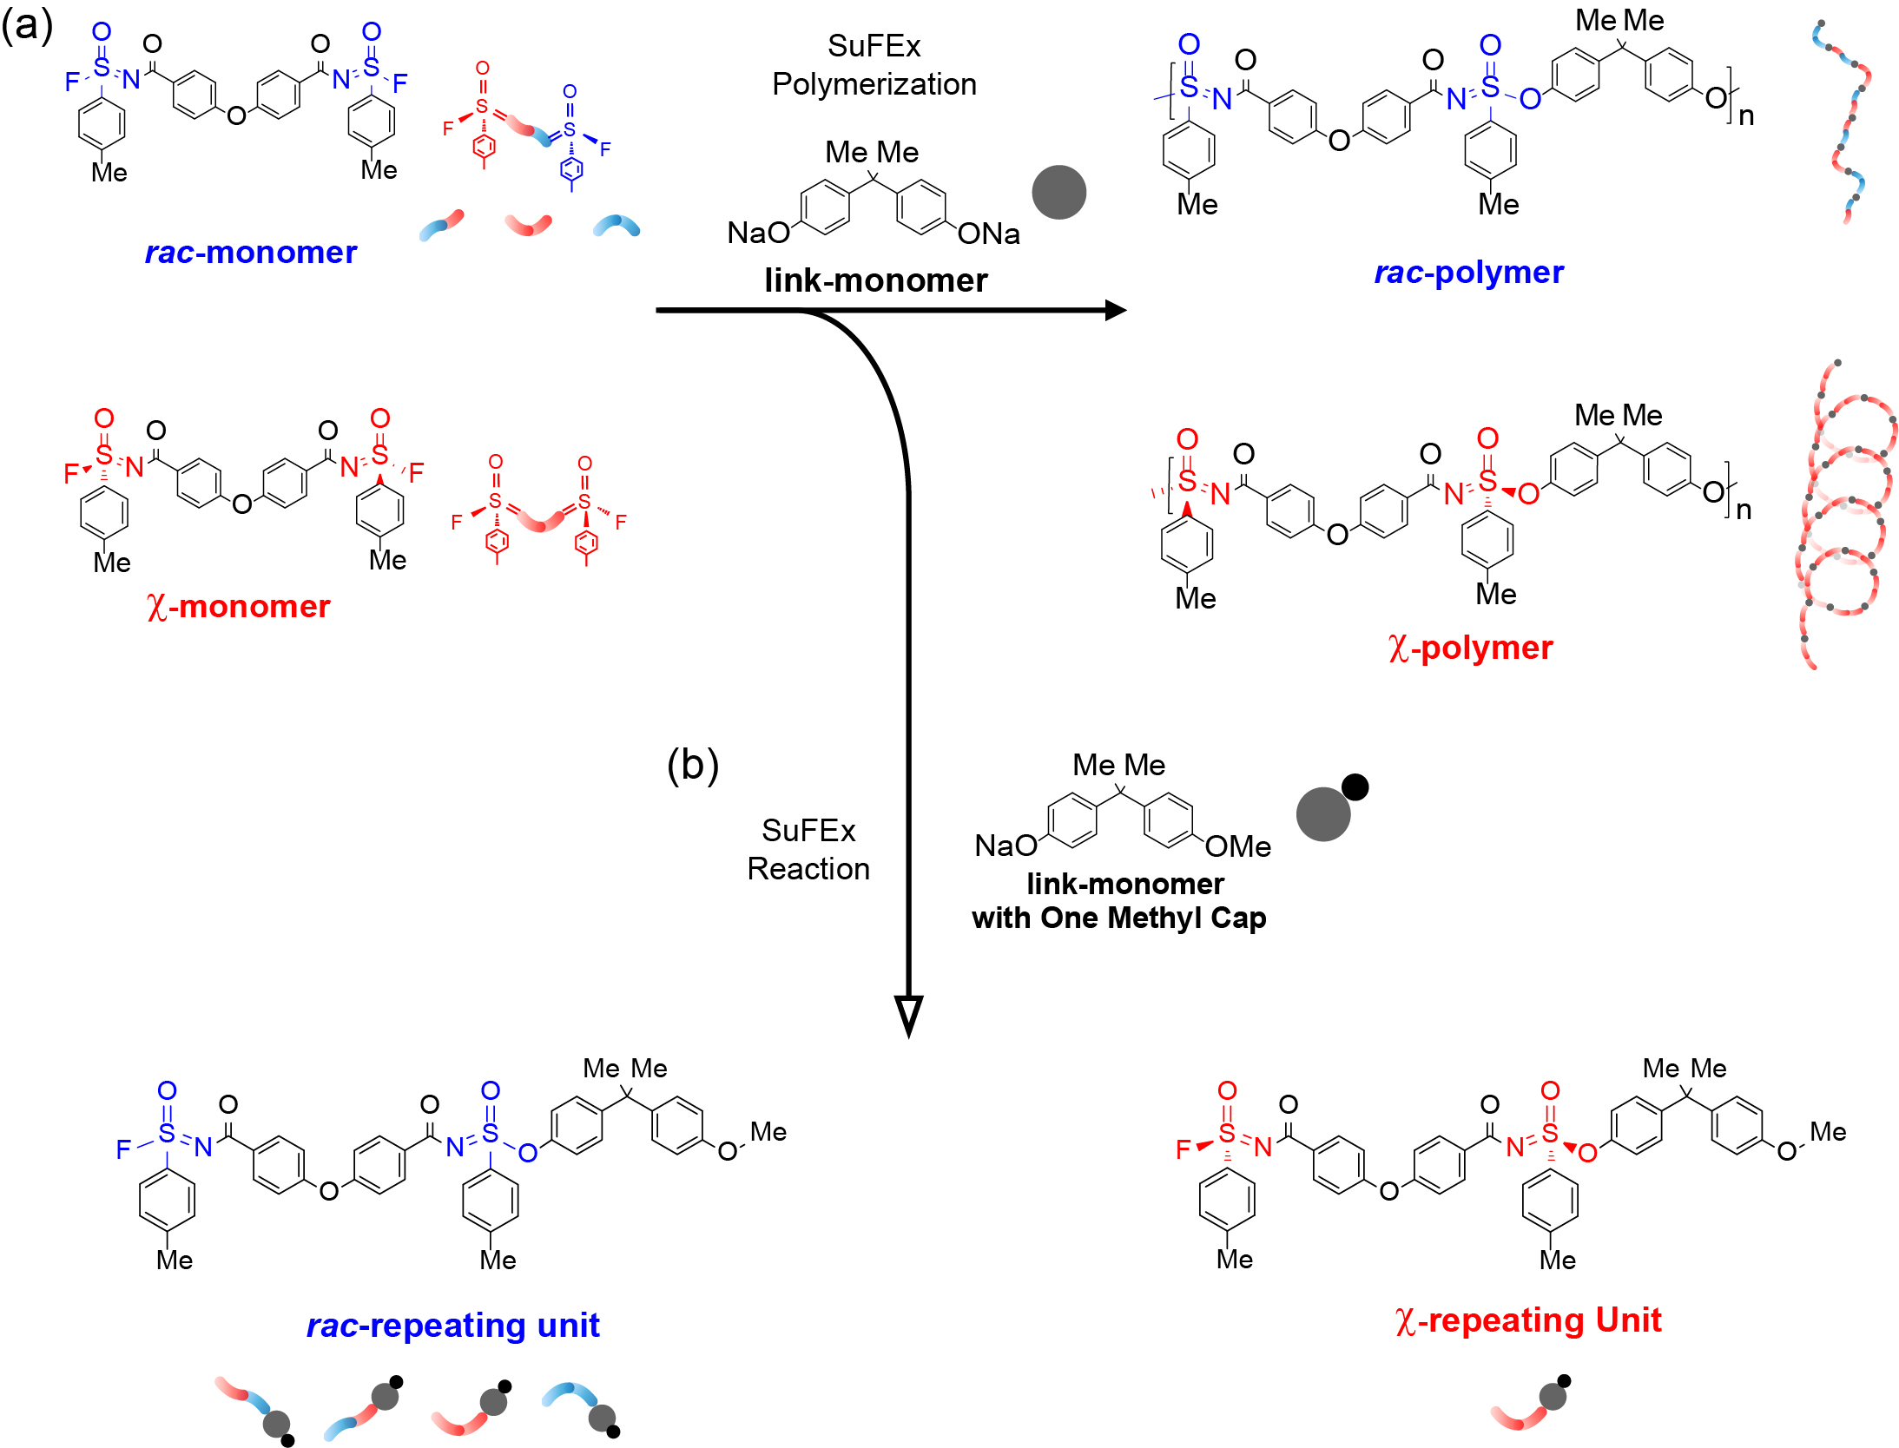
Supplementary Figure 1. Schematic Representation of the Reaction Pathways for the Synthesis of rac- or χ- Repeating units and Polymers via SuFEx Reaction. The chemical reaction scheme displays two reactions for the formation of polymers using rac- or χ- bis(iminosulfur oxydifluorides) (di-SFs) monomers. (a) Reaction 1 (top left to top right): SuFEx polymerization of rac- or χ-monomer with link-monomers bis(phenyl ethers) (di-phenolate), resulting in either rac- or χ-polymers, respectively. (b) Reaction 2 (top left to bottom): SuFEx reaction of rac- or χ-monomer with a link-monomer bearing a single methyl cap. This reaction leads to the formation of rac- or χ-repeating units.

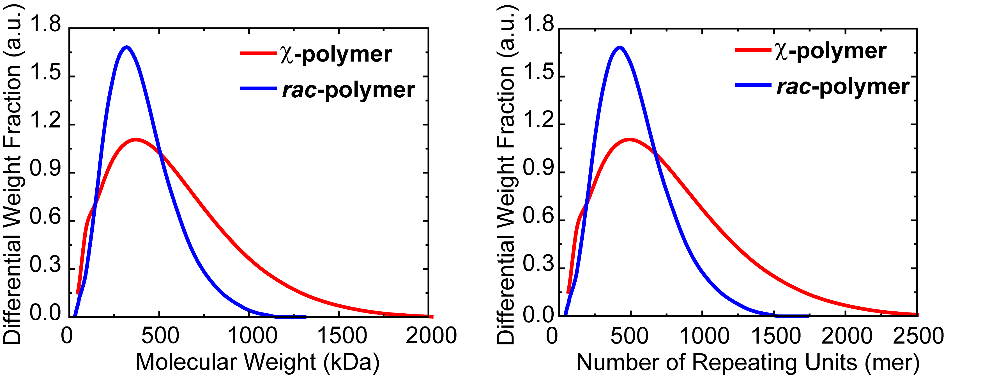
Supplementary Figure 2. GPC Chromatography of Polymers. Left: Differential Weight Fraction against Molecular Weight of χ- (Red Curve) and rac- (Blue Curve) polymers. Right: Differential weight fraction against number of repeating units.
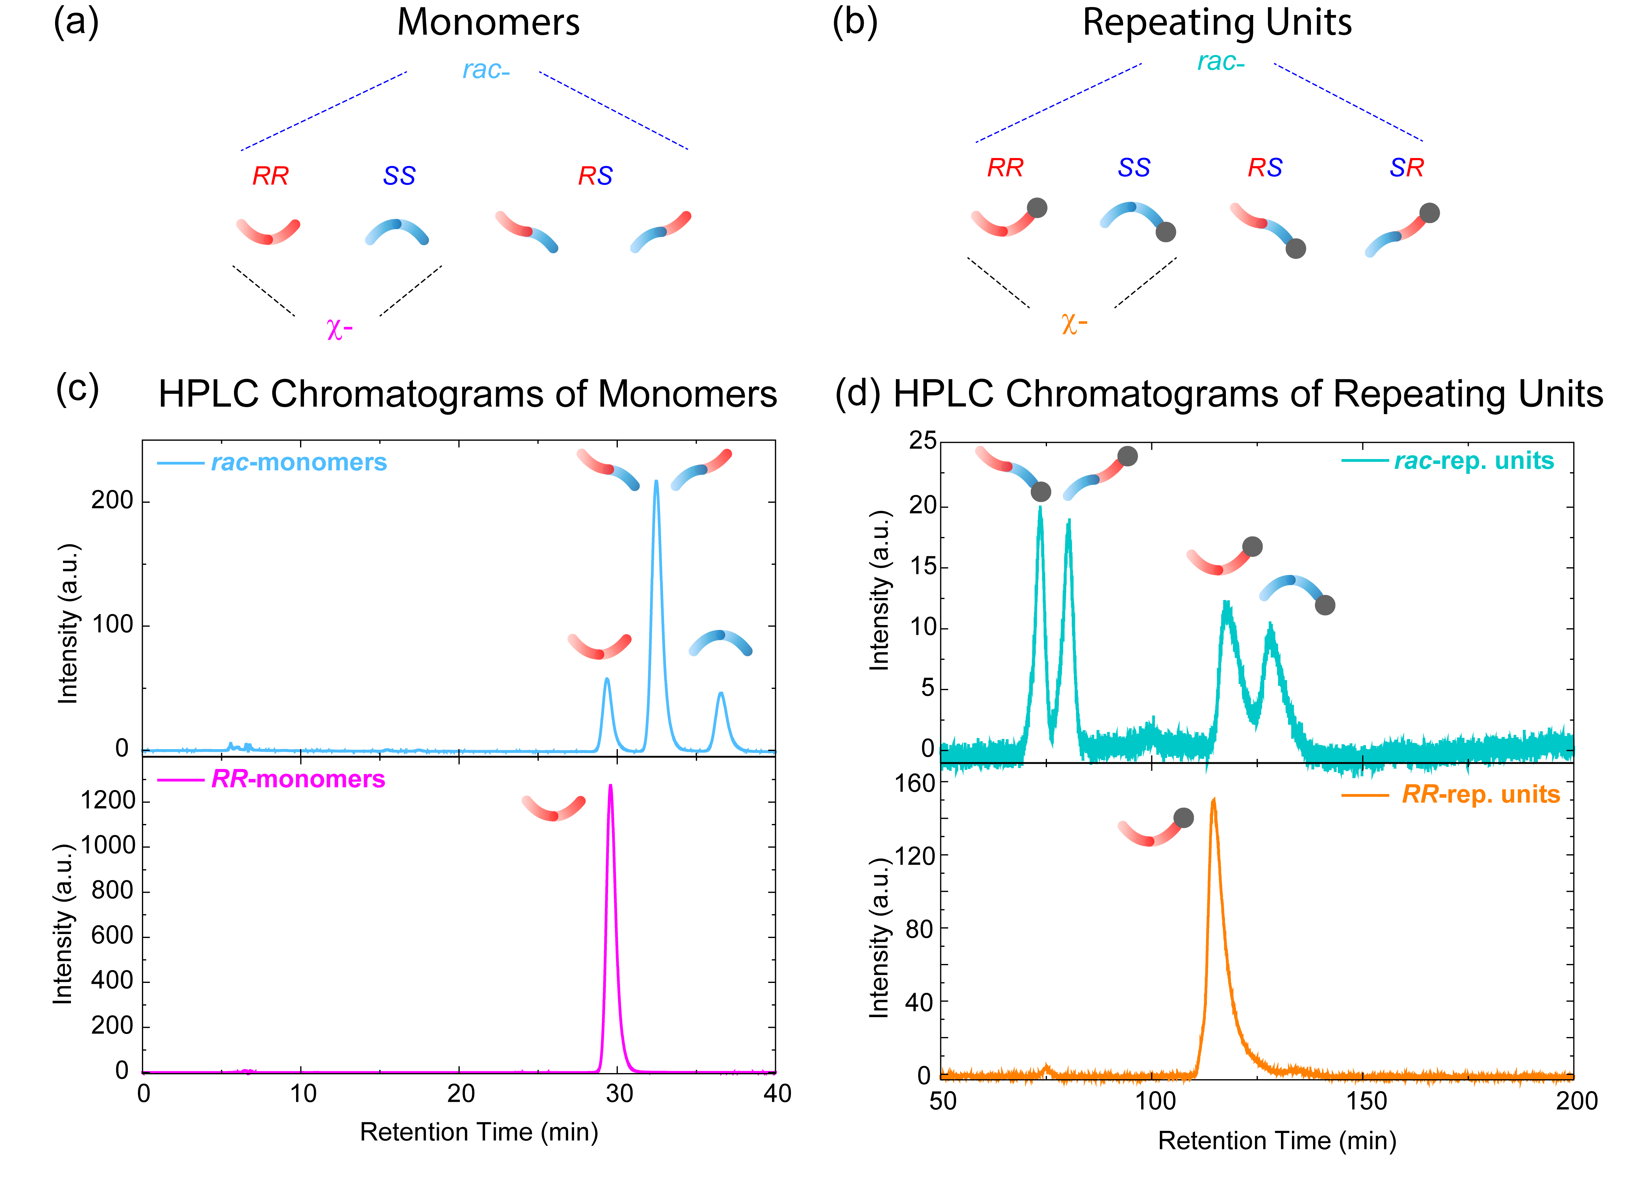
Supplementary Figure 3. HPLC Chromatography of Monomers and Repeating units. (a) schematic representations of monomers in different stereochemical forms: RR, RS, and SS.¹ (b) schematic representations of repeating units in different stereochemical forms: RR, SS, RS and SR. (c) HPLC trace for rac-monomers (Light Blue Curve, upper left), with three peaks corresponding to the RR, RS and SS configurations, and χ-monomers (Magenta Curve, bottom left) with RR Configuration. (d) HPLC trace for rac-rep. units (Green Blue Curve, top right), with four peaks corresponding to RS, SR, RR and SS configurations, and χ-repeating units (Orange Curve, bottom right) with RS configuration.¹
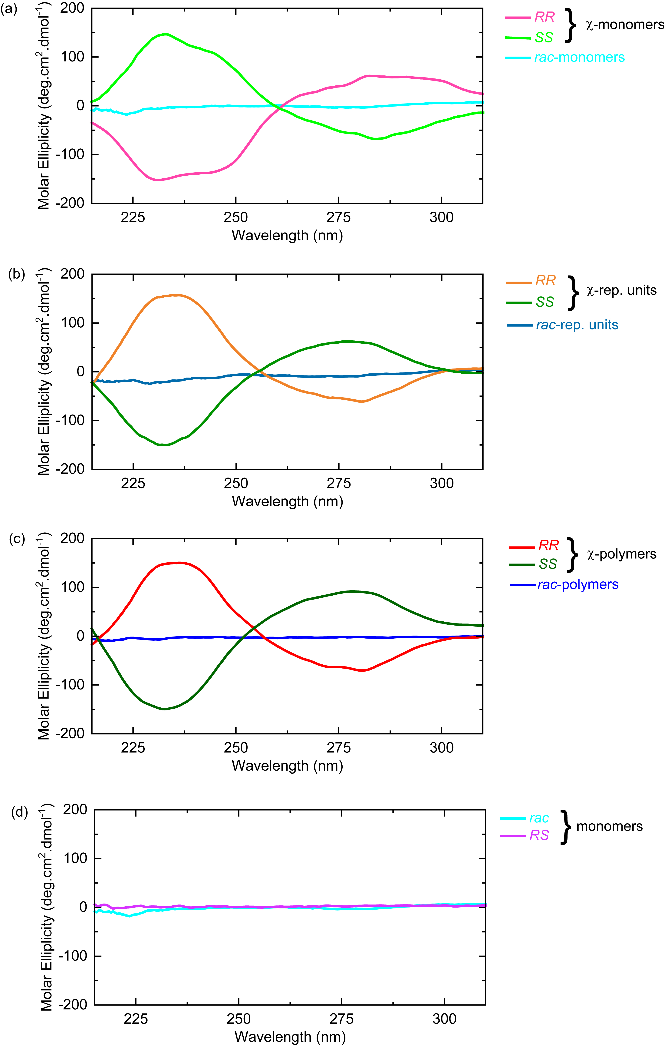
Supplementary Figure 4. CD spectra of monomers, repeating units and polymers. (a) Monomers: rac- (light blue), RR- (magenta) and SS- (light green). (b) Repeating units: rac- (green blue), RR- (orange) and SS- (green). (c) Polymers: rac- (blue), RR- (red) and SS- (dark green). (d) Monomers: rac- (light blue) and RS- (light purple).
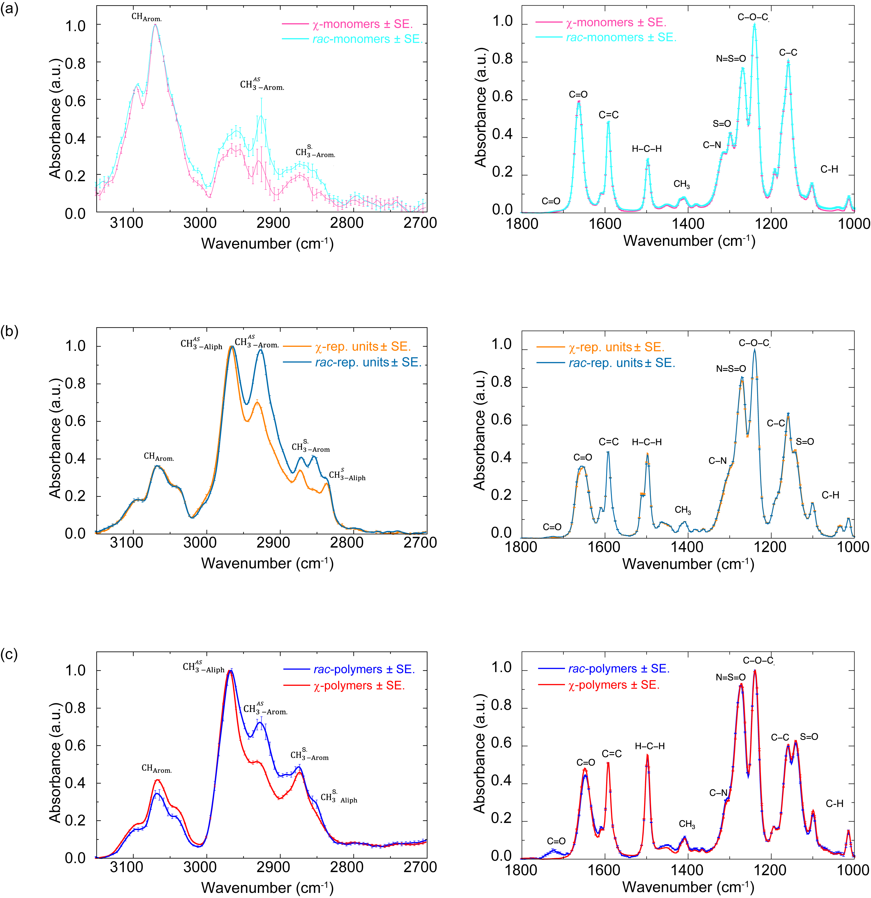
Supplementary Figure 5. IR spectra of monomers, repeating units, and polymers, with assignments. (a) Monomers: rac- (light blue, independent experiments N=5, replicates n=5) and χ- (magenta, N=5, n=5). (b) Repeating units: rac- (green blue, N=5, n=5) and χ- (orange, N=5, n=5). (c) Polymers: rac- (blue, N=6, n=10) and χ- (red, N=6, n=10).
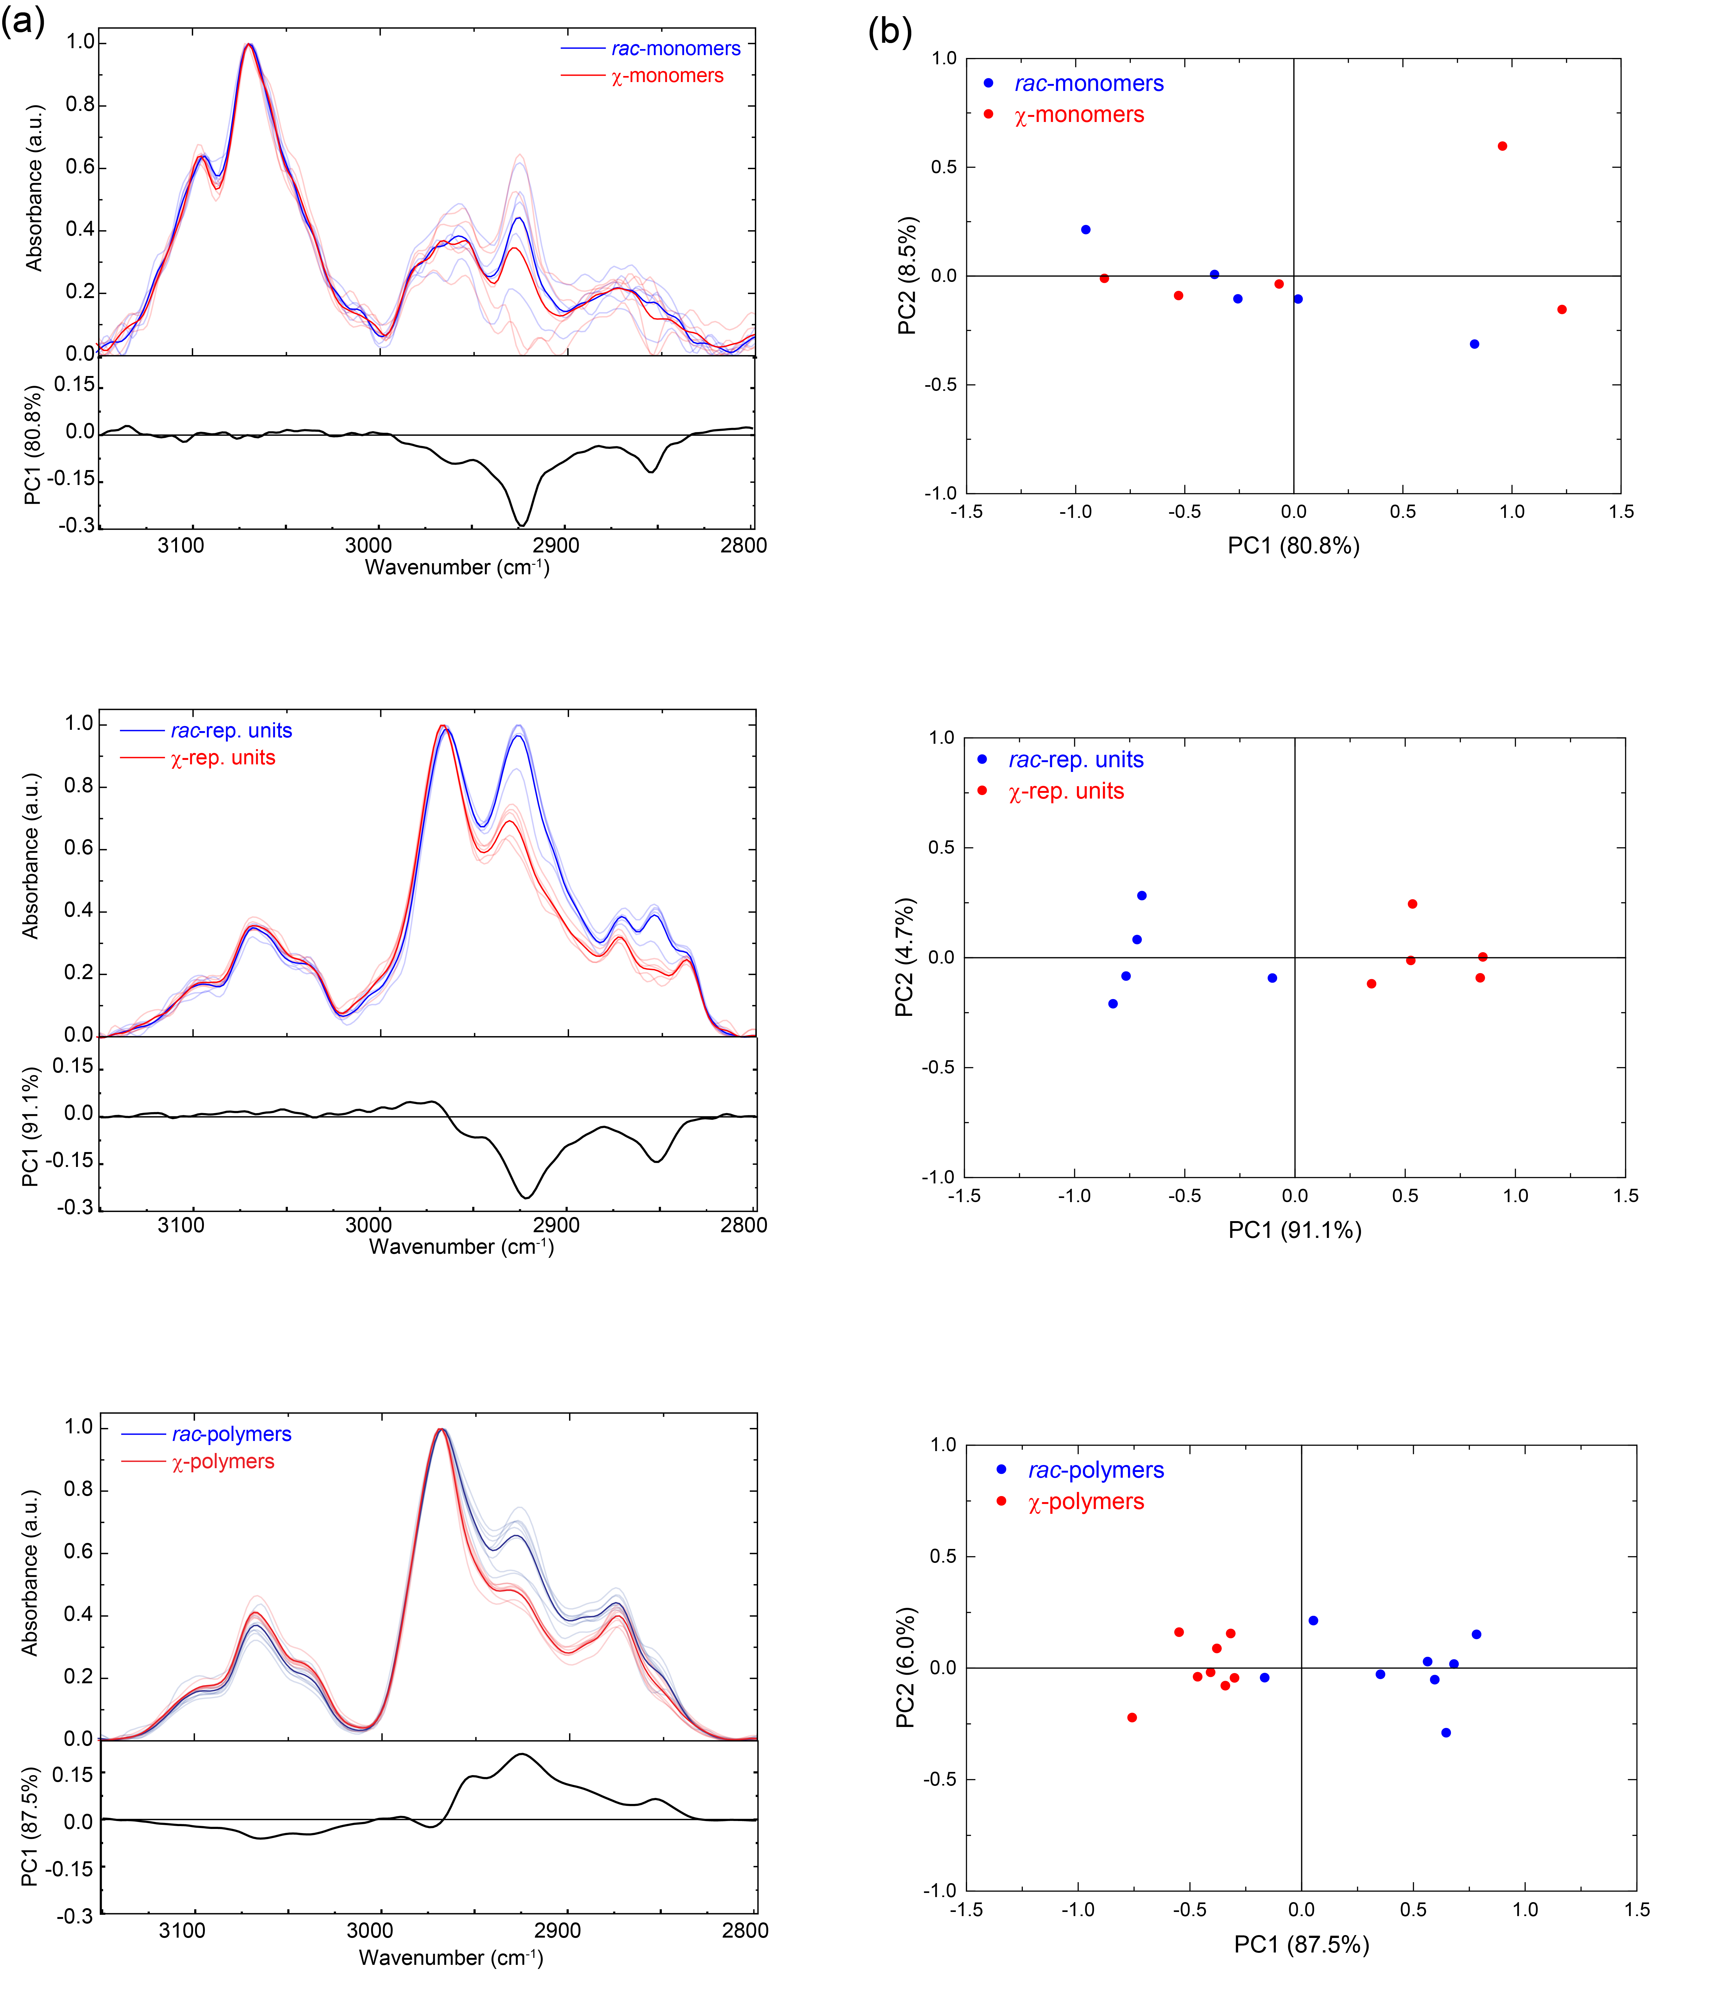
Supplementary Figure 6. Principle Component Analysis (PCA) of IR Spectra of Polymers in the methyl region. (a) IR Spectra and loading plots of PC1 in the range from 3150-2800 cm⁻¹: Five independent experiments, five replicates, each co-averaging 512 spectra for rac- (blue) and χ- (red) monomers and repeating units; Ten independent experiments, ten spectra, each co-averaging 512 spectra for rac- (blue) and χ- (red) polymers. (b) Score plots of PCA analysis applied to rac- (blue) and χ- (red) monomers, repeating units and polymers (independent experiments N=6, replicates n=10).
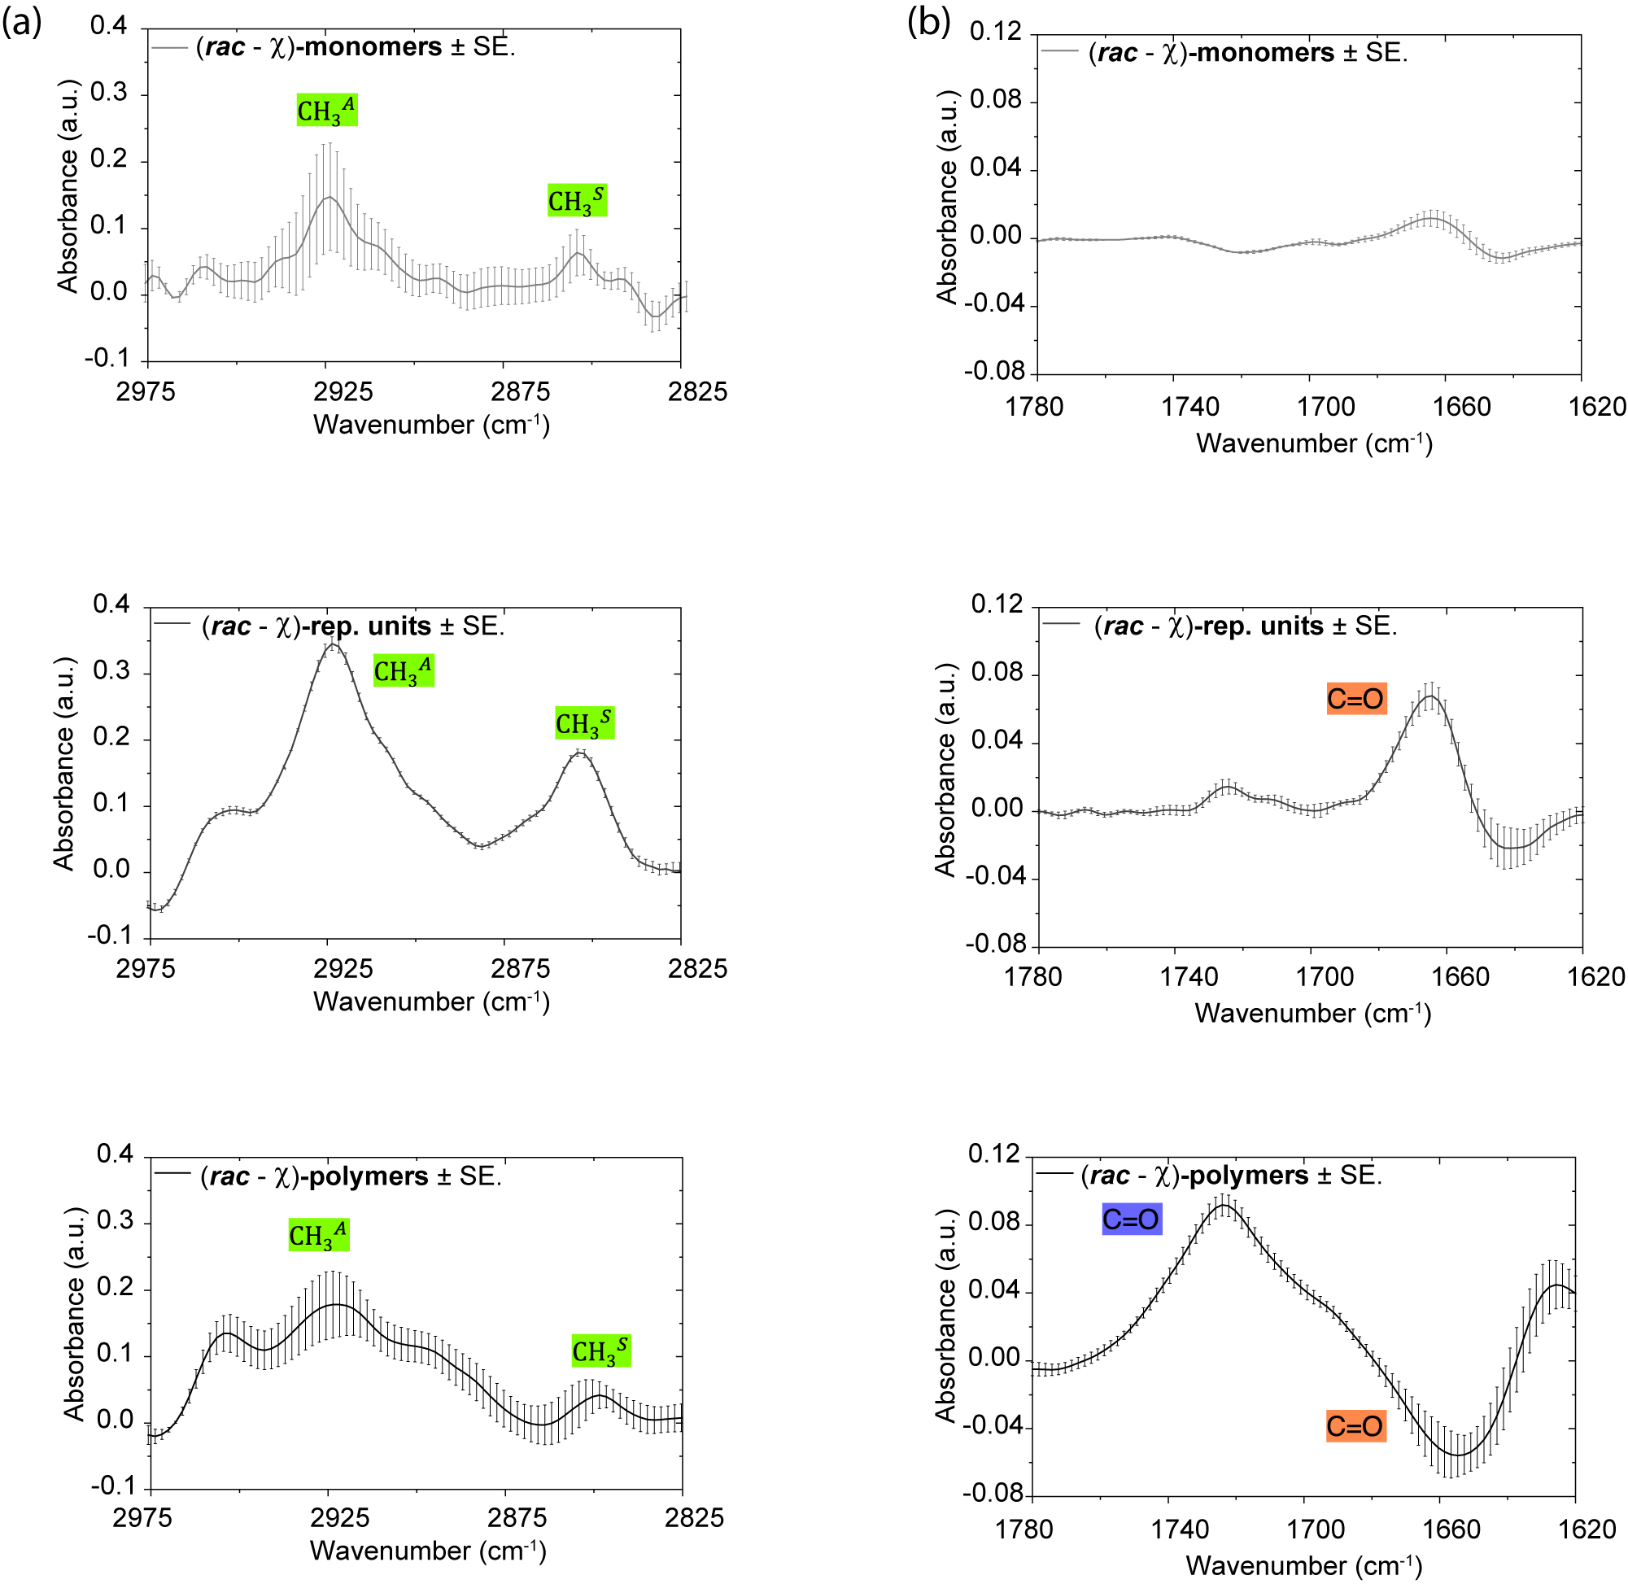
Supplementary Figure 7. Difference IR spectroscopy for the χ- vs. rac- polymers. (a) 2975-2825 cm⁻¹ and (b) 1780-1620 cm⁻¹ with assignments. (a) Top: (rac minus χ)-monomers; Middle: (rac minus χ)-repeating units; Bottom: (rac minus χ)-polymers. (b) Top: (rac minus χ)-monomers; Middle: (rac minus χ)-repeating units; Bottom: (rac minus χ)-polymers. All plotted as average ± SE.

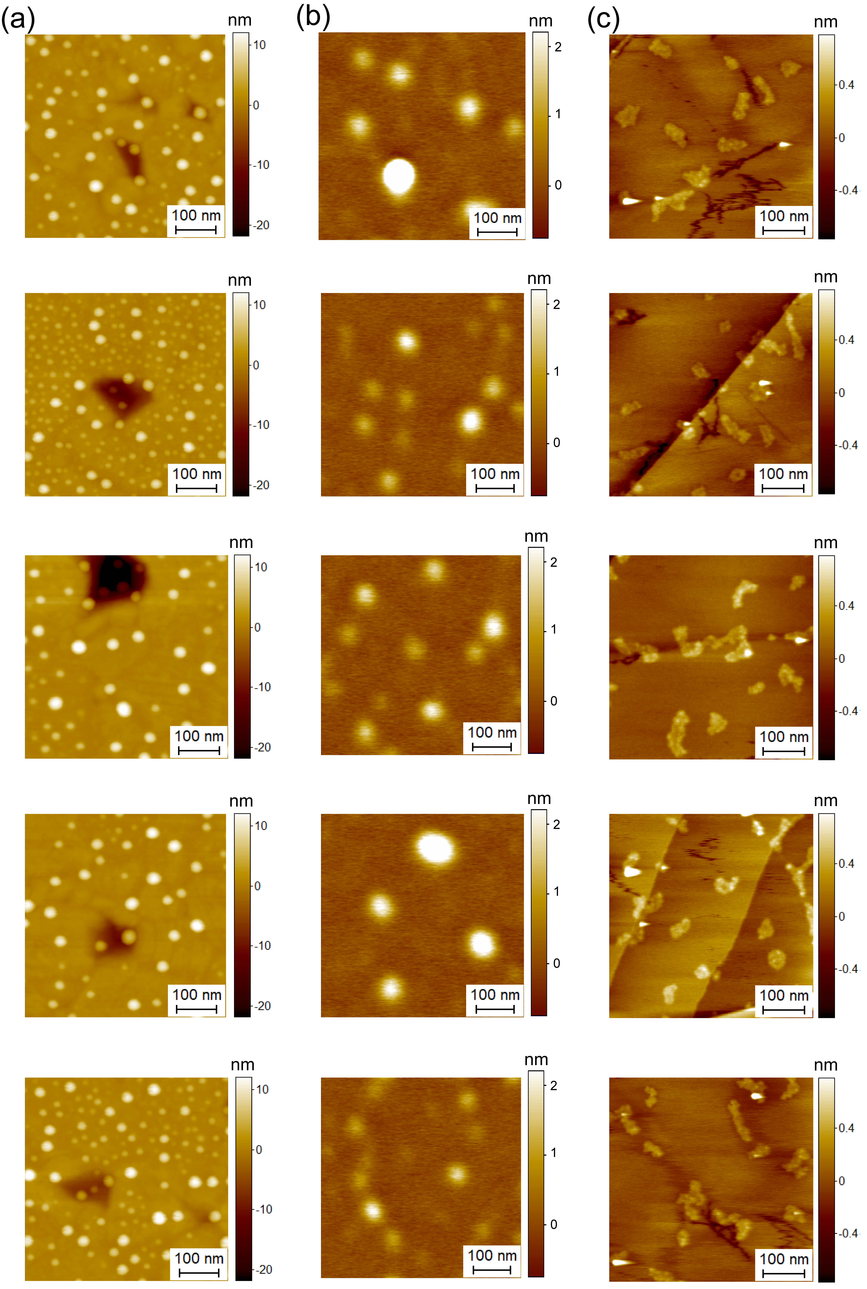
Supplementary Figure 8. Representative AFM Morphological Maps of χ-Polymers on Different Substrates at 2ug/mL concentration. (a) Positive charged gold. (b) Negative charged muscovite mica. (c) Hydrophobic Highly Ordered Pyrolytic Graphite (HOPG). Several areas were randomly imaged across the sample’s surface (n=5) to account for possible heterogeneity.
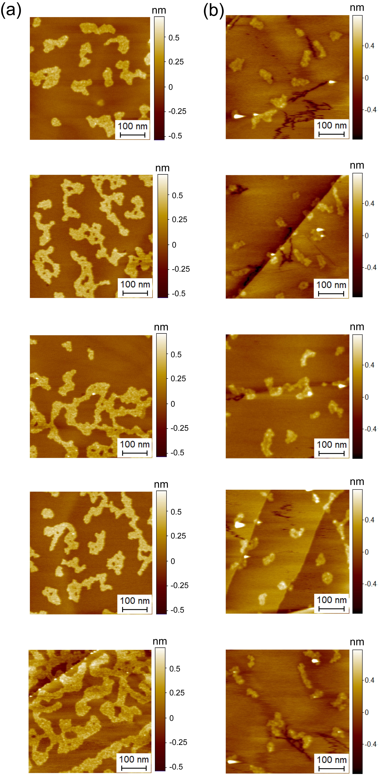
Supplementary Figure 9. Comparison of Representative AFM Morphological Maps at 2ug/mL concentration of (a) rac-polymers. (b) χ-polymers on HOPG.
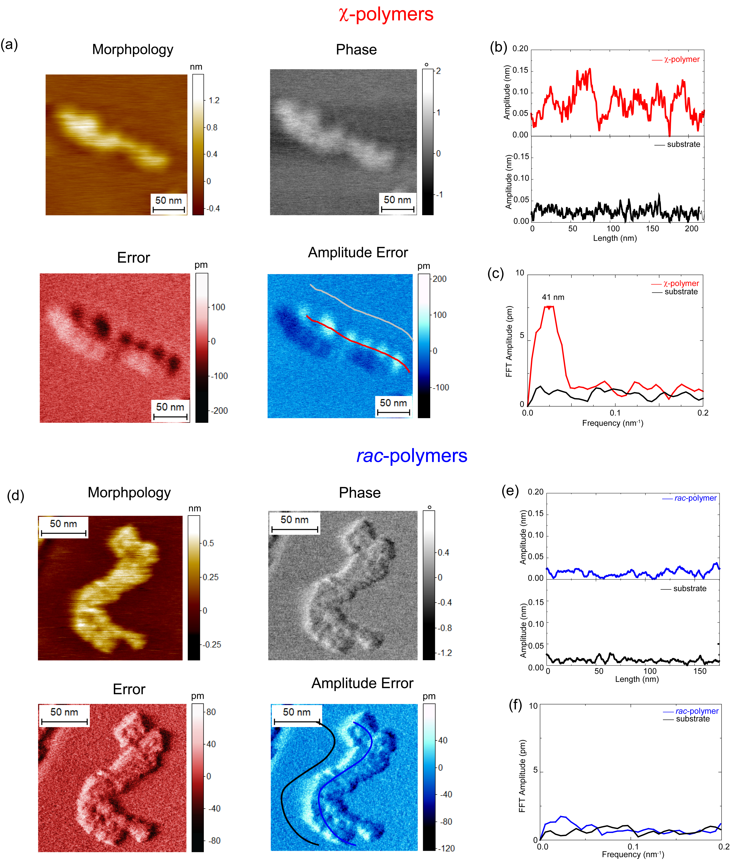
Supplementary Figure 10. Analysis of Helicity of Rac- and χ-polymers at Angstrom Resolution. AFM data channels of a representative (a) single χ-polymers chain and (b) cross-sectional profile of the single polymer chain(s) and substrate on the Amplitude Error channel. (c) FFT power spectrum of the line-profile of the single polymer chain(s) and substrate. (d) Rac-polymers chains at angstrom resolution. (e) Cross-sectional profile of the single polymer chain(s) and substrate on the Amplitude Error channel. (f) FFT power spectrum of the line-profile of the single polymer chain(s) and substrate.
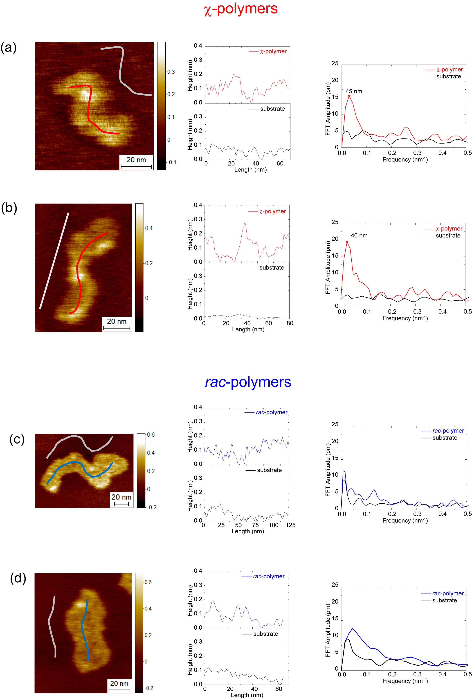
Supplementary Figure 11. Analysis of Periodicity of other rac- and χ-polymers on conventional AFM maps. (a)(b) Left: Morphological map of a representative single χ-polymer chain. Middle: Cross-sectional profile of the single polymer chain and substrate. Right: FFT power spectrum of the line-profile of the single polymer chain and substrate. (c)(d) Left: Morphological map of a representative single rac-polymer chains. Middle: Cross-sectional profile of the single rac-polymer chains and substrate. Right: FFT power spectrum of the line-profile of the single rac-polymer chains and substrate.
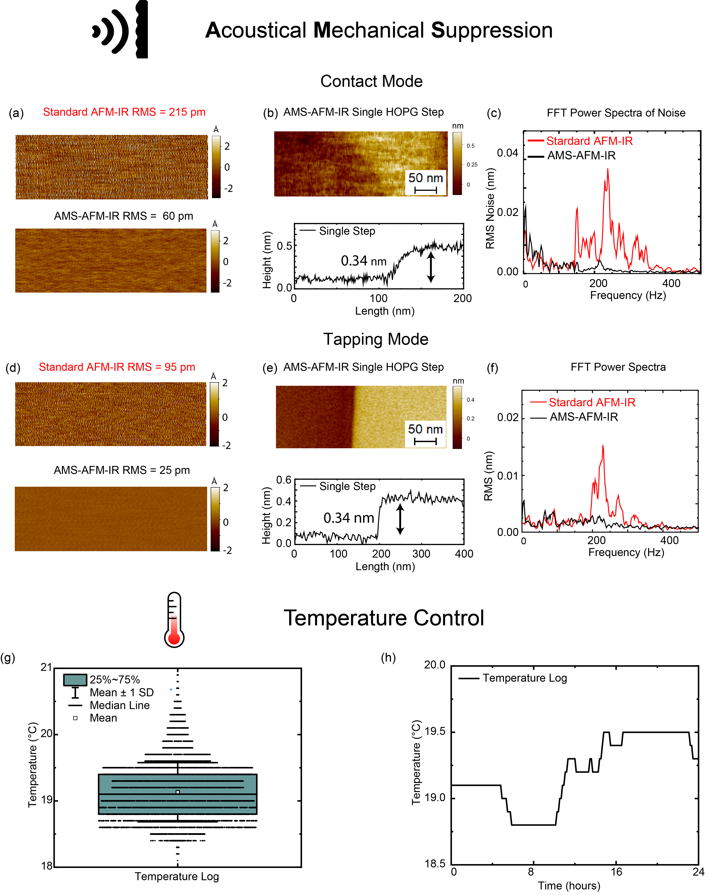
Supplementary Figure 12. AFM-IR Noise Level Comparison Before and After Acoustical Mechanical Suppression (AMS) and Temperature Stability of AFM-IR. (a) Morphological map of the bare HOPG substrate in contact mode, before and after AMS. (b) Morphological map of a single HOPG step and line profile of the step. (c) FFT power spectra of noise contribution before and after AMS. (d) Morphological map of the bare HOPG substrate in tapping mode, before and after AMS. (e) Morphological map of a single HOPG step and line profile of the step. (f) FFT power spectra of noise contribution before and after AMS. (g) Box plot showing the distribution of the temperature log, encapsulating the median, interquartile range (25th to 75th percentile), and mean with an indication of standard deviation (±0.5°C). (h) Typical temperature log upon 24 hours measurements.
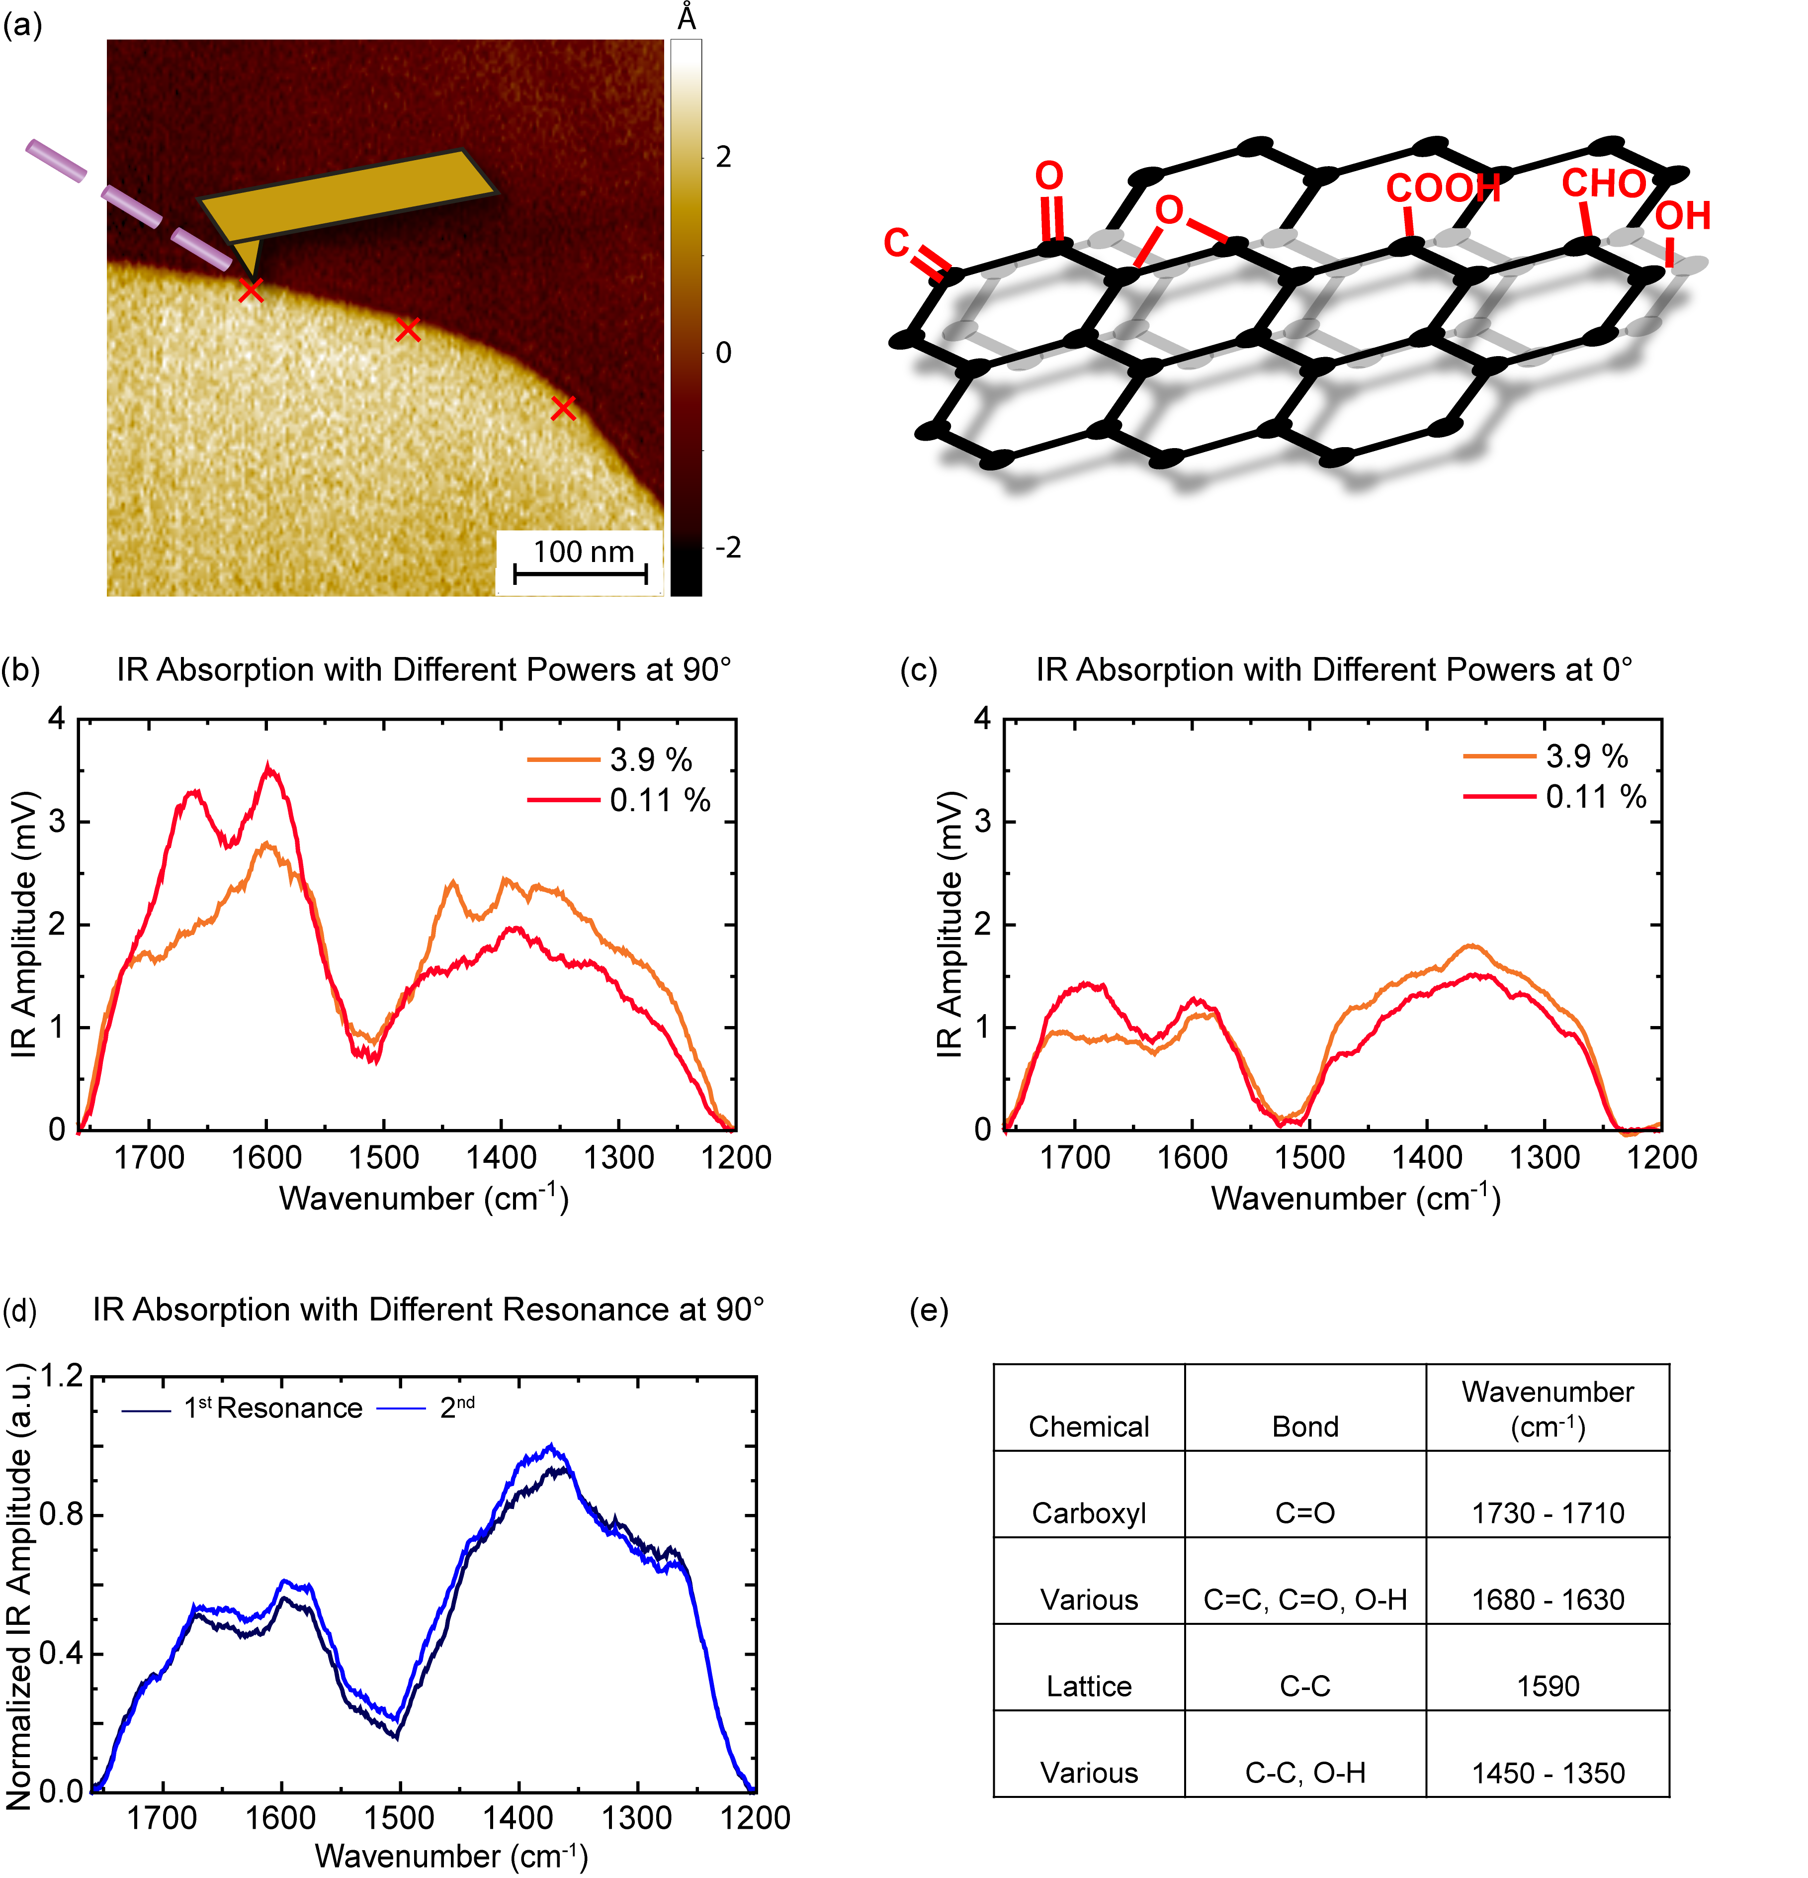
Supplementary Figure 13. Determination of Substrate IR Absorption in Contact Mode for HOPG. (a) Left: AFM map of a single atomical step. Right: Illustration of chemical environment around the step. (b) IR absorption of HOPG at the second resonance under perpendicular polarization with respect to the surface, for varying laser power levels. (c) IR absorption of HOPG at the second resonance under parallel polarization with respect to the surface, for varying laser power levels. (d) IR absorption of HOPG at 12.5% laser power under perpendicular polarization with respect to the surface, for different resonance frequencies. (e) Assignments of HOPG IR absorption peaks.

Supplementary Figure 14. AFM-IR Spectra of Different Assemblies and Spectra Analysis Procedure for rac-Polymers. (a-d) AFM-IR morphology, cross-sectional profile and spectra of different assemblies of rac-Polymers. (e) Spectra of all assemblies ranking from smallest (light blue) to largest (dark blue) height, n=18. (f) Unprocessed HOPG substrate spectra and representative polymer spectra. (g) Subtracted polymer spectra. (h) Mean of the ratioed spectra with standard error of the mean. (i) Smoothed spectra using a 15-point, 2nd order Savitzky-Golay filter. (j) Final normalized spectra within the range [0,1].
Supplementary References
1 Liang, D.-D., Pujari, S. P., Subramaniam, M., Besten, M. & Zuilhof, H. Configurationally Chiral SuFEx-Based Polymers. Angewandte Chemie International Edition 61, e202116158 (2022). https://doi.org:https://doi.org/10.1002/anie.202116158
2 Wang, H. F. et al. Generalizing the effects of chirality on block copolymer assembly. Proc Natl Acad Sci U S A 116, 4080-4089 (2019). https://doi.org:10.1073/pnas.1812356116
3 Bulheller, B. M., Rodger, A. & Hirst, J. D. Circular and linear dichroism of proteins. Phys Chem Chem Phys 9, 2020-2035 (2007). https://doi.org:10.1039/b615870f
4 Kane-Maguire, L. A. P. & Wallace, G. G. Chiral conducting polymers. CHEMICAL SOCIETY REVIEWS 39, 2545-2576 (2010). https://doi.org:10.1039/b908001p
5 Nakano, T. & Okamoto, Y. Synthetic helical polymers: Conformation and function. CHEMICAL REVIEWS 101, 4013-4038 (2001). https://doi.org:10.1021/cr0000978
6 Pop, F., Zigon, N. & Avarvari, N. Main-Group-Based Electro- and Photoactive Chiral Materials. Chemical Reviews 119, 8435-8478 (2019). https://doi.org:10.1021/acs.chemrev.8b00770
7 Zhang, L., Wang, H.-X., Li, S. & Liu, M. Supramolecular chiroptical switches. Chemical Society Reviews 49, 9095-9120 (2020). https://doi.org:10.1039/D0CS00191K
8 Ernst, K.-H. Molecular chirality at surfaces. physica status solidi (b) 249, 2057-2088 (2012). https://doi.org:https://doi.org/10.1002/pssb.201248188
9 Barth, A. Infrared spectroscopy of proteins. Biochim. Biophys. Acta 1767, 1073-1101 (2007). https://doi.org:10.1016/j.bbabio.2007.06.004
10 Leigh, T. & Fernandez-Trillo, P. Helical polymers for biological and medical applications. Nature Reviews Chemistry 4, 291-310 (2020). https://doi.org:10.1038/s41570-020-0180-5
11 Osman, Z. & Arof, A. K. FTIR studies of chitosan acetate based polymer electrolytes. Electrochimica Acta 48, 993-999 (2003). https://doi.org:https://doi.org/10.1016/S0013-4686(02)00812-5
12 Aoi, K., Nakamura, R. & Okada, M. Polypeptide-synthetic polymer hybrids, 2. Miscibility of poly(vinyl alcohol) with polysarcosine. Macromolecular Chemistry and Physics 201, 1059-1066 (2000). https://doi.org:https://doi.org/10.1002/1521-3935(20000701)201:11<1059::AID-MACP1059>3.0.CO;2-O
13 Wu, L. C. et al. A charge density study of π-delocalization and intermolecular interactions. Physical Chemistry Chemical Physics 17, 14177-14184 (2015). https://doi.org:10.1039/C5CP01575H
14 Hirata, S., Shigeta, Y., Xantheas, S. S. & Bartlett, R. J. Helical Organic and Inorganic Polymers. The Journal of Physical Chemistry B 127, 3556-3583 (2023). https://doi.org:10.1021/acs.jpcb.3c00620
15 Rohmer, M., Freudenberg, J. & Binder, W. H. Secondary Structures in Synthetic Poly(Amino Acids): Homo- and Copolymers of Poly(Aib), Poly(Glu), and Poly(Asp). Macromolecular Bioscience 23, 2200344 (2023). https://doi.org:https://doi.org/10.1002/mabi.202200344
16 Mondal, S. I., Sen, S., Hazra, A. & Patwari, G. N. π-Stacked Dimers of Fluorophenylacetylenes: Role of Dipole Moment. The Journal of Physical Chemistry A 121, 3383-3391 (2017). https://doi.org:10.1021/acs.jpca.7b00209
17 Ruggeri, F. S. et al. Nanoscale studies link amyloid maturity with polyglutamine diseases onset. Sci Rep 6, 31155 (2016). https://doi.org:10.1038/srep31155
18 Ruggeri, F. S., Sneideris, T., Vendruscolo, M. & Knowles, T. P. J. Atomic force microscopy for single molecule characterisation of protein aggregation. Arch Biochem Biophys 664, 134-148 (2019). https://doi.org:10.1016/j.abb.2019.02.001
19 Liang, D.-D. et al. Silicon-Free SuFEx Reactions of Sulfonimidoyl Fluorides: Scope, Enantioselectivity, and Mechanism. Angewandte Chemie International Edition 59, 7494-7500 (2020). https://doi.org:https://doi.org/10.1002/anie.201915519

