Additional files
Table S1. PCR primers used for detecting indel mutation loci of five goat MMAF-related genes
Genes | Primers | Sequences (5′-3′) | loci | Length (bp)
QRICH2 | P1 | F: TCCGTACCTTGTTCAGGTTGC  R: TGTGGACAGAATCTAGGGAGCT | upstream variant | 117
 | P2 | F: GACATTGCCTCTGAGACTTCC  R: CACATCCCCTACCACTCATCT | intron variant | 130
 | P3 | F: GGGCTCCCACTCCACAGG  R: CTGCTGCCCAGCTTCAGG | intron variant | 100
 | P4 | F: TATGTACCCACAATGCTTTGCA  R: GCACTGGTTTCTGGCTCCTG | intron variant | 149/138
CFAP43 | P1 | F: TCAAGGACTGAAAACAAGCAT  R: ACTCCCATCTCCAAAATGACT | upstream variant | 250
 | P2 | F: TAATTTTAAAGGTAAGGCCCAGA  R: TTTCCAGTGAAGCACAACCTC | intron variant | 156
 | P3 | F: ATGGCTAAAAGATGAGGACGG  R: GGAAAGGGCATACCAAAATAAA | intron variant | 219
 | P4 | F: TGTTAAGACCATTTTCCACCCT  R: GAGAAGCTCCCATAGAAGCACA | intron variant | 255
 | P5 | F: CTGAGCCACCAGGGAAGATTT  R: GGCGGTGTAGTTCATACAGAAAA | intron variant | 278
 | P6 | F: ACAAGCGAAGGAATTTGGTGA  R: TGTGGTCAATGATCCTGCTGA | upstream variant | 176
 | P7 | F: CAGTATCATTTTGACAACTCCCTT  R: GTTTTAAGACCCAGCAATCCAC | upstream variant | 189
CFAP69 | P1 | F: TAGAAGGGAATTTCCTTAATCT  R: TGTCACTGTTCCAGAAGTTTTA | 3' UTR | 111
 | P2 | F: TAAAATTCAACACCCATTCAAGA  R: TACCTAACATATTTGTTGGCAGC | 3' UTR | 121
 | P3 | F: TGTCCTGCGTTCGTTTGCT  R: TTTCGCCTGTCACCTGCTT | 3' UTR | 112
 | P4 | F: GAAAGTAGTCTTGTCCATCACTC  R: ATATGAGGAACAGTAGATGCTCT | intron variant | 134/126
 | P5 | F: TATTGTTCAATTTGACAAACGTC  R: CAGTGGGTTGCCTAGATGC | intron variant | 128
 | P6 | F: TGGGTGTAGGGAGGAGGAAG  R: CCATGGGGTCACTCAAAGAG | intron variant | 96/90
 | P7 | F: GGTATAGTCCCCAGCCTGAAT  R: GGGGAAGGACATGGAAGTATT | intron variant | 154/146
CCDC39 | P1 | F: AGGCGAGAATACTGGAGTGG  R: GGTTCCTTCGGAGAAGTCAAT | upstream variant | 190
 | P2 | F: TATAGGATCAGTAGGCAACAAA  R: TGACCACATATCCAATAAAGAG | intron variant | 150
 | P3 | F: ATCACTTCCCTCTATTTCAGAAC  R: CAGGGAGAAATAACAAAACACTA | intron variant | 186
 | P4 | F: ATGTTATGCAAGAAAATTCACC  R: GCATTGAACACTTGGATCATTT | downstream variant | 139
DNAH1 | P1 | F: GGTGCTGGCTGACTGTGCTT  R: TGCCTACTGCCTCTTGGTACTCT | intron variant | 145/118
 | P2 | F: GAAAGTGGGTGATGCTCTGGGA  R: TCATGGCATAATCCGGAACCAT | intron variant | 111
 | P3 | F: GGGACTTGCTGACGAGACAA  R: GGTGGTACAAGACAGGGTTGG | intron variant | 128
 | P4 | F: GGCAGGGCTTGGCAGTAAG  R: CCTCCCAGTTGGTCTCGTAGAG | intron variant | 241
 | P5 | F: GAGGAGAAGGTGCCCAAGC  R: CAGGGAGGTCCCAGAGGAA | intron variant | 101
 | P6 | F: GCCCTGACCAAGCCTGAACT  R: CAGAAGGGTGGGTGGGTAGA | intron variant | 102
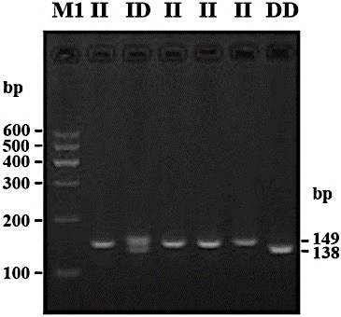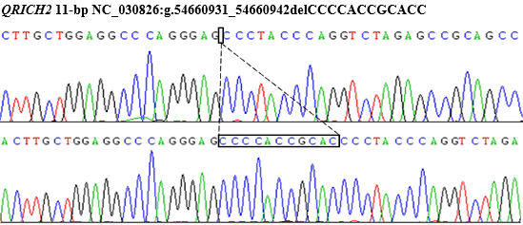
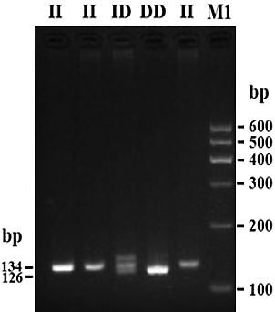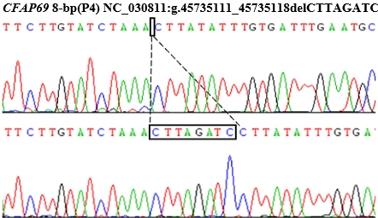
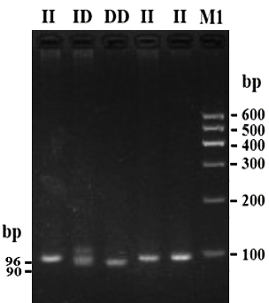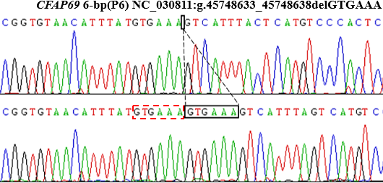
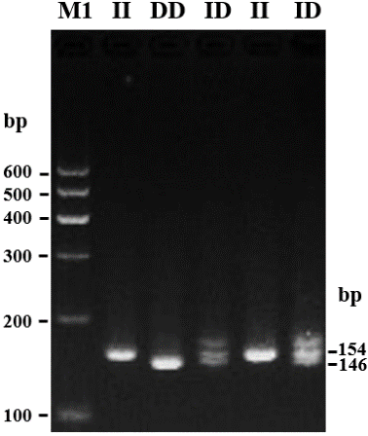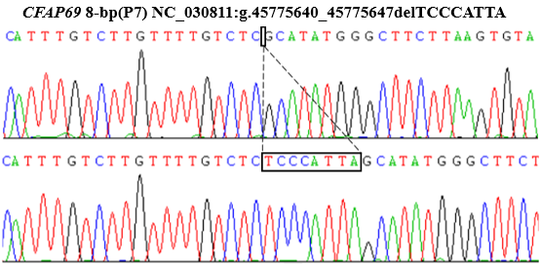
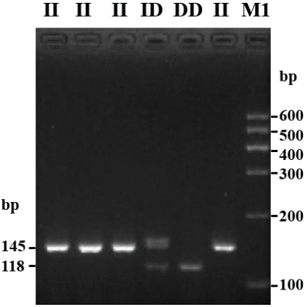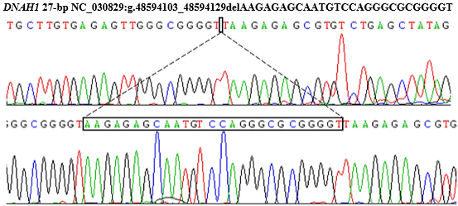
Figure S1 Electrophoresis and sequence diagrams of five indel loci of MMAF-related genes, including QRICH2 (P4), CFAP69 (P4, P6, P7) and DNAH1 (P1) in Shaanbei white cashmere goat.
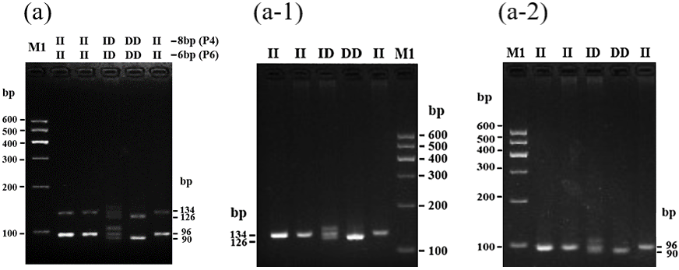
Figure S2 Electrophoresis pattern of two indel mutations within CFAP69 gene by using multiplex PCR and conventional PCR. Electrophoresis pattern of P4 and P6 indel loci in CFAP69 by multiplex PCR (a); electrophoresis pattern of P4 (a-1) and P6 (a-2) indel loc

