Table 1: Binding Energies/Docking Scores of 3-diazo-1-methyl-1, 3-dihydro-indol-2-one and standard drug (Ibuprofen) against some Inflammatory Mediators

Targets | 3-diazo-1-methyl-1,3-dihydro-indol-2-one | Standard Drug  (Ibuprofen)
COX-2 | -7.5 | -6.8
TNF-α | -5.9 | -5.7
NMDA receptor | -5.8 | -5.6
PGE-Synthase | -4.9 | -5.2
IL-1β | -5.3 | -6.1

Table 2: 2D views of 3-diazo-1-methyl-1, 3-dihydro-indol-2-one and standard drug (Ibuprofen) against some Inflammatory Mediators
Targets | 3-diazo-1-methyl-1,3-dihydro-indol-2-one | Standard Drug  (Ibuprofen)
COX-2  (Active site AAs: Arg 120, Glu 524, Lys 83, Ser 119) | 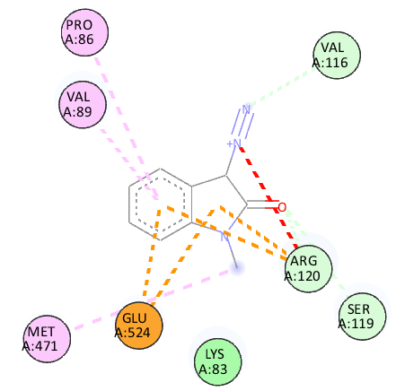 | 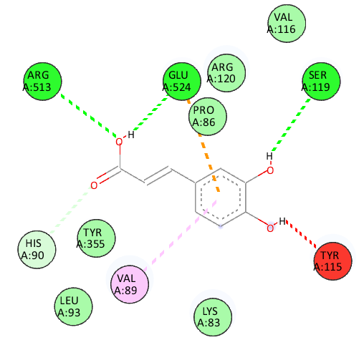
TNF-alpha  (Active site AAs: Tyr 59, Tyr 119, Tyr 151, Leu 57) | 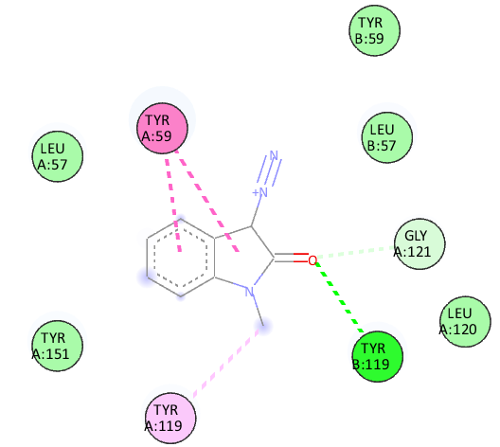 | 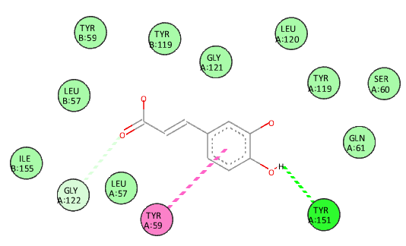
NMDA receptor (Active site AAs: Asp 364, Lys 179, Asn 362, Ala 175 and Lys 178 | 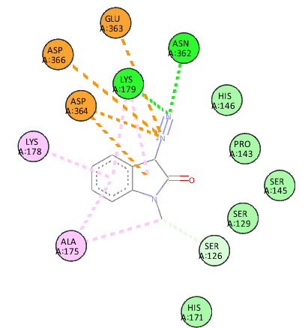 | 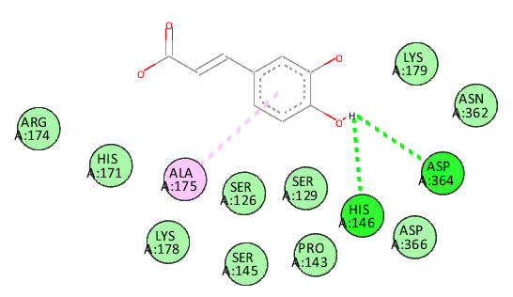
PGE-Synthase | 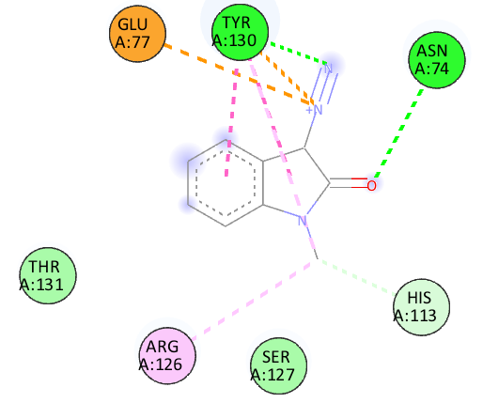 | 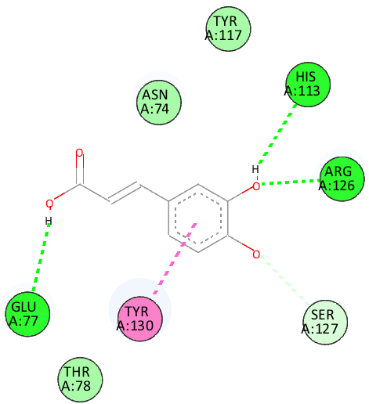
IL-1 beta | 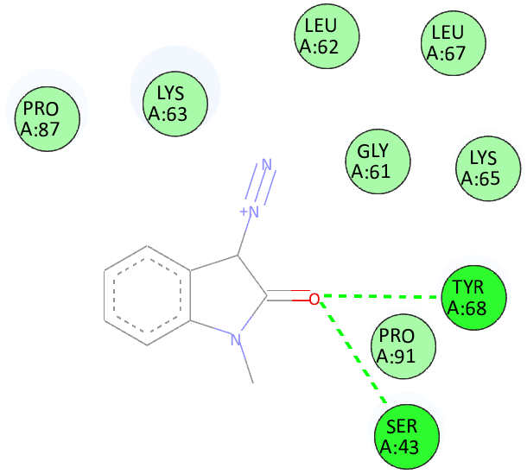 | 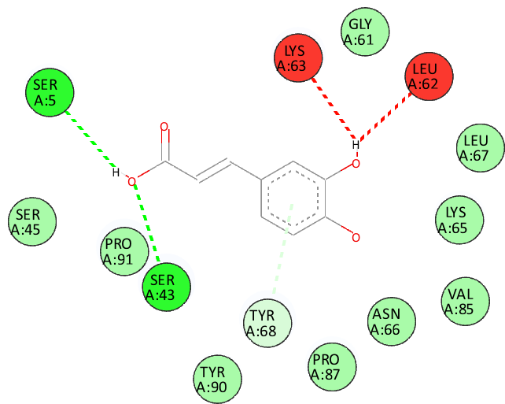
 | 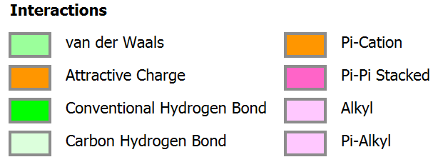

Table 3: 3D views of 3-diazo-1-methyl-1, 3-dihydro-indol-2-one and standard drug (Ibuprofen) against some Inflammatory Mediators
Targets | 3-diazo-1-methyl-1,3-dihydro-indol-2-one | Standard Drug  (Ibuprofen)
COX-2 | 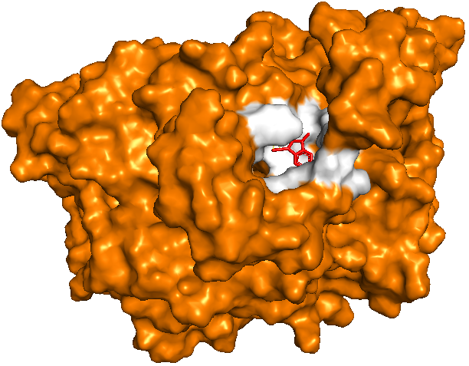 | 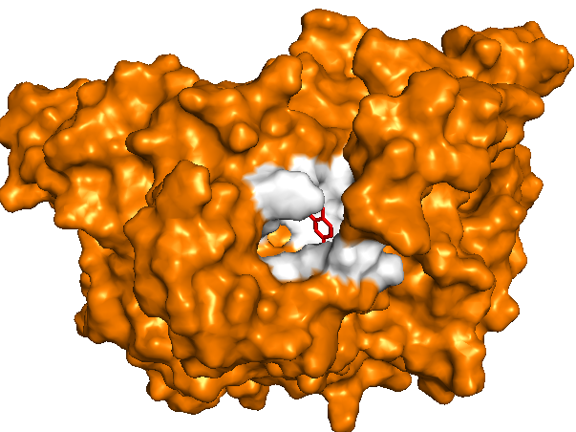
TNF-alpha | 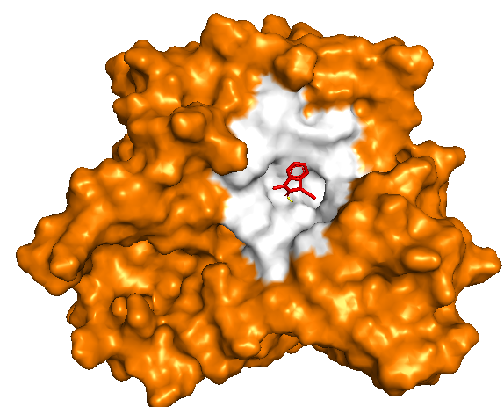 | 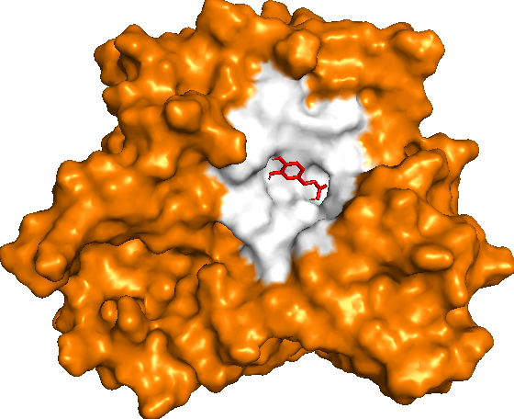
NMDA receptor | 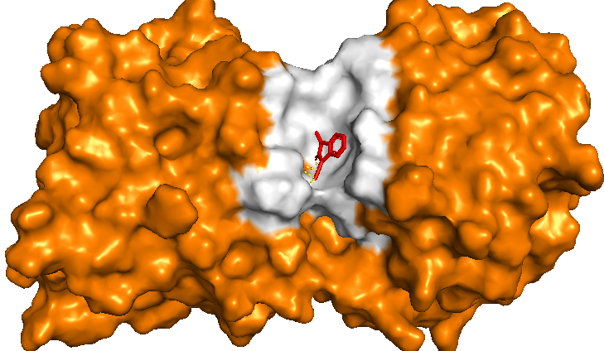 | 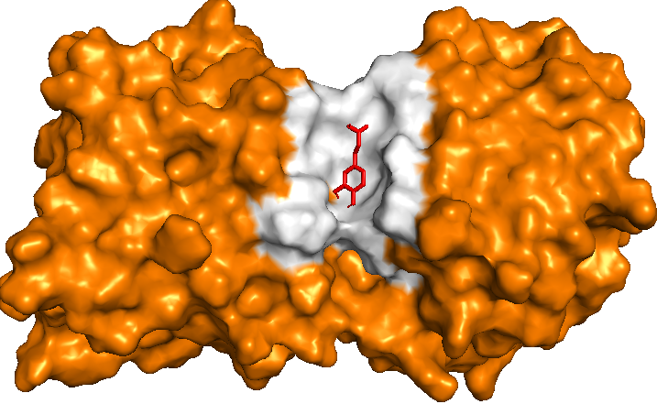
PGE-Synthase | 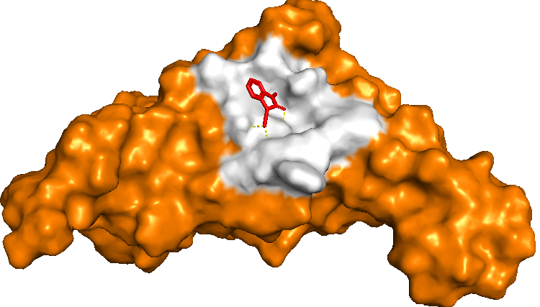 | 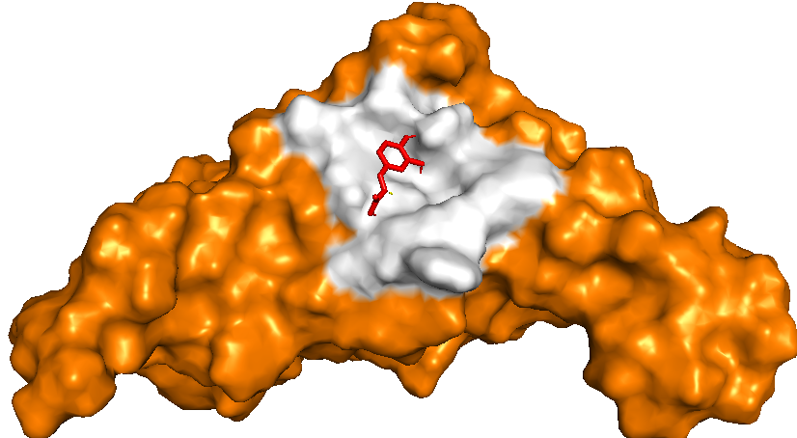
IL-1 beta | 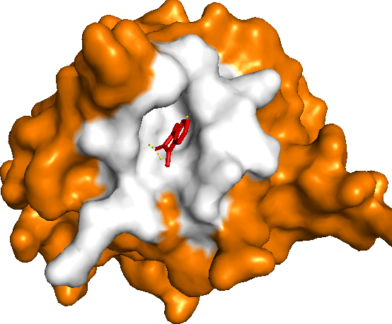 | 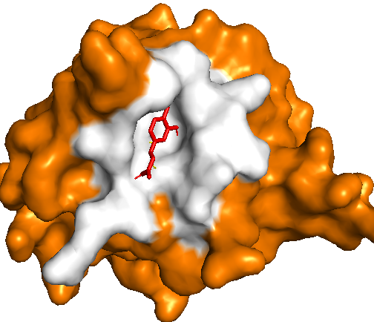

Table 4: Pharmacokinetic and Drug likeness properties (ADMET) of Studied compounds of 3-diazo-1-methyl-1, 3-dihydro-indol-2-one and standard drug (Ibuprofen).

Parameters | 3-diazo-1-methyl-1,3-dihydro-indol-2-one | Ibuprofen
Phytochemical Properties
Molecular formular | C9H7N3O | C13H18O2
Molecular weight(g/mol) | 173.17 | 206.28
Num. H-Bond acceptor | 3 | 2
Num. H-Bond donor | 0 | 1
Molar refractivity | 48.08 | 62.18
Lipophilicity CLogP_{o/w}value | 1.35 | 3.00
Water solubility | Soluble | Soluble
Druglikeness
Obeys Lipinski rule? | Yes, 0-violation | Yes, 0-violation
Verber violations | Yes | Yes
Bioavailability score | 0.85 | 0.85
Pharmacokinetics
GI absorption | High | High
BBB permeant | yes | Yes
P – gp substrate | No | No
CYP1A2 inhibitor | Yes | No
CYP2C19 inhibitor | No | No
CYP2A9 inhibitor | No | No
CYP2A6 inhibitor | No | No
CYP3A4 inhibitor | No | No
Log K_{p} (cm/s)(skin permeation) | -5.09 | -5.07

