Supplementary materials
Supplementary table S1. List of antibodies used in immunocytochemistry
Type | Antibody | Origin | Manufacturer | Cat. No. | Dilution | Fixation
Primary | aSMA | mouse | Sigma | A5228 | 1:300 | FA/MeOH
Primary | CD13 | mouse | Santa Cruz | sc-166105 | 1:200 | FA
Primary | PDGFRa&b | rabbit | Abcam | ab32570 | 1:100-125 | FA/MeOH
Primary | VE-cadherin | mouse | Santa Cruz | sc-9989 | 1:100 | MeOH
Secondary | anti-mouse 488 | goat | Invitrogen | A11001 | 1:300
 | anti-rabbit 568 | goat | Invitrogen | A11011 | 1:300

Supplementary table S2. List of primers used in RT-qPCR
Gene symbol | Gene name | TagMan Gene expression assay ID
ACTB | Beta-actin | 4326315 E
CSPG4 | Chondroitin Sulfate Proteoglycan 4 (Neural/glial antigen 2, NG2) | Hs00426981_m1
LRRK2 | Leucine rich repeat kinase 2 | Hs00968209_m1
OCLN | Occludin | Hs00170162_m1
PDGFRb | Platelet derived growth factor beta | Hs01019589_m1
SNCA | Synuclein alpha | Hs01103383_m1
VTN | Vitronectin | Hs00169863_m1

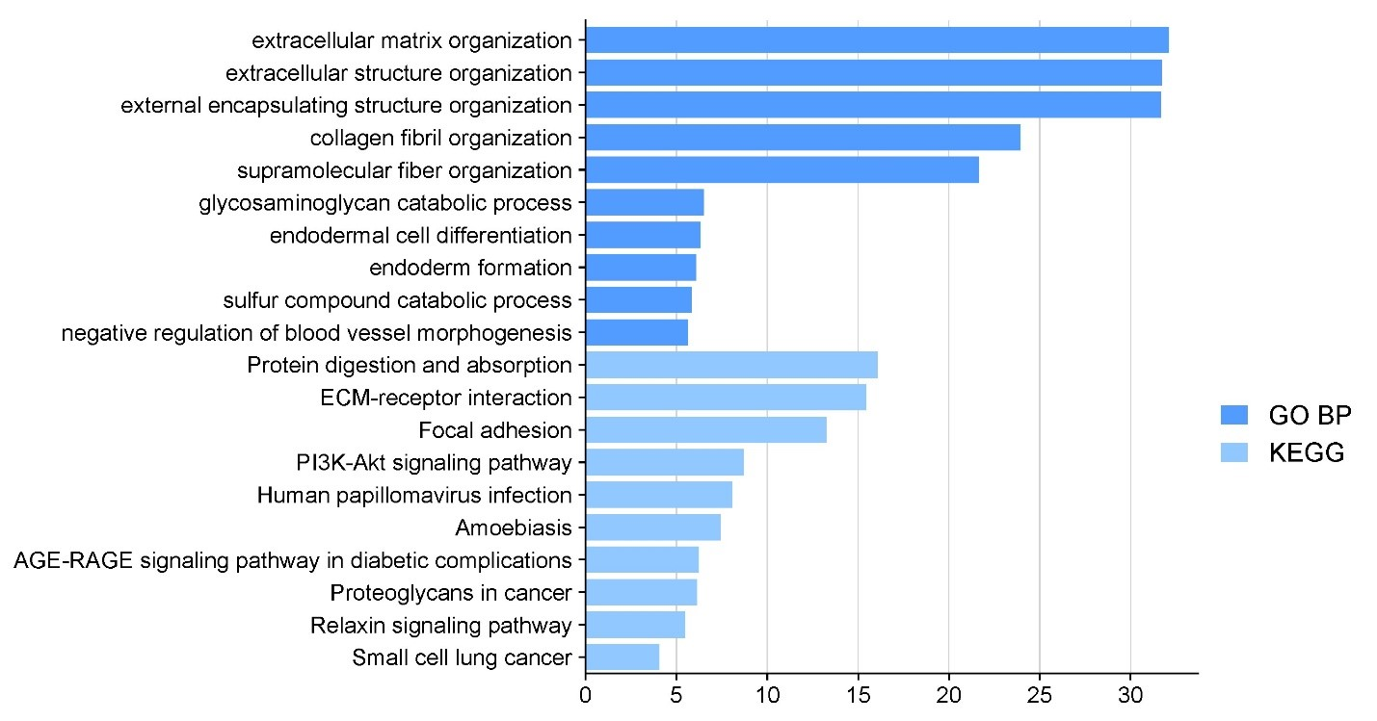
Supplementary figure S1: Pericyte associated pathways. GO BP and KEGG pathways associated with pericytes. Based on 98 pericyte genes from Pericyte: brain CellMarker_Augmented_2021 data set in EnrichR.
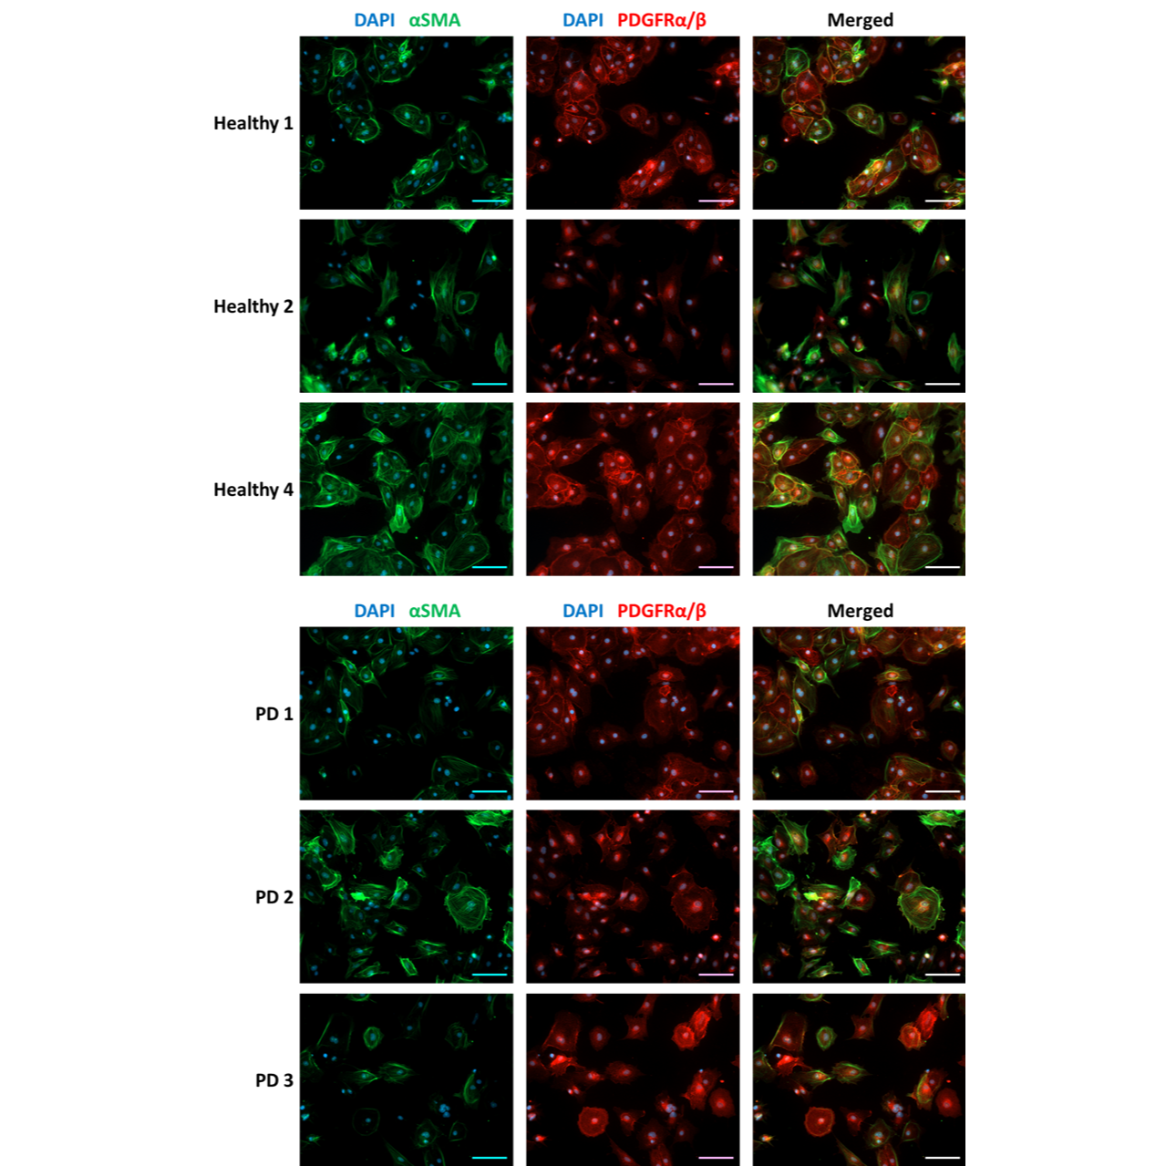
Supplementary figure S2: Expression of pericyte markers in hiPSC-derived pericyte-like cells. Representative immunofluorescence images of healthy (H1,2 and 4) and PD (PD1-3) pericyte-like cells stained for αSMA and PDGFRβ/α. Scale bar 100 µm.

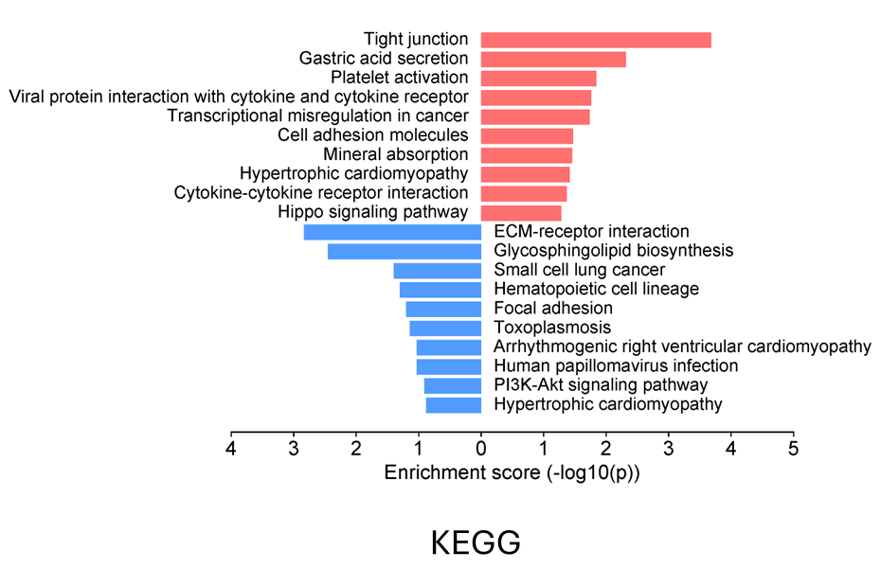Supplementary figure S3: KEGG pathway analysis of up- and down regulated genes in PD pericyte-like cells compared to healthy cells. (From genes with p-value <0.05).
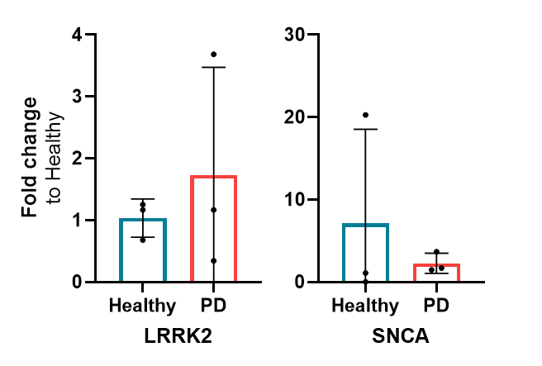
Supplementary figure S4: Relative expression of LRRK2 and SNCA in healthy and PD pericyte-like cells. (n=3) (+/-SD)

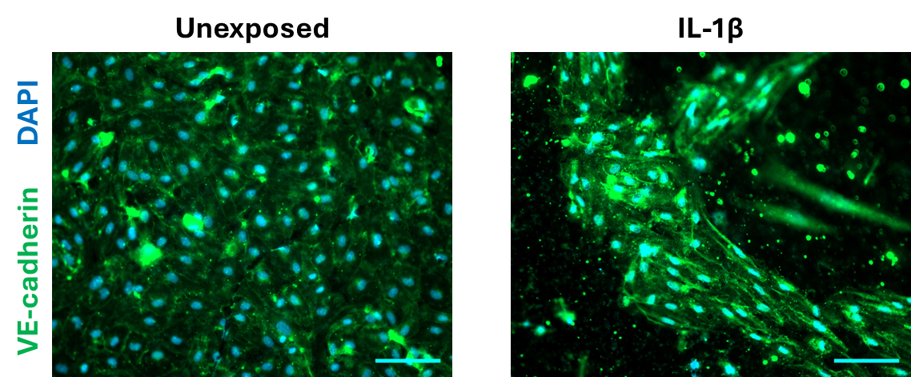
Supplementary figure S5: Representative images of unexposed and IL-1β exposed endothelial cells on inserts stained with VE-cadherin. Scale bar 100 µm.

