Supporting Information
Self-healing polyurethane/cellulose nanocrystal composite fibers with fatigue and aging resistance for smart wearable elastic yarns
The supplementary information file includes 8 figures (Fig. S1-S8).
Fig. S1. Cross-sectional SEM images and cross-sectional partially enlarged SEM images of PU-0% CNC, PU-3% CNC, PU-5% CNC, PU-7% CNC and PU-10% CNC composite fibers.
Fig. S2. XPS plots of PU-0% CNC, PU-1% CNC, PU-3% CNC, PU-5% CNC and PU-10% CNC composite fibers.
Fig. S3. Cyclic tensile test curves for PU-0% CNC, PU-3% CNC, PU-5% CNC, PU-7% CNC and PU-10% CNC composite fibers.
Fig. S4. Stress-strain curves for fatigue testing of PU-0% CNC, PU-3% CNC, PU-5% CNC, PU-7% CNC and PU-10% CNC composite fibers.
Fig. S5. Storage modulus plots for DMA tests of PU-0% CNC, PU-1% CNC, PU-3% CNC, PU-5% CNC, PU-7% CNC and PU-10% CNC composite fibers.
Fig. S6. Ultra-depth three-dimensional microscope images of self-healing of PU-0% CNC, PU-3% CNC, PU-5% CNC, PU-7% CNC and PU-10% CNC composite fibers.
Fig. S7. Temperature profiles of the relaxation process in the interfacial simulation systems of PU-0% CNC, PU-3% CNC, PU-5% CNC, PU-7% CNC and PU-10% CNC composite fibers.
Fig. S8. Total energy variation curves of the relaxation process for the interfacial simulation systems of PU-0% CNC, PU-3% CNC, PU-5% CNC, PU-7% CNC and PU-10% CNC composite fibers.
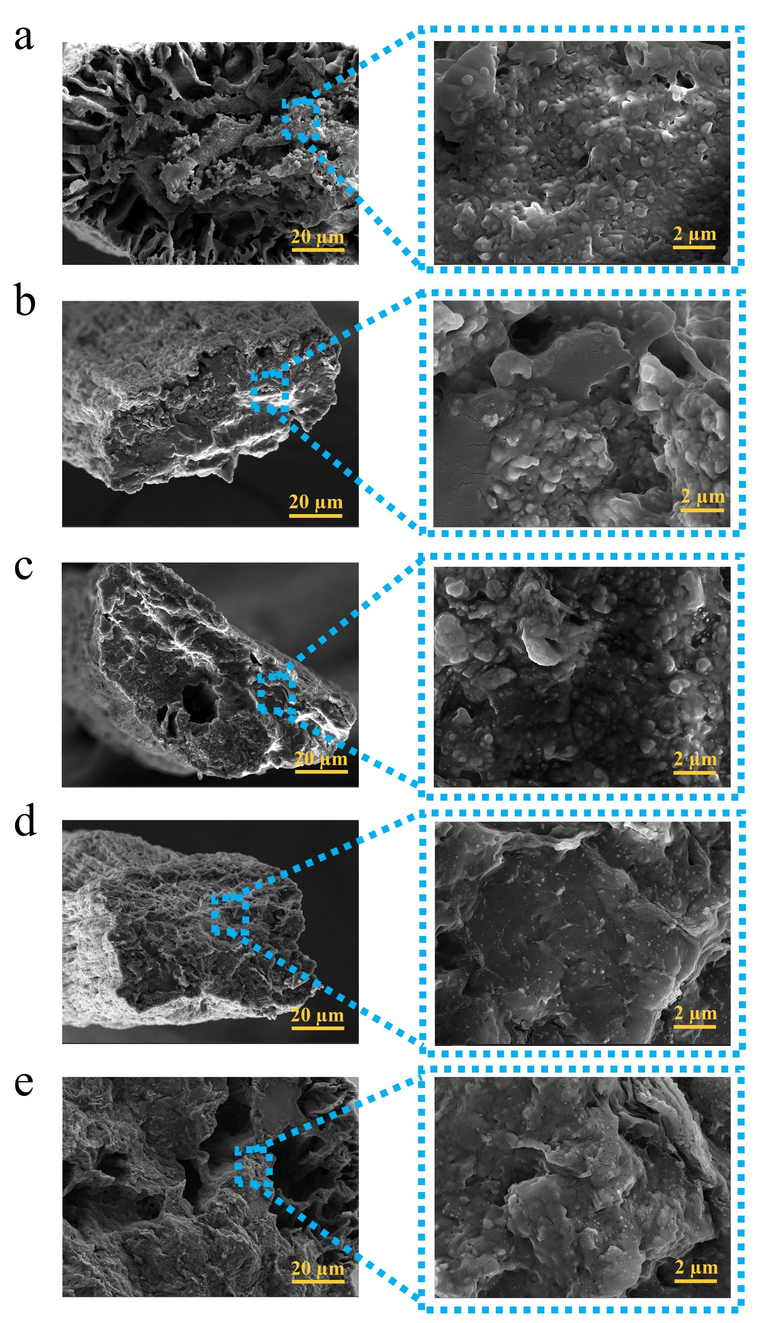
Fig. S1 (a) Cross-sectional SEM image and cross-sectional enlarged SEM image of PU-0% CNC composite fibers. (b) Cross-sectional SEM image and cross-sectional enlarged SEM image of PU-1% CNC composite fibers. (c) Cross-sectional SEM image and cross-sectional enlarged SEM image of PU-3% CNC composite fibers. (d) Cross-sectional SEM image and cross-sectional enlarged SEM image of PU-5% CNC composite fibers. (e) Cross-sectional SEM image and cross-sectional enlarged SEM image of PU-10% CNC composite fibers.
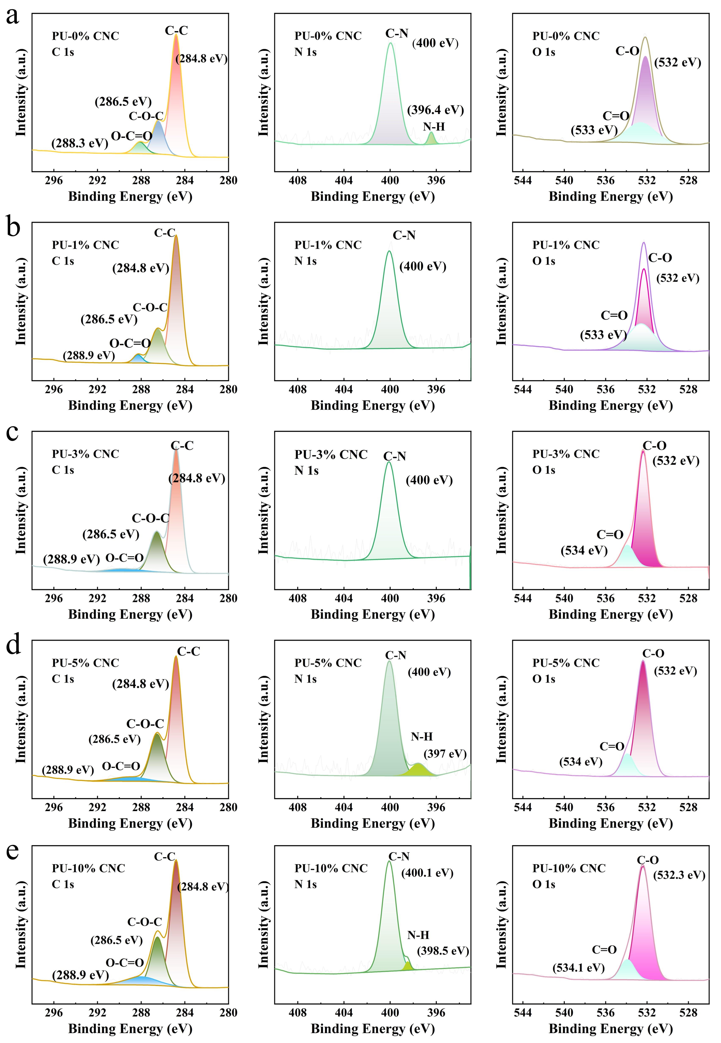
Fig. S2 (a) XPS plots of PU-0% CNC composite fibers. (b) XPS plots of PU-1% CNC composite fibers. (c) XPS plots of PU-3% CNC composite fibers. (d) XPS plots of PU-5% CNC composite fibers. (e) XPS plots of PU-10% CNC composite fibers.
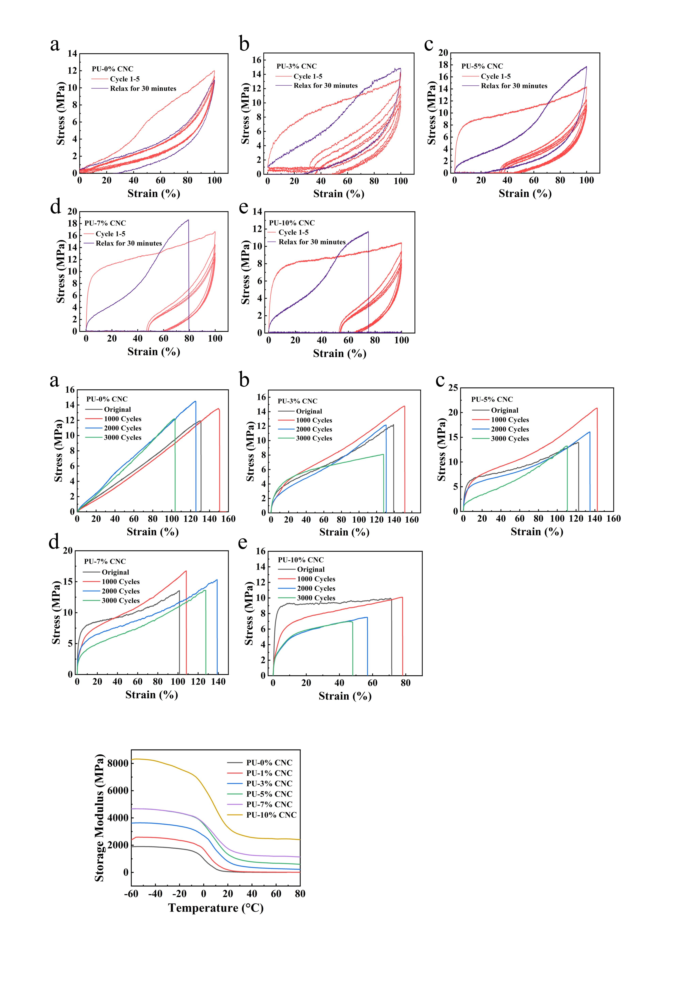
Fig. S3 (a) Cyclic tensile test of PU-0% CNC composite fibers. (b) Cyclic tensile test of PU-3% CNC composite fibers. (c) Cyclic tensile test of PU-5% CNC composite fibers. (d) Cyclic tensile test of PU-7% CNC composite fibers. (e) Cyclic tensile test of PU-10% CNC composite fibers.
Fig. S4 (a) Stress-strain curves for fatigue testing of PU-0% CNC composite fibers. (b) Stress-strain curves for fatigue testing of PU-3% CNC composite fibers. (c) Stress-strain curves for fatigue testing of PU-5% CNC composite fibers. (d) Stress-strain curves for fatigue testing of PU-7% CNC composite fibers. (e) Stress-strain curves for fatigue testing of PU-10% CNC composite fibers.
Fig. S5 Storage modulus plots of PU-CNC composite fibers for DMA testing.
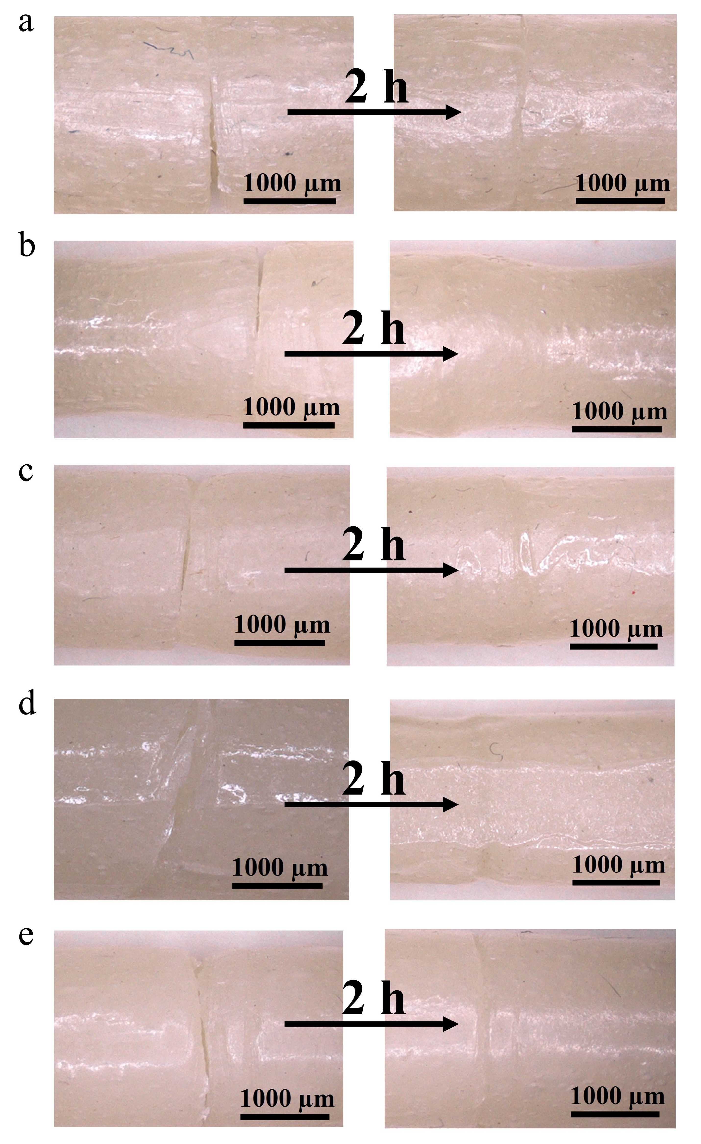
Fig. S6 (a) Ultra-depth three-dimensional microscope images of self-healing of PU-0% CNC composite fibers. (b) Ultra-depth three-dimensional microscope images of self-healing of PU-3% CNC composite fibers. (c) Ultra-depth three-dimensional microscope images of self-healing of PU-5% CNC composite fibers. (d) Ultra-depth three-dimensional microscope images of self-healing of PU-7% CNC composite fibers. (e) Ultra-depth three-dimensional microscope images of self-healing of PU-10% CNC composite fibers.
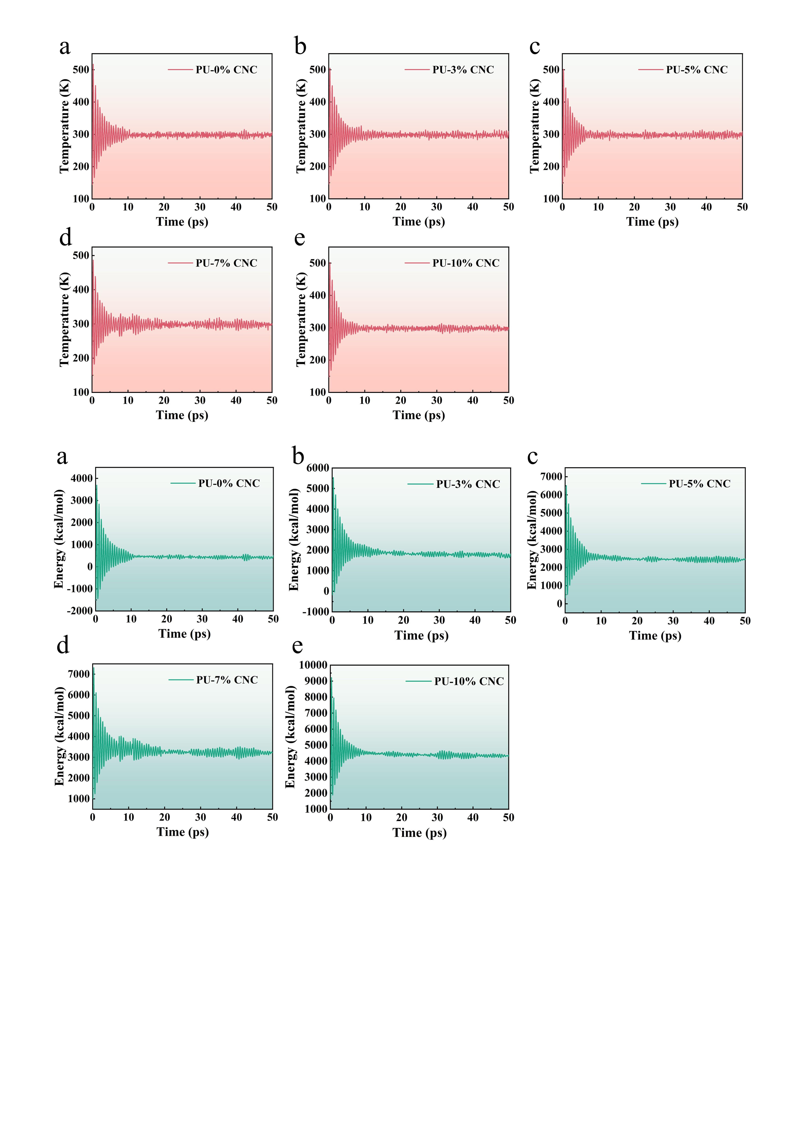
Fig. S7 (a) Temperature variation curves of the relaxation process of the simulated system of PU-0% CNC composite fibers. (b) Temperature variation curves of the relaxation process of the simulated system of PU-3% CNC composite fibers. (c) Temperature variation curves of the relaxation process of the simulated system of PU-5% CNC composite fibers. (d) Temperature variation curves of the relaxation process of the simulated system of PU-7% CNC composite fibers. (e) Temperature variation curves of the relaxation process of the simulated system of PU -10% CNC composite fibers.
Fig. S8 (a) Total energy variation curves of the relaxation process for the simulated system of PU-0% CNC composite fibers. (b) Total energy variation curves of the relaxation process for the simulated system of PU-3% CNC composite fibers. (c) Total energy variation curves of the relaxation process for the simulated system of PU-5% CNC composite fibers. (d) Total energy variation curves of the relaxation process for the simulated system of PU-7% CNC composite fibers. (e) Total energy variation curves of the relaxation process for the simulated system of PU-10% CNC composite fibers.

