Fig. S1

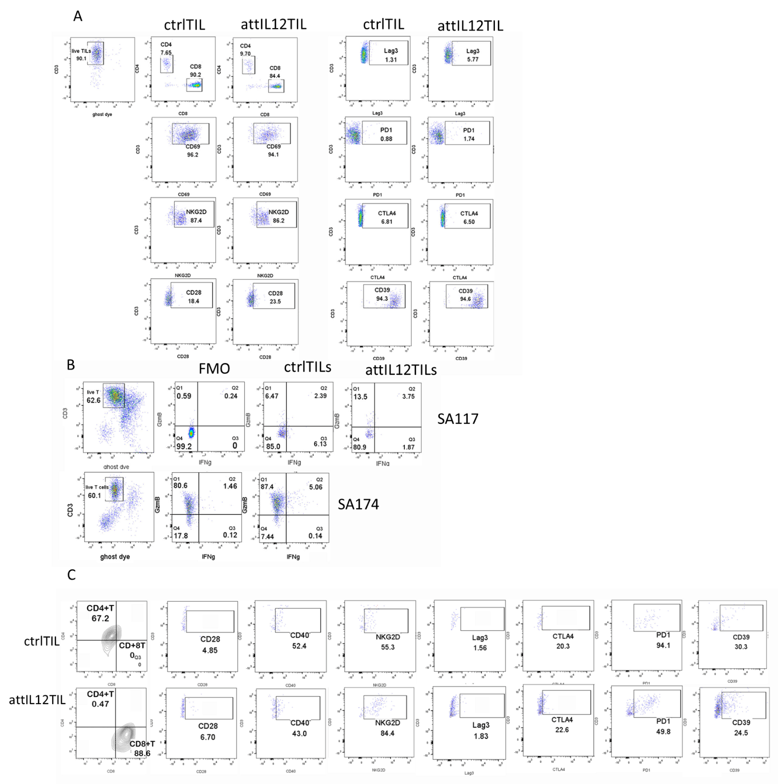

Fig. S2
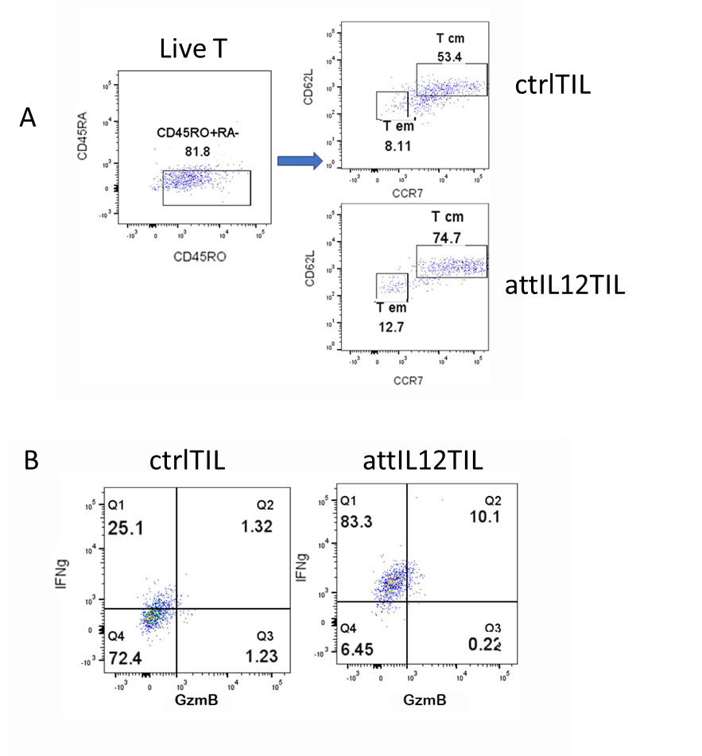

Fig. S3
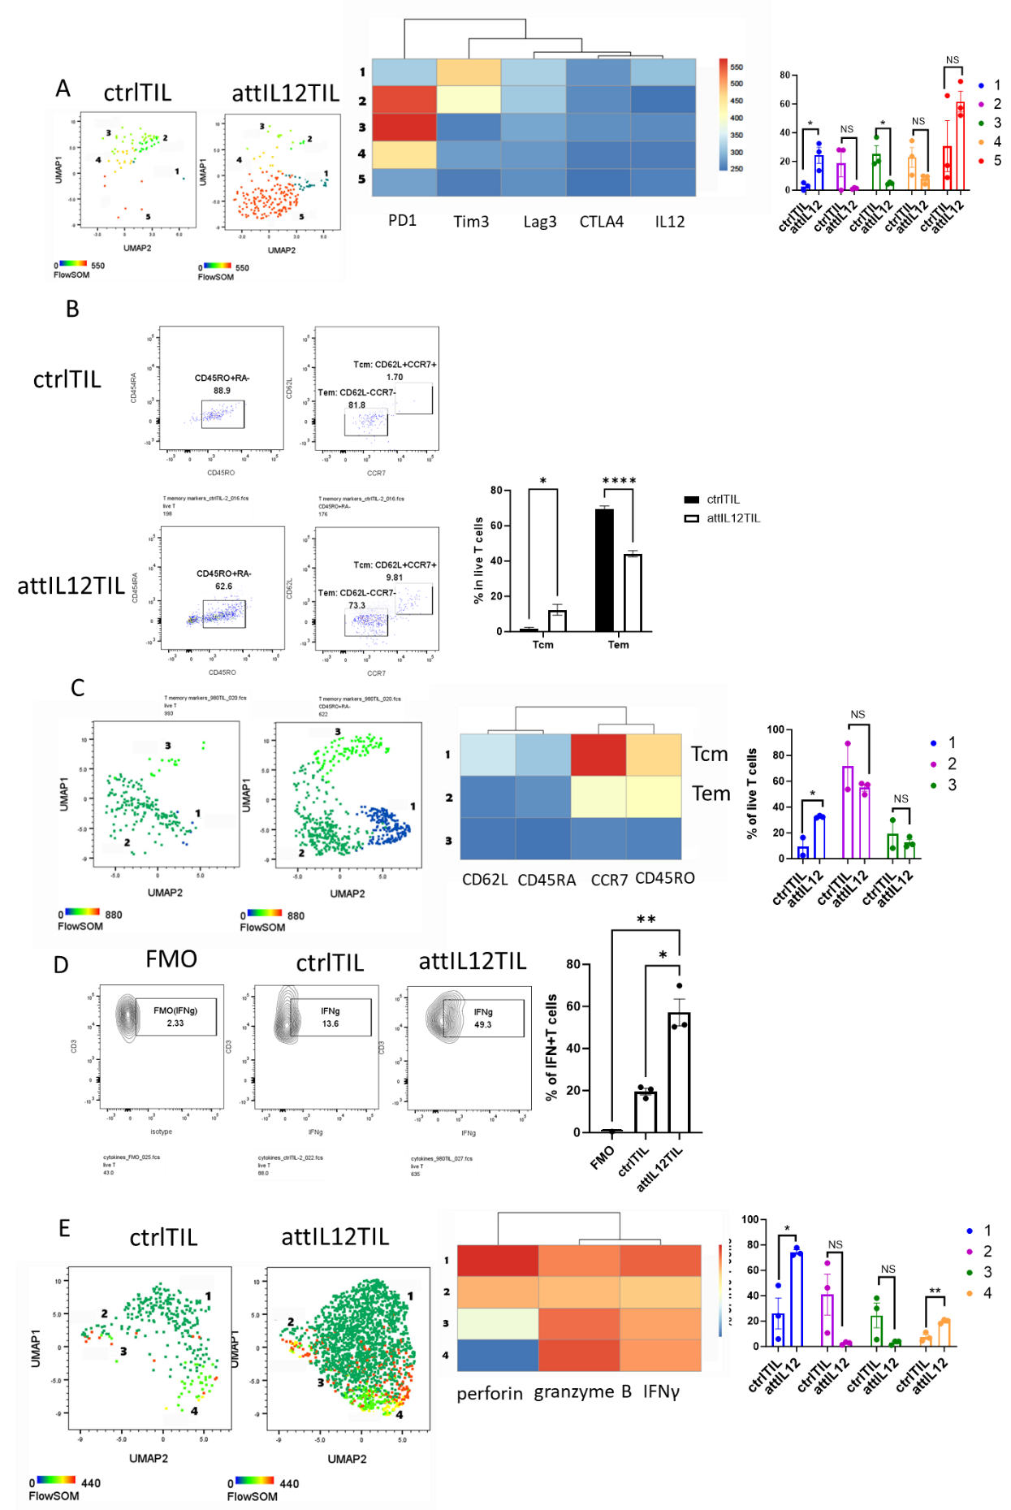
Fig. S4
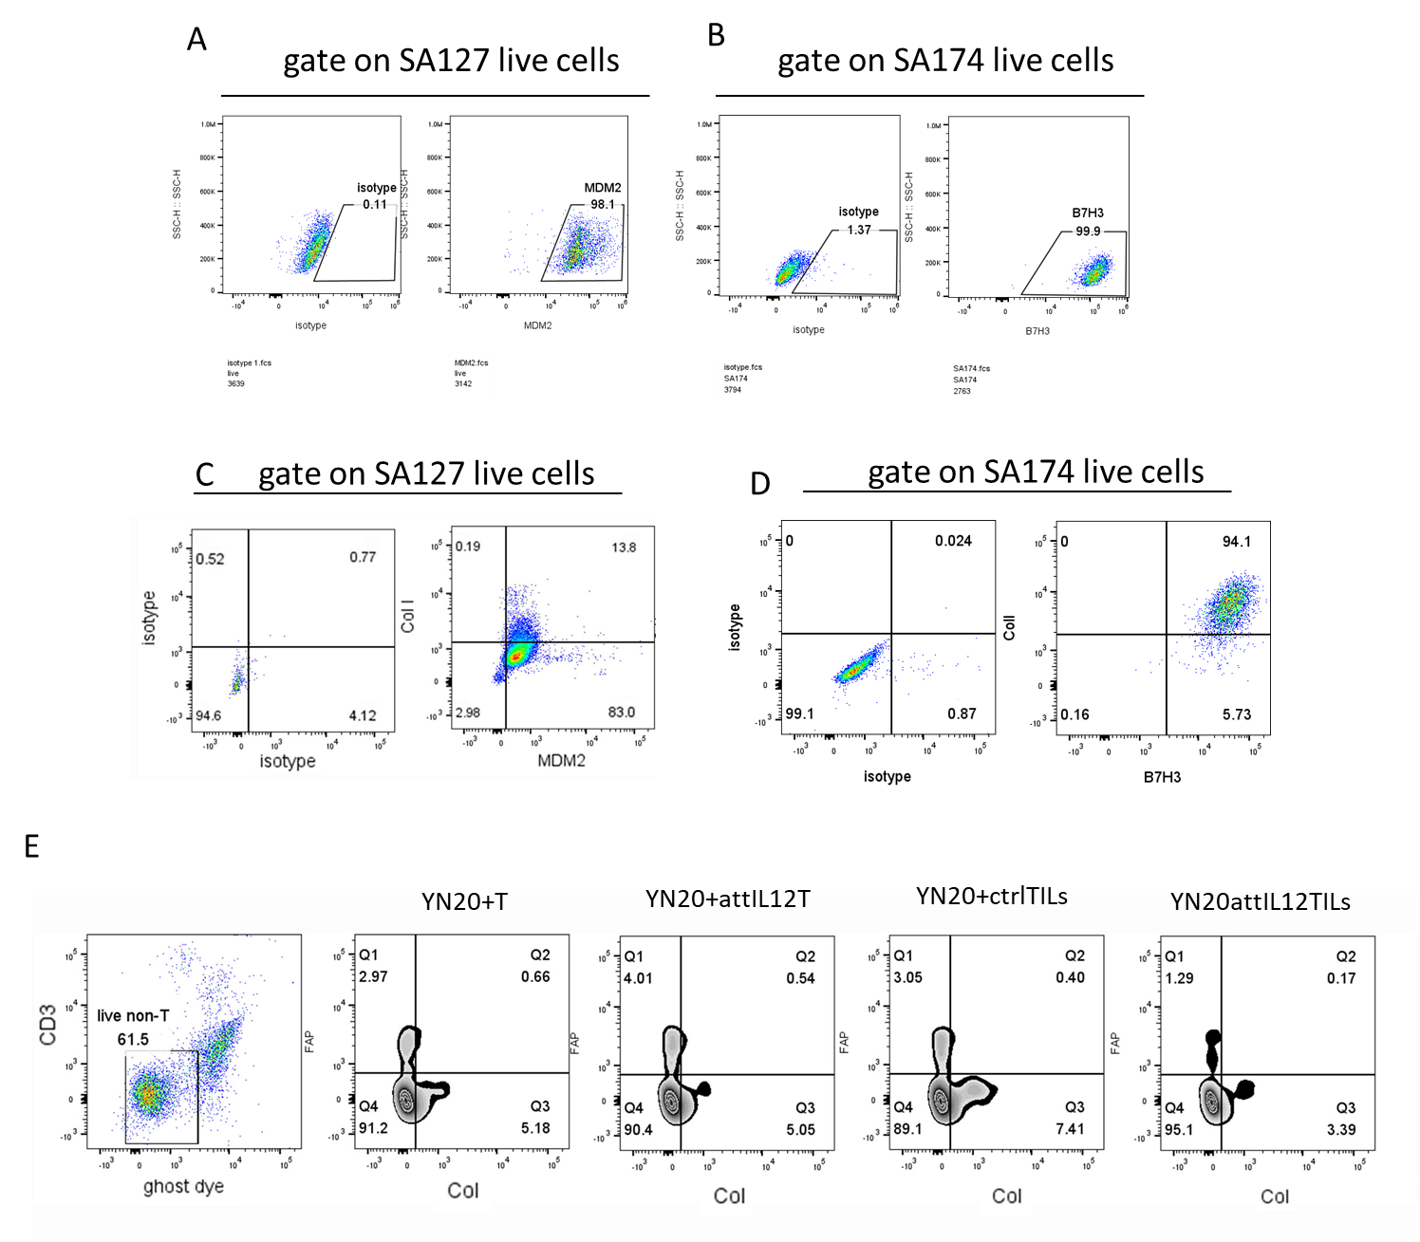

Fig. S5
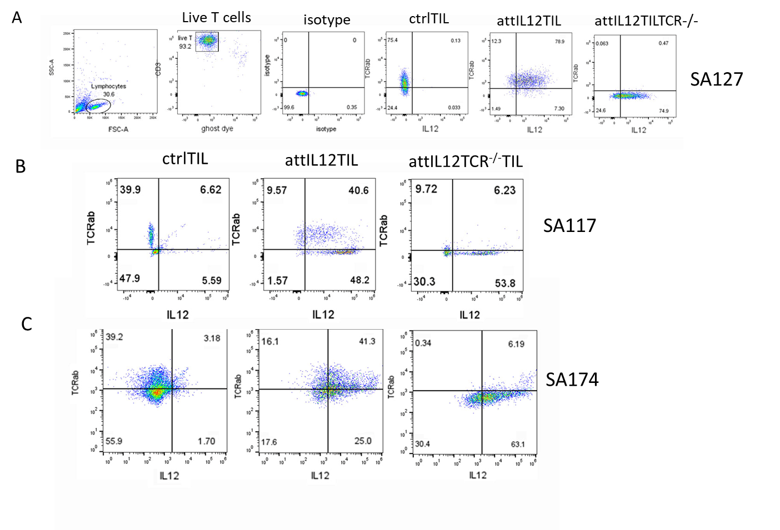

Fig. S6
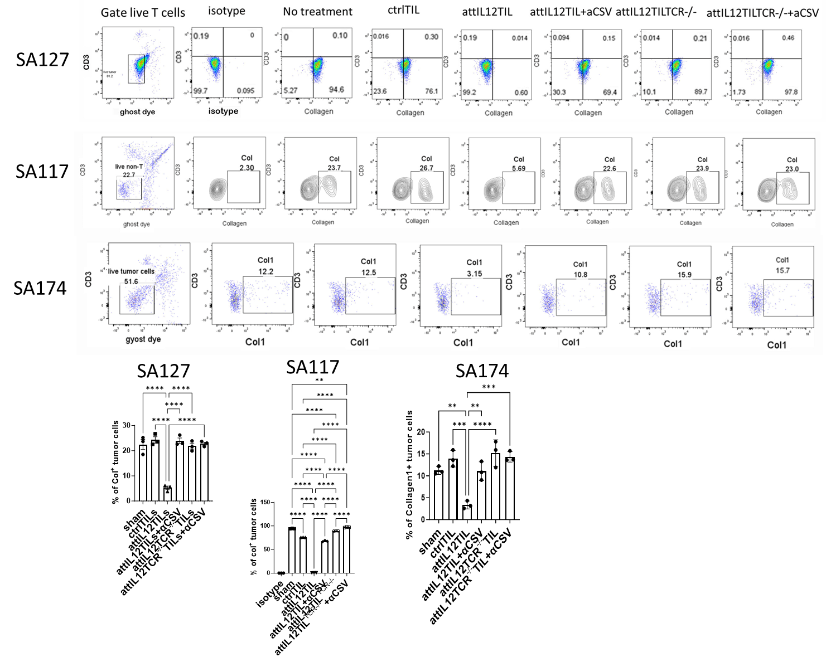

Fig. S7
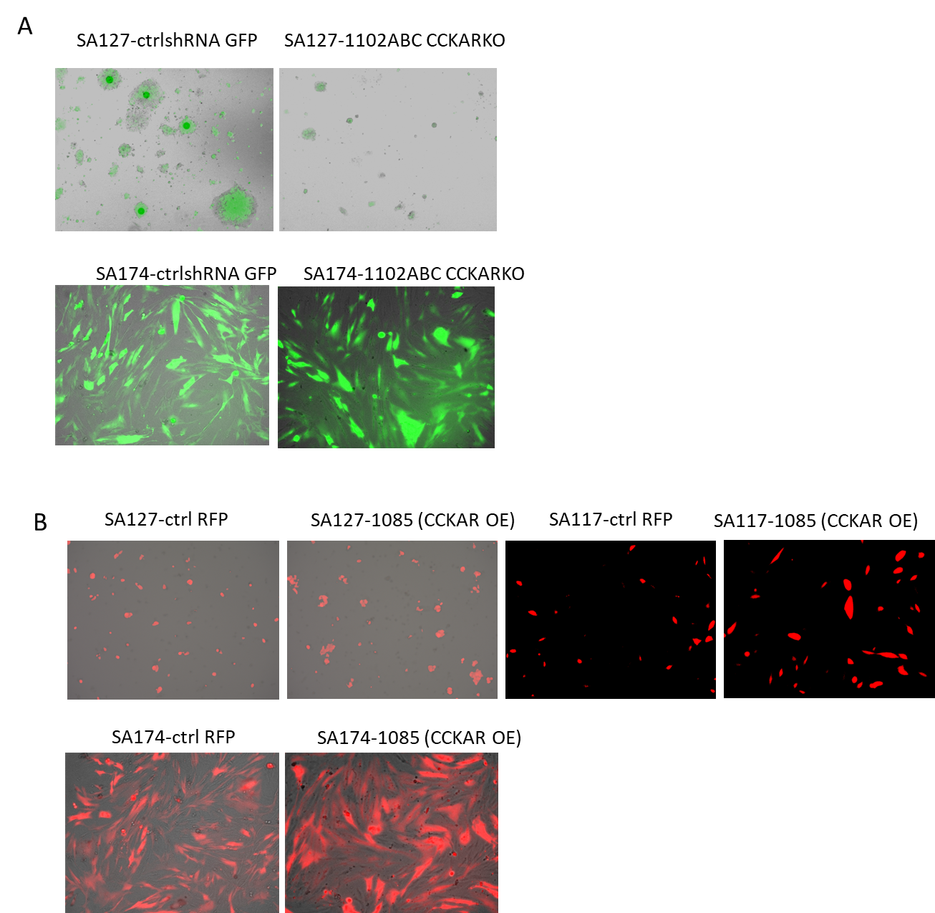

Fig S1. SA174 and SA117 attIL12-TIL cell surface marker/effector molecule profiles. (A) SA174 control TILs (ctrlTIL) and attIL12-TILs show similar cell surface markers. (B) Ctrl-TILs and attIL12-TILs from SA117 and SA174 models show similar effector molecule expression. (C) SA174 ctrlTILs and attIL12-TILs that infiltrated into tumors show similar cell surface marker profiles.

Fig S2. SA127 TIL memory and effector molecule expression. TILs isolated from SA127 tumors (Fig 2A) were stained with (A) memory feature markers, and (B) effector molecule markers.

Fig S3. SA174 TIL cell surface markers and memory and effector molecule expression. TILs isolated from SA174 tumors (Fig 2C) were stained with (A) cell surface markers, (B, C) memory feature markers, and (D, E) effector molecule markers. (A, C, E) Dimension reduction by UMAP, heatmaps, and graphs show the cluster for each treatment group.
Fig S4. Collagen is mainly produced by sarcoma PDX tumor cells. (A, B) SA127 (A) and SA174 (B) cells were stained with MDM2 (A) and B7H3 (B) antibodies, respectively, and detected via flow cytometry. (C, D) SA127 (C) and SA174 (D) tumors were dissociated and stained with collagen I and MDM2 (C) or B7H3 (D) antibodies, respectively, and detected via flow cytometry. (E) YN20 PDX tumors were dissociated and cocultured with T cells, attIL12-T cells, control TILs, or attIL12-TILs at a 1:1 ratio for 24 hours. Cell mixtures were stained with FAP and Col to determine immune cells’ impact on cancer-associated fibroblasts and collagen expression via flow cytometry.

Fig S5. Effects of TCRα knockout (KO) in TILs. (A-C) TILs from SA127 (A), SA117 (B), and SA174 (C) tumors were transduced with lentivirus containing a control vector, attIL12, or attIL12 plus TCRα KO, respectively. After 48 h, IL12 and TCRα/β expression were detected via flow cytometry.

Fig S6. Collagen expression from tumor cells after coculture with control TILs, attIL12-TILs, or attIL12^{TCRα-/-} TILs. SA127, SA117, or SA174 tumor cells were cocultured with autologous control TILs, attIL12-TILs, or attIL12^{TCRα-/-}TILs with or without a CSV-blocking antibody. Collagen was detected after coculture via flow cytometry.

Fig S7. Immunofluorescence images of CCKAR knockout and CCKAR-overexpressing (OE) tumor cell lines. (A) SA127 and SA174 tumor cells transduced with control (GFP) or CCKAR shRNA (GFP) virus. (B) SA127, SA117, and SA174 tumor cells transduced with control (cherry) or CCKAR (cherry) virus.

