An Island that has been an Island twice:
How and why small volcanic ocean islands collapse and move vertically up and down
Fernando O. Marques*, Luísa P. Ribeiro^{1,2}, Christian Hübscher³, Ana C.G. Costa⁴, Anthony Hildenbrand⁵
* Corresponding author, Retired, no affiliation, fomarques@gmail.com
¹ EMEPC – Task Group for the Extension of the Continental Shelf, Paço de Arcos, Portugal
² GeoBioTec, University of Aveiro, Portugal
³ Institute of Geophysics, University of Hamburg, Germany
⁴ Institut für Geothermisches Ressourcenmanagement, Bingen, Germany
⁵ GEOPS, Univ. Paris-Sud, CNRS, Université Paris-Saclay, 91405 Orsay, France

Supplementary Material

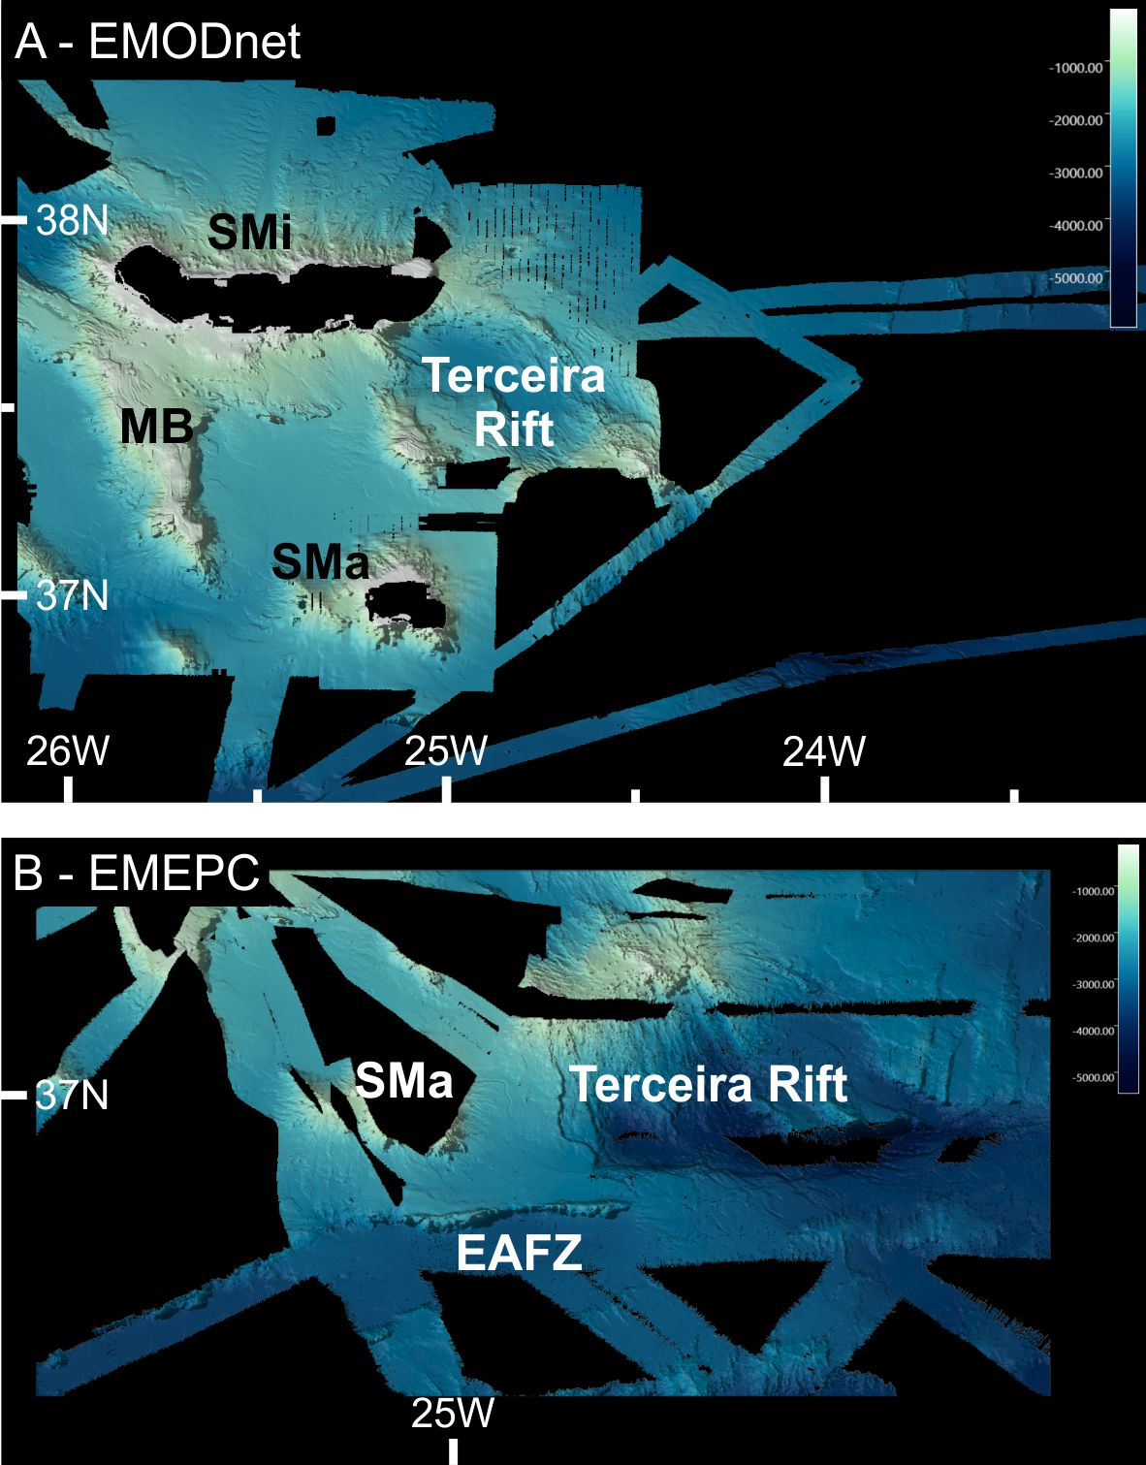
Figure S1. Multibeam bathymetric data used in this work was obtained from EMODnet (A) and from EMEPC (B).

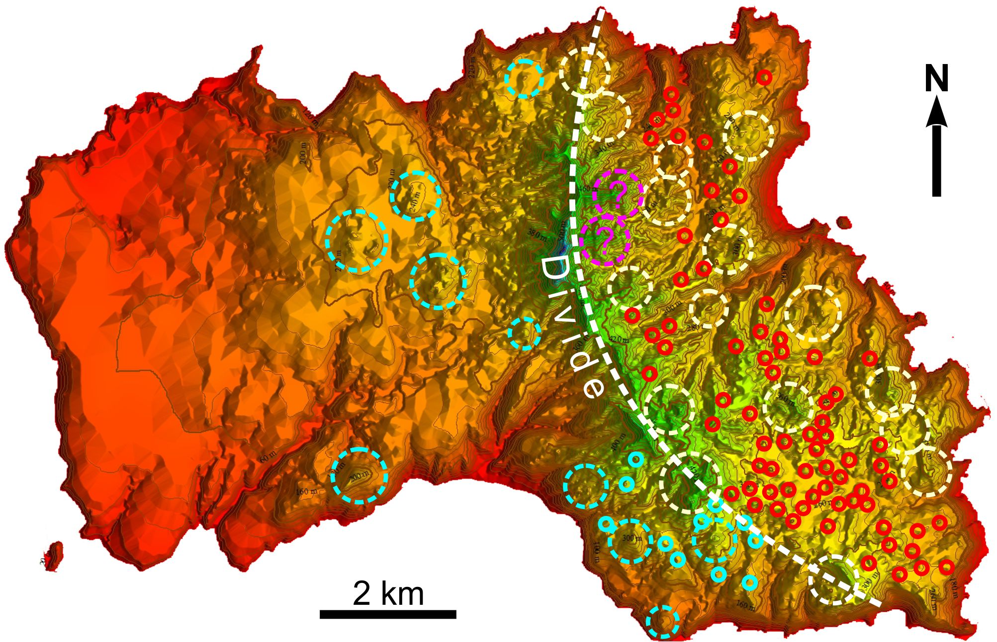
Figure S2. Shaded relief with volcanic cones plotted as circles. Large cones W and E of the divide (white dashed line) are marked by dashed cyan and white circles, respectively. Small cones W and E of the divide are marked by cyan and red small circles, respectively. Magenta dashed circles with question marks inside represent interpreted cones not confirmed in the field. Not all identified small cones are plotted for the sake of clarity.
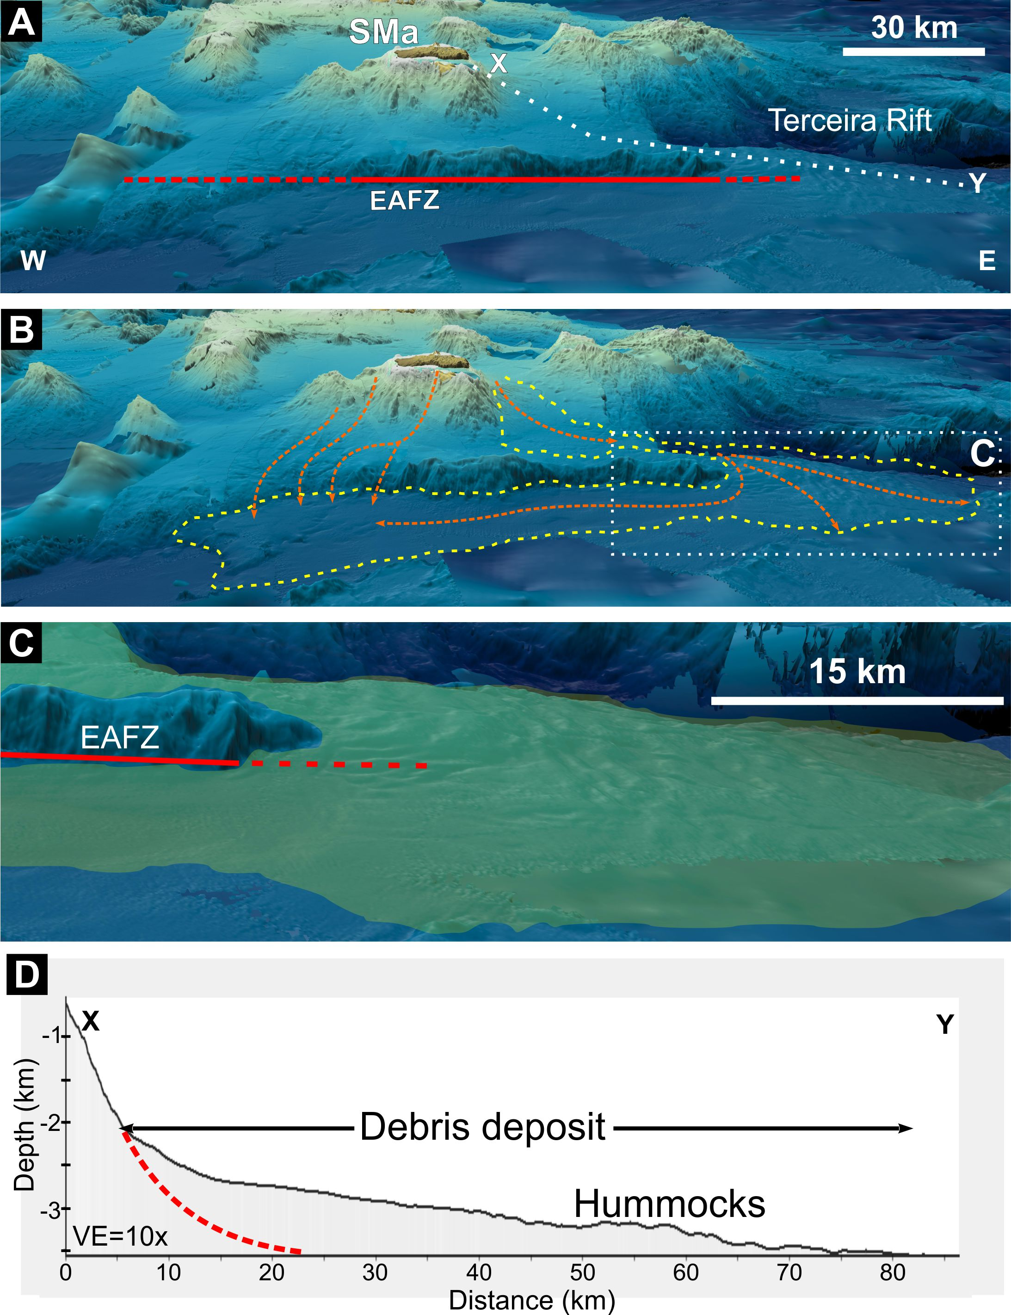
Figure S3. A – uninterpreted 3-D shaded relief around Santa Maria (SMa), oblique view from the south. B – interpreted distribution of the debris deposits, in which the dashed yellow line and the dotted green lines mark the limits of the deposit and the flow, respectively. C – 3-D zoom of the dotted rectangle drawn in B, in which the deposit is represented by a green shade. D – cross-section along the X-Y dotted line drawn in A, showing the upward convex shape of the deposit and a hummocky terrain in the frontal part. EAFZ – East Azores Fracture Zone.
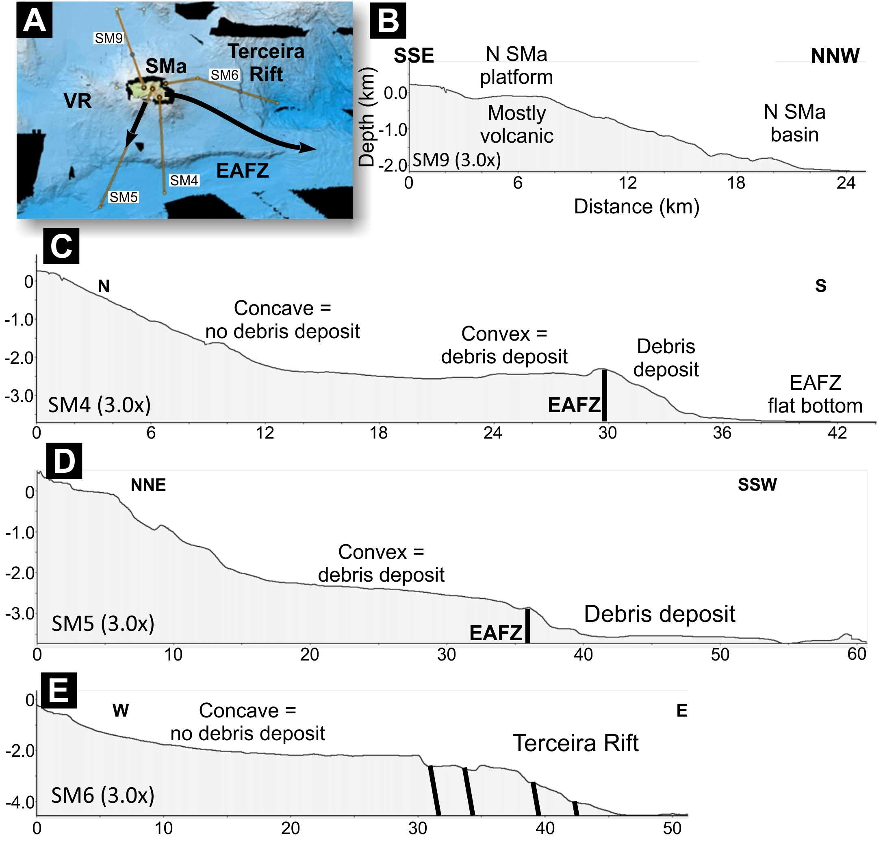
Figure S4. Topographic profiles along critical directions to show the shape of the topography where we infer the existence (convex upward) or absence (concave upward) of debris deposits. Black arrows mark the position and flow of the landslides inferred from on and offshore data. Note that, outside these areas of debris avalanches with upward convex profiles, the topographic profiles are concave upwards. VR = volcanic ridge; EAFZ = East Azores Fracture Zone; N SMa basin = north Santa Maria basin.

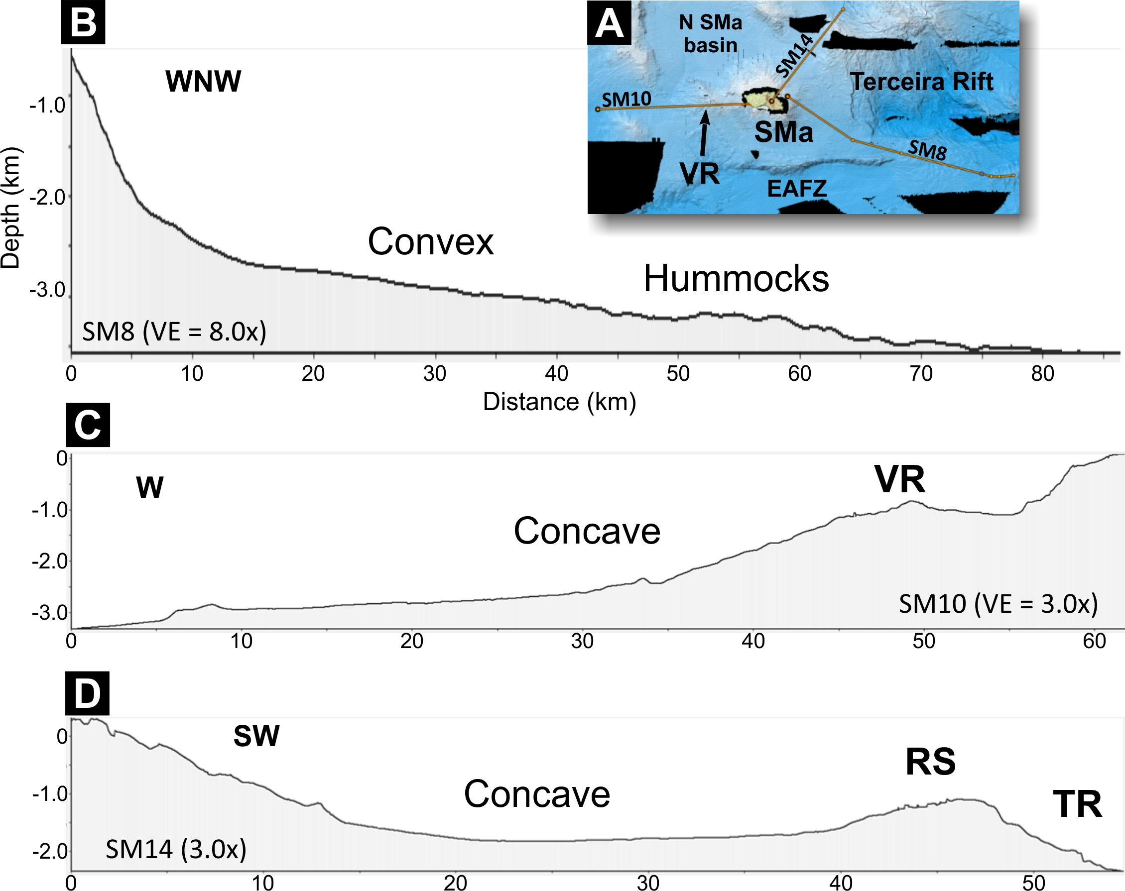
Figure S5. Topographic profiles along critical directions to show the shape of the topography where we infer the existence (convex) or absence (concave) of debris deposits. EAFZ – East Azores Fracture Zone; VR – volcanic ridge; TR – Terceira Rift; RS – rift shoulder.
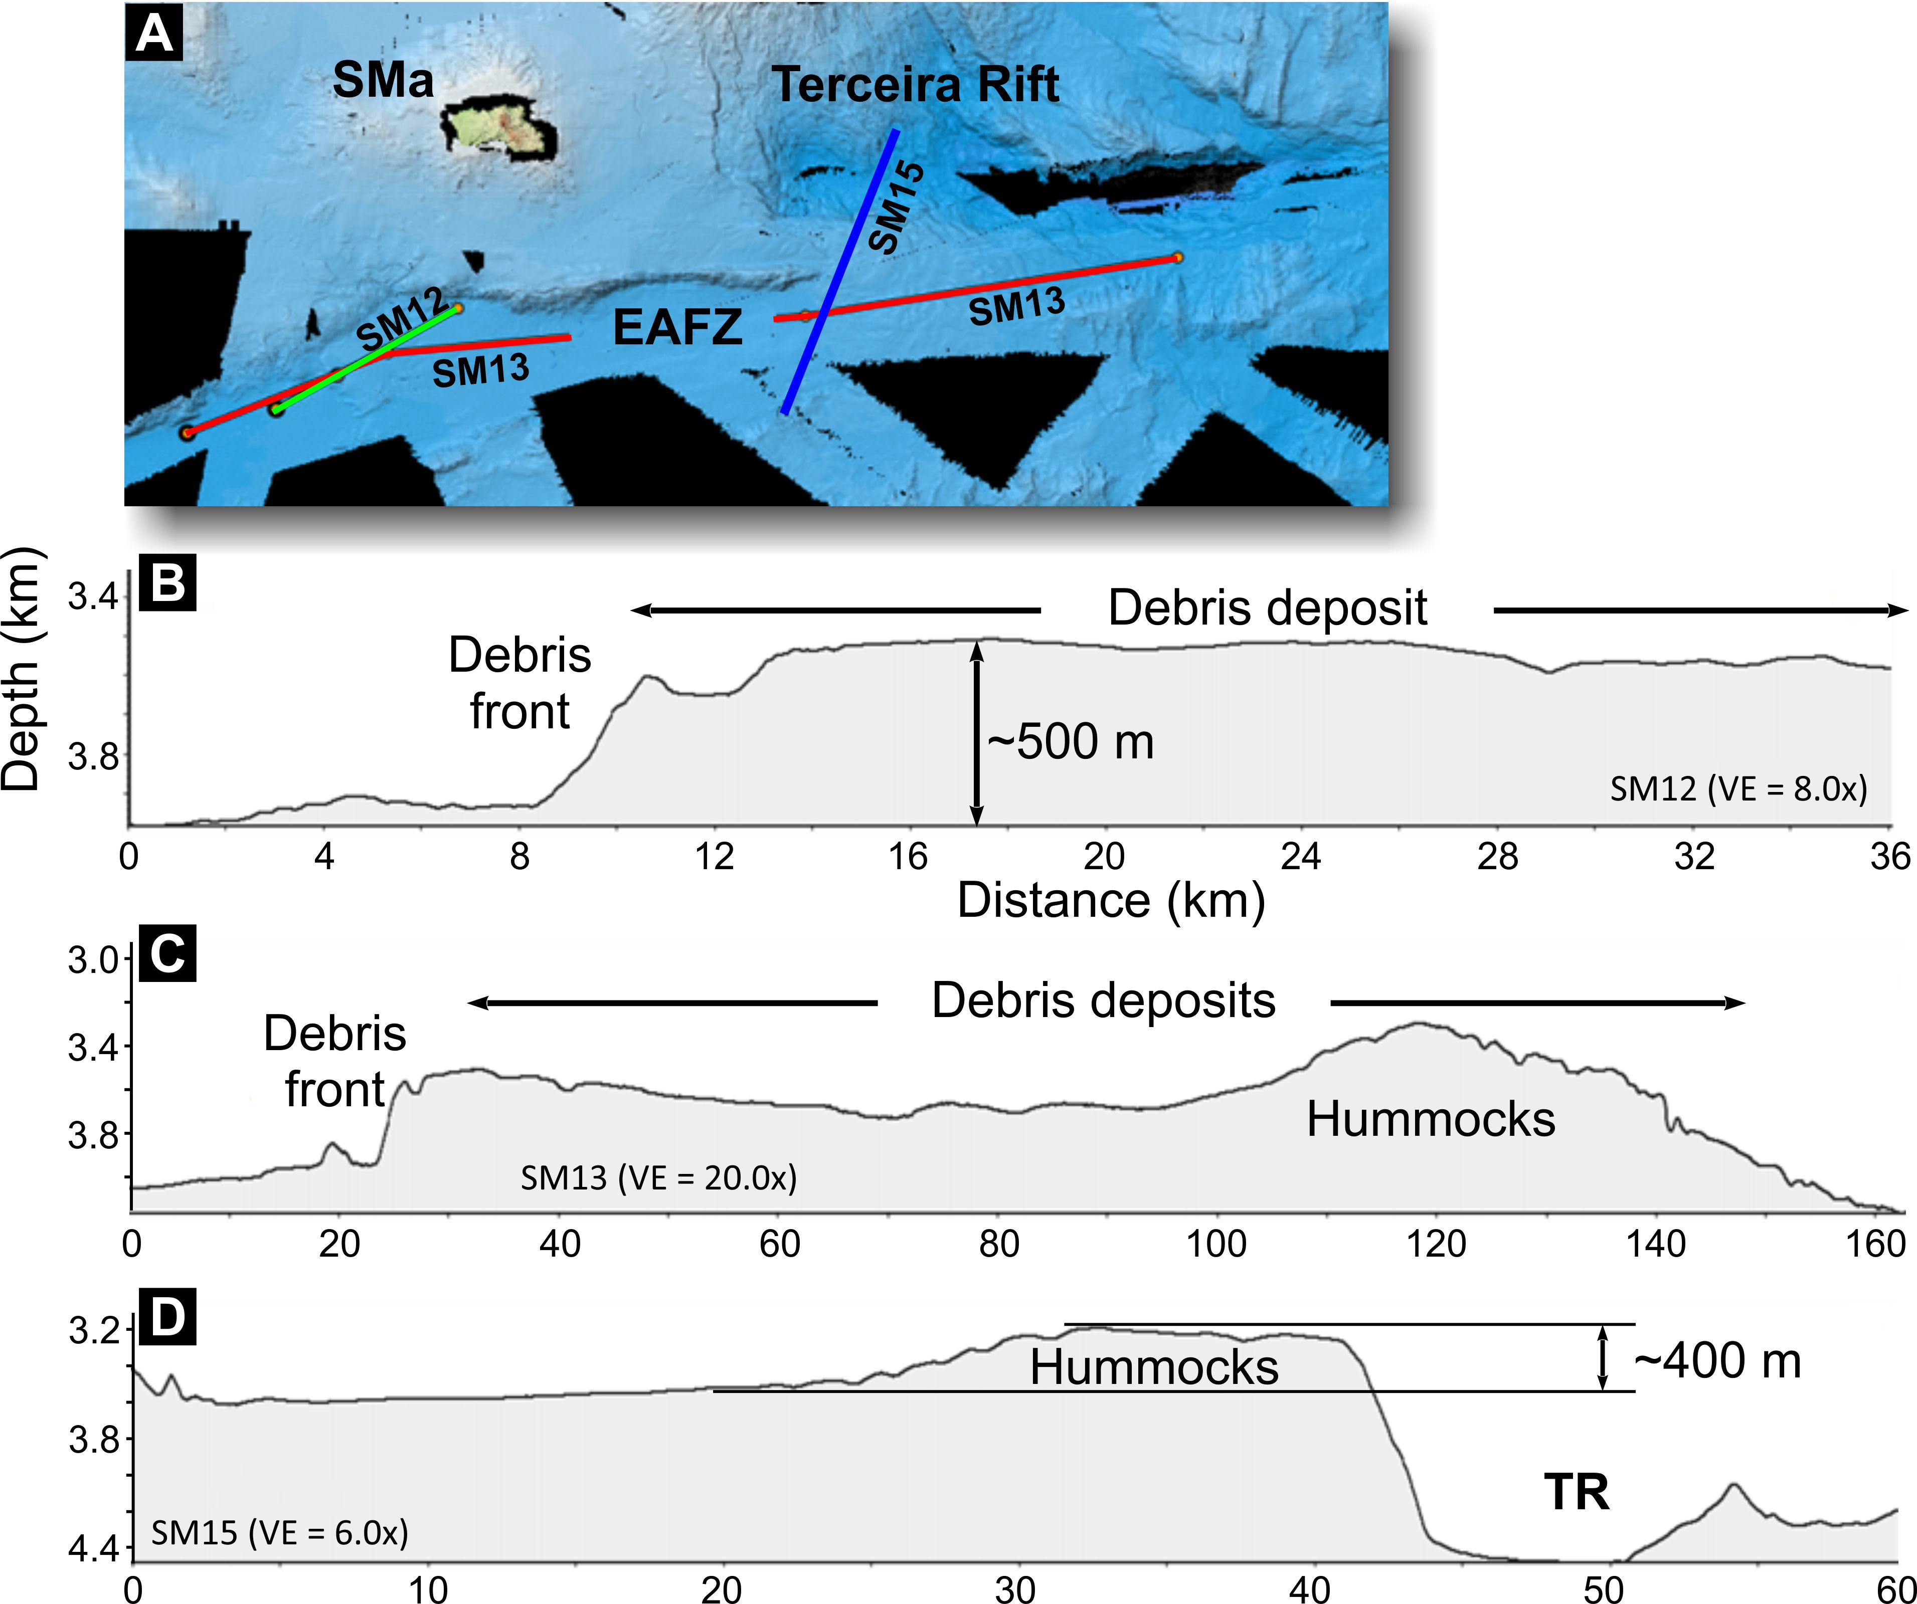
Figure S6. Topographic profiles inside the East Azores Fracture Zone (EAFZ) to show the inferred debris deposits and their local thicknesses. SMa – Santa Maria Island; EAFZ – East Azores Fracture Zone; TR – Terceira Rift.
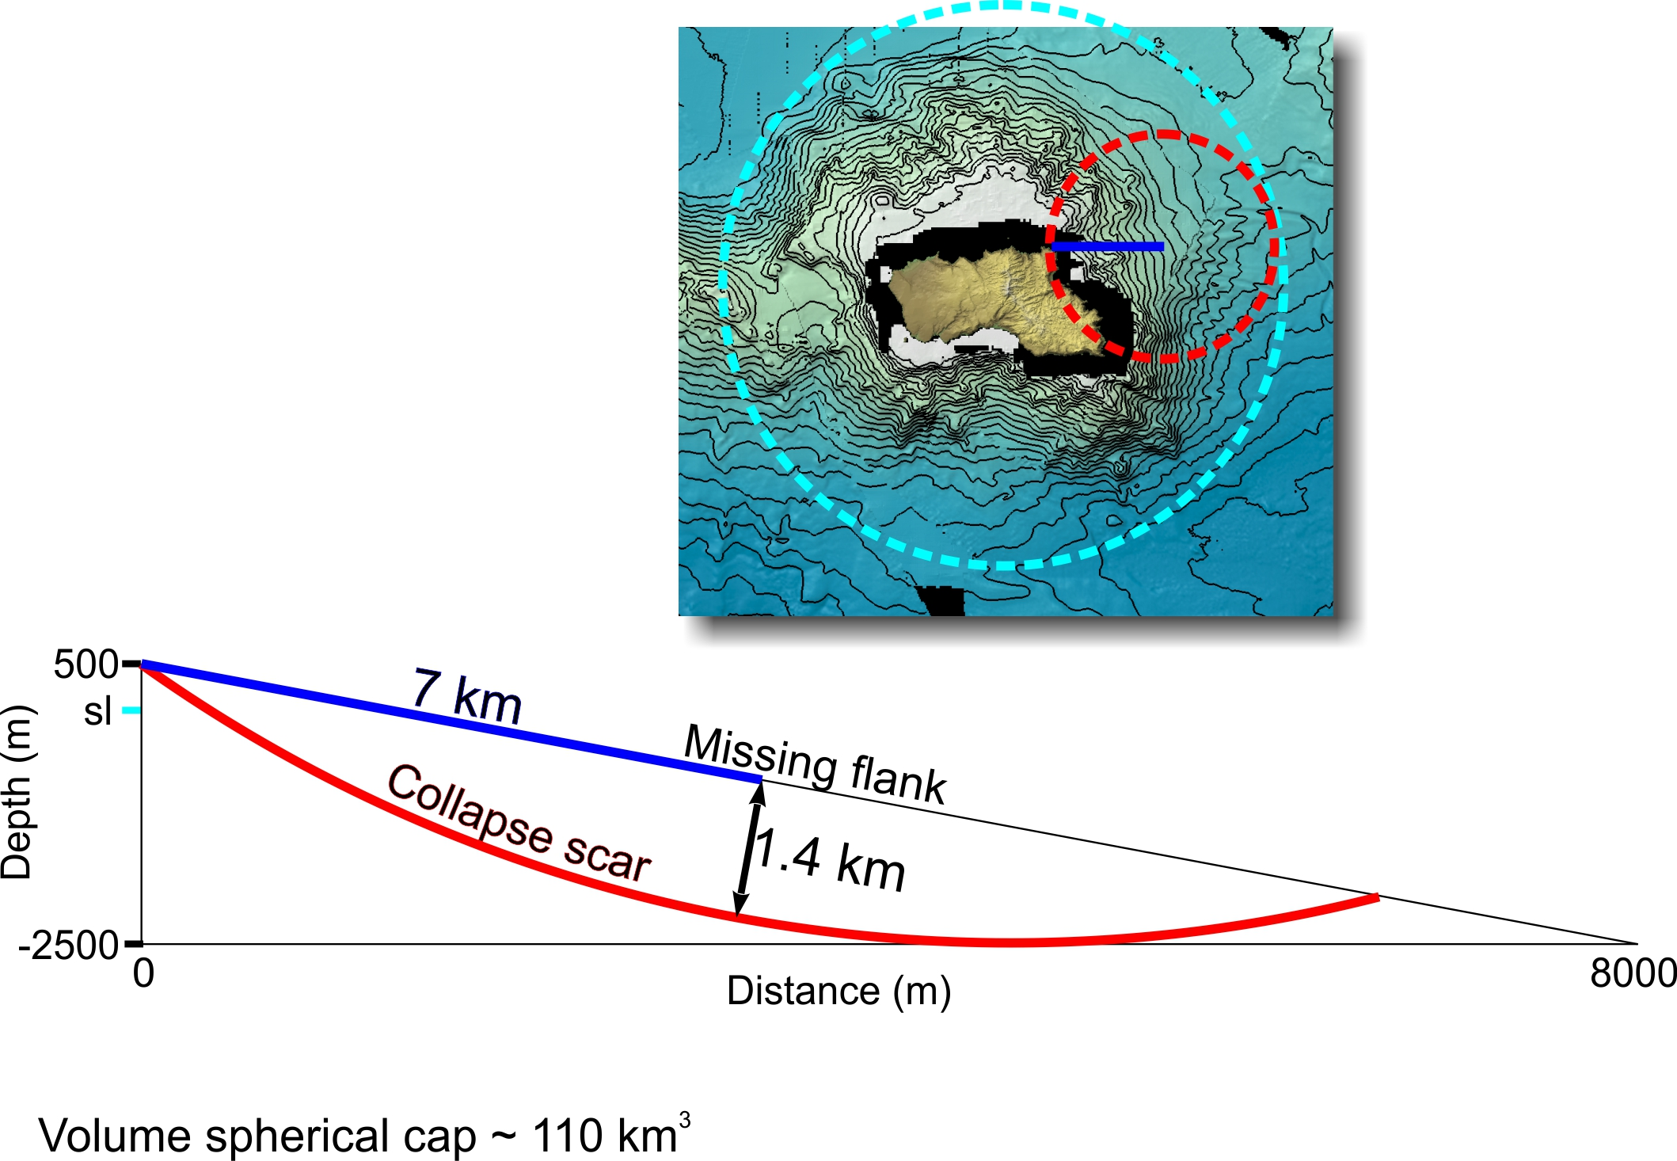
Figure S7. Sketch to illustrate how one can find the volume of a spherical cap, which we take as good representation of the volume of rock involved in each collapse. The volume was calculated here: https://www.omnicalculator.com/math/sphere-volume. sl – sea level.

