Supplementary materials
Strong immune privileges of MSC and other Nes-GFP⁺ progenitors in bone marrow of transgenic mice
D.V. Karpenko, N.M. Kapranov, A.E. Bigildeev,
- Method for measuring antibodies concentration against GFP in blood serum of mice
We acquired reads from plates of ELISA. Each plate contained serum samples and graduating anti-GFP Ab in certain dilutions for a calibration. For each sample, we made a plot with calibration dilution (Supplementary Fig. S1). For the calibration, the abscissa was taken as a logarithm from known concentration of Ab related to a starting concentration A = 1 mg/mL. For a sample, the abscissa was taken according to the dilution of serum. A shift between the curves (l) provided us with information to find the concentration in serum, which was calculated by the equation:
$C={A*10}^{5\frac{l}{l_{0}}}$,
where l₀ is a calibrating distance between dilutions from 10⁻¹ to 10⁻⁶ determined from the plot

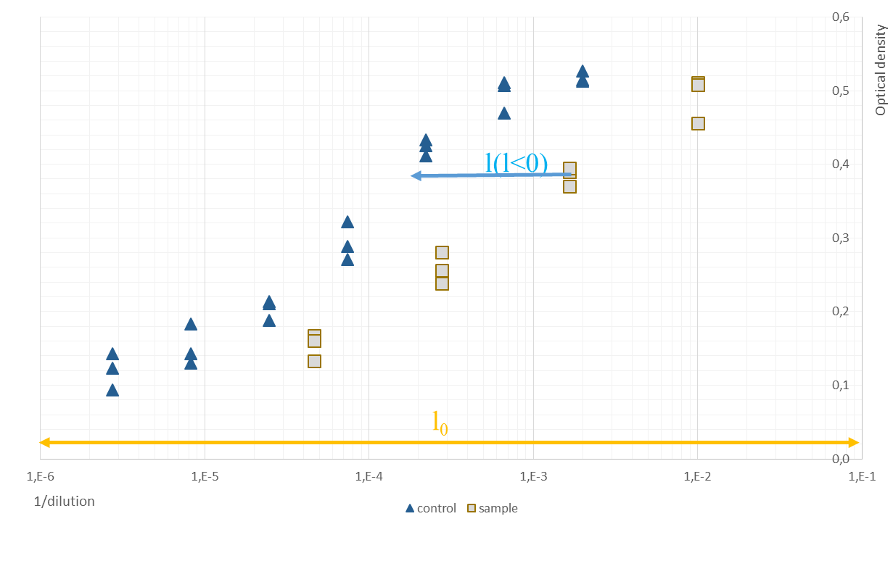
Supplementary Fig. S1. An example of a plot used to calculate anti-GFP Ab in a sample of blood serum. Triangles designate dilutions of the sample. Squares designate dilutions of commercial anti-GFP Ab with known concentration used for calibration. All measurements were done it triplicates. The ordinate means optical density at 450 nm. The abscissa means 1/dilution from Ab concentration 1 mg/mL for calibrating anti-GFP Ab and 1/dilution factor for the sample. If dilutions of a sample was to the left from dilutions of calibrating anti-GFP Ab, l was negative, else – l was positive.

Difficulties in aggregation of data arose because of inherited error in pipetting during step dilutions. Strict aggregation from dilutions and technical repeats in one graduating analytical curve is not obvious. Therefore, l was estimated using expert estimation of visual presentation for each plot.

- Immunization results
We detected considerable amount of anti-GFP antibodies in blood serum of all mice immunized by GFP regardless of the dose and strain (Supplementary Fig. S2).
Supplementary Fig. S2. Measurement of anti-GFP IgG in blood serum of mice. Each circle/triangle is a serum sample from a separate animal. Groups are as follows: “non-immunized” is serum of non-immunized mice, “BSA” is serum of mice immunized with BSA, “GFP 20” is serum of C57Bl/6 mice immunized with 20 μg GFP, “GFP 200” is serum of C57Bl/6 mice immunized with 200 μg GFP, “CBF/GFP 200” is serum of CBF1 mice immunized with 200 μg GFP. Mean values are depicted as horizontal lines in groups GFP 20, GFP 200, CBF/GFP 200. **** designates p < 0.0001; *** designates p < 0.001.
Measured level of anti-GFP antibodies in blood serum of mice immunized with BSA did not have statistically significant differences with non-immunized animals, in which non-zero values could be explained by non-specific IgG binding to GFP. While the mean value of anti-GFP antibodies was slightly higher in mice immunized with 20 µg GFP as compared to 200 µg GFP, the differences were not statistically significant (p = 0.31 between GFP-20 and GFP-200 groups; p = 0.06 between GFP-20 and CBF/GFP-200 groups; p = 0.19 in one-way ANOVA test among GFP-20, GFP-200, and CBF/GFP-200 groups).

- Comparison of the size of the foci
We compared the size of the foci between isogeneic and syngeneic non-transgeneic transplantations (Student’s t-test, p=0.7) (Supplementary Fig. S3).

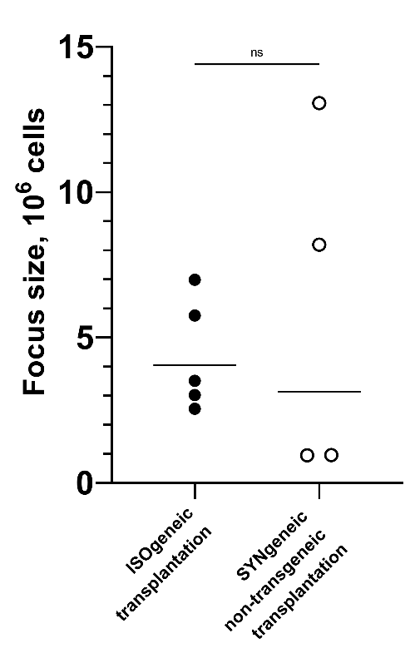
Supplementary Fig. S3. Comparison of the size of the foci in cohorts. The recipients of the compared groups were C57Bl/6 mice immunized with GFP. In isogeneic transplantation, BM of Nes-GFP mice was implanted to the recipients. In syngeneic non-transgeneic transplantation, BM of C57Bl/6 mice was implanted. Formal analysis did not demonstrate statistically significant differences between groups.

- Gating strategy of GFP⁺ cells from foci by flow cytometry
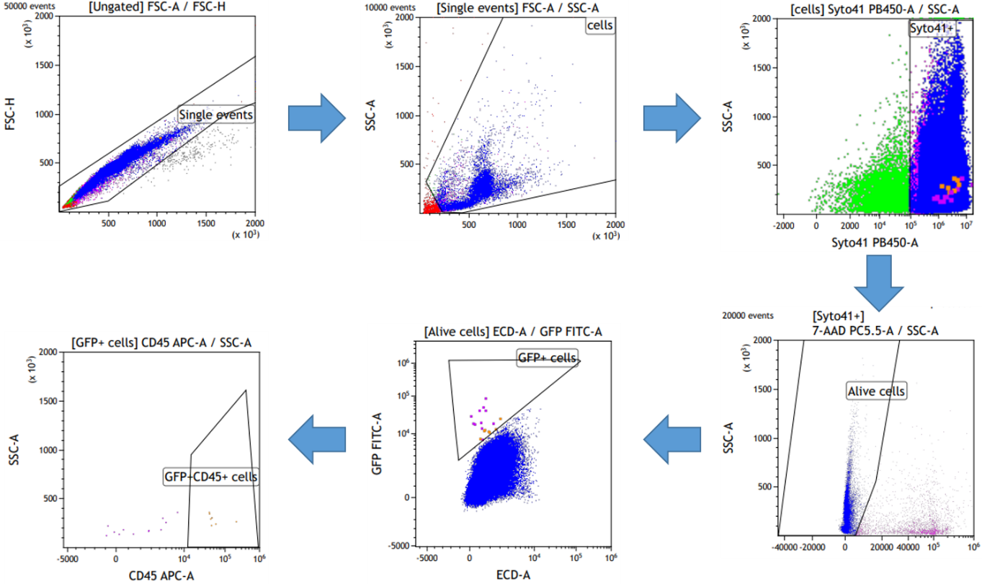
Supplementary Fig. S4. Step-wise strategy utilized to count GFP⁺ cells in experimental groups.

- Consistency of negative controls
A part of negative control samples were processed at a separate date from main samples and provided inconsistent results: we gated GFP⁺ cells in these samples. The numbers of GFP⁺ cells put at the question our main results, so we performed additional checks (data is presented in Tab. S1 and Fig. S5). As we gated GFP⁺ cells in HEFs and in BM of inconsistent samples, we performed additional measurements of BM samples from non-transgenic mice. Most additional samples demonstrated 0 gated GFP⁺ cells. Several additional samples demonstrated a number of gated “GFP⁺” cells, albeit it was so low that it did not interfere with our main results. Low proportion of gated GFP⁺ cells in those samples was consistent with other results from early studies (ссылка на рисунок/таблицу/статью). Values of low proportions of GFP⁺ cells did not interfere with the values for main groups (Fig. S5), not for BMs neither for HEFs. It could be suggested that “inconsistent” results could be explained by the fact that these “inconsistent” negative controls were BMs and HIFs obtained from non-transgenic mice immunized with GFP, so that GFP as a protein was injected into these mice and for some unknown reason it resulted in GFP⁺ cells. However, inconsistent results demonstrate bigger numbers of GFP⁺ cells even in case of BSA immunization. We interpret the found inconsistency as an artifact of experiment. Results of measurements for main experiment were acquired together with negative controls presented in the main text, they did not demonstrate mentioned inconsistency.

Table S1. Consistency of negative controls. Negative controls for BMs and HEFs were acquired from samples without Nes-GFP transgene cells and data of main interest acquired from HEFs samples for Nes-GFP transgene donors and non-transgene recipient. Group “HEF published data” presents results from our previous experiment (1). Table presents number of gated GFP⁺ cells, alive cells in samples and proportion of GFP⁺ cells.
Group | Immunization | Proportion of GFP⁺ cells х10⁵ | GFP⁺ cells | Alive nucleated cells
Non-transgenic donor and recipient
HEF inconsistent results | GFP 200 | 1,3 | 9 | 668111
HEF inconsistent results | GFP 200 | 1,1 | 10 | 932054
HEF inconsistent results | GFP 200 | 0,26 | 5 | 1909933
HEF inconsistent results | GFP 200 | 0,89 | 7 | 783536
HEF inconsistent results | BSA | 1,3 | 18 | 1424918
HEF inconsistent results | BSA | 1,1 | 7 | 641643
BM inconsistent results | GFP 200 | 9,8 | 23 | 233643
BM inconsistent results | GFP 200 | 10 | 25 | 248978
BM inconsistent results | GFP 200 | 3,6 | 11 | 301463
BM inconsistent results | GFP 200 | 5,4 | 22 | 408039
BM inconsistent results | BSA | 5,7 | 20 | 353506
BM inconsistent results | BSA | 3,7 | 12 | 321605
BM additional measurements | - | 0,14 | 2 | 1437284
BM additional measurements | - | 0,011* | 0 | 951433
BM additional measurements | - | 0,0084* | 0 | 1186455
BM additional measurements | - | 0,082 | 1 | 1219038
BM additional measurements | - | 0,0090* | 0 | 1107194
BM additional measurements | - | 0,089 | 1 | 1125146
BM additional measurements | - | 0,0093* | 0 | 1069538
BM additional measurements | - | 0,010* | 0 | 1029122
BM additional measurements | - | 0,012* | 0 | 848029
BM early experiments | - | 0,039 | 1 | 2587753
BM early experiments | - | 0,11 | 1 | 938397
HEF this study | GFP 200 | 0,10* | 0 | 95314
HEF this study | GFP 200 | 0,054* | 0 | 184141
HEF published data | - | 0,033* | 0 | 302269
HEF published data | - | 0,11* | 0 | 89398
HEF published data | - | 0,013* | 0 | 779434
HEF published data | - | 0,15* | 0 | 67475
Nes-GFP transgenic donor and non-transgenic recipient
HEF initial transplantation | GFP 20 | 70 | 651 | 933929
HEF initial transplantation | GFP 20 | 83 | 377 | 456961
HEF initial transplantation | GFP 20 | 156 | 1367 | 877670
HEF initial transplantation | GFP 200 | 12 | 65 | 564019
HEF initial transplantation | GFP 200 | 5,4 | 27 | 496327
HEF initial transplantation | GFP 200 | 11 | 60 | 551181
HEF initial transplantation | GFP 200 | 12 | 60 | 507518
HEF retransplantation | GFP 20 | 4,0 | 19 | 477919
HEF retransplantation | GFP 200 | 9,1 | 62 | 680854
HEF retransplantation | GFP 200 | 8,4 | 45 | 535181
HEF transplantation published | - | 19 | 189 | 993267
HEF transplantation published | - | 0,016* | 0 | 615881
HEF transplantation published | - | 23 | 428 | 1885924
HEF transplantation published | - | 9,0 | 135 | 1497972
HEF transplantation published | - | 7,0 | 52 | 745908
HEF transplantation published | - | 3,8 | 42 | 1102013
*calculated according to materials and methods as 1/10 of the detection limit.

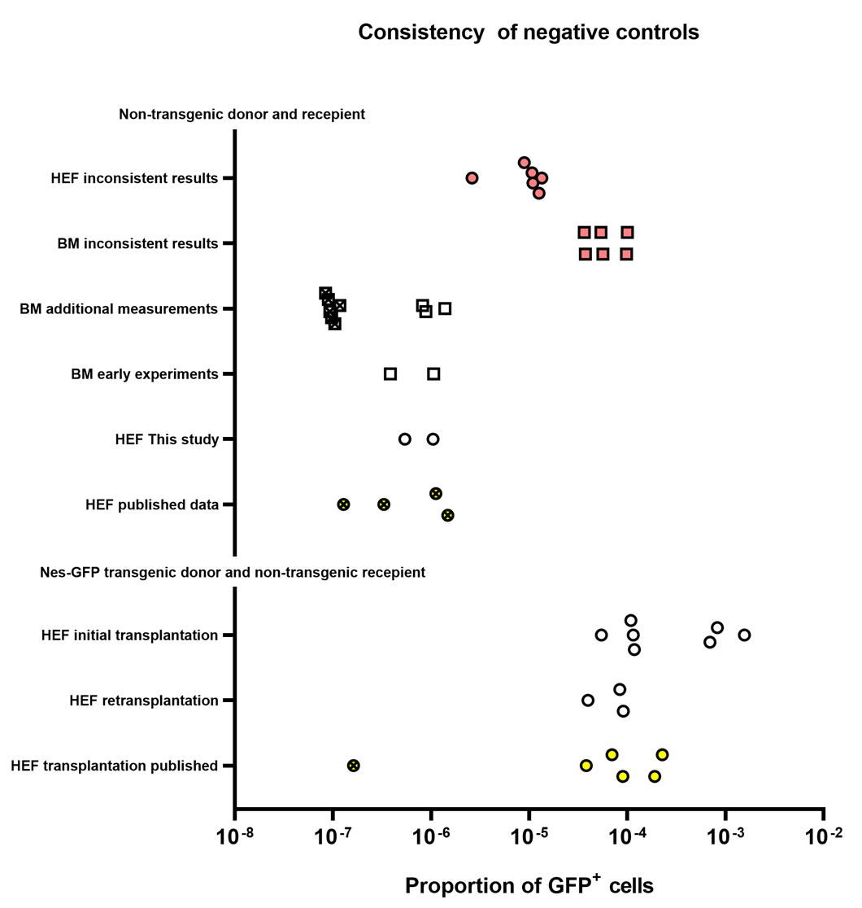
Fig. S5. Consistency of negative controls. Negative controls for BMs and HEFs were acquired from samples without Nes-GFP transgenic cells and data of main interest acquired from HEFs samples for Nes-GFP transgenic donors and non-transgenic recipient. Group “HEF published data” presents results from our previous experiment (1). Figure presents proportion of GFP⁺ cells in samples. Crossed markers represent samples without gated GFP⁺ cells. For these samples, the proportion depicted was calculated according to materials and methods as 1/10 of the detection limit in order to plot them in log-scale. Red color represents “inconsistent” controls. Yellow color represents previously published data (1). Circles represent data for HEFs and squares represent data for BMs.

- CD45⁺/CD45⁻ inclusion criterion
We suggested the proportion of hematopoietic and non-hematopoietic cells reflects right cellular composition of the focus and is related to its functionality. To take this into account we created rank order plot for the ratio of CD45⁺ to CD45– alive nucleated cells and appended the same data of our previous experiment (Fig. S6) (1). Here we took into account all samples from all groups with an exception of samples, in which 0 CD45– cells was detected. Basing on the plot, we excluded samples that corresponded to peripheral inflections. Graphically determined range of acceptability was arbitrarily set as 43 – 241.

Fig. S6. Rank order plot for the ratio of CD45⁺ to CD45– cells. Black circles correspond to samples that were included in analysis; white circles correspond to samples that were excluded.

- Immunization vs. non-immunization
We compared the frequencies of GFP⁺ cells with our previous experiment, which was similar to this one, except for the recipients were not immunized (1). The proportion of GFP⁺ cells in isogeneic transplantations was 25.6 × 10^{–5} ×÷ 3.6 (Supplementary Fig. S7, panel A).
Table S2. MFC analysis of absolute and relative numbers of GFP⁺ cells in ectopic foci formed in GFP-immunized recipients and in non-immunized recipients from our previous experiment (1).
Group | GFP immunization | GFP⁺CD45– |  | GFP⁺CD45⁺ |  | Alive nucleated cells
Group | GFP immunization | Proportion, × 10⁻⁵; | Number, cells | Proportion, × 10⁻⁵; | Number, cells | Alive nucleated cells
isogeneic transplantation | 20 μg | 1,5 | 14 | 68,21 | 637 | 933929
isogeneic transplantation | 20 μg | 0,66 | 3 | 81,85 | 374 | 456961
isogeneic transplantation | 20 μg | 0,57 | 5 | 155,18 | 1362 | 877670
isogeneic transplantation | 200 μg | 2,13 | 12 | 9,4 | 53 | 564019
isogeneic transplantation | 200 μg | 0,4 | 2 | 5,04 | 25 | 496327
isogeneic transplantation | 200 μg | 0,54 | 3 | 10,34 | 57 | 551181
isogeneic transplantation | 200 μg | 0,59 | 3 | 11,23 | 57 | 507518
isogeneic retransplantation | 20 μg | 2,51 | 12 | 1,46 | 7 | 477919
isogeneic retransplantation | 200 μg | 0,59 | 4 | 8,52 | 58 | 680854
isogeneic retransplantation | 200 μg | 0,37 | 2 | 8,03 | 43 | 535181
negative control transplantation | 200 μg | 0,1* | 0 | 0,1* | 0 | 95314
negative control transplantation | 200 μg | 0,05* | 0 | 0,05* | 0 | 184141
Data from the previous experiment:
isogeneic transplantation | none | 16,06 | 49 | 2,62 | 8 | 305111
isogeneic transplantation | none | 4,53 | 45 | 14,5 | 144 | 993267
isogeneic transplantation | none | 0.02* | 0 | 0.02* | 0 | 615881
isogeneic transplantation | none | 6,95 | 131 | 15,75 | 297 | 1885924
isogeneic transplantation | none | 1,47 | 22 | 7,54 | 113 | 1497972
isogeneic transplantation | none | 4,29 | 32 | 2,68 | 20 | 745908
isogeneic transplantation | none | 2,09 | 23 | 1,72 | 19 | 1102013
*calculated according to materials and methods as 1/10 of the detection limit.

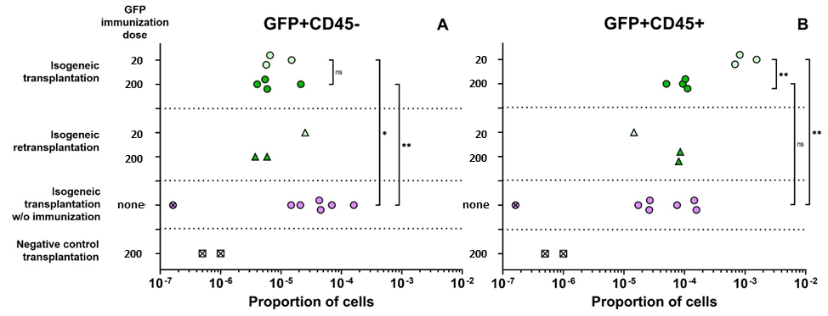
Supplementary Fig. S7. Relative numbers of GFP⁺ cells in ectopic foci. The obtained data were appended by the data from our previous experiment without immunization (1). The numbers are taken from Table S2. A. GFP⁺CD45– cells. B. GFP⁺CD45⁺ cells. There were no GFP⁺ cells in negative control transplantations and in one isogenic transplant in experiment without immunization (designated as crossed markers). For these samples, the proportion depicted was calculated according to materials and methods as 1/10 of the detection limit in order to plot them in log-scale.

Both CD45⁺ and CD45– cells expressing GFP were detected in the inner contents of the foci in isogenic transplantations. The proportion of GFP⁺CD45– cells, which are associated with MSCs in Nestin-GFP mice, did not demonstrate significant difference relative to immunization dose (p = 0.80), and its aggregated mean value was 0.8 × 10^{–5} ×÷ 1.8 (Supplementary Fig. S7, panel A). It was lower than the proportion of GFP⁺CD45– cells in isogeneic transplantations in our previous experiment with non-immunized recipients, (p = 0.019 and p = 0.009 according to Students t-test comparing non-immunized recipients with 20 and 200 µg immunization groups, respectively). It implies that although Nestin-GFP⁺CD45– MSCs and other progenitors have strong IPs, they still experience some pressure from the targetedly activated immune system. It is important to note that the small number of positive events and some subjectivity in positioning of MFC gates may have some impact on derived numbers of GFP⁺CD45– cells. Cytokines produced in immunized and non-immunized recipients may also contribute to foci regulation beyond the specific immune response. Therefore, the found differences should be interpreted with additional caution.
Unlike GFP⁺CD45– cells, the proportion of GFP⁺CD45⁺ cells in isogenic transplants strongly depended on the immunization dose: it was 95.3 × 10^{–5} ×÷ 1.5 and 8.6 × 10^{–5} ×÷ 1.4 for lower and higher immunization dose, correspondingly. Surprisingly, the proportion of GFP⁺CD45⁺ cells obtained in recipients, which were immunized with a lower dose, was significantly higher (p = 0.0018) than the proportion of such cells in our previous experiment with non-immunized recipients (Supplementary Fig. S7, panel B). At the same time, GFP⁺CD45⁺ cells proportion observed in the primary foci, obtained in recipients immunized with a higher doze, did not significantly differ from subpopulation of such cells in non-immunized recipients (p = 0.36). This demonstrates the existence of a complex internally contradirectional regulation providing non-linear effects, at least for GFP⁺CD45⁺.
Looking at retransplantation data, we can see that the proportion of GFP+ cells in the secondary recipients depends on the immunization dose of the primary recipients, and we can see that these dependencies are different for GFP⁺CD45– and GFP⁺CD45⁺ cells (Fig. S7). We can see an increase in GFP⁺CD45⁺ cells proportion and a decrease in GFP⁺CD45– cells proportion, as the GFP immunization dose is increased. Yet, we compare the group with one sample and the group with two samples. It is appealing to make conclusions, since two samples from the group immunized with 200 µg GFP demonstrate close values, while a single sample comprising another group stay apart. So, we note it, but don’t provide further analysis as we don’t have enough grounds.
Summarizing our results, we observe different effects exerted by immunization on GFP⁺CD45– and GFP⁺CD45⁺ cells, which may point to different regulation of these subpopulations by immune system.
1. Karpenko D, Kapranov N, Bigildeev A. Nestin-GFP transgene labels immunoprivileged bone marrow mesenchymal stem cells in the model of ectopic foci formation. Front Cell Dev Biol [Internet]. 2022 Sep 5 [cited 2022 Dec 21];10:993056. Available from: /pmc/articles/PMC9483855/

