Thianthrenium-Enabled Chromium-Catalyzed Deuterated Alkyl Addition to Aldehydes via Photoactive Electron Donor-Acceptor Complex
(Supporting Information)

Wenjuan Xiao,¹ Youye Tian,¹ Liting Du, ³ Wen Liu,¹ Changping Fang,¹ Mengtao Ma,¹ Binlin Zhao,^{1,2}*
¹Department of Chemistry and Materials Science, College of Science, Nanjing Forestry University, Nanjing 210037, China.
²State Key Laboratory of Coordination Chemistry, School of Chemistry and Chemical Engineering, Nanjing University, Nanjing 210093, China.
³Advanced Analysis and Testing Center, Nanjing Forestry University, Nanjing 210037, China.

1. General Information 2
2. Preparation of alkyl thianthrenium salts and d2-alkyl thianthrenium salts. 3
3. Procedure for the preparation of aldehyde 2v. 9
4. Reaction optimization. 9
5. Experimental procedures and characterization of products 10
6. Experimental procedures for photoactive chromium-catalyzed three-component reactions and characterization of products 33
7. Mechanistic experiments 36
7.1 Radical trapping experiments 36
7.2 Emission quenching experiments (Stern–Volmer studies) 37
7.3 UV-vis absorption study 38
7.4 Job’s method experiment: 40
8. References 41
9. Copies of NMR Spectra 42

- General Information
Unless otherwise noted, all reactions were performed under an N₂ atmosphere using flame-dried glassware. All new compounds were fully characterized. NMR-spectra were recorded on ARX-600 Associated. ¹H NMR spectra data were reported as δ values in ppm relative to chloroform (δ 7.26) if collected in CDCl₃. ¹³C NMR spectra data were reported as δ values in ppm relative to chloroform (δ 77.00). ¹H NMR coupling constants were reported in Hz, and multiplicity was indicated as follows: s (singlet); d (doublet); t (triplet); q (quartet); quint (quintet); m (multiplet); dd (doublet of doublets); ddd (doublet of doublet of doublets); dddd (doublet of doublet of doublet of doublets); dt (doublet of triplets); td (triplet of doublets); ddt (doublet of doublet of triplets); dq (doublet of quartets); app (apparent); br (broad). Mass spectra were conducted at Micromass Q-Tof instrument (ESI) and Agilent Technologies 5973N (EI). All reactions were carried out in flame-dried 10 mL schlenk tubes with Teflon screw caps under N₂. Unless otherwise noted, materials obtained from commercial suppliers were used without further purification. Blue LEDs (45 W, λmax = 400-410 nm) purchased were used for blue light irradiation. A fan attached to the apparatus was used to maintain the reaction temperature at room temperature.
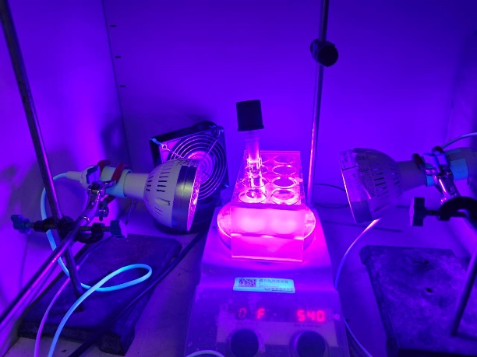
Figure S1. Reaction set up for this project

2. Preparation of alkyl thianthrenium salts and d2-alkyl thianthrenium salts.
Table S1: Scope of alkyl thianthrenium salts
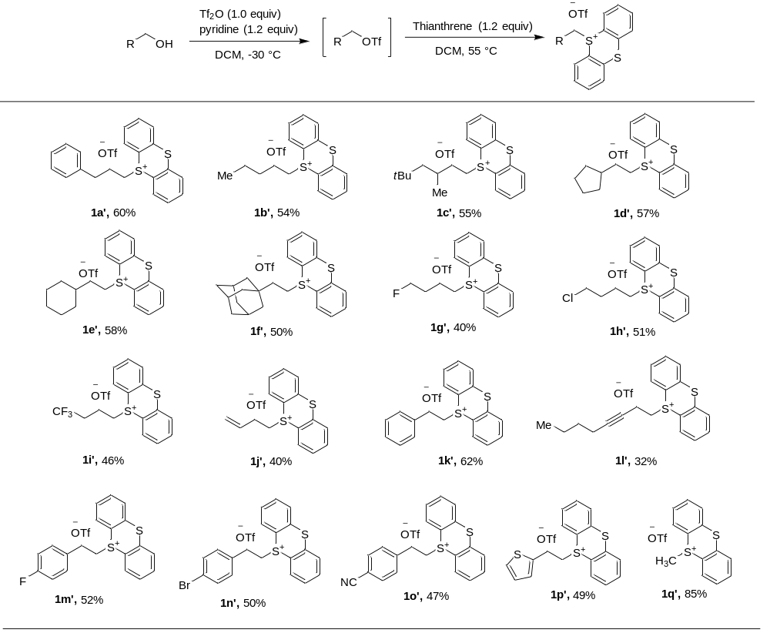
2.1 General procedure A for alkyl thianthrenium salts ^{[1]}：A flame-dried 100 mL flask was placed under an atmosphere of nitrogen and charged with a stir bar and alcohol (5.0 mmol, 1.0 equiv). The alcohol was dissolved in CH₂Cl₂ (20.0 mL) and cooled to -30 °C before adding pyridine (483 µL, 6.0 mmol, 1.2 equiv). While stirring, triflic anhydride (1.0 mL, 6.0 mmol, 1.20 equiv) was added dropwise, and then the reaction mixture stirred for 3 h while remaining at -5 °C. While the flask was still in a -5 °C bath, 0.5 M H₂SO₄ (30 mL) was added. The flask was removed from the cold bath, and the mixture was transferred to a separatory funnel and extracted with 3×20 mL of CH₂Cl₂. The organic layers were combined and washed 1× 50 mL of distilled water. The collected organic layers were then dried over MgSO₄, then filtered and concentrated to a 10 mL liquid under vacuum (without heating), which was used directly in the next step.
Flame-dried 25 mL schlenk tube was added thianthrene (1.08g, 5.0 mmol), then the above liquid was added. The mixture was stired at 55 °C for 24 h. The mixture was carefully condensed under reduced pressure at 25 ºC and purified by precipitation with Et₂O/DCM. Most of the unreacted dibenzothiophene was removed by repeating the precipitation procedure 2 or 3 times. If the salt still did not precipitate, it was subjected to silica gel chromatography with acetone/DCM.
2.2 General procedure B for d2-alkyl thianthrenium salts: To a flame-dried 10 mL flask with a stir bar was added the alkyl thianthrenium salts 1 (0.6 mmol, 1.0 equiv), K₂CO₃ (1.8 mmol, 3.0 equiv), MeCN (2 mL) and D₂O (1 mL). The reaction was stirred at 40 ℃. for 2h. Then the reaction mixture was dried over anhydrous MgSO₄, then filtered and concentrated under reduced pressure to give the product. Or the product then was purified by precipitation with Et₂O/DCM. Deuterium incorporation of the product was determined by ¹H NMR spectroscopy or HRMS. The d2-alkyl thianthrenium salts were used without further purification.

5-(3-phenylpropyl)-5H-thianthren-5-ium trifluoromethanesulfonate (1a’)
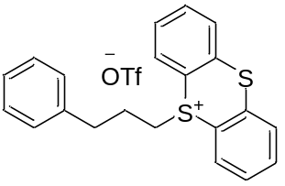¹H NMR (600 MHz, CDCl₃) δ 8.29 (dd, J = 7.9, 1.3 Hz, 2H), 7.77 (dd, J = 7.9, 1.4 Hz, 2H), 7.72 (td, J = 7.6, 1.4 Hz, 2H), 7.65 (td, J = 7.6, 1.4 Hz, 2H), 7.24 – 7.16 (m, 3H), 7.03 – 6.98 (m, 2H), 3.82 – 3.76 (m, 2H), 2.71 (t, J = 7.4 Hz, 2H), 1.91 (p, J = 7.6 Hz, 2H). All data are in accordance with the literature.^{[1]}

5-pentyl-5H-thianthren-5-ium trifluoromethanesulfonate (1b’)
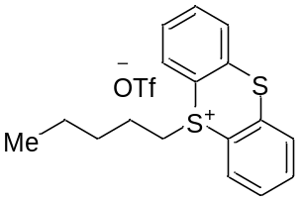¹H NMR (600 MHz, CDCl₃) δ 8.27 (d, J = 7.8 Hz, 2H), 7.83 (d, J = 7.9 Hz, 2H), 7.75 (t, J = 7.6 Hz, 2H), 7.65 (t, J = 7.5 Hz, 2H), 3.80 – 3.70 (m, 2H), 1.52 (p, J = 7.6 Hz, 2H), 1.34 (dd, J = 10.7, 4.9 Hz, 2H), 1.21 (h, J = 7.3 Hz, 2H), 0.77 (t, J = 7.3 Hz, 3H). ¹³C NMR (151 MHz, CDCl₃) δ 135.6, 134.8, 134.4, 123.0, 129.9, 117.4, 40.4, 29.8, 24.1, 21.8, 13.5. ¹⁹F NMR (565 MHz, CDCl₃) δ -78.3. ¹⁹F NMR (565 MHz, CDCl₃) δ -78.31.HRMS m/z (ESI) calculated for C₁₈H₁₉F₃O₃S₃ (M – OTf)⁺ 287.0923, found 287.0925.

5-(3,5,5-trimethylhexyl)-5H-thianthren-5-ium trifluoromethanesulfonate (1c’)
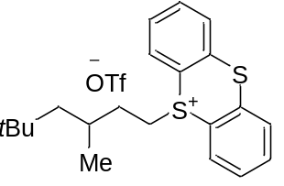¹H NMR (600 MHz, CDCl₃) δ 8.35 – 8.30 (m, 2H), 7.83 (d, J = 7.9 Hz, 2H), 7.77 – 7.73 (m, 2H), 7.70 – 7.64 (m, 2H), 3.76 (dtd, J = 15.6, 11.6, 6.1 Hz, 2H), 1.54 – 1.45 (m, 2H), 1.44 – 1.36 (m, 1H), 1.01 – 0.94 (m, 2H), 0.84 (d, J = 6.4 Hz, 3H), 0.76 (s, 9H). ¹³C NMR (151 MHz, CDCl₃) δ 135.5, 135.0, 135.0, 134.4, 129.9, 117.6, 50.2, 38.6, 32.8, 30.9, 29.7, 28.9, 21.7. ¹⁹F NMR (565 MHz, CDCl₃) δ -78.2. HRMS m/z (ESI) calculated for C₂₂H₂₇F₃O₃S₃ (M – OTf)⁺ 343.1549, found 343.1547.

5-(2-cyclopentylethyl)-5H-thianthren-5-ium trifluoromethanesulfonate (1d’)
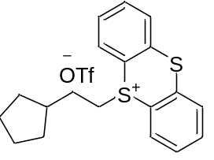¹H NMR (600 MHz, CDCl₃) δ 8.29 (dd, J = 7.9, 1.4 Hz, 2H), 7.83 (dd, J = 8.0, 1.3 Hz, 2H), 7.75 (td, J = 7.7, 1.3 Hz, 2H), 7.66 (td, J = 7.7, 1.3 Hz, 2H), 3.78 – 3.68 (m, 2H), 1.79 – 1.61 (m, 3H), 1.55 – 1.37 (m, 6H), 0.97 (dq, J = 12.1, 7.9 Hz, 2H). ¹³C NMR (151 MHz, CDCl₃) δ 135.5, 135.0, 134.3, 129.9, 129.9, 117.7, 39.7, 38.7, 32.1, 30.2, 24.9. ¹⁹F NMR (565 MHz, CDCl₃) δ -78.2. HRMS m/z (ESI) calculated for C₂₀H₂₁F₃O₃S₃ (M – OTf)⁺ 313.1079, found 313.1081.

5-(2-cyclohexylethyl)-5H-thianthren-5-ium trifluoromethanesulfonate (1e’)
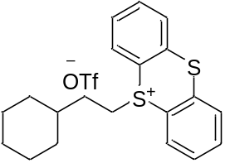¹H NMR (600 MHz, CDCl₃) δ 8.35 (dd, J = 7.9, 1.4 Hz, 2H), 7.85 (dd, J = 7.9, 1.3 Hz, 2H), 7.77 (td, J = 7.7, 1.3 Hz, 2H), 7.69 (td, J = 7.7, 1.3 Hz, 2H), 3.87 – 3.76 (m, 2H), 1.66 – 1.53 (m, 5H), 1.49 – 1.40 (m, 2H), 1.33 – 1.26 (m, 1H), 1.17 – 1.01 (m, 3H), 0.82 (qd, J = 12.3, 3.3 Hz, 2H). ¹³C NMR (151 MHz, CDCl₃) δ 135.6, 135.0, 134.3, 129.9, 129.9, 117.6, 38.8, 36.7, 32.4, 31.3, 26.0, 25.8. ¹⁹F NMR (565 MHz, CDCl₃) δ -78.2. HRMS m/z (ESI) calculated for C₂₁H₂₃F₃O₃S₃ (M – OTf)⁺ 327.1236, found 327.1237.

5-(2-((3r,5r,7r)-adamantan-1-yl)ethyl)-5H-thianthren-5-ium trifluoromethanesulfonate (1f’)
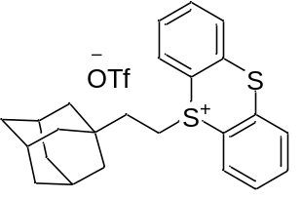¹H NMR (600 MHz, CDCl₃) δ 8.36 (dd, J = 7.9, 1.4 Hz, 2H), 7.82 (dd, J = 7.9, 1.3 Hz, 2H), 7.74 (td, J = 7.7, 1.4 Hz, 2H), 7.68 (td, J = 7.7, 1.4 Hz, 2H), 3.82 – 3.75 (m, 2H), 1.91 – 1.86 (m, 3H), 1.72 (s, 2H), 1.63 (d, J = 3.0 Hz, 1H), 1.51 (dq, J = 12.7, 2.0 Hz, 3H), 1.34 (d, J = 2.9 Hz, 6H), 1.29 – 1.23 (m, 2H). All data are in accordance with the literature.^{[1]}

5-(4-fluorobutyl)-5H-thianthren-5-ium trifluoromethanesulfonate (1g’)
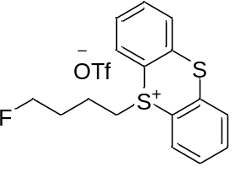¹H NMR (600 MHz, CDCl₃) δ 8.33 (d, J = 7.8 Hz, 2H), 7.83 (d, J = 7.9 Hz, 2H), 7.75 (t, J = 7.6 Hz, 2H), 7.68 (t, J = 7.6 Hz, 2H), 4.45 (t, J = 5.3 Hz, 1H), 4.38 (t, J = 5.3 Hz, 1H), 3.88 (t, J = 7.7 Hz, 2H), 1.90 – 1.79 (m, 2H), 1.74 (p, J = 7.5 Hz, 2H). ¹³C NMR (151 MHz, CDCl₃) δ 135.7, 134.6, 134.5, 130.1, 129.9, 116.8, 82.9 (d, J = 165.2 Hz), 40.0, 28.3 (d, J = 19.9 Hz), 21.0 (d, J = 4.1 Hz). ¹⁹F NMR (565 MHz, CDCl₃) δ -78.2, -219.4. HRMS m/z (ESI) calculated for C₁₇H₁₆F₄O₃S₃ (M – OTf)⁺ 291.0672, found 291.0672.

5-(4-chlorobutyl)-5H-thianthren-5-ium trifluoromethanesulfonate (1h’)
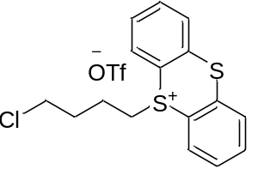¹H NMR (600 MHz, CDCl₃) δ 8.30 (dd, J = 7.9, 1.3 Hz, 2H), 7.84 (dd, J = 7.9, 1.3 Hz, 2H), 7.76 (td, J = 7.7, 1.3 Hz, 2H), 7.67 (td, J = 7.7, 1.3 Hz, 2H), 3.89 – 3.80 (m, 2H), 3.49 (t, J = 6.1 Hz, 2H), 1.96 – 1.88 (m, 2H), 1.73 (p, J = 7.5 Hz, 2H).
All data are in accordance with the literature. ^{[1]}

5-(4,4,4-trifluorobutyl)-5H-thianthren-5-ium trifluoromethanesulfonate (1i’)
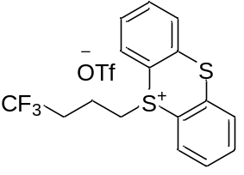¹H NMR (600 MHz, CDCl₃) δ 8.32 (dd, J = 7.9, 1.3 Hz, 2H), 7.85 (dd, J = 7.9, 1.3 Hz, 2H), 7.78 (td, J = 7.7, 1.3 Hz, 2H), 7.69 (td, J = 7.7, 1.3 Hz, 2H), 3.96 – 3.87 (m, 2H), 2.31 (qt, J = 10.5, 7.5 Hz, 2H), 1.84 (p, J = 7.7 Hz, 2H). All data are in accordance with the literature. ^{[2]}

5-(but-3-en-1-yl)-5H-thianthren-5-ium trifluoromethanesulfonate (1j’)
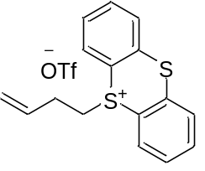¹H NMR (600 MHz, CDCl₃) δ 8.31 (dd, J = 7.9, 1.4 Hz, 2H), 7.83 (dd, J = 8.0, 1.3 Hz, 2H), 7.75 (td, J = 7.7, 1.3 Hz, 2H), 7.67 (td, J = 7.7, 1.3 Hz, 2H), 5.72 (ddt, J = 16.9, 10.2, 6.7 Hz, 1H), 5.19 – 4.99 (m, 2H), 3.91 (t, J = 7.4 Hz, 2H), 2.40 – 2.32 (m, 2H). All data are in accordance with the literature. ^{[3]}

5-phenethyl-5H-thianthren-5-ium trifluoromethanesulfonate (1k’)
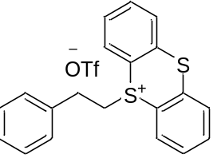¹H NMR (600 MHz, CDCl₃) δ 8.24 (dd, J = 7.9, 1.4 Hz, 2H), 7.80 (dd, J = 7.9, 1.3 Hz, 2H), 7.71 (td, J = 7.7, 1.4 Hz, 2H), 7.61 (td, J = 7.7, 1.3 Hz, 2H), 7.19 (ddd, J = 12.2, 7.7, 6.0 Hz, 3H), 7.13 – 7.09 (m, 2H), 4.10 – 4.04 (m, 2H), 3.05 – 2.97 (m, 2H). All data are in accordance with the literature. ^{[1]}

5-(oct-3-yn-1-yl)-5H-thianthren-5-ium trifluoromethanesulfonate (1l’)
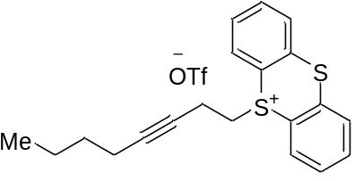¹H NMR (600 MHz, CDCl₃) δ 8.36 (dd, J = 7.9, 1.4 Hz, 2H), 7.83 (dd, J = 7.9, 1.3 Hz, 2H), 7.74 (td, J = 7.6, 1.3 Hz, 2H), 7.67 (td, J = 7.7, 1.3 Hz, 2H), 3.94 (t, J = 6.6 Hz, 2H), 2.66 (tt, J = 6.6, 2.4 Hz, 2H), 2.00 (tt, J = 7.1, 2.3 Hz, 2H), 1.39 – 1.28 (m, 4H), 0.88 (t, J = 7.1 Hz, 3H). ¹³C NMR (151 MHz, CDCl₃) δ 136.1, 134.8, 134.6, 130.1, 129.8, 120.7 (q, J = 320.7 Hz) 117.1, 85.9, 73.2, 40.2, 30.5, 21.9, 18.3, 15.5, 13.5. ¹⁹F NMR (565 MHz, CDCl₃) δ -78.2. HRMS m/z (ESI) calculated for C₂₁H₂₁F₃O₃S₃ (M – OTf)⁺ 325.1079, found 325.1079.

5-(4-fluorophenethyl)-5H-thianthren-5-ium trifluoromethanesulfonate (1m’)
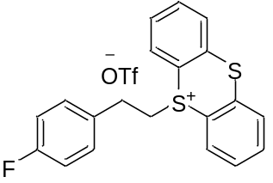¹H NMR (600 MHz, CDCl₃) δ 8.22 (dd, J = 8.0, 1.4 Hz, 2H), 7.81 (dd, J = 7.9, 1.3 Hz, 2H), 7.73 (td, J = 7.7, 1.3 Hz, 2H), 7.62 (td, J = 7.7, 1.3 Hz, 2H), 7.13 – 7.08 (m, 2H), 6.91 – 6.85 (m, 2H), 4.08 – 4.00 (m, 2H), 3.03 – 2.93 (m, 2H). All data are in accordance with the literature. ^{[1]}

5-(4-bromophenethyl)-5H-thianthren-5-ium trifluoromethanesulfonate (1n’)
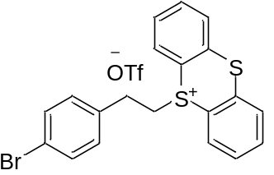¹H NMR (600 MHz, CDCl₃) δ 8.15 (dd, J = 8.0, 1.3 Hz, 2H), 7.81 (dd, J = 7.9, 1.3 Hz, 2H), 7.72 (td, J = 7.7, 1.3 Hz, 2H), 7.59 (td, J = 7.7, 1.3 Hz, 2H), 7.30 – 7.24 (m, 2H), 7.03 – 6.98 (m, 2H), 4.05 – 3.99 (m, 2H), 2.96 (t, J = 7.8 Hz, 2H). All data are in accordance with the literature. ^{[1]}

5-(4-cyanophenethyl)-5H-thianthren-5-ium trifluoromethanesulfonate (1o’)
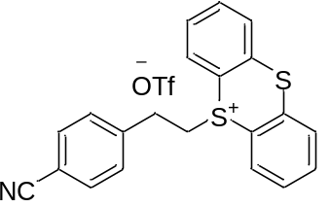¹H NMR (600 MHz, CDCl₃) δ 8.26 (dd, J = 7.9, 1.3 Hz, 2H), 7.83 (dd, J = 7.9, 1.3 Hz, 2H), 7.75 (td, J = 7.7, 1.3 Hz, 2H), 7.65 (td, J = 7.7, 1.3 Hz, 2H), 7.49 (d, J = 8.1 Hz, 2H), 7.30 (d, J = 8.1 Hz, 2H), 4.11 – 4.03 (m, 2H), 3.07 (t, J = 7.9 Hz, 2H). All data are in accordance with the literature. ^{[1]}

5-(2-(thiophen-2-yl)ethyl)-5H-thianthren-5-ium trifluoromethanesulfonate (1p’)
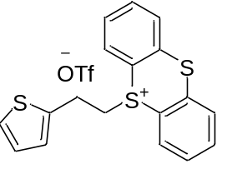¹H NMR (600 MHz, CDCl₃) δ 8.17 (dd, J = 8.0, 1.3 Hz, 2H), 7.80 (dd, J = 7.9, 1.3 Hz, 2H), 7.70 (td, J = 7.7, 1.3 Hz, 2H), 7.60 (td, J = 7.7, 1.3 Hz, 2H), 7.07 (dd, J = 5.1, 1.2 Hz, 1H), 6.98 (dd, J = 3.5, 1.2 Hz, 1H), 6.86 (dd, J = 5.1, 3.5 Hz, 1H), 4.11 (t, J = 7.3 Hz, 2H), 3.33 (t, J = 7.2 Hz, 2H). All data are in accordance with the literature. ^{[1]}

5-methyl-5H-thianthren-5-ium trifluoromethanesulfonate (1q’)
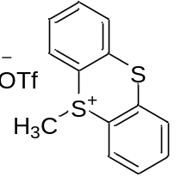¹H NMR (600 MHz, CDCl₃) δ 8.36 (dd, J = 7.9, 1.4 Hz, 2H), 7.83 (dd, J = 7.9, 1.3 Hz, 2H), 7.74 (td, J = 7.7, 1.3 Hz, 2H), 7.68 (td, J = 7.7, 1.4 Hz, 2H), 3.34 (s, 3H). All data are in accordance with the literature. ^{[1]}

5-(3-phenylpropyl-1,1-d2)-5H-thianthren-5-ium trifluoromethanesulfonate (1a)
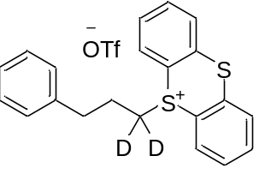¹H NMR (600 MHz, CDCl₃) δ 8.16 (d, J = 7.9 Hz, 2H), 7.77 (d, J = 7.9 Hz, 2H), 7.72 (t, J = 7.6 Hz, 2H), 7.59 (t, J = 7.8 Hz, 2H), 7.20 – 7.11 (m, 3H), 6.99 (d, J = 7.4 Hz, 2H), 2.67 (t, J = 7.5 Hz, 2H), 1.84 (t, J = 7.5 Hz, 2H). ¹³C NMR (151 MHz, CDCl₃) δ 138.76, 135.55, 134.44, 134.30, 130.04, 129.68, 128.54, 128.19, 126.46, 120.75 (q, J = 320.12 Hz), 116.68, 33.27, 25.41.¹⁹F NMR (565 MHz, CDCl₃) δ -78.16. HRMS m/z (ESI) calculated for C₂₂H₁₇D₂F₃O₃S₃ (M – OTf)⁺ 337.1048, found 337.1044.
 | Calculated weight | Found weight | Intensity | D%
C₂₁H₁₇D₂S₂⁺ | 337.1048 | 337.1044 | 4178846 | 98%
C₂₁H₁₈DS₂⁺ | 336.0985 | 336.0983 | 177694 | 98%
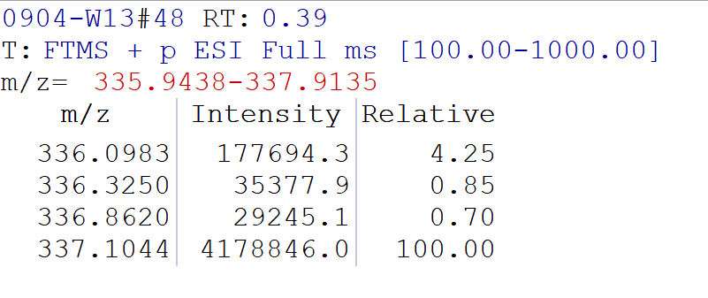
Calculation of D-incorporation^{[4]}
We obtained %D incorporation values via HRMS using Thermo Fisher LTQ Orbitrap XL for deuterated alkyl TT salts and β-deuterated alcohols.
Abbreviations used in formulas:
I_{Dn} = intensity of desired product [M+n] peak
I_{D(n-1)} = intensity of desired product [M+(n-1)] peak
$$\% D incorportion=\frac{I_{Dn}+\frac{I_{D(n-1)}}{n}}{I_{Dn}+I_{D(n-1)}} × 100\%$$

3. Procedure for the preparation of aldehyde 2v.
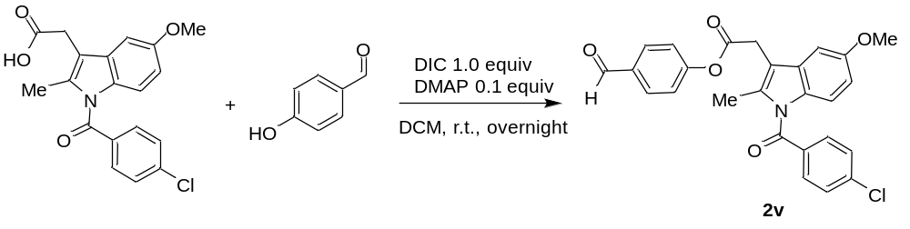
Aldehyde 2v was prepared according to the procedure: ^{[5]} 4-hydroxybenzaldehyde (5.0 mmol, 1.0 equiv), DMAP (0.5 mmol, 0.1 equiv) and indomethacin (5.0 mmol, 1.0 equiv) were added to a 50 mL schlenk tube. Dichloromethane (0.2 M) was then added, followed by DIC (5.0 mmol, 1.0 equiv). The reaction mixture was allowed to stir at room temperature overnight. The solution was washed with water three times and the organic layer was dried with Na₂SO₄. Then the reaction mixture was concentrated under reduced pressure and purified by column chromatography on silica gel to afford 2v as a white solid (5.0 mmol, 3.5 g, 70%): ¹H NMR (600 MHz, CDCl₃) δ 9.97 (s, 1H), 7.93 – 7.87 (m, 2H), 7.72 – 7.64 (m, 2H), 7.51 – 7.45 (m, 2H), 7.27 – 7.23 (m, 2H), 7.04 (d, J = 2.5 Hz, 1H), 6.88 (d, J = 9.0 Hz, 1H), 6.70 (dd, J = 9.0, 2.5 Hz, 1H), 3.94 (s, 2H), 3.84 (s, 3H), 2.47 (s, 3H). All data are in accordance with the literature^{[6]}.

4. Reaction optimization.
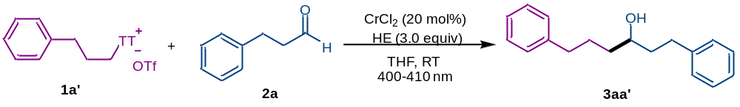
Entry | Variation from the “standard conditions” | Yield (%)^{b}
1 | none | 90 (85)^{c}
2 | Et₃N instead of HE | Trace
3 | DIPEA instead of HE | Trace
4 | CrCl₃ instead of CrCl₂ | 74
5 | CrCl₂ (10 mol%) instead of CrCl₂ (20 mol%) | 72
6 | CH₃CN instead of THF | 66
7 | DCM instead of THF | Trace
8 | DMF instead of THF | Trace
9 | DME instead of THF | 71
10 | DCE instead of THF | Trace
11 | dioxane instead of THF | 60
12 | toluene instead of THF | 16
13 | EA instead of THF | 55
14 | acetone instead of THF | 70
15 | Et₂O instead of THF | Trace
16 | 440-450 nm instead of 400-410 nm | 70
17 | 410-420 nm instead of 400-410 nm | 83
18 | 490-500 nm instead of 400-410 nm | 0
19 | Without light | 0
ª Standard conditions: 1a' (0.3 mmol), 2a (0.2 mmol), CrCl₂ (20 mol %), and HE (0.6 mmol) in THF (1.0 mL), 400 nm-410 nm LEDs, RT, 12 h. ^{b1}H NMR yield using CH₂Br₂ as an internal standard. ^{c} Yield of isolated 3aa' was in parentheses.

5. Experimental procedures and characterization of products
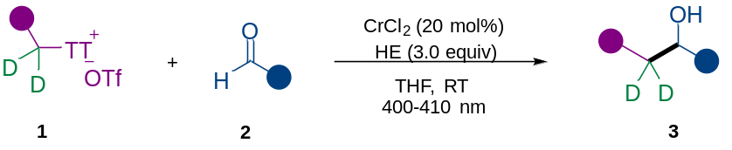
In a nitrogen-filled glove box, to a 10 mL oven-dried schlenk tube equipped with a stir bar was added CrCl₂ (0.04 mmol, 20 mol%). The schlenk tube was sealed and removed from the glovebox. Then alkyl thianthrenium salts 1 (0.3 mmol, 1.5 equiv) and HE (0.6 mmol, 3 equiv) were added under a nitrogen atmosphere. Subsequently, anhydrous THF (1.0 mL) were added via syringe, followed by addition of aldehyde 2 (0.2 mmol, 1.0 equiv). The reaction mixture was stirred and irradiated with two 400-410 nm blue LED lamps for 12 hours. After the reaction completed, the reaction mixture was opened to air diluted with 3 mL of ethyl acetate, and filtered over a 1 cm pad of silica. The pad was rinsed with ethyl acetate (3$×$2 mL), and the combined solutions were concentrated in vacuo. The crude material was loaded onto a silica gel column and separated by flash chromatography (eluent: PE/EA).

1,6-diphenylhexan-3-ol (3aa’)
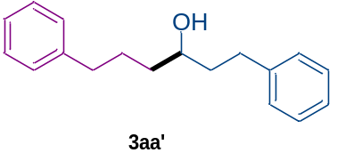According to the general procedure above, eluent in chromatography: petroleum ether: ethyl acetate = 30 : 1, 3aa’ was obtained as a colorless oil (43.2 mg, 85% yield). ¹H NMR (600 MHz, CDCl₃) δ 7.30 – 7.26 (m, 4H), 7.22 – 7.14 (m, 6H), 3.65 (tt, J = 8.2, 4.4 Hz, 1H), 2.78 (ddd, J = 13.7, 9.8, 5.7 Hz, 1H), 2.69 – 2.58 (m, 3H), 1.82 – 1.63 (m, 4H), 1.56 – 1.49 (m, 2H), 1.33 (br, s, 1H). All data are in accordance with the literature.^{[7]}

1,6-diphenylhexan-4,4-d2-3-ol (3aa)
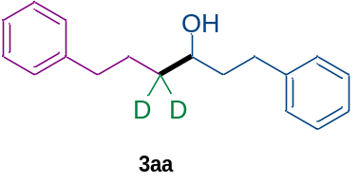According to the general procedure above, eluent in chromatography: petroleum ether: ethyl acetate = 30 : 1, 3aa was obtained as a colorless oil (42.0 mg, 82% yield). ¹H NMR (600 MHz, CDCl₃) δ 7.28 (td, J = 7.5, 2.8 Hz, 4H), 7.22 – 7.15 (m, 6H), 3.64 (dd, J = 8.2, 4.1 Hz, 1H), 2.78 (ddd, J = 13.7, 9.8, 5.6 Hz, 1H), 2.65 (dddd, J = 14.8, 13.5, 9.8, 6.7 Hz, 3H), 1.82 – 1.70 (m, 3H), 1.66 (dt, J = 14.0, 7.6 Hz, 1H), 1.36 (br, s, 1H). ¹³C NMR (151 MHz, CDCl₃) δ 142.3, 142.1, 128.4, 128.3, 125.8, 125.7, 71.1, 39.0, 36.3 (dd, J = 37.1, 19.3 Hz), 35.8, 32.0, 27.2. HRMS m/z (ESI) calculated for C₁₈H₂₀D₂ONa⁺ [M + Na]⁺ 279.1688, found 279.1688.
 | Calculated weight | Found weight | Intensity | D%
C₁₈H₂₀D₂ONa⁺ | 279.1688 | 279.1688 | 655453 | 98%
C₁₈H₂₁DONa⁺ | 278.1626 | 278.1629 | 29549 | 98%
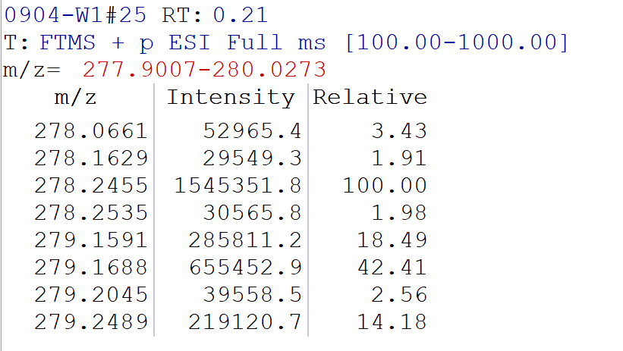

1-phenyloctan-3,3-d2-4-ol (3ab)
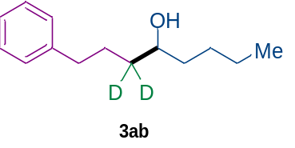According to the general procedure above, eluent in chromatography: petroleum ether: ethyl acetate = 40 : 1, 3ab was obtained as a colorless oil (27.1 mg, 65% yield). ¹H NMR (600 MHz, CDCl₃) δ 7.29 – 7.26 (m, 2H), 7.19 (d, J = 7.3 Hz, 3H), 3.61 (d, J = 6.5 Hz, 1H), 2.67 – 2.59 (m, 2H), 1.77 (dt, J = 15.0, 7.8 Hz, 1H), 1.68 – 1.63 (m, 1H), 1.43 (dddd, J = 28.9, 13.0, 6.4, 4.3 Hz, 3H), 1.35 – 1.27 (m, 4H), 0.90 (t, J = 6.9 Hz, 3H). ¹³C NMR (151 MHz, CDCl₃) δ 142.4, 128.4, 128.3, 125.7, 71.7, 37.1, 36.1 (dd, J = 38.8, 18.6 Hz), 35.9, 27.8, 27.3, 22.7, 14.1. HRMS m/z (ESI) calculated for C₁₄H₂₀D₂ONa⁺ [M + Na]⁺ 231.1688, found 231.1690.
 | Calculated weight | Found weight | Intensity | D%
C₁₄H₂₀D₂ONa⁺ | 231.1688 | 231.1690 | 272286 | 94%
C₁₄H₂₁DONa⁺ | 230.1626 | 230.1623 | 36206 | 94%
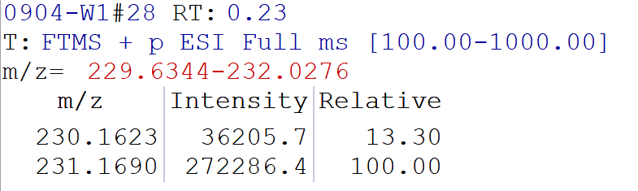

1-cyclopentyl-4-phenylbutan-2,2-d2-1-ol (3ac)
According to the general procedure above, eluent in chromatography: petroleum ether: ethyl acetate = 40 : 1, 3ac was obtained as a white solid (27.3 mg, 62% yield)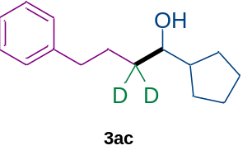. ¹H NMR (600 MHz, CDCl₃) δ 7.30 – 7.26 (m, 2H), 7.21 – 7.15 (m, 3H), 3.42 (d, J = 7.2 Hz, 1H), 2.70 – 2.57 (m, 2H), 1.90 – 1.74 (m, 3H), 1.70 – 1.58 (m, 4H), 1.57 – 1.49 (m, 2H), 1.37 – 1.29 (m, 2H), 1.22 – 1.15 (m, 1H). ¹³C NMR (151 MHz, CDCl₃) δ 142.5, 128.4, 128.3, 125.7, 75.7, 46.3, 35.9, 35.0 (dd, J = 37.9, 19.0 Hz), 29.1, 28.5, 27.3, 25.7, 25.6. HRMS m/z (ESI) calculated for C₁₅H₂₀D₂ONa⁺ [M + Na]⁺ 243.1688, found 243.1689.
 | Calculated weight | Found weight | Intensity | D%
C₁₅H₂₀D₂ONa⁺ | 243.1688 | 243.1689 | 255056 | 96%
C₁₅H₂₁DONa⁺ | 242.1626 | 242.1623 | 21152 | 96%
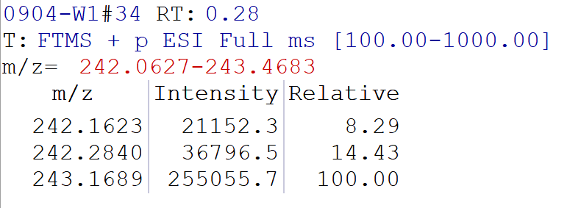
1-cyclohexyl-4-phenylbutan-2,2-d2-1-ol (3ad)
According to the general procedure above, eluent in chromatography: petroleum ether: ethyl acetate = 40 : 1, 3ad was obtained as a white solid (30.5 mg, 65% yield)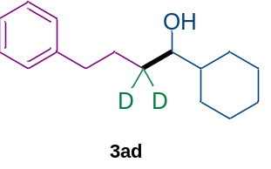. ¹H NMR (600 MHz, CDCl₃) δ 7.28 (dd, J = 8.3, 7.0 Hz, 2H), 7.19 (dd, J = 7.9, 1.8 Hz, 3H), 3.37 (d, J = 5.4 Hz, 1H), 2.69 – 2.58 (m, 2H), 1.84 – 1.71 (m, 4H), 1.69 – 1.60 (m, 3H), 1.34 – 1.19 (m, 4H), 1.18 – 0.96 (m, 3H). ¹³C NMR (151 MHz, CDCl₃) δ 142.5, 128.4, 128.3, 125.7, 75.9, 43.6, 35.9, 32.9 (dd, J = 37.6, 18.8 Hz), 29.3, 27.7, 27.6, 26.5, 26.3, 26.2. HRMS m/z (ESI) calculated for C₁₆H₂₂D₂ONa⁺ [M + Na]⁺ 257.1845, found 257.1844.
 | Calculated weight | Found weight | Intensity | D%
C₁₆H₂₂D₂ONa⁺ | 257.1845 | 257.1844 | 506842 | 98%
C₁₆H₂₃DONa⁺ | 256.1782 | 256.1786 | 23754 | 98%
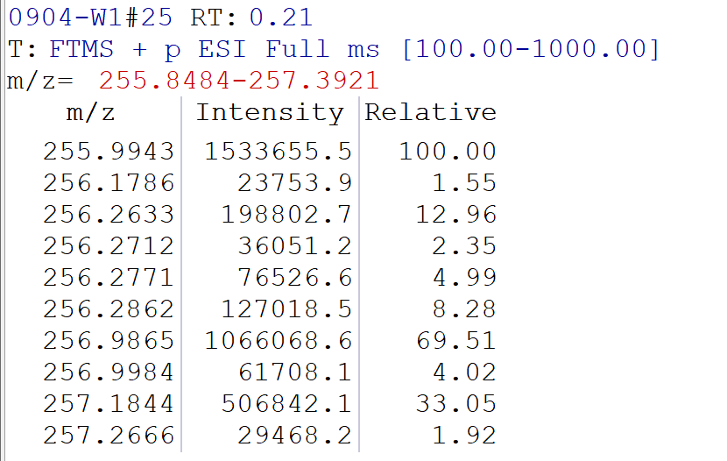
8-chloro-1-phenyloctan-3,3-d2-4-ol (3ae)
According to the general procedure above, eluent in chromatography: petroleum ether: ethyl acetate = 30 : 1, 3ae was obtained as a colorless oil (33.0 mg, 68% yield)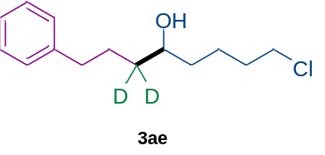. ¹H NMR (600 MHz, CDCl₃) δ 7.28 (dd, J = 8.2, 7.0 Hz, 2H), 7.21 – 7.17 (m, 3H), 3.62 (dd, J = 7.7, 3.8 Hz, 1H), 3.54 (t, J = 6.7 Hz, 2H), 2.68 – 2.59 (m, 2H), 1.84 – 1.73 (m, 3H), 1.68 – 1.62 (m, 1H), 1.61 – 1.56 (m, 1H), 1.51 – 1.41 (m, 3H), 1.33 (br, s, 1H). ¹³C NMR (151 MHz, CDCl₃) δ 142.3, 128.4, 128.3, 125.7, 71.4, 44.9, 36.5, 36.1 (dd, J = 37.8, 19.0 Hz), 35. 8, 32.5, 27.2, 23.0. HRMS m/z (ESI) calculated for C₁₄H₁₉D₂ClONa⁺ [M + Na]⁺ 265.1299, found 265.1295.
 | Calculated weight | Found weight | Intensity | D%
C₁₄H₁₉D₂ClONa⁺ | 265.1299 | 265.1295 | 117892 | 94%
C₁₄H₂₀DClONa⁺ | 264.1236 | 264.1233 | 15059 | 94%
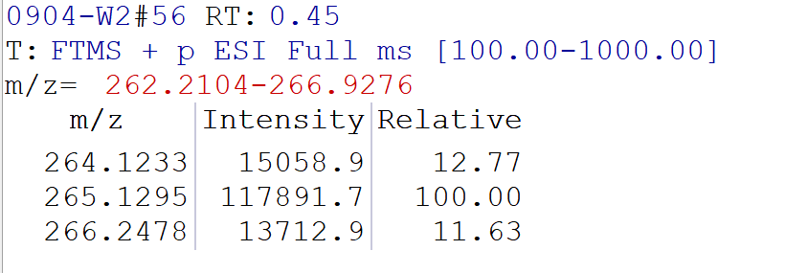
1-((tert-butyldimethylsilyl)oxy)-5-phenylpentan-3,3-d2-2-ol (3af)
According to the general procedure above, eluent in chromatography: petroleum ether: ethyl acetate = 30 : 1, 3af was obtained as a colorless oil (21.3 mg, 36% yield)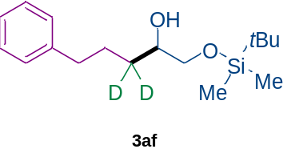. ¹H NMR (600 MHz, CDCl₃) δ 7.29 – 7.25 (m, 2H), 7.18 (d, J = 7.4 Hz, 3H), 3.65 (dt, J = 7.3, 3.3 Hz, 1H), 3.61 (dd, J = 9.9, 3.3 Hz, 1H), 3.38 (dd, J = 9.8, 7.6 Hz, 1H), 2.64 (t, J = 7.7 Hz, 2H), 2.42 (d, J = 3.5 Hz, 1H), 1.80 (dt, J = 15.0, 7.8 Hz, 1H), 1.66 (dt, J = 14.2, 7.8 Hz, 1H), 0.90 (s, 9H), 0.07 (s, 6H). ¹³C NMR (151 MHz, CDCl₃) δ 142.3, 128.4, 128.3, 125.7, 71.6, 67.2, 35.9, 31.6 (dd, J = 38.2, 20.0 Hz), 27.2, 25.9, 18.3, -5.4, -5.4. HRMS m/z (ESI) calculated for C₁₇H₂₈D₂O₂SiNa⁺ [M + Na]⁺ 319.2033, found319.2029.
 | Calculated weight | Found weight | Intensity | D%
C₁₇H₂₈D₂O₂SiNa⁺ | 319.2033 | 319.2029 | 35631884 | 98%
C₁₇H₂₉DO₂SiNa⁺ | 318.1970 | 318.1970 | 1719094 | 98%
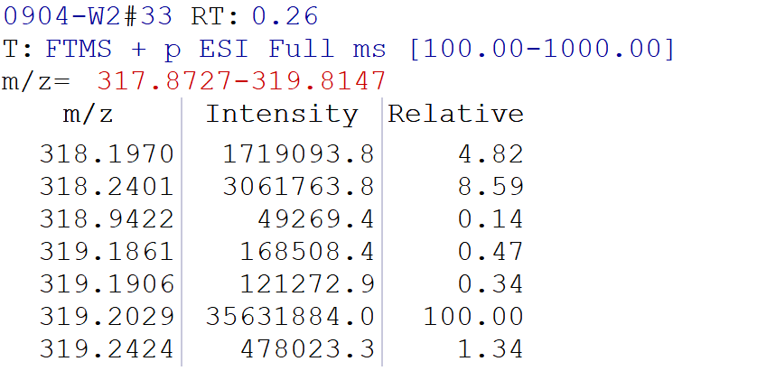
1-(benzyloxy)-5-phenylpentan-3,3-d2-2-ol (3ag)
According to the general procedure above, eluent in chromatography: petroleum ether: ethyl acetate = 30 : 1, 3ag was obtained as a colorless oil (31.6 mg, 58% yield)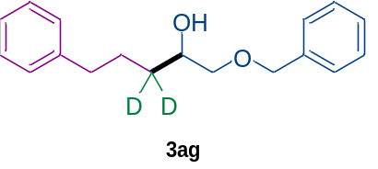. ¹H NMR (600 MHz, CDCl₃) δ 7.38 – 7.26 (m, 7H), 7.21 – 7.16 (m, 3H), 4.55 (s, 2H), 3.89 – 3.79 (m, 1H), 3.50 (dd, J = 9.4, 3.0 Hz, 1H), 3.33 (dd, J = 9.4, 7.9 Hz, 1H), 2.64 (t, J = 7.7 Hz, 2H), 2.36 (br, s, 1H), 1.80 (dt, J = 13.6, 7.8 Hz, 1H), 1.67 (dd, J = 14.4, 6.7 Hz, 1H). ¹³C NMR (151 MHz, CDCl₃) δ 142.2, 137.9, 128.4, 128.4, 128.3, 127.8, 127.7, 125.7, 74.5, 73.3, 70.2, 35.8, 31.8 (dd, J = 39.1, 19.6 Hz), 27.1. HRMS m/z (ESI) calculated for C₁₈H₂₀D₂O₂Na⁺ [M + Na]⁺ 295.1638, found 295.1637.
 | Calculated weight | Found weight | Intensity | D%
C₁₈H₂₀D₂O₂Na⁺ | 295.1638 | 295.1637 | 51073164 | 97%
C₁₈H₂₁DO₂Na⁺ | 294.1575 | 294.1579 | 2808942 | 97%
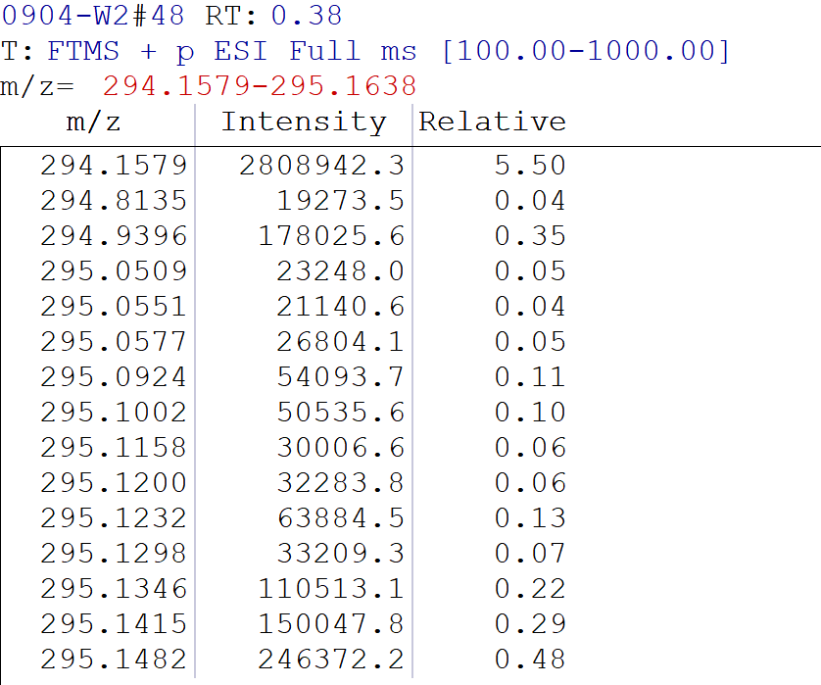
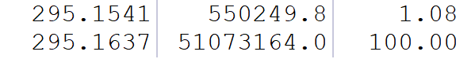
1,4-diphenylbutan-2,2-d2-1-ol (3ah)
According to the general procedure above, eluent in chromatography: petroleum ether: ethyl acetate = 30 : 1, 3ah was obtained as a colorless oil (35.6 mg, 78% yield)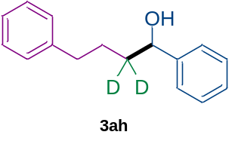. ¹H NMR (600 MHz, CDCl₃) δ 7.38 – 7.30 (m, 4H), 7.30 – 7.25 (m, 3H), 7.21 – 7.11 (m, 3H), 4.68 (s, 1H), 2.64 (t, J = 7.7 Hz, 2H), 1.81 (br, s, 1H), 1.76 (dt, J = 13.4, 7.8 Hz, 1H), 1.61 (dt, J = 13.4, 7.8 Hz, 1H). ¹³C NMR (151 MHz, CDCl₃) δ 144.7, 142.2, 128.5, 128.4, 128.3, 127.6, 125.9, 125.7, 74.4, 37.8 (dd, J = 38.5, 19.1 Hz), 35.7, 27.4. HRMS m/z (ESI) calculated for C₁₆H₁₆D₂ONa⁺ [M + Na]⁺ 251.1375, found251.1375.
 | Calculated weight | Found weight | Intensity | D%
C₁₆H₁₆D₂ONa⁺ | 251.1375 | 251.1375 | 187213 | 95%
C₁₆H₁₇DONa⁺ | 250.1313 | 250.1304 | 21268 | 95%
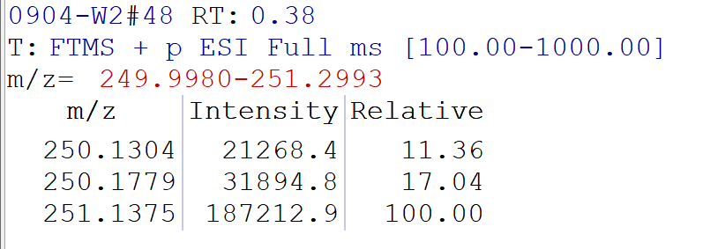
4-phenyl-1-(p-tolyl)butan-2,2-d2-1-ol (3ai)
According to the general procedure above, eluent in chromatography: petroleum ether: ethyl acetate = 30:1, 3ai was obtained as a colorless oil (29.1 mg, 60% yield)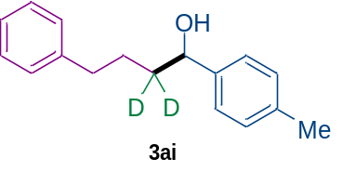.
¹H NMR (600 MHz, CDCl₃) δ 7.29 – 7.25 (m, 2H), 7.23 (d, J = 8.0 Hz, 2H), 7.20 – 7.14 (m, 5H), 4.65 (s, 1H), 2.64 (t, J = 7.7 Hz, 2H), 2.36 (s, 3H), 1.80 (br, s, 1H), 1.75 (dt, J = 13.6, 7.8 Hz, 1H), 1.62 (d, J = 7.7 Hz, 1H). ¹³C NMR (151 MHz, CDCl₃) δ 142.3, 141.7, 137.2, 129.1, 128.4, 128.3, 125.8, 125.7, 74.3, 37.6 (dd, J = 38.7, 18.8 Hz), 35.7, 27.4, 21.1. HRMS m/z (ESI) calculated for C₁₇H₁₈D₂ONa⁺ [M + Na]⁺ 265.1532, found 265.1531.
 | Calculated weight | Found weight | Intensity | D%
C₁₇H₁₈D₂ONa⁺ | 265.1532 | 265.1531 | 663438 | 97%
C₁₇H₁₉DONa⁺ | 264.1469 | 264.1465 | 39645 | 97%
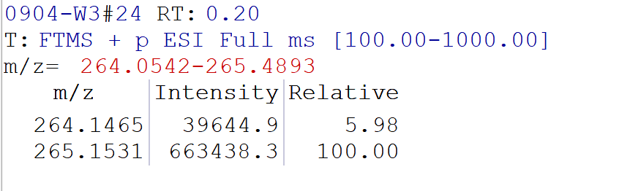
1-(4-fluorophenyl)-4-phenylbutan-2,2-d2-1-ol (3aj)
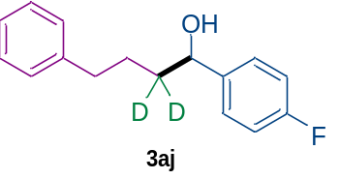According to the general procedure above, eluent in chromatography: petroleum ether: ethyl acetate = 30 : 1, 3aj was obtained as a colorless oil (40.9 mg, 83% yield). ¹H NMR (600 MHz, CDCl₃) δ 7.28 (ddd, J = 15.6, 7.9, 4.8 Hz, 4H), 7.21 – 7.12 (m, 3H), 7.05 – 6.98 (m, 2H), 4.66 (s, 1H), 2.63 (t, J = 7.7 Hz, 2H), 1.85 (br, s, 1H), 1.73 (dt, J = 13.4, 7.8 Hz, 1H), 1.59 (dd, J = 14.4, 6.7 Hz, 1H). ¹³C NMR (151 MHz, CDCl₃) δ 162.1 (d, J = 245.2 Hz), 142.1, 140.4 (d, J = 3.1 Hz), 128.4, 128.3, 127.5 (d, J = 8.2 Hz), 125.8, 115.2 (d, J = 21.3 Hz), 73.7, 37.8 (dd, J = 38.3, 20.1 Hz), 35.6, 27.3. ¹⁹F NMR (565 MHz, CDCl₃) δ -115.1. HRMS m/z (ESI) calculated for C₁₆H₁₅D₂FONa⁺ [M + Na]⁺ 269.1281, found 269.1282.
 | Calculated weight | Found weight | Intensity | D%
C₁₆H₁₅D₂FONa⁺ | 269.1281 | 269.1282 | 138050 | >99%
C₁₆H₁₆DFONa⁺ | 268.1218 | / | 0 | >99%
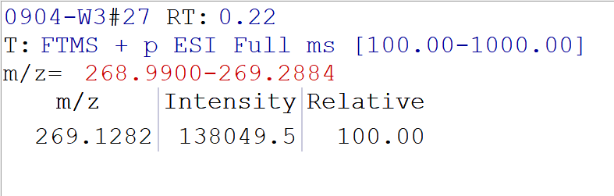
1-(4-bromophenyl)-4-phenylbutan-2,2-d2-1-ol (3ak)
According to the general procedure above, eluent in chromatography: petroleum ether: ethyl acetate = 30 : 1, 3ak was obtained as a colorless oil (49.8 mg, 81% yield).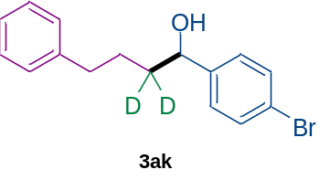 ¹H NMR (600 MHz, CDCl₃) δ 7.48 – 7.44 (m, 2H), 7.27 (dd, J = 8.2, 6.9 Hz, 2H), 7.21 – 7.16 (m, 3H), 7.16 – 7.12 (m, 2H), 4.64 (s, 1H), 2.63 (t, J = 7.7 Hz, 2H), 1.86 (br, s, 1H), 1.73 (dt, J = 13.4, 7.8 Hz, 1H), 1.61 – 1.56 (m, 1H). ¹³C NMR (151 MHz, CDCl₃) δ 143.6, 142.0, 131.5, 128.4, 128.3, 127.6, 125.8, 121.2, 73.7, 37.8 (dd, J = 38.2, 18.9 Hz), 35.6, 27.2. HRMS m/z (ESI) calculated for C₁₆H₁₅D₂BrONa⁺ [M + Na]⁺ 329.0481, found 329.0480.
 | Calculated weight | Found weight | Intensity | D%
C₁₆H₁₅D₂BrONa⁺ | 329.0481 | 329.0480 | 322995.2 | >99%
C₁₆H₁₆DBrONa⁺ | 328.0418 | / | 0 | >99%
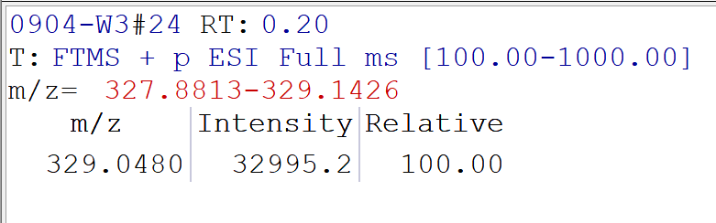
4-phenyl-1-(4-(trifluoromethyl)phenyl)butan-2,2-d2-1-ol (3al)
According to the general procedure above, eluent in chromatography: petroleum ether: ethyl acetate = 30 : 1, 3al was obtained as a colorless oil (42.7 mg, 72% yield)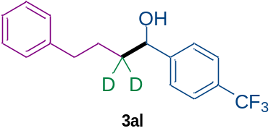. ¹H NMR (600 MHz, CDCl₃) δ 7.60 (d, J = 8.0 Hz, 2H), 7.43 (d, J = 8.0 Hz, 2H), 7.28 (t, J = 7.5 Hz, 2H), 7.18 (dd, J = 22.9, 7.4 Hz, 3H), 4.74 (s, 1H), 2.64 (t, J = 7.7 Hz, 2H), 1.98 (br, s, 1H), 1.76 (dt, J = 14.9, 7.8 Hz, 1H), 1.65 – 1.60 (m, 1H). ¹³C NMR (151 MHz, CDCl₃) δ 148.6, 141.9, 129.7 (q, J = 32.2 Hz), 128.4, 128. 3, 126.1, 125.8, 125.4 (q, J = 3.7 Hz), 124.1(q, J = 271.8 Hz), 73.7, 37.9 (dd, J = 39.1, 20.3 Hz), 35.6, 27.1. ¹⁹F NMR (565 MHz, CDCl₃) δ -62.4. HRMS m/z (ESI) calculated for C₁₇H₁₅D₂F₃ONa⁺ [M + Na]⁺ 319.1249, found 319.1248.
 | Calculated weight | Found weight | Intensity | D%
C₁₇H₁₅D₂F₃ONa⁺ | 319.1249 | 319.1248 | 73320 | >99%
C₁₇H₁₆DF₃ONa⁺ | 318.1186 | / | 0 | >99%
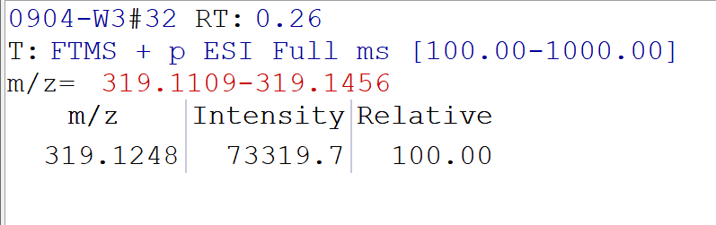
Methyl -4-(1-hydroxy-4-phenylbutyl-2,2-d2)benzoate (3am)
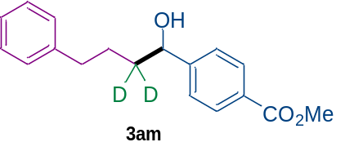According to the general procedure above, eluent in chromatography: petroleum ether : ethyl acetate = 30 : 1, 3am was obtained as a colorless oil (31.5 mg, 55% yield). ¹H NMR (600 MHz, CDCl₃) δ 8.03 – 7.96 (m, 2H), 7.38 (d, J = 7.9 Hz, 2H), 7.26 (d, J = 14.9 Hz, 2H), 7.16 (dd, J = 22.9, 7.5 Hz, 3H), 4.73 (s, 1H), 3.90 (s, 3H), 2.62 (t, J = 7.7 Hz, 2H), 2.15 (br, s, 1H), 1.74 (dt, J = 14.9, 7.8 Hz, 1H), 1.60 (dt, J = 14.2, 7.8 Hz, 1H). ¹³C NMR (151 MHz, CDCl₃) δ 166.9, 149.9, 142.0, 129.7, 129.2, 128.3, 128.3, 125.8, 125.7, 73.8, 52.0, 37.7 (dd, J = 37.7, 18.9 Hz), 35.6, 27.1. HRMS m/z (ESI) calculated for C₁₈H₁₈D₂O₃Na⁺ [M + Na]⁺ 309.1430, found 309.1430.
 | Calculated weight | Found weight | Intensity | D%
C₁₈H₁₈D₂O₃Na⁺ | 309.1430 | 309.1430 | 376606 | 97%
C₁₈H₁₉DO₃Na⁺ | 308.1367 | 308.1360 | 24236 | 97%
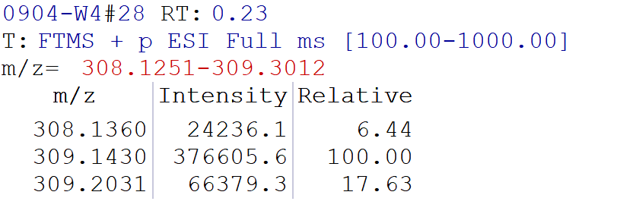
4-(1-hydroxy-4-phenylbutyl-2,2-d2)benzonitrile (3an)
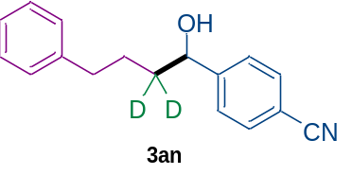According to the general procedure above, eluent in chromatography: petroleum ether: ethyl acetate = 30 : 1, 3an was obtained as a colorless oil (39.5 mg, 78% yield). ¹H NMR (600 MHz, CDCl₃) δ 7.65 – 7.59 (m, 2H), 7.44 – 7.41 (m, 2H), 7.27 (t, J = 7.6 Hz, 2H), 7.20 – 7.17 (m, 1H), 7.16 – 7.13 (m, 2H), 4.75 (s, 1H), 2.63 (t, J = 7.6 Hz, 2H), 2.05 (br, s, 1H), 1.75 (dd, J = 13.4, 7.6 Hz, 1H), 1.63 – 1.60 (m, 1H).¹³C NMR (151 MHz, CDCl₃) δ 150.0, 141.8, 132.2, 128.3, 128.3, 126.5, 125.9, 118.8, 111.1, 73.5, 37.8 (dd, J = 40.7, 19.5 Hz), 35.5, 27.0. HRMS m/z (ESI) calculated for C₁₇H₁₅D₂NONa⁺ [M + Na]⁺ 276.1328, found 276.1329.
 | Calculated weight | Found weight | Intensity | D%
C₁₇H₁₅D₂NONa⁺ | 276.1328 | 276.1329 | 20388 | 91%
C₁₇H₁₆DNONa⁺ | 275.1265 | 275.1267 | 4658 | 91%
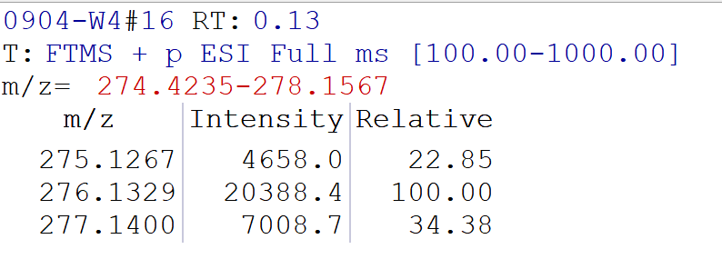
1-(naphthalen-2-yl)-4-phenylbutan-2,2-d2-1-ol (3ao)
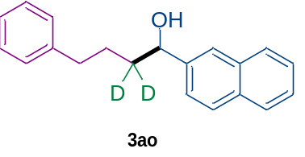According to the general procedure above, eluent in chromatography: petroleum ether: ethyl acetate = 30 : 1, 3ao was obtained as a white solid (35.1 mg, 63% yield). ¹H NMR (600 MHz, CDCl₃) δ 7.84 (dt, J = 9.3, 4.5 Hz, 3H), 7.76 (d, J = 1.8 Hz, 1H), 7.48 (dddd, J = 12.0, 10.3, 6.1, 1.7 Hz, 3H), 7.27 (t, J = 7.5 Hz, 2H), 7.21 – 7.14 (m, 3H), 4.84 (s, 1H), 2.65 (t, J = 7.7 Hz, 2H), 2.02 (br, s, 1H), 1.79 (dt, J = 15.1, 7.8 Hz, 1H), 1.64 (dd, J = 14.1, 7.1 Hz, 1H). ¹³C NMR (151 MHz, CDCl₃) δ 142.2, 142.0, 133.2, 133.0, 128.4, 128.3, 128.3, 127.9, 127.6, 126.1, 125.8, 125.7, 124.6, 124.0, 74.5, 37.7 (dd, J = 38.7, 18.7 Hz), 35.7, 27.3. HRMS m/z (ESI) calculated for C₂₀H₁₈D₂ONa⁺ [M + Na]⁺ 301.1532, found 301.1528.
 | Calculated weight | Found weight | Intensity | D%
C₂₀H₁₈D₂ONa⁺ | 301.1532 | 301.1528 | 74255 | 93%
C₂₀H₁₉DONa⁺ | 300.1469 | 300.1469 | 11836 | 93%
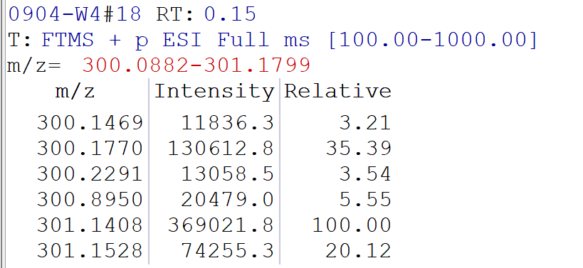
1-(1-bromonaphthalen-2-yl)-4-phenylbutan-2,2-d2-1-ol (3ap)
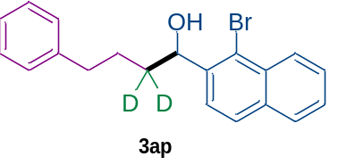According to the general procedure above, eluent in chromatography: petroleum ether: ethyl acetate = 30 : 1, 3ap was obtained as a yellow oil (41.4 mg, 58% yield). ¹H NMR (600 MHz, CDCl₃) δ 8.33 (d, J = 8.5 Hz, 1H), 7.82 (dd, J = 8.3, 3.4 Hz, 2H), 7.66 (d, J = 8.5 Hz, 1H), 7.60 (ddd, J = 8.3, 6.8, 1.3 Hz, 1H), 7.52 (ddd, J = 8.1, 6.8, 1.1 Hz, 1H), 7.29 – 7.24 (m, 2H), 7.21 – 7.14 (m, 3H), 5.50 – 5.41 (m, 1H), 2.74 – 2.63 (m, 2H), 2.06 (d, J = 3.3 Hz, 1H), 1.92 – 1.84 (m, 1H), 1.79 – 1.72 (m, 1H). ¹³C NMR (151 MHz, CDCl₃) δ 142.2, 141.5, 134.0, 132.1, 128.4, 128.3, 128.1, 127.4, 127.4, 126.5, 125.7, 125.3, 124.4, 121.7, 73.5, 36.4 (dd, J = 36.3, 19.1 Hz), 35.7, 27.3. HRMS m/z (ESI) calculated for C₂₀H₁₇D₂BrONa⁺ [M + Na]⁺ 379.0637, found 379.0634.
 | Calculated weight | Found weight | Intensity | D%
C₂₀H₁₇D₂BrONa⁺ | 379.0637 | 379.0634 | 29952 | 93%
C₂₀H₁₈DBrONa⁺ | 378.0574 | 378.0557 | 4761 | 93%
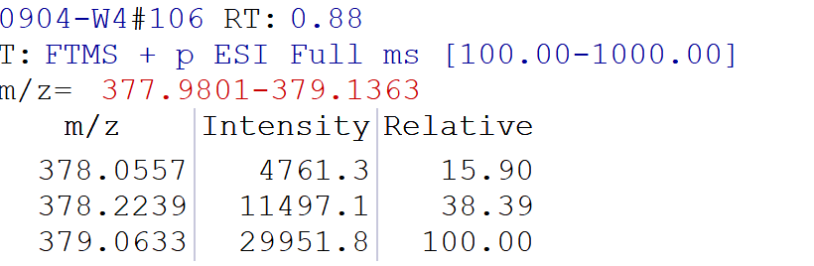
4-phenyl-1-(thiophen-3-yl)butan-2,2-d2-1-ol (3aq)
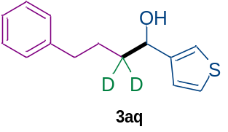According to the general procedure above, eluent in chromatography: petroleum ether: ethyl acetate = 30 : 1, 3aq was obtained as a colorless oil (35.6 mg, 76% yield). ¹H NMR (600 MHz, CDCl₃) δ 7.30 – 7.26 (m, 3H), 7.23 – 7.09 (m, 4H), 7.06 (dd, J = 5.0, 1.3 Hz, 1H), 4.78 (s, 1H), 2.64 (t, J = 7.7 Hz, 2H), 1.80 – 1.71 (m, 2H), 1.63 (dd, J = 14.1, 7.1 Hz, 1H). ¹³C NMR (151 MHz, CDCl₃) δ 146.2, 142.2, 128.4, 128.3, 126.1, 125.8, 125.6, 120.7, 70.4, 37.1 (dd, J = 39.2, 20.4 Hz), 35.6, 27.2. HRMS m/z (ESI) calculated for C₁₄H₁₄D₂OSNa⁺ [M + Na]⁺ 257.0940, found 257.0938.
 | Calculated weight | Found weight | Intensity | D%
C₁₄H₁₄D₂OSNa⁺ | 257.0940 | 257.0938 | 95850 | >99%
C₁₄H₁₅DOSNa⁺ | 256.0877 | / | 0 | >99%
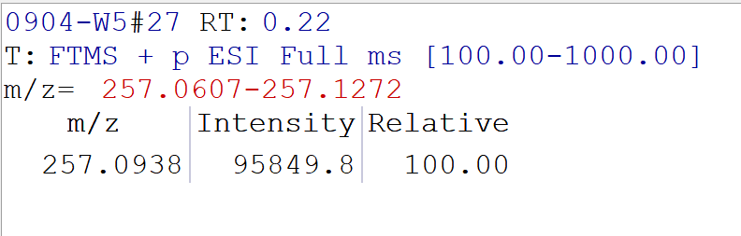
1-(5-bromofuran-2-yl)-4-phenylbutan-2,2-d2-1-ol (3ar)
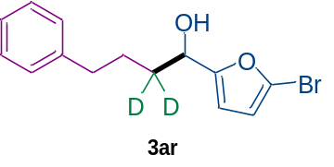According to the general procedure above, eluent in chromatography: petroleum ether: ethyl acetate = 30 : 1, 3ar was obtained as a colorless oil (30.9 mg, 52% yield).
¹H NMR (600 MHz, CDCl₃) δ 7.28 (dd, J = 8.4, 6.8 Hz, 2H), 7.21 – 7.16 (m, 3H), 6.24 (d, J = 3.2 Hz, 1H), 6.18 (d, J = 3.3 Hz, 1H), 4.63 (d, J = 4.6 Hz, 1H), 2.66 (t, J = 7.7 Hz, 2H), 1.89 (d, J = 5.1 Hz, 1H), 1.78 (dt, J = 13.5, 7.7 Hz, 1H), 1.65 (dt, J = 14.2, 7.7 Hz, 1H). ¹³C NMR (151 MHz, CDCl₃) δ 158.7, 142.0, 128.4, 128.3, 125.8, 121.2, 111.8, 108.6, 67.5, 35.4, 34.0 (dd, J = 39.4, 18.8 Hz), 27.0. HRMS m/z (ESI) calculated for C₁₄H₁₃D₂BrO₂Na⁺ [M + Na]⁺ 319.0273, found 319.0268.
 | Calculated weight | Found weight | Intensity | D%
C₁₄H₁₃D₂BrO₂Na⁺ | 319.0273 | 319.0268 | 30662 | >99%
C₁₄H₁₄DBrO₂Na⁺ | 318.0210 | / | 0 | >99%
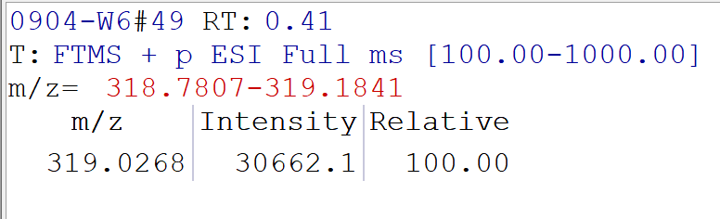
2-methyl-1,6-diphenylhex-1-en-4,4-d2-3-ol (3as)
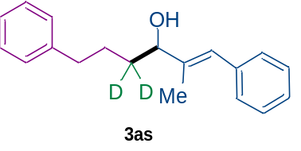According to the general procedure above, eluent in chromatography: petroleum ether: ethyl acetate = 30 : 1, 3as was obtained as a yellow oil (22.5 mg, 42% yield). ¹H NMR (600 MHz, CDCl₃) δ 7.34 (t, J = 7.6 Hz, 2H), 7.30 – 7.26 (m, 4H), 7.25 – 7.11 (m, 4H), 6.49 (s, 1H), 4.19 (s, 1H), 2.68 (t, J = 7.7 Hz, 2H), 1.84 (d, J = 1.4 Hz, 3H), 1.76 (dt, J = 14.9, 7.7 Hz, 1H), 1.65 (dd, J = 14.5, 6.7 Hz, 1H). ¹³C NMR (151 MHz, CDCl₃) δ 142.3, 140.2, 137.5, 129.0, 128.4, 128.3, 128.1, 126.4, 125.9, 125.7, 77.9, 35.7, 33.8 (dd, J = 37.9, 19.7 Hz), 27.4, 13.1. HRMS m/z (ESI) calculated for C₁₉H₂₀D₂ONa⁺ [M + Na]⁺ 291.1688, found 291.1688.
 | Calculated weight | Found weight | Intensity | D%
C₁₉H₂₀D₂ONa⁺ | 291.1688 | 291.1688 | 190918 | 96%
C₁₉H₂₁DONa⁺ | 290.1626 | 290.1628 | 17699 | 96%
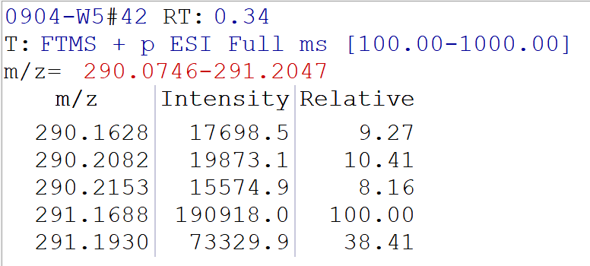
6-phenyl-1-(trimethylsilyl)hex-1-yn-4,4-d2-3-ol (3at)
According to the general procedure above, eluent in chromatography: petroleum ether: ethyl acetate = 40 : 1, 3at was obtained as a colorless oil (27.3 mg, 55% yield)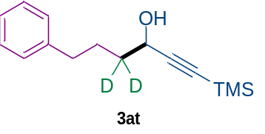. ¹H NMR (600 MHz, CDCl₃) δ 7.31 – 7.26 (m, 2H), 7.21 – 7.17 (m, 3H), 4.37 (d, J = 5.1 Hz, 1H), 2.67 (t, J = 7.7 Hz, 2H), 1.85 – 1.73 (m, 3H), 0.17 (s, 9H). ¹³C NMR (151 MHz, CDCl₃) δ 142.1, 128.4, 128.3, 125.8, 106.6, 89.6, 62.6, 36.4 (dd, J = 37.8, 19.0 Hz), 35.3, 26.6, -0.1. HRMS m/z (ESI) calculated for C₁₅H₂₀D₂OSiNa⁺ [M + Na]⁺ 271.1458, found 271.1457.
 | Calculated weight | Found weight | Intensity | D%
C₁₅H₂₀D₂OSiNa⁺ | 271.1458 | 271.1457 | 685188 | 97%
C₁₅H₂₁DOSiNa⁺ | 270.1395 | 270.1391 | 37398 | 97%
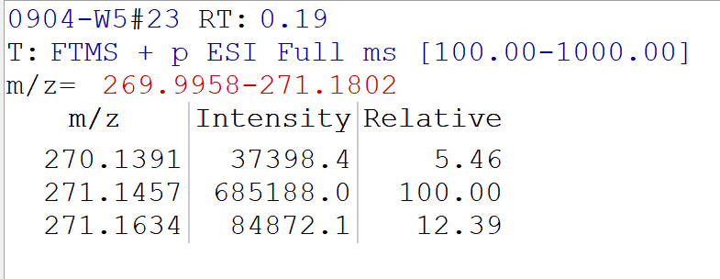
6,10-dimethyl-1-phenylundec-9-en-3,3-d2-4-ol (3au)
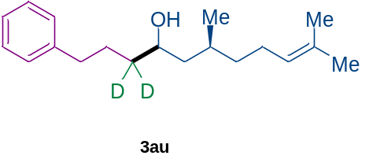According to the general procedure above, eluent in chromatography: petroleum ether: ethyl acetate = 40 : 1, 3au was obtained as a colorless oil (34.8 mg, 63% yield, d. r. > 20 : 1). ¹H NMR (600 MHz, CDCl₃) δ 7.30 – 7.26 (m, 2H), 7.19 (d, J = 7.2 Hz, 3H), 5.10 (td, J = 6.9, 3.5 Hz, 1H), 3.74 – 3.68 (m, 1H), 2.64 (dpt, J = 10.2, 7.1, 3.7 Hz, 2H), 1.98 (ddq, J = 30.4, 15.4, 7.4 Hz, 2H), 1.78 (ddd, J = 14.1, 7.0, 3.8 Hz, 1H), 1.69 – 1.64 (m, 4H), 1.60 (s, 3H), 1.46 – 1.24 (m, 4H), 1.23 – 1.08 (m, 2H), 0.90 (dd, J = 9.7, 6.6 Hz, 3H). ¹³C NMR (151 MHz, CDCl₃) δ 142.4, 131.3, 131.2, 128.4, 128.3, 125.7, 124.7, 69.7, 69.4, 45.1, 44.9, 37.9, 36.6, 35.9, 29.7, 29.2, 28.9, 27.3, 27.1, 25.7, 25.5, 25.3, 20.3, 19.1, 17.6. HRMS m/z (ESI) calculated for C₁₉H₂₈D₂ONa⁺ [M + Na]⁺ 299.2314, found 299.2313.
 | Calculated weight | Found weight | Intensity | D%
C₁₉H₂₈D₂ONa⁺ | 299.2314 | 299.2313 | 856455 | 97%
C₁₉H₂₉DONa⁺ | 298.2252 | 298.2248 | 61711 | 97%
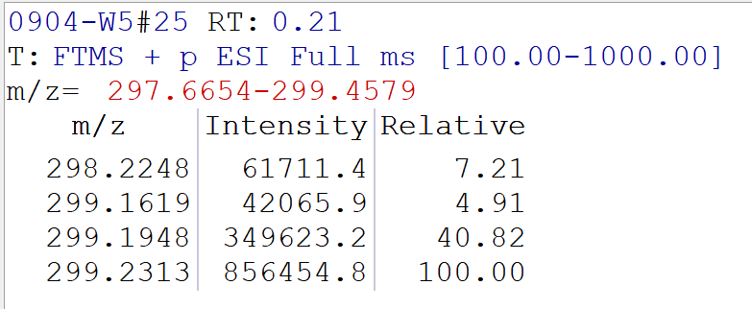
4-(1-hydroxy-4-phenylbutyl-2,2-d2)phenyl 2-(1-(4-chlorobenzoyl)-5-methoxy-2-methyl-1H-indol-3-yl)acetate (3av)
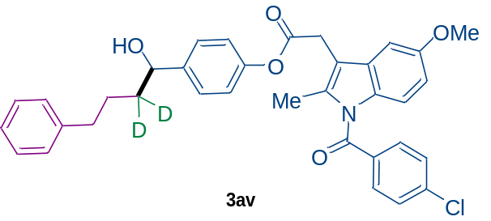According to the general procedure above, eluent in chromatography: petroleum ether: ethyl acetate = 5 : 1, 3av was obtained as a white solid (67.8 mg, 58% yield). ¹H NMR (600 MHz, CDCl₃) δ 7.67 (dd, J = 8.6, 1.9 Hz, 2H), 7.47 (dt, J = 8.9, 2.2 Hz, 2H), 7.32 – 7.23 (m, 4H), 7.16 (ddd, J = 19.1, 7.4, 4.0 Hz, 3H), 7.09 – 7.01 (m, 3H), 6.91 (dd, J = 9.0, 3.1 Hz, 1H), 6.71 (dd, J = 9.0, 2.6 Hz, 1H), 4.64 (s, 1H), 3.91 (d, J = 2.3 Hz, 2H), 3.84 (d, J = 2.0 Hz, 3H), 2.62 (t, J = 7.8 Hz, 2H), 2.46 (d, J = 2.1 Hz, 3H), 2.04 (br, s, 1H), 1.73 (dt, J = 13.1, 7.8 Hz, 1H), 1.59 (dt, J = 13.2, 7.8 Hz, 1H). ¹³C NMR (151 MHz, CDCl₃) δ 169.3, 168.3, 156.1, 149.8, 142.4, 142.1, 139.3, 136.2, 133.8, 131.1, 130.8, 130.4, 129.1, 128.3, 128.2, 126.9, 125.7, 121.3, 115.0, 111.9, 111.7, 101.2, 73.7, 55.7, 37.8 (dd, J = 38.4, 18.5 Hz), 35.6, 30.5, 27.2, 13.4. HRMS m/z (ESI) calculated for C₃₅H₃₀D₂ClNO₅Na⁺ [M + Na]⁺ 606.1987, found 606.1982.
 | Calculated weight | Found weight | Intensity | D%
C₃₅H₃₀D₂ClNO₅Na⁺ | 606.1987 | 606.1982 | 1002136 | 97%
C₃₅H₃₁DClNO₅Na⁺ | 605.1924 | 605.1924 | 62742 | 97%
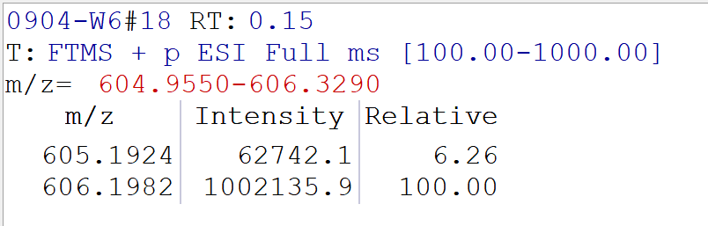
1-phenyloctan-4,4-d2-3-ol (3ba)
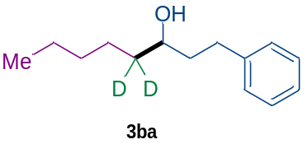According to the general procedure above, eluent in chromatography: petroleum ether: ethyl acetate = 40 : 1, 3ba was obtained as a colorless oil (31.7 mg, 76% yield). ¹H NMR (600 MHz, CDCl₃) δ 7.29 (t, J = 7.6 Hz, 2H), 7.24 – 7.13 (m, 3H), 3.62 (dd, J = 8.1, 4.1 Hz, 1H), 2.80 (ddd, J = 13.6, 9.9, 5.6 Hz, 1H), 2.68 (ddd, J = 13.7, 9.8, 6.6 Hz, 1H), 1.82 – 1.71 (m, 2H), 1.42 (dd, J = 11.8, 7.5 Hz, 1H), 1.37 – 1.26 (m, 6H), 0.89 (t, J = 6.9 Hz, 3H). ¹³C NMR (151 MHz, CDCl₃) δ 142.2, 128.4, 128.4, 125.8, 71.3, 39.0, 36.7 (dd, J = 37.9, 19.0 Hz), 32.1, 31.8, 25.1, 22.6, 14.0. HRMS m/z (ESI) calculated for C₁₄H₂₀D₂ONa⁺ [M + Na]⁺ 231.1688, found 231.1685.
 | Calculated weight | Found weight | Intensity | D%
C₁₄H₂₀D₂ONa⁺ | 231.1688 | 231.1685 | 172235 | 97%
C₁₄H₂₁DONa⁺ | 230.1626 | 230.1621 | 9388 | 97%
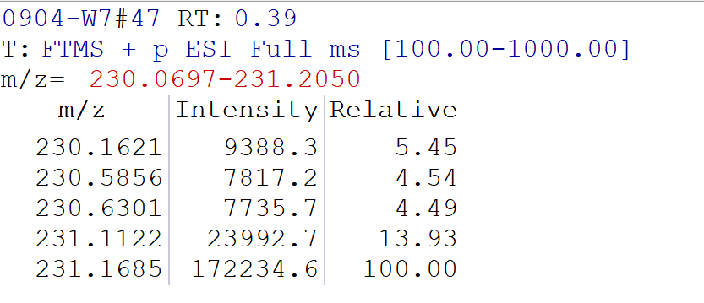
6,8,8-trimethyl-1-phenylnonan-4,4-d2-3-ol (3ca)
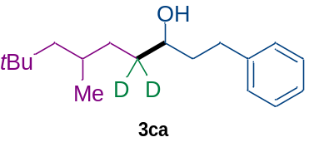According to the general procedure above, eluent in chromatography: petroleum ether: ethyl acetate = 40 : 1, 3ca was obtained as a colorless oil (37.6 mg, 71% yield). ¹H NMR (600 MHz, CDCl₃) δ 7.29 (t, J = 7.6 Hz, 2H), 7.24 – 7.15 (m, 3H), 3.60 (dt, J = 8.2, 4.0 Hz, 1H), 2.80 (ddd, J = 15.0, 10.0, 5.6 Hz, 1H), 2.68 (ddd, J = 13.8, 9.8, 6.6 Hz, 1H), 1.84 – 1.69 (m, 2H), 1.45 (hd, J = 6.4, 3.4 Hz, 1H), 1.37 (d, J = 3.2 Hz, 1H), 1.31 – 1.11 (m, 3H), 1.04 (dt, J = 13.9, 6.1 Hz, 1H), 0.92 (dd, J = 6.6, 2.2 Hz, 3H), 0.89 (d, J = 2.6 Hz, 9H). ¹³C NMR (151 MHz, CDCl₃) δ 142.2, 128.4, 128.4, 125.8, 71.6, 51.2, 51.1, 39.0, 39.0, 35.1, 35.0, 34.5 (dd, J = 36.8, 19.9 Hz), 32.1, 32.0, 31.0, 31.0, 30.0, 29.3, 29.2, 22.7, 22.6. HRMS m/z (ESI) calculated for C₁₈H₂₈D₂ONa⁺ [M + Na]⁺ 287.2314, found 287.2312.
 | Calculated weight | Found weight | Intensity | D%
C₁₈H₂₈D₂ONa⁺ | 287.2314 | 287.2312 | 457876 | 96%
C₁₈H₂₉DONa⁺ | 286.2252 | 286.2251 | 40949 | 96%
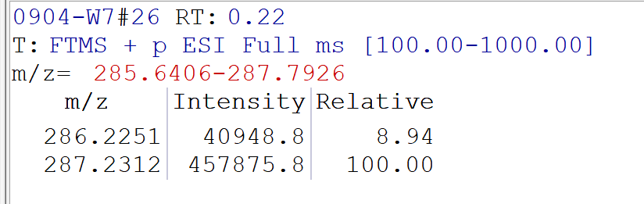
1-cyclopentyl-5-phenylpentan-2,2-d2-3-ol (3da)
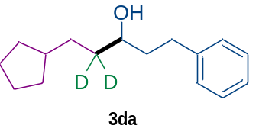According to the general procedure above, eluent in chromatography: petroleum ether: ethyl acetate = 40 : 1, 3da was obtained as a colorless oil (38.4 mg, 82% yield). ¹H NMR (600 MHz, CDCl₃) δ 7.29 (t, J = 7.5 Hz, 2H), 7.20 (dd, J = 17.0, 7.7 Hz, 3H), 3.61 (dd, J = 8.4, 4.0 Hz, 1H), 2.80 (ddd, J = 15.1, 10.0, 5.6 Hz, 1H), 2.67 (ddd, J = 13.8, 9.8, 6.6 Hz, 1H), 1.83 – 1.70 (m, 5H), 1.60 (q, J = 4.3 Hz, 2H), 1.51 (qt, J = 7.9, 3.4 Hz, 2H), 1.42 (dd, J = 13.3, 6.0 Hz, 1H), 1.36 (br, s, 1H), 1.31 (dd, J = 12.4, 5.2 Hz, 1H), 1.08 (dt, J = 12.9, 4.7 Hz, 2H). ¹³C NMR (151 MHz, CDCl₃) δ 142.2, 128.4, 128.4, 125.8, 71.5, 40.1, 39.0, 35.9 (dd, J = 38.4, 18.5 Hz), 32.8, 32.7, 32.1, 31.9, 31.8, 25.2. HRMS m/z (ESI) calculated for C₁₆H₂₂D₂ONa⁺ [M + Na]⁺ 257.1845, found 257.1841.
 | Calculated weight | Found weight | Intensity | D%
C₁₆H₂₂D₂ONa⁺ | 257.1845 | 257.1841 | 108389 | 90%
C₁₆H₂₃DONa⁺ | 256.1782 | 256.1766 | 31717 | 90%
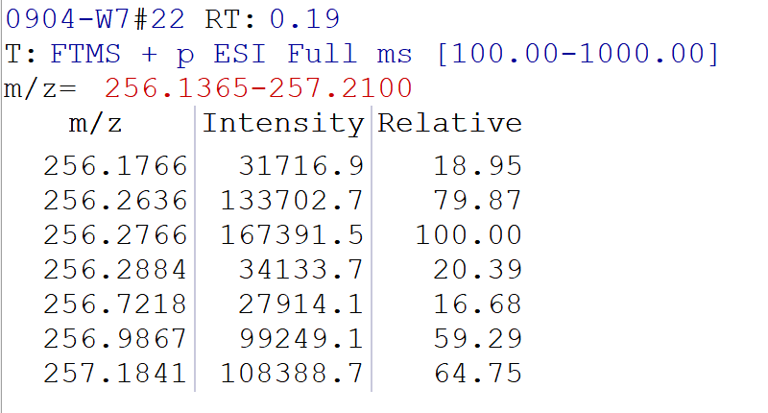
1-cyclohexyl-5-phenylpentan-2,2-d2-3-ol (3ea)
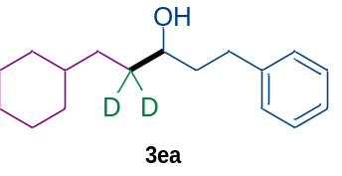According to the general procedure above, eluent in chromatography: petroleum ether: ethyl acetate = 40 : 1, 3ea was obtained as a colorless oil (27.8 mg, 56% yield). ¹H NMR (600 MHz, CDCl₃) δ 7.29 (t, J = 7.6 Hz, 2H), 7.25 – 7.14 (m, 3H), 3.59 (dt, J = 8.1, 3.9 Hz, 1H), 2.80 (ddd, J = 13.6, 10.0, 5.6 Hz, 1H), 2.67 (ddd, J = 13.7, 9.8, 6.6 Hz, 1H), 1.83 – 1.68 (m, 6H), 1.66 – 1.62 (m, 1H), 1.37 (d, J = 4.1 Hz, 1H), 1.32 – 1.28 (m, 1H), 1.19 (dddd, J = 26.4, 14.9, 6.3, 2.9 Hz, 5H), 0.88 (tdd, J = 14.1, 8.7, 3.6 Hz, 2H). ¹³C NMR (151 MHz, CDCl₃) δ 142.2, 128.4, 128.4, 125.8, 71.6, 39.0, 37.7, 34.1 (dd, J = 38.1, 18.8 Hz), 33.5, 33.3, 33.1, 32.1, 26.7, 26.4, 26.3. HRMS m/z (ESI) calculated for C₁₇H₂₄D₂ONa⁺ [M + Na]⁺ 271.2001, found 271.2002.
 | Calculated weight | Found weight | Intensity | D%
C₁₇H₂₄D₂ONa⁺ | 271.2001 | 271.2002 | 151655 | 90%
C₁₇H₂₅DONa⁺ | 270.1939 | 270.1934 | 40087 | 90%
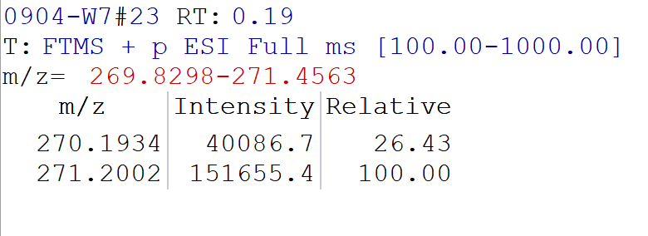
1-((3S,5S,7S)-adamantan-1-yl)-5-phenylpentan-2,2-d2-3-ol (3fa)
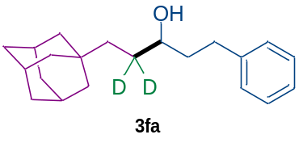According to the general procedure above, eluent in chromatography: petroleum ether: ethyl acetate = 40 : 1, 3fa was obtained as a colorless oil (42.1 mg, 70% yield). ¹H NMR (600 MHz, CDCl₃) δ 7.29 (t, J = 7.6 Hz, 2H), 7.24 – 7.14 (m, 3H), 3.56 (dt, J = 7.7, 3.4 Hz, 1H), 2.80 (ddd, J = 13.7, 10.0, 5.6 Hz, 1H), 2.68 (ddd, J = 13.8, 9.8, 6.5 Hz, 1H), 1.94 (s, 3H), 1.80 (ddt, J = 9.9, 6.3, 3.1 Hz, 1H), 1.77 – 1.73 (m, 1H), 1.72 – 1.69 (m, 3H), 1.64 – 1.61 (m, 3H), 1.46 (d, J = 2.9 Hz, 6H), 1.39 (d, J = 3.6 Hz, 1H), 1.20 (d, J = 13.2 Hz, 1H), 1.02 (d, J = 13.2 Hz, 1H). ¹³C NMR (151 MHz, CDCl₃) δ 142.2, 128.4, 128.4, 125.8, 72.1, 42.4, 40.0, 38.9, 37.2, 32.1, 31.9, 29.5 (dd, J = 37.7, 18.3 Hz), 28.7. HRMS m/z (ESI) calculated for C₂₁H₂₈D₂ONa⁺ [M + Na]⁺ 323.2314, found 323.2313.
 | Calculated weight | Found weight | Intensity | D%
C₂₁H₂₈D₂ONa⁺ | 323.2314 | 323.2313 | 235735 | 97%
C₂₁H₂₉DONa⁺ | 322.2252 | 322.2253 | 15915 | 97%
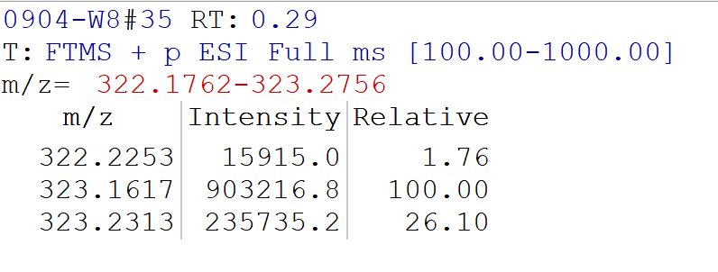
7-fluoro-1-phenylheptan-4,4-d2-3-ol (3ga)
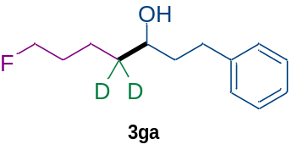According to the general procedure above, eluent in chromatography: petroleum ether: ethyl acetate = 20 : 1, 3ga was obtained as a colorless oil (35.2 mg, 83% yield). ¹H NMR (600 MHz, CDCl₃) δ 7.29 (dd, J = 8.1, 7.1 Hz, 2H), 7.23 – 7.17 (m, 3H), 4.49 (t, J = 6.1 Hz, 1H), 4.41 (t, J = 6.1 Hz, 1H), 3.64 (dd, J = 8.3, 4.1 Hz, 1H), 2.80 (ddd, J = 13.8, 9.7, 5.7 Hz, 1H), 2.68 (ddd, J = 13.8, 9.6, 6.7 Hz, 1H), 1.85 – 1.66 (m, 4H), 1.59 – 1.52 (m, 1H), 1.49 – 1.40 (m, 2H). ¹³C NMR (151 MHz, CDCl₃) δ 142.0, 128.4, 128.4, 125.8, 84.0 (d, J = 164.3 Hz), 71., 39.02, 36.2 (dd, J = 37.9, 19.1 Hz), 32.0, 30.3 (d, J = 19.5 Hz), 21.2 (d, J = 5.4 Hz). ¹⁹F NMR (565 MHz, CDCl₃) δ -218.3. HRMS m/z (ESI) calculated for C₁₃H₁₇D₂FONa⁺ [M + Na]⁺ 235.1438, found 235.1437.
 | Calculated weight | Found weight | Intensity | D%
C₁₃H₁₇D₂FONa⁺ | 235.1438 | 235.1437 | 250082 | 98%
C₁₃H₁₈DFONa⁺ | 234.1375 | 234.1371 | 10374 | 98%
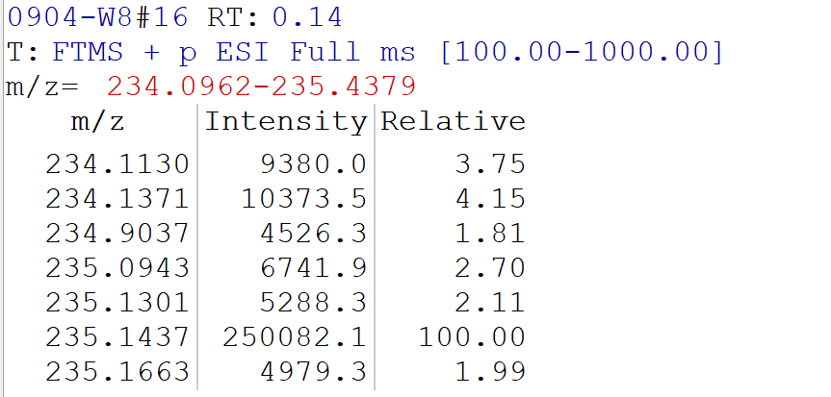
7-chloro-1-phenylheptan-4,4-d2-3-ol (3ha)
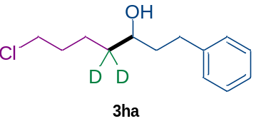According to the general procedure above, eluent in chromatography: petroleum ether: ethyl acetate = 20 : 1, 3ha was obtained as a colorless oil (28.8 mg, 63% yield).
¹H NMR (600 MHz, CDCl₃) δ 7.31 – 7.27 (m, 2H), 7.20 (dt, J = 8.3, 2.4 Hz, 3H), 3.63 (dd, J = 8.4, 4.1 Hz, 1H), 3.54 (t, J = 6.7 Hz, 2H), 2.80 (ddd, J = 13.7, 9.7, 5.7 Hz, 1H), 2.68 (ddd, J = 13.7, 9.6, 6.7 Hz, 1H), 1.84 – 1.71 (m, 4H), 1.60 – 1.55 (m, 1H), 1.51 – 1.45 (m, 1H), 1.42 (q, J = 4.9 Hz, 1H). ¹³C NMR (151 MHz, CDCl₃) δ 142.0, 128.4, 128.4, 125.9, 71.0, 44.9, 39.0, 35.8 (dd, J = 38.1, 18.8 Hz), 32.5, 32.0, 22.8. HRMS m/z (ESI) calculated for C₁₃H₁₇D₂ClONa⁺ [M + Na]⁺ 251.1142, found 251.1138.
 | Calculated weight | Found weight | Intensity | D%
C₁₃H₁₇D₂ClONa⁺ | 251.1142 | 251.1138 | 158956 | 98%
C₁₃H₁₈DClONa⁺ | 250.1079 | 250.1081 | 5866 | 98%
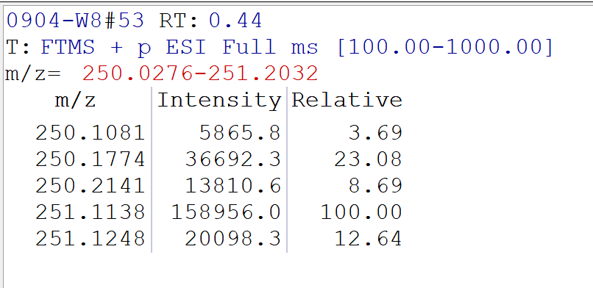
7,7,7-trifluoro-1-phenylheptan-4,4-d2-3-ol (3ia)
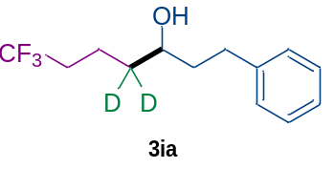According to the general procedure above, eluent in chromatography: petroleum ether: ethyl acetate = 30 : 1, 3ia was obtained as a colorless oil (32.8 mg, 66% yield). ¹H NMR (600 MHz, CDCl₃) δ 7.30 (dd, J = 8.6, 6.5 Hz, 2H), 7.23 – 7.18 (m, 3H), 3.63 (dd, J = 8.1, 4.3 Hz, 1H), 2.79 (ddd, J = 13.7, 9.4, 5.9 Hz, 1H), 2.68 (ddd, J = 13.8, 9.3, 6.9 Hz, 1H), 2.15 – 2.05 (m, 2H), 1.84 – 1.70 (m, 3H), 1.62 (t, J = 7.6 Hz, 1H), 1.43 – 1.37 (m, 1H). ¹³C NMR (151 MHz, CDCl₃) δ 141.7, 128.5, 128.4, 127.1(q, J = 277.84 Hz), 126.0, 70.7, 39.1, 35.4 (dd, J = 38.3, 19.4 Hz), 33.6 (q, J = 28.5 Hz), 32.0, 18.1 (q, J = 3.0 Hz). ¹⁹F NMR (565 MHz, CDCl₃) δ -66.4. HRMS m/z (ESI) calculated for C₁₃H₁₅D₂F₃ONa⁺ [M + Na]⁺ 271.1249, found 271.1249.
 | Calculated weight | Found weight | Intensity | D%
C₁₃H₁₅D₂F₃ONa⁺ | 271.1249 | 271.1249 | 43140 | 92%
C₁₃H₁₆DF₃ONa⁺ | 270.1186 | 270.1188 | 8765 | 92%
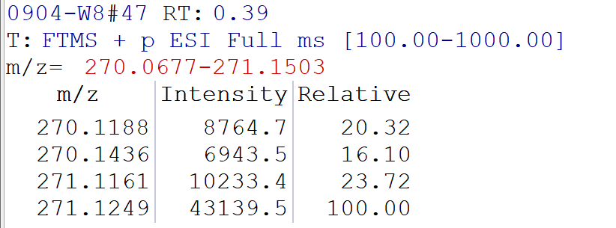
1-phenylhept-6-en-4,4-d2-3-ol (3ja)
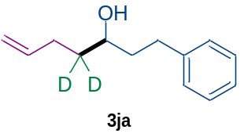According to the general procedure above, eluent in chromatography: petroleum ether: ethyl acetate = 30 : 1, 3ja was obtained as a colorless oil (29.6 mg, 77% yield). ¹H NMR (600 MHz, CDCl₃) δ 7.29 (t, J = 7.6 Hz, 2H), 7.22 – 7.17 (m, 3H), 5.83 (ddt, J = 16.9, 10.5, 3.1 Hz, 1H), 5.07 – 4.95 (m, 2H), 3.67 (tt, J = 7.5, 3.9 Hz, 1H), 2.82 – 2.77 (m, 1H), 2.68 (ddd, J = 13.8, 9.7, 6.7 Hz, 1H), 2.22 – 2.10 (m, 1H), 1.78 (ddddd, J = 13.9, 11.5, 9.6, 6.1, 2.1 Hz, 2H), 1.56 (td, J = 12.4, 6.0 Hz, 1H), 1.44 (br, s, 1H).¹³C NMR (151 MHz, CDCl₃) δ 142.1, 138.5, 138.4, 128.4, 128.4, 125.8, 114.9, 114.8, 70.9, 70.9, 39.1, 39.0, 32.0, 29.9. HRMS m/z (ESI) calculated for C₁₃H₁₆D₂ONa⁺ [M + Na]⁺ 215.1375, found 215.1374.
 | Calculated weight | Found weight | Intensity | D%
C₁₃H₁₆D₂ONa⁺ | 215.1375 | 215.1374 | 54074 | >99%
C₁₃H₁₇DONa⁺ | 214.1313 | / | 0 | >99%
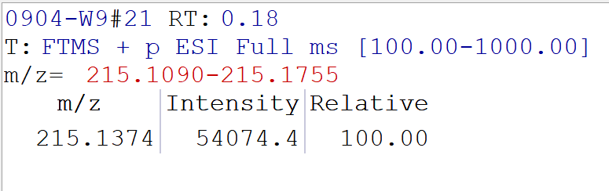
1-cyclohexylnon-4-yn-2,2-d2-1-ol (3kd)
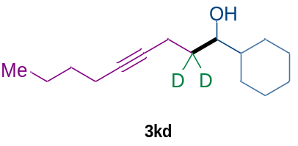According to the general procedure above, eluent in chromatography: petroleum ether : ethyl acetate = 40 : 1, 3kd was obtained as a colorless oil (22.4 mg, 50% yield). ¹H NMR (600 MHz, CDCl₃) δ 3.48 (d, J = 5.6 Hz, 1H), 2.28 (s, 2H), 2.14 (ddt, J = 7.1, 4.9, 2.5 Hz, 2H), 1.83 – 1.79 (m, 1H), 1.78 – 1.74 (m, 2H), 1.69 – 1.65 (m, 2H), 1.48 – 1.43 (m, 2H), 1.41 – 1.36 (m, 2H), 1.32 (td, J = 6.6, 3.0 Hz, 1H), 1.28 (s, 1H), 1.26 – 1.20 (m, 2H), 1.15 (tt, J = 12.8, 3.3 Hz, 1H), 1.04 (ddt, J = 24.5, 12.3, 8.8 Hz, 2H), 0.90 (t, J = 7.2 Hz, 3H). ¹³C NMR (151 MHz, CDCl₃) δ 81.1, 79.8, 75.4, 43.6, 32.5 (dd, J = 39.4, 19.7 Hz), 31.1, 29.1, 27.9, 26.5, 26.3, 26.2, 21.9, 18.4, 15.5, 13.6. HRMS m/z (ESI) calculated for C₁₅H₂₄D₂ONa⁺ [M + Na]⁺ 247.2001, found 247.2000.
 | Calculated weight | Found weight | Intensity | D%
C₁₅H₂₄D₂ONa⁺ | 247.2001 | 247.2000 | 860235 | 98%
C₁₅H₂₅DONa⁺ | 246.1939 | 246.1931 | 35318 | 98%
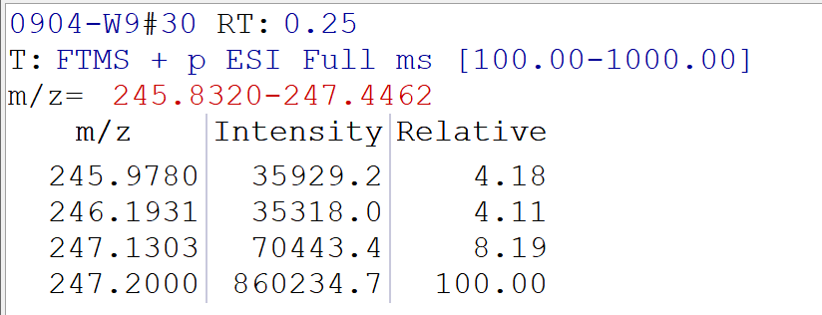
1,5-diphenylpentan-2,2-d2-3-ol (3la)
According to the general procedure above, eluent in chromatography: petroleum ether : ethyl acetate = 30: 1, 3la was obtained as a colorless oil (36.3 mg, 75% yield)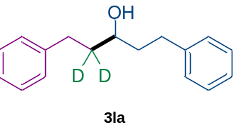.
¹H NMR (600 MHz, CDCl₃) δ 7.29 (t, J = 7.6 Hz, 4H), 7.19 (dd, J = 7.6, 4.5 Hz, 6H), 3.67 (dd, J = 8.1, 4.4 Hz, 1H), 2.83 – 2.74 (m, 2H), 2.71 – 2.61 (m, 2H), 1.86 – 1.75 (m, 2H). ¹³C NMR (151 MHz, CDCl₃) δ 142.0, 128.4, 128.4, 125.8, 70.7, 39.1, 38.3 (dd, J = 38.6, 19.6 Hz), 32.0, 31.8. HRMS m/z (ESI) calculated for C₁₇H₁₈D₂ONa⁺ [M + Na]⁺ 265.1532, found 265.1529.
 | Calculated weight | Found weight | Intensity | D%
C₁₇H₁₈D₂ONa⁺ | 265.1532 | 265.1529 | 176482 | 97%
C₁₇H₁₉DONa⁺ | 264.1469 | 264.1468 | 13230 | 97%
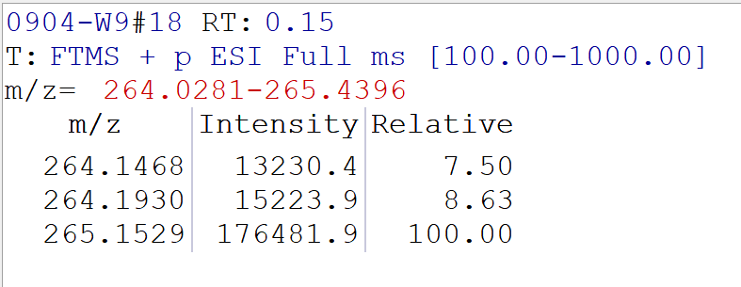
1-(4-fluorophenyl)-5-phenylpentan-2,2-d2-3-ol (3ma)
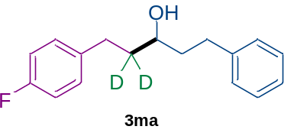According to the general procedure above, eluent in chromatography: petroleum ether : ethyl acetate = 30 : 1, 3ma was obtained as a colorless oil (27.6 mg, 53% yield). ¹H NMR (600 MHz, CDCl₃) δ 7.29 (dd, J = 8.6, 6.6 Hz, 2H), 7.19 (d, J = 7.6 Hz, 3H), 7.13 (dd, J = 8.4, 5.5 Hz, 2H), 6.96 (t, J = 8.7 Hz, 2H), 3.64 (dt, J = 8.5, 4.3 Hz, 1H), 2.82 – 2.61 (m, 4H), 1.80 (ddddd, J = 19.7, 16.6, 14.1, 8.1, 5.2 Hz, 2H), 1.39 (d, J = 4.9 Hz, 1H). ¹³C NMR (151 MHz, CDCl₃) δ 161.2 (d, J = 243.3 Hz), 141.9, 137.6 (d, J = 3.5 Hz), 129.7 (d, J = 7.7 Hz), 128.4, 128.4, 125.9, 115.1 (d, J = 21.0 Hz), 70.5, 39.2, 38.4 (dd, J = 37.2, 19.5 Hz), 32.0, 31.0. ¹⁹F NMR (565 MHz, CDCl₃) δ -117.7. HRMS m/z (ESI) calculated for C₁₇H₁₇D₂FONa⁺ [M + Na]⁺ 283.1438, found 283.1434.
 | Calculated weight | Found weight | Intensity | D%
C₁₇H₁₇D₂FONa⁺ | 283.1438 | 283.1434 | 34675 | 90%
C₁₇H₁₈DFONa⁺ | 282.1375 | 282.1370 | 9529 | 90%
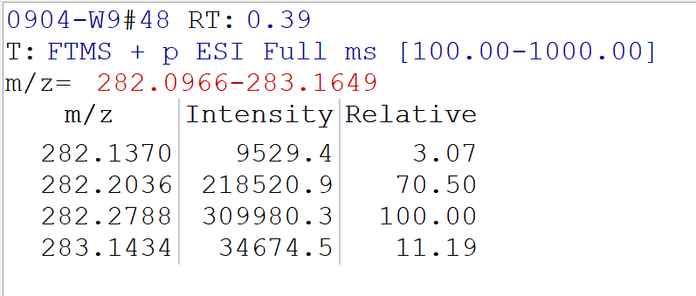
1-(4-bromophenyl)-5-phenylpentan-2,2-d2-3-ol (3na)
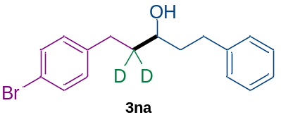According to the general procedure above, eluent in chromatography: petroleum ether : ethyl acetate = 30 : 1, 3na was obtained as a white solid (39.2 mg, 61% yield). ¹H NMR (600 MHz, CDCl₃) δ 7.42 – 7.38 (m, 2H), 7.29 (t, J = 7.6 Hz, 2H), 7.22 – 7.17 (m, 3H), 7.08 – 7.04 (m, 2H), 3.64 (dd, J = 7.9, 4.4 Hz, 1H), 2.83 – 2.59 (m, 4H), 1.87 – 1.74 (m, 2H), 1.41 (br, s, 1H). ¹³C NMR (151 MHz, CDCl₃) δ 141.9, 141.0, 131.4, 130.2, 128.4, 128.4, 125.9, 119.5, 70.5, 39.2, 38.1 (dd, J = 38.3, 19.6 Hz), 32.0, 31.2. HRMS m/z (ESI) calculated for C₁₇H₁₇D₂BrONa⁺ [M + Na]⁺ 343.0637, found 343.0636.
 | Calculated weight | Found weight | Intensity | D%
C₁₇H₁₇D₂BrONa⁺ | 343.0637 | 343.0636 | 68574 | >99%
C₁₇H₁₈DBrONa⁺ | 342.0574 | / | 0 | >99%
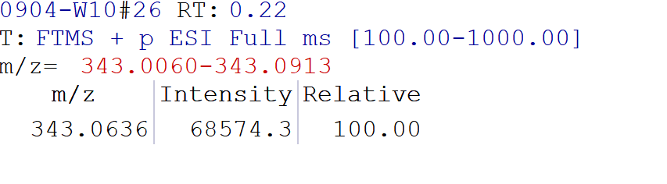
4-(3-hydroxy-5-phenylpentyl-2,2-d2)benzonitrile (3oa)
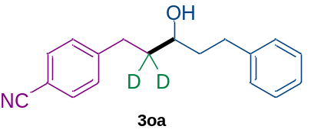According to the general procedure above, eluent in chromatography: petroleum ether : ethyl acetate = 30 : 1, 3oa was obtained as a colorless oil (28.9 mg, 54% yield). ¹H NMR (600 MHz, CDCl₃) δ 7.56 (d, J = 8.0 Hz, 2H), 7.31 – 7.26 (m, 4H), 7.19 (dd, J = 12.9, 7.3 Hz, 3H), 3.63 (t, J = 6.5 Hz, 1H), 2.87 – 2.64 (m, 4H), 1.87 – 1.75 (m, 2H), 1.51 (br, s, 1H). ¹³C NMR (151 MHz, CDCl₃) δ 147.8, 141.7, 132.2, 129.2, 128.5, 128.3, 126.0, 119.0, 109.7, 70.3, 39.1, 37.8 (dd, J = 38.5, 20.3 Hz), 32.0, 29.7. HRMS m/z (ESI) calculated for C₁₈H₁₇D₂NONa⁺ [M + Na]⁺ 290.1484, found 290.1484.
 | Calculated weight | Found weight | Intensity | D%
C₁₈H₁₇D₂NONa⁺ | 290.1484 | 290.1484 | 203695 | 98%
C₁₈H₁₈DNONa⁺ | 289.1422 | 289.1420 | 8443 | 98%
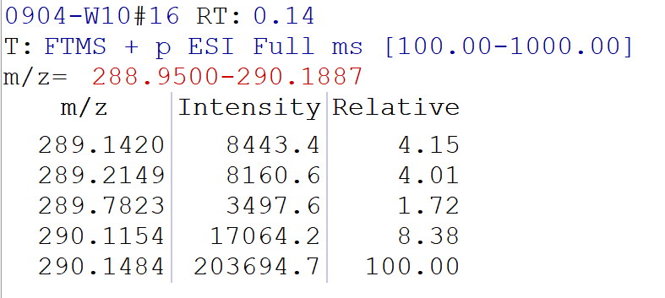
1-phenyl-5-(thiophen-2-yl)pentan-4,4-d2-3-ol (3pa)
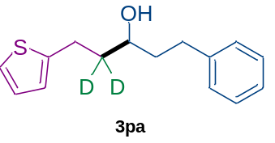According to the general procedure above, eluent in chromatography: petroleum ether : ethyl acetate = 30 : 1, 3pa was obtained as a yellow oil (28.3 mg, 57% yield).
¹H NMR (600 MHz, CDCl₃) δ 7.33 – 7.27 (m, 2H), 7.23 – 7.18 (m, 3H), 7.13 (dd, J = 5.1, 1.2 Hz, 1H), 6.93 (dd, J = 5.2, 3.4 Hz, 1H), 6.80 (dd, J = 3.3, 1.3 Hz, 1H), 3.70 (dt, J = 8.0, 3.7 Hz, 1H), 3.04 – 2.89 (m, 2H), 2.80 (ddd, J = 13.8, 9.6, 6.0 Hz, 1H), 2.69 (ddd, J = 13.8, 9.6, 6.7 Hz, 1H), 1.87 – 1.76 (m, 2H), 1.47 (br, s, 1H). ¹³C NMR (151 MHz, CDCl₃) δ 144.8, 141.9, 128.4, 128.4, 126.8, 125.9, 124.2, 123.0, 70.4, 39.1, 38.6 (dd, J = 38.5, 19.7 Hz), 32.0, 25.9. HRMS m/z (ESI) calculated for C₁₅H₁₆D₂OSNa⁺ [M + Na]⁺ 271.1096, found 271.1096.
 | Calculated weight | Found weight | Intensity | D%
C₁₅H₁₆D₂OSNa⁺ | 271.1096 | 271.1096 | 624664 | 98%
C₁₅H₁₇DOSNa⁺ | 270.1033 | 270.1034 | 25260 | 98%
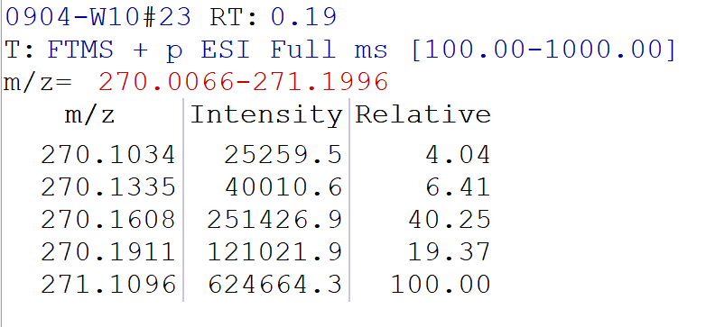
4-phenylbutan-1,1,1-d3-2-ol (3qa)
According to the general procedure above, eluent in chromatography: petroleum ether : ethyl acetate = 30 : 1, 3qa was obtained as a colorless oil (19.9mg, 65% yield)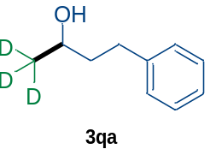. ¹H NMR (600 MHz, CDCl₃) δ 7.29 (t, J = 7.6 Hz, 2H), 7.22 – 7.17 (m, 3H), 3.82 (t, J = 6.2 Hz, 1H), 2.76 (ddd, J = 13.7, 9.5, 6.1 Hz, 1H), 2.68 (ddd, J = 13.8, 9.4, 6.9 Hz, 1H), 1.82 – 1.74 (m, 2H), 1.36 (br, s, 1H). ¹³C NMR (151 MHz, CDCl₃) δ 142.0, 128.4, 128.4, 125.8, 67.4, 40.8, 32.1, 29.7. HRMS m/z (ESI) calculated for C₁₀H₁₁D₃ONa⁺ [M + Na]⁺ 176.1125, found 176.1122.
 | Calculated weight | Found weight | Intensity | D%
C₁₀H₁₁D₃ONa⁺ | 176.1125 | 176.1122 | 71473 | >99%
C₁₀H₁₂D₂ONa⁺ | 175.1062 | / | 0 | >99%
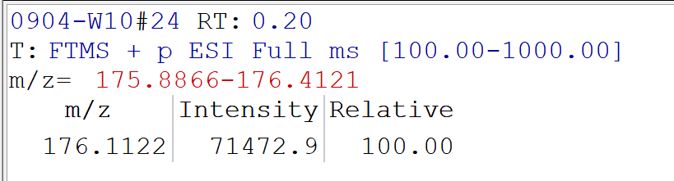

6. Experimental procedures for photoactive chromium-catalyzed three-component reactions and characterization of products
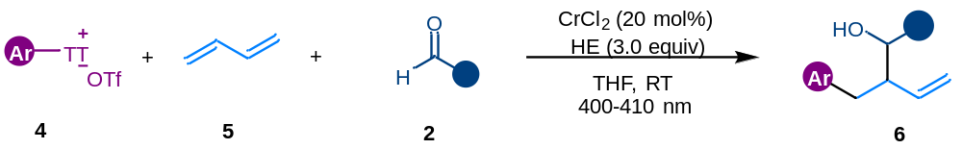
In a nitrogen-filled glove box, to a 10 mL oven-dried schlenk tube equipped with a stir bar was added CrCl₂ (0.04 mmol, 20 mol%). The schlenk tube was sealed and removed from the glovebox. Then aryl thianthrenium salts 4 (0.3 mmol, 1.5 equiv) and HE (0.6 mmol, 3 equiv) were added under a nitrogen atmosphere. Subsequently, anhydrous THF (1.0 mL) were added via syringe, followed by addition of aldehyde 2 (0.2 mmol, 1.0 equiv) and 1,3-butadiene 5 ( 0.8 mmol, 4.0 equiv, 2.0 M in THF). The reaction mixture was stirred and irradiated with two 400-410 nm blue LED lamps for 12 hours. After the reaction completed, the reaction mixture was opened to air diluted with 3 mL of ethyl acetate, and filtered over a 1 cm pad of silica. The pad was rinsed with ethyl acetate (3$×$2 mL), and the combined solutions were concentrated in vacuo. The crude material was loaded onto a silica gel column and separated by flash chromatography (eluent: PE/EA).
4-(4-methoxybenzyl)-1-phenylhex-5-en-3-ol (6a)
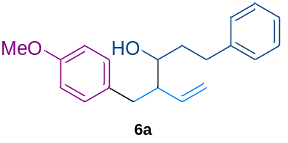According to the general procedure above, eluent in chromatography: petroleum ether: ethyl acetate = 30 : 1, 6a was obtained as a colorless oil (26.1 mg, 44% yield, d. r. = 8 : 1).Major : ¹H NMR (600 MHz, CDCl₃) δ 7.29 – 7.26 (m, 2H), 7.21 – 7.15 (m, 3H), 7.08 – 7.03 (m, 2H), 6.84 – 6.77 (m, 2H), 5.75 (ddd, J = 17.2, 10.4, 8.9 Hz, 1H), 5.13 (dd, J = 10.3, 1.8 Hz, 1H), 5.00 (dd, J = 17.3, 1.8 Hz, 1H), 3.79 (s, 3H), 3.55 (dq, J = 8.8, 4.5 Hz, 1H), 2.85 – 2.75 (m, 2H), 2.68 – 2.58 (m, 2H), 2.35 (qd, J = 8.4, 4.4 Hz, 1H), 1.85 – 1.73 (m, 2H), 1.48 (d, J = 5.4 Hz, 1H); Minor : ¹H NMR (600 MHz, CDCl₃) δ 7.42 (d, J = 8.6 Hz, 1H), 7.27 – 7.22 (m, 3H), 7.15 (d, J = 7.6 Hz, 1H), 7.06 – 6.88 (m, 4H), 5.66 (dt, J = 17.0, 9.6 Hz, 1H), 5.13 – 5.07 (m, 1H), 5.00 – 4.96 (m, 1H), 3.85 (s, 3H), 3.12 (dd, J = 13.6, 6.9 Hz, 1H), 2.90 (m, 2H), 2.62 – 2.54 (m, 2H), 2.50 – 2.42 (m, 1H), 1.69 (m, 2H), 1.44 (d, J = 7.2 Hz, 1H). ¹³C NMR (151 MHz, CDCl₃) δ 157.8, 142.1, 137.5, 132.1, 130.1, 128.4, 128.4, 125.8, 118.2, 113.6, 71.9, 55.2, 51.6, 37.1, 36.6, 32.3. HRMS m/z (ESI) calculated for C₂₀H₂₄O₂Na⁺ [M + Na]⁺ 319.1669, found 319.1669.

1-(4-fluorophenyl)-2-(4-methylbenzyl)but-3-en-1-ol (6b)
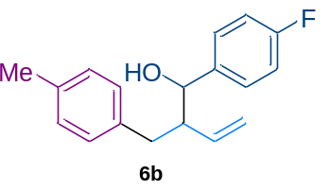According to the general procedure above, eluent in chromatography: petroleum ether: ethyl acetate = 40 : 1, 6b was obtained as a colorless oil (30.8 mg, 57% yield, d. r. > 20 : 1).
¹H NMR (600 MHz, CDCl₃) δ 7.33 – 7.28 (m, 2H), 7.04 (td, J = 8.3, 1.9 Hz, 4H), 6.96 (d, J = 8.0 Hz, 2H), 5.70 (ddd, J = 17.2, 10.3, 8.6 Hz, 1H), 5.15 (dd, J = 10.3, 1.7 Hz, 1H), 4.99 (dd, J = 17.8, 1.6 Hz, 1H), 4.52 (d, J = 6.4 Hz, 1H), 2.65 (dd, J = 13.2, 5.3 Hz, 1H), 2.59 (ddd, J = 14.5, 8.6, 5.9 Hz, 1H), 2.50 (dd, J = 13.2, 8.8 Hz, 1H), 2.30 (s, 3H). ¹³C NMR (151 MHz, CDCl₃) δ 163.0 (d, J = 3.3 Hz), 161.4, 138.3 (d, J = 3.0 Hz), 137.7, 136.6, 135.5, 128.9 (d, J = 2.2 Hz), 128.3, 128.3, 115.1 (d, J = 21.5 Hz), 74.8, 54.0, 36.8, 21.0. ¹⁹F NMR (565 MHz, CDCl₃) δ -115.1. HRMS m/z (ESI) calculated for C₁₈H₁₉FONa⁺ [M + Na]⁺ 293.1312, found 293.1312.

1-cyclohexyl-2-(4-methylbenzyl)but-3-en-1-ol (6c)
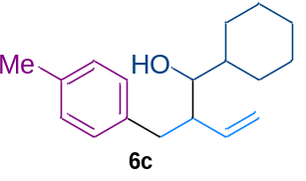According to the general procedure above, eluent in chromatography: petroleum ether: ethyl acetate = 40 : 1, 6c was obtained as a colorless oil (23.8 mg, 46% yield, d. r. > 20 : 1). ¹H NMR (600 MHz, CDCl₃) δ 7.07 (q, J = 7.9 Hz, 4H), 5.80 (ddd, J = 17.2, 10.4, 8.7 Hz, 1H), 5.13 (dd, J = 10.5, 1.8 Hz, 1H), 5.00 (dd, J = 17.3, 1.8 Hz, 1H), 3.15 (dd, J = 7.8, 3.9 Hz, 1H), 2.82 (dd, J = 13.6, 7.1 Hz, 1H), 2.66 (dd, J = 13.6, 7.8 Hz, 1H), 2.59 – 2.53 (m, 1H), 2.32 (s, 3H), 1.92 (d, J = 12.8 Hz, 1H), 1.77 – 1.64 (m, 4H), 1.41 (qd, J = 7.2, 3.6 Hz, 2H), 1.19 (ddt, J = 16.2, 7.6, 3.9 Hz, 2H), 1.12 (tt, J = 12.7, 3.3 Hz, 1H), 0.96 (dtd, J = 15.3, 12.3, 3.5 Hz, 2H). ¹³C NMR (151 MHz, CDCl₃) δ 137.6, 137.2, 135.2, 129.0, 128.9, 117.6, 76.5, 47.5, 40.9, 37.4, 29.2, 28.5, 26.4, 26.1, 26.0, 21.0. HRMS m/z (ESI) calculated for C₁₈H₂₆ONa⁺ [M + Na]⁺ 281.1876, found 281.1874.

N-(4-(2-((4-fluorophenyl)(hydroxy)methyl)but-3-en-1-yl)phenyl)-N,4-dimethylbenzenesulfonamide (6d)
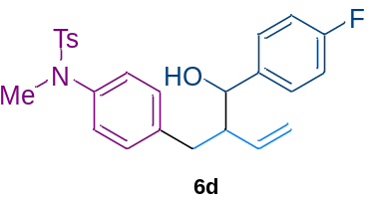According to the general procedure above, eluent in chromatography: petroleum ether: ethyl acetate = 10 : 1, 6d was obtained as a yellow oil (39.6mg, 45% yield, d. r. > 20 : 1). ¹H NMR (600 MHz, CDCl₃) δ 7.39 – 7.35 (m, 2H), 7.33 – 7.28 (m, 2H), 7.19 (d, J = 8.0 Hz, 2H), 7.07 – 7.02 (m, 2H), 7.00 – 6.94 (m, 4H), 5.67 (ddd, J = 17.2, 10.3, 8.6 Hz, 1H), 5.14 (dd, J = 10.3, 1.6 Hz, 1H), 4.98 – 4.92 (m, 1H), 4.52 (d, J = 6.4 Hz, 1H), 3.12 (s, 3H), 2.67 (dd, J = 13.2, 4.9 Hz, 1H), 2.56 (ddd, J = 14.4, 8.9, 6.1 Hz, 1H), 2.49 (dd, J = 13.2, 9.3 Hz, 1H), 2.40 (s, 3H), 2.19 (br, s, 1H). ¹³C NMR (151 MHz, CDCl₃) δ 162.2 (d, J = 245.8 Hz), 143.4, 139.4, 139.0, 138.1 (d, J = 3.2 Hz), 137.3, 133.4, 129.4, 129.2, 128.3 (d, J = 8.1 Hz), 127.9, 126.3, 119.2, 115.2 (d, J = 21.2 Hz), 75.0, 54.0, 38.0, 36.7, 21.5. ¹⁹F NMR (565 MHz, CDCl₃) δ -114.8. HRMS m/z (ESI) calculated for C₂₅H₂₆FNO₃SNa⁺ [M + Na]⁺ 462.1510, found 462.1507.

7. Mechanistic experiments

7.1 Radical trapping experiments
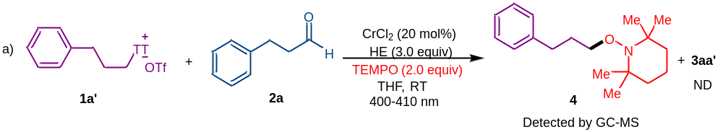
In a nitrogen-filled glove box, to a 10 mL oven-dried schlenk tube equipped with a stir bar was added CrCl₂ (0.04 mmol, 20 mol%). The schlenk tube was sealed and removed from the glovebox. Then alkyl thianthrenium salts 1a’ (0.3 mmol, 1.5 equiv), HE (0.6 mmol, 3 equiv) and TEMPO (0.4 mmol, 2.0 equiv) were added under a nitrogen atmosphere. Subsequently, anhydrous THF (1.0 mL) were added via syringe, followed by addition of aldehyde 2a (0.2 mmol, 1.0 equiv). The reaction mixture was stirred and irradiated with two 400-410 nm blue LED lamps for 12 hours. The resulting mixture was analyzed by GC-MS, it was found that no desired product 3aa’ was detected and TEMPO-adduct 4 was observed.
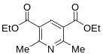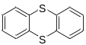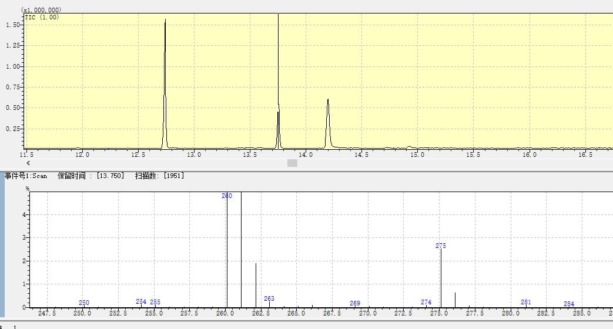
TEMPO-adduct
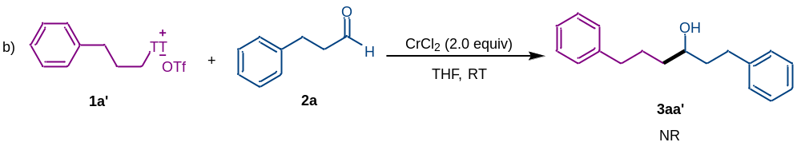
In a nitrogen-filled glove box, to a 10 mL oven-dried schlenk tube equipped with a stir bar was added CrCl₂ (0.4 mmol, 2.0 equiv). The schlenk tube was sealed and removed from the glovebox. Then alkyl thianthrenium salts 1a’ (0.3 mmol, 1.5 equiv) were added under a nitrogen atmosphere. Subsequently, anhydrous THF (1.0 mL) were added via syringe, followed by addition of aldehyde 2a (0.2 mmol, 1.0 equiv). The reaction mixture was stirred for 12 hours without light. The resulting mixture was analyzed by GC-MS and TLC, no desired product 3aa’ was detected.

7.2 Emission quenching experiments (Stern–Volmer studies)
Fluorescence quenching studies were performed using an EDINBURCH 48 INSTRUMENTS Spectrofluorometer FS5. The HE and quencher were weighed into a 10 mL schlenk tube and placed inside a glovebox under a positive pressure of N₂. THF were degassed separately outside of the glove box by sparging with N₂ for 5 minutes. Stern-Volmer luminescence quenching studies were carried out using a solution of HE (50μM) and variable concentrations of quencher in THF. The solution was irradiated at 365 nm, and the emission intensity was observed at 450 nm. Plots were constructed according to the Stern–Volmer equation I₀/I = 1+k_{q}τ₀[Q].
Figure S2 HE emission quenching by CrCl₃(THF)₃.
Figure S3 HE emission quenching by TT salts.
Figure S4 Stern–Volmer fluorescence quenching.

7.3 UV-vis absorption study
UV-vis absorption spectra were recorded on a Shimadzu UV-2700 spectrometer with a resolution of 1.0 nm using a quartz cuvette with a path length of 1.0 cm.
The UV/Vis absorption spectra of THF solutions of alkyl thianthrenium salts 1a’ (blue line, 0.15 M), Hantzsch ester (black line, 0.10 M in THF), and a mixture of 1a’ (0.15 M) and Hantzsch ester (0.10 M) are shown in Figure S5. The bathochromic shift is indicative of EDA complex formation.
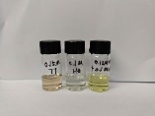
Figure S5. UV/visible absorption spectra of THF solution of 1a’ (0.15 M), Hantzschester (0.10 M), and a mixture of 1a’ (0.15 M) and Hantzsch ester (0.10 M).
7.4 Determination of association constant (k_{EDA})
The association constant for the EDA complex formed between alkyl thianthrenium salts 1a’ and Hantzsch ester was determined by UV-vis measurements in THF employing the Benesi Hilde brand^{[8]} method. The absorbance of a constant concentration of 1a’ (0.02 M) and an increasing concentration of HE (0.02-0.07 M) was recorded at 430 nm. The absorption spectra shown in Figure S6 were recorded in 1 cm path quartz cuvette.
To determine the k_{EDA}, the reciprocal concentration of HE was plotted against the reciprocal absorbance of HE at 430 nm (Table S2 and Figure S7). A straight line was obtained, and by dividing the intercept through the slope: k_{EDA} = 4.60 M⁻¹ for 1/HE.
Figure S6. UV-vis absorption spectra of alkyl thianthrenium salts (1a’, 0.02 M in THF) in combination with increasing concentrations of HE (0.02 M up to 0.07 M in THF).

Table S2. Data obtained from the UV-vis absorption spectra of the EDA complex between 1a’ and HE in THF. The concentration of 1a’ was kept at 0.02 M in THF.
HE(M) | 1/HE(M⁻¹) | Abs_{EDA} | 1/ Abs_{EDA}-A₀
0.02 | 50 | 0.227 | 4.405
0.03 | 33.3 | 0.334 | 2.994
0.04 | 25 | 0.438 | 2.283
0.05 | 20 | 0.571 | 1.751
0.06 | 16.7 | 0.690 | 1.449
0.07 | 14.3 | 0.775 | 1.290
Figure S7. Benesi Hilde brand^{[8]} plot for the EDA complex generated in THF upon association of alkyl thianthrenium salts 1a’ with HE.

7.4 Job’s method experiment:
The stoichiometry of the EDA complex was determined using Job’s method^{[9]} with varying ratios of alkyl thianthrenium salts 1a’ and Hantzsch ester (HE) in THF (0.1 M) at 452 nm. Δ fluorescence intensity was plotted against the molar fraction of alkyl thianthrenium salts 1a’. Minimum variation of fluorescence intensity was detected at 50% molar fraction of alkyl thianthrenium salts 1a’, indicating a 1:1 stoichiometry of the EDA complex.
Figure S8. Job plot of the EDA complex (0.1M total concentration in THF) between Hantzsch ester(HE) and alkyl thianthrenium salts 1a’ recorded at 452 nm.

8. References
1. (a) Chen, C., Wang, M., Lu, H., Zhao, B. & Shi, Z. Enabling the Use of Alkyl Thianthrenium Salts in Cross‐Coupling Reactions by Copper Catalysis. Angew. Chem. Int. Ed. 60, 21756–21760 (2021); (b) Chen, C., Wang, Z.-J., Lu, H., Zhao, Y. & Shi, Z. Generation of non-stabilized alkyl radicals from thianthrenium salts for C–B and C–C bond formation. Nat.Commun. 12, 4526 (2021).
2. Li, X. et al. Visible-Light-Promoted Desulfurative Alkylation of Alkyl Thianthrenium Salts with Activated Olefins. Org. Lett. 24, 4070–4074 (2022).
3. Jiao, M., Zhang, J., Wang, M., Lu, H. & Shi, Z. Metallaphotoredox deuteroalkylation utilizing thianthrenium salts. Nat. Commun. 15, 5067 (2024).
4. Nguyen, H. M. H. et al. Synthesis of ¹⁵ N-Pyridines and Higher Mass Isotopologs via Zincke Imine Intermediates. J. Am. Chem. Soc. 146, 2944–2949 (2024).
5. Fawcett, A. et al. Photoinduced decarboxylative borylation of carboxylic acids. Science 357, 283–286 (2017).
6. Lin, S. et al. Activation of Chromium Catalysts by Photoexcited Hantzsch Ester for Decarboxylative Allylation of Aldehydes with Butadiene. Org. Lett. 23, 8077–8081 (2021).
7. Too, P. C., Tnay, Y. L. & Chiba, S. Copper-catalyzed aerobic aliphatic C–H oxygenation with hydroperoxides. Beilstein J. Org. Chem. 9, 1217–1225 (2013).
8. Benesi, H. A. & Hildebrand, J. H. A Spectrophotometric Investigation of the Interaction of Iodine with Aromatic Hydrocarbons. J. Am. Chem. Soc. 71, 2703–2707 (1949).
9. Renny, J. S., Tomasevich, L. L., Tallmadge, E. H. & Collum, D. B. Method of Continuous Variations: Applications of Job Plots to the Study of Molecular Associations in Organometallic Chemistry. Angew. Chem. Int. Ed. 52, 11998–12013 (2013).

9. Copies of NMR Spectra
