Supplementary Information
Novel thermoresponsive ether-based electrolyte for wide-temperature operating lithium metal batteries

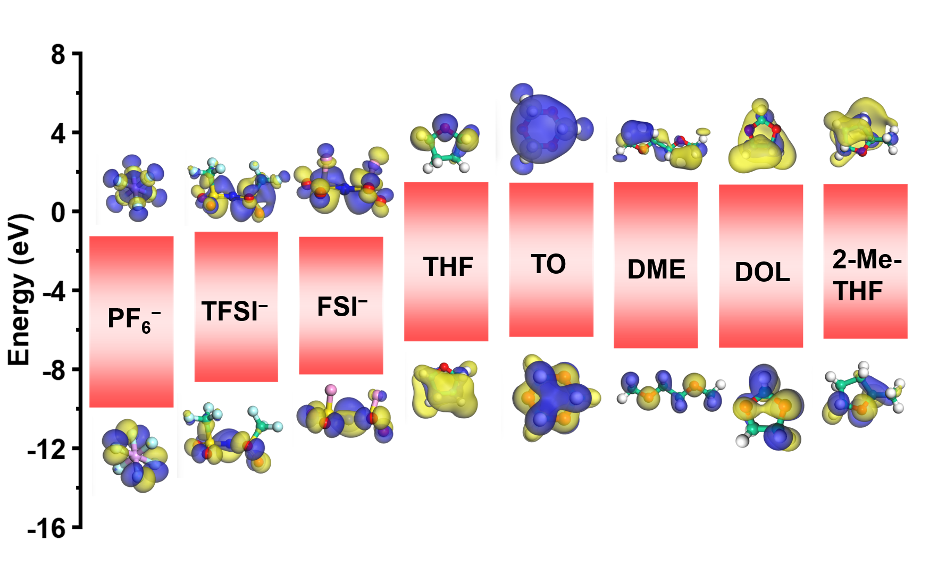
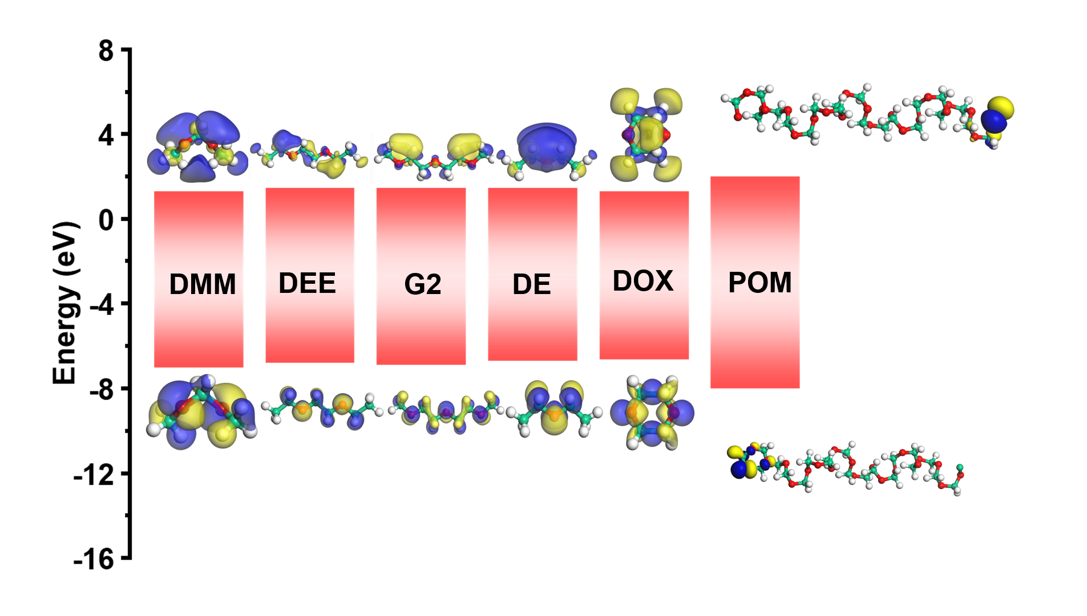
Supplementary Fig. 1 Comparison of the highest occupied molecular orbital (HOMO) and lowest unoccupied molecular orbital (LUMO) energy levels for various commonly used Li salts and ether-based solvents.

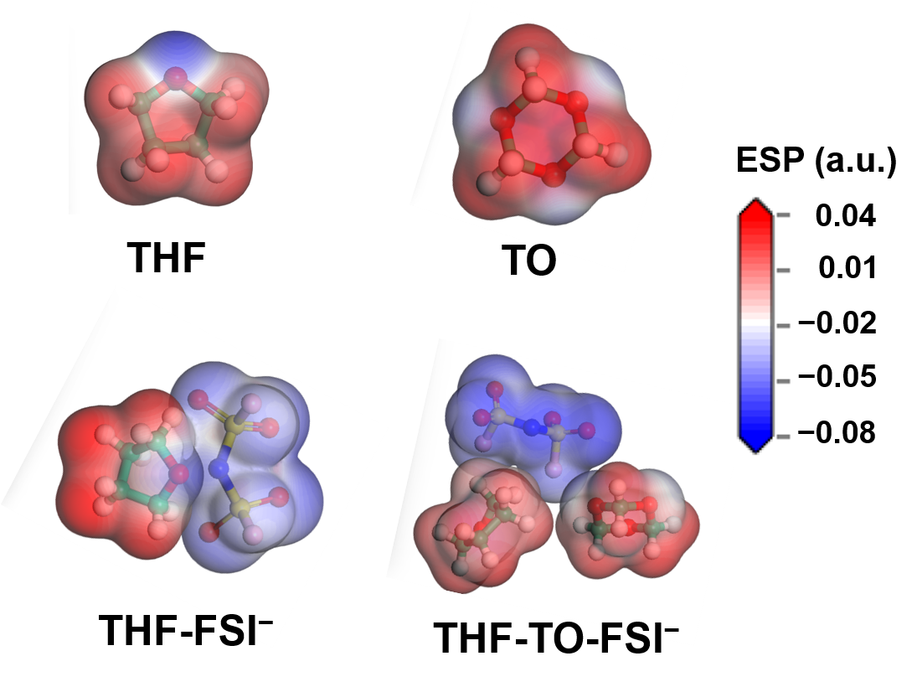
Supplementary Fig. 2 Electrostatic potential (ESP) maps of THF, TO, THF-FSI⁻, THF-TO-FSI⁻.

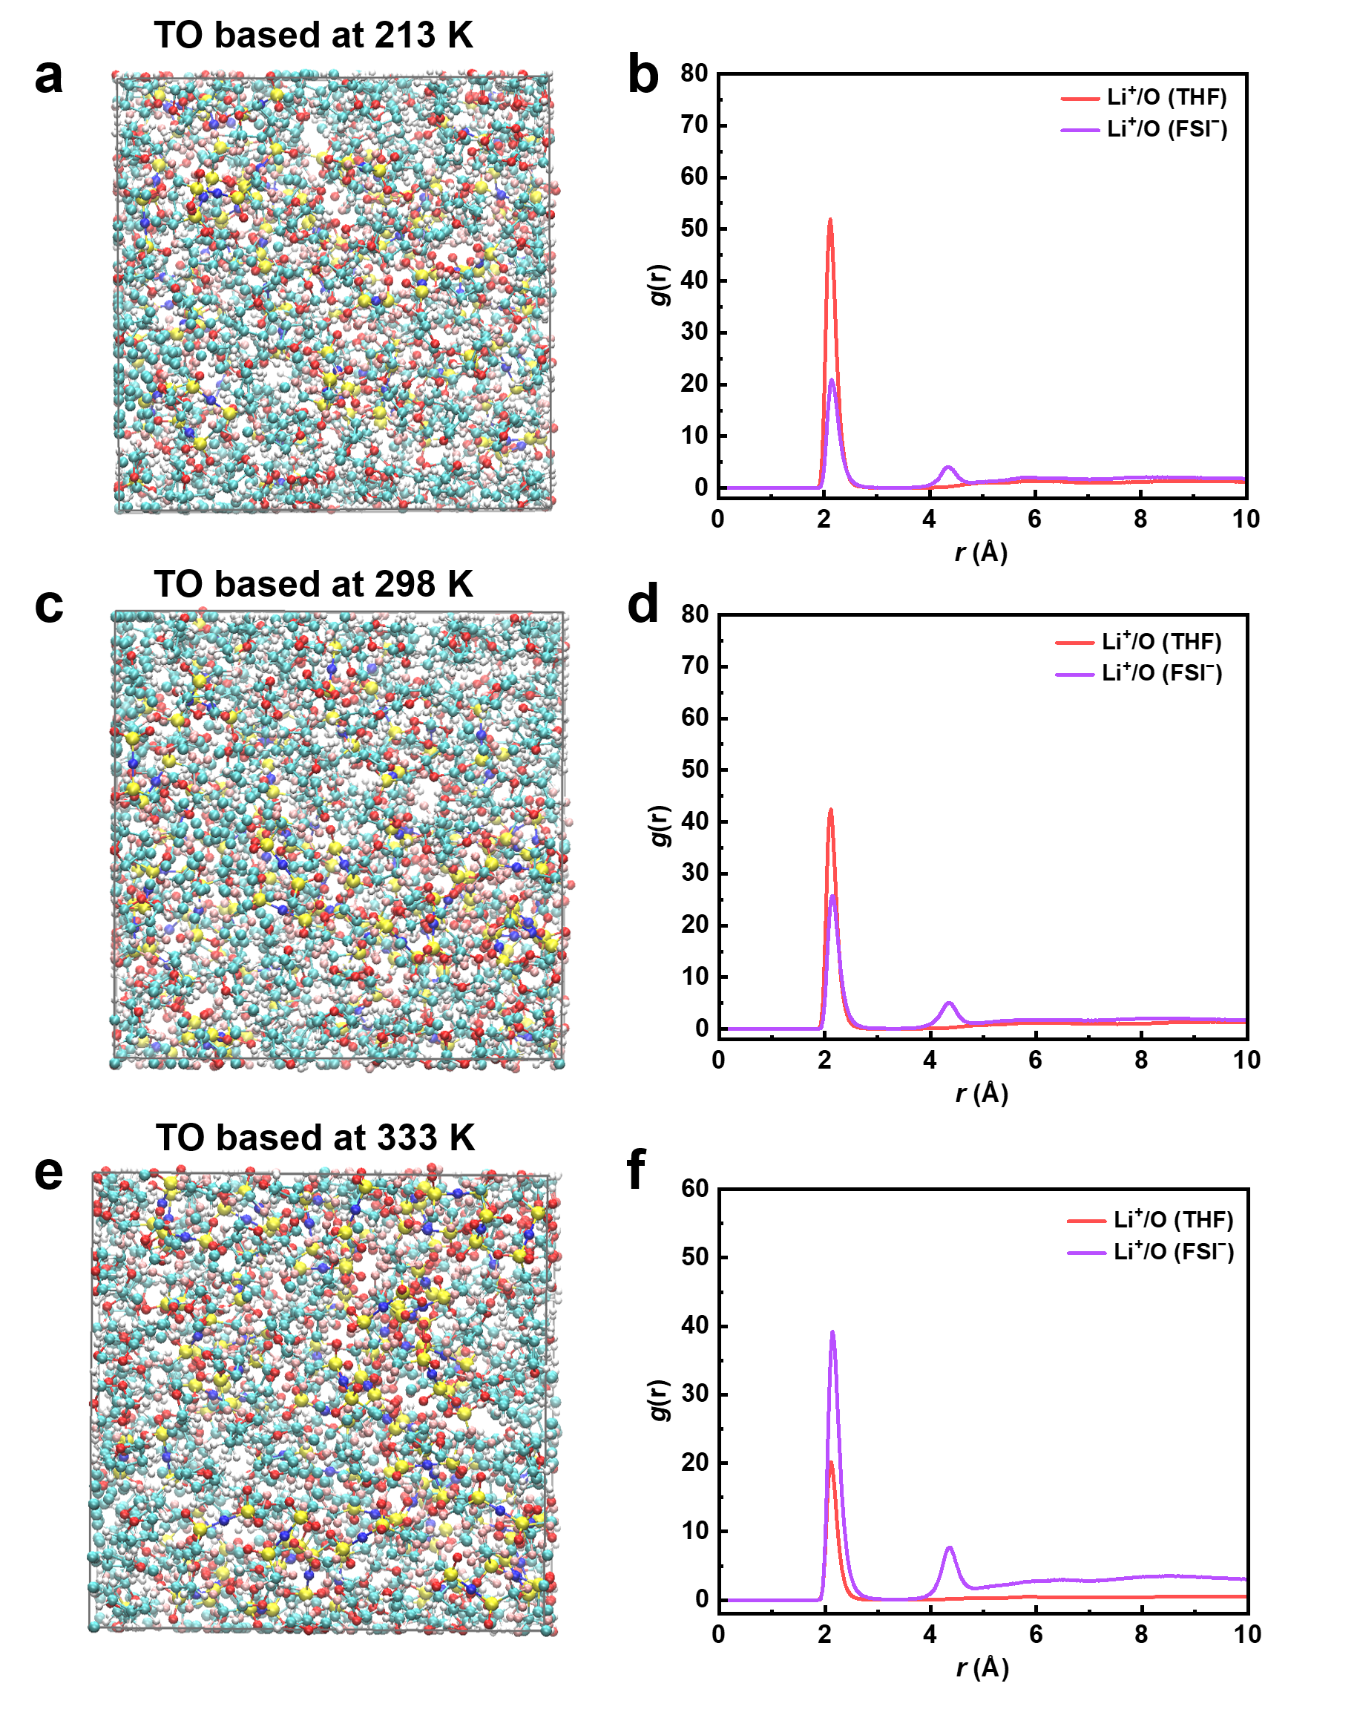
Supplementary Fig. 3 MD simulation Snapshots of TO-based electrolytes at (a) 213K, (c) 298K, and (e) 333K. Radial distribution function (RDF) profiles of TO-based electrolytes at (b) 213K, (d) 298K, and (f) 333K.
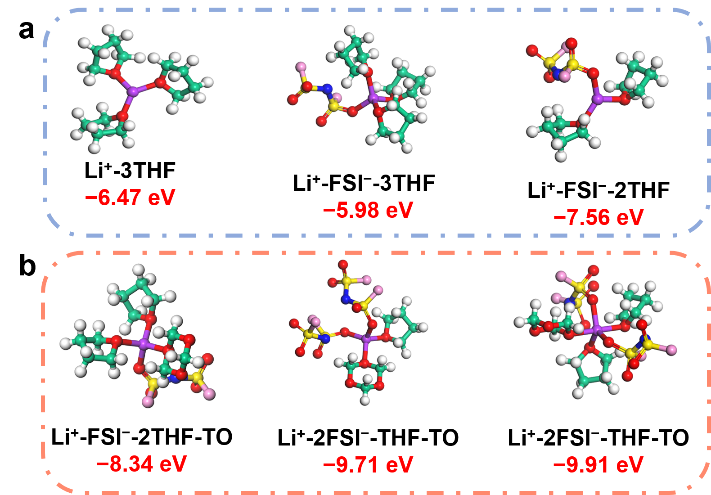

Supplementary Fig. 4 The representative Li⁺ coordination structure of THF- (c) and TO-based (d) electrolytes at 333K.

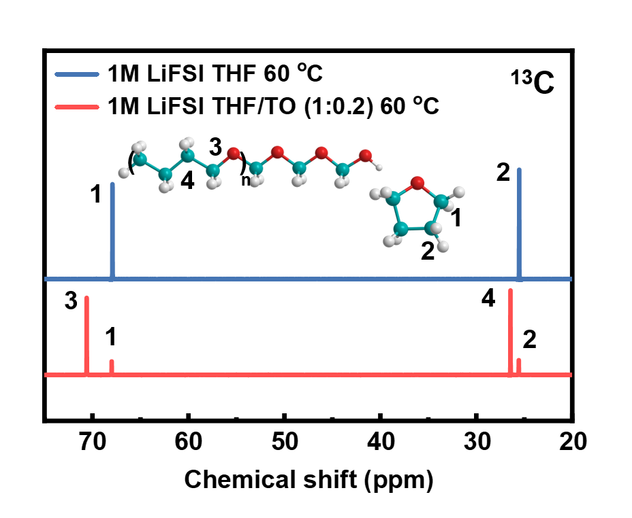
Supplementary Fig. 5 ¹³C NMR spectra of THF- and TO-based electrolytes at 60 °C.

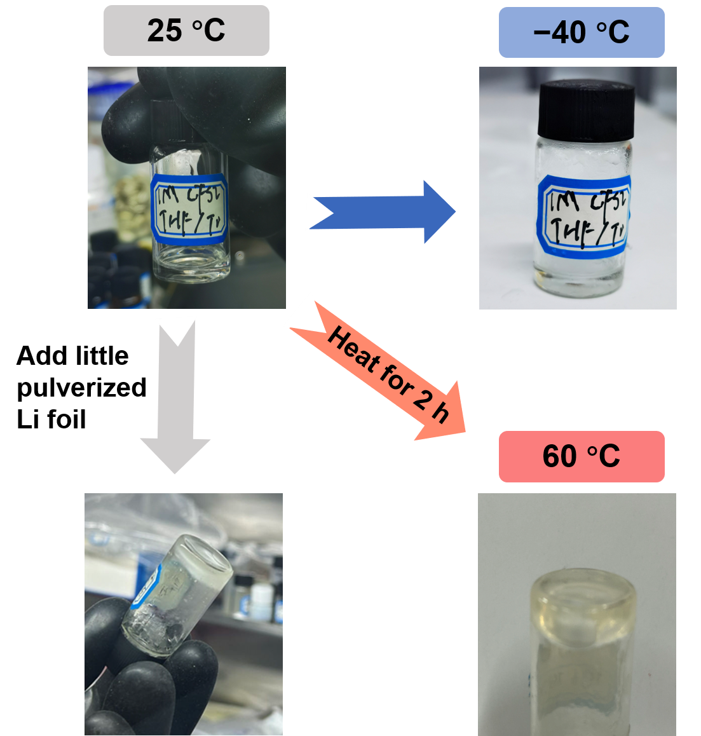

Supplementary Fig. 6 Photos of the state of TO-based electrolyte at different temperatures.

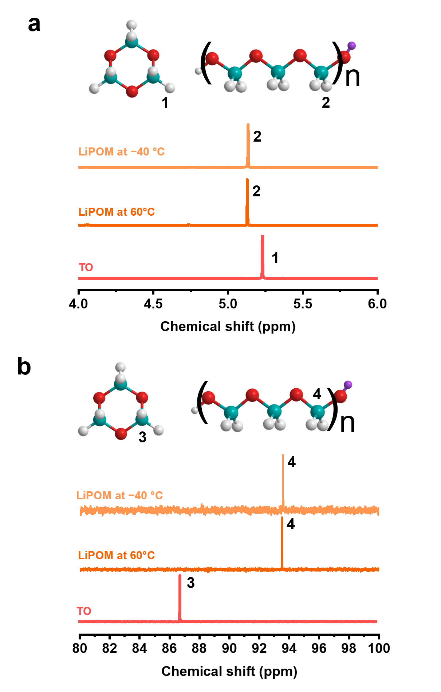
Supplementary Fig. 7 NMR spectra of TO and the polymerization products of TO at −40 °C and 60°C: a. hydrogen, b. carbon.
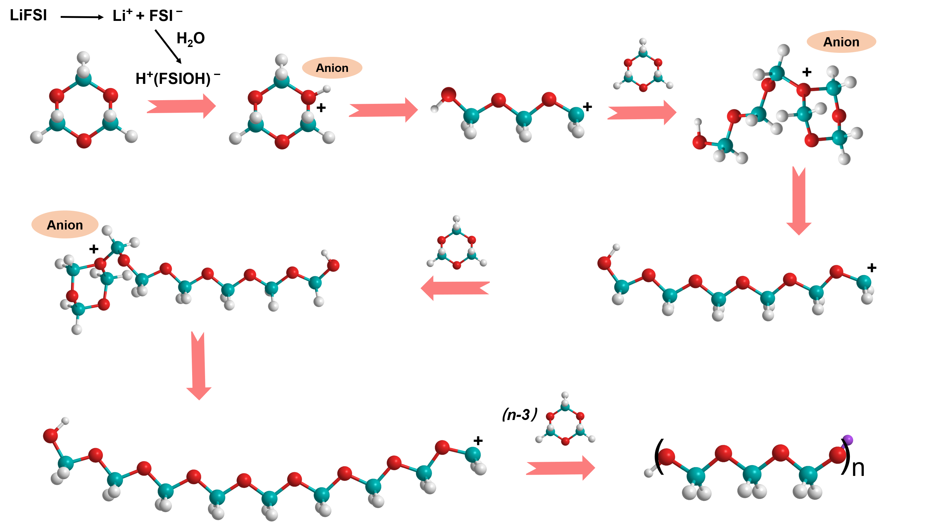

Supplementary Fig. 8 The polymerization mechanism of TO.

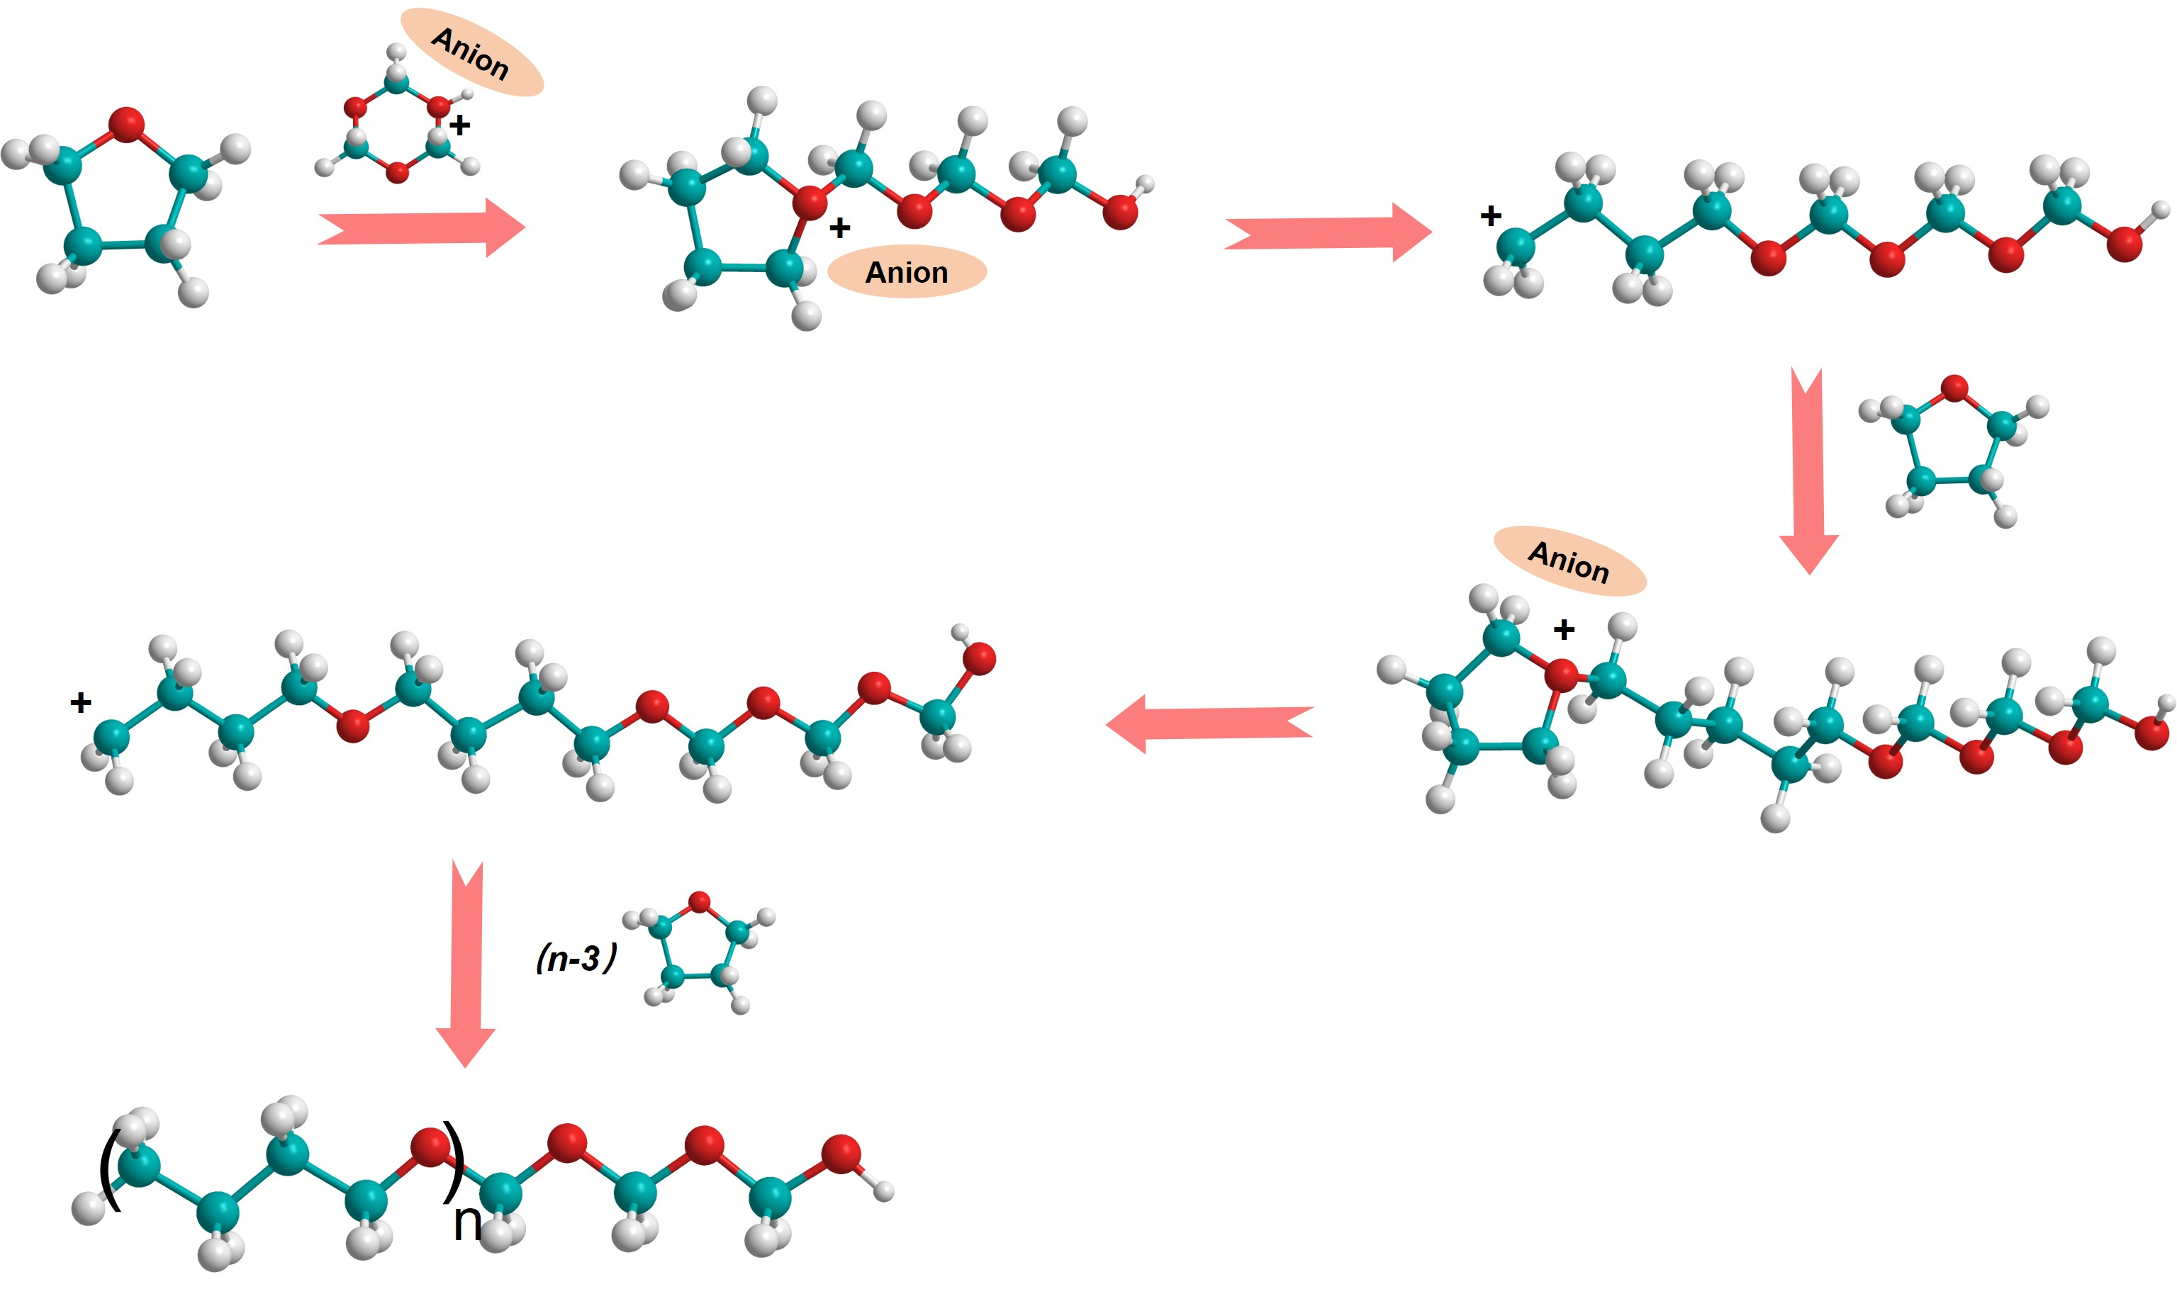

Supplementary Fig. 9 The polymerization mechanism of THF.

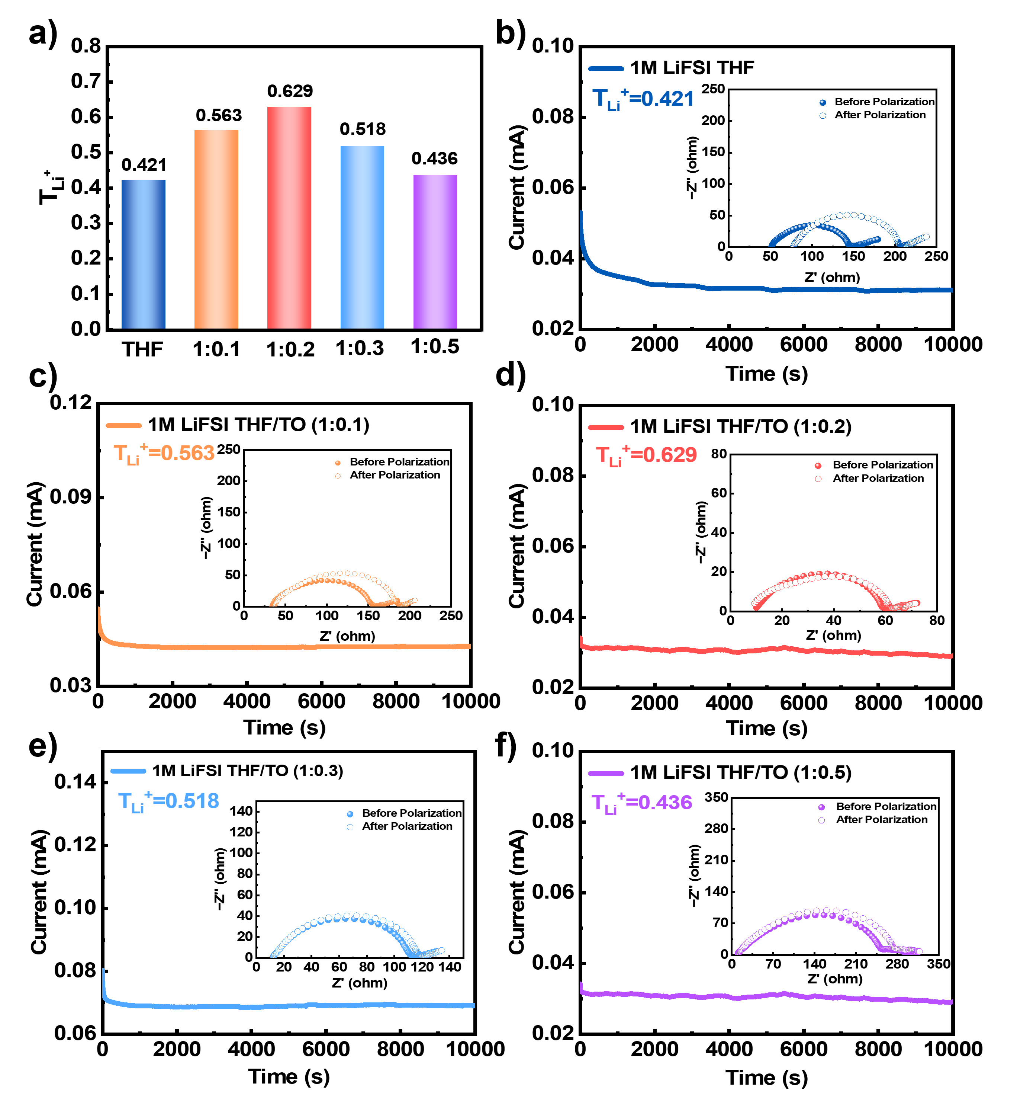
Supplementary Fig.10 a. Li⁺ transference number (T_{Li}⁺) of five electrolytes. b-f, Chronoamperometry profile collected from a symmetric Li||Li cell (inset shows the EIS plots of the Li||Li coin cell before and after chronoamperometry) using 1M LiFSI THF (b), 1M LiFSI THF/TO (1:0.1) (c), 1M LiFSI THF/TO (1:0.2) (d), 1M LiFSI THF/TO (1:0.3) (e), 1M LiFSI THF/TO (1:0.5) (f) electrolytes.
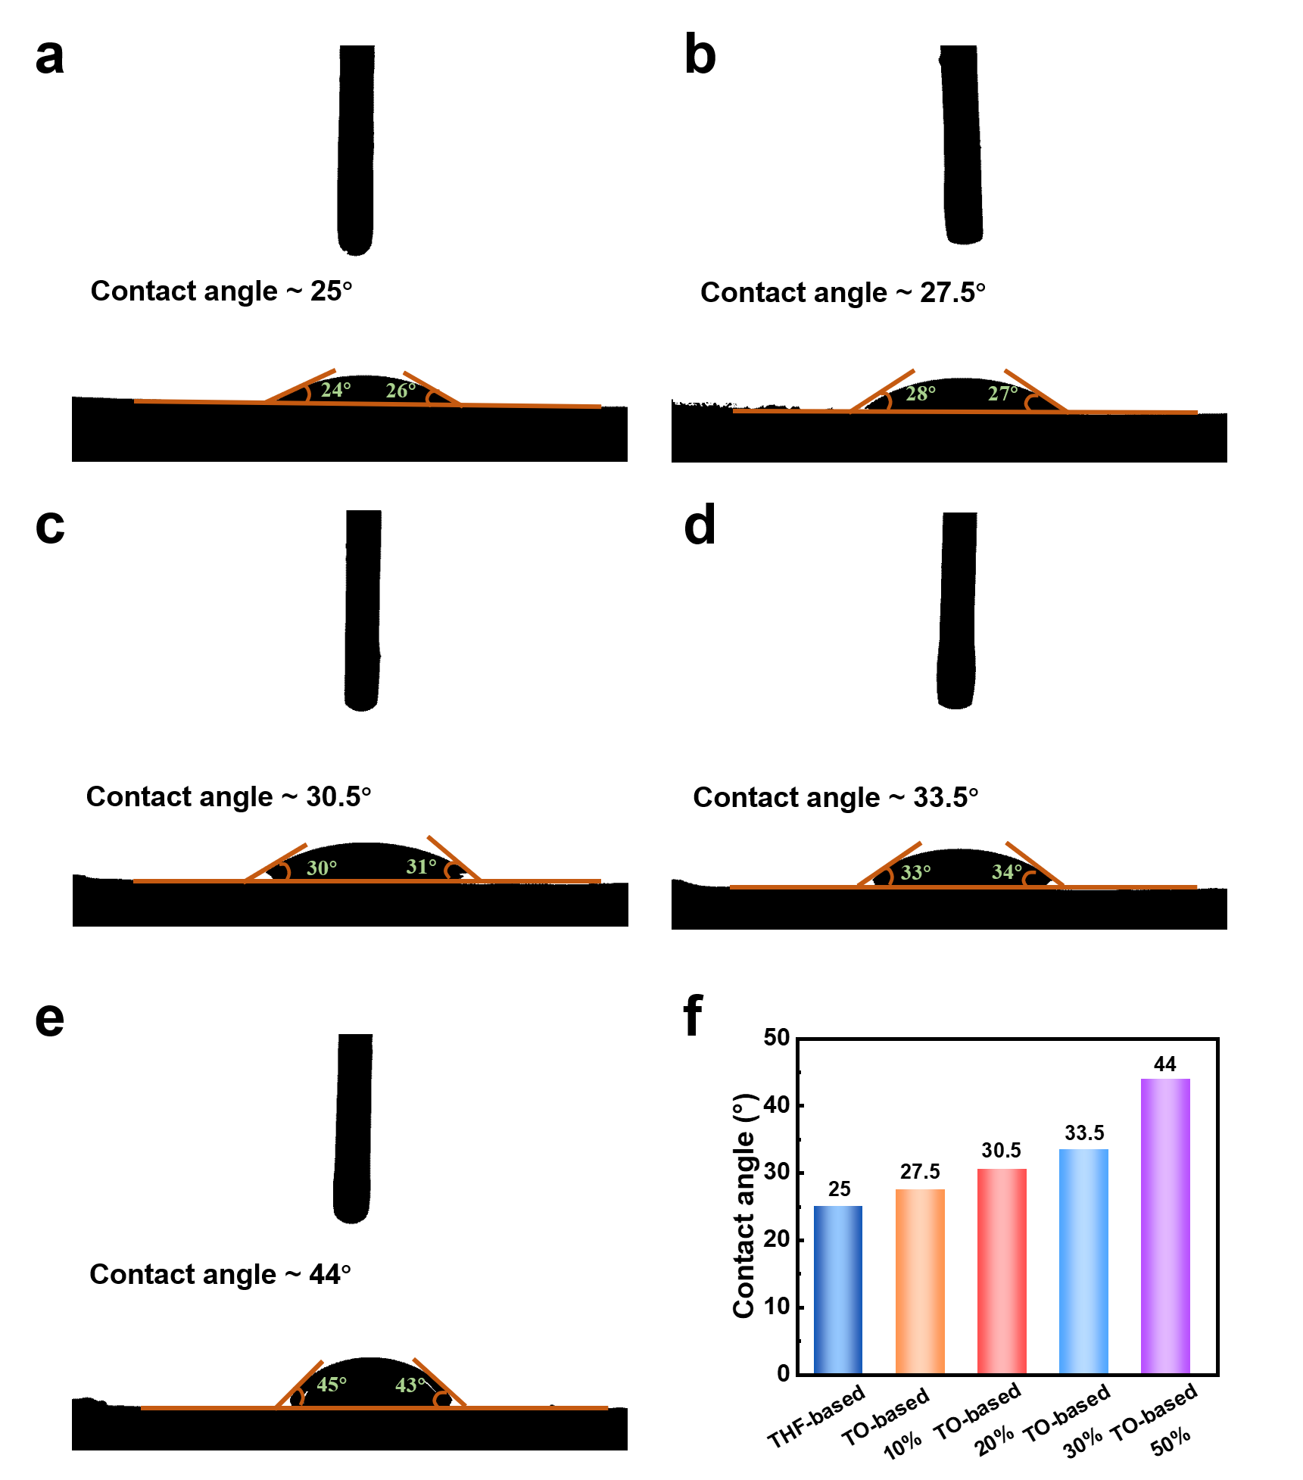
Supplementary Fig.11 The wettability tests for 1M LiFSI THF (a), 1M LiFSI THF/TO (1:0.1) (b), 1M LiFSI THF/TO (1:0.2) (c), 1M LiFSI THF/TO (1:0.1) (d), 1M LiFSI THF/TO (1:0.1) (e) electrolytes dropped in PE separators. f. Summary of contact angles for five electrolytes.

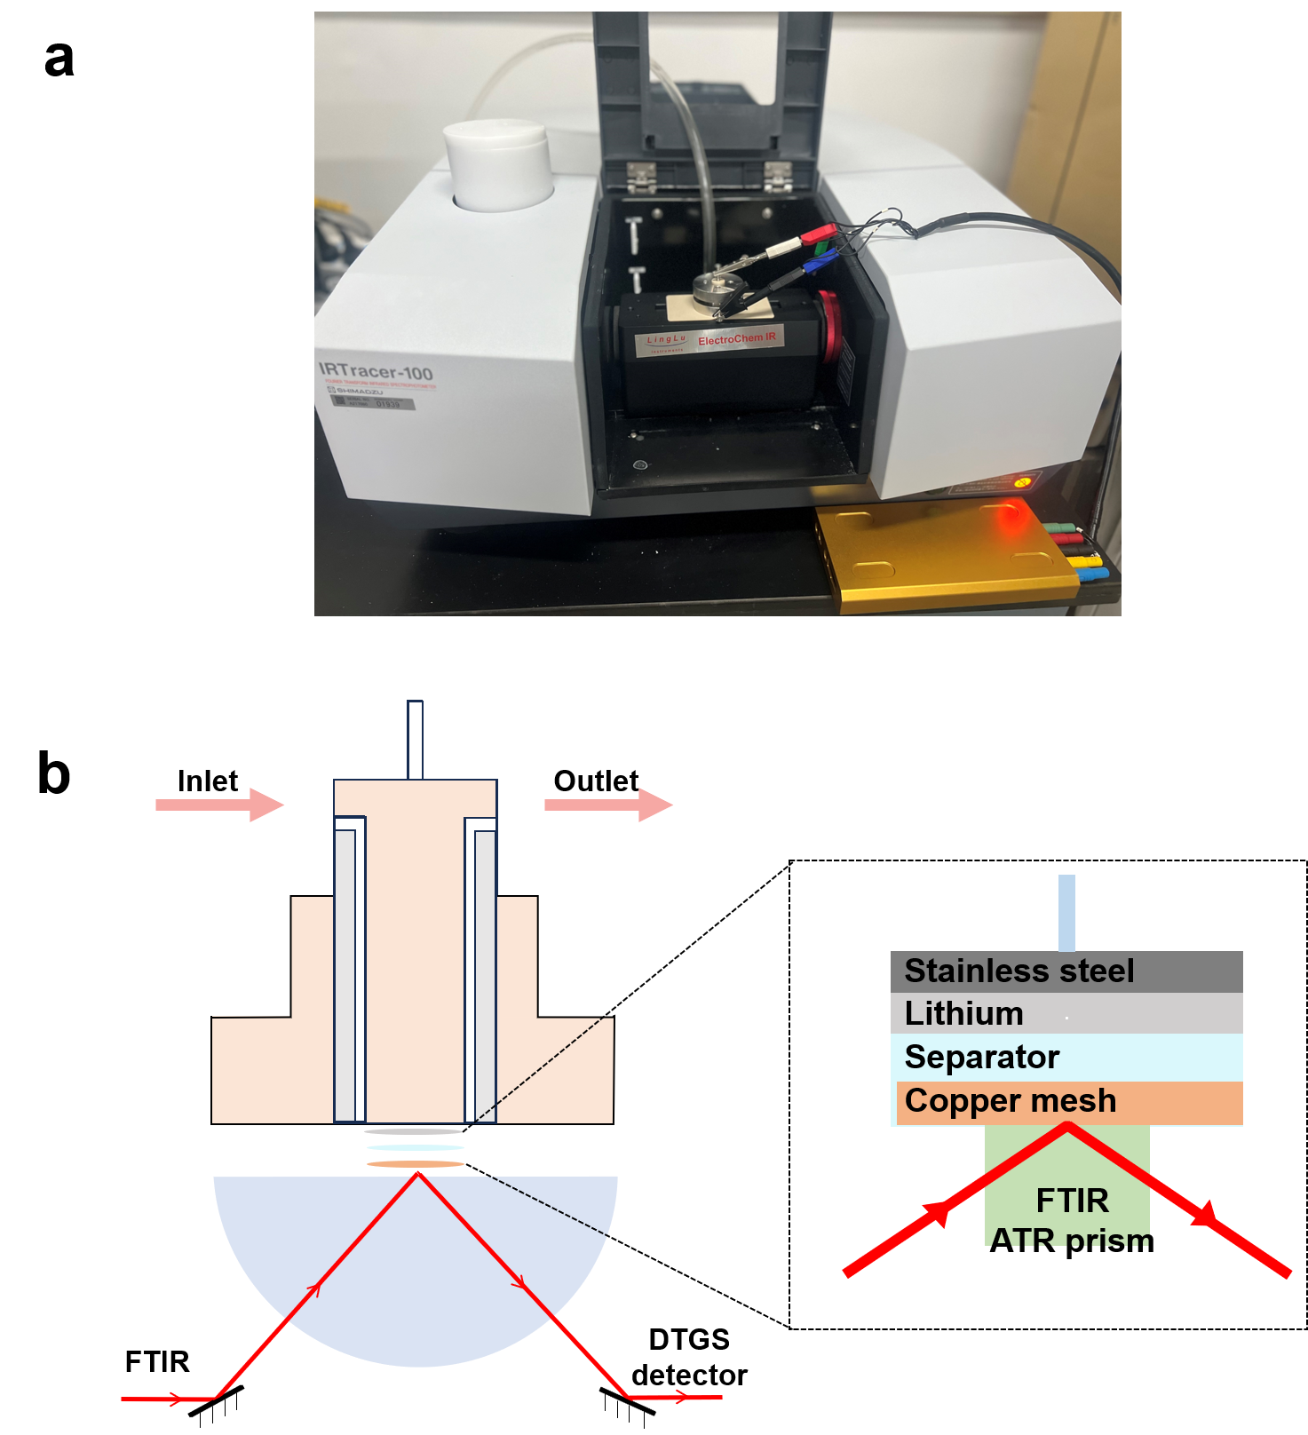
Supplementary Fig.12 a. The physical object of the in-situ FTIR device. b. The schematic of in-situ FTIR spectro-electrochemical cell.

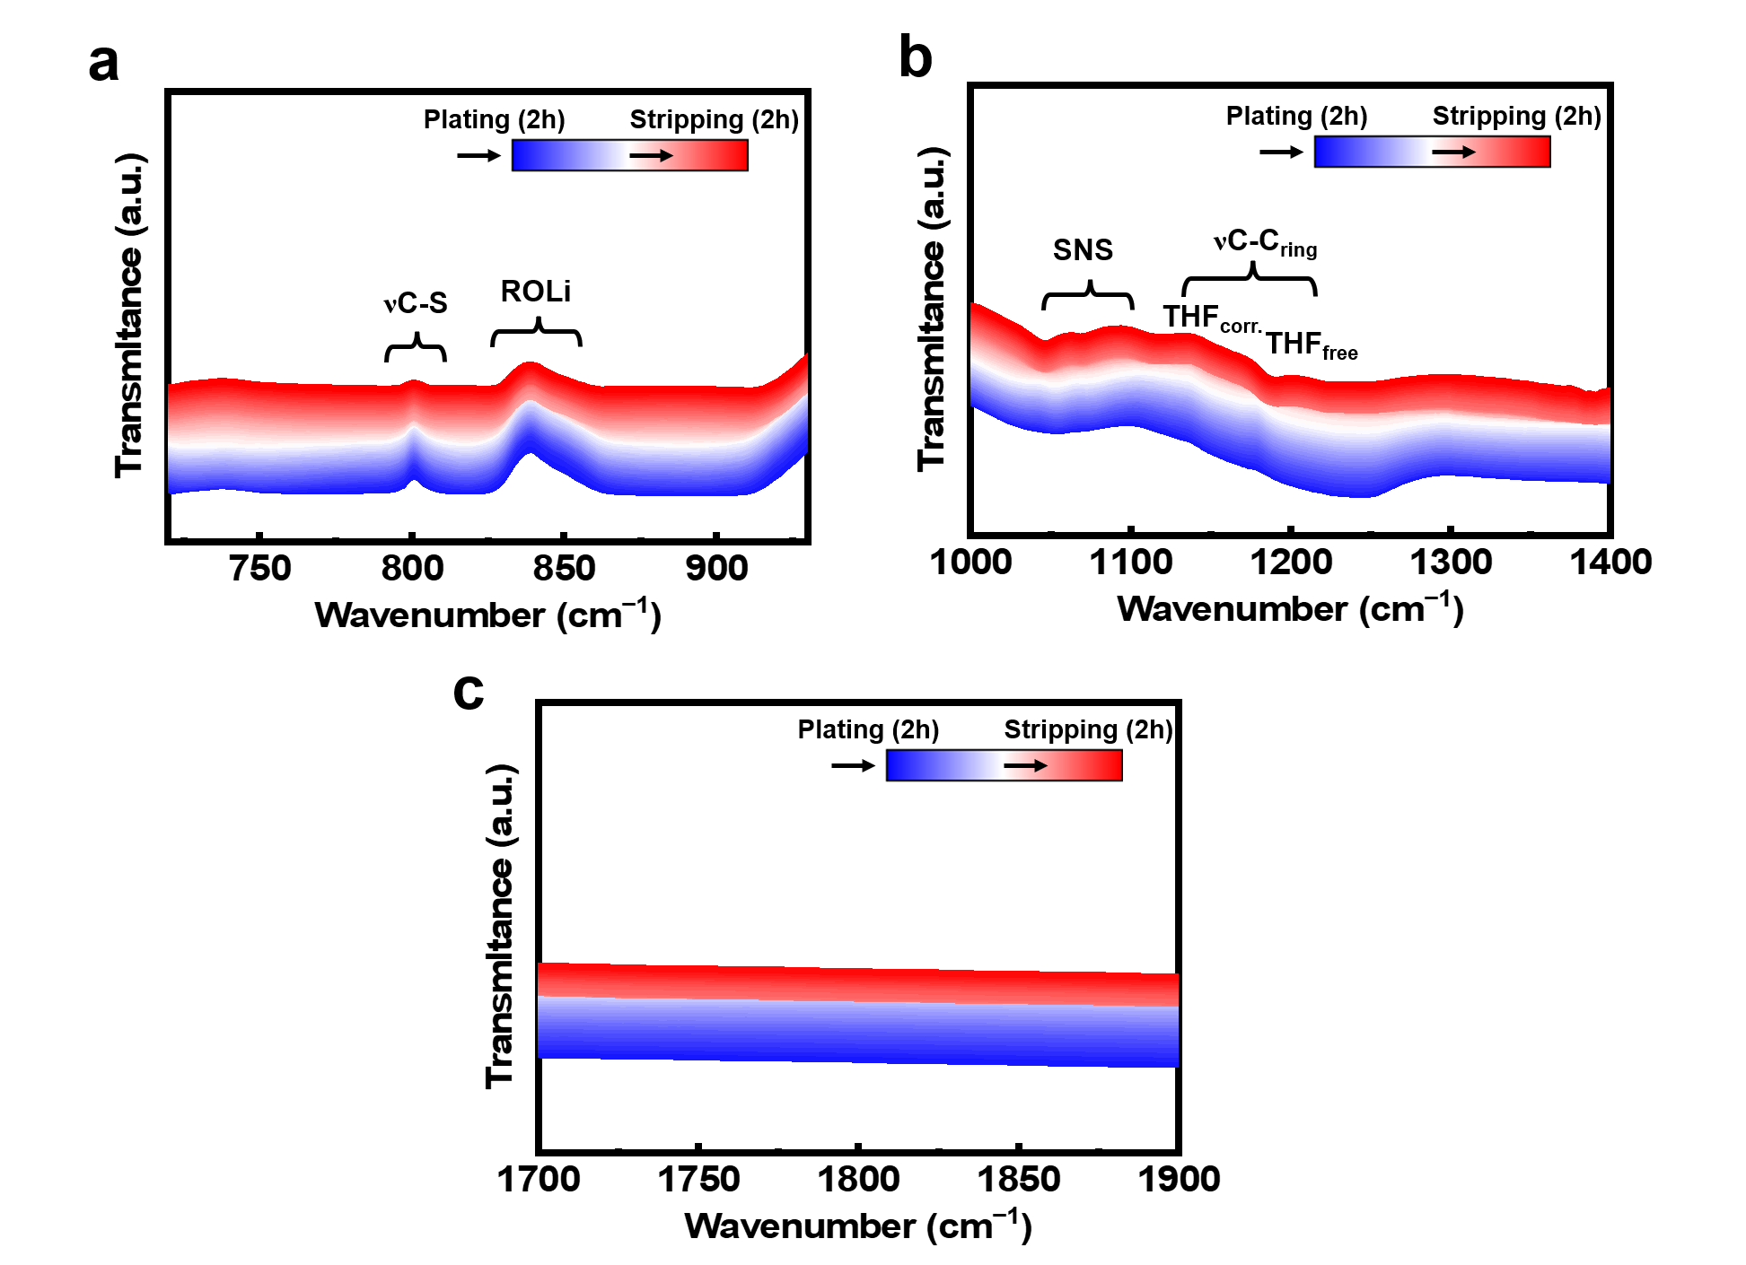Supplementary Fig.13 a-c, In-situ raw FTIR spectra of TO-based electrolyte during potentiostatic plating/stripping.

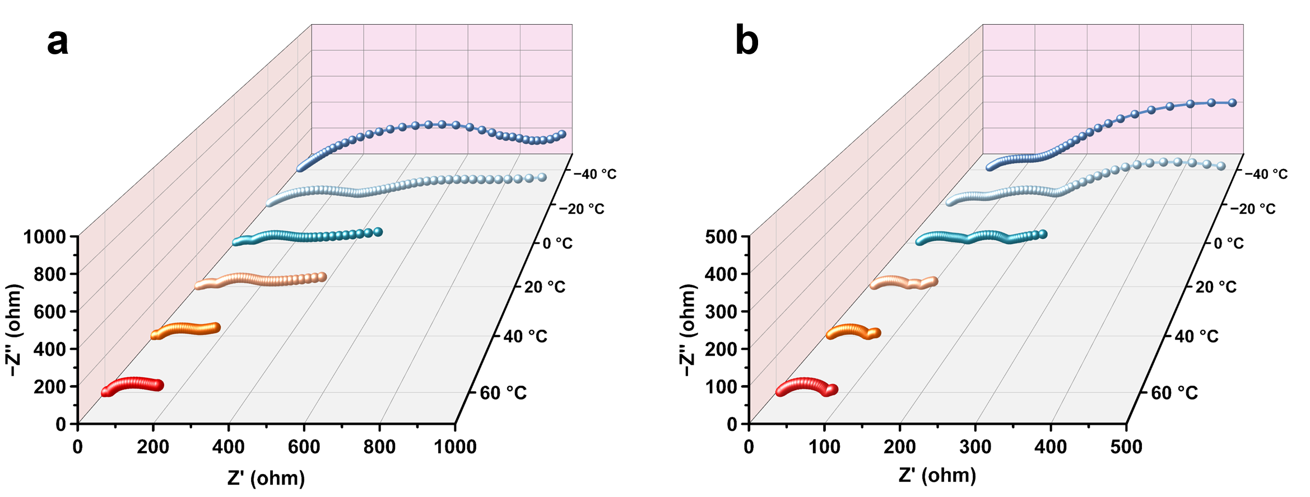
Supplementary Fig.14 a,b, Nyquist plots of Li||NCM811 coin cells in THF- (a) and TO-based (b) electrolytes at different temperature.

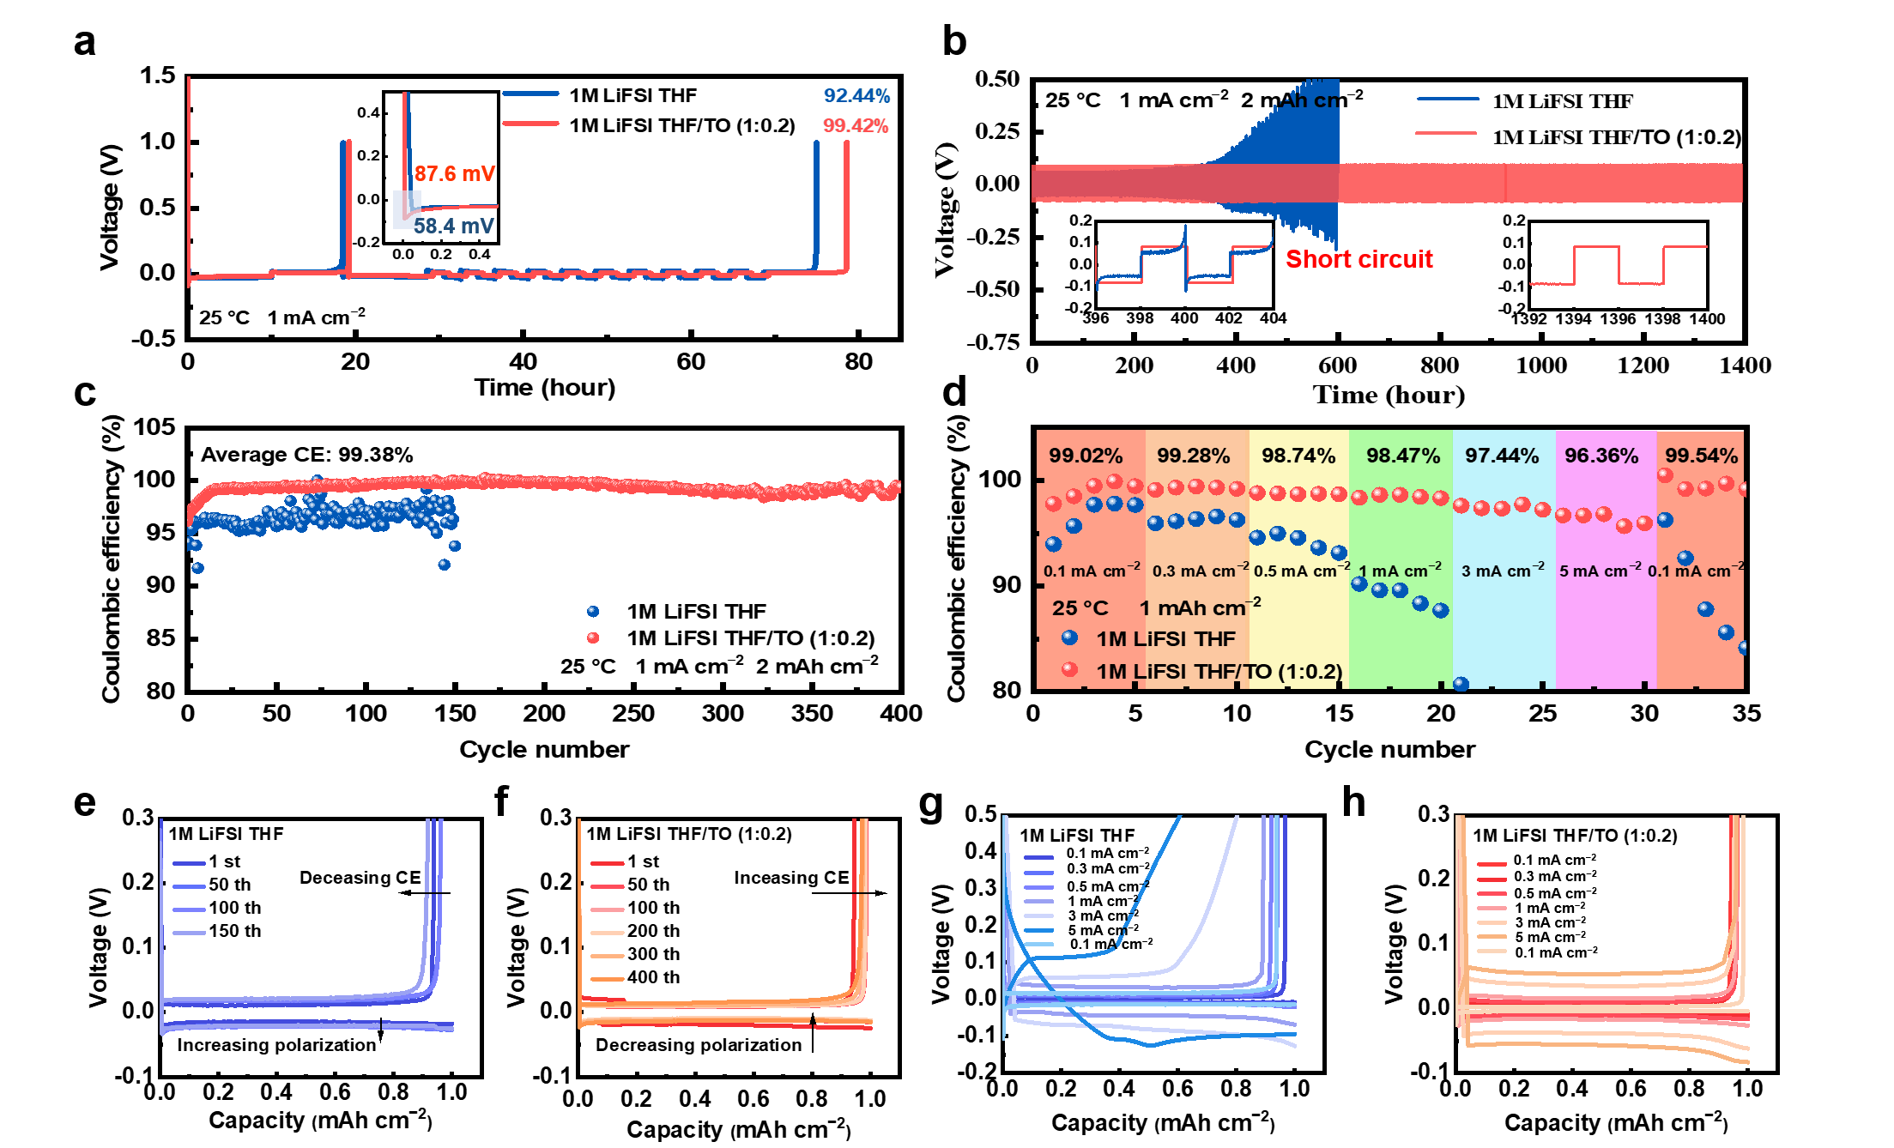
Supplementary Fig.15 a. CE of Li||Cu cells with designed electrolytes under 1 mA cm⁻². b Long-term cycling performance of Li||Li cells with designed electrolytes at 1 mA cm⁻² and 2 mAh cm⁻². c Long-term CE of Li||Cu cells with designed electrolytes at 1 mA cm⁻² and 2 mAh cm⁻². d Rate performance of Li||Cu cells with designed electrolytes at different current densities. e,f, Voltage profiles of Li||Cu cells with THF- (e) and TO-based (f) electrolytes for different cycles. g,h, Voltage profiles of Li||Cu cells THF- (g) and TO-based (h) electrolytes for different current densities.

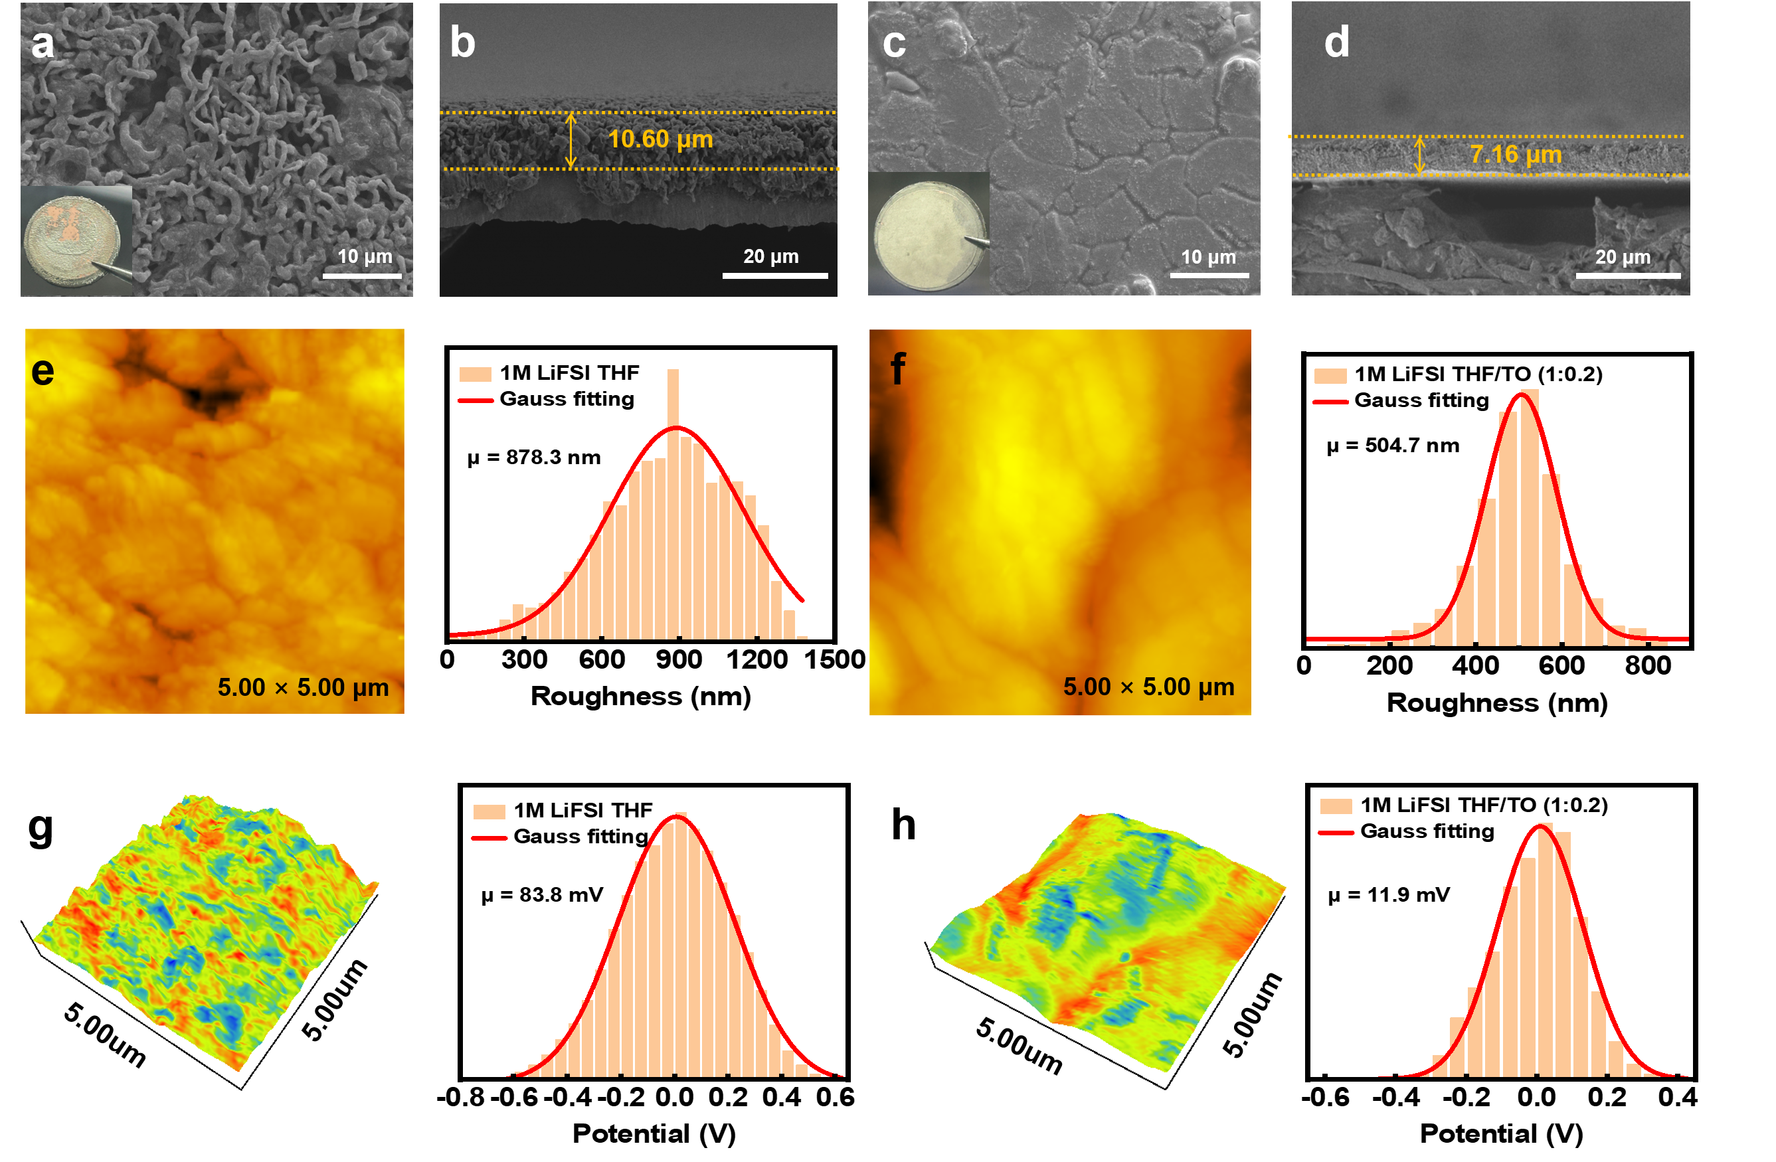
Supplementary Fig.16 a-d, Topview and cross-sectional SEM images of plated Li metal on Cu foil at 1 mA cm⁻² with a cutoff capacity of 5 mAh cm⁻² at 25 °C, including THF- (a,b) and TO-based (c,d) electrolytes. e-h, The surface topography and 3D-KPFM-images of plated Li metal on Cu foil in THF- (e,g) and TO-based (f,h) electrolytes at 25 °C.

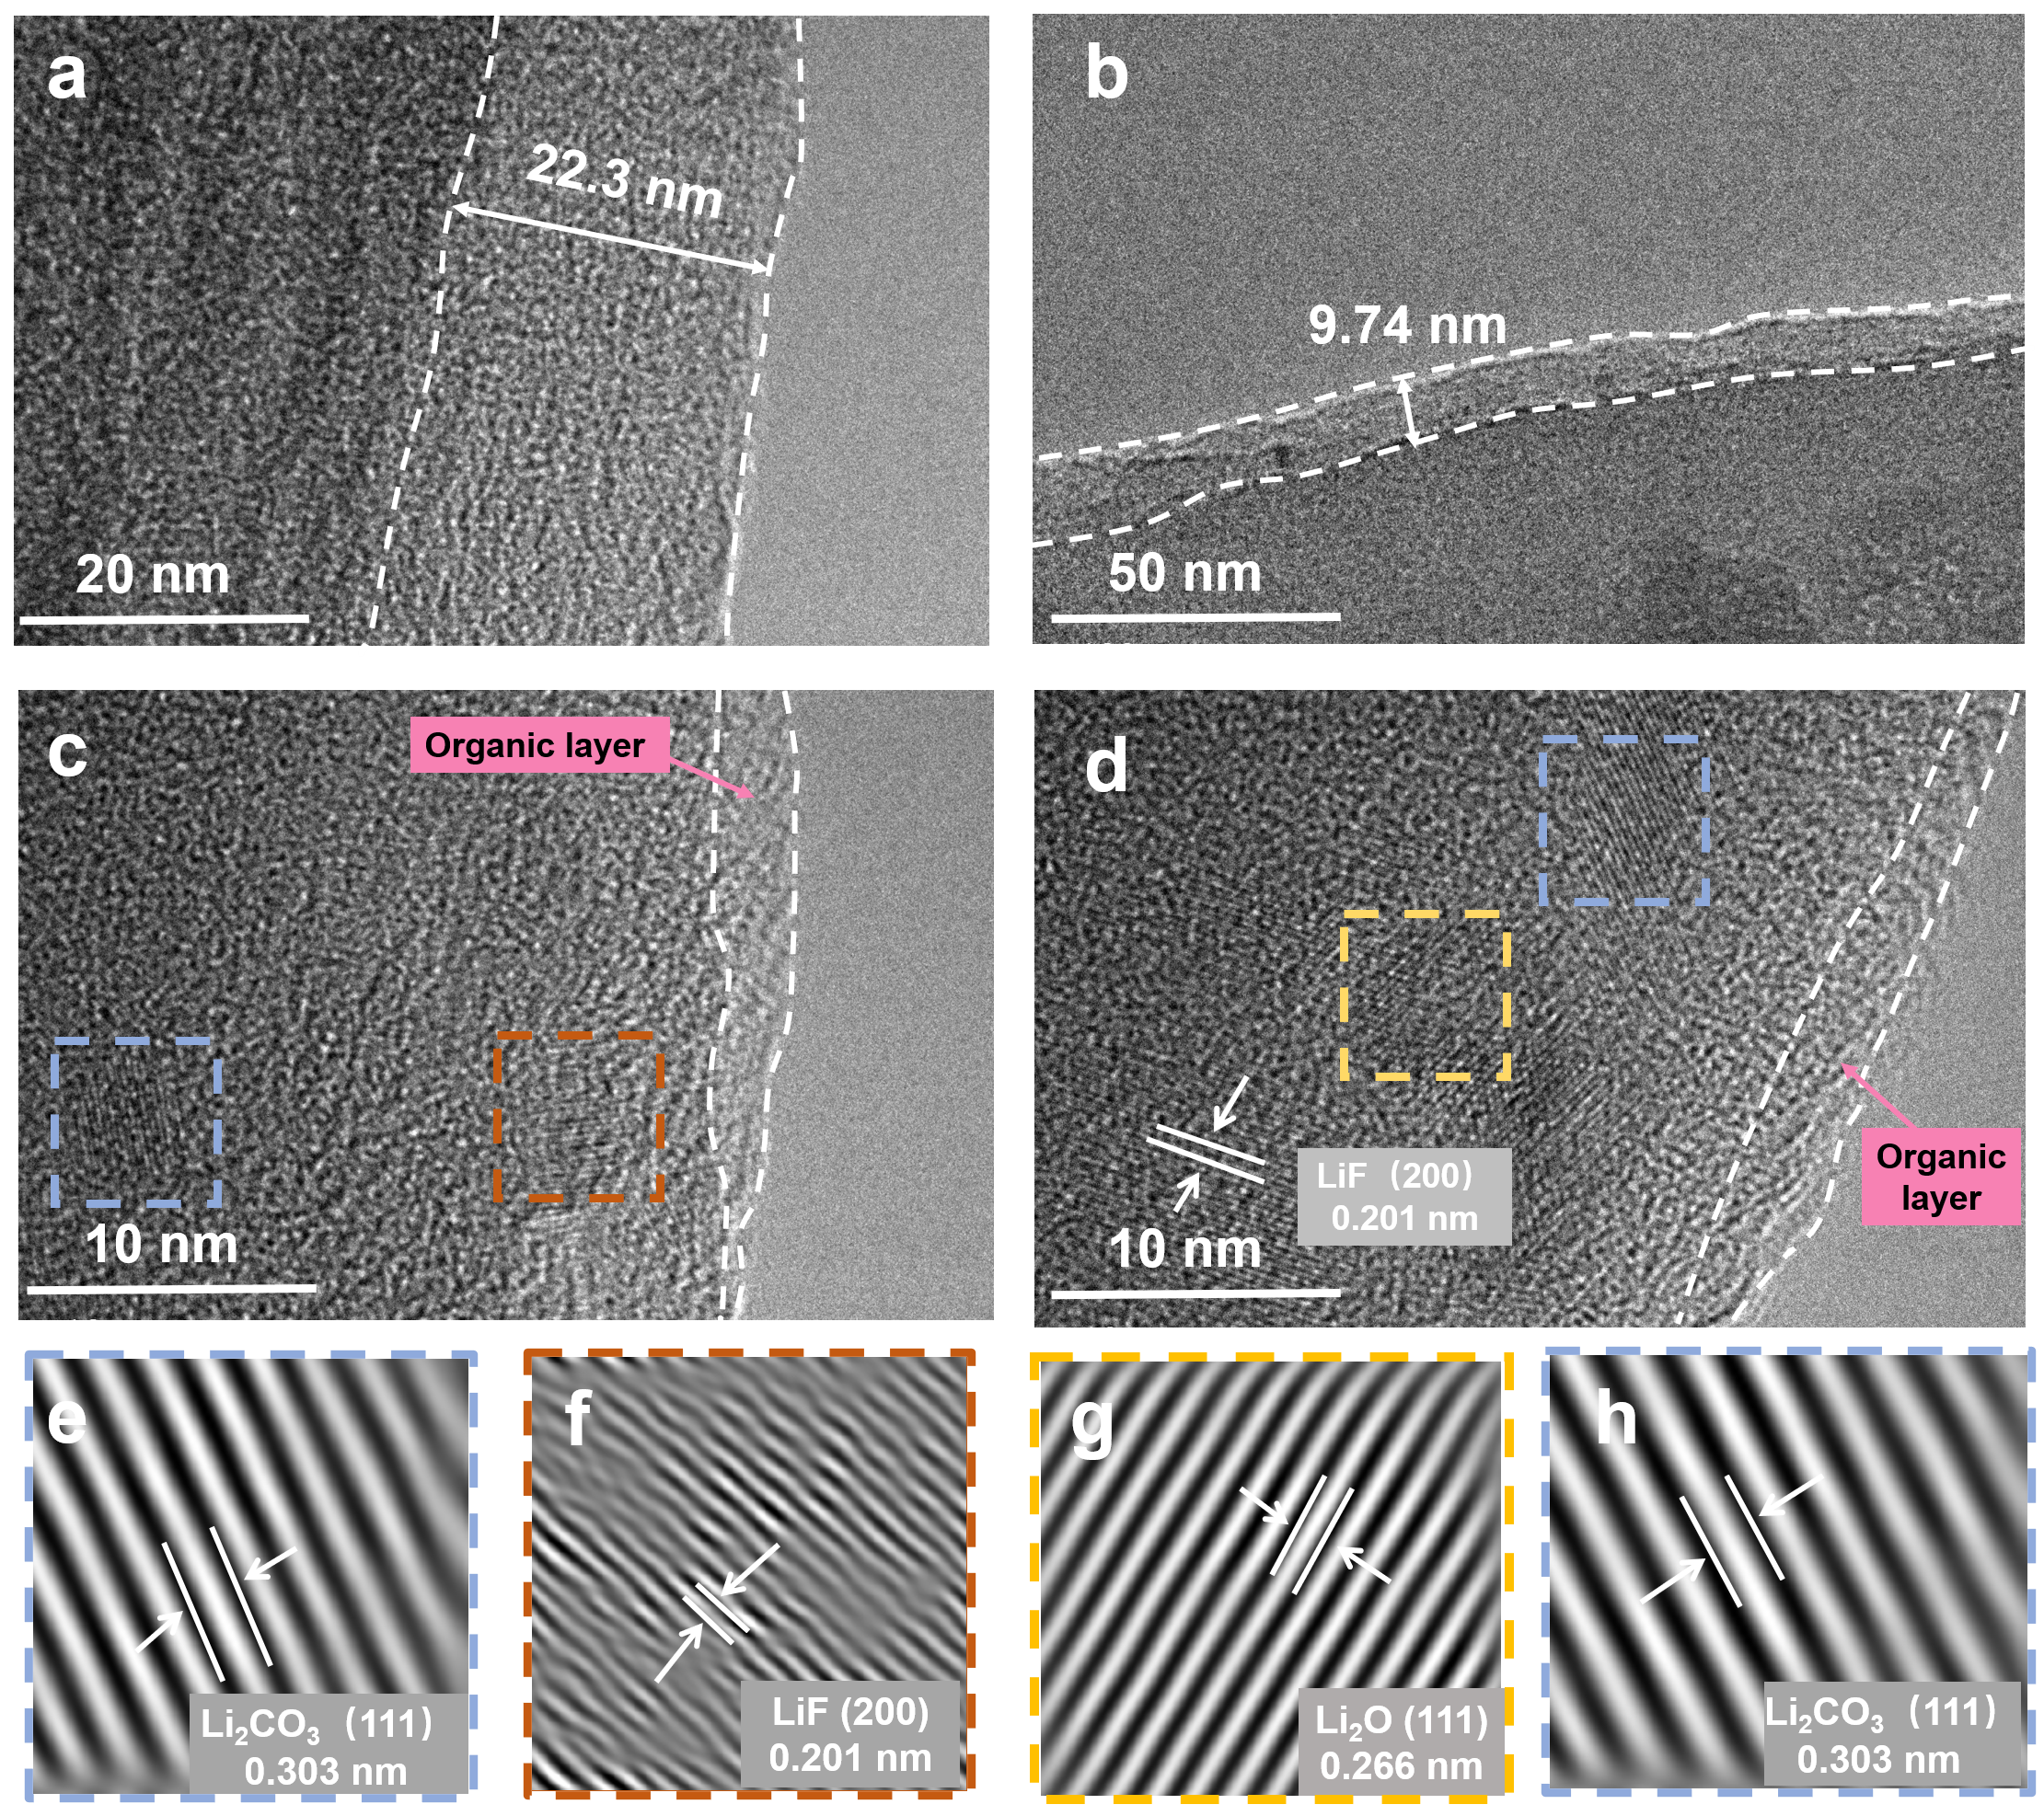
Supplementary Fig.17 a-d, HRTEM and e-h, IFFT images of cycled Li metal on Cu grid in THF- (a,c,e,f) and TO-based (b,d,g,h) electrolytes (the Li metal was plated on the Cu grid via Li||Cu cells through electrochemical deposition at −40 °C).

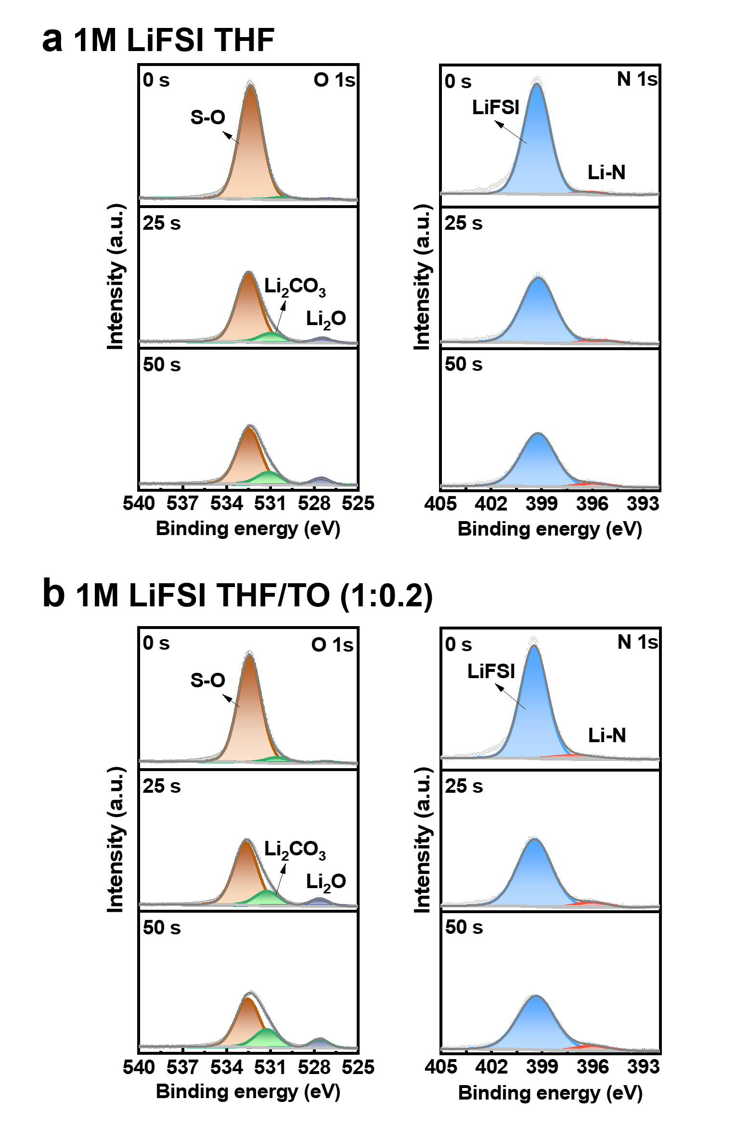
Supplementary Fig.18 a,b, O 1s and N 1s spectra of SEI in THF- (a) and TO-based (b) electrolytes at the sputtering times of 0, 25, and 50s.

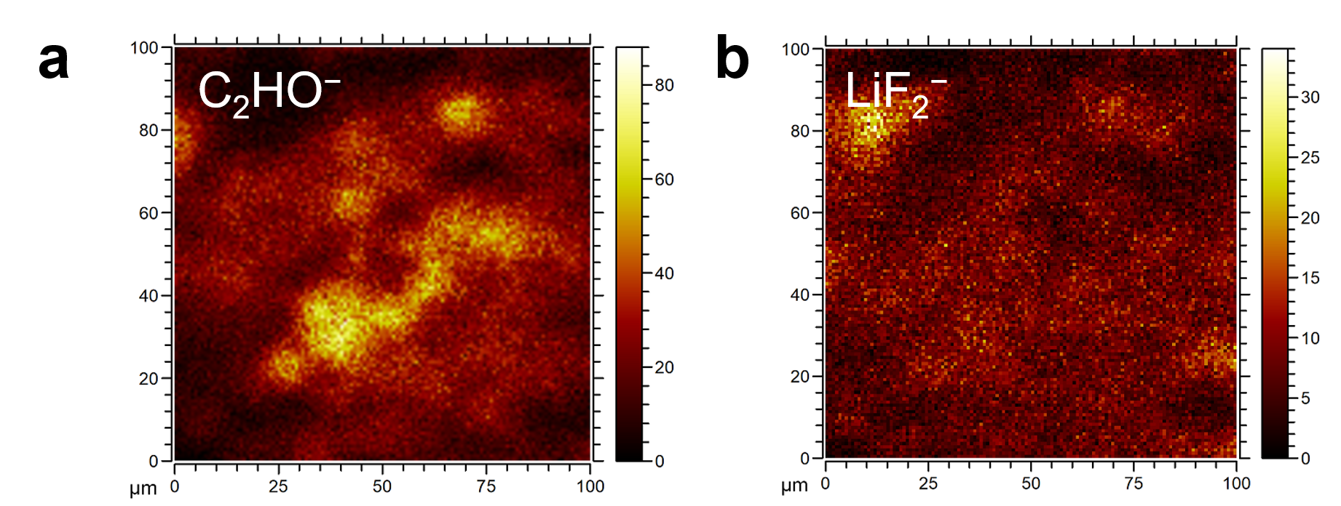
Supplementary Fig.19 a,b, TOF-SIMS mappings of the (a) C₂H₂O⁻ and (b) LiF₂⁻ species on the surface of the cycled LMAs in TO-based electrolyte.

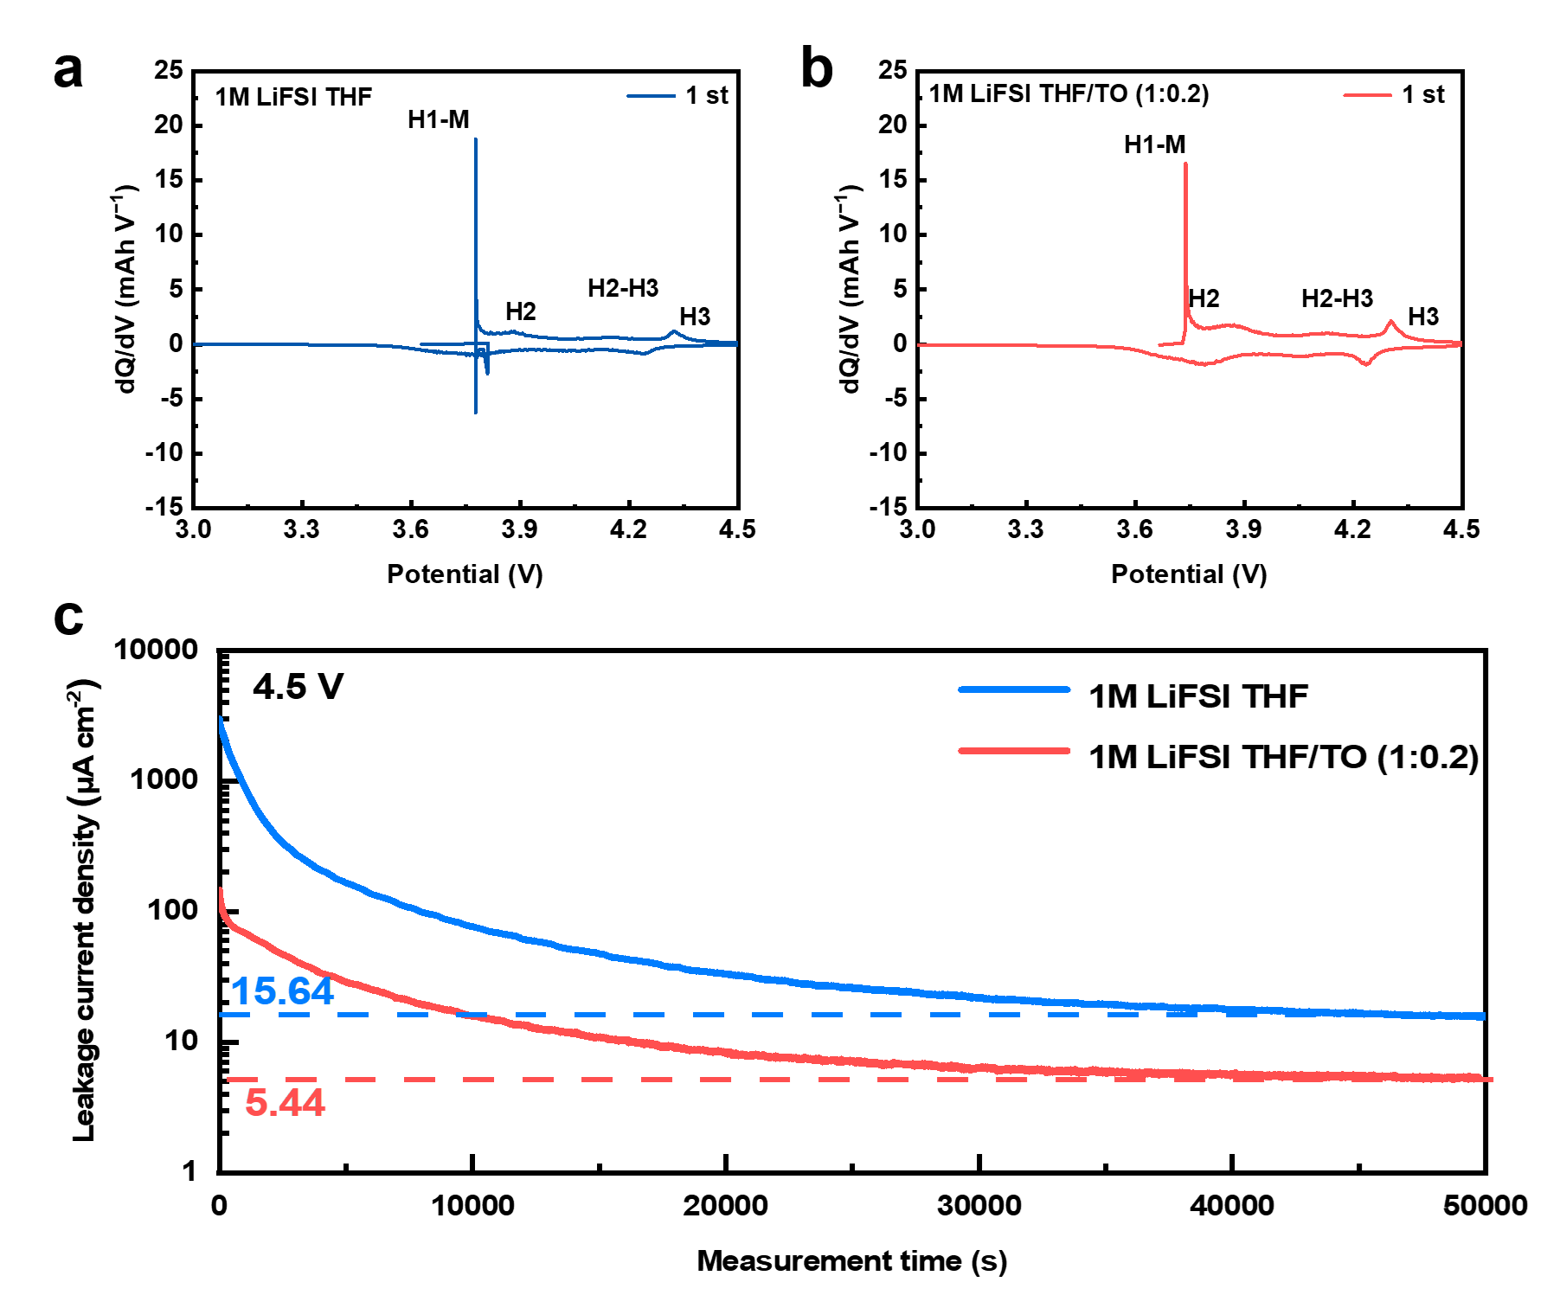
Supplementary Fig.20 a,b, Differential capacity plots for first cycle of the NCM811 cathode with THF- (a) and TO-based (b) electrolytes at 0.5 mA cm⁻² under 25 °C. c. Leakage currents during 4.5 V constant-voltage floating test of NCM811 cathodes cycled at 25 °C.

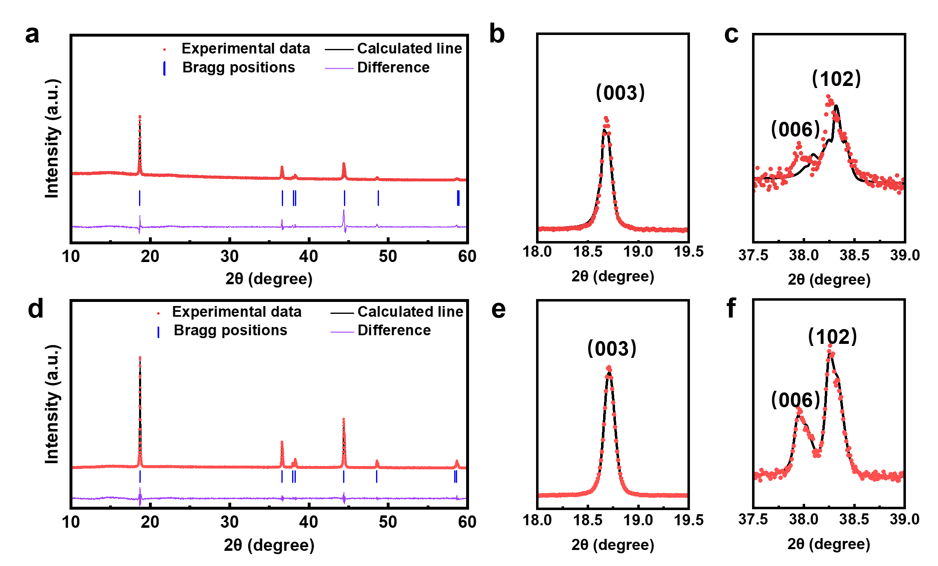
Supplementary Fig.21 a-f, Ex situ XRD measurements of NCM811 cathode after 100 cycles in THF- (a-c) and TO-based (d-f) electrolytes at −40 °C.

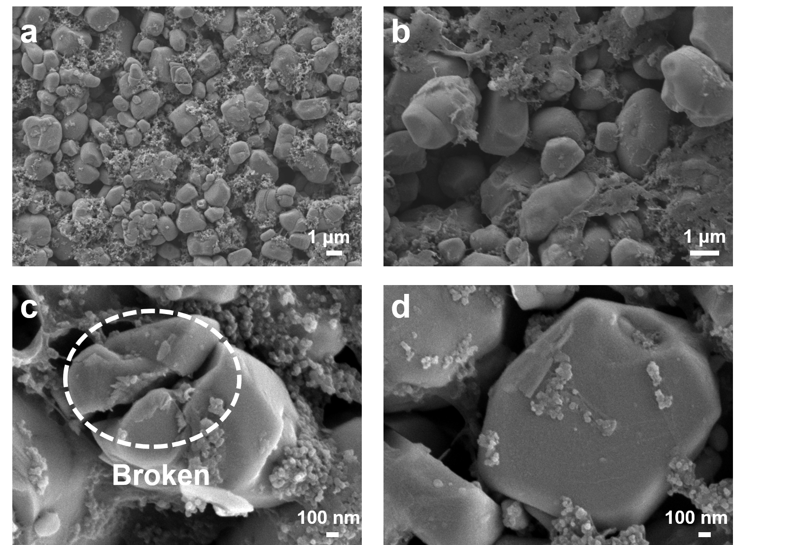
Supplementary Fig.22 SEM characterization of NCM811 cathode retrieved from Li||NCM811 cells with THF- (a,c) and TO-based (b,d) electrolytes at −40 °C after 100 cycles. The cell was disassembled at fully discharged state.

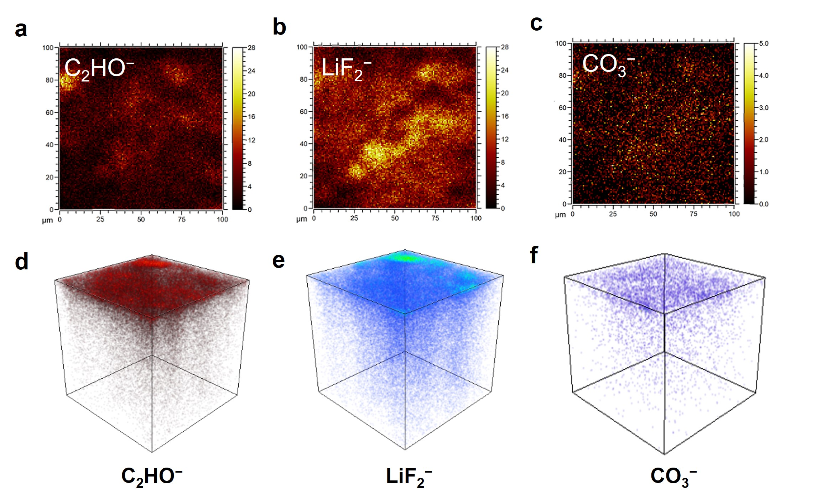
Supplementary Fig.23 a-c, TOF-SIMS mappings of the (a) C₂H₂O⁻, (b) LiF₂⁻ and (c) CO₃²⁻species on the surface of the cycled LMAs in TO-based electrolyte. d-f 3D renders of the CEI formed in the TO-based electrolyte.

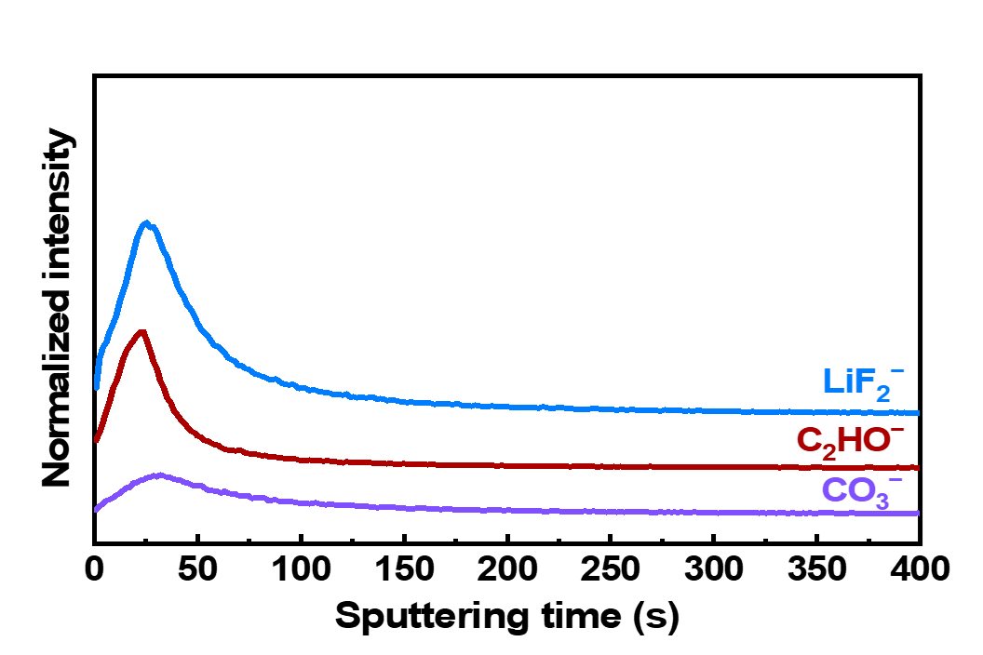
Supplementary Fig.24 Depth sputtering profiles of C₂H₂O⁻, LiF₂⁻ and CO₃⁻ segments by TOF-SIMS.

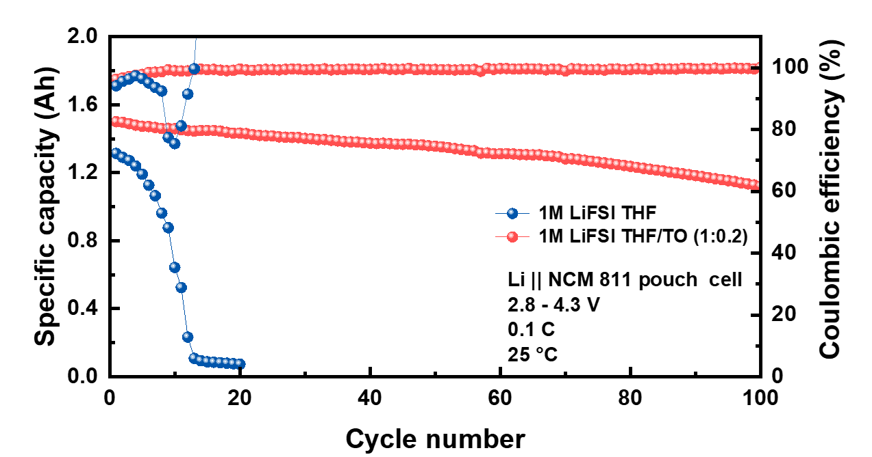

Supplementary Fig.25 Cycling performance of Li||NCM811 pouch cell at 0.1C at 25℃.

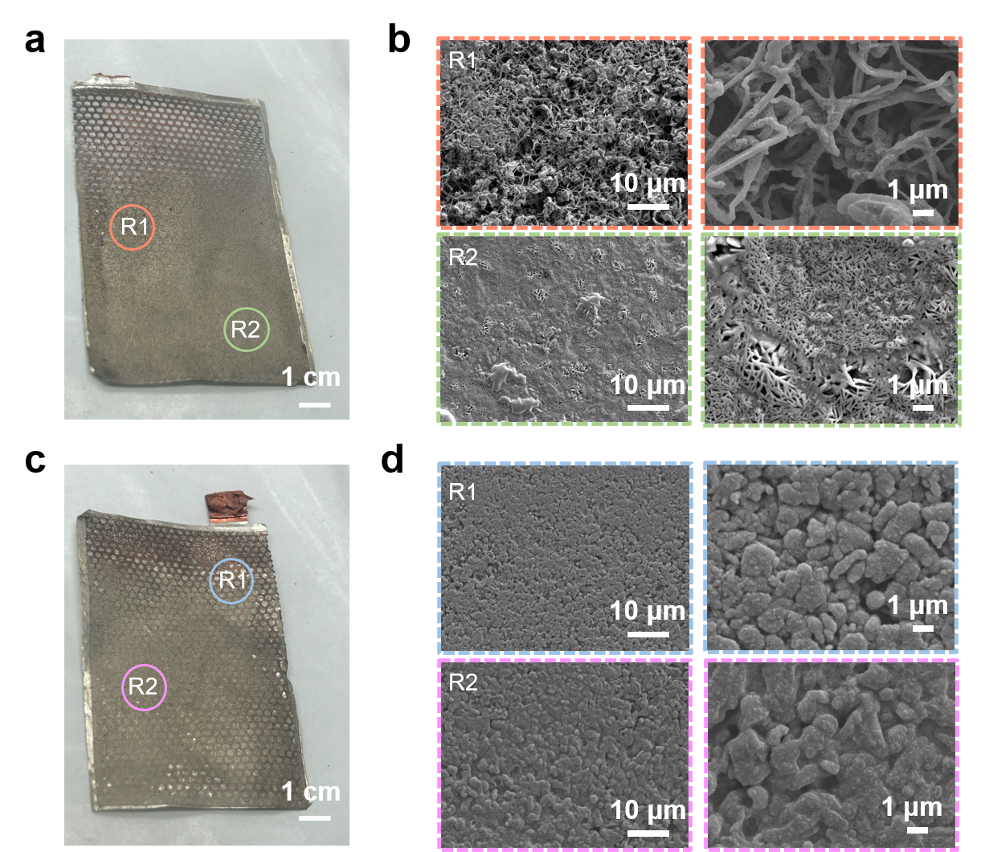
Supplementary Fig.26 Analysis of the Li||NCM811 pouch cell using THF- (a,b) and TO-based (c,d) electrolytes at −40 °C after 60 cycles. a,c, Optical images of the Li metal anode. b,d, SEM images of the cycled Li metal anode in various regions.
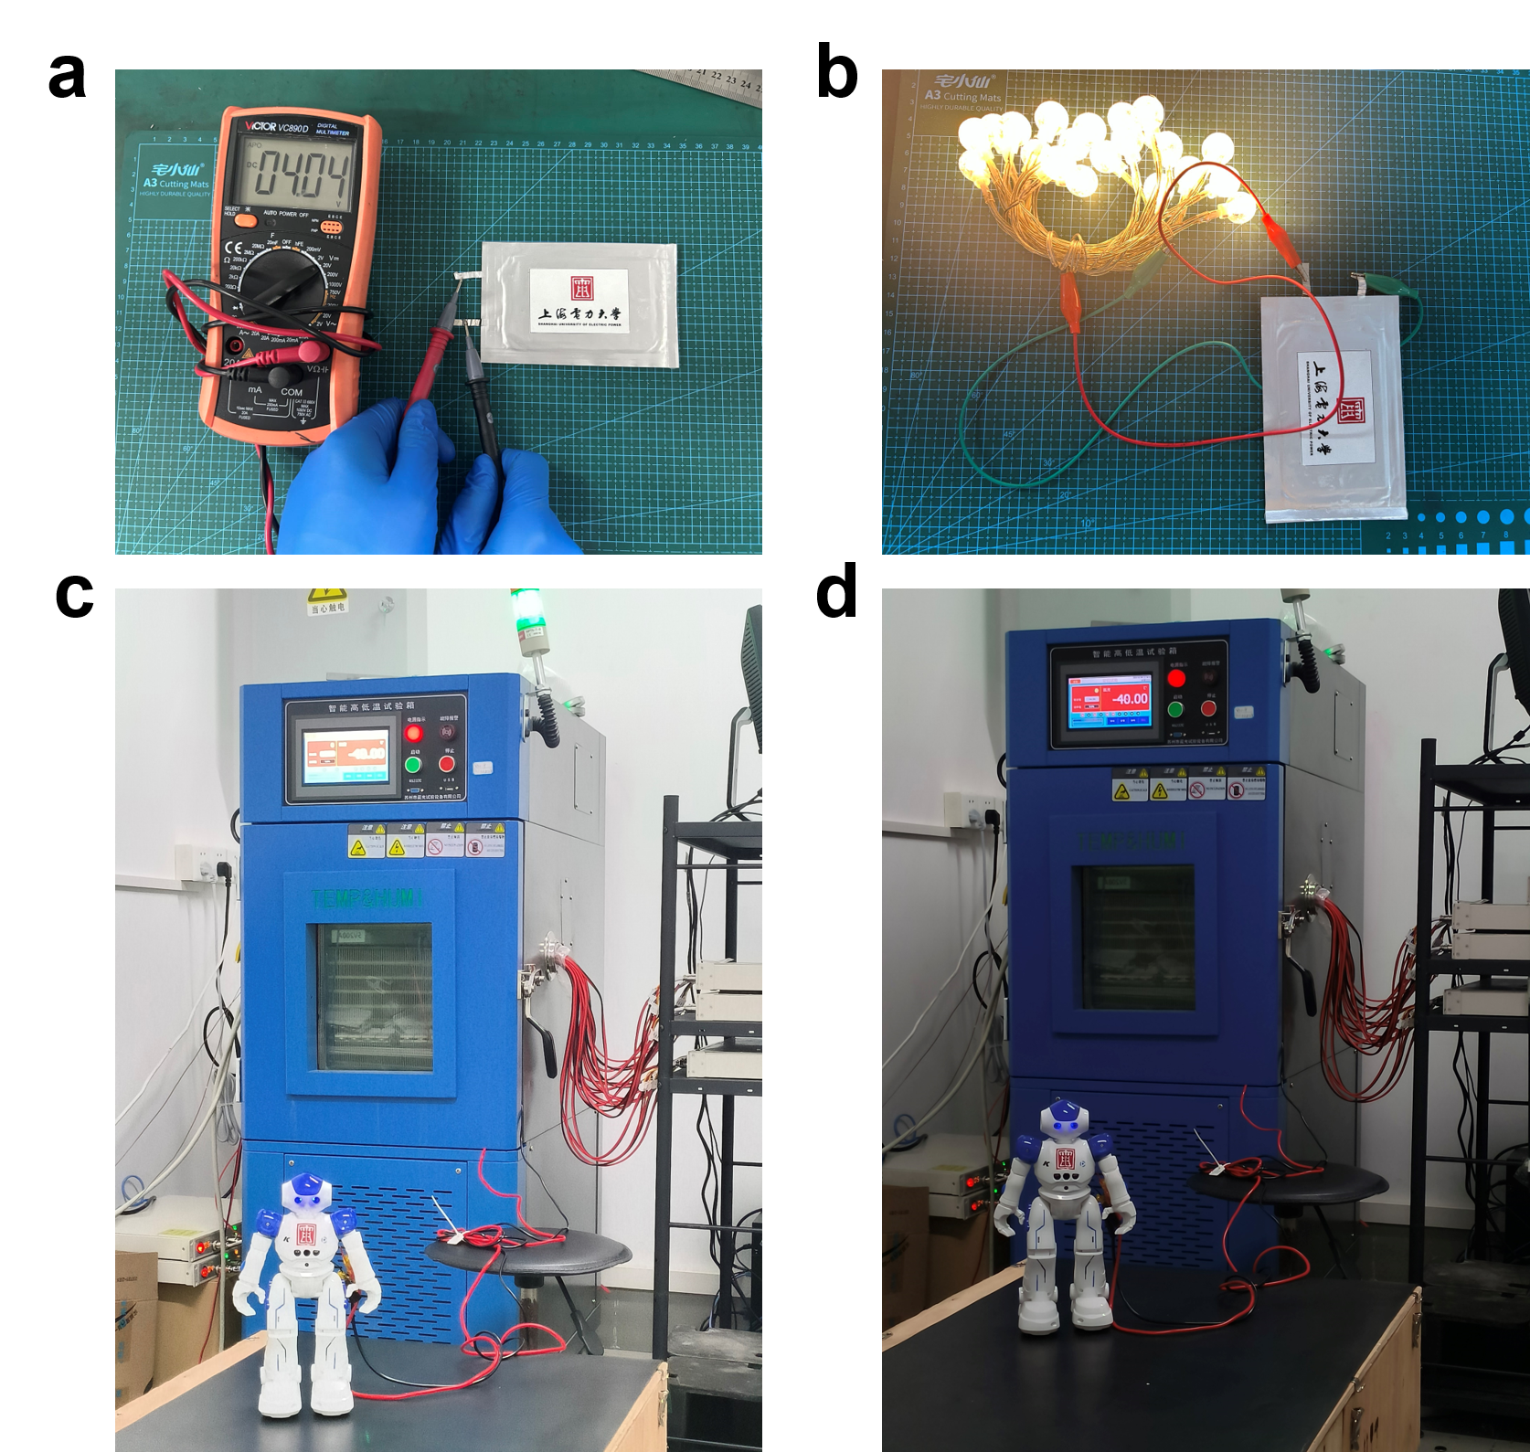
Supplementary Fig.27 a. The open-circuit voltage of Li||NCM811 pouch cell. b. Optical image of the lamps lit by the pouch cell. c,d, Optical images of a robot powered by the Li||NMC811 pouch cell using TO-based electrolytes at −40 °C.

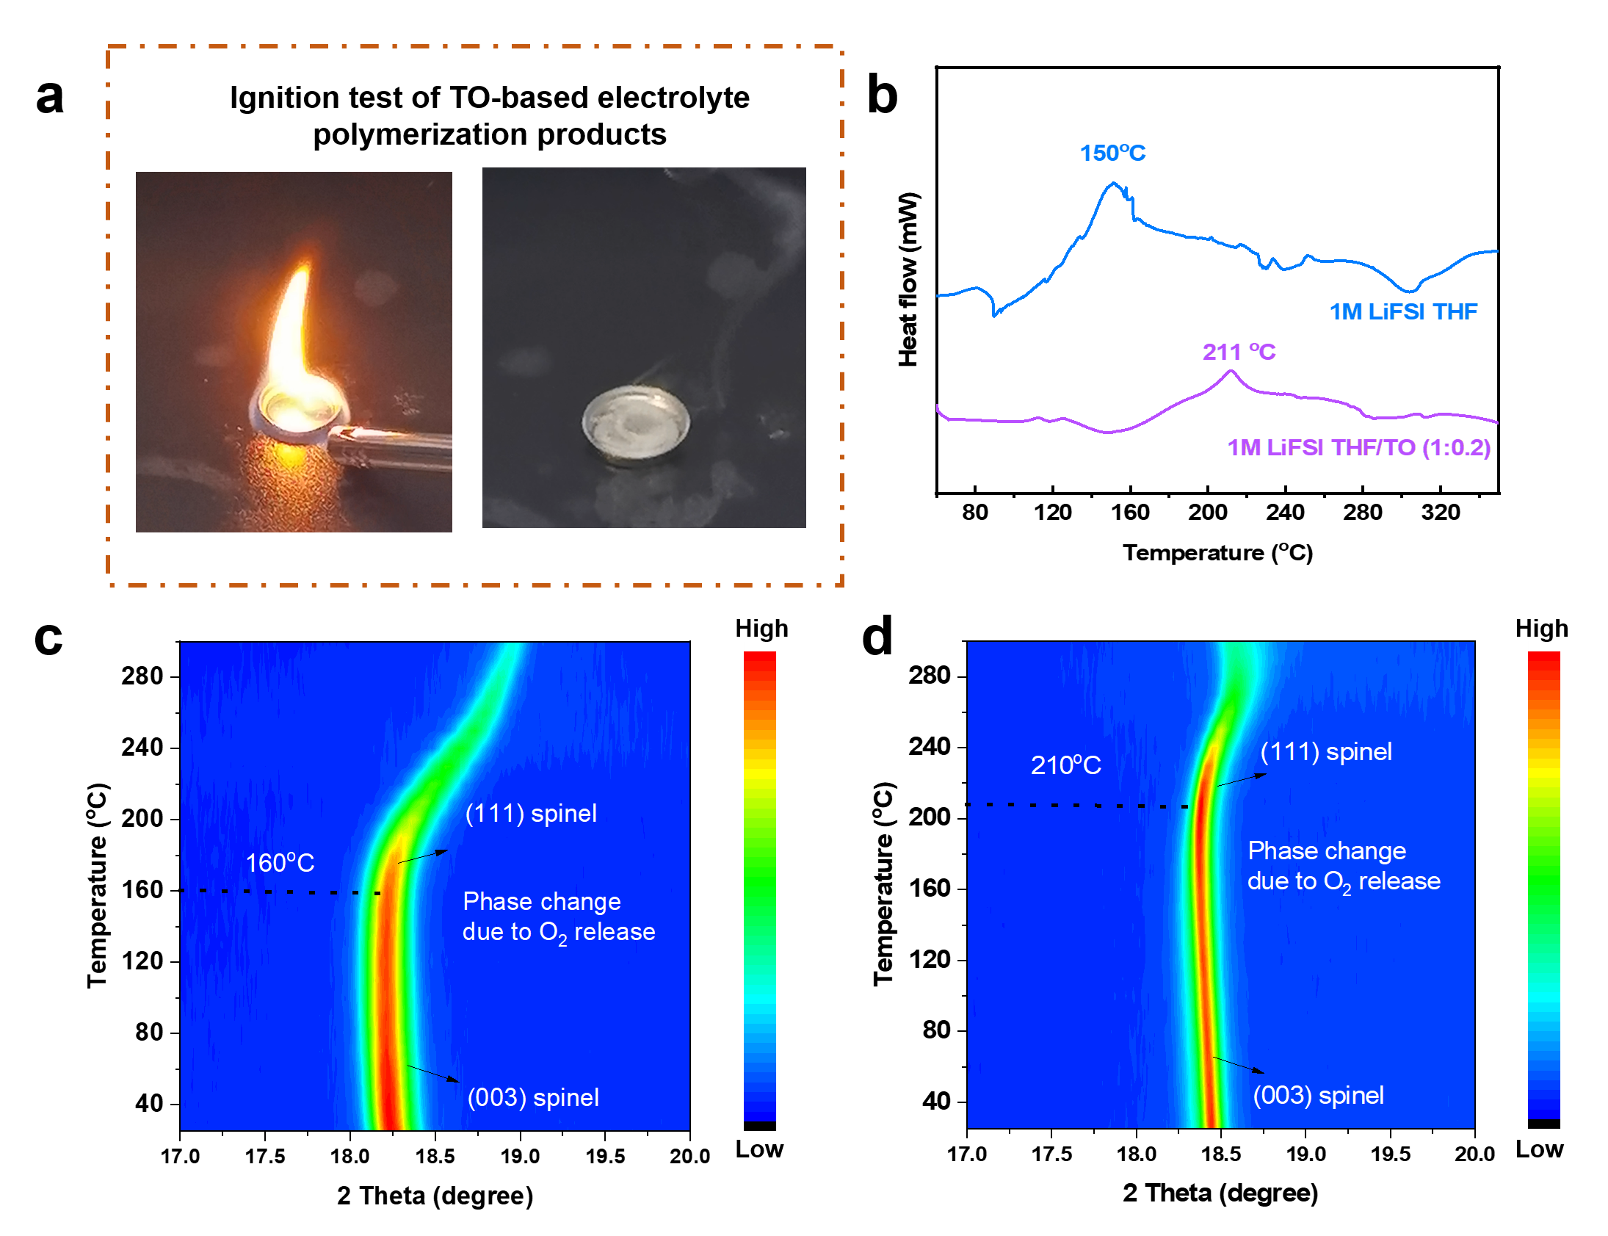
Supplementary Fig.28 a. Ignition test of TO-based electrolyte polymerization products. b. DSC curves of THF- and TO-based electrolytes. In-situ XRD results of NCM811 electrode fully charged in THF- (c) and TO-based (d) electrolytes during the heating experiment.

Supplementary Table 1. Comparison of different physical parameters of various organic solvents

Sovents | Melting point  °C | Boiling point  °C | Viscosity  mPa·S  25 °C | Dielectric constant  25 °C | Ionic conductivity  mS cm⁻¹  25 °C | Flash point  （°C）
THF | −109.00 | 66.00 | 0.46 | 7.40 | 9.10 | −17.00
TO | 59.00 | 112 | / | / | / | 45
DME | −58.00 | 84.00 | 0.46 | 7.20 | 11.10 | 0.00
2-Me-THF | −137.00 | 80.00 | 0.47 | 6.20 | 1.70 | −11.00
DOL | −95.00 | 78.00 | 0.59 | 7.10 | 5.70 | 1.00
DMM | −105.00 | 41.00 | 0.33 | 2.70 | 1.50 | −17.00
DEE | −74.00 | 121.00 | 0.56 | 5.10 | 5.80 | 20.00
G2 | −64.00 | 162.00 | 1.06 | 7.40 | / | 57.00
DE | −116.00 | 34.60 | / | / | / | −40.00
DOX | 11.80 | 102.00 | / | / | / | 12.00
EC | 35.00 | 244.00 | 2.00 | 89.00 | 8.30 | 143.00
PC | −48.80 | 242.00 | 2.53 | 64.90 | 5.60 | 135.00
DEC | −43.00 | 127.00 | 0.80 | 3.00 | 2.40 | 25.00
DMC | 3.00 | 90.00 | 0.70 | 3.00 | 6.00 | 18.00
EMC | -53.00 | 110.00 | 0.65 | 2.90 | 3.50 | 23.00
VC | 22.00 | 162.00 | 1.54 | 126.00 | 13.20 | 73.00
FEC | 17.30 | 210.00 | 4.10 | 78.40 | 5.00 | 130.00
EA | −84.00 | 77.00 | 0.45 | 6.02 | 11.50 | −3.00
MA | −98.20 | 57.00 | 0.37 | 6.70 | 14.80 | 35.00
MB | −84.00 | 102.00 | 0.60 | 5.50 | 4.20 | 11.00
EB | −93.00 | 120.00 | 0.71 | 5.10 | 2.70 | 19.00
DMSO | 19.00 | 189.00 | 1.37 | 47.00 | 13.90 | 85
ES | −17.00 | 174.00 | 2.06 | 39.60 | 9.80 | 79.00
PS | −60.29 | 214.00 | / | / | 6.30 | 56.60

THF: tetrahydrofuran, TO: 1,3,5-Trioxane, DME: 1,2-dimethoxyethane, 2-Me-THF: 2-Methyl tetrahydrofurane, DOL: 1,3dioxolane, DMM: Dimethoxymethane, DEE: 1,2-diethoxyethane, G2: Diglyme, DE: Diethyl ether, DOX: Dioxane, EC: Ethylene carbonate, PC: Propylene carbonate, DEC: Diethyl carbonate, DMC: Dimethyl carbonate, EMC: Ethyl methyl carbonate, VC: Vinylene Carbonate, FEC: Fluoroethylene carbonate, EA: Ethyl acetate, MA: Methyl acetate, MB: Methyl butyrate, EB: Ethyl butyrate, DMSO: Dimethyl sulfoxide, ES: Ethylene sulfite, PS: Propylene sulfite.
The basic information about these organics is collected in Lange's Handbook of Chemistry and ChemSpider/PubChem database.

Supplementary Table 2. The specifications of the Li || NCM811 pouch cell

Cell component | Specification | Parameters
Cathode  (NCM 811 with Al current collector) | Active material mass loading  (mg cm⁻², each side) | 22
Cathode  (NCM 811 with Al current collector) | Active material ratio | 96.8%
Cathode  (NCM 811 with Al current collector) | Number | 4
Cathode  (NCM 811 with Al current collector) | Weight (g) | 7.57
Anode (Li) | Thickness (μm) | 50
Anode (Li) | Number | 5
Anode (Li) | Weight (g) | 1.068
Collector (Cu) | Thickness (μm) | 8.0
Collector (Cu) | Weight (g) | 1.075
Electrolyte | Electrolyte/Capacity (g Ah⁻¹) | 2
Electrolyte | Weight (g) | 3
Separator (PE) | Weight (g) | 0.275
Package and tabs | Weight (g) | 1.75
Package and tabs | Size (cm×cm) | 10.0*7.0
Full cell | N/P | 2.2
Full cell | Discharge capacity (Ah) | 1.5
Full cell | Mid-value voltage (V) | 3.80
Full cell | Discharge energy (Wh) | 5.7
Full cell | Total weight (g) | 14.738
Full cell | Specific energy (Wh kg⁻¹) | 386.8

Specific energy = discharge energy (Wh) / total weight (kg). This is a more precise calculation method compared to the method: Specific energy =discharge capacity (Ah) × mid-value voltage (V) / total weight (kg).

Supplementary Table 3. Comparison of our work with recent electrolyte works on lithium metal batteries

Electrolyte | Cell condition | Cell capacity | Temperature | Cycling Condition | Cycling life | Energy density | Reference
1.0 M LiFSI  THF+0.5%wt  NaPFO+2%wt  TMSP | Li||NMC811 pouch cell, N/P=1.26 | 0.5 Ah | −40 °C | charge/discharge at 0.1C | ~54% after 20 cycles | 327 Wh kg⁻¹  (except taps and packing foil) | S1
1.0 M LiFSI  BTFE/DME  (5:1 vol%) | Li||NMC811 pouch cell, 4 mAh cm⁻², N/P=2 | 1.0 Ah | 23 °C | charge/discharge at 0.1C | Not mentioned | 307 Wh kg⁻¹ | S2
1.0 M LiFSI  BTFE/DME  (5:1 vol%) | Li||NMC811 pouch cell, 4 mAh cm⁻², N/P=2 | 1.0 Ah | −40 °C | 0.1C charge at 23 °C/0.1C discharge at −40 °C | Not mentioned | 230 Wh kg⁻¹ | S2
1.0 M LiTFSI HFB/FEC  (1:1 vol%) | Li||NMC811 pouch cell, 3.86 mAh cm⁻², N/P=1.2, E/C=2.72 g Ah⁻¹ | 1.36 Ah | 60 °C | charge/discharge at 0.3C | 93.86% after 50 cycles | 327 Wh kg⁻¹ | S3
1.0 M LiTFSI HFB/FEC  (1:1 vol%) |  | 1.30 Ah | −30 °C | charge/discharge at 0.3C | 96.60% after 50 cycles | 288 Wh kg⁻¹ | S3
1.5 M LiFSI/MixTHF-TTE | Li||LFP pouch cell, 3.0 mAh cm⁻², N/P=3 | 1.0 Ah | 23 °C | charge/discharge at 0.1C | Not mentioned | ~242 Wh kg⁻¹  (calculated) | S4
1.5 M LiFSI/MixTHF-TTE | Li||LFP pouch cell, 3.0 mAh cm⁻², N/P=3 | 1.0 Ah | −40 °C | charge/discharge at 0.1C | Not mentioned | ~158 Wh kg⁻¹  (calculated) | S4
1.0 M LiFSI DMTMSA | NCM811||Li pouch  cell, 4.3 mAh cm⁻² | Not mentioned | 25 °C | 0.2C charge/0.5C  discharge | ~75% after 80 cycles | 353 Wh kg⁻¹ | S5
1.5M LiFSI-DME-TTE | Li||NCM622 pouch  cell, 4.0 mAh cm⁻², N/P=1 | 2.0 Ah | 25 °C | 0.1C charge/0.3C  discharge | ~81% after 510  cycles | 350 Wh kg⁻¹ | S6
1.0M LiTFSI+1.5M  LiFSI +10%HFE in  G3 | NCM811@Li₂O||Cu  pouch cell,  E/C=2.5g Ah⁻¹ | 2.46 Ah | 25 °C | 0.375C charge/0.5C  discharge | ~80% after 300  cycles | 320 Wh kg⁻¹ | S7
1.2M LiFSI TEP/BTFE | NMC622||Li pouch cell, 3.8 mAh cm⁻² | 1.17 Ah | 25 °C | 0.1C charge/0.3C  discharge | 83% after 200  cycles | 313 Wh kg⁻¹ | S8
0.1 M LiFEA in EC/DEC  (1:1 vol%) | NCM811||Li pouch  cell, 3.66 mAh cm ⁻² | ~0.42 Ah | 25 °C | 0.2C charge/0.6C discharge | 90% after 120 cycles | ~310 Wh kg⁻¹ | S9
1M LiPF₆ FEC/DMC  (1:4 vol%) with LiNO₃ | NCM523||Li pouch cell, 4.4 mAh cm ⁻², | 3.5 Ah | 25 °C | Charge/discharge at 0.1C | 90% after 60  cycles | 350 Wh kg⁻¹ | S10
1M LiFSI THF/TO  (1:0.2) | Li||NMC811 pouch cell, 5.6 mAh cm⁻², N/P=1.79, E/C=2.1 g Ah⁻¹ | 1.5 Ah | 25 °C | charge/discharge at 0.1C | 75% after 100 cycles | 387 Wh kg⁻¹ | This work
1M LiFSI THF/TO  (1:0.2) |  | 1.5 Ah | −40 °C | charge/discharge at 0.05C | 84.7% after 60  cycles | 317 Wh kg⁻¹ | This work

Supplementary Note 1
As shown in Supplementary Fig. 6, the TO-based electrolyte (1:0.2) was placed in an ultra-low-temperature chamber at −40 °C overnight. The electrolyte remained in a liquid state with satisfactory fluidity, and no freezing or polymerization occurred, which initially ensures that the electrolyte operates at ultra-low temperatures. When the temperature reaches 60 °C, THF initiates a cationic ring-opening polymerization reaction in the presence of TO primary oxonium ions, leading to the formation of polyether (PTHF) with enhanced antioxidant resilience. This process results in the rapid transformation of the electrolyte into a gel state, which plays a crucial role in ensuring the safe and stable operation of the battery at high temperatures. It is noteworthy that the addition of a minute quantity of pulverized lithium foil to TO results in the complete polymerization of TO to form LiPOM, irrespective of temperature.
In order to gain further insight into the nature of the post-polymerization products, the products resulting from the polymerization reaction were dissolved in deuterated chloroform and subjected to ¹H and ¹³C tests. As shown in Supplementary Fig. 7, the characteristic peaks of TO disappeared while those of LiPOM appeared, indicating that TO was completely polymerized and converted to LiPOM.
As shown in Supplementary Fig. 8, LiFSI undergoes decomposition into Li⁺ and FSI⁻ in the presence of alkaline lithium. Subsequently, FSI⁻ combines with traces of water in the solvent to form H⁺(FSIOH)⁻, which will induce the formation of primary oxonium ions from the TO monomer. Furthermore, the ring will be opened to form a carbon cation, which will then be converted by rapid protonation to a reactive secondary oxonium ion. This secondary oxonium ion will then be inserted repeatedly by the TO monomer in order to achieve polymer chain growth.
Since the TO molecule has a lower LUMO energy level and more initiating affinity reaction sites provided by heteroatoms, it is easier for TO to react with lithium metal upon contact to form a LiPOM layer, which is able to prevent THF from lithium metal, so that THF does not undergo a ring-opening reaction at room and low temperatures. At high temperature, the thermal motion and kinetic energy of THF molecules increase, and it is able to undergo a cationic ring-opening polymerization reaction initiated by TO primary oxonium ions to form a second oxonium ion, which then opens the ring to form a carbon cation and is converted by rapid protonation to a reactive third oxonium ion, into which THF monomers are repeatedly inserted to achieve the growth of the polymer chain (Supplementary Fig. 9).

Supplementary Note 2
An in-situ FTIR spectro-electrochemical cell was designed, as shown in Supplementary Fig. 9. The in-situ FTIR spectroscopy was carried out on IR Tracer-100. In our design, a PEEK holder and lid assembly is attached to an ATR-FTIR prism plate, creating an air-tight seal. To the surface of the germanium crystal, we place a copper mesh as a working electrode. As counter and reference electrodes, we use a Li-metal foil, which is attached to a stainless steel (SS316) spacer. The electrolyte used consisted of 1M LiFSI THF and 1M LiFSI THF/TO (1:0.2). When closing the lid, an SS316 rod presses against the 'coin-type' cell to ensure good electrical contact between the electrodes and also to create an intimate interface between the cathode surface and the germanium crystal, resulting in high FTIR signal intensity. The cell was rested for 6 hours after assembly. Next, galvanostatic discharge/charge were performed using IVIUM electrochemical workstation. The in-situ cell was discharged for 2 hours and charged for 2 hours at a current density of 0.5 mA cm⁻², the real-time FT-IR data was collected during the cycle.

References
- A reversible self-assembled molecular layer for lithium metal batteries with high energy/power densities at ultra-low temperatures
- Electrolyte Design Implications of Ion-Pairing in Low-Temperature Li Metal Batteries
- All-fluorinated electrolyte engineering enables practical wide-temperature-range lithium metal batteries
- Designing Temperature-Insensitive Solvated Electrolytes for Low-Temperature Lithium Metal Batteries
- Xue, W. et al. Ultra-high-voltage Ni-rich layered cathodes in practical Li metal batteries enabled by a sulfonamide-based electrolyte. Nat Energy 6, 495-505 (2021).
- Niu, C. et al. Balancing interfacial reactions to achieve long cycle life in high-energy lithium metal batteries. Nat Energy 6, 723-732 (2021).
- Qiao, Y. et al. A high-energy-density and long-life initial-anode-free lithium battery enabled by a Li2O sacrificial agent. Nat Energy 6, 653-662 (2021).
- Niu, C. et al. High-energy lithium metal pouch cells with limited anode swelling and long stable cycles. Nat Energy 4, 551-559 (2019).
- Designing an asymmetric ether-like lithium salt to enable fast-cycling high-energy lithium metal batteries
- Niu, C. et al. Self-smoothing anode for achieving high-energy lithium metal batteries under realistic conditions. Nat Nanotechnology 14, 594-601 (2019).

