Supporting materials
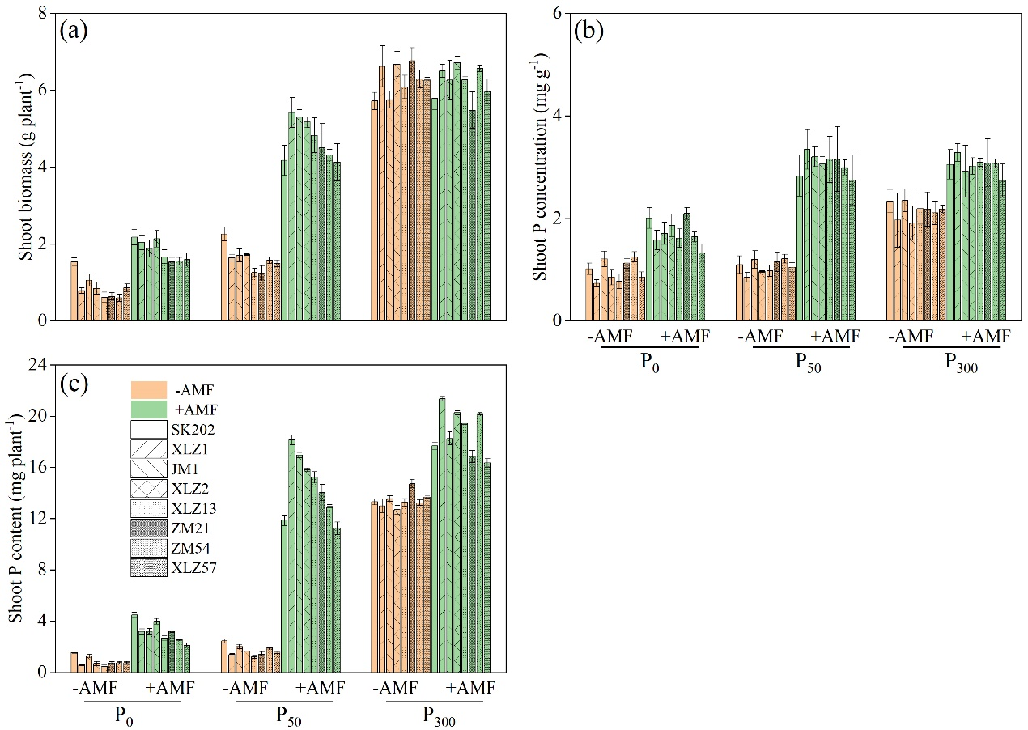
Fig. S1 Shoot biomass (a), shoot P concentration (b), and shoot P content (c) influenced by P application (P₀, P₅₀, P₃₀₀), AMF (brown and green columns represent non-mycorrhizal and mycorrhizal treatments, respectively) and cotton varieties (SK202, XLZ1, JM1, XLZ2, XLZ13, ZM21, ZM54 and XLZ57).

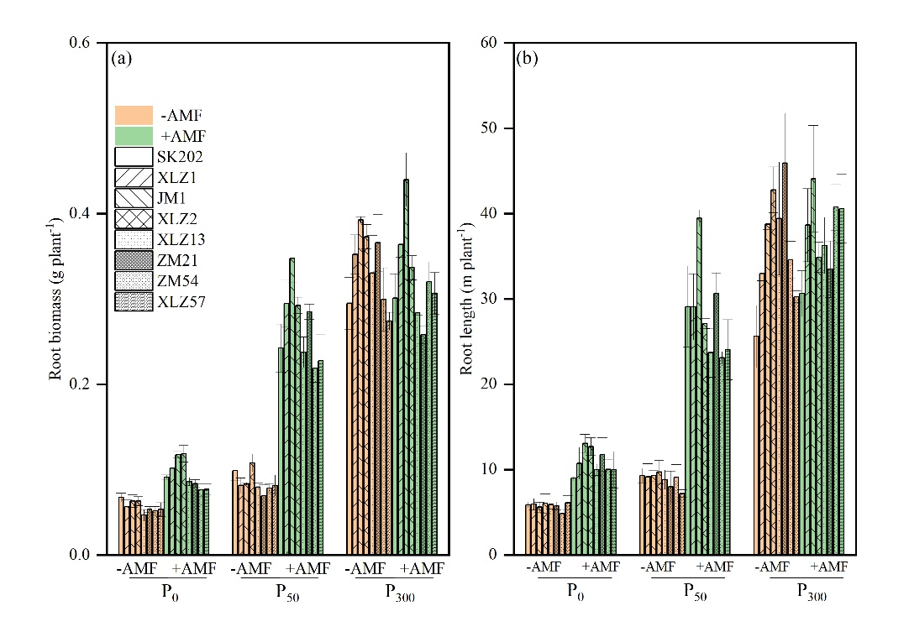
Fig. S2 Root biomass (a) root length (b) influenced by P application (P₀, P₅₀, P₃₀₀), AMF (brown and green columns represent non-mycorrhizal and mycorrhizal treatments, respectively) and cotton varieties (SK202, XLZ1, JM1, XLZ2, XLZ13, ZM21, ZM54 and XLZ57).
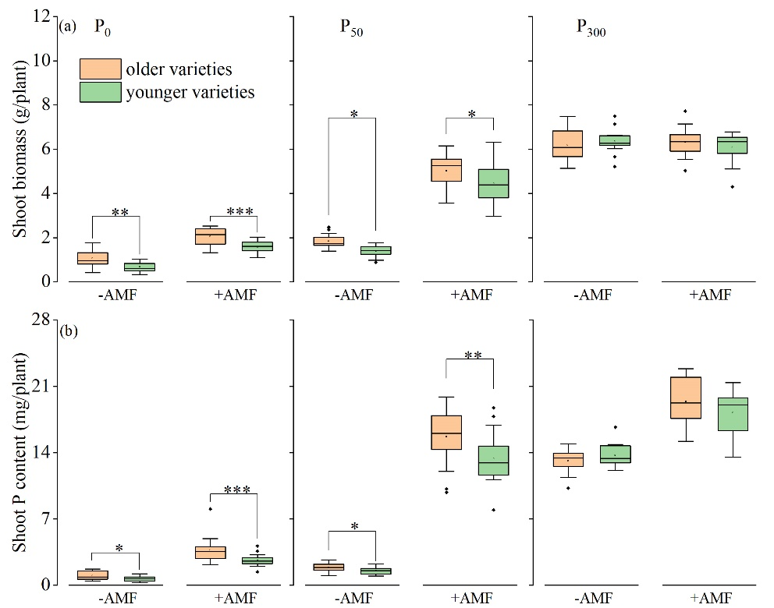
Fig. S3 Shoot biomass (a) and shoot P content (b) of older and younger cotton varieties influenced by P application (P₀, P₅₀, P₃₀₀), and arbuscular mycorrhizal fungi (AMF). *, **, *** present significance between older and younger cotton varieties at P < 0.05, P < 0.01 and P < 0.001, respectively (t-test).
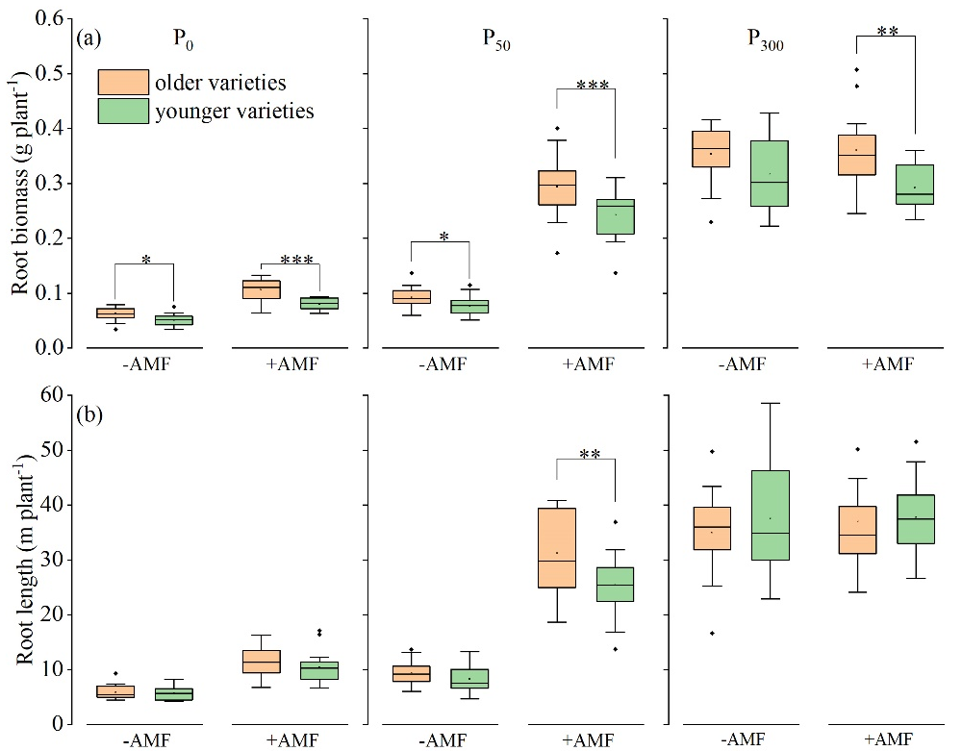
Fig. S4 Root biomass (a) and root length (b) of older and younger cotton varieties influenced by P application (P₀, P₅₀, P₃₀₀) and arbuscular mycorrhizal fungi (AMF). *, **, *** presents significance between older and younger cotton varieties at P < 0.05, P < 0.01 and P < 0.001, respectively (t-test).

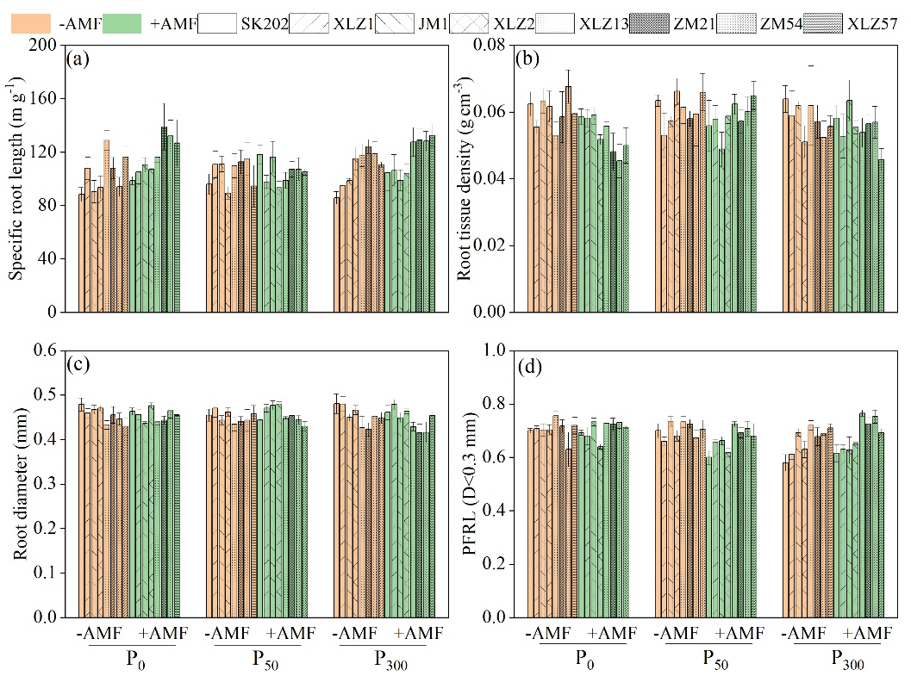
Fig. S5 Morphological traits (specific root length, a; root tissue density, b; root diameter, c; proportion of fine root length, PFRL, d) variation influenced by P application (P₀, P₅₀, P₃₀₀), (brown and green columns represent non-mycorrhizal and mycorrhizal treatments, respectively) and cotton varieties (SK202, XLZ1, JM1, XLZ2, XLZ13, ZM21, ZM54 and XLZ57).

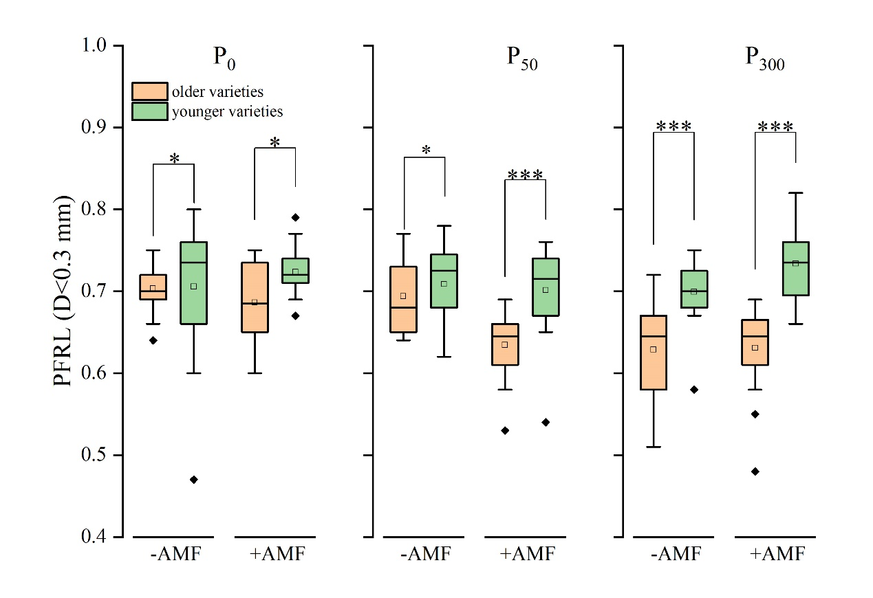
Fig. S6 Proportion of fine root length (D<0.3 mm) (PFRL) of older and younger cotton varieties influenced by P application (P₀, P₅₀, P₃₀₀) and arbuscular mycorrhizal fungi (AMF). * and *** presents significance between older and younger cotton varieties at P < 0.05 and P < 0.001, respectively (t-test).
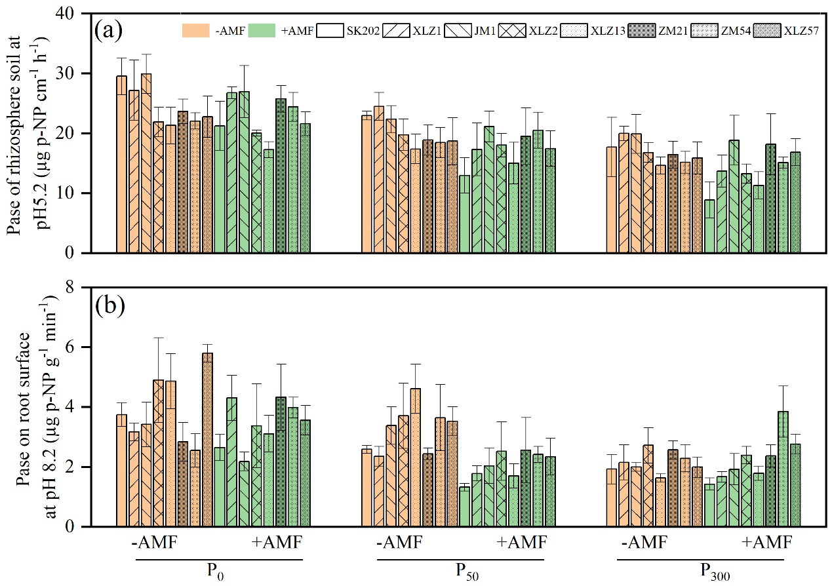
Fig. S7 Physiological traits (phosphatase activity of rhizosphere soil, a; phosphatase activity on root surface, b), influenced by P application (P₀, P₅₀, P₃₀₀), AMF (brown and green columns represent non-mycorrhizal and mycorrhizal treatments, respectively) and cotton varieties (SK202, XLZ1, JM1, XLZ2, XLZ13, ZM21, ZM54 and XLZ57).

Table S1 Correlation between relative mycorrhizal (P) responsiveness / absolute mycorrhizal (P) responsiveness and shoot biomass / shoot P content of non-mycorrhizal plants at three levels of P application (P₀, P₅₀, P₃₀₀).
 |  | MGR  (%) | MPR  (%) | AMGR  (g plant⁻¹) | AMPR  (mg plant⁻¹)
P₀ | non-mycorrhizal shoot biomass (g/plant) | -0.81** | -0.65** | -0.52** | 0.017
 | non-mycorrhizal shoot P content (mg/plant) | -0.75** | -0.73** | -0.49** | -0.038
P₅₀ | non-mycorrhizal shoot biomass (g/plant) | -0.77** | -0.64** | -0.38* | -0.19
 | non-mycorrhizal shoot P content (mg/plant) | -0.69** | -0.80** | -0.41* | -0.32
P₃₀₀ | non-mycorrhizal shoot biomass (g/plant) | -0.57** | -0.26 | -0.63** | -0.22
 | non-mycorrhizal shoot P content (mg/plant) | -0.36* | -0.59** | -0.42* | -0.53**
Note: * and ** mean significance at P < 0.05 and P < 0.01, respectively (Pearson correlation at P < 0.05).

